ECOLOGO_W-C

Recommendations for the Design of a Long-term Toxics Monitoring Program in the Mainstem of the Spokane River

Prepared by the Environmental Assessment Program – Toxics Studies Unit

For the Water Quality Program Eastern Regional Office and the

Spokane Regional Toxics Task Force

June 19, 2012

**Table of Contents**

[Background 3](#_Toc327878029)

[Project Description 4](#_Toc327878030)

[Considerations for Monitoring of Toxics 5](#_Toc327878031)

[Environmental Fate of Toxics 5](#_Toc327878032)

[Part 1: Recommended Sampling for FY13 6](#_Toc327878033)

[Fish 7](#_Toc327878034)

[Water 7](#_Toc327878035)

[Particulates 7](#_Toc327878036)

[Part 2: Recommendations for a Long-term Toxics Monitoring Plan 9](#_Toc327878037)

[Core Components for Toxics Monitoring and Trend Detection 9](#_Toc327878038)

[Surface Water 10](#_Toc327878039)

[Particulates 13](#_Toc327878040)

[Bottom Sediments 14](#_Toc327878041)

[Fish 15](#_Toc327878042)

[Osprey 17](#_Toc327878043)

[PCB Congeners versus Aroclors 19](#_Toc327878044)

[Sampling Procedures 21](#_Toc327878045)

[Surface Water 21](#_Toc327878046)

[Particulates 21](#_Toc327878047)

[Bottom Sediments 22](#_Toc327878048)

[Fish 22](#_Toc327878049)

[Osprey 22](#_Toc327878050)

[Measurement Procedures 23](#_Toc327878051)

[Cost Estimates for FY13 and Long-term Toxics Monitoring 25](#_Toc327878052)

[Surface Water 25](#_Toc327878053)

[Particulates 25](#_Toc327878054)

[Sediment 26](#_Toc327878055)

[Fish 26](#_Toc327878056)

[Osprey 26](#_Toc327878057)

[Data Quality 27](#_Toc327878058)

[Data Management Procedures 27](#_Toc327878059)

[Audits and Reports 27](#_Toc327878060)

[References 28](#_Toc327878061)

[Appendices 31](#_Toc327878062)

# Background

The Spokane River contains elevated levels of a number of toxic chemicals including polychlorinated biphenyls (PCBs), polybrominated diphenyl ethers (PBDEs), dioxins/furans and metals. These contaminants are prevalent in water, sediment, and fish tissue. Numerous studies and clean-up activities to address contamination are ongoing in the Spokane River watershed.

The Washington State Department of Ecology (Ecology) recently entered into a Memorandum of Understanding to establish a Spokane River Regional Toxics Task Force (SRRTTF). The mission of this regional task force is to work collaboratively to characterize the sources of toxics in the Spokane River and identify and implement appropriate actions needed to make measurable progress towards meeting applicable water quality standards for the State of Washington, State of Idaho, and the Spokane Tribe of Indians and in the interests of public and environmental health.

To assist the regional task force in accomplishing their mission, Ecology’s Eastern Regional Office (ERO) has requested that the Environmental Assessment (EA) Program draft recommendations for a long-term monitoring plan for toxics in the mainstem of the Spokane River. Mainstem monitoring is the focus of these recommendations in order to track overall progress in bringing the river into compliance with applicable water quality standards. It is intended that mainstem monitoring will compliment source identification activities occurring throughout the watershed by a number of groups.

# 

# Project Description

The objective of the long-term monitoring plan presented in this document is to assess current concentrations of PCBs, PBDEs, dioxins/furans, and metals in the mainstem of the Washington portion of the Spokane River. Future sampling efforts will then be able to follow such a monitoring plan in order to establish trends for toxics in the Spokane River. It should be stressed that this document presents only recommendations for a long-term monitoring plan for toxics in the Spokane River, any final decisions on the long-term monitoring plan will be based on input from SRRTTF and the consideration of available funding to support monitoring.

Various monitoring and toxics reduction efforts are currently being undertaken by NPDES permittees and other stakeholders along the Spokane River. This long-term monitoring plan will focus on toxics in the mainstem Spokane River in order to assess the overall impact of toxic reduction efforts in the mainstem Spokane River.

The recommended long-term monitoring plan is composed of multiple environmental matrices such as water, sediment, and fish that each represents a different time frame and chemical fate for toxics in the Spokane River. This is a multiple lines of evidence approach. The intent is that the sampling design will provide useful information in the short-term while laying out the baseline for future trend detection.

Monitoring recommendations in this document are divided into 2 parts:

1. Recommendations for monitoring to be conducted during the State fiscal year 2013 (FY13), specifically fall 2012 and spring 2013: This monitoring will generate a large data set for toxics in fish tissue and answer some preliminary questions on sampling methodologies for measuring toxics in surface water.
2. Recommendations for a long-term toxics monitoring plan for the mainstem Spokane River: These recommendations are given to generate discussion and to help the SRRTTF decide on options for future long-term monitoring based on the monitoring objectives identified by the SRRTTF as they continue to define their strategy for making measurable progress towards reducing toxics in the mainstem Spokane River.

Prior to the implementation of any of the monitoring plan components, a detailed quality assurance (QA) project plan should be developed to guide the sampling. Quality assurance and data quality are generally discussed in this document and will provide an outline for the development of any future QA project plans.

# Considerations for Monitoring of Toxics

This section provides a background on the complexities of monitoring toxic chemicals in environmental systems such as the Spokane River. The document then shifts to Part 1: *Recommended Sampling Plan for FY13,* where a preliminary sampling plan for the upcoming field season is discussed. *Part 2: Recommendations for a Long-term Toxics Monitoring Plan* explains monitoring options for possible inclusion into a long-term toxics monitoring strategy for the Spokane River.

For the remainder of this document, the term “toxics” will refer to the following toxic parameters: PCBs, PBDEs, dioxins/furans and metals, unless stated otherwise.

## Environmental Fate of Toxics

Rivers like the Spokane are dynamic systems where the water chemistry can change rapidly over the course of hours. Seasonal, weather, and hydrogeologic patterns as well as landuse changes in the watershed and point and non-point source discharges to the river can change stream chemistry over the short-term and long-term. This makes it challenging to characterize a true baseline and to detect trends in the load of toxic chemicals present in any riverine system.

Toxics can exist in surface water in both the dissolved and particulate fraction. Many organic chemicals such as PCBs are hydrophobic and prefer to attach to particulates in the water column. How much of a toxic chemical that can be found in the dissolved versus particulate fractions at any given time is highly dependent on variables such as the amount of organic carbon and suspended particulates in the water column and the octanol-water partitioning coefficient (affinity to absorb to organic matter) of each toxic chemical.

When water velocities slow down in a river, particulates (with toxics attached to them) will deposit in the bottom sediments of the waterbody. Surface sediments therefore, can represent months to years of the chemical load from the water column depending on sedimentation rates.

Adult fish can represent many years of bioaccumulation of toxic chemicals, especially lipophilic (fat-loving) chemicals such as PCBs. Predator species such as osprey eat fish and then these lipophilic chemicals biomagnify up the food chain. Osprey eggs can be particularly high in lipophilic contaminants as the eggs have high lipid content.

# Part 1: Recommended Sampling for FY13

It is a good idea to gain more information on the variability and character of the waterbody of interest prior to the onset of monitoring, especially when limited financial resources are considered. Rivers are highly variable systems and the collection and analysis of environmental samples for toxics, especially organics, can be challenging.

In light of this, it is recommended to start the long-term toxics monitoring plan for the Spokane River in the fall of 2012 by implementing the full fish tissue monitoring component, since fish tissue monitoring is a well established monitoring method. A limited number of surface water (whole water) and particulate samples should be collected and analyzed for toxics to inform the design of the larger long-term toxics monitoring plan. Preliminary monitoring would occur during FY13, fall 2012 and spring 2013, with funds provided by Ecology and field work conducted by Ecology’s Environmental Assessment (EA) Program.

A detailed QA project plan will need to be developed prior to the onset of the FY13 monitoring, but a general overview including estimated costs is shown in Table 1.

Table 1. Monitoring Plan and Laboratory Analysis Costs for Spokane River Toxics in FY13.



DOH = Washington State Department of Health

WQP ERO = Water Quality Program Eastern Regional Office (Ecology)

EAP = Environmental Assessment Program (Ecology)

EAP Programs:

WSTMP = Washington State Toxics Monitoring Program

PBT = Persistent Bioaccumulative Toxics Program

## Fish

The fish tissue monitoring plan should be implemented as explained in further detail in *Part 2: Recommendations for a Long-term Toxics Monitoring Plan*. Fish sampling includes composite samples of suckers (bottom fish) analyzed as whole body from 4 river reaches for analysis of trends for toxics as shown in Table 2. Composite samples of sport fish analyzed as edible fillets will be analyzed from 3 river reaches to meet the needs of a toxics fish consumption review by the Washington State Department of Health (DOH). Sampling will be conducted in fall of 2012.

Table 2. Monitoring Locations and Number of Samples for FY13 Fish Tissue Collection.

|  |  |  |  |  |  |
| --- | --- | --- | --- | --- | --- |
| River Reach | River Mile | Bottom Fish | Sport Fish\* | | Total Number of Samples |
| Suckers | Species 1 | Species 2 |
| Numbers of Composite† Samples | | |
| Upriver Dam to Plante Ferry | 81 – 86 | 7 | 0 | 0 | 7 |
| Mission Park | 75 – 77 | 7 | 3 | 3 | 13 |
| Ninemile | 60 – 64 | 7 | 3 | 3 | 13 |
| Upper Long Lake | 52 – 56 | 7 | 3 | 3 | 13 |
| Total Number of Samples | | 28 | 9 | 9 | **46** |

\* Sport fish species include mountain whitefish, smallmouth bass, rainbow trout, and brown trout.

† Composite samples consist of 3-5 individual fish per composite.

## Water

Surface water samples will be collected at 3 sites: *Plante Ferry*, *Above Latah* Creek, and at *Ninemile Dam* to evaluate whether desired detection limits can be met with whole water sampling. Sampling will occur in fall of 2012 and again in spring of 2013, covering two different flow periods.

*Plante Ferry* and *Above Latah* are free-flowing monitoring sites and samples will be collected at these locations using the depth-integrated samplers. The *Ninemile Dam* monitoring site is where a sediment trap will also be placed. Surface water will be collected here as a grab sample. The fall whole water sample from *Ninemile Dam* can then be compared to the particulate concentration found at the site during fall deployment. More information on the surface water monitoring is covered in *Part 2: Recommendations for a Long-term Toxics Monitoring Plan*.

## Particulates

One sediment trap will be placed at both *Upriver Dam* and at *Ninemile Dam* in fall of 2012. The estimated deployment period will be 2 – 3 months, since the fall is a low-flow period and particulate concentrations will be lower than during the spring high-flow period. A sediment trap placed at *Ninemile Dam* for approximately 6 weeks in spring of 2009 yielded adequate deposition for analysis. More information on monitoring for particulates is covered in *Part 2: Recommendations for a Long-term Toxics Monitoring Plan*.

# Part 2: Recommendations for a Long-term Toxics Monitoring Plan

Part 2 describes the recommended environmental sampling matrices and rational for including them in a long-term monitoring plan for toxics in the mainstem Spokane River. These are only recommendations. It is the intent that this plan will generate discussion and will assist the SRRTTF in deciding on the best options for future long-term monitoring. The final long-term monitoring plan should be shaped by the specific monitoring objectives identified by the SRRTTF.

The recommended long-term monitoring plan is designed to measure toxics present in the Spokane River both in terms of relative concentrations at different segments of the river and to identify short-term and long-term trends. The plan will focus on multiple environmental matrices that represent shorter and longer time frames as well different environmental fates (see Table 3).

Table 3. Recommended Sampling Matrices for the Spokane Long-term Monitoring Plan.

|  |  |  |
| --- | --- | --- |
| Matrix | Sampling Method | Temporal Representation of Environmental Condition |
| Surface Water (whole)\* | Depth integrated composites | 1 hour |
| Particulates (suspended solids)\* | Sediment traps | 1 – 3 months |
| Bottom Sediment (0-2 cm) | Ponar grab | months to years |
| Fish Tissue\* | Electrofishing and gill-netting | months to years |
| Osprey Eggs | Physical removal from nest | months |

\* = sampling matrices to be measured in FY13

## Core Components for Toxics Monitoring and Trend Detection

Though any environmental medium (surface water, sediments, fish tissue, etc.) has its strengths and weaknesses for use in toxics monitoring, some media may be better suited for long-term trend detection. For the purposes of trend monitoring in the Spokane River, fish tissue, osprey eggs, and bottom sediments are recommended as the core monitoring components. These media are good at integrating some of the variability and episodic nature of toxics in riverine systems and have been used in trend-monitoring programs nationwide.

The surface water monitoring components recommended for the long-term monitoring plan: surface water (via depth integration collection) and particulates (via sediment traps) need further investigation before they are included in a long-term plan. Surface water monitoring can be a useful tool for showing relative concentrations (i.e., upstream versus downstream) of toxics in a river, but its use for trend detection may be limited.

The preliminary surface water monitoring recommend for FY13 should give more information on detection limits and on variability of toxics in surface waters. This will be useful in informing how surface water monitoring can be added to the long-term toxics monitoring plan.

## Surface Water

It is recommended that surface water be collected to represent whole water (dissolved + particulate fractions) concentrations of toxics in the Spokane River. However, a potential draw-back to analyzing surface water concentrations for most organic toxics (PCBs, PBDEs, and dioxins/furans) is that these chemicals have historically been too low for detection. On the other hand, detection and reporting limits for many of these organic toxics have greatly improved in recent years. An example is the Puget Sound Toxics Loading Analysis (PSTLA) where as part of the loading analysis, two studies were conducted to measure PCBs, PBDEs, and metals in whole water samples from major rivers and from smaller streams in the Puget Sound Watershed (Gries and Osterberg, 2011 and Herrera Environmental Consultants, Inc., 2011).

Tables A-1 and A-2 (in the appendix) show toxics detection frequencies based on storm events versus base flow and also by land use for Puget Sound streams. Table A-3 shows detection frequencies for major rivers in Puget Sound. For major rivers, total PCB congeners were detected 100% of the time and total PBDEs were detected 47% of the time (Table A-3). Metals (cadmium, lead, and zinc) had varied detection frequencies from 60 – 100%, depending on whether the samples were dissolved or total. For Puget Sound streams, samples taken during storm flows yielded higher detection frequencies than samples taken at base flow conditions (Table A-2). The Highest detection frequencies were generally found in streams that had watersheds with commercial land compared to those with watersheds that mainly consisted of residential, agricultural, or forested lands (Table A-1).

Very little data exists for toxics in whole water samples from the Spokane River. Current low-level analytical methods may be sufficient to detect toxics in surface water samples in the Spokane River. However, without any current whole water data from the Spokane River, it is difficult to determine if monitoring toxics in whole water makes sense. Because of this, Ecology is recommending collection of whole water samples at 3 sites in the Spokane River during Ecology’s fiscal year 2013 (FY13). This preliminary sampling is proposed for fall 2012 and spring 2013, to inform future use of whole water sampling in the long-term toxics monitoring plan. Details of the preliminary whole water sampling are discussed in further detail in Part 1: *Recommended Sampling Plan for FY13*.

If it is found that toxics are not consistently detected in whole water samples after the preliminary monitoring, whole water sampling can be dropped from the long-term plan and a pre-concentration collection method, such as the XAD resin column can be considered. Alternatively, it may be that the other monitoring components (particulates, sediment, fish, and osprey eggs) may suffice to meet the goals of long-term monitoring of toxics in the Spokane River.

**Design for Long-term Monitoring of Surface Water**

Surface water generally represents seasonal conditions in a river, but surface water chemistry can change rapidly in minutes to hours during storm events or during other significant events such as spills. In order to capture some of this variability, surface water should be collected to capture a range of flow conditions. Three flow conditions were chosen for long-term monitoring of surface water in the Spokane River:

1. low flow (August – September)
2. moderate flow (January – February)
3. high flow (May – June)

The low flow period of August – September represents base flow conditions. The high flow period of May – June represents both snow melt flows from further upriver in Idaho and run-off producing storm events in Spokane proper. The moderate flow period of January – February represents a transition between the extremes.

Ideally it would useful to capture run-off producing storm events separately from the regular spring high flows when sampling surface water. However, storm event sampling in the Spokane River can be challenging as runoff producing storm events are not a frequent or often predictable occurrence in the Spokane River watershed. Previous stormwater sampling by the City of Spokane and Parsons Inc. occurred in May and June (Serdar et al., 2011 and Parsons, 2007). It’s important to distinguish that their sampling targeted stormwater prior to reaching the river, while the long-term monitoring plan would target river water during similar runoff events. Field staff should try to target 1 or 2 storms during the high flow period if possible; however, it’s not imperative to sampling design.

Surface water should be sampled 3 times during each of 3 flow periods for a total of 9 surface water samples each year at each of the 6 monitoring locations shown in Table 4 and Figures A-3 through A-5. Having 3 samples per flow period allows for measurement of statistical variability in each flow period.

Table 4. Recommended Long-term Monitoring Locations for Whole Surface Water Sampling.

|  |  |  |
| --- | --- | --- |
| River Reach | River Mile | Location Description |
| Stateline | 96.4 | From the Centennial Trail Bridge |
| Plante Ferry\* | 84.2 | From foot bridge below boulder section of the river |
| Greene Street | 78 | From the N Greene Street Bridge |
| Above Latah\* | 72.5 | From foot bridge at People’s Park (upstream of Latah Creek) |
| 7-Mile1 | 62 | From W 7 Mile Road Bridge |
| Little Spokane R.2 | 1.1 | From N 9 Mile Road Bridge |

\*Locations proposed for preliminary sampling in FY13; Additional site for FY13 includes Ninemile Dam.

1Foot Bridge at Bowl and Pitcher Park (RM 66) is another option in this stretch of the river.

2Bridge at W Rutter Parkway (RM 3.9) is another option for sampling the Little Spokane River.

Prior to implementing surface water sampling to the long-term monitoring plan, a statistical power analysis should be conducted using the preliminary surface water toxics data collected in 2012-13. This type of statistical analysis will help determine the number of samples needed to detect trends for toxics in the Spokane River. Similar statistical analysis has been conducted for metals in surface water statewide (Hallock, 2010). If it is determined that a large number of samples (>10 per year) is needed at each monitoring location to detect trends, another sampling option could be to focus a higher number samples at 1 or 2 of the proposed monitoring locations.

The 5 mainstem monitoring sites shown in Table 4 are strategically placed to define specific segments of the Spokane River. *Stateline* represents toxics coming from upstream of the Washington-Idaho border. *Plante Ferry* is located downstream of the Liberty Lake Water Reclamation Facility and Kaiser Trentwood. *Greene Street* is located downstream of Inland Empire Paper and the Spokane County Regional Water Reclamation Facility. *Above Latah* is downstream of the City of Spokane and most of the major stormwater inputs from the City. There is a stormwater discharge at the Greene Street Bridge. Field staff should attempt to sample upstream of this discharge, especially during storm events, so as to bracket the major stormwater inputs between *Greene Street* and *Above Latah*. The *7-Mile* monitoring location is downstream of the Riverside Park Water Reclamation Facility.

The mainstem monitoring sites and the site on the Little Spokane River are located in free-flowing sections. Sampling a free-flowing section of river captures the true whole water condition (dissolved and suspended particulate fractions). United States Geological Survey (USGS) surface water sampling methods for free-flowing rivers will be used. These methods are discussed later on in *Sampling Procedures*.

Whole surface water samples will be analyzed for PCB congeners, PBDEs (high resolution methods), and metals: cadmium, lead, and zinc. Analysis of metals will include total and dissolved fractions. Dissolved metals will require filtering and acidification in the field. Dioxins/furans will not be analyzed for in whole water as they are less likely to be detected compared to PCBs and PBDEs. Dioxins/furans will be analyzed in particulate samples (as discussed later in this document).

Lower detection limits for PCBs and PBDEs will likely require large quantities of water. For example, 2 liters is a common requirement for low-level PCB congener analysis.

Ancillary laboratory parameters: total suspended solids (TSS), total organic carbon (TOC), dissolved organic carbon (DOC), and turbidity should also be analyzed.

**Flow Measurements**

The United States Geological Survey (USGS) operates 2 real time (every 15 minute) gaging stations on the Spokane River and 1 on the Little Spokane River. They are shown in bold in Table 5. Flow data is available on the internet at <http://waterdata.usgs.gov/nwis>. It may be beneficial to the long-term monitoring study if the 2 upriver gaging stations below the state border (Spokane above Liberty Bridge and Spokane at Green Acres) were started up again. According to USGS, these gaging stations were stopped in 2011 due to lack of funding.

Table 5. USGS Flow Gaging Stations for the Spokane River.

|  |  |  |
| --- | --- | --- |
| Station ID | Station Name | Status |
| **12419000** | **Spokane R. near Post Falls Idaho** | **Real Time** |
| 12419500 | Spokane R. above Liberty Br nr Otis Orchard | Stopped in 2011 |
| 12420500 | Spokane R. at Green Acres | Stopped in 2011 |
| 12421500 | Spokane R. below Trent Br nr Spokane | Seasonal (Jun-Sep) |
| **12422500** | **Spokane R. at Spokane** | **Real Time** |
| **12431000** | **Little Spokane at Dartford** | **Real Time** |
| 12431500 | Little Spokane near Dartford | Stand Alone |

## Particulates

Particulate sampling represents the suspended fraction of solids and sediment present in surface water. Sediment traps and centrifuging are two common particulate collection methods that have been successfully used by Ecology in various water quality studies statewide. Centrifuging is generally conducted over the course of hours to days, depending on the amount of suspended solids present in the water, while sediment traps are deployed over the course of weeks to months.

For the long-term toxics monitoring plan for the Spokane River, it is recommended to use sediment traps for collection of particulates, in order to characterize river toxics concentrations over a longer deployment period. The proposed particulate sampling locations are shown in Table 6 and would be deployed, triennially, during 3 seasons: August-September, January-February, and May-June. With the exception of *Stateline*, these locations are generally in deeper pool areas behind the dams. Deeper pooled areas are ideal for the middle water column sediment trap deployment method used by Ecology. Sediment trap deployment procedures are explained in further detail in the *Sampling* *Procedures* Section.

Table 6. Long-term Monitoring Locations for Particulates.

|  |  |
| --- | --- |
| River Reach | River Mile |
| Stateline | 96 |
| Upriver Dam\* | 80 |
| Upper Falls Dam | 74.5 |
| Ninemile Dam\* | 58 |
| Long Lake Dam | 34 |

\*Locations for preliminary particulate monitoring in FY13.

Similar to the surface water monitoring, the first step for particulates should be preliminary sampling at couple of monitoring locations to evaluate the use of sediment traps for the long-term monitoring plan. Upriver Dam and Ninemile Dam are proposed for preliminary sampling in fall of 2012 (Table 6).

In spring of 2009, a sediment trap was deployed by Ecology behind Ninemile Dam for approximately 6 weeks (Callie Mathieu, personal communication). The sample yielded an adequate amount of sampling material for toxics analyses, but was never analyzed. While the 2009 sample represented high flow conditions, the fall 2012 preliminarymonitoring samples will represent low flow conditions.

As with surface water monitoring, 1 or 2 monitoring sites for particulates may suffice for trend detection, but a higher number of monitoring sites such as those shown in Table 6 can bracket known sources of toxics in the river.

Centrifuging should be considered a suitable alternative method for collecting particulates, though if centrifuging was used instead of sediment traps, the monitoring locations would likely be different due to the logistics of setting up the centrifuge trailer.

Ecology used a centrifuge to measure PCB particulate concentrations at 3 locations in the Spokane River in fall of 2003 as part of the Spokane River PCB Source Assessment (Serdar, et al., 2011). Results for the centrifuge particulates are shown in Table 7.

Table 7. PCBs in Suspended Particulates from the Spokane River collected in fall of 2003.

|  |  |
| --- | --- |
| Spokane River Location | Total PCBs (ng/g, dry weight, ppb) |
| Harvard Road | 10 |
| Plante Ferry Park | 7 |
| Riverside State Park | 69 |

Particulates should be analyzed for PCB congeners, PBDEs (high resolution methods), dioxin/furans and metals: cadmium, lead, and zinc. Ancillary parameters include TOC and percent solids.

## Bottom Sediments

Bottom sediments (top 0-2 cm) should be collected every 5 years from 3 locations throughout Long Lake and at 1 location further downstream in Porcupine Bay, in the Spokane Arm (Table 8 and Figures A-2 and A-3). Three individual grab samples should be taken at each site and analyzed separately in order to provide an adequate measurement of statistical variability.

Table 8. Monitoring Locations† for Bottom Sediments in the Lower Spokane River.

|  |  |  |  |
| --- | --- | --- | --- |
| River Reach | River Miles | Latitude North | Longitude West |
| Upper Long Lake | 54.3 | 47○ 47’ 38” | 117○ 34’ 11” |
| Middle Long Lake | 44.3 | 47○ 53’ 10” | 117○ 41’ 28” |
| Lower Long Lake | 38.4 | 47○ 49’ 44” | 117○ 46’ 8.2” |
| Porcupine Bay | 12.6 | 47○ 53’ 3” | 118○ 8’ 59” |

† Locationsfrom Serdar et al., 2011.

The reason that bottom sediment sampling should be focused on Long Lake and the Spokane Arm is that previous studies have had difficulty finding depositional areas of fine sediments in the Spokane River (Serdar et al., 2011). Naturally low suspended sediments in the river and high energy spring flows tend to leave few areas of significant deposition. It can also be challenging to know if bottom sediments in a high energy river system are originating from resuspension or from new deposition originating from upland sources.

Long Lake is the ultimate sink for the majority of the toxics attached to suspended particulates in the Spokane River. Suspended sediments are more likely to be evenly integrated over time into the lake sediments making the determination of trends more discernable there.

Sediments should be analyzed for PCB congeners, PBDEs (high resolution methods), dioxin/furans and metals: cadmium, lead, and zinc. Ancillary parameters will include TOC, percent solids, and grain size.

## Fish

Fish should be collected every 5 years at the 6 historical locations shown in Table 9 and Figures A-3 through A-5. However, as a significant cost-savings measure, collection can be limited to 4 locations and still meet monitoring objectives: Upriver, Mission Park, Ninemile and upper Long Lake. The monitoring locations shown in Table 9 are consistent with previous Spokane River fish tissue studies conducted by Ecology.

Fish should be collected in the late summer or fall for comparison to historical data and also because it is generally an easier time for collection due to lower flows in the river.

Table 9. Monitoring Locations and Number of Samples for Fish Tissue Collection.

|  |  |  |  |  |  |
| --- | --- | --- | --- | --- | --- |
| River Reach | River Mile | Bottom Fish | Sport Fish\* | | Total Number of Samples |
| Suckers | Species 1 | Species 2 |
| Numbers of Composite† Samples | | |
| Stateline | 96 | 0 | 0 | 0 | 0 |
| Upriver Dam to Plante Ferry | 81 – 86 | 7 | 0 | 0 | 7 |
| Mission Park | 75 – 77 | 7 | 3 | 3 | 13 |
| Ninemile | 60 – 64 | 7 | 3 | 3 | 13 |
| Upper Long Lake | 52 – 56 | 7 | 3 | 3 | 13 |
| Lower Long Lake | 37 – 40 | 0 | 0 | 0 | 0 |
| Total Number of Samples | | 28 | 9 | 9 | **46** |

\* Sport fish species include mountain whitefish, smallmouth bass, rainbow trout, and brown trout.

† Composite samples consist of 3-5 individual fish per composite.

Bottom fish and sport fish will be targeted for overlapping but different purposes. Bottom fish (largescale and bridgelip suckers) will be collected to assess long-term trends. Sport fish, which include mountain whitefish, smallmouth bass, rainbow trout, and brown trout, will be collected to support a review by the Washington State Department of Health (DOH). DOH will determine if any updates to current fish tissue consumption advisories for the Spokane River may be warranted based on this data (McBride, personal communication).

Suckers are present in most every section of the river and much historical data has been collected on them. This makes suckers a good species to analyze for trends. Seven composite samples at each monitoring location are recommended. While most of the historic fish studies on the Spokane River have included fewer than 4 composite samples per species and location, a recent Ecology study concluded that a minimum of 5 composite samples per species and location were needed to measure trends for DDT and PCBs in the Okanogan River, assuming a statistical power of 80% (Newell, 2011). Seven composite samples of suckers per location in the Spokane River has a likely chance of detecting change over time, however the actual number can’t be known until a full statistical power analysis is conducted on the fish tissue data. Power analysis should be conducted on the sucker results to inform future sampling.

Suckers will be analyzed as whole-body composites consisting of 3-5 individuals in each composite (21-35 individual suckers for each site). All of the sucker samples will be analyzed for the 3 major PCB Aroclors (1248, 1254, and 1260), PBDEs, cadmium, lead and zinc. Subsets of sucker samples will be analyzed for PCB congeners, dioxin/furans, and mercury. See Table 10 for fish tissue parameters to be analyzed in suckers and sport fish.

DOH was consulted on the sampling design for sport fish and the proposed design will meet their needs. Sport fish will be analyzed as composites of edible fillet tissue with each composite consisting of 3-5 individuals. At 2 species per site, this equates to 18-30 sport fish per site. Sport fish species will be targeted in preferential order compared to species collected in the 2005 Ecology study (Serdar and Johnson, 2006). This includes mountain whitefish and rainbow trout at both the Mission Park and Ninemile sites. In upper Long Lake targeted species include mountain whitefish, brown trout, and smallmouth bass.

All sport fish will be analyzed for PCB Aroclors, PBDEs, dioxin/furans, and metals (Table 10). At the request of DOH, if field staff encounters northern pike during fish collection, some will be taken for analysis of mercury by DOH. Due to funding limitations, sport fish samples are not planned for PCB congener analysis. However, all samples will be archived, and as funding becomes available, samples may be analyzed for congeners. There is also a chance that if contract laboratory bids come in under the current estimated costs, some of the sport fish samples could be analyzed for congeners with the existing Ecology funds.

Table 10. Parameters to be analyzed in Spokane River Fish.

|  |  |  |  |
| --- | --- | --- | --- |
| Parameter | Bottom Fish (Suckers) | Sport Fish | Northern Pike |
| PCB Aroclors | All (7 samples per site) | All (6 samples per site) | none |
| PCB Congeners | 2 samples per site | none | none |
| PBDEs | All | All | none |
| Dioxin/furans | 2 samples per site | All | none |
| Metals (Cd, Pb, & Zn) | All | All | none |
| Mercury | 3 samples per site | All | TBD |

## Osprey

Osprey eggs should be collected every 5 years in the spring at the 12 Spokane River locations shown in Table 11 and Figures A-3 through A-5. Two nearby reference Lakes should also be sampled, for a total of 14 egg samples (1 egg each from 14 nest sites). These monitoring locations are based on a joint study conducted by the United States Geological Survey (USGS) and Ecology in spring of 2009 (Henny et al., 2011). Researchers collected 1 osprey egg from 14 nest sites along the Spokane River and analyzed them for PBDEs. Four nearby reference Lakes (Williams, Philleo, Bonnie, and Rock Lakes) were also sampled.

Due to the need for field reconnaissance 1 nesting season prior to sampling, coordination with landowners and utility companies, and funding, the earliest this work could happen would be spring of 2014. Ideally, during the next potential round of sampling for fish tissue and osprey eggs, the two types of monitoring would occur closer together. For example, fish tissue monitoring in fall 2017 and osprey eggs in spring 2018

There is overlap between most of the fish tissue monitoring sites and proposed osprey monitoring nests. Though it will not be the intent of the long-term monitoring plan to characterize the link between fish and osprey at these locations, the data will available for such interpretation.

Table 11. Monitoring Locations for Osprey Eggs.

|  |  |  |
| --- | --- | --- |
| River Reach | River Mile | Sampled in 2009 |
| Reference Lake 1 | -- | Yes |
| Reference Lake 2 | -- |
| Stateline | 96 |
| Upriver | 86 – 92 | No |
| Upriver Dam to Plante Ferry | 81 – 86 | Yes |
| Mission Park to Upriver | 77 – 80 |
| Mission Park | 75 – 76 |
| Above Latah Creek | 72 – 74 |
| Downstream of Bowl & Pitcher | 63 – 66 | No |
| Ninemile Reservoir | 59 – 61 | Yes |
| Ninemile Dam | 58 |
| Upper Long Lake | 55 – 57 |
| Middle Long Lake 1 | 47 |
| Middle Long Lake 2 | 44 |

Researchers from the 2009 joint USGS-Ecology study found that PBDE concentrations were an order of magnitude higher in the Spokane River compared to nearby reference lakes (Table 12). Concentrations were also found to be higher in the lower portion of the Spokane River downstream of urban and industrial areas. Researchers defined the lower portion of the river as those monitoring sites below the City of Spokane Riverside Park Water Reclamation Facility.

Table 12. PBDE Concentrations in Osprey Eggs from the Spokane River.

|  |  |  |  |
| --- | --- | --- | --- |
| Monitoring Site | River Mile | No.  Samples | ∑PBDEs\* |
| Upper River | 68-96 | 8 | 518 |
| Lower River | 47-67 | 7 | 749 |
| Reference Lakes | NA | 8 | 62 |

\* Geometric mean of total PBDEs as ng/g, part per billion, wet weight.

USGS has conducted extensive research on organic contaminants (PCBs, PBDEs and pesticides) in osprey eggs over the years. USGS states that the use of osprey eggs for measuring contaminant trends has many positive qualities (Henny et al., 2010). Some of these qualities of monitoring osprey include:

* Known to bioaccumulate lipophilic contaminants
* Diet consists of 99+% fish (predominately suckers)
* Restricted home range – osprey generally forage with 1-2 miles of their nest site
* Nests are spatially distributed at regular intervals
* Available in high numbers – healthy populations
* Removal of “sample egg” from the usual 3-egg clutch has shown limited effect on productivity of sampled nests
* Tolerant of short-term nest disturbance (i.e. taking an egg from a nest)

Ecology has contacted the lead USGS researchers, Jim Kaiser (biologist) and Chuck Henny (USGS research zoologist – emeritus), from the 2009 joint study for guidance on including osprey eggs in the long-term toxics monitoring plan for the Spokane River. They said that a 5-year sampling schedule for osprey egg collection should be appropriate for not impacting osprey populations along the Spokane River (Kaiser and Henny, personal communications). They also stated that monitoring 12 nest sites along the Spokane River should be adequate to measure long-term trends of organic chemicals based on their experience studying osprey in the Willamette River, Oregon and in other Pacific Northwest rivers. Jim Kaiser has offered to give a presentation to ERO and SRTTF on the merits of using osprey eggs for long-term toxics monitoring.

Osprey egg samples collected for the long-term monitoring plan should be analyzed for PCB Aroclors, PBDEs, dioxin/furans, and lipids. It is recommended that at least a subset of samples be analyzed for PCB congeners.

Archived osprey egg samples from the 2009 joint study are currently in storage at the Environment Canada National Wildlife Research Centre (NWRC) Laboratory in Ottawa, Canada. These archived samples could be analyzed for PCB congeners by the NWRC through a contract with Ecology. Analytical holding times have passed for the 2009 archives, but PCBs are very stable, especially in frozen samples. Analysis of samples from 2009 could provide useful information for assessing PCB trends in osprey eggs.

## PCB Congeners versus Aroclors

PCBs in environmental samples can be analyzed as either congeners or Aroclors. Congener analysis measures for all possible 209 congeners. Aroclor analysis measures for the 15 or so historical industrial Aroclor mixtures (which are mixtures of specific congeners), with Aroclors 1248, 1254, and 1260 being the most commonly detected. Because congener analysis accounts for all possible PCBs, it provides much more information. On the other hand, PCB congener analysis is very expensive compared to Aroclor analysis.

Depending on the goals of a particular study, either analysis can be adequate. For the Spokane River long-term study, it is recommended that PCB congener analysis is used for all sampling matrices where possible. An exception can be for fish tissue and osprey eggs. The majority of historical PCB data for Spokane River fish have been Aroclor data and the Washington State Department of Health (DOH) uses Aroclor data to evaluate risks to human health from fish consumption. In addition, concentrations of PCBs in fish and osprey eggs should be high enough that quantifying total PCB concentrations will be adequate through the use of Aroclor analysis.

A subset of fish and osprey egg samples may be analyzed for PCB congeners as a comparison to the Aroclor data. Samples can also be archived and saved for future analysis as funding allows. Though the official analytical holding time for PCBs in tissue and sediments is 1 year, samples can be held for many years and still yield fairly accurate results when analyzed later.

For surface water, suspended particulates, and sediments that will be analyzed for the long-term monitoring plan, PCB congener analysis should be utilized for comparison to source-tracing PCB congener data from effluents and stormwater conveyance systems in the Spokane River watershed.

# Sampling Procedures

## Surface Water

Surface water samples will be collected from foot or road bridges with a USGS depth integrating bridge sampler. Sampling procedures for the depth integrating samplers are described in detail in the USGS National Field Manual for Collection of Water Quality Data (USGS, 2005). Surface water is collected at 3 quarter points along a river cross-section. The depth-integrating sampler is lowered and raised at a fixed rate. Once enough volume is collected at each quarter point, the samples are manually composited so that water from each quarter point will contribute one third of the volume for analysis in the sample container.

The appropriate type of USGS bridge sampler depends on the depth and velocity of the river at each monitoring location. The 2009-10 toxics study of major rivers to the Puget Sound successfully used the DH-95 sampler for flows ranging from 470 to 18,400 cfs (Gries and Osterberg, 2011). Based on conversations with USGS field staff from the Spokane area, there is a chance that flows greater than 10,000 cfs will create velocities (>7.4 ft/sec) in the river that could exceed the operational limit for the DH-95 (Elwell, personal communication). The DH-96 is an option for flows between 10,000 and 30,000 cfs with an operational limit of >12.5 ft/sec.

An option for sampling surface water during very high flows (>30,000 cfs) would be using a surface grab sampler; however such high flows are on the extreme end of the range of high flows for the Spokane River. A gross estimate by USGS is that there is a 5% chance of exceeding 30,000 cfs in any given year (Elwell, personal communication).

Both the DH-95 and DH-96 samplers are heavy and require a bridge crane to lower and raise the sampler in and out of the water column. These samplers take time to set up and the sampling area on the foot or road bridges will need to be properly flagged for visibility to passing traffic. Field staff should allow 1-2 hours for each visit to a monitoring location.

Equipment decontamination procedures for using USGS depth integrating samplers for organic toxics will be followed (Wilde, 2004 and Anderson, 2012).

Temperature, pH, and conductivity will be measured with a Hydrolab MiniSonde® meter following the EA Program *Standard Operating Procedure* *for Hydrolab® DataSonde® and MiniSonde® Multiprobes, Version 1.0* (Swanson, 2007).

## Particulates

The Ecology Environmental Assessment (EA) Program’s standard sediment trap deployment method for reservoirs and deep water is to suspend a trap in the middle of the water column with an anchor, snag line, and hardball float. This method is described in detail in Norton (1996). The hardball float sits 6 feet below the water surface, so that it can stay taut with fluctuating water levels and that it’s not disturbed by vessel traffic or floating debris. The trap is then retrieved by dragging a hook to grab the snag line underwater.

The trap itself holds 2 glass collection cylinders each with a collection area of 78.5 cm2 and a height-to-width ration of 5. This same trap was used at Ninemile Dam in spring of 2009, though the deployment consisted of only an anchor and hardball float just below the water surface.

Field researchers for the EA Program will either use the same sediment trap deployment system or design a similar type of trap that can be attached to structures on the dams. Four of the 5 proposed monitoring locations (Upriver, Upper Falls, Ninemile, and Long Lake) are at dams. The Stateline monitoring location will also require some planning to ensure that sampling methods there are comparable to the dam sites.

## Bottom Sediments

Bottom sediments (top 0-2 cm) from Long Lake and Porcupine Bay will be collected using a large Ponar grab from a research boat following theEA Program *Standard Operating Procedure for Obtaining Freshwater Sediment Samples* (Blakley, 2008).

## Fish

Fish will be collected and processed following the EA Program *Standard Operating Procedure* *for Field Collection, Processing and Preservation of Finfish Samples at the Time of Collection in the Field* and the EA Program *Standard Operating Procedure for Resecting Finfish Whole Body, Body Parts or Tissue Samples* (Sandvik, 2010a and 2010b).

Fish will be caught primarily by electrofishing boat in the river above Ninemile Dam and by gill nets in upper Long Lake. Aging structures will be taken and sent to the Washington State Department of Fish and Wildlife (WDFW) for age determination.

## Osprey

Much preparation prior to any osprey egg monitoring project is important to the success of the study. Reconnaissance of active nesting sites a year prior to collection is strongly recommended. A fly-over by small aircraft is useful for reconnaissance as well as after egg collection to measure nest productivity (Kaiser, personal communication).

Assistance from Avista Utilities and the Inland Power and Light Company will be necessary to access nests (i.e., bucket truck and crew) along with landowner permissions. In some cases, construction of artificial nesting structures may be necessary to place a nest where one does not currently exist. This can benefit the monitoring plan for future egg collections.

Partially incubated eggs will be collected and processed following the *Protocol for Bird Egg Collection, Measurement, Preparation, and Shipment for Contaminant Residue Analysis* (Buck, 2008) and the QA Project Plan for the 2009 joint USGS-Ecology study (Furl et. al., 2009).

# Measurement Procedures

Complete detailed information on analytical methods and costs will need to be developed in a QA project plan prior to the start of any sampling for the long-term toxics monitoring plan for the Spokane River. QA project plans should be developed following the Ecology guidance document: *Guidelines for Preparing Quality Assurance Project Plans for Environmental Studies* (Lombard and Kirchmer, 2004).

Table 13 gives the recommended methods and expected reporting limits for each method as well as cost estimates for analysis of the toxics included in the long-term toxics monitoring plan. Some analyses can be conducted by Ecology’s Manchester Laboratory and some the analyses will need to be contracted out to accredited laboratories.

Laboratory reporting limits can be quite variable depending on the specific analytical method, the laboratory, and the sampling matrix. However, concentrations of toxics in fish tissue from the Spokane River are expected to far exceed reporting limits for the methods shown in Table 13. Toxics in sediment and particulate samples will also likely be detectable at the reporting limits shown. Whether or not PCB congeners and PBDEs are detectable in whole surface water samples will be determined through the FY13 preliminary sampling. Every effort will be made to get whole water detection limits for these parameters as low as possible.Table 13. Analytical Methods, Reporting Limits, Costs, and Laboratories.

|  |  |  |  |  |  |
| --- | --- | --- | --- | --- | --- |
| Parameter | Matrix | Method | Reporting Limits\* | Cost per†  Sample | Lab |
| PCB Aroclors | Fish | EPA 8082 | 1-4 ug/Kg (ppb) ww | 200 | MEL |
| PCB Aroclors | Osprey Egg | EPA 8082 | 1-4 ug/Kg (ppb) ww | 200 | MEL |
| PCB Congeners | Fish | EPA 1668A | 0.05-0.1 ug/kg (ppb) ww | 700 | Contract |
| PCB Congeners | Osprey Egg | EPA 1668A | 0.05-0.1 ug/kg (ppb) ww | 700 | Contract |
| PCB Congeners | Surface Water | EPA 1668A | 10 pg/L (ppq) | 700 | Contract |
| PCB Congeners | Sediment | EPA 1668A | 20 ng/kg (pptr) dw | 700 | Contract |
| PCB Congeners | Particulates | EPA 1668A | 20 ng/kg (pptr) dw | 700 | Contract |
| PBDEs | Fish | EPA 8270 | 1-5 ug/kg (ppb) ww | 210 | MEL |
| PBDEs | Osprey Egg | EPA 8270 | 1-5 ug/kg (ppb) ww | 210 | MEL |
| PBDEs | Surface Water | EPA 1614 | 5 pg/L (ppq) | 600 | Contract |
| PBDEs | Sediment | EPA 1614 | 2-500 ng/Kg (pptr) dw | 600 | Contract |
| PBDEs | Particulates | EPA 1614 | 2-500 ng/Kg (pptr) dw | 600 | Contract |
| Dioxins/furans | Fish | EPA 1613B | 0.1-1 ng/kg (pptr) ww | 650 | Contract |
| Dioxins/furans | Osprey Egg | EPA 1613B | 0.1-1 ng/kg (pptr) ww | 650 | Contract |
| Dioxins/furans | Sediment | EPA 1613B | 0.05 ng/kg (pptr) dw | 600 | Contract |
| Dioxins/furans | Particulates | EPA 1613B | 0.05 ng/kg (pptr) dw | 600 | Contract |
| Cd, Pb, & Zn | Fish | EPA 200.8 | 0.1 (5.0 for Zn) mg/kg (ppm) ww | 100 | MEL |
| Cd, Pb, & Zn | Surface Water | EPA 200.8 | 0.1 (5.0 for Zn) ug/L (ppb) | 82 | MEL |
| Cd, Pb, & Zn | Sediment | EPA 200.8 | 0.1 (5.0 for Zn) mg/kg (ppm) dw | 90 | MEL |
| Cd, Pb, & Zn | Particulates | EPA 200.8 | 0.1 (5.0 for Zn) mg/kg (ppm) dw | 90 | MEL |
| Lipids | Fish | EPA 608.5 | 0.1% | 32 | MEL |
| Lipids | Osprey Egg | EPA 608.5 | 0.1% | 32 | MEL |
| Hardness | Surface Water | EPA 200.7 | 0.3 mg/L | 24 | MEL |
| TSS | Surface Water | SM 5310B | 1 mg/L | 12 | MEL |
| DOC | Surface Water | SM 5310B | 1 mg/L | 40 | MEL |
| TOC | Surface Water | EPA 415.1 | 1 mg/L | 37 | MEL |
| TOC | Sediment | PSEP 1986 | 0.1 % | 45 | MEL |
| TOC | Particulates | PSEP 1986 | 0.1 % | 45 | MEL |
| % Solids | Sediment | PSEP 1986 | 0.1 % | 12 | MEL |
| % Solids | Particulates | PSEP 1986 | 0.1 % | 12 | MEL |
| Grain Size | Sediment | PSEP 1986 | 0.1 % | 100 | Contract |

\* Reporting limits vary for PCBs, PBDEs, and dioxin/furans depending on the congener.

† Costs include 50% discount for all analyses conducted by Manchester Lab; Add 25% for all contract analysis through Manchester Lab.

ppm = part per million

ppb = part per billion

pptr = part per trillion

ppq = part per quadrillion

dw = dry weight

ww = wet weight

# Cost Estimates for FY13 and Long-term Toxics Monitoring

Analytical cost estimates for the recommended long-term toxics monitoring plan for the Spokane River are shown in Table 14. These estimates are provided for discussion and planning purposes. A cost summary for each of the monitoring components follows.

Table 14. Analytical Cost Estimates for Recommended Long-term Toxics Monitoring.

|  |  |  |  |
| --- | --- | --- | --- |
| Monitoring Component | FY13 Preliminary Sampling Costs | Long-term Plan Monitoring Frequency | Estimated Analytical Costs for Long-term Plan |
| Surface Water | $18,200 | Annually (9x per year) | $90,000 |
| Particulates | $11,000 | Annually (3x per year) | $43,000 |
| Sediment | none | Every 5 years | $30,000 |
| Fish | $55,300 | Every 5 years | $55,000 |
| Osprey | none | Every 5 years | $18,000 |
| Totals: | **$84,500** |  | **$341,000\*** |

\*$341,000 represents an annual cost if all the monitoring components (annual and 5 year frequency) occurred during the same fiscal year.

## Surface Water

The estimated analytical cost for the FY13 preliminary surface water sampling is **$18,200** as shown in Table 1 and 14.

The estimated analytical cost for the full surface water component of the long-term monitoring plan is **$90,000** annually (or about $1,500 per sample). This includes 6 monitoring sites, analyzed 3 times during 3 flow periods (triennially) for a total of 54 surface water samples a year plus QA/QC samples (~60 samples per year). Analysis includes PCB congeners, PBDEs (high resolution) and ancillary parameters. If contracted through Ecology’s Manchester Environmental Laboratory (MEL), another $20,000 would need to be added for contracting fees.

If sampling was just focused on 1 or 2 monitoring locations (with a higher number of samples for greater statistical power for trend detection) then analytical costs would be lower. For example: 1 monitoring location sampled 15x per year (plus 5 QA/QC samples = 20 samples) would cost around $30,000 per year. MEL contracting fees not included.

## Particulates

The estimated analytical cost for the FY13 preliminary particulate sampling is **$11,000** as detailed in Table 1 and 14.

The analytical cost for analysis of particulates is **$43,000** annually. This includes monitoring at 5 locations triennially (3 seasons) for PCB congeners, PBDEs (high resolution), dioxins/furans, and ancillary parameters. QA/QC samples included and estimate does not include MEL contracting fees.

As with surface water samples and SPMDs, if sampling was just focused on 1 or 2 monitoring locations (with a higher number of samples for greater statistical power for trend detection) then analytical costs could potentially be lower than the cost for monitoring 5 locations triennially.

## Sediment

The analytical cost for analysis of surface sediments is **$30,000** every 5 years as shown in Table 14. This includes 3 separate samples collected at 4 monitoring locations (12 samples + 2 QA/QC samples) in Long Lake and Porcupine Bay for PCB congeners, PBDEs (high resolution), dioxins/furans, and ancillary parameters. Estimate does not include MEL contracting fees.

## Fish

The estimated analytical cost for the recommended fish tissue monitoring component in FY13 is **$55,300** as detailed in Table 1 and 14. This includes sampling at 4 locations for trend monitoring with suckers and 3 locations for sport fish sampling (see Table 9). Fish tissue monitoring only occurs every 5 years, so analytical costs are much lower on average annual basis.

The analytical costs would more double if sampling were to occur at the 6 monitoring locations shown in Table 9 and if more of the fish samples were analyzed for PCB congeners (instead of Aroclors) and for dioxins/furans.

## Osprey

The analytical cost for osprey eggs would be **$18,000** (Table 14) every 5 years for 14 nest sites plus QA/QC samples. This assumes analysis of eggs for PCB Aroclors, PBDEs, and dioxins/furans. The price would be higher ($27,000) if samples were analyzed for PCB congeners instead of Aroclors. Estimates don’t include MEL contracting fees.

A contract with biologist, Jim Kaiser or other expert, for osprey egg collection (includes airplane fly-over costs) would need to be included.

Analysis of archive osprey eggs from 2009 for PCB congeners would be $8,000 – $10,000.

# Data Quality

Data quality will be explained in further detail in any QA project plan developed prior to the start of sampling for the long-term toxics monitoring plan following Ecology’s QA project plan guidance document (Lombard and Kirchmer, 2004). QA project plans are reviewed by Ecology’s data quality officer, Bill Kammin and at least one peer reviewer from the EA Program prior to approval.

Data quality will be improved in the field by following the field method SOPs listed in the *Sampling Procedures* section of this monitoring plan.

Additional laboratory QA/QC analyses should be conducted to assure data accuracy and precision. These analyses include field replicates, laboratory duplicates, laboratory control samples, surrogate recoveries, matrix spikes and matrix spike duplicates, and blanks. Analysis of standard reference materials (SRMs) is also included for the appropriate environmental sampling matrices.

# Data Management Procedures

Any data collected by Ecology for the long-term toxics monitoring project will be entered into Ecology’s Environmental Information Management (EIM) database ([www.ecy.wa.gov](http://www.ecy.wa.gov)). Ecology follows an internal QA/QC protocol for the entry of data into EIM. Data tables and location information will be formatted for upload into Ecology’s Urban Waters GIS system.

# 

# Audits and Reports

QA project plans should outline the content of the report(s) that will be produced for the long-term toxics monitoring project for the Spokane River. Reports produced by the EA Program generally include:

* Information about the sampling locations, including geographic coordinates and maps.
* Descriptions of field and laboratory methods.
* Tables presenting all the data.
* Discussion of project data quality.
* Summary of significant findings.
* Comparisons to historical, statewide, and national datasets.
* Recommendations for future work.
* Once an adequate amount of data is collected for the Spokane River, it can be assessed for trends. For fish tissue data, this could be done after the fall 2012 data is collected for comparison to the 2005 data. However, the best trend analysis for fish will be when data from 2012 and 2017 are compared since monitoring designs should be similar. Determining an adequate amount of data for trend analysis of the other monitoring components can only be determined through statistical testing with appropriate data sets.

# References

Anderson, P., 2012. Standard Operating Procedure for Sampling of Pesticides in Surface Waters. Washington State Department of Ecology, Olympia, WA.    
SOP Number EAP003. [www.ecy.wa.gov/programs/eap/quality.html](http://www.ecy.wa.gov/programs/eap/quality.html).

Blakley, N., 2008. Standard Operating Procedures for Obtaining Freshwater Sediment Samples. Washington State Department of Ecology, Olympia, WA.  SOP Number EAP040. [www.ecy.wa.gov/programs/eap/quality.html](http://www.ecy.wa.gov/programs/eap/quality.html).

Buck, J. 2008. Protocol for Bird Egg Collection, Measurement, Preparation, and Shipment for

Contaminant Residue Analysis. Standard Operating Procedure (SOP) F003. U.S. Fish and

Wildlife Service. Oregon Field Office. Portland, OR. 6 pp.

Elwell, N., 2012. Personal communication. Hydrologic Technician for the United States Geological Survey, Spokane, Washington.

Furl, C., C. Meredith, and M. Friese, 2009. Quality Assurance Project Plan – PBDE Flame Retardants in Spokane River Fish Tissue and Osprey Eggs. Washington State Department of Ecology, Olympia, WA.  Publication No. 09-03-108. <http://www.ecy.wa.gov/biblio/0903108.html>.

Gries, T. and D. Osterberg, 2011. Control of Toxic Chemicals in Puget Sound: Characterization of Toxic Chemicals in Puget Sound and Major Tributaries, 2009-10. Washington State Department of Ecology, Olympia, WA.  Publication No. 11-03-008.

<http://www.ecy.wa.gov/biblio/1103008.html>.

Hallock, D., 2010. River and Stream Water Quality Monitoring Report – Water Year 2009.

Washington State Department of Ecology, Olympia, WA.  Publication No. 10-03-046. <http://www.ecy.wa.gov/biblio/1003046.html>.

Henny, C., 2012. Personal communication. Research Zoologist (Emeritus) United States Geological Survey – Biological Resources Division. Forest and Rangeland Ecosystem Science Center, Corvallis, Oregon.

Henny, C., R. Grove, J. Kaiser, and B. Johnson, 2010. North American Osprey Populations and Contaminants: Historic and Contemporary Perspectives. Journal of Toxicology and Environmental Health, Part B, 13:579-603.

Henny, C., R. Grove, J. Kaiser, B. Johnson, C. Furl, and R. Letcher, 2011. Wastewater Dilution Index Partially Explains Observed Polybrominated Diphenyl Ether Flame Retardant Concentrations in Osprey Eggs from the Columbia River Basin, 2008-2009. Ecotoxicology: DOI 10.1007/s10646-011-0608-2.

Herrera Environmental Consultants, Inc., 2011. Toxics in Surface Runoff to Puget Sound: Phase 3 Data and Load Estimates. Under contract to the Environmental Assessment Program, Washington State Department of Ecology, Olympia, WA. Publication No. 11-03-010. <http://www.ecy.wa.gov/biblio/1103010.html>.

Kaiser, J., 2012. Personal communication. Biologist and Osprey Researcher. Seattle, Washington.

Lombard, S. and C. Kirchmer, 2004.  Guidelines for Preparing Quality Assurance Project Plans for Environmental Studies.  Washington State Department of Ecology, Olympia, WA.  Publication No. 04-03-030. [www.ecy.wa.gov/biblio/0403030.html](http://www.ecy.wa.gov/biblio/0403030.html).

McBride, D., 2012. Personal communication. Toxicologist for the Office of Environmental Health Assessments - Washington State Department of Health, Olympia, Washington.

Newell, E., 2011. Lower Okanogan River Basin DDT and PCB Total Maximum Daily Load – Water Quality Effectiveness Monitoring Report. Washington State Department of Ecology, Olympia, WA.  Publication No. 11-03-009. <http://www.ecy.wa.gov/biblio/1103009.html>.

Norton, D., 1996. Commencement Bay Sediment Trap Monitoring Program. Washington State Department of Ecology, Olympia, WA.  Publication No. 96-315. <http://www.ecy.wa.gov/biblio/96315.html>.

Parsons, 2007. Spokane River PCB TMDL Stormwater Loading Analysis Final Technical Report. *Prepared by* Parsons Inc. *for* USEPA Region 10 and Washington State Department of Ecology, Olympia, WA. Publication No. 07-03-055.  [www.ecy.wa.gov/biblio/0703055.html](http://www.ecy.wa.gov/biblio/0703055.html).

Sandvik, P., 2010a. Standard Operating Procedures for Field Collection, Processing and Preservation of Finfish Samples at the Time of Collection in the Field. Washington State Department of Ecology, Olympia, WA. SOP Number EAP009. [www.ecy.wa.gov/programs/eap/quality.html](http://www.ecy.wa.gov/programs/eap/quality.html).

Sandvik, P., 2010b. Standard Operating Procedures for Resecting Finfish Whole Body, Body Parts or Tissue Samples. Washington State Department of Ecology, Olympia, WA.    
SOP Number EAP007. [www.ecy.wa.gov/programs/eap/quality.html](http://www.ecy.wa.gov/programs/eap/quality.html).

Serdar, D. and A. Johnson, 2006. PCBs, PBDEs, and Selected Metals in Spokane River Fish, 2005. Washington State Department of Ecology, Olympia, WA.  Publication No. 06-03-025. <http://www.ecy.wa.gov/biblio/0603025.html>.

Serdar, D., B. Lubliner, A. Johnson, and D. Norton, 2011. Spokane River PCB Source Assessment 2003-2007. Washington State Department of Ecology, Olympia, WA.  Publication No. 11-03-013. [www.ecy.wa.gov/biblio/1103013.html](http://www.ecy.wa.gov/biblio/1103013.html)

Swanson, T., 2007.  Standard Operating Procedure for Hydrolab® DataSonde® and MiniSonde® Multiprobes, Version 1.0.  Washington State Department of Ecology, Olympia, WA.  SOP No. EAP033. [www.ecy.wa.gov/programs/eap/quality.html](http://www.ecy.wa.gov/programs/eap/quality.html)

USGS, 2005. National Field Manual for the Collection of Water-Quality Data: U.S. Geological Survey Techniques of Water-Resources Investigations, Book 9, Chapters A1-A4. <http://pubs.water.usgs.gov/twri9A>.

Wilde, F., 2004. Clean of Equipment for Water Sampling – Version 2.0: US Geological Survey Techniques of Water-Resources Investigations, book 9, Chapter A3. <http://water.usgs.gov/owq/FieldManual/chapter3/final508Chap3book.pdf>

# Appendices

**Figures Showing Monitoring Locations**

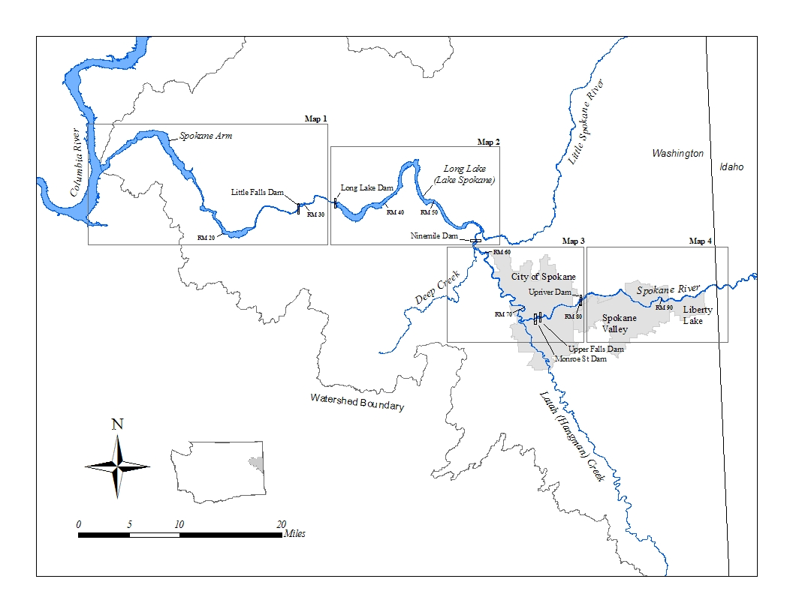

Figure A-1. Spokane River showing Sampling Maps for the Long-term Toxics Monitoring Plan.

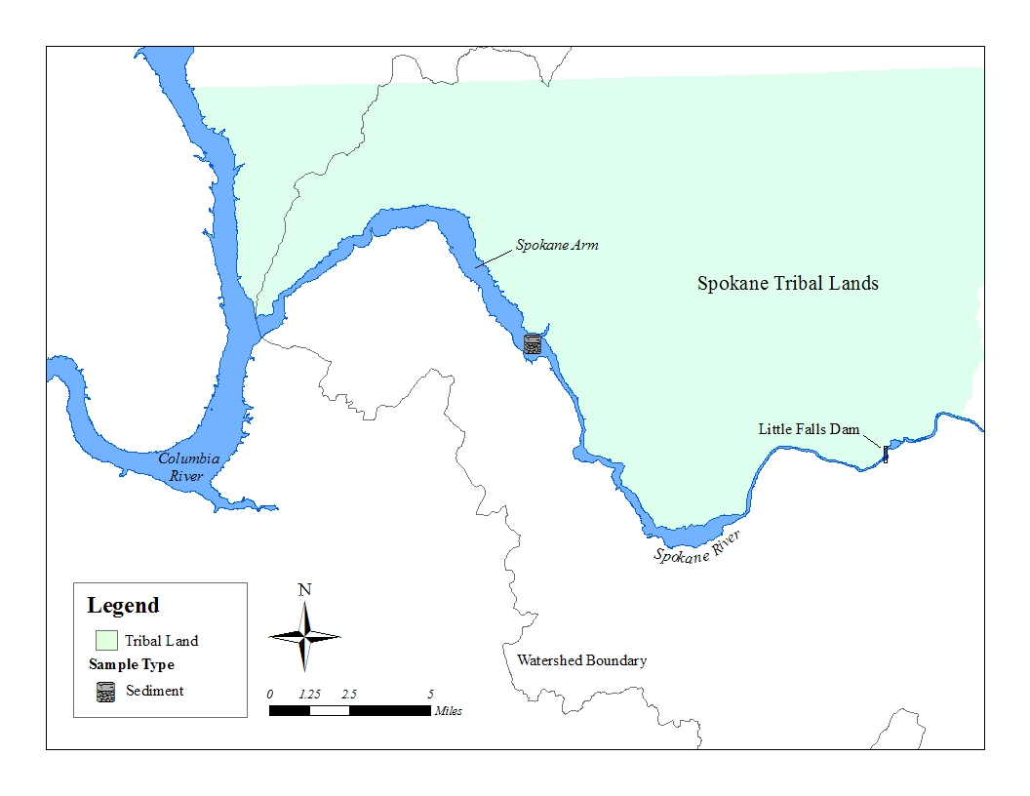

Figure A-2. Sampling Map 1: Lower Spokane River and Spokane Arm.

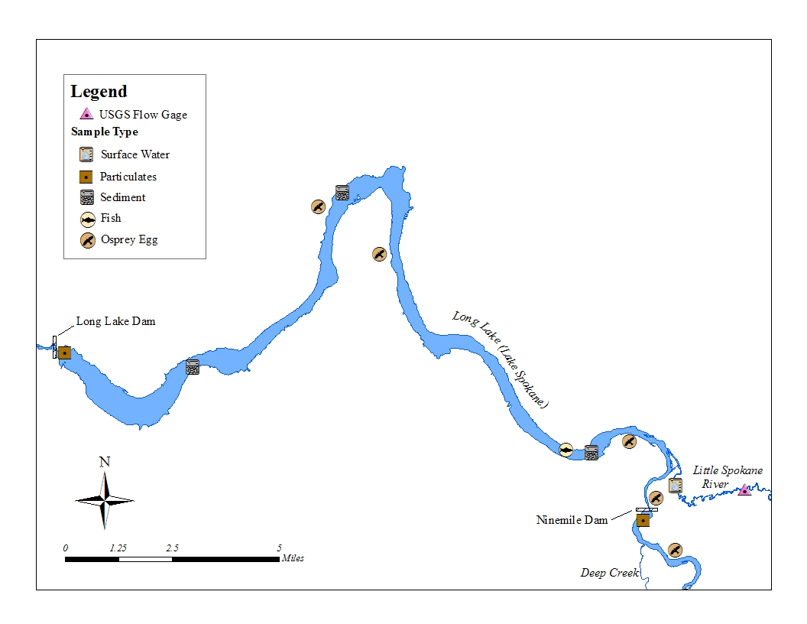

Figure A-3. Sampling Map 2: Long Lake (Lake Spokane) Dam to Nine Mile Dam.

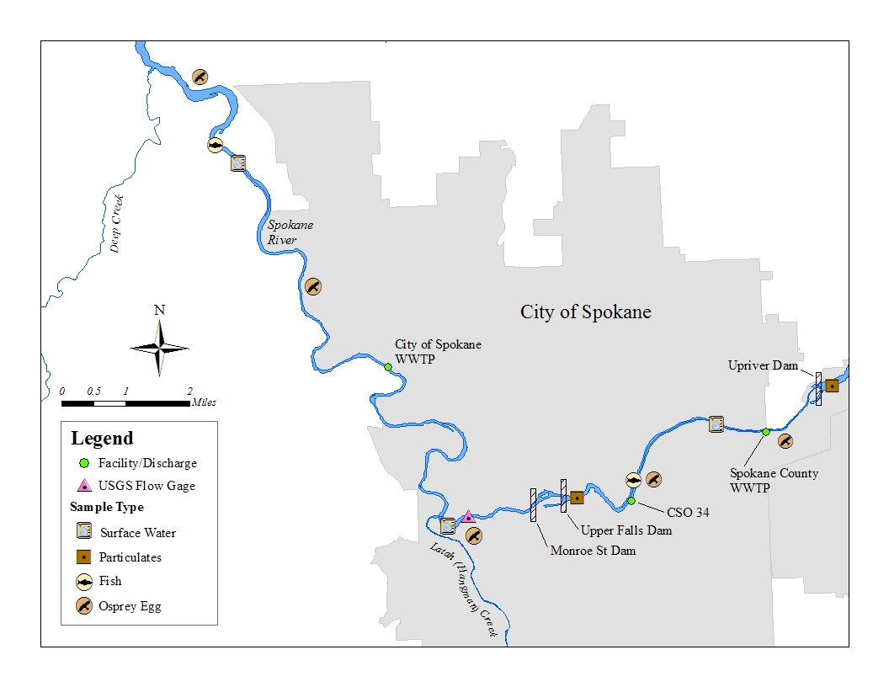

Figure A-4. Sampling Map 3: Deep Creek to Upriver Dam.

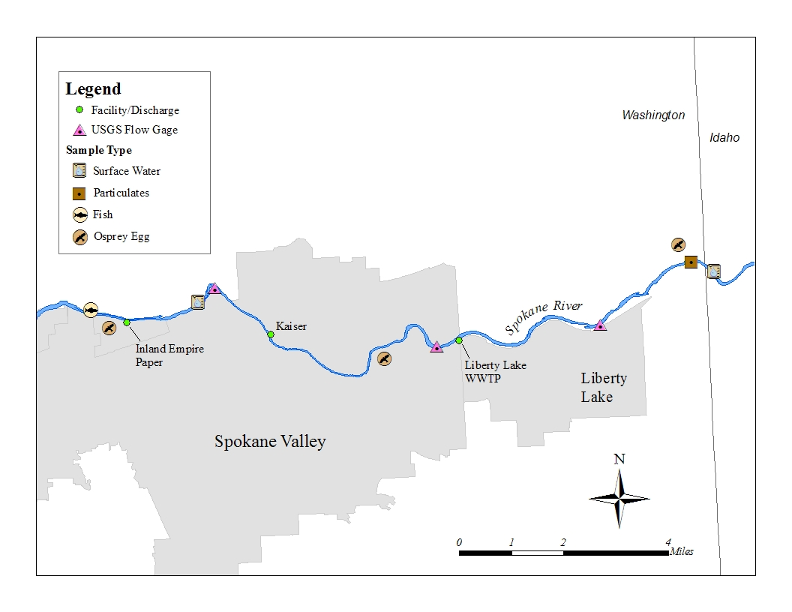

Figure A-5. Sampling Map 4: Upriver to Stateline.

Table A-1. Toxics Measured in Puget Sound Streams, 2009 – 10.

|  |  |  |  |  |  |  |  |  |  |  |
| --- | --- | --- | --- | --- | --- | --- | --- | --- | --- | --- |
| Parameter | Method | Reporting Limits | Detection Frequency (based on landuse type) | | | | | | | |
| Comm. | N | Res. | N | Ag. | N | Forest | N |
| Cd - dissolved | EPA 200.8 | 0.1 ug/L | 87% | 30 | 0% | 32 | 34% | 32 | 0% | 32 |
| Cd - total | 27% | 0% | 0% | 0% |
| Pb - dissolved | 97% | 97% | 97% | 78% |
| Pb- total | 93% | 100% | 81% | 59% |
| Zn - dissolved | 5 ug/L | 100% | 100% | 100% | 69% |
| Zn - total | 100% | 56% | 84% | 16% |
| t-PCB Congeners | EPA 1668A | 24 – 240 pg/L | 100% | 18 | 65% | 20 | 75% | 12 | 60% | 20 |
| t-PBDEs | EPA 1614 | 34 – 625 pg/L | 100% | 22 | 50% | 24 | 56% | 25 | 38% | 24 |

Comm. = commercial

Res. = residential

Ag. = agriculture

N = number of samples

t- = total

Table A-2. Toxics Measured in Puget Sound Streams during Storm and Base Flows, 2009 – 10.

|  |  |  |  |  |
| --- | --- | --- | --- | --- |
| Parameter | No. of Samples | | Detection Frequency | |
| Storm Flow | Base Flow | Storm Flow | Base Flow |
| Cd - dissolved | 96 | 30 | 34% | 13% |
| Cd - total | 8% | 0% |
| Pb - dissolved | 96% | 80% |
| Pb - total | 91% | 60% |
| Zn - dissolved | 93% | 90% |
| Zn - total | 69% | 47% |
| t-PCB Congeners | 40 | 30 | 83% | 63% |
| t-PBDEs | 64 | 31 | 66% | 48% |

Table A-3. Toxics Measured in Puget Sound Major Rivers, 2009 – 10.

|  |  |  |  |  |
| --- | --- | --- | --- | --- |
| Parameter | Method | Reporting Limits | No. of Samples | Detection Frequency |
| Cd - dissolved | EPA 200.8 | 0.002 ug/L | 9 | 60% |
| Cd - total | 15 | 100% |
| Pb - dissolved | 0.006 ug/L | 11 | 73% |
| Pb - total | 13 | 87% |
| Zn - dissolved | 0.70 ug/L | 15 | 100% |
| Zn - total | 14 | 93% |
| t-PCB Congeners | EPA 1668A | 4 – 11 pg/L | 15 | 100% |
| t-PBDEs | EPA 1614 | 5 – 250 pg/L | 15 | 47% |