March 31, 2014 **DRAFT**

**TO:** Adriane Borgias

**THROUGH:** Dale Norton

**FROM:** Brandee Era-Miller

**SUBJECT: Technical Memo: Spokane River Toxics Sampling 2012-2013 – Surface**

**Water, CLAM and Sediment Trap Results.**

**EA Project Code: 12-027**

# Background

In support of ongoing efforts to address levels of concern for PCBs, dioxins and furans, and other toxics in the Spokane River, Ecology conducted a study to evaluate several types of sample collection methods and analytical methods for toxics monitoring in the Spokane River during fall 2012 through spring 2013. Details further explaining the purpose and scope of the Ecology study are outlined in the Quality Assurance Project Plan (QAPP) for the study (Era-Miller, 2013).

The study focused on PCBs, dioxins and furans, PBDEs, cadmium, lead, and zinc. Environmental samples included surface water collected both by composite hand grabs and through 24-hour filtration in the field and sediments collected by sediment traps deployed for several months at a time.

During fall 2012, Ecology also conducted our most comprehensive fish tissue study to date in the Spokane River. Fish tissue results will not be covered in this technical memo. Fish tissue results from the 2012 effort will instead be summarized in the Freshwater Fish Contaminant Monitoring Program (FFCMP) report which is slated for publication in March 2014. Details outlining the FFCMP are available in the project QAPP (Seiders, 2013).

This technical memo presents the results of the 2012 – 2013 surface water and sediment trap monitoring effort and provides recommendations for the use of these environmental sample collection and analytical methods to aide in the design of a long-term monitoring program for the Spokane River. The purpose of a long-term monitoring program is to evaluate changes in levels of toxics in the river over time as source control work proceeds in the watershed.

# Methods

## Surface Water

Surface water was collected both by composite hand grabs and with use of Continuous Low-Level Aqueous Monitoring (CLAM) devices. The CLAM is a pre-concentration collection method for water that allows for lower (up to 100 times lower) detection limits than with direct analysis of surface water samples. This is because the CLAM can filter up to 100 liters of surface water through an EPA approved SPE (solid phase extraction) disk over a 24-hour deployment in a waterbody. More information on CLAM technology can be found at the manufacturer’s website: http://www.ciagent-stormwater.com/new-water-monitoring/.

Surface water grab samples were collected by wading out into a well-mixed section of the river and using a pole sampler to fill (1 – 2 ft below the water surface) a certified organics-free compositing jar. Water from the compositing jar was poured into the sample containers. Half the sample containers were filled on day one and held cold in a cooler and the other half were filled the following day to create a single composite sample for analysis. Where surface water and CLAM sampling overlapped (Upriver Dam and Ninemile Dam in the fall of 2012), a surface water sample was taken during the same 24-hour CLAM deployment period in the same location as the CLAMs, so comparisons could be made between the two collection methods.

Surface water was collected by hand composite grabs in both fall 2012 and spring 2013 at 5 locations. CLAMs were only used in fall 2012 at 2 locations: Upriver Dam and Ninemile Dam. Table 1 shows the sampling schedule. Appendix A gives detailed information on the monitoring locations including maps.

*Table 1. Surface Water Sampling Schedule.*



X = Samples collected; -- No Samples collected

EPA = Environmental Protection Agency; SM = Standard Methods

MEL = Manchester Environmental Laboratory; PRL = Pacific Rim Laboratories

DOC = dissolved organic carbon; TOC = total organic carbon; TSS = total suspended solids

PCB Aroclors and PBDEs by method EPA 8027 were analyzed at Ecology’s Manchester Environmental Laboratory (MEL). The high resolution methods for PCB congeners, PBDEs by method EPA 1614, and dioxins/furans were analyzed at Pacific Rim Laboratories (PRL).

## Sediment Traps

Sediment traps were deployed in the reservoirs above Upriver and Ninemile Dams in order to collect suspended particulates over an extended period of time. Total suspended solids (TSS) are generally low in the Spokane River with values below 5 mg/L 90% of the time. It was therefore anticipated that a several month deployment would be needed to accumulate enough material for multiple toxics analyses. The monitoring schedule for the sediment traps, analytical methods, and laboratories used are shown in table 2. Appendix A gives detailed information on the monitoring locations including maps.

*Table 2. Sediment Trap Monitoring Schedule.*

|  |  |  |  |  |  |
| --- | --- | --- | --- | --- | --- |
| Location | Deployment Period | Days Deployed | Analyses | Methods | Laboratories |
| Upriver Dam | 10/9/12 – 1/31/13 | 113 | PCB congeners, PBDEs, dioxin/furans, Metals (cadmium, lead and zinc) | EPA 1668c,  EPA 1614,  EPA 1613b,  and EPA 200.8 | PRL; MEL for metals |
| 1/31/13 – 4/9/13 | 68 |
| Ninemile Dam | 10/10/12 – 2/1/13 | 113 |
| 2/1/13 – 6/13/13 | 132 |

A standard sediment trap deployment method for reservoirs and deep water is to suspend a trap in the middle of the water column with an anchor, snag line, and hardball float. This method is described in detail in Norton (1996) and a schematic of the sediment trap design and deployment configuration is displayed in Figure 1. A hard shell float sits 6 feet below the water surface so that the trap can stay suspended in the water column and so it’s not disturbed by vessel traffic or floating debris. The trap is retrieved by dragging a grapple hook across the snag line between the two anchors.



*Figure 1. Schematic of Sediment Trap Design and Deployment Configuration (Norton, 1996).*

Each sediment trap holds two glass collection cylinders each with a collection area of 78.5 cm2 and a height-to-width ratio of 5. Two traps (each holding 2 pre-cleaned glass collection cylinders) were deployed in each reservoir, for a total of 4 cylinders in each reservoir per deployment period.

Before deployment, cylinders were cleaned with Liquinox soap and hot water, followed by 10% nitric acid, and then rinsed with deionized water. Cylinders were then rinsed with pesticide-grade acetone and finally hexane. Collection cylinders were then air dried under a fume hood and capped with aluminum foil until used in the field.

At deployment, the cylinders were partially filled with high salinity water (4% sodium chloride – NaCl), which included mercuric chloride (HgCl) as a preservative to reduce microbial degradation of the samples.

For Upriver Dam, one trap was placed closer to the right bank and one was placed closer to the left bank of the reservoir (Appendix A, Figure A-2). For Ninemile Dam, both traps were placed in the main channel roughly 200 yards apart along the left bank forming an inline transect with the flow (Appendix A, Figure A-3). Several factors supported this design:

* With low sediment rates, more cylinders means more material can be collected for multiple analyses.
* There is a back-up sample in case something happens to one of the traps.
* Suspended sediments collected from two locations in a reservoir is more representative as the hydrology likely varies within each.

Sediment trap samples were retrieved after 113 days (almost 4 months) for the first deployment period from October 2012 to February 2013. In April 2013, the sediment traps were again retrieved after 68 days (just over 2 months) at Upriver Dam. Due to high flows, the traps at Ninemile Dam could not be retrieved in April. Flows went down significantly by June. At that time only one of the traps at Ninemile Dam was found (after 132 days), but there was enough sediment for analysis. The other trap was lost and never retrieved.

## Data Reduction

For the high resolution gas chromatography/mass spectrometry (HR GC/MS) methods (PCB congeners – EPA1668c, PBDEs – EPA1614, and dioxins/furans – EPA 1613b), results were considered to be non-detects (“U”) if the congener concentrations were less than five times the concentration of the associated laboratory method blanks. The result values (qualified as non-detects) were then either reported at the estimated quantitation limit (EQL) or at the level of detection, whichever was higher.

*Data Qualifier Definitions:*

U The analyte was not detected at or above the reported sample quantitation limit.

J The analyte was positively identified; the associated numerical value is the approximate

concentration of the analyte in the sample.

NJ The analyte has been “tentatively identified” and the associated numerical value represents its approximate concentration.

ND Not Detected.

Results for the HR GC/MS methods that did not meet the isotopic abundance ratio and retention time criteria for positive identification were qualified by MEL with an “NJ” and considered to be tentatively identified. Due to the uncertainly of “NJ” data and because it cannot be used for regulatory purposes, it was decided to report these data as non-detects for the purposes of this technical memo. Qualifiers were changed to “U” and the result values were either reported at the estimated quantitation limit (EQL) or at the level of detection, whichever was higher. Project data including NJ qualified results are available from the project manager upon request. Data entered into Ecology’s Environmental Information Management system (EIM) database includes the NJ qualified results.

For summing of all sample totals (e.g. total PCBs and PCB homologues, total PBDEs and dioxin TEQs), non-detected results comprising a total value were assigned a value of zero. If only non-detected results comprised a total value, then the final total result was simply reported as “ND”. Sample totals were assigned a qualifier of “J” (estimated) only if more than 10% of the result concentration was comprised of results containing a “J” qualifier. Total values are not entered into EIM.

EIM can be accessed at: <http://www.ecy.wa.gov/eim>. The study ID for this project is BERA0009.

# Results and Discussion

## Surface Water

Ancillary chemistry samples (table 3) were collected during the same time period as grab and CLAM samples. Ancillary chemistry parameters included dissolved organic carbon (DOC), total organic carbon (TOC), and total suspended solids (TSS). Temperature, conductivity, pH, and dissolved oxygen were also recorded in the field using a MiniSonde multi-parameter field meter. Field measurement data is shown in Appendix C, Table C-1.

*Table 3. Ancillary Surface Water Chemistry Data (mg/L).*



**Bold** values are a visual aid to identify detected values

U = Result is not detected at the value reported

DOC, TOC, and TSS were all very low (near detection limits) for all the monitoring locations during both fall 2012 and spring 2013. One exception was that TSS was higher at Ninemile Dam during October 24th and 25th. This is because the reservoir was drawn-down for a week at this time for dam repairs. The draw-down caused the reservoir to behave more like a free-flowing river. The water was more turbid and TSS values were 4 mg/L compared to 1 mg/L or less at the other monitoring locations. The October Ninemile Dam samples should not be considered representative of typical seasonal reservoir conditions. The hydrological conditions created by the draw-down may have influenced the surface water and CLAM samples that were analyzed for toxics. Episodic events such as the reservoir draw-down could be important for the transport of contaminants in the river system.

**PCBs**

PCB congeners were detected in surface water samples collected by composite grabs during both fall 2012 and spring 2013. The concentrations were similar to the transfer and laboratory method blanks as shown in Figure 2, making it difficult to discern a real environmental signal. Total PCBs in the spring did appear slightly higher compared to the fall samples, however the Above Latah field replicates collected during the spring showed high variability, with an RPD of 97% (38 versus 109 pg/L). Individual PCB congeners and homologue totals for the surface water data are tabulated in Appendix C, tables C-2 and C-3.



*Figure 2. Total PCB Congeners in Surface Water Grab Samples from fall 2012 and spring 2013 Monitoring.*

PCB congeners in the CLAM samples gave a clear environmental signal with results that were 1-2 orders of magnitude higher than the laboratory method blank concentration. Detection limits for many of the individual congeners reached down into the sub pg/L (ppq - part per quadrillion) range. Full results including homologue totals for the CLAM data is tabulated in Appendix C, Table C-6. Precision of samples deployed in triplicate was excellent with a relative standard deviation of 11% for Upriver and 14% for Nine Mile. Data quality for the CLAM data and is discussed in more detail in Appendix B of this technical memo.

Figure 3 shows results for the CLAM samples compared to applicable water quality standards. Concentrations were within the National Toxics Rule (NTR) water quality criterion of 170 pg/L, but exceeded the Spokane Tribal water quality criterion of 1.3 pg/L.



*Figure 3. PCB Congener Results for CLAM Samples deployed at Ninemile and Upriver Dams (pg/L, ppq).*

On the first deployment day, CLAMs were only installed at Ninemile Dam. On day 2, CLAMs were deployed at both Ninemile Dam and Upriver Dam, where pre-filters were added to one sample at both monitoring locations. The pre-filters have a filter size of 1.5 microns. Suspended particulates greater than 1.5 microns are retained on the pre-filter and anything smaller along with the dissolved fraction can pass through to the SPE disk behind the pre-filter. This was done to gain a general sense of how much of the PCBs in surface water are in the dissolved versus particulate phase.

According to Ecology’s PCB Source Assessment (Serdar et al., 2011), approximately 94% of the PCBs in Spokane River surface water are in the dissolved phase. This estimate was based on sediment-water partitioning using suspended particulate matter (SPM) data. According to the CLAM results, the dissolved fraction (defined by a <1.5 micron filter size) was 30% at Ninemile Dam and 50% at Upriver Dam (Figure 3). More research needs to be conducted to understand how accurately the CLAM can define the dissolved fraction especially since a 1.5 micron filter size could allow some finer clay to pass through.

PCB Aroclors were also analyzed in some of the CLAM samples from Ninemile Dam, but were not detected above the detection limits of 700 – 920 pg/L. Aroclor results are shown in Appendix C, Table C -7.

**PBDEs**

PBDE congeners analyzed by high resolution method EPA 1614 were detected in most of the surface water grab samples collected during both fall 2012 and spring 2013 (Figure 4). EPA 1614 measures more than twice the number of PBDE congeners compared to EPA method 8270. The only surface water samples that gave a clear environmental signal above the blank sample concentrations were the samples taken at Above Latah and at Ninemile Dam during fall monitoring. The spring samples had high contamination in the laboratory method blank. Individual PBDE congener data for the surface water is given in Appendix C, tables C-4 and C-5.



*Figure 4. PBDE Results for Surface Water Grab Samples (pg/L, ppq); ND = not detected.*

Similar to PCB congeners, PBDEs measured in the CLAM samples by method EPA 1614 gave a clear environmental signal with results that were 1-2 orders of magnitude higher than the laboratory method blank concentration (Figure 5). PBDEs were not detected in the laboratory method blank for samples analyzed with method EPA 8270. Even though PBDEs measured at Ninemile Dam and Upriver Dam were only 24 hours apart (deployment day 1 versus day 2), concentrations at Ninemile Dam were almost 20 times higher than at Upriver Dam. Individual PBDE congener data for the CLAM samples is presented in Appendix C, tables C-8 and C-9.



*Figure 5. Total PBDE Results for CLAM samples (pg/L, ppq); NAF = not analyzed for; ND = not detected.*

PBDEs were analyzed in the CLAM samples from Ninemile Dam using both EPA methods 1614 and 8270 (see data for 9M Day 1 in Figure 5). The Ninemile CLAM samples were analyzed as field triplicates with excellent precision for both methods ranging from 9 – 19% RSD (see Appendix B for more detail).

Detection limits for many of the individual PBDE congeners reached down into the sub pg/L (ppq - part per quadrillion) range for EPA 1614 and down into the sub ng/L (pptr - part per trillion) range for EPA 8270. Even with this difference in detection levels and the difference in number of congeners analyzed between the two analytical methods, results between the two sets of triplicate data were highly comparable (see Figure 6). This is probably due to the fact the PBDE congeners 47, 99, and 209 make-up 80 – 90% of the total PBDE concentrations for these samples. EPA 8270 measures only 14 congeners compared to EPA 1614’s 38 congeners, but the three most concentrated congeners (47, 99, and 209) are represented in both methods.



*Figure 6. CLAM Field Triplicate Results for Total PBDEs for Two Analytical Methods (pg/L, ppq).*

**Dioxins and Furans**

Dioxins and furans were not analyzed in surface water grab samples due to the unlikely possibility that they would be detected. CLAM samplers were used to concentrate contaminants, but results were not as clear as with the PCBs and PBDEs results. The field samples deployed in triplicate at Ninemile Dam (51% RSD) and in duplicate at Upriver Dam (192% RPD) showed low precision (figure 7). Data in figure 7 are presented as dioxin/furan toxic equivalents (TEQs) with the specific congener data for the CLAM samples presented in Appendix C, table C-10.

## 

*Figure 7. Dioxin/furan TEQ Results for CLAM Samples.*

The most toxic congener of dioxin is 2,3,7,8-TCDD. It was not detected in any of the CLAM samples. The State water quality standard (NTR) and Spokane Tribal water quality standard for dioxins and furans is only for congener 2,3,7,8-TCDD. The criteria values are 0.013 and 0.000104 pg/L (ppq), respectively.

Another way to determine a total sample toxicity is to calculate a TEQ value and compare it to the 2,3,7,8-TCDD criteria. TEQs are calculated by applying a toxic equivalency factor (TEF) to each dioxin and furan congener then adding up the TEFs to create an overall sample toxicity equivalent. The TEFs used to calculate the TEQs in figure 7 are shown in the table C-10 of Appendix C. Based on the TEQ calculations, two of the five CLAM samples (one sample at each Dam site) analyzed for dioxins/furans exceed the State water quality criterion of 0.013 pg/L. All of the samples, including the REP1 at Upriver Dam and the lab blank, exceed Spokane Tribe’s criterion of 0.000104 pg/L.

***Sediment Traps***

Sediment flux rate was calculated for all four sediment trap deployments (Table 4). The higher the flow of the river during deployment, the higher the corresponding sediment flux rate. There were also large differences in sediment loading between traps at each site. Sediments were combined from the two traps at each site and deployment periods for toxics analysis. An average flux rate was applied to all samples, except for the second deployment at Ninemile Dam where Trap 2 was lost.

*Table 4. Sedimentation Rates for Sediment Traps.*

|  |  |  |  |  |  |  |
| --- | --- | --- | --- | --- | --- | --- |
| Location | Deployment Period | Days Deployed | Average Flow (cfs) | Sediment Flux (g/cm2/yr) | | |
| Trap 1 | Trap 2 | Average |
| Upriver Dam | 10/9/12 – 1/31/13 | 113 | 4,600a | 0.3 | 0.6 | 0.4 |
| 1/31/13 – 4/9/13 | 68 | 7,400a | 0.5 | 1.7 | 1.1 |
| Ninemile Dam | 10/10/12 – 2/1/13 | 113 | 5,300b | 2.0 | 6.0 | 4 |
| 2/1/13 – 6/13/13 | 132 | 10,100b | 3.7 | NC | NC |

a = Flow data from USGS gage near Post Falls, Idaho

b = Flow data from Avista

NC = Not calculated due to loss of Trap 2 during second deployment at Ninemile Dam

A summary of the toxics data for the sediment traps is shown in Table 5. Ancillary data included % solids and % TOC (total organic carbon). Analytical laboratories use the solids data to calculate toxics analyte results. Solids data is also used to calculate sediment flux. TOC was higher at Upriver Dam compared to Ninemile Dam. Detections in the laboratory method blanks were low compared to the sample results for all toxics.

*Table 5. Data Summary for the Toxics in Sediment Traps Deployed in the Spokane River.*



**Bold** values are a visual aid to identify detected values

J = Result value is an estimate

ND = Not detected

mg/Kg (ppm) = milligram per kilogram (part per million)

ug/Kg (ppb) = microgram per kilogram (part per billion)

ng/Kg (pptr) = nanogram per kilogram (part per trillion)

**PCBs**

Total PCB congener results were higher at Upriver Dam compared to Ninemile Dam during both sample periods (figure 8). Full congener results and homologue totals are presented in Appendix C, table C-11. The Washington State Freshwater Sediment Cleanup Objective (SCO) for Total PCB Aroclors is 110 ug/Kg, dry weight (dw), ppb. The SCO is the Washington State Sediment Management Standards’ screening level for no adverse affects to benthic organisms (WAC 173-204-563). None of the sediment trap samples exceeded this PCB criterion.



*Figure 8. Total PCB Congeners in Sediment Trap Samples (ug/Kg, dw) ppb.*

During October to November of 2003, Ecology’s Spokane River PCB Source Assessment staff analyzed PCB congeners in suspended particulate matter (SPM) collected over three-day sampling events (Serdar et al., 2011). SPM was collected on three occasions by centrifuge. Although collected at different periods using different methods, the 2003 SPM data and the data from the 2012-2013 sediment traps represent a similar sample matrix. The homologue group totals for these data are compared in Table 6. Data from the first sediment trap deployment was used for comparison (to represent similar conditions). Although total PCB congener concentrations are different between the two collection types at both the Ninemile and Upriver areas, homologue patterns appear to be similar.

*Table 6. Total PCBs and Homologue Comparisons between SPM and Sediment Trap Data (ug/Kg, dw) ppb.*



* = mean value of replicate samples.

ND = Not detected.

RM = River mile.

**PBDEs**

Total PBDE concentrations were similar for all deployments with the exception of Ninemile Dam during the first deployment representing the fall-winter low flow period (10/10/12 through 2/1/13) as shown in figure 9. Full PBDE congener results are listed in Appendix C, table C-12. Like the PBDEs in CLAM samples, congeners 47, 99, and 209 were the major components of the total concentrations representing 82 – 84 % of the total.



*Figure 9. Total PBDEs in Sediment Trap Samples (ug/Kg, dw) ppb.*

**Dioxins/furans**

The most toxic form of dioxin, congener 2,3,7,8-TCDD, was not found in any of the sediment trap samples. This is consistent with the CLAM results. Full dioxin and furan congener results and the TEFs used to calculate TEQs are located in Appendix B, table B-13. Dioxin/furan TEQ values are shown in table 5 and figure 10. TEQ results were similar with the exception of Upriver Dam during the second deployment, representing the winter-spring higher flow period from 1/31/13 through 4/9/13.



*Figure 10. Dioxin/furan TEQ Values for Sediment Trap Samples (ng/Kg, dw) pptr.*

There are no Washington State standards for dioxins and furans in freshwater sediments. All sediment trap concentrations were at or below background levels for both Puget Sound sediments (4.0 ng/Kg TEQ – Herrera, 2010) and Statewide Soils (5.21 ng/Kg TEQ – Bradley, 2010).

**Metals**

Cadmium, lead and zinc in the sediment traps were higher at Upriver Dam compared to Ninemile Dam for both deployment periods (figure 11). State Freshwater Sediment Cleanup Objective (SCO) levels are shown in Figure 11. All the cadmium samples for both monitoring locations and lead samples at Upriver Dam exceeded the SCOs. None of the zinc samples exceeded SCOs. SCOs are the no adverse effects level for benthic communities. Chemical concentrations below these levels correspond to sediment quality that results in no adverse effects to the benthic community.



*Figure 1. Metals Concentrations in Sediment Trap Samples (mg/Kg, dw) ppm.*

The trend of metals being higher at Upriver Dam compared to Ninemile Dam is not surprising as metals have been shown to be elevated in the Spokane River in areas above Upriver Dam. Ecology’s (Persistent, Bioaccumulative, and Toxic Chemical) PBT Trend Monitoring Program for Lead in Washington Rivers and Lakes (Mathieu and Friese, 2012) has also reported higher lead concentrations at Upriver Dam.

The PBT Program monitors for lead in SPM from two sites on the Spokane River each spring and fall: 1) at the Idaho Stateline and 2) Ninemile Dam. Lead samples are collected by in-line filtration. This sampling technique is different from both sediment trap and centrifuge sampling, but represents a similar environmental matrix. Lead results from SPM and sediment traps are compared in figure 12 showing a decreasing trend in concentrations from the upper Spokane River to Ninemile Dam.



*Figure 12. Comparison of Lead Concentrations between the Upper Spokane River and Ninemile Dam Area (mg/Kg, dw) ppm.*

# Evaluation of Collection and Analytical Methods

The primary objective of the 2012-2013 toxics monitoring study in the Spokane River was to evaluate the usefulness of multiple field collection and analytical methods. This evaluation could then be used in the design of a long-term monitoring program for toxics in the Spokane River. A rating system was developed to assist in the selection process. Figure 13 gives a rating to each collection and analytical method combination that was used in this study. The rating system is based on a Yes or No answer to the 4 following questions:

1. Was there a clear environmental signal above the analytical background noise (this was based on laboratory method blank and transfer blank contamination)?
2. Was the variability of field replicates and split samples of acceptable quality?
3. Is the field collection method easily reproducible on a larger scale?
4. Were detection limits low enough to evaluate applicable water quality standards?

Each collection method/analytical method combination was rated as either good, poor or okay based on the majority of yes or no answers. Water quality standards based on Human Health Criteria don’t apply to PBDEs or sediment data.

## 

**P** = Poor, **G** = Good, **OK** = okay, and **NA** = not applicable

*Figure 13. Evaluation Matrix of Collection and Analytical Methods used for Spokane River Toxics Monitoring.*

## Surface Water

Analysis of surface water composite grabs samples was not a good monitoring tool for low level organics in the Spokane River. The two analytical methods used (EPA 1668c for PCB congeners and EPA 1614 for PBDEs) are high resolution methods and represent the best analytical methods currently available for low detection limits. The PCB congener sample data in general did not give a clear environmental signal above the analytical background noise. The PBDE congener sample data was slightly better giving an environmental signal for some of the samples, but laboratory method blank contamination and high variability of field replicate samples was an issue for most of the data.

***CLAM***

The CLAM collection method for PCB and PBDE congeners in the Spokane River is a good surrogate for grab sampling. PCB and PBDE congeners gave a clear environmental signal and had good precision of field triplicates. PCB Aroclor method EPA 8082 is a poor choice to use with the CLAM samplers due to detection limits above environmental concentrations in the Spokane River. Both PBDE methods EPA 1614 (measures for 38 congeners) and EPA 8270 (14 congeners), could be used with CLAM samplers because the congeners representing >80% of the total PBDE concentrations in the Spokane River (PBDEs 47, 99 and 209) are reported in both analytical methods.

Dioxin/furan results using the CLAM samplers were evaluated as poor because of variability (low precision) between the field replicates and triplicates. It is possible that dioxin/furan concentrations are just too low in surface water for accurate analysis and reporting using CLAM samplers deployed for 24 hours.

CLAMs have the potential to answer the question of how much of the PCBs in Spokane surface water is in the dissolved versus particulate forms. Serdar et al., 2011 suggested that 94% of PCBs in Spokane River surface water can be found in the dissolved phase. This is unusual as PCBs are non-polar chemicals that tend to be associated with particulates. More research in this area could shed light into the fate and transport of PCBs in the Spokane River.

Monitoring with CLAMs has the advantage of representing continuous sampling over a 24-hour period. SPE disks can be swapped out and batteries changed in the CLAM units every 24 hours if multi-day monitoring is desired. With the low TSS and turbidity in the Spokane River, SPE filters are unlikely to get clogged in a given 24-hour period. In addition, CLAMs could possibly be deployed in river to capture specific events such as storm events.

During the study fourteen CLAM deployments were conducted, with only two equipment failures, where the pump stopped working. CLAMs are moderately easy to deploy. Currently the pumping rate at deployment and retrieval is required to determine a sample volume to calculate a contaminant concentration. They can be used in both quiescent and flowing water with many possible deployment setups.

## Sediment Traps

Sediment trap sampling was rated “good” for the PCBs and PBDE high resolution methods (EPA 1668c and EPA 1614) and for metals. Results for these analyses gave a clear environmental signal above the analytical background noise. Laboratory duplicates and split samples showed low variability (high precision).

Dioxin and furan results for the sediment traps were rated “okay”. Sample results were well above background noise. Laboratory duplicate precision was high, but the split samples had high variability. Similar to the CLAM results, 2,3,7,8-TCDD was not found in any of the samples. Overall TEQ values were relatively low. Since all the sediment trap results were comparable to background levels for both Puget Sound sediments (4.0 ng/Kg TEQ) and Statewide Soils (5.21 ng/Kg TEQ), it’s possible that dioxin/furan concentrations in Spokane River suspended sediments are simply too low for accurate monitoring using sediment traps. Dioxin/furan congener patterning could be a valuable exercise to determine if dioxins and furans in the Spokane River suggest background concentrations, mostly of atmospheric deposition, or if there are still sources in the watershed.

Only one of the eight sediment traps deployed during the study was lost. This collection method appeared to work well although it does have limitations. The biggest challenge was trying to deploy and retrieve traps during high flow conditions. These sediment traps can only be deployed in deeper (>10 ft), somewhat calm water (depositional areas), not in shallow fast-moving sections of the river.

## Other Monitoring Techniques

Several analytical methods and monitoring techniques were evaluated for this study, but it is important to point out that other analytical methods and monitoring techniques may also be useful. For example, XAD resin columns could be useful for monitoring surface water contaminants in the dissolved phase. No one technique is the best for all matrices so application is still a consideration. The best long-term monitoring program will integrate multiple techniques and analytical methods to achieve study objectives.

# References

Bradley, D., 2010. Natural Background for Dioxin/Furans in WA Soils, Technical Memorandum #8. Washington State Department of Ecology, Olympia, WA. Publication No. 10-09-53. <https://fortress.wa.gov/ecy/publications/SummaryPages/1009053.html>.

Era-Miller, B., 2013. Quality Assurance Project Plan: Spokane River Toxics Fish Tissue and Preliminary Monitoring in Fiscal Year 2013 in Support of the Long-term Toxics Monitoring Strategy. Washington State Department of Ecology, Olympia, WA. Publication No. 13-03-103. <https://fortress.wa.gov/ecy/publications/SummaryPages/1303103.html>.

Herrera Environmental Consultants, 2010. Sediment Investigation Report, Oakland Bay Sediment Characterization Study, Mason County, Washington. Prepared for Washington State Department of Ecology, Toxics Cleanup Program, Southwest Regional Office. November 17, 2010.

Mathieu, C. and M. Friese, 2012. PBT Trend Monitoring: Measuring Lead in Suspended Particulate Matter from Washington State Rivers and Lakes, 2011 Results. Washington State Department of Ecology, Olympia, WA. Publication No. 12-03-031. <https://fortress.wa.gov/ecy/publications/summarypages/1203031.html>.

Norton, D., 1996. Commencement Bay Sediment Trap Monitoring Program. Washington State Department of Ecology, Olympia, WA.  Publication No. 96-315. <https://fortress.wa.gov/ecy/publications/summarypages/96315.html>

Seiders, K., 2013. Quality Assurance Project Plan: Washington Freshwater Fish Contaminant Monitoring Program. Washington State Department of Ecology, Olympia, WA. Publication No. 13-03-111. <https://fortress.wa.gov/ecy/publications/SummaryPages/1303111.html>.

Serdar, D., B. Lubliner, A. Johnson, and D. Norton, 2011. Spokane River PCB Source Assessment, 2003-2007.

Washington State Department of Ecology, Olympia, WA. Publication No. 11-03-013. <https://fortress.wa.gov/ecy/publications/summarypages/1103013.html>.

Van den Berg et al., 2005. The World Health Organization Re-Evaluation of Human and Mammalian Toxic Equivalency Factors for Dioxin and Dioxin-Like Compounds. ToxSci Advance Access, July2006.

# Appendix A. Sampling Location Information

*Table A - 1. Monitoring Locations for the 2012 – 2013 Spokane River Toxics Study.*



NA = not applicable

EIM = Ecology’s Environmental Information Management system database

* = Centroid locations are for data entry into EIM and do not represent actual monitoring locations.

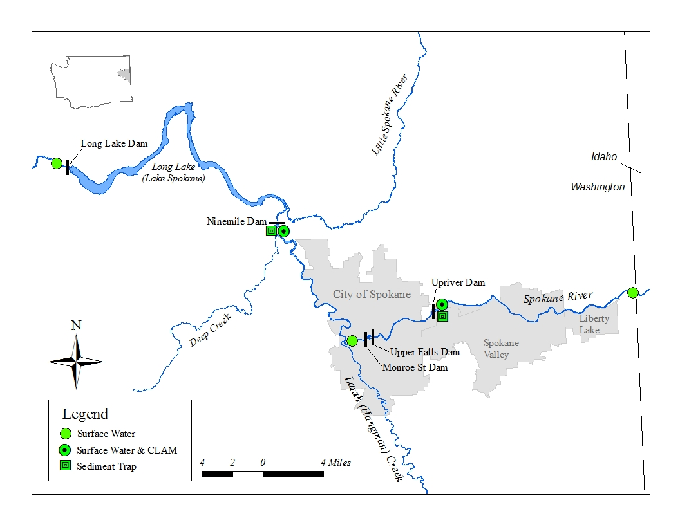

*Figure A - 1. Monitoring Locations for the 2012 – 2013 Spokane River Toxics Study.*

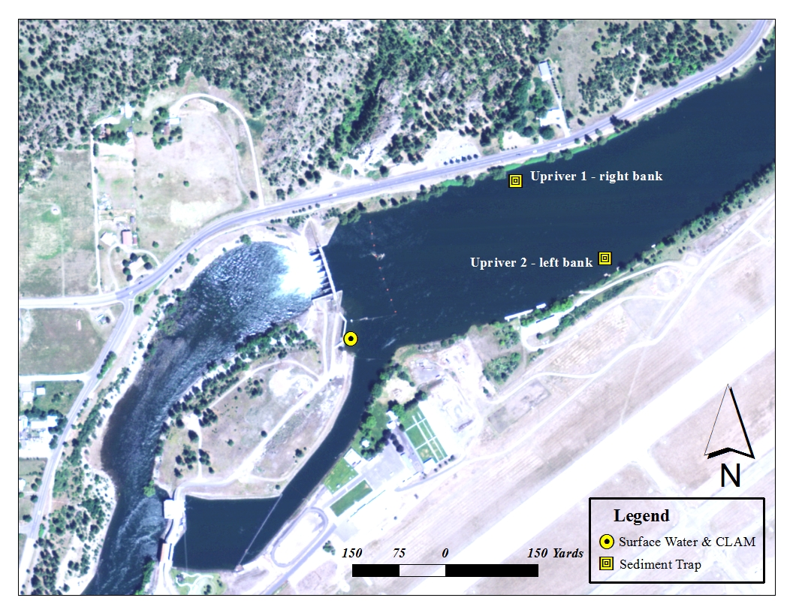

*Figure A - 2. Upriver Dam Monitoring Locations.*

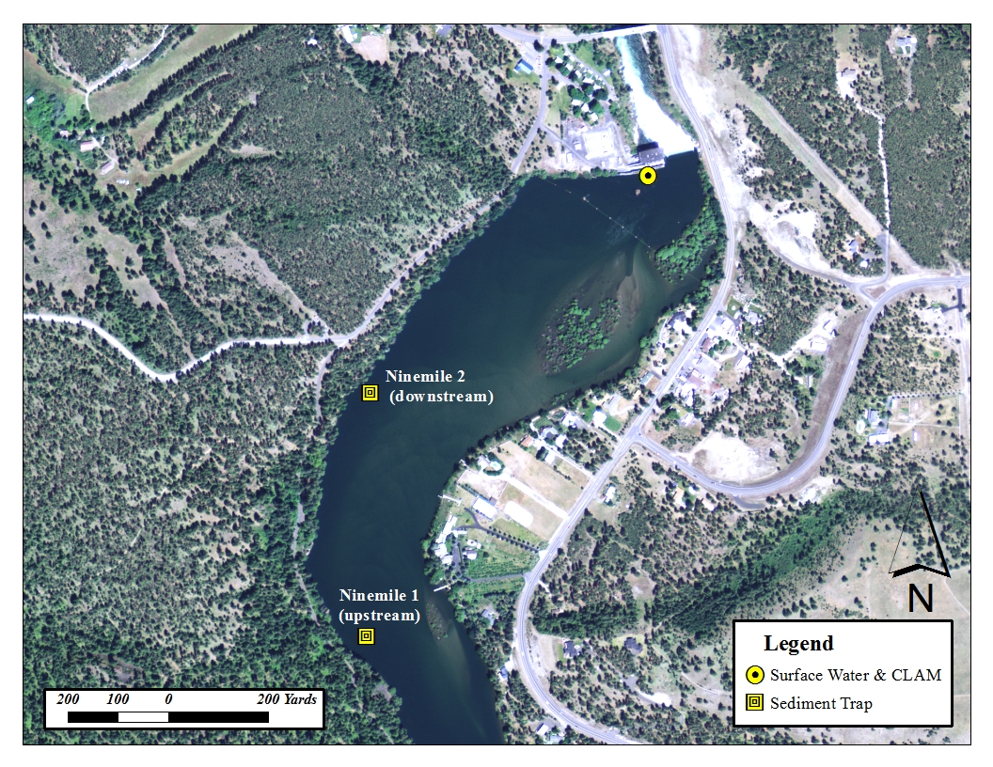

*Figure A - 3. Ninemile Dam Monitoring Locations.*

# Appendix B. Data Quality

# Data Quality

Data were reviewed by the laboratories and the project manager and deemed useable as qualified and presented in this technical memo. Case narratives are available from the project manager upon request. Karin Fedderson (contract lab manager) and Joel Bird (lab director) from MEL both reviewed the data from PRL. Project data were qualified according to whether or not the data met analytical method quality control/quality (QA/QC) assurance, laboratory QA/QC, and measurement quality objectives (MQOs) as outlined in the QAPP for the study (Era-Miller, 2013). MQOs include recovery of laboratory control samples, laboratory duplicate precision, matrix spike recovery, matrix spike duplicate precision, and surrogate chemical recovery.

For the technical memo only laboratory duplicate precision, field replicate precision, blank contamination, and data reduction are discussed in detail. Laboratory duplicates give an estimate of precision for the analytical process. Field replicates and split samples not only give an estimate of laboratory precision but also give an indication of natural variability in the samples as well as consistency with field collection methods.

Precision of duplicate or replicate samples is expressed as relative percent difference (RPD). Precision of triplicate samples is expressed as relative standard deviation (RSD). Anything below 20% RPD or RSD is generally considered good precision. RPDs and RSDs can be skewed high when concentrations are low or if they are close to the analytical detection limits.

## Precision

The RPDs for the surface water sample pairs are shown below in Table B-1. With the exception of lab duplicates for PCBs in spring (5% RPD) and the field replicate for PCBs in the fall (13% RPD), there was a fair amount of variability amongst the samples, indicating that the surface water analyses had moderate precision.

CLAM field triplicate sample precision on the other hand, was excellent for PCB and PBDE congeners ranging from 9 – 19% RPD (table B - 2). PCB Aroclor precision could not be calculated because all Aroclors were non-detects. Dioxin/furan TEQ values had lower triplicate precision (51% RSD).

*Table B - 1. Surface Water and Sediment Trap Sample Precision.*



RPD = relative percent difference

J = Result value is an estimate

ND = not detected

NC = not calculated

*Table B - 2. CLAM Triplicate Sample Precision.*



RSD = relative standard deviation

The RPDs for the sediment trap samples (table B - 1) indicated good precision for PCB, PBDE, and dioxin/furan congeners (0 – 12%) with the exception of the split sample for dioxin/furan TEQs. Split samples were created by splitting a sample during sample homogenization and processing and then submitting them to the laboratory in separate jars as separate samples. Low precision may indicate heterogeneity of the sample. RPDs may also be higher due to the low dioxin/furan concentrations found in the samples.

## Blank Contamination

Blank contamination was only an issue for the surface water grab samples as shown in table B - 3. Concentrations of the transfer and laboratory method blanks often overlapped with the sample concentrations. This makes it difficult to recognize an environmental signal from background noise. Laboratory method blank contamination for the CLAM and sediments was minimal. In many cases the sample concentrations were orders of magnitude higher than the laboratory method blank concentrations, indicating a clear signal above the background noise. The reason for the substantially lower blank PCB and PBDE concentrations in the CLAM samples compared to the surface water grab samples is because of the high volume of water filtered through the SPE disk. Typical water volumes are 1 -2 liters for surface water samples collected in bottles. Up to 100 liters can be filtered through the CLAM SPE disks in the field.

*Table B - 3. Sample Concentrations versus Blank Concentrations.*

|  |  |  |  |  |
| --- | --- | --- | --- | --- |
| Matrix | Parameter | Sample Concentration Range | Transfer Blank | Lab Method Blank |
| Surface Water (pg/L) | tPCB Congeners - fall | 13 – 36 | 26 | 73 |
| tPCB Congeners - spring | 13 – 122 | 35 | 38 |
| tPBDES - fall | 17 – 723 | ND | 13 |
| tPBDEs - spring | 45 – 640 | 42 | 198 |
| CLAM (pg/L) | tPCB Congeners | 62 – 154 | -- | 2 |
| tPBDEs (EPA 1614) | 30 – 714 | -- | 3 |
| tPBDEs (EPA 8270) | 540 – 780 | -- | ND |
| Dioxin/furan TEQs | 0.001 – 0.034 | -- | 0.001 |
| Sediment Traps (dw) | tPCB Congeners (ug/Kg) | 14 – 29 | -- | 0.1 |
| tPBDEs (ug/Kg) | 19 – 65 | -- | 0.04 |
| Dioxin/furan TEQ (ng/Kg) | 0.6 – 4.5 | -- | ND |
| Cadmium (mg/Kg) | 5 – 24 | -- | ND |
| Lead (mg/Kg) | 83 – 825 | -- | ND |
| Zinc (mg/Kg) | 777 – 2,580 | -- | ND |

ND = non-detect

t = total

## Detection limits

Table B - 4 summarizes the number of detected congeners and the minimum, maximum, and median value for detection limits achieved using high resolution methods for PCB and PBDE congeners. Far fewer congeners were detected in surface water compared to the CLAM and sediment trap matrices for both PCBs and PBDEs.

Minimum, maximum, and median detection limits were one to two orders of magnitude lower with the CLAM compared to surface water for PCBs and PBDEs.

*Table B - 4. Summary of Detection Limits Achieved for PCBs and PBDEs using HR/GC-MS Methods.*

|  |  |  |  |  |  |  |  |  |
| --- | --- | --- | --- | --- | --- | --- | --- | --- |
|  | PCBs | | | | PBDEs | | | |
| Matrix | # Congeners Detected | min | max | median | # Congeners Detected | min | max | median |
| Surface Water (pg/L, *ppq*) | 27 | 0.7 | 73.5 | 10 | 13 | 0.3 | 1720 | 10 |
| CLAM  (pg/L, *ppq*) | 138 | 0.002 | 3.1 | 0.03 | 29 | 0.028 | 16.3 | 0.2 |
| Sediment Traps  (ug/Kg, dw) *ppb* | 139 | 0.0006 | 0.375 | 0.004 | 34 | 0.001 | 0.12 | 0.005 |

ppq = part per quadrillion.

ppb = part per billion.

# Appendix C. Data Tables

*Table C - 1. Surface Water Measurement Data for the Spokane River.*



Deg. C = degrees Celsius

uS/cm = microsiemens per centimeter

mg/L = milligram per liter

% Sat. = percent saturation

*Table C - 2. PCB Congeners in Surface Water Samples (pg/L) ppq, Collected in fall 2012.*



*Table C - 2. PCB Congeners in Surface Water Samples (pg/L) ppq, Collected in fall 2012. (Continued)*



*Table C - 2. PCB Congeners in Surface Water Samples (pg/L) ppq, Collected in fall 2012. (Continued)*



*Table C - 2. PCB Congeners in Surface Water Samples (pg/L) ppq, Collected in fall 2012. (Continued)*



*Table C - 2. PCB Congeners in Surface Water Samples (pg/L) ppq, Collected in fall 2012. (Continued)*



**Bold** values are a visual aid to identify detected values.

J = Result value is an estimate.

U = Result is not detected at the value reported.

UJ = Result is not detected at the estimated value reported.

ND = Not detected.

pg/L = picogram per liter.

ppq = part per quadrillion.

*Table C - 3. PCB Congeners in Surface Water Samples (pg/L) ppq, Collected in spring 2013.*



*Table C - 3. PCB Congeners in Surface Water Samples (pg/L) ppq, Collected in spring 2013. (Continued)*



*Table C - 3. PCB Congeners in Surface Water Samples (pg/L) ppq, Collected in spring 2013. (Continued)*



*Table C - 3. PCB Congeners in Surface Water Samples (pg/L) ppq, Collected in spring 2013. (Continued)*



*Table C - 3. PCB Congeners in Surface Water Samples (pg/L) ppq, Collected in spring 2013. (Continued)*



**Bold** values are a visual aid to identify detected values.

J = Result value is an estimate.

U = Result is not detected at the value reported.

UJ = Result is not detected at the estimated value reported.

ND = Not detected.

pg/L = picogram per liter.

ppq = part per quadrillion.

*Table C - 4. PBDEs in Surface Water Samples (pg/L) ppq, Collected in fall 2012.*



**Bold** values are a visual aid to identify detected values.

J = Result value is an estimate.

U = Result is not detected at the value reported.

UJ = Result is not detected at the estimated value reported.

ND = Not detected.

pg/L = picogram per liter.

ppq = part per quadrillion.

*Table C - 5. PBDEs in Surface Water Samples (pg/L) ppq, Collected in spring 2013.*



**Bold** values are a visual aid to identify detected values.

J = Result value is an estimate.

U = Result is not detected at the value reported.

UJ = Result is not detected at the estimated value reported.

ND = Not detected.

pg/L = picogram per liter.

ppq = part per quadrillion.

*Table C - 6. PCB Congeners in CLAM Samples (pg/L) ppq.*



*Table C - 6. PCB Congeners in CLAM Samples (pg/L) ppq. (Continued)*



*Table C - 6. PCB Congeners in CLAM Samples (pg/L) ppq. (Continued)*



*Table C - 6. PCB Congeners in CLAM Samples (pg/L) ppq. (Continued)*



**Bold** values are a visual aid to identify detected values.

J = Result value is an estimate.

U = Result is not detected at the value reported.

UJ = Result is not detected at the estimated value reported.

ND = Not detected.

pg/L = picogram per liter.

ppq = part per quadrillion.

*Table C - 7. PCB Aroclors in CLAM Samples (pg/L) ppq.*



U = Result is not detected at the value reported.

pg/L = picogram per liter.

ppq = part per quadrillion.

*Table C - 8. PBDEs in CLAM Samples Analyzed by Method EPA1614, (pg/L) ppq.*



**Bold** values are a visual aid to identify detected values.

J = Result value is an estimate.

U = Result is not detected at the value reported.

UJ = Result is not detected at the estimated value reported.

pg/L = picogram per liter.

ppq = part per quadrillion.

*Table C - 9. PBDEs in CLAM Samples Analyzed by Method EPA 8270, (pg/L) ppq.*



**Bold** values are a visual aid to identify detected values.

J = Result value is an estimate.

U = Result is not detected at the value reported.

UJ = Result is not detected at the estimated value reported.

pg/L = picogram per liter.

ppq = part per quadrillion.

*Table C - 10. Dioxins and Furans in CLAM Samples (pg/L) ppq.*



TEF = Toxic Equivalency Factor.

TEQ = Toxic Equivalency, calculated with Van den Berg et. al. (2005) TEFs. Non-detects assigned a value of zero.

**Bold** values are a visual aid to identify detected values.

J = Result value is an estimate.

U = Result is not detected at the value reported.

UJ = Result is not detected at the estimated value reported.

pg/L = picogram per liter.

ppq = part per quadrillion

*Table C - 11. PCB Congeners in Sediment Trap Samples (ug/Kg, dw) ppb.*



*Table C - 11. PCB Congeners in Sediment Trap Samples (ug/Kg, dw) ppb. (Continued)*



*Table C - 11. PCB Congeners in Sediment Trap Samples (ug/Kg, dw) ppb. (Continued)*



*Table C - 11. PCB Congeners in Sediment Trap Samples (ug/Kg, dw) ppb. (Continued)*



*Table C - 11. PCB Congeners in Sediment Trap Samples (ug/Kg, dw) ppb. (Continued)*



**Bold** values are a visual aid to identify detected values.

J = Result value is an estimate.

U = Result is not detected at the value reported.

UJ = Result is not detected at the estimated value reported.

ND = Not detected.

ug/Kg = microgram per kilogram.

ppb = part per billion.

*Table C - 12. PBDEs in Sediment Trap Samples (ng/Kg, dw) pptr.*



**Bold** values are a visual aid to identify detected values. ng/Kg = nanograms per kilogram.

J = Result value is an estimate. pptr = part per trillion.

U = Result is not detected at the value reported.

UJ = Result is not detected at the estimated value reported.

*Table C - 13. Dioxins and Furans in Sediment Trap Samples (ng/Kg, dw) pptr.*



TEF = Toxic Equivalency Factor.

TEQ = Toxic Equivalency, calculated with Van den Berg et. al. (2005) TEFs and non-detects assigned a value of zero.

**Bold** values are a visual aid to identify detected values.

J = Result value is an estimate.

U = Result is not detected at the value reported.

UJ = Result is not detected at the estimated value reported.

ng/Kg = nanogram per kilogram.

pptr = part per trillion.