Memorandum

From: Dave Dilks | Date: February 4, 2014
 | Project: SRRTTF
To: SRRTTF | CC:
SUBJECT: Data Collection Strategy for PCB Comprehensive Plan

Summary
The Spokane River Regional Toxics Task Force (SRRTTF) is developing a comprehensive plan to reduce toxic pollutants in the Spokane River, and recognizes that additional data will need to be collected to develop this plan. LimnoTech is serving as a technical advisor to the SRRTTF, with a scope of work that includes defining the additional data collection necessary to support development of the comprehensive plan. The purpose of this memorandum is to present a data collection strategy, based on feedback received from the Monitoring Objectives memorandum (LimnoTech, 2013a), findings of the Data Gap Assessment (LimnoTech, 2013b), and the results of a monitoring workshop conducted in Spokane on December 4-5, 2013.
The first year of monitoring will focus on the Spokane River upstream of Lake Spokane, and is designed to supplement the existing Ecology mass balance assessment and address data gaps related to groundwater and upstream sources of PCBs. The data collection strategy consists of two components:
- A synoptic survey, conducted along the length of the river during the summer low flow period
- Seasonally integrated sampling at the Lake Coeur d’Alene outlet, composited over different flow regimes. An optional sampling location is also proposed in the direct vicinity of Spokane.
The synoptic and seasonal data collection activity will support the initial modeling efforts that will also be undertaken. Monitoring efforts to better define specific wet weather and atmospheric sources will be deferred to later years, with near-term efforts to define these sources consisting of “data mining” of existing information.

Introduction
The SRRTTF is developing a comprehensive plan to reduce toxic pollutants in the Spokane River, designed to identify specific management actions that can be undertaken to control pollutant loads such that water quality objectives can ultimately be attained. Comprehensive plans of this type require data capable of describing individual sources and site-specific processes that drive resulting concentrations. Initial efforts towards developing a monitoring plan to provide these data have been conducted in prior tasks: work has been conducted to begin defining higher level SRRTTF monitoring objectives, as well as to identify key gaps in the existing data set. LimnoTech (2013c) prepared a draft initial data collection strategy and identified key management objectives that still needed to be defined; these issues were addressed at a monitoring workshop in Spokane on December 4-5, 2013. The efforts that led to the preparation of this data collection strategy are described below.

Monitoring Objectives
LimnoTech (2013a) described the types of management-oriented monitoring objectives that must be defined prior to development of a formal monitoring plan. The monitoring objectives memorandum was originally presented at the July 24th SRRTTF meeting and subsequently discussed further at the September 25th SRRTTF meeting. Consensus was obtained on the following management objectives:
- The primary objectives of this study are to: 1) define the nature and magnitude of existing pollutant loads, 2) define the relationship between loads and resulting environmental concentration, and 3) assess the effectiveness of toxic reduction measures towards reducing pollutant loading and resulting environmental concentrations.
- PCBs are the pollutant of primary concern; dioxins will be addressed as resources allow.
- The spatial domain of the system to be considered starts at the Lake Coeur d’Alene outlet and extends to where the Spokane River joins Lake Roosevelt.

Data Gap Assessment
LimnoTech (2013b) reviewed the amount of data available describing the processes controlling PCB concentrations in the Spokane River and Lake Spokane and concluded that the primary data gaps correspond to:
- The magnitude of true sources contributing to stormwater loads.
- The nature of PCB sources upstream of the Idaho/Washington border.
- The significance of loading from atmospheric and groundwater sources.
The data gap related to true sources contributing to stormwater loads was especially problematic, as available data indicate that the PCBs are widely distributed and difficult to trace back to their origin.

Initial Data Collection Strategy
LimnoTech (2013c) prepared a draft initial data collection strategy consists of two components: 1) Baseline monitoring, and 2) Discretionary special studies. The baseline monitoring would include routine dry weather monitoring of the Spokane River upstream of Lake Spokane to supplement the existing Ecology mass balance assessment and address data gaps related to groundwater and upstream sources of PCBs. The discretionary special studies were intended to help define true sources of PCBs and delivery pathways, and include:
  - Wet weather sampling in the Spokane River to estimate PCB loads delivered during storm events
  - Additional sampling within the Spokane storm water system, designed to better define true sources
  - Sampling of PCB concentrations in biota, to supplement pattern tracing efforts and to support a revised assessment of bioaccumulation in the Spokane River and Lake Spokane food chain.
  - Research on atmospheric PCB cycling and contribution to watershed.
This Initial Data Collection Strategy memorandum noted that some key management objectives that affect the design of the monitoring program required further discussion before the data collection strategy could be finalized.

December 4-5 Workshop
The SRRTTF convened a workshop in Spokane on December 4-5, 2013, designed to solicit expert opinion from others who have been involved in development of PCB TMDLs and to attain consensus on near-term high level monitoring objectives. The key conclusions from this workshop were as follows:
- It is not feasible to gain a detailed understanding of all contributing PCBs sources in a one (or two) year monitoring program.
- The first year of monitoring should focus on gaining a better understanding of existing dry weather sources, through baseline monitoring of the Spokane River above Lake Spokane.
- Additional “data mining” should be conducted to identify potential source areas prior to conducting any additional direct monitoring. In particular, data mining efforts should focus on: reviewing historical land used information to identify potential source areas, review of recently collected fish tissue data, and finger-printing assessment of existing PCB data.

Baseline Monitoring
Based on the workshop consensus, first-year monitoring will focus on the Spokane River upstream of Lake Spokane, and is designed to supplement the mass balance assessment conducted by Ecology. This monitoring program will consist of two components:
- A synoptic survey, conducted during summer low flow period
- Seasonally integrated sampling, composited over a wide flow regime
Each component is described below, followed by a rough estimate of overall monitoring costs.

Synoptic Survey
The first component of the proposed baseline monitoring consists of dry weather sampling at multiple locations in the Spokane River upstream of Lake Spokane, consisting of:
- River locations with flow gaging stations
- NPDES permitted sources
- Hangman Creek mouth
This aspect of the monitoring is designed to build upon the existing Ecology mass balance assessment (Serdar et al, 2011) and address data gaps related to groundwater and the nature of upstream sources of PCBs. Collection of data specifically at locations where flow gaging data are available will allow all concentration measurements to be converted to mass loads. Knowledge of PCB mass loading at multiple river locations will allow the amount of PCB gained from and/or lost to groundwater between each station to be directly calculated. By extending the monitoring network to cover multiple locations in Idaho, this strategy will also provide necessary understanding of the relative contribution of the different Idaho sources (i.e. Lake Coeur d’Alene, point sources, groundwater).
A schematic of sampling locations is shown in Figure 1. The gaging stations shown in Figure 1 should be considered as draft locations, because:
- Gaging stations may also be available at the Green Street Bridge and at the Nine Mile Dam.
- Some of the gages are no longer actively monitored by USGS (Greenacres, Otis Orchards) according to their website. It may be possible to pay USGS to re-activate gages, if necessary.
- The logistics of accessing the river at these gaging stations and collecting/transporting large amounts of water need to be confirmed.
Details regarding the specific gaging stations to be monitored will be provided subsequently as part of the Sampling and Analysis Plan in Task 9.
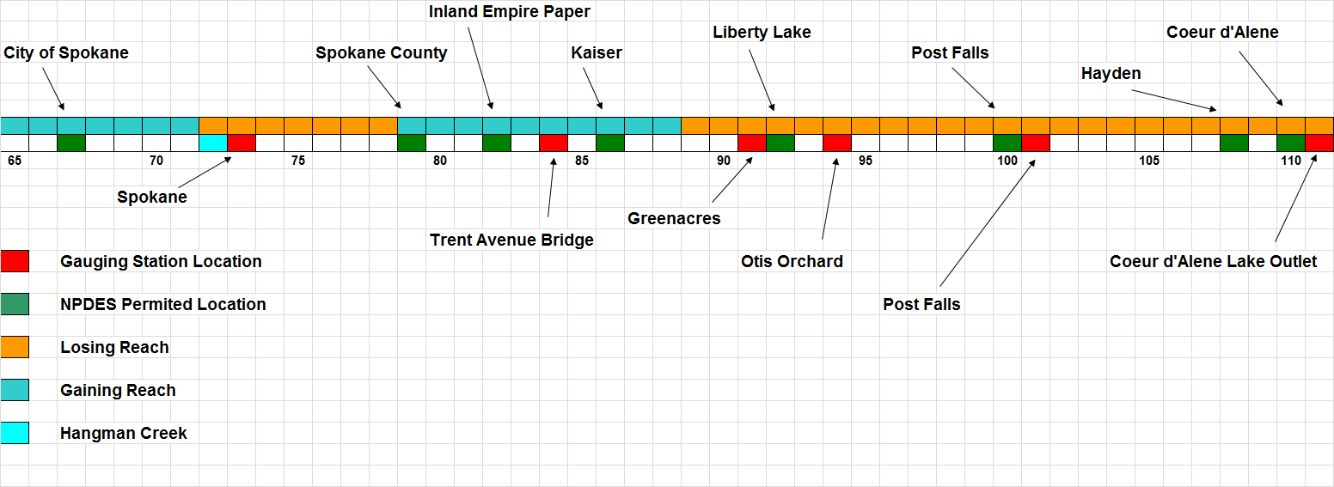
Figure 1. Schematic of Baseline Dry Weather Monitoring Upstream of Lake Spokane
It is recommended that sampling be conducted synoptically (i.e. samples at all stations collected during the same time period). Sampling will be conducted during the summer low flow period to removing potential confounding effects of wet weather sources. Multiple river sampling events should be conducted (with samples composited to reduce analytical costs) over a two-week sampling period to reduce the uncertainty in loading estimates caused by day-to-day variability in river concentrations.

Seasonally Integrated Sampling
The second component of the monitoring program consists of sampling of the Spokane River at the outlet of Lake Coeur d’Alene. The intent of this monitoring is to provide information on the seasonal variability of upstream PCB loading from Lake Coeur d’Alene, which will provide insight on the atmospheric contribution to the snow pack in the upstream watershed.
This sampling will be conducted on a seasonally integrated basis, with multiple samples taken (and composited) over each of three different flow regimes:
- Spring high flow
- Summer low flow
- Winter moderate flow
Optionally, additional seasonally integrated sampling could also be conducted at a second river location near Spokane, to provide information on seasonal distribution of loads entering the river between Lake Coeur d’Alene and Spokane. The concern with this additional mid-river monitoring location is that wet weather loading sources to the river may be too variable over time to be accurately represented by discrete sampling events.

Costs
The overall cost for most PCB monitoring is driven by the cost of laboratory analysis, such that monitoring cost is roughly proportional to the number of samples analyzed. A sufficiently large number of samples must be collected to reduce the effect of variability in sample results, but costs can be constrained to a degree through the analysis of composite samples. Rough budget estimates for the proposed monitoring activities are as follows:
- Synoptic Survey: $125,000
- Seasonally Integrated Sampling at Lake Coeur d’Alene Outlet: $50,000
- (Optional) Seasonally Integrated Sampling in Spokane: $50,000

References
LimnoTech, 2013a. Issues to Consider Prior to First Monitoring Objectives Meeting. Prepared for the Spokane River Regional Toxics Task Force. Spokane, WA. July 16, 2013.
LimnoTech, 2013b. Identification of Data Gaps. Prepared for the Spokane River Regional Toxics Task Force. Spokane, WA. October 4, 2013.
LimnoTech, 2013c. Initial Data Collection Strategy for PCB Comprehensive Plan. Prepared for the Spokane River Regional Toxics Task Force. Spokane, WA. October 15, 2013.
Serdar, D., B. Lubliner, A. Johnson, and D. Norton. 2011. Spokane River PCB Source Assessment, 2003-2007. Washington Department Of Ecology, Toxics Studies Unit, Environmental Assessment Program. Department of Ecology Publication No. 11-03-013.

