Notes from Conversation with C.I.Agent and Ecology 6-27-14

From C.I.Agent (CLAM manufacturer):

“We are making headway with a dipping bucket type counter for the CLAM. I included a illustration type photo of it, This unit uses a single AAA battery and will last over a year, and can be mounted on most any surface, pole, stake etc. It is accurate to +/- 1 percent.”
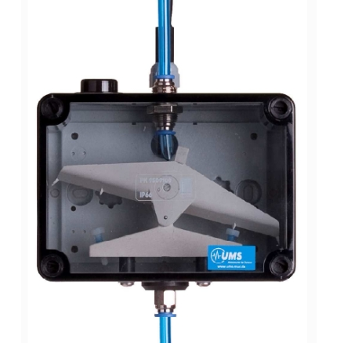
CLAM effluent line

The dipping bucket counter is field ready now. C.I.Agent is currently conducting a validation study that should be finished in a week or so. They are willing to loan dipping bucket counters for a preliminary study in the Spokane River if SRRTTF is interested.

