Suspended Sediments Laboratory Study:
Overview and approach: Experiment was conducted at CAS laboratories in Kelso, WA to evaluate the efficiency of the Krebs model P0.5-160 vortex separator to remove suspended sediment. Arizona dust with a even particle distribution from 0.1 micron to 180 microns was mixed in 5 gallon carboys and sampled pre and post vortex separator. 40 sample sets were completed to evaluate efficiency. A flow rate of 3 Liters/minute for sampling was maintained. A LISST particle analyzer was used to sample the suspended sediments pre and post vortex separator. The LISST particle analyzer measures particles using a laser and presents both concentration and particle size distribution data.
Photo 1: Gravity P2900 HVS system and particle standard in Carboy
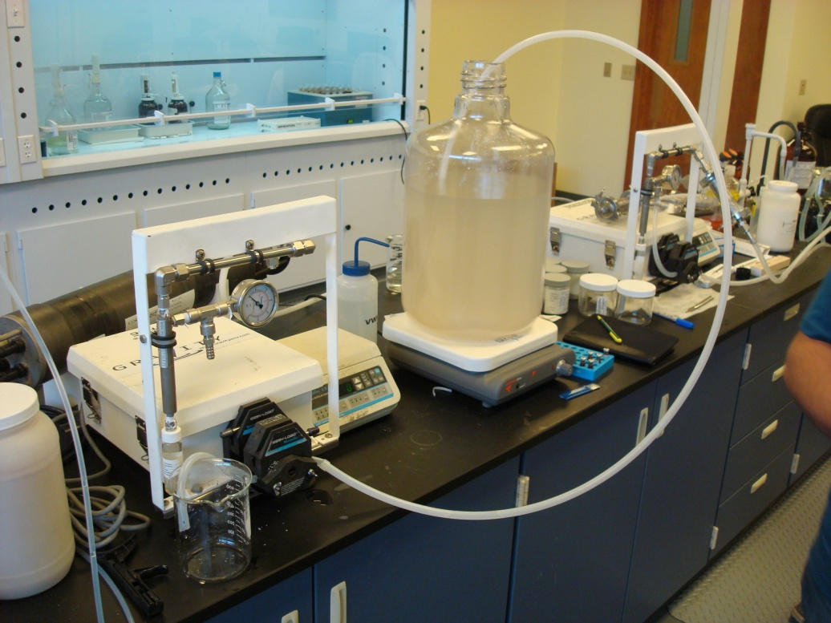
Photo 2: LISST particle analyzer connected with a flow through chamber to HVS system
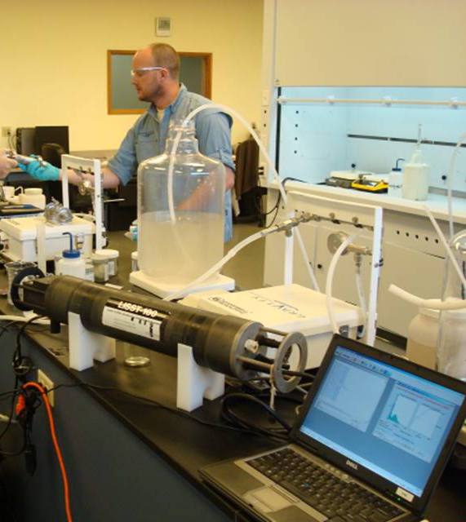
Results Pre Vortex Separator:
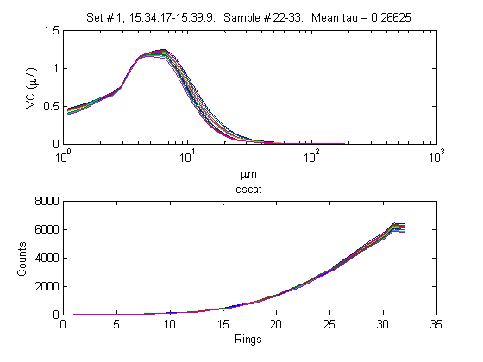
Results: post Vortex separator
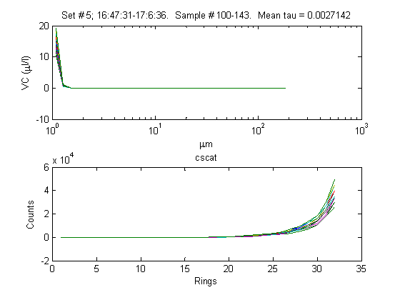
Conclusions: The vortex separator efficiently removed suspended particles between 0.5 microns and 100 microns. Small particles below 0.5 microns were not captured by the Vortex Separator.

