DRAFT Meeting Summary
Spokane River Flow Monitoring Workgroup

4/8/15, 130 pm, Spokane County Water Resource Center
Attendees:
Rob Lindsay, Mike Hermanson; Spokane County
Kevin Wright; USGS
David Stasney; Spokane Community College
Lynn Schmidt; City of Spokane
Katherine Rowden; National Weather Service
Meghan Lunney, Steve Esch; Avista
John Covert; Washington Dept. of Ecology (WDOE)

Purpose of the meeting is to identify flow monitoring needs for the SRRTTF data collection activities and to make recommendations to meet those needs.

The group made the following observations and recommendations with respect to flow monitoring stations on the Spokane River, starting upstream at Coeur d’Alene Lake

Discussion
- Coeur d’Alene Lake outlet – the “Below Blackwell” gage is operational and funded by EPA. No changes are recommended
- The Post Falls gage (aka Maguire, located below Post Falls dam) is operational and funded by Avista. No changes are recommended.
- The Trent gage is NO LONGER operational. The previous funding agency has withdrawn. The group recommends that this gage be operational. The fee to USGS for annual operation and maintenance will be $19,880/year for 2016, and will include annual increases. This needs to be an action item for the SRRTTF.
- The Green Street gage in in the process of being upgraded by Spokane Community College, with equipment to be purchased by the SRRTTF. SRRTTF ACE will contract with SCC to provide approximately $9,200.00 in funding. SCC students will install, operate and maintain the gage in coordination with USGS. An additional $2,000.00 will be needed for USGS to develop an updated rating curve for this gage. It is anticipated this will be funded initially through an existing Agreement between USGS and Spokane County, and eventually reimbursed by SRRTTF. Flow data will be hosted and available on-line via the National Weather Service. This option provides only 10 days of archive, however, and the National Weather Service has identified the US Army Corps as an agency that can archive the data for a longer period of time.
- The Spokane gage is operational and funded by Avista and the City of Spokane. No changes are recommended. Minor modifications are being considered by the USGS which will not have an effect on the SRRTTF.
- The 7 Mile gage (across from the Gun Club in Riverside State Park) was discussed as potentially desirable in order to quantify the aquifer inflow through gaining reach of the Spokane River below the Spokane gage and above the Nine Mile Dam pool. Previous experience has indicated that the Nine Mile Dam pool affects this location when full. There was discussion of potentially moving the gage upstream to avoid this influence, but no recommendation was made.
- Nine Mile gage (below Nine Mile Dam) was discussed extensively. The workgroup recommends collection of real time flow data from this location. The gage is not currently operational and new equipment will need to be reinstalled. Per USGS, the following costs may be anticipated:
  - Purchase equipment and install - $25,000.00 (includes rating curve)
  - If the site is inaccessible by boat, a cable way would be needed; if so, the fee to install a cable way will be an additional $20,000.00 to $40,000.00
  - Permitting for Spokane County shorelines and WDFW/JARPA are not included. This is an unknown additional cost at this point.
  - Operations/maintenance and data hosting by the USGS will be approximately $19,880.00 per year for 2016, with annual increases to follow.
USGS/WDOE will visit the site soon to identify the installation needs for this location. A photograph of the gage site location is attached.

Action Items
- Complete the Greene Street Upgrade soon, and develop a new rating curve
- Identify a funding agency/partnership for the Trent gage
- Identify a funding agency/partnership for the Nine Mile gage and reactivate this location. USGS will provide additional information regarding installation requirements and costs.

A summary of estimated costs by the USGS area attached.

Location of Existing Gage below Nine Mile Dam
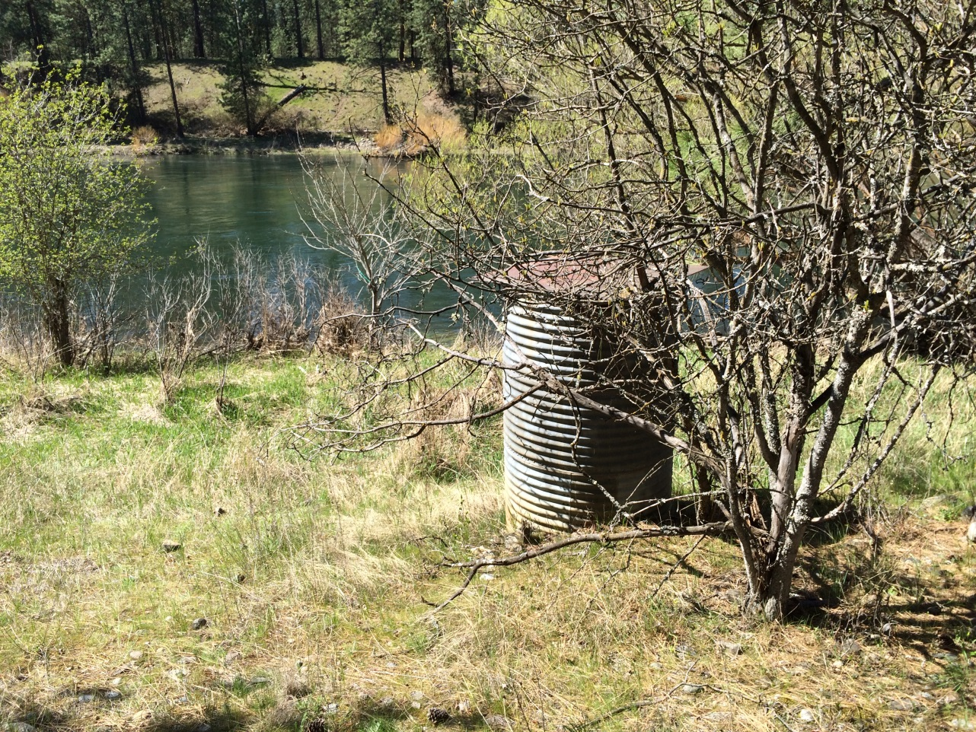

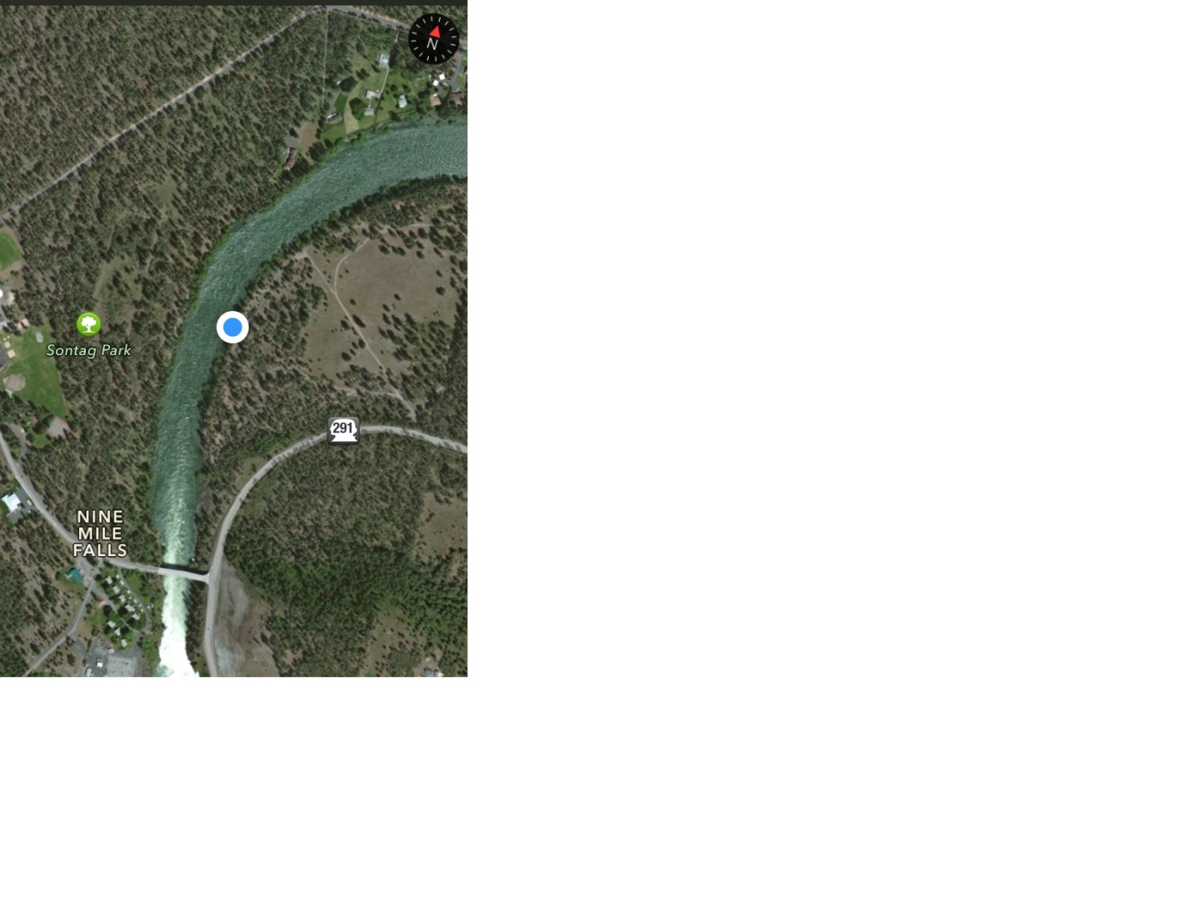
Proposal for the PCB TMDL Flow Workgroup / USGS Cost
12421500 Spokane River below Trent Bridge near Spokane
Cost $19,880 O&M for FY2016
Start up the gage by installing the equipment back inside the gage. This gage would be a full year gage as previously it was operated as a partial year gage.

12422000 Spokane River blw Green St at Spokane, Wa
Cost $2000
USGS would develop a rating based on the last three years of discharge measurements made by Spokane Community College at this location. USGS would supply the rating points and a full rating to SCC and NWS so it can be posted in near realtime one the NWS website or the alternate WADOE website.

12426000 Spokane River below Nine Mile Dam at Spokane, WA Operated 3/1/1948 to 9/30/1950
Cost $19,880 O&M
Startup cost Approx $25,000
The cost includes purchasing a DCP, Sensor, Antenna and Solar Panel. Installation of a NEMA Style enclosure, Pressure treated wood. Approx 100’ of 1 ½ inch galvanized pipe with fittings, three 8” inch channel iron and wood for outside reference gages, two 5’ long 2” galvanized pipes with caps and 1x2” wood to make Crest Stage Gages. Then Miscellaneous parts for wiring and installation. A narrow trench would need to be made to bury the Pipe from the Enclosure down to the river bank. At mean flow water line the live would become aboveground and anchored with brackets with 1” x 4’ long rods on the ground.

