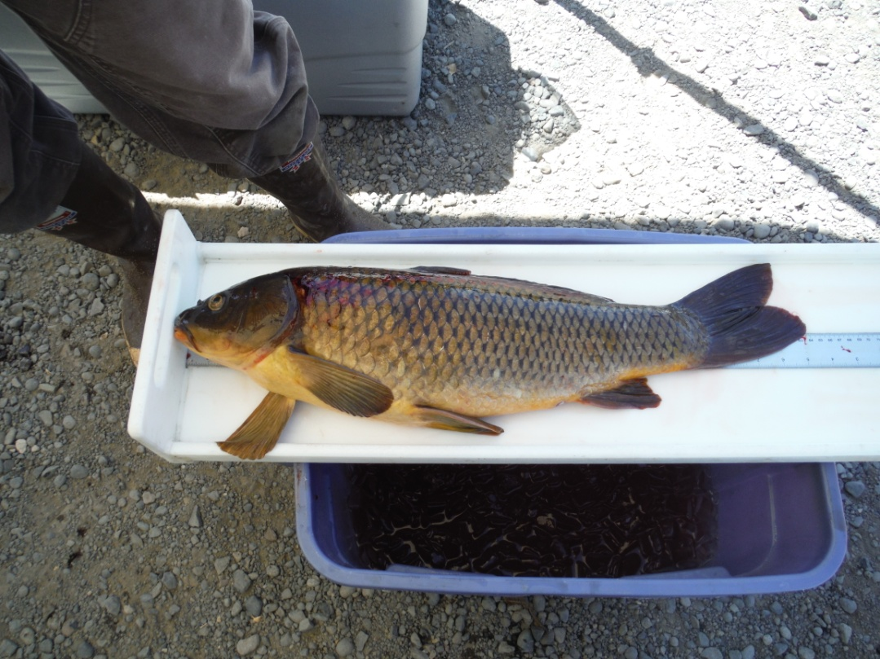

*DRAFT –* 6/30/15

PCBs in Carp from Lake Spokane

ECOLOGO-C.wmf

July 2015

Publication No. 15-03-0xx

**Publication and contact information**

This report is available on the Department of Ecology’s website at <https://fortress.wa.gov/ecy/publications/SummaryPages/1503xxx.html> (Joan will complete)

Data for this project are available at Ecology’s Environmental Information Management (EIM) website [www.ecy.wa.gov/eim/index.htm](http://www.ecy.wa.gov/eim/index.htm). Search Study ID BERA0011.

The Activity Tracker Code for this study is 14-032.

For more information contact:

Publications Coordinator

Environmental Assessment Program

P.O. Box 47600, Olympia, WA 98504-7600

Phone: (360) 407-6764

Washington State Department of Ecology - [www.ecy.wa.gov](http://www.ecy.wa.gov)

* + Headquarters, Olympia (360) 407-6000
  + Northwest Regional Office, Bellevue (425) 649-7000
  + Southwest Regional Office, Olympia (360) 407-6300
  + Central Regional Office, Yakima (509) 575-2490
  + Eastern Regional Office, Spokane (509) 329-3400

Cover photo: Common Carp from Casey Pond located near the McNary National Wildlife Refuge. Photo taken by Keith Seiders.

*Any use of product or firm names in this publication is for descriptive purposes only and   
does not imply endorsement by the author or the Department of Ecology.*

*Accommodation Requests: To request ADA accommodation**including materials in a format   
for the visually impaired, call Ecology at 360-407-6764. Persons with impaired hearing may call   
Washington Relay Service at 711. Persons with speech disability may call TTY at 877-833-6341.*

PCBs in Carp from Lake Spokane

by

Brandee Era-Miller

Environmental Assessment Program

Washington State Department of Ecology

Olympia, Washington 98504-7710

Water Resource Inventory Area (WRIA) and 8-digit Hydrologic Unit Code (HUC) numbers for the study area:

WRIA

* 54

HUC number

* 17010307

*This page is purposely left blank*

**Table of Contents**

Page

List of Figures and Tables 5

Abstract 6

Introduction 7

Background 7

Study Area 8

Methods 9

Fish Collection and Processing 9

Laboratory Methods 9

Data Quality 10

Project Completeness and Representativeness 10

Laboratory 11

Results 11

Discussion 12

Body Burden and Estimation of PCB Removal 14

Conclusions 14

Recommendations 15

References 16

Appendices 17

Appendix A. Location and Result Data 18

Appendix B. Data Correlations 19

Appendix C. Glossary, Acronyms, and Abbreviations 21

# List of Figures and Tables

Page

**Figures**

Figure 1. Lake Spokane and 2014 Carp Collection Locations. 8

Figure 2. Percentages in 100 mm Length Class for Two Carp Collection Events. 10

Figure 3. Comparison of Total PCB Aroclors and Congeners in Lake Spokane Carp. 13

Figure 4. Total PCB Aroclor Concentrations in Largescale Suckers and Common Carp from upper Lake Spokane. 13

**Tables**

Table 1. Analytical Methods for the Lake Spokane Carp PCB Study. 9

Table 2. Summary of Results for Carp Collected from Lake Spokane in September 2014. 11

Table 3. Statistics for Lake Spokane Carp PCB Data. 12

# Abstract

The Department of Ecology (Ecology) conducted a study to characterize PCB concentrations in Common carp (*Cyprinus carpio*) from Lake Spokane in September 2014. PCB concentrations in carp can be used to estimate the mass of PCBs removed from Lake Spokane as a part of Avista Utilities’ proposed carp population reduction project.

The September 2014 fish collection effort for Ecology’s study yielded far fewer carp than was planned. The original objective of the study was to analyze 75 carp used in 15 composite samples from several size classes and determine an average PCB concentration for each size class. Instead, only 15 individual carp were analyzed. The size distribution of these 15 fish was found to be representative of an earlier population survey of 639 carp from Lake Spokane.

Whole fish were processed and analyzed for lipids and PCB Aroclors. A subset of the samples (N=10) was analyzed for PCB congeners. Aroclors and congeners were highly correlated with an R2 of 0.98. Aroclor data (N=15) was then used to calculate an average total PCB mass per fish.

The average mass of PCB Aroclors per fish was 0.0027 grams and can be applied to any individual common carp removed from upper Lake Spokane within the length range of 569 to 798 millimeters. A range of 0.0015 – 0.0041 grams, based on the 95% confidence interval, can also be used to estimate a range of total PCB Aroclor masses. These numbers can be scaled-up and applied to the number of carp removed for an estimation of bulk mass of PCBs removed.

# Introduction

The purpose of this study was to quantify the concentrations of polychlorinated biphenyls (PCBs) in Common carp (*Cyprinus carpio*) from Lake Spokane. The PCB results will be used to estimate the mass of PCBs that could be potentially removed from Lake Spokane during Avista Utilities’ (Avista) proposed carp population reduction project or other projects where carp are removed from Lake Spokane. The removal of carp is expected to help improve water quality problems related to phosphorus loading and low levels of dissolved oxygen in Lake Spokane.

## Background

Lake Spokane and portions of the Spokane River are listed as impaired for PCBs under Section 303d of the Clean Water Act. Carp are known to accumulate high levels of PCBs in their tissue because they have high fat content, are a long-lived species, and are bottom feeders. Carp are frequently in contact with sediments where PCBs settle out in slower moving areas of riverine systems. The Department of Ecology (Ecology) recognized Avista Utilities’ (Avista) carp population reduction project as an opportunity to help reduce the mass of PCBs in Lake Spokane. In order to estimate the potential mass of PCBs that could be removed, PCB concentrations in carp were needed.

Avista is an energy production and transmission company that supplies electricity and natural gas to customers in eastern Washington and northern Idaho. They own and operate five hydroelectric dams on the Spokane River. Long Lake Dam at the western downstream end creates the reservoir known as Lake Spokane. Ninemile Dam bounds Lake Spokane at the eastern upstream end.

Dissolved oxygen (DO) levels in portions of the Spokane River and Lake Spokane do not meet Washington’s water quality standards, and these portions are listed as “impaired” under Section 303d of the Clean Water Act.  In response, Ecology developed the *Spokane River and Lake Spokane Dissolved Oxygen Total Maximum Daily Load Water Quality Improvement Report* (DO TMDL) (Moore and Ross, 2010).  Within the DO TMDL, Avista was assigned a proportional level of responsibility to improve DO concentrations within Lake Spokane.  This requirement was amended into Avista’s 401 Water Quality Certification (Certification), included as Appendix B of its Federal Energy Regulatory Commission License for the Spokane River Hydroelectric Project (Lunney, personal communication).

Subsequent to the DO TMDL and the Certification amendment, Avista completed a *Lake Spokane Dissolved Oxygen Water Quality Attainment Plan,* which identified potential measures to improve DO conditions within Lake Spokane (Avista and Golder, 2012). These measures focused on reducing nonpoint sources of phosphorus loading into Lake Spokane.  One such measure includes investigating whether a carp population reduction program would improve water quality (Lunney, personal communication). Carp are believed to play a large role in the recycling of phosphorus from lake sediments to the water column due to their feeding behavior (stirring up bottom sediments). Phosphorus then contributes to algal growth which eventually decomposes and reduces DO in the lake.

Avista contracted with Golder Associates to conduct a carp population study that would characterize population abundance, distribution, and habitat use of carp and to help develop a carp population reduction program (Lunney, personal communication). Golder Associates conducted the first stage of the carp population study in June of 2014, with a marking and tagging event that involved the capture and release of 639 carp. Golder Associates went back in September of 2014 to recapture carp, but were only to able to collect 18 carp because the carp had already moved deeper into the lake to overwinter. Ecology obtained 15 of these carp for PCB analysis.

## Study Area

Lake Spokane (formerly known as Long Lake) is located in eastern Washington and several miles to the northwest of the city of Spokane (Figure 1). The lake is a part of the Spokane River and was created by the formation of Long Lake Dam (completed in 1915) at its western downstream end. The lake boundary for the eastern upstream end is approximately one mile downstream of Nine Mile Dam. The lake covers 24 river miles between the dams. It straddles three counties: Stevens to the north, Lincoln to the west, and Spokane to the south, southeast, and northeast.

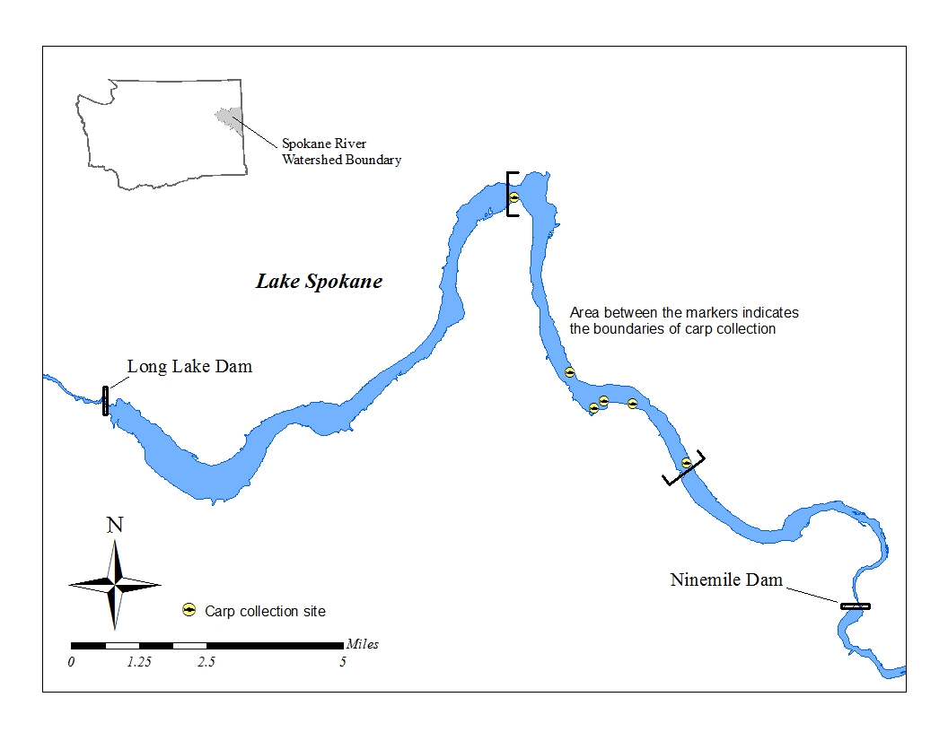

Figure 1. Lake Spokane and 2014 Carp Collection Locations.

# Methods

## Fish Collection and Processing

Fish were collected by Golder Associates, a contractor of Avista. Ecology staff met the contractor on the day of fish collections at the Nine Mile boat ramp, located on upper Lake Spokane. Fish were then processed in the field by following Standard Operating Procedure (SOP) EAP009 *for Field Collection, Processing, and Preservation of Finfish Samples at the Time of Collection in the field* (Sandvik, 2010a).

Staff from Golder recorded field data which included: collection locations, times, weights, and lengths of individual carp. Golder staff also identified the sex of each fish by carefully cutting in to the abdomen and examining gonads, took aging structures, and assigned a fish sample number to each fish before handing them off to Ecology staff. Ecology staff then double wrapped each fish in foil, and secured them in plastic bags in coolers on ice for transport to Ecology headquarters. Location data obtained from Golder Associates is located in Appendix A, Table A-1. These locations are also shown on Figure 1.

Fish were processed at Ecology headquarters by removing scales, rinsing with deionized water, and cutting the whole bodies into rounds and the heads into several smaller portions so that the tissue could fit into the Hobart commercial grade food grinder. Each fish (as multiple pieces) was then processed following SOP EAP007 *for Resecting Finfish Whole Body, Body Parts or Tissue Samples* (Sandvik, 2010b). This procedure is briefly described in the following paragraphs.

All processing utensils were cleaned in order to prevent contamination of the samples. Utensils included stainless steel bowls and knives and tissue grinding appliances having plastic and stainless steel parts. The cleaning steps were: (1) Liquinox soap and hot water wash, (2) 10% nitric acid rinse, (3) deionized water rinse, and (4) acetone and hexane rinses. The Hobart grinder was only rinsed with acid and solvent before the first sample was processed. Between each sample it was washed with Liquinox soap and hot water.

Tissue for each fish was passed three times through the Hobart grinder and homogenized to a consistent color and texture. Certified organics-free jars were then filled with tissue and frozen prior to shipment to the laboratories. Additional samples were archived at Ecology Headquarters.

## Laboratory Methods

Analytical methods for the project are shown in Table 1.

Table 1. Analytical Methods for the Lake Spokane Carp PCB Study.

|  |  |  |  |
| --- | --- | --- | --- |
| Parameter | Number of samples | Analytical Method | Laboratory |
| Lipids | 15 | MEL SOP 730009 | MEL |
| PCB Aroclors | 15 | EPA 8082 | MEL |
| PCB congeners | 10* | EPA 1668C | Pacific Rim (Surrey, BC) |

EPA = U.S. Environmental Protection Agency

MEL SOP = Manchester Environmental Laboratory Standard Operating Procedure

*=These were a subset of the 15 samples analyzed for congeners (i.e. 10 samples had both PCB analyses)

## Data Quality

### Project Completeness and Representativeness

Project goals for completeness were not met, but sample representativeness was excellent for the study. Carp were originally planned to be analyzed as 15 composite samples of 5 fish each for a total of 75 fish, however Golder Associates was only able to capture ~18 carp for Ecology in September 2014. Though only portion of the planned number of carp were analyzed for the study (N=15 instead of N=75), the 15 carp analyzed as individuals were highly representative of the much larger group of carp (N=639) that Golder Associates had measured during their June 2014 marking event. Figure 2 shows the overlap of length classes by percentage between the two populations. The majority of carp fell between the 500 – 799 mm length classes for both populations.



Figure 2. Percentages in 100 mm Length Class for Two Carp Collection Events.

### Laboratory

All project data were reviewed by the laboratories and project manager and judged to be acceptable as qualified by the laboratories. All the laboratory measurement quality objectives (MQOs) laid out in the Quality Assurance Project Plan (QAPP) for the project were met (Era-Miller, 2014). Several items are noteworthy: the weathered state of PCB Aroclors and the comparability of PCB congener and PCB Aroclor results.

Due to weathering of the PCB Aroclors and interference between Aroclor patterns during analysis, most of the Aroclor 1260 results were qualified with a “J” indicating that the reported values are estimates. Aroclor 1248 appeared to be present in most of the samples, but Aroclor 1254 concentrations overwhelmed it with at least 50% of the apparent concentration contributed by Aroclor 1254. Because the interference was too high to calculate a reliable concentration in any of the samples, all Aroclor 1248 results were qualified with a “U” as non-detected and reported at the level of interference.

Precision for the lipids, PCB Aroclor and PCB congener data was measured by calculating the relative percent difference (RPD) between laboratory duplicate samples. Project acceptance limits for RPDs were met for all the analyses (≤20% for lipids, ≤40% for Aroclors and 50% for congeners). This data is available upon request from the project manager.

# Results

Table 4 shows results for biological data, lipids, and totals for both PCB Aroclors and congeners. Full Aroclor and congener results are available in EIM and also shown in Appendix A, Tables A-1 and A-2. Only Aroclors 1254 and 1260 were reported as detected by MEL. Though there was evidence that weathered Aroclor 1248 was present in most of the samples, it could not be quantified due to significant overlap from Aroclor 1254 (this is covered more in the data quality section of this report). There was good correlation (R2 = 0.98) between the total PCB results for Aroclors and congeners.

Table 2. Summary of Results for Carp Collected from Lake Spokane in September 2014.



*Mean of duplicate sample analysis

-- Not analyzed

J = Result value is an estimate

Unit of measure for PCB Aroclors and congeners is ug/Kg (part per billion) wet weight

Table 3 gives basic statistics for the carp results. The 95% confidence interval indicates that there is 95% certainty that the mean of the actual carp population in Lake Spokane lies between the lower and upper values given. For example, the mean for total Aroclors in carp from Lake Spokane lies between 410 and 756 ug/Kg (mean of 583 ±173).

Table 3. Statistics for Lake Spokane Carp PCB Aroclor Data.

|  |  |  |  |  |  |
| --- | --- | --- | --- | --- | --- |
| Parameter | N = | Mean ± 95% Confidence Interval | Minimum Value | Maximum Value | Standard Deviation |
| Length (mm) | 15 | 674 ±37 | 569 | 798 | 66 |
| Weight (g) | 4605 ±882 | 2660 | 7820 | 1593 |
| Age (years) | 10 ±2 | 5 | 17 | 3 |
| Lipids (%) | 10 ±2 | 5 | 18 | 4 |
| Total Aroclors (ug/Kg) | 583 ±173 | 227 | 1380 | 312 |

# Discussion

Correlations were calculated between all the carp measurements and both PCB Aroclors and congeners to identify factors affecting PCB concentration. Correlations are shown in Appendix C. With the exception of Aroclors versus congeners, which had an R2 of 0.98, no strong relationships stood out with the data. Lipids were somewhat correlated with Aroclors (R2 = 0.26) and congeners (R2 = 0.47) and also age with Aroclors (R2 = 0.27) and congeners (R2 = 0.15). Length, weight and sex were very poorly correlated. This suggests that the carp samples (N=10 and 15) analyzed for this study have highly variable characteristics (i.e. lipid content, age, weight and PCB levels) even though they are in similar length class (500 –799 mm).

Figure 3 shows a comparison between the subset (N = 10) of samples that were strongly correlated between PCB Aroclors and congeners. This correlation supports the use of Aroclors for measuring PCB concentrations in carp from Lake Spokane.



Figure 3. Comparison of Total PCB Aroclors and Congeners in Lake Spokane Carp.

A search in Ecology’s EIM database revealed very little PCB data for whole carp, making it difficult to put the PCB concentrations for whole carp from this study into context. The next best data for comparison would be whole Largescale suckers (*Catostomus macrocheilus*) from upper Lake Spokane which were analyzed for PCB Aroclors by Ecology in 2005 and 2012 (Serdar et al., 2011; Seiders et al., 2014). Figure 4 compares the mean concentrations for whole Largescale suckers (LSS) and whole common carp (CCP). The suckers were analyzed as composite samples while carp were analyzed as individual samples.



Figure 4. Total PCB Aroclor Concentrations in Largescale Suckers and Common Carp from upper Lake Spokane.

## Body Burden and Estimation of PCB Removal

Aroclor results were used for estimating the mass of PCBs in carp because there is more data for Aroclors (N = 15) versus congeners (N = 10) and because of the strong correlation between total PCBs for both methods (R2 = 0.98).

The average mass of PCBs per fish can be calculated by multiplying the mean concentration of total Aroclors (583 ug/Kg) by the mean weight (4,605 g) of carp in our dataset (N=15):



The range of PCB mass per carp is calculated by using the 95% confidence intervals for the mean of total Aroclors (583 ±173 ug/Kg) and mean weight (4,605 ±882). This yields a range of PCB mass per carp of 0.0015 – 0.0041 grams. This range of masses can then be applied to each carp removed from upper Lake Spokane within the length range of 569 – 798 mm. This length range fits into 94% of the most common length classes (500 – 799) as identified during the Golder Associates June 2014 marking event.

Applying the range of PCB mass per fish to the number of fish removed for this study (N=15) yields an estimate of 0.023 – 0.062 grams of PCBs removed from Lake Spokane during the September 2014 collection. Scaling this range up to 100 and 1000 carp yields ranges of 0.15 –

0.41 and 1.5 – 4.1 grams of PCBs that could potentially be removed from Lake Spokane.

# Conclusions

Results of this (2014) study support the following conclusions:

* The15 carp analyzed for the Ecology study were highly representative of the much larger group of carp (N=639) that Golder Associates measured during their June 2014 marking event. The majority of carp fell between the 500 – 799 mm length classes for both populations. Although all the other data (e.g. weight, lipid content, and PCB concentration) from the Ecology study was variable between samples within this length class, the PCB concentration data is useable for estimating PCB concentrations on a per carp basis for the length class. Carp outside of this length class (either shorter or longer) would need to be analyzed for PCBs in order to estimate concentrations for their length classes.
* Total PCB Aroclors (N=15) had excellent correlation with the total PCB congener data (N=10) with an R2 of 0.98. Aroclor analysis is suitable for measuring PCBs in fish from Lake Spokane for the purposes of calculating total PCBs or for trend monitoring. Aroclor analysis is much more cost effective than congener analysis.
* The average mass of 0.0027 grams of total PCBs (Aroclors) per carp calculated with the data from this study can be applied to any individual common carp removed from upper Lake Spokane within the length range of 569 to 798 millimeters. A range of 0.0015 – 0.0041 grams of PCBs, based on the 95% confidence interval, can also be used to estimate a range of PCB mass per carp. These values can be applied to the number of carp removed to estimate the mass of PCB removed.

# Recommendations

Results of this (2014) study support the following recommendations:

* The average mass of 0.0027 grams of total PCBs (Aroclors) per fish or the range of 0.0015 – 0.0041 grams per fish, based on the 95% confidence interval, should be used to calculate total PCB masses for Lake Spokane carp with a length range of 569 to 798 millimeters. These numbers can then be scaled-up and applied to the number of carp removed.
* The SRRTTF should remain aware of Avista’s plans to remove carp from Lake Spokane as part of Avista’s ongoing efforts to improve dissolved oxygen in Lake Spokane. This way, any PCB removal from the lake via carp, can be estimated.

When Ecology’s Freshwater Fish Contaminant Monitoring Program (FFCMP) returns to the Spokane River around 2022 to analyze fish for PCBs and other contaminants, it should analyze whole carp from Lake Spokane and target fish in the same length class as this study in order to help track trends of PCBs in fish.

# References

Avista and Golder, 2012. Lake Spokane Dissolved Oxygen Water Quality Attainment Plan. Spokane River Hydroelectric Project, FERC Project No. 2545, Washington 401 Certification, Section 5.6.

Era-Miller, 2014. Quality Assurance Project Plan: Lake Spokane PCBs in Carp. Washington State Department of Ecology, Olympia, WA. Publication No. 14-03-123.

<https://fortress.wa.gov/ecy/publications/SummaryPages/1403123.html>

Lunney, M., 2013 - 2015. Personal communications with Meghan Lunney of Avista Utilities.

Sandvik, P., 2010a. Standard Operating Procedure for Field Collection, Processing and Preservation of Finfish Samples at the Time of Collection in the Field. Washington State Department of Ecology, Olympia, WA.  SOP Number EAP009. [www.ecy.wa.gov/programs/eap/quality.html](http://www.ecy.wa.gov/programs/eap/quality.html)

Sandvik, P., 2010b. Standard Operating Procedures for Resecting Finfish Whole Body, Body Parts or Tissue Samples. Washington State Department of Ecology, Olympia, WA.    
SOP Number EAP007. [www.ecy.wa.gov/programs/eap/quality.html](http://www.ecy.wa.gov/programs/eap/quality.html)

Seiders, K., C. Deligeannis, P. Sandvik, and M. McCall, 2014. Freshwater Fish Contaminant Monitoring Program: 2012 Results. Washington State Department of Ecology, Olympia, WA. Publication No. 14-03-020. <https://fortress.wa.gov/ecy/publications/SummaryPages/1403020.html>.

Serdar, D., B. Lubliner, A. Johnson, and D. Norton, 2011. Spokane River PCB Source Assessment, 2003-2007. Washington State Department of Ecology, Olympia, WA. Publication No. 11-03-013. <https://fortress.wa.gov/ecy/publications/summarypages/1103013.html>.

Moore D. and J. Ross, 2007 (Revised 2010). Spokane River and Lake Spokane Dissolved Oxygen Total Maximum Daily Load: Water Quality Improvement Report. Washington State Department of Ecology, Olympia, WA. Publication No. 07-10-073. <https://fortress.wa.gov/ecy/publications/SummaryPages/0710073.html>

# Appendices

## 

## Appendix A. Location and Result Data

Table A-1. Locations for Carp Collection



EIM Study Name = BERA0011

EIM Location ID = LONG-F

Table A-2. PCB Aroclor Results (ug/Kg, wet weight) for Carp from Lake Spokane



Values **bolded** to represent detected chemicals

J = Result value is an estimate

U = Result is not detected at the value reported

Table A-3. PCB Congener Results (ug/Kg, wet weight) for Carp from Lake Spokane

*<<Insert 5 pages Landscape with header repeated>>*

Values **bolded** to represent detected chemicals

J = Result value is an estimate

U = Result is not detected at the value reported

UJ = Result is not detected at the estimated value reported

ND = Not detected

## Appendix B. Data Correlations

## 

## Appendix C. Glossary, Acronyms, and Abbreviations

Glossary

**Clean Water Act:** A federal act passed in 1972 that contains provisions to restore and maintain the quality of the nation’s waters. Section 303(d) of the Clean Water Act establishes the TMDL program.

**Dissolved oxygen (DO):** A measure of the amount of oxygen dissolved in water.

**Effluent:** An outflowing of water from a natural body of water or from a man-made structure. For example, the treated outflow from a wastewater treatment plant.

**Nonpoint source:** Pollution that enters any waters of the state from any dispersed land-based or water-based activities, including but not limited to atmospheric deposition, surface-water runoff from agricultural lands, urban areas, or forest lands, subsurface or underground sources, or discharges from boats or marine vessels not otherwise regulated under the NPDES program.Generally, any unconfined and diffuse source of contamination. Legally, any source of water pollution that does not meet the legal definition of “point source” in section 502(14) of the Clean Water Act.

**Parameter:** Water quality constituent being measured (analyte). A physical, chemical, or biological property whose values determine environmental characteristics or behavior.

**Point source:** Sources of pollution that discharge at a specific location from pipes, outfalls, and conveyance channels to a surface water. Examples of point source discharges include municipal wastewater treatment plants, municipal stormwater systems, industrial waste treatment facilities, and construction sites where more than 5 acres of land have been cleared.

**Pollution:** Contamination or other alteration of the physical, chemical, or biological properties of any waters of the state. This includes change in temperature, taste, color, turbidity, or odor of the waters. It also includes discharge of any liquid, gaseous, solid, radioactive, or other substance into any waters of the state. This definition assumes that these changes will,   
or are likely to, create a nuisance or render such waters harmful, detrimental, or injurious to   
(1) public health, safety, or welfare, or (2) domestic, commercial, industrial, agricultural, recreational, or other legitimate beneficial uses, or (3) livestock, wild animals, birds, fish, or other aquatic life.

**Surface waters of the state:** Lakes, rivers, ponds, streams, inland waters, salt waters, wetlands and all other surface waters and water courses within the jurisdiction of Washington State.

**Total Maximum Daily Load (TMDL):**  Water cleanup plan. A distribution of a substance in a waterbody designed to protect it from not meeting (exceeding) water quality standards. A TMDL is equal to the sum of all of the following: (1) individual wasteload allocations for point sources, (2) the load allocations for nonpoint sources, (3) the contribution of natural sources, and (4) a Margin of Safety to allow for uncertainty in the wasteload determination. A reserve for future growth is also generally provided.

**Watershed:** A drainage area or basin in which all land and water areas drain or flow toward a central collector such as a stream, river, or lake at a lower elevation.

**303(d) list:** Section 303(d) of the federal Clean Water Act requires Washington State to periodically prepare a list of all surface waters in the state for which beneficial uses of the water – such as for drinking, recreation, aquatic habitat, and industrial use – are impaired by pollutants. These are water quality-limited estuaries, lakes, and streams that fall short of state surface water quality standards and are not expected to improve within the next two years.

#### Acronyms and Abbreviations

Following are acronyms and abbreviations used frequently in this report.

Ecology Washington State Department of Ecology

EIM Environmental Information Management database

EPA U.S. Environmental Protection Agency

GIS Geographic Information System software

MEL Manchester Environmental Laboratory

NPDES (See Glossary above)

NTR National Toxics Rule

PBT persistent, bioaccumulative, and toxic substance

PCB Polychlorinated Biphenyl

RM River mile

RPD Relative percent difference

SOP Standard operating procedures

TMDL (See Glossary above)

WRIA Water Resource Inventory Area

*Units of Measurement*

°C degrees centigrade

ft feet

g gram, a unit of mass

kg kilograms, a unit of mass equal to 1,000 grams

m meter

mg milligram

mm millimeters

ug microgram

ug/Kg micrograms per kilogram (parts per billion)

ww wet weight