APPENDIX B – FIELD PHOTOGRAPHS
Picture 1. Daily preparation in the field lab; beginning YSI calibration
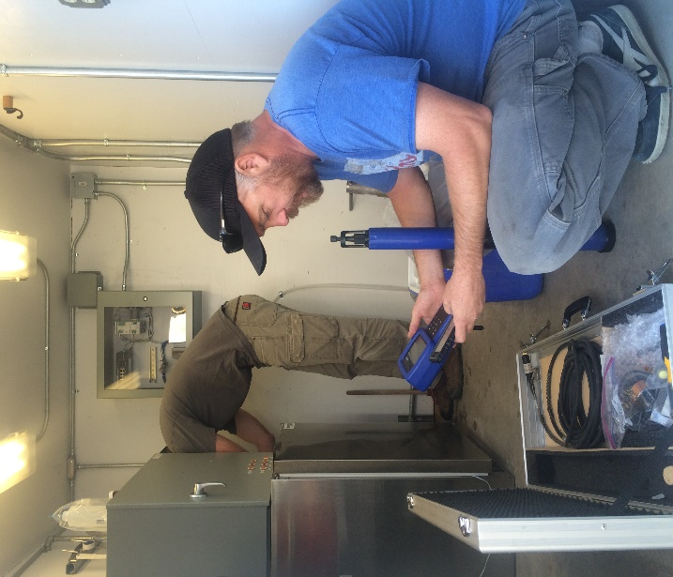
Picture 2. Packing samples in the field lab for shipping; applying custody seals
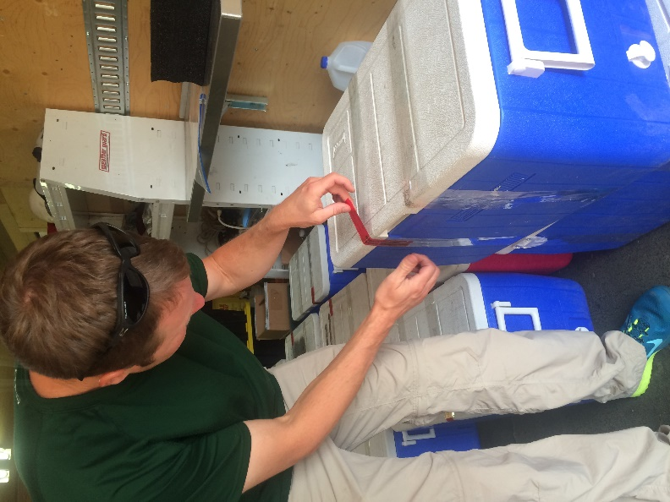
Pictures 3 and 4. Measuring flow at SR 8a using a Sontek River Surveyor
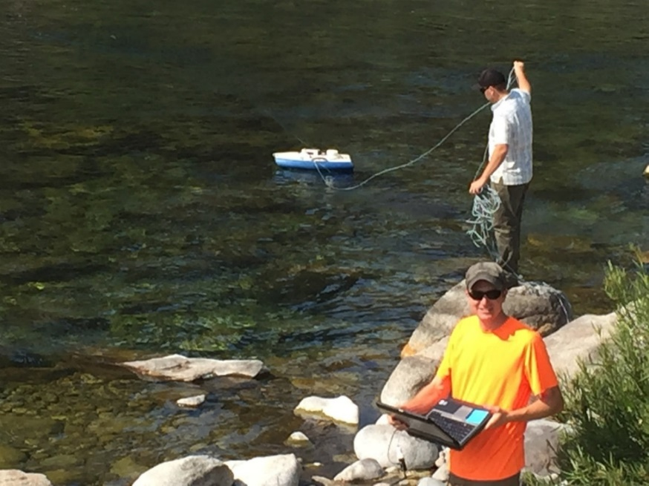
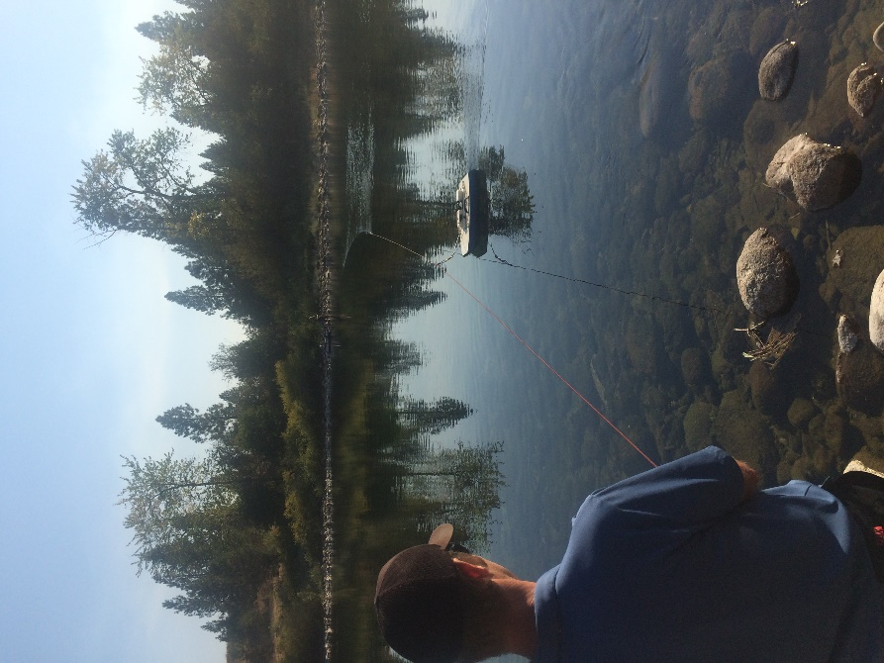

Picture 5. Direct immersion sampling at SR3
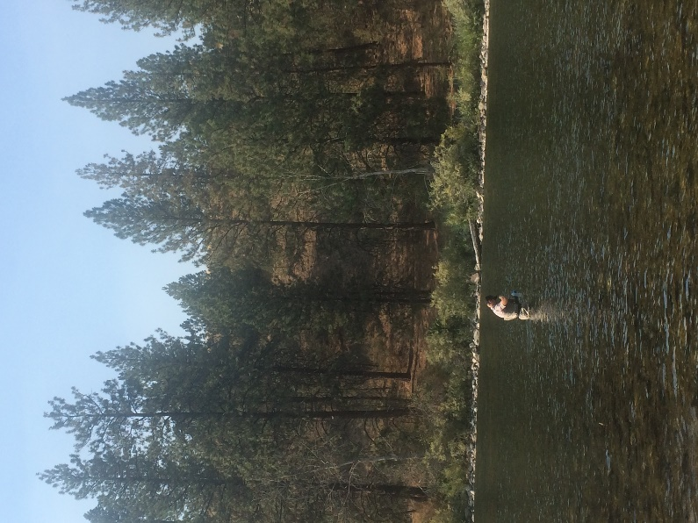
Picture 6. Sampling using a dip sampler at SR5
