Report:

PCB Characterization of Spokane Regional Vactor Waste Decant Facilities

Prepared for the Spokane River Regional Toxics Taskforce

July, 2015

By:

City of Spokane RPWRF Laboratory
4401 North A. L. White Parkway
Spokane, WA 99205

Table of Contents

Background 1
City of Spokane Decant Facility 2
City of Spokane Valley/WSDOT Pines Decant Facility 2
Spokane County Decant Facility 3

Project Overview 4

Results 5
City of Spokane - Playfair Facility 5
WSDOT/City of Spokane Valley – Pines Facility 5
Quality Control Data 6

Results Discussion 7

Conclusions 11

Appendix A: Additional Metals Testing Data 13

Appendix B: Original Data Reports – Electronic Files Attached 14

Background

The Spokane River has been listed as an impaired water body for polychlorinated biphenyls (PCBs). PCBs are a manmade chemical with no known natural sources. PCBs have been used in a variety of applications in the past, including insulating fluids for transformers and capacitors, hydraulic fluids, and plasticizers in paints, caulking and cements. Because of their toxicity, PCBs have been banned by the EPA in all manufacturing processes since 1977. Some PCBs, however, still get produced inadvertently today during the production of other chemicals. PCBs do not readily degrade and bio-accumulate in the environment.

The Spokane River Regional Toxics Taskforce (SRRTTF) was formed in 2012 to address the issue of PCBs in the Spokane River. SRRTTF is a collection of regulators, public and private dischargers, environmental groups, and other interested parties spanning both Idaho and Washington. SRRTTF has taken on the adaptive management approach (source identification and cleanup actions are pursued concurrently) to address the PCB issue in this area. With the goal of making measured PCB reductions in the Spokane River sooner rather than later, the adaptive management approach was chosen as an alternative to the predictably long and costly process of developing a TMDL. The ultimate goal of the taskforce is to make measurable progress towards meeting the water quality standards for PCBs in the Spokane River.

Stormwater runoff has been one of the previously identified contributors to PCBs in the Spokane River. As part of the Eastern Washington Phase II Municipal Permit, best management practices (BMPs) require stormwater catch basins to be periodically cleaned out to remove buildup of solids. Previous testing by the City of Spokane has shown that catch basin sediment can contain orders of magnitude greater PCB content than the stormwater itself. This can be reasoned due to the fact that PCBs are generally hydrophobic and tend to adhere to the particulate material in a given waste stream. Monitoring by the city has shown that in the Union Stormwater and CSO 34 area of the system, total PCBs in catch basin sediment ranged between 25 µg/kg and 1,700 µg/kg. These samples were taken from an industrial area with known PCB contamination. Only one sample was taken in an area representing a more typical catch basin, which gave a result of 13 µg/kg.

Stormwater sediment is removed from catch basins in the Spokane area by using vacuum eductor trucks (vactors). Environmental concerns were raised in recent years about how this material was being handled. The material itself still contains a significant amount of free liquids and must be drained and dried before it can be disposed. Regionally, Beginning in 2014, two new decant facilities came online, with a third set to come online in 2015, to allow for catch basin sediment to be drained and dried prior to land-filling or recycling. These facilities were designed as, essentially, large concrete pads where the sediment is allowed to drain. The liquid portion of the sediment is then either treated prior to infiltration in the case of the Spokane County and Joint WSDOT-City of Spokane Valley facility or directed to an evaporation pond in the case of the City of Spokane facility.

City of Spokane Decant Facility

The City of Spokane Decant Facility is located at 2813 E. Ferry Ave. on what was formerly the Playfair site. The facility consists of an approximately 20,000 square-ft covered concrete slab which drains into an evaporation pond. The evaporation pond was designed such that overflows would not occur. Stormwater sediment is taken to landfill after it has sufficiently dried on the pad. The landfill the City currently uses is the North Side landfill, but plans are underway to transition to the Graham Rd. landfill. It is anticipated that solids will accumulate in the pond over time and will have to be removed periodically and taken to landfill as well.

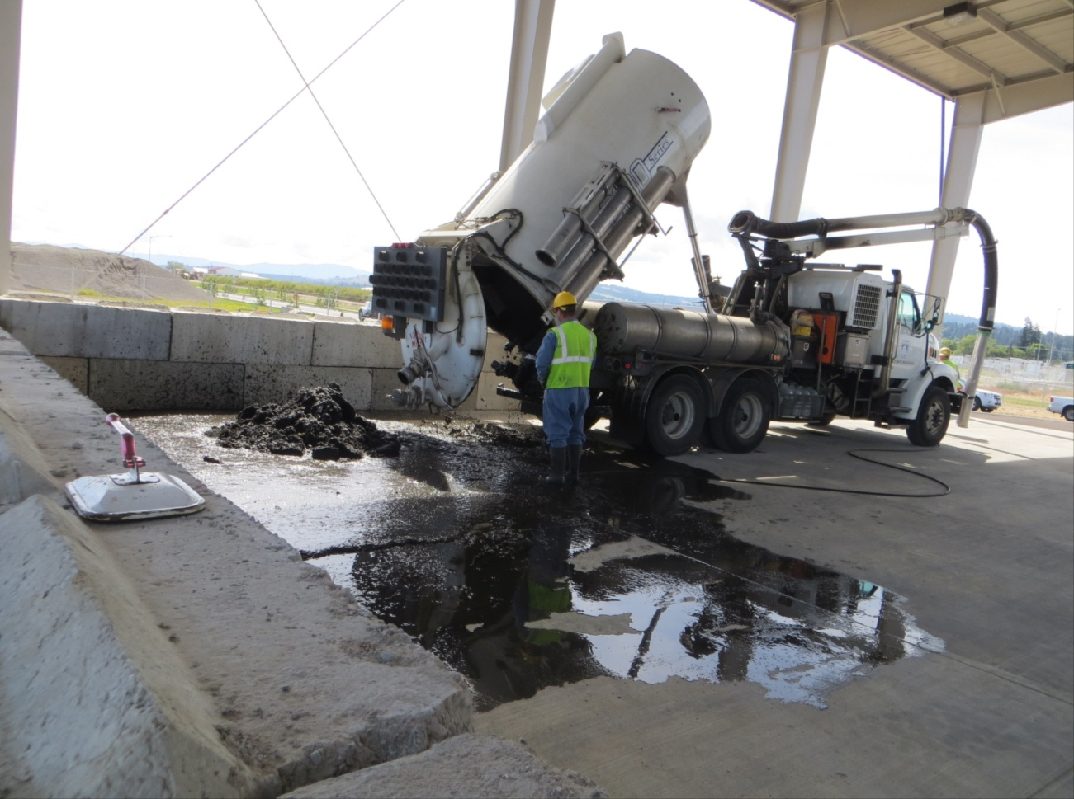
Fig-1 City of Spokane Decant Facility – vactor unloading

City of Spokane Valley/WSDOT Pines Decant Facility

The joint City of Spokane Valley –WSDOT facility is located at E. 12102 Montgomery Dr., adjacent to I-90, just west of the Pines Exit. The facility consists of an approximately 6,400 square-ft slab which allows decanted material to drain into an adjacent settling pool. Water from the settling pool is then directed to an oil-water separator, followed by a sand filter bed, and finally to a bio-infiltration pond. Stormwater exceeding the capacity of the bio-infiltration pond is directed to a drywell. There are plans to cover this facility in the future as well as potentially discharge decant-water to the sewer leading to the Spokane County Reclamation Facility.

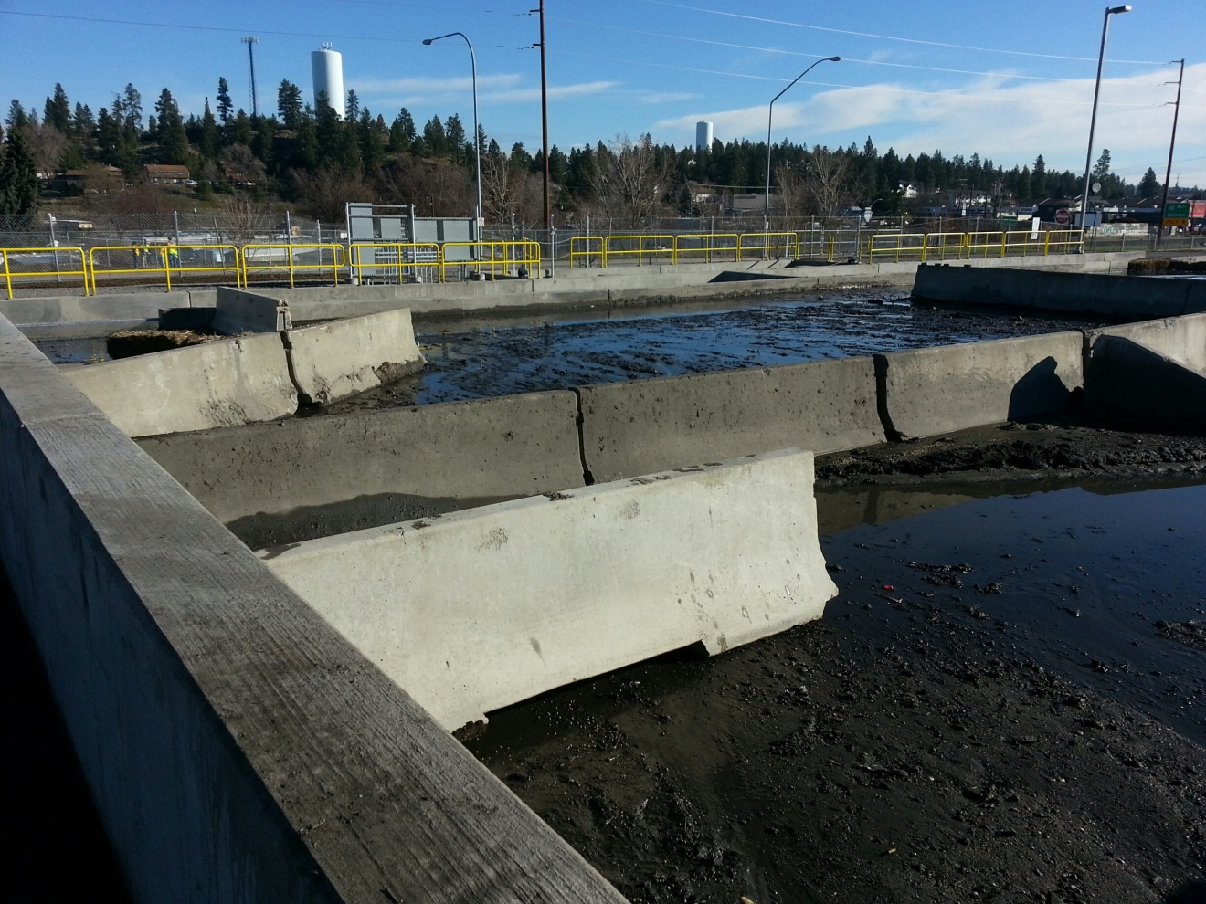
Fig-2 City of Spokane Valley/WSDOT facility

Spokane County Decant Facility

Construction is currently underway for the Spokane County Facility at 12807 N. Mayfair in North Spokane and is anticipated to be completed by mid-2015. The capacity of the facility will be similar to the Playfair location, with a 100-ft-by-200-ft covered concrete slab. Decanted liquid will be treated with an oil-water separator followed by a bio-swale and dry well. Testing of this facility was not included in this study .

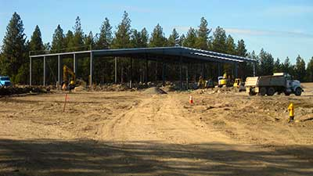
Fig-3 Spokane County Decant Facility – under construction

Project Overview

The primary goal of this project was to characterize the material at the regional decant facilities for PCBs. Additional analytes were tested to see if correlations existed with other parameters of concern. A QAPP was developed by City of Spokane staff which detailed how this would be accomplished.

Samples were taken on April 16th and April 17th, 2015 at the City of Spokane facility and on April 22nd and 23rd, 2015 at the DOT/Pines facility. All samples were taken by City of Spokane staff. PCB samples were analyzed by AXYS labs in British Columbia. Metals and total suspended solids were analyzed at the City of Spokane RPWRF Lab. pH and Temperature measurements were taken in the field. Sample locations and the associated analyses are summarized in Table 1.

Table 1: Sampling/Testing Overview

Sample Location | Sample Description | Analyte | Test Method
COS Evaporation Pond Influent | Liquid runoff from sediment at City of Spokane Facility – sampled from outfall leading to evaporation pond | PCB Congeners (209) | EPA 1668 C
 |  | Total Metals (As, Cd, Cr, Cu, Pb, Zn) | EPA 200.7
 |  | Total Suspended Solids | SM 2540 D
 |  | Temperature | --
 |  | pH | SM 4500 H+
COS Vactor Sediment | Sediment from City of Spokane Facility - sampled from pile | PCB Congeners (209) | Modified EPA 8270
DOT Liquid Runoff | Liquid runoff from sediment – sampled from settling pond | PCB Congeners (209) | EPA 1668 C
 |  | Total Metals (As, Cd, Cr, Cu, Pb, Zn) | EPA 200.7
 |  | Total Suspended Solids | SM 2540 D
 |  | Temperature | --
 |  | pH | SM 4500 H+
DOT Sand Filter-Treated liquid | Liquid – sampled from outfall of sand filter | PCB Congeners (209) | EPA 1668 C
 |  | Total Metals (As, Cd, Cr, Cu, Pb, Zn) | EPA 200.7
 |  | Total Suspended Solids | SM 2540 D
 |  | Temperature | --
 |  | pH | SM 4500 H+
DOT Vactor Sediment | Sediment - sampled from pile | PCB Congeners (209) | Modified EPA 8270

The funding for the PCB analyses was provided by SRRTTF. The Cost associated with sampling and testing of the other parameters was covered by the City of Spokane.

Results

City of Spokane - Playfair Facility

Analytical results for the City of Spokane facility are summarized in Table 2.

Table 2: City of Spokane Facility - Results Summary

SAMPLE | DATE | Total PCBs (pg/L, ppq) | Total PCBs (ug/kg, ppb) | Temp (˚C) | pH | TSS (mg/L)
COS Vactor Sediment | 4/16/2015 |  | 399
COS Vactor Sediment | 4/17/2015 |  | 11.9
COS Evaporation Pond Influent | 4/16/2015 | 25,257,519 |  | 10.2 | 7.07 | 7,740
COS Evaporation Pond Influent Dup | 4/16/2015 | 6,889,355 |  | 10.2 | 7.07 | 9,500
COS Evaporation Pond Influent | 4/17/2015 | 1,823,207 |  | 10.9 | 7.18 | 13,440

Table 2: Continued

SAMPLE | DATE | As (mg/L) | Cd (mg/L) | Cr (mg/L) | Cu (mg/L) | Pb (mg/L) | Zn (mg/L)
COS Vactor Sediment | 4/16/2015
COS Vactor Sediment | 4/17/2015
COS Evaporation Pond Influent | 4/16/2015 | 0.246 | <0.0020 | 0.339 | 0.816 | 0.447 | 4.55
COS Evaporation Pond Influent Dup | 4/16/2015 | 0.212 | 0.0021 | 0.296 | 0.696 | 0.409 | 4.03
COS Evaporation Pond Influent | 4/17/2015 | 0.429 | 0.0022 | 0.408 | 1.243 | 0.439 | 6.11
Note: Additional metals species were analyzed besides those indicated in the QAPP. This data is included in appendix A.

WSDOT/City of Spokane Valley – Pines Facility

Analytical Results for the DOT/Pines facility are summarized in table 3.

Table 3: Pines Facility – Results Summary

SAMPLE | DATE | Total PCB's (pg/L, ppq) | Total PCB's (ug/kg, ppb) | Temp ˚C | pH | TSS (mg/L)
DOT Vactor Sediment | 4/22/2015 |  | 5.00
DOT Vactor Sediment DUP | 4/22/2015 |  | 4.00
DOT Vactor Sediment | 4/23/2015 |  | 3.06
DOT Settling Pond | 4/22/2015 | 36,488 |  | 20.7 | 7.31 | 452
DOT Settling Pond DUP | 4/22/2015 |  |  | 20.7 | 7.31 | 391
DOT Settling Pond | 4/23/2015 | 103,939 |  | 15 | 6.9 | 1,365
DOT Sand Filter Effluent | 4/22/2015 | 842 |  | 17.7 | 7.49 | 7
DOT Sand Filter Effluent DUP | 4/22/2015 | 719 |  | 17.7 | 7.49 | 40
DOT Sand Filter Effluent | 4/23/2015 | 3,172 |  | 14.7 | 7.07 | 25.5

Table 3: Continued

SAMPLE | DATE | As (mg/L) | Cd (mg/L) | Cr (mg/L) | Cu (mg/L) | Pb (mg/L) | Zn (mg/L)
DOT Vactor Sediment | 4/22/2015
DOT Vactor Sediment DUP | 4/22/2015
DOT Vactor Sediment | 4/23/2015
DOT Settling Pond | 4/22/2015 | <0.025 | <0.002 | 0.025 | 0.093 | 0.050 | 0.58
DOT Settling Pond DUP | 4/22/2015 | <0.025 | <0.002 | 0.024 | 0.089 | 0.049 | 0.56
DOT Settling Pond | 4/23/2015 | 0.034 | 0.003 | 0.085 | 0.233 | 0.133 | 1.82
DOT Sand Filter Effluent | 4/22/2015 | <0.025 | <0.002 | <0.005 | 0.013 | <0.030 | 0.04
DOT Sand Filter Effluent DUP | 4/22/2015 | <0.025 | <0.002 | <0.005 | 0.012 | <0.030 | 0.03
DOT Sand Filter Effluent | 4/23/2015 | <0.025 | <0.002 | <0.005 | 0.017 | <0.030 | 0.07
Note: Additional metals species were analyzed besides those indicated in the QAPP. This data is included in appendix A.

Quality Control Data

Quality control data for PCBs are summarized in Table 4. Specific PCB QC issues are discussed below:

- The lab blank associated with the higher concentration liquid samples was above the acceptance criteria. However, the associated samples with this batch contained detections well above the range in the blank and did not significantly affect how the PCB totals were calculated. The only sample which required blank correction for this batch, as per the rule stipulated in the QAPP, was the 4/22/2015 DOT Settling pond sample (36,495 pg/L uncorrected versus 36,488 pg/L with the blank correction).
- The 4/22/2015 DOT Settling Pond Sample bottle was broken in the lab prior to the extraction process. Only half of the sample was saved so the full 1L could not be used for the extraction. Reporting limits do not appear to have been raised significantly compared to the 4/23/2015 sample from the same location.
- The RPD for most of the congeners in the 4/16/2015 COS Settling Pond sample and its duplicate were outside the QAPP criteria of less than 50% (for results greater than 10 times the EDL). This likely has to do with the dynamic, episodic, nature of how flow is diverted when a truck unloads vactor water.
- Due to an oversight/communication error, laboratory duplicates were not analyzed by the contract lab (as was indicated in the QAPP).

Table 4: PCB QC Results Summary

SAMPLE | QC Sample Result | QAPP Acceptance Criteria | Passed Acceptance Criteria?
COS Solids Equipment/Field Blank - Total PCBs | 29.0 pg/L | <5 ug/kg | yes
DOT Liquid Field Blank - Total PCBs | 26.1 pg/L | <200 pg/L | yes
Solids Lab Blank - Total PCBs | Non-Detect | <5 ug/kg | yes
Liquids Lab Blank 1 - Total PCBs | 136 pg/L | <200 pg/L | yes
Liquids Lab Blank 2 - Total PCBs | 306 pg/L | <200 pg/L | no
Solids LCS Recovery Range | 79.6-113.0% | 60-135% | yes
Liquids LCS Recovery Range | 89.3-112.0% | 60-130% | yes
Solids Surrogate Recovery Range | 43.3-111% | 40-130% | yes
Liquids Surrogate Recovery Range | 29.1-93.2% | 25-150% | yes
COS Evap. Pond Dup. RPD Range (for results >10x EDL) | 28.1-126.3% | <50% | no
DOT Sand Filter Dup. RPD Range (for results >10x EDL) | 0.9-25.3% | <50% | yes
DOT Vactor Sed. Dup. RPD Range (for results >10x EDL) | All <10x EDL | <50% | yes

All suspended solids results met the applicable QC requirements except for the DOT sand filter effluent and duplicate sampled on 4/22/2015 (RPD: 140%, 7 mg/L vs. 40 mg/L; criteria: <30%). All total metals QC results met the respective QAPP acceptance criteria. A field blank was not collected or analyzed for suspended solids or metals due to a communication error with the sampling staff.

Results Discussion

The sediment results for both the DOT and City of Spokane facility were found to be consistent with previous stormwater sediment testing conducted by the City. As can be seen in Table 2, the first sediment sample collected at the City of Spokane facility was significantly higher in PCBs than the one from the second day of sampling. The first sample is in the range of the previous PCB catch basin sampling conducted in the more industrial portion of the City. The second sample fell in line with what was found in the residential area sampling.

The DOT sediment samples were both lower in total PCBs than the City of Spokane samples. It is hard to say, given the limited amount of data, whether this always would be the case, and would likely depend more on where a given vactor truck is collecting catch basin material for that given day. Determining the origin of the sediment tested within the catch basin system was beyond the scope of this study.

Figure 4 shows a comparison between individual congeners in the sediment at each of the two facilities monitored. For comparison purposes, each congener is represented as a ratio of the individual concentration to the total PCB concentration for a given sample. The error bars represent ± 1 standard deviation. As can be seen in the graph, the City of Spokane sediment appears to be more heavily concentrated in the mid-weight congeners whereas the DOT samples appears to contain several lower and higher weight congeners that were not detected in the COS samples. PCB 11 was one of the lower weight congeners that was detected in the DOT samples that did not show up in the COS samples. PCB 11 is often associated with PCBs generated inadvertently through the production of chemicals such as yellow dye and is generally not found in arochlor formulations of PCBs.

Fig-4 Congener Comparison between DOT and COS Sediment Samples

Figure 5 is a similar comparison between the COS and DOT liquid samples. Congener distributions appear to generally match with the sediment samples for each of the two sampling locations. It should be noted that the coeluting congeners differ between the method used for the sediment samples and the liquid samples and thus a direct comparison between the two datasets is made more difficult. The congener pattern of the DOT sand filter also correlates well with DOT settling pond sampling, with perhaps a slight shift from some of the heavier weight congeners in the settling pond to more of the lighter weight congeners once the material passes through the sand filter.

Fig-5 Congener Comparison between DOT and COS Liquid Samples

Figures 6 and 7 compare the COS Evaporation Pond Influent and the DOT Settling Pond samples, respectively, to the best-fit combination of specific Arochlors. Arochlors were fit to the data by minimizing the sum of the square of residuals when comparing each congener in the sample to the corresponding weighted sum of the four most commonly found Arochlors (Arochlors 1242, 1248, 1254, and 1260). The COS sample appears to contain primarily Arochlor 1254 with a small amount of Arochlor 1260; the DOT sample includes all four Arochlors with Arochlors 1254 and 1260 being more pronounced. As was noted before, PCB-11 was not part of any of the original Arochlor formulations but appears to be significant in the DOT sample. Some of the higher weight congeners in the DOT sample also appear to be higher than what would be expected from the congener distribution of native Arochlor mixtures. The coeluting PCBs 110 and 115 appear to be significantly higher in both the COS and DOT samples than what would be expected from a combination of Arochlors.

Fig-6 COS Arochlor Composition

Fig-7 DOT Arochlor Composition

For the liquid samples tested, total PCB levels generally correlated well with total suspended solid concentrations (see: Fig-8). PCBs are predominately hydrophobic and typically adhere to the particulate material in a given waste stream so seeing this correlation would be expected. Similar correlations were found between total PCBs and the metals that were tested. This is likely more of a function of suspended solids content rather than a direct relationship between pollutants.

Fig-8 PCB/TSS Comparison. Note: Logarithmic-Scale

Conclusions

Based on the two days of sampling, the DOT facility demonstrated 98% removal of total PCBs when comparing the average in the DOT settling pond to the discharge from the sand filter. The DOT Facility sand filter effluent was shown to be lower in PCBs than what has been typically found during stormwater testing conducted by the City of Spokane. For example, PCBs in the Cochran Basin study showed stormwater to have an average PCB concentration of 7,300 pg/L whereas the average for the three sand filter samples was 1,580 pg/L. It is hard to predict the amount of PCBs that would be introduced to the Spokane River from this facility given the often complex interchange between the Aquifer and the River. Further PCB removal would probably be likely through infiltration, especially those PCBs contained in the remaining suspended solid material that was present after the sand filter.

The City of Spokane Playfair facility was designed to confine all PCB-containing material onsite through the use of the evaporation pond. The main potential for reintroduction of this material to the environment at this facility is through aerial re-suspension of sediment in the evaporation pond during dry periods as dust. Recommended best practices for this facility would include measures to ensure dust is kept at a minimum. This could include activities such as spraying down the evaporation pond with water to direct any sediment in the pond to a central location and routinely removing sediment from the pond to be taken to landfill with the rest of the catch-basin sediment.

Future studies involving stormwater/vactor sediment could include monitoring of the Spokane County facility to confirm the expectation that PCB levels would be similar at this location. Another project that has been suggested is to determine if additional filtration utilizing biochar, an activated carbon product, would be appropriate for PCB removal of vactor liquid runoff. The City of Spokane is currently conducting a pilot study to determine the effectiveness of biochar amended soil in storm gardens that have been built along Garland St. in North Spokane. The results of this study could likely be used to inform and supplement future studies involving biochar. Another idea that has been suggested was to take sediment core samples at the infiltration area of the DOT facility to see if PCBs are primarily accumulating in the top layer of soil or if migration of PCBs down into the aquifer is occurring.

Overall, the results of this study confirmed the presence of PCBs at levels of concern in catch-basin sediment at the DOT/Pines and City of Spokane Decant Facilities. However, treatment at both of these facilities appears to significantly reduce the amount of PCBs being discharged to the environment. Given the limited number of samples that were collected for this study, it should be emphasized that PCB levels may be significantly different at different times of the year and that the results should be considered, at best, semi-quantitative estimates. Given previous studies, the relative magnitude of the PCB results confirm what was generally expected at these sites. The Department of Transportation has been conducting additional sampling for PCBs and other pollutants at the Pines facility. At the time of writing this report, the results of this study were not yet available.

Appendix A: Additional Metals Testing Data

SAMPLE | DATE | Ag (mg/L) | Al (mg/L) | Ba (mg/L) | Be (mg/L) | Ca (mg/L) | Mg (mg/L)
COS Evaporation Pond Influent (Metals) | 4/16/2015 | <0.005 | 220 | 2.15 | 0.009 | 233 | 126
COS Evaporation Pond Influent Dup (Metals) | 4/16/2015 | <0.005 | 190 | 1.90 | 0.008 | 213 | 117
COS Evaporation Pond Influent (Metals) | 4/17/2015 | <0.005 | 272 | 2.55 | 0.012 | 255 | 133
DOT Settling Pond | 4/22/2015 | <0.005 | 15.5 | 0.495 | <0.002 | 90.9 | 58.1
DOT Settling Pond DUP | 4/22/2015 | <0.005 | 15.0 | 0.502 | <0.002 | 95.3 | 60.8
DOT Settling Pond | 4/23/2015 | <0.005 | 49.7 | 0.819 | <0.002 | 77.7 | 49.8
DOT Sand Filter Effluent | 4/22/2015 | <0.005 | 0.45 | 0.139 | <0.002 | 78.5 | 29.1
DOT Sand Filter Effluent DUP | 4/22/2015 | <0.005 | 0.45 | 0.135 | <0.002 | 76.1 | 28.3
DOT Sand Filter Effluent | 4/23/2015 | <0.005 | 0.99 | 0.243 | <0.002 | 107 | 52.9

SAMPLE | DATE | Mo (mg/L) | Ni (mg/L) | Sb (mg/L) | Se (mg/L) | Tl (mg/L) | V (mg/L)
COS Evaporation Pond Influent (Metals) | 4/16/2015 | <0.015 | 0.260 | <0.025 | <0.025 | 0.0395 | 0.607
COS Evaporation Pond Influent Dup (Metals) | 4/16/2015 | <0.015 | 0.228 | <0.025 | <0.025 | 0.0264 | 0.532
COS Evaporation Pond Influent (Metals) | 4/17/2015 | <0.015 | 0.319 | 0.036 | <0.025 | 0.0279 | 0.616
DOT Settling Pond | 4/22/2015 | 0.021 | 0.024 | <0.025 | <0.025 | <0.020 | 0.036
DOT Settling Pond DUP | 4/22/2015 | 0.022 | 0.024 | <0.025 | <0.025 | <0.020 | 0.034
DOT Settling Pond | 4/23/2015 | <0.015 | 0.057 | <0.025 | <0.025 | <0.020 | 0.102
DOT Sand Filter Effluent | 4/22/2015 | 0.018 | 0.006 | <0.025 | <0.025 | <0.020 | <0.005
DOT Sand Filter Effluent DUP | 4/22/2015 | 0.018 | 0.006 | <0.025 | <0.025 | <0.020 | <0.005
DOT Sand Filter Effluent | 4/23/2015 | 0.021 | 0.008 | <0.025 | <0.025 | <0.020 | <0.005

Appendix B: Original Data Reports – Electronic Files Attached

