ECOLOGO_W-C

***Draft – 3/29/16***

Quality Assurance Project Plan

Spokane River Atmospheric Deposition Study for PCBs

March 2016

Publication No. xx-03-1xx

**Publication Information**

Each study conducted by the Washington State Department of Ecology (Ecology) must have an approved Quality Assurance Project Plan. The plan describes the objectives of the study and the procedures to be followed to achieve those objectives. After completing the study, Ecology will post the final report of the study to the Internet.

This Quality Assurance Project Plan is available on Ecology’s website at <https://fortress.wa.gov/ecy/publications/SummaryPages/xx031xx.html>*(Jean Maust will add this.)*

Data for this project will be available on Ecology’s Environmental Information Management (EIM) website at [www.ecy.wa.gov/eim/index.htm](http://www.ecy.wa.gov/eim/index.htm). Search Study ID BERA0013.

Ecology’s Activity Tracker Code for this study is 16-032

**Author and Contact Information**

Brandee Era-Miller and Siana Wong

P.O. Box 47600

Environmental Assessment Program

Washington State Department of Ecology

Olympia, WA 98504-7710

Communications Consultant: phone 360-407-6834.

Washington State Department of Ecology – [www.ecy.wa.gov](http://www.ecy.wa.gov)

* + Headquarters, Lacey 360-407-6000
  + Northwest Regional Office, Bellevue 425-649-7000
  + Southwest Regional Office, Lacey 360-407-6300
  + Central Regional Office, Union Gap 509-575-2490
  + Eastern Regional Office, Spokane 509-329-3400

*Any use of product or firm names in this publication is for descriptive purposes only  
 and does not imply endorsement by the author or the Department of Ecology.*

*Accommodation Requests: To request ADA accommodation including materials in a format for the visually impaired, call Ecology at 360-407-6834. Persons with impaired hearing may call Washington Relay Service at 711. Persons with speech disability may call TTY at 877-833-6341.*

Quality Assurance Project Plan

Spokane River

Atmospheric Deposition Study for PCBs

March 2016

**Approved by:**

|  |  |
| --- | --- |
| Signature: | Date: |
| Adriane Borgias, Client, Water Quality Program, Eastern Regional Office |  |
|  |  |
| Signature: | Date: |
| David T. Knight, Client’s Unit Supervisor, WQP, Eastern Regional Office |  |
|  |  |
| Signature: | Date: |
| Jim Bellatty, Client’s Section Manager, WQP, Eastern Regional Office |  |
|  |  |
| Signature: | Date: |
| Brandee Era-Miller, Author / Project Manager, EAP |  |
|  |  |
| Signature: | Date: |
| Brandee Era-Miller, Author’s Acting Unit Supervisor, EAP |  |
|  |  |
| Signature: | Date: |
| Jessica Archer, Author’s Section Manager, EAP |  |
|  |  |
| Signature: | Date: |
| Thomas Mackie, Section Manager for Project Study Area, EAP |  |
|  |  |
| Signature: | Date: |
| Joel Bird, Director, Manchester Environmental Laboratory |  |
|  |  |
| Signature: | Date: |
| Bill Kammin, Ecology Quality Assurance Officer |  |

Signatures are not available on the Internet version.

EAP: Environmental Assessment Program

# 1.0 Title Page and Table of Contents

**Table of Contents**

Page

[1.0 Title Page and Table of Contents 2](#_Toc444080924)

[2.0 Abstract 7](#_Toc444080925)

[3.0 Background 8](#_Toc444080926)

[3.1 Study area and surroundings 8](#_Toc444080927)

[3.1.1 Logistical problems 9](#_Toc444080928)

[3.1.2 History of study area 10](#_Toc444080929)

[3.1.3 Parameters of interest 11](#_Toc444080930)

[3.1.4 Results of previous studies 11](#_Toc444080931)

[3.1.5 Regulatory criteria or standards 12](#_Toc444080932)

[4.0 Project Description 13](#_Toc444080933)

[4.1 Project goals 14](#_Toc444080934)

[4.2 Project objectives 14](#_Toc444080935)

[4.3 Information needed and sources 15](#_Toc444080936)

[4.4 Target population 15](#_Toc444080937)

[4.5 Study boundaries 16](#_Toc444080938)

[4.6 Tasks required 17](#_Toc444080939)

[4.7 Practical constraints 17](#_Toc444080940)

[4.8 Systematic planning process 18](#_Toc444080941)

[5.0 Organization and Schedule 19](#_Toc444080942)

[5.1 Key individuals and their responsibilities 19](#_Toc444080943)

[5.2 Special training and certifications 20](#_Toc444080944)

[5.3 Organization chart 20](#_Toc444080945)

[5.4 Project schedule 20](#_Toc444080946)

[5.5 Limitations on schedule 22](#_Toc444080947)

[5.6 Budget and funding 22](#_Toc444080948)

[6.0 Quality Objectives 23](#_Toc444080949)

[6.1 Decision Quality Objectives (DQOs) 23](#_Toc444080950)

[6.2 Measurement Quality Objectives 23](#_Toc444080951)

[6.2.1 Targets for Precision, Bias, and Sensitivity 23](#_Toc444080952)

[6.2.2 Targets for Comparability, Representativeness, and Completeness 24](#_Toc444080953)

[7.0 Sampling Process Design (Experimental Design) 25](#_Toc444080954)

[7.1 Study Design 25](#_Toc444080955)

[Bulk Atmospheric Deposition 25](#_Toc444080956)

[Dry Deposition 26](#_Toc444080957)

[Plume Dispersion Modeling 27](#_Toc444080958)

[Wind Rose 28](#_Toc444080959)

[Back Trajectories and Air Mass Residence Times 28](#_Toc444080960)

[7.1.1 Field measurements 28](#_Toc444080961)

[7.1.2 Sampling location and frequency 28](#_Toc444080962)

[7.1.3 Parameters to be determined 29](#_Toc444080963)

[7.2 Maps or diagram 29](#_Toc444080964)

[7.3 Assumptions underlying design 29](#_Toc444080965)

[7.4 Relation to objectives and site characteristics 30](#_Toc444080966)

[7.5 Characteristics of existing data 30](#_Toc444080967)

[8.0 Sampling Procedures 31](#_Toc444080968)

[8.1 Field measurement and field sampling SOPs 31](#_Toc444080969)

[Bulk Atmospheric Deposition Collection Procedure: 31](#_Toc444080970)

[Dry Deposition (PM10) Collection Procedure: 32](#_Toc444080971)

[8.2 Containers, preservation methods, holding times 32](#_Toc444080972)

[8.3 Invasive species evaluation 32](#_Toc444080973)

[8.4 Equipment decontamination 33](#_Toc444080974)

[8.5 Sample ID 33](#_Toc444080975)

[8.6 Chain-of-custody, if required 33](#_Toc444080976)

[8.7 Field log requirements 33](#_Toc444080977)

[8.8 Other activities 34](#_Toc444080978)

[9.0 Measurement Methods 35](#_Toc444080979)

[9.1 Field procedures table/field analysis table 35](#_Toc444080980)

[9.2 Lab procedures table 35](#_Toc444080981)

[9.2.1 Analyte 35](#_Toc444080982)

[9.2.2 Matrix 35](#_Toc444080983)

[9.2.3 Number of samples 36](#_Toc444080984)

[9.2.4 Expected range of results 36](#_Toc444080985)

[9.2.5 Analytical method 36](#_Toc444080986)

[9.2.6 Sensitivity/Method Detection Limit (MDL) 36](#_Toc444080987)

[9.3 Sample preparation method(s) 36](#_Toc444080988)

[9.4 Special method requirements 36](#_Toc444080989)

[9.5 Lab(s) accredited for method(s) 37](#_Toc444080990)

[10.0 Quality Control (QC) Procedures 38](#_Toc444080991)

[10.1 Table of field and lab QC required 38](#_Toc444080992)

[10.2 Corrective action processes 40](#_Toc444080993)

[11.0 Data Management Procedures 41](#_Toc444080994)

[11.1 Data recording/reporting requirements 41](#_Toc444080995)

[11.2 Laboratory data package requirements 41](#_Toc444080996)

[11.3 Electronic transfer requirements 41](#_Toc444080997)

[11.4 Acceptance criteria for existing data 41](#_Toc444080998)

[11.5 EIM/STORET data upload procedures 41](#_Toc444080999)

[12.0 Audits and Reports 42](#_Toc444081000)

[12.1 Number, frequency, type, and schedule of audits 42](#_Toc444081001)

[12.2 Responsible personnel 42](#_Toc444081002)

[12.3 Frequency and distribution of report 42](#_Toc444081003)

[12.4 Responsibility for reports 42](#_Toc444081004)

[13.0 Data Verification 43](#_Toc444081005)

[13.1 Field data verification, requirements, and responsibilities 43](#_Toc444081006)

[13.2 Lab data verification 43](#_Toc444081007)

[13.3 Validation requirements, if necessary 43](#_Toc444081008)

[14.0 Data Quality (Usability) Assessment 44](#_Toc444081009)

[14.1 Process for determining whether project objectives have been met 44](#_Toc444081010)

[14.2 Data analysis and presentation methods 44](#_Toc444081011)

[14.3 Treatment of non-detects 44](#_Toc444081012)

[Censoring for Method Blank Contamination 45](#_Toc444081013)

[Censoring for Tentatively Identified Analytes 45](#_Toc444081014)

[14.4 Sampling design evaluation 45](#_Toc444081015)

[14.5 Documentation of assessment 45](#_Toc444081016)

[15.0 References 46](#_Toc444081017)

[16.0 Figures 49](#_Toc444081018)

[17.0 Tables 50](#_Toc444081019)

[18.0 Appendices 51](#_Toc444081020)

[Appendix A. Historical Meteorological Data 52](#_Toc444081021)

[Appendix B. Glossaries, Acronyms, and Abbreviations 55](#_Toc444081022)

[Appendix C. Forms 63](#_Toc444081023)

**List of Figures and Tables**

Page

Figures

[Figure 1. Spokane River Basin. 9](#_Toc444081024)

[Figure 2. Map showing monitoring locations. 16](#_Toc444081025)

[Figure 3. Schematic of Bulk deposition sampler. 26](#_Toc444081026)

[Figure 4. PM10 Filter Sample. 27](#_Toc444081027)

Tables

[Table 1. Daily Total PCB Flux (ng/m2-day) in the Duwamish River Watershed, 2011-2013. 11](#_Toc444081028)

[Table 2. Daily Total PCB Flux (ng/m2-day) at Sites close to the Puget Sound, 2008-2009. 11](#_Toc444081029)

[Table 3. Collection and Analytical Methods for Bulk Atmospheric Deposition Studies in Western Washington and the upcoming Spokane River Study. 12](#_Toc444081030)

[Table 4. Specific Data Needs for the PCB Atmospheric Deposition Study. 15](#_Toc444081031)

[Table 5. Organization of project staff and responsibilities. 19](#_Toc444081032)

[Table 6. Proposed schedule for field work and data analysis. 21](#_Toc444081033)

[Table 7. Proposed schedule for completing field and laboratory work, data entry into EIM, and reports. 21](#_Toc444081034)

[Table 8. Project budget and funding. 22](#_Toc444081035)

[Table 9. Measurement Quality Objectives (MQOs) for PCB Congener Analysis. 23](#_Toc444081036)

[Table 10. Stations for the Spokane River Watershed PCBs in Atmospheric Deposition Study. 25](#_Toc444081037)

[Table 11. Wind Data Sources 28](#_Toc444081038)

[Table 12. Sample containers, preservation and holding times. 32](#_Toc444081039)

[Table 13. Laboratory Methods and Sample Information. 35](#_Toc444081040)

[Table 14. Field and Laboratory Quality Control Samples for the Project. 38](#_Toc444081041)

[Table 15. Quality Control Sample Collection Schedule for Bulk Deposition. 38](#_Toc444081042)

# 2.0 Abstract

There is currently a data gap for polychlorinated biphenyls (PCBs), and for toxics in general, regarding atmospheric deposition for eastern Washington. The only regional atmospheric deposition studies that exist for PCBs come from the Puget Sound region.

Filling this data gap is an important first step in determining the significance of the role that PCBs in atmospheric deposition play as a source of PCBs to the Spokane River Watershed and ultimately to concentrations found in the Spokane River.

This study will measure seasonal PCB flux concentrations in dry deposition and in bulk (wet + dry) deposition in the Spokane River Watershed. Dry deposition will be measured by analyzing PM10 (particulate matter ≤ 10 microns) from a high volume sampler located in an urban area of Spokane. Bulk deposition will be collected with passive samplers at two urban locations and at a regional background location. Samples will be analyzed with high resolution method EPA 1668c for PCB congeners. Sampling will commence in early 2016 with quarterly collection periods over the course of one year (through early 2017).

Secondary objectives to be addressed by this study include:

* Determining if the Spokane Waste to Energy Facility is a potential source of PCBs to atmospheric deposition by modeling PCB emission data using AERMOD, a plume dispersion model.
* Provide data for estimating the contribution of PCBs in bulk atmospheric deposition to stormwater in Spokane’s Cochran stormwater basin. The City of Spokane will be collecting PCBs in stormwater from the Cochran basin starting in spring of 2016.

# Background

The Spokane River is listed on the 303(d) List as water quality impaired for polychlorinated biphenyls (PCBs). The Department of Ecology (Ecology) first documented PCB contamination in the Spokane River in the early 1980s (Hopkins et al., 1985). Since that time, numerous studies and cleanup activities to address PCB contamination have been conducted and are ongoing in the Spokane River watershed (Serdar et al., 2011; LimnoTech, 2015). PCBs are currently being addressed through the efforts of the Spokane River Regional Toxics Task Force (SRRTTF).

PCBs have been studied in surface water, groundwater, sediment and fish as well as well as in anthropogenic inputs to the Spokane River such as stormwater and discharge from permitted facilities. However, a potentially large environmental matrix remains unstudied in the Spokane River Watershed. This environmental matrix is atmospheric deposition.

SRRTTF and Ecology’s Eastern Regional Office Water Quality Program (ERO-WQP) have requested a study be conducted to address this data gap for the Spokane River. This Quality Assurance Project Plan (QAPP) will describe a study to characterize atmospheric deposition of PCBs in the Spokane River Watershed.

Several recent Ecology documents have also highlighted the need for toxics atmospheric deposition data in the Spokane River, eastern Washington and the State at large. The Ecology documents include the Statewide PCB Chemical Action Plan (Davies, 2015) and internal technical memos on the State-of-the-Science of toxics in atmospheric deposition in Washington (Hobbs, 2015; Era-Miller, 2011).

## 3.1 Study area and surroundings

The Spokane River, shown in Figure 1, begins in Idaho at the outlet of Lake Coeur d’Alene and flows west 112 miles to the Columbia River. The Spokane River watershed encompasses over 6,000 square miles in Washington and Idaho (Serdar et al., 2011). The river originates in Lake Coeur d’Alene in Idaho then flows through the smaller cities of Coeur d’Alene and Post Falls before passing through large urban and industrial areas in the cities of Spokane Valley and Spokane in Washington. Other cities include Liberty Lake in Washington, Hayden Lake in Idaho as well as smaller communities upstream of Lake Coeur d’Alene.

The Spokane River watershed is located in a transition area between the barren scablands of the Columbia Basin to the west, coniferous forests and mountainous regions to the north and east, and prairie lands to the south.

Spokane receives an average of 16.5 inches of precipitation annually. Spokane is affected by the rain shadow from the Cascade Mountains and thus receives roughly half of what Seattle gets annually (36.2 inches). Temperatures in Spokane also tend to be more extreme compared to Western Washington with Spokane having warmer summers and colder winters. Much of the winter precipitation can fall as snow, particularly at higher elevations. See Appendix A for graphics showing average daily and monthly temperatures, rainfall and snowfall for Spokane. Detailed meteorological data for the Spokane area can also be accessed at the National Oceanic and Atmospheric Administration website (NOAA) website: <http://www.wrh.noaa.gov/mso/newrgl.php>.

The Spokane River sits atop the western portion of the Spokane Valley-Rathdrum Prairie Aquifer. There is significant interchange between the river and the aquifer. Spring snowmelt and rainfall dominate flows in the Spokane River from April through June, whereas most of the inputs to the river in July through September are from the aquifer.

The Spokane River is impacted by 7 major dams that create reservoirs behind them. From upstream to downstream they are: Post Falls Dam, Upriver Dam, Upper Falls Dam, Monroe Street Dam, Nine Mile Dam, Long Lake Dam and Little Falls Dam.

With the exception of Lake Coeur D’Alene and Lake Spokane, *direct* deposition of PCBs to the surface of the Spokane River is likely to be minimal due to the river’s small surface area relative to the basin area. PCBs delivered to Lake Coeur D’Alene from atmospheric inputs are accounted for in the PCB load at Stateline (Serdar, et al., 2011).

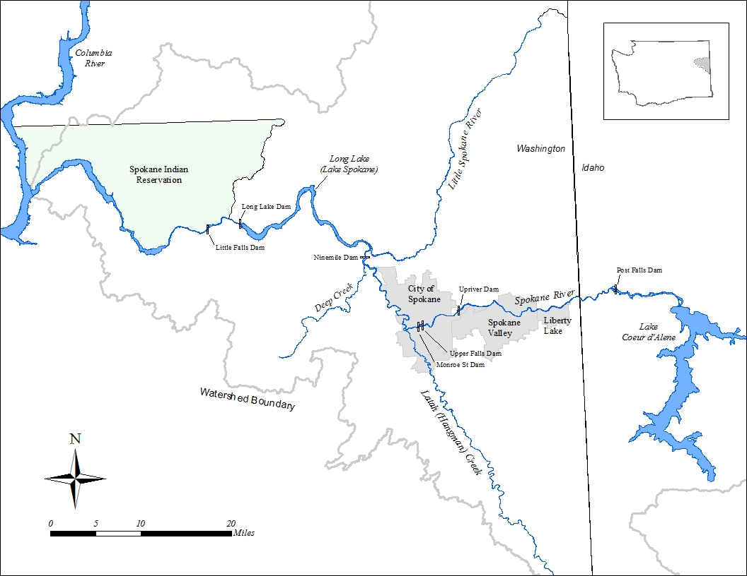

Figure 1. Spokane River Basin.

### 3.1.1 Logistical problems

General logistical problems for monitoring of PCBs in atmospheric deposition include:

* Chemical concentrations in atmospheric deposition can vary widely by physical location, even at the scale of several hundred feet. Characterizing this environmental variability could be challenging.
* Background concentrations of PCBs and cross contamination will need to be carefully accounted for due to the ubiquitous nature of PCBs.

Part of the project includes collecting bulk (dry + wet) atmospheric deposition in a passive device that will funnel precipitation into a sample container. Logistical problems for monitoring of PCBs in bulk deposition includes:

* Extreme hot and cold temperatures could affect water samples through evaporation or freezing. The sample containers will need to be insulated from extreme conditions and checked frequently.
* Seasonal differences in precipitation (wet deposition) volumes will need to be considered for sample collection. Collection containers will need to accommodate the potential for larger than average amounts of precipitation.
* The quality assurance and quality control (QA/QC) program for the project will have to be carefully conducted due to the heterogeneous nature of the rain/snow matrix for PCB analysis.
* Atmospheric deposition samplers will need to be outfitted to deter birds from landing on them.

### 3.1.2 History of study area

Ecology first documented PCB contamination in the Spokane River in the early 1980s (Hopkins et al., 1985). Since that time, Ecology has conducted numerous on-going studies and cleanup activities to address PCB contamination in the Spokane River watershed (Serdar et al., 2011; LimnoTech, 2015).

Ecology has identified that PCB loading due to atmospheric deposition is a significant data gap in the Spokane River Watershed (Hobbs, 2015; Era-Miller, 2011).

Spokane is the second largest city in Washington State. The combined population of the sister cities of Spokane, Spokane Valley and Liberty Lake is over 312,000 according to the 2014 census (US Census Bureau, 2015). As with any large metropolitan area, Spokane has many different types of land uses including urban, industrial, transportation, agricultural, residential, lakes, forests, parks and green spaces, all of which have varying potential to be sources of atmospheric PCBs to the Spokane River.

The Spokane Valley – Rathdrum Prairie Aquifer, which interchanges substantially with the river, provides drinking water to more than 500,000 people (MacInnis et al., 2009). Many people use the Spokane River for fishing, swimming, and boating. Numerous dams provide electricity and flood control.

The Spokane Tribe of Indians’ reservation borders the lower section of the river from Long Lake Dam down to the confluence with the Columbia River (Figure 1). This river has been an important source of food and ceremony for the Spokane Tribe for centuries.

### 3.1.3 Parameters of interest

The parameters of interest for this study are PCB congeners. PCBs can cause adverse health effects to humans and wildlife including cancer, and harm to immune, nervous, and reproductive systems. PCBs are persistent in the environment and bioaccumulate in people and animals (Davies, 2015). The Spokane River is listed on the 303(d) List as water quality impaired for PCBs based on elevated PCB concentrations in fish tissue.

### 3.1.4 Results of previous studies

Numerous studies have been conducted to characterize the extent of PCB contamination in the Spokane River (Serdar et al., 2011). Studies have included surface water, ground water, stormwater, effluent discharge, sediments and fish tissue. No studies currently exist for PCBs in atmospheric deposition in eastern Washington, but there have been a few studies in the Puget Sound region.

Tables 1 and 2 give concentrations of total PCBs in atmospheric flux samples collected in 2008-2009 as part of the Control of Toxic Chemicals in the Puget Sound project and in 2011-2013 as part of the lower Duwamish Waterway Source Control project (Ecology, 2010a; King County, 2015). Both studies measured bulk deposition (dry deposition + precipitation together) and presented the results as flux measurements. Flux can be defined as the rate of contaminant deposition, in this case it is expressed as nanograms of total PCBs per meter squared per day.

Table 1. Daily Total PCB Flux (ng/m2-day) in the Duwamish River Watershed, 2011-2013.1

|  |  |  |  |  |  |  |  |
| --- | --- | --- | --- | --- | --- | --- | --- |
| Landuse Type | Urban/  Residential | Industrial/  Urban | Urban/  Transportation | Urban/Commercial | | | Rural |
| Station | Beacon Hill | Duwamish | Georgetown | South Park | Kent | Kent SC | Enumclaw |
| Sample Size | 7 | 12 | 5 | 15 | 10 | 5 | 7 |
| Minimum | 2.25 | 2.87 | 9.68 | 4.61 | 0.91 | 1.40 | 0.35 |
| Maximum | 8.51 | 56.1 | 205 | 85.8 | 7.00 | 3.97 | 3.02 |
| Median | 4.99 | 9.65 | 67.9 | 18.0 | 4.35 | 1.99 | 0.75 |
| Mean | **4.98** | **16.2** | **80.0** | **20.6** | **3.87** | **2.48** | **1.12** |

1 = Colton, et al., 2015

Table 2. Daily Total PCB1 Flux (ng/m2-day) at Sites close to the Puget Sound, 2008-2009.2

|  |  |  |  |  |  |  |  |  |
| --- | --- | --- | --- | --- | --- | --- | --- | --- |
| Landuse Type | Rural/Sub-urban | | | | Rural/  Industrial | Industrial/Urban | | |
| Station | HC | NR | SB | PO | PB | WP | TCB | TM |
| Sample Size | 19 | | | | | | | 6 |
| Minimum | 0.04 | 0.05 | 0.03 | 0.05 | 0.12 | 0.05 | 0.23 | 0.05 |
| Maximum | 4.52 | 1.72 | 2.18 | 2.67 | 4.52 | 4.59 | 7.01 | 2.33 |
| Median | 0.24 | 0.64 | 0.32 | 0.39 | 0.40 | 0.57 | 1.81 | 0.45 |
| Mean | **0.76** | **0.87** | **0.78** | **0.75** | **1.05** | **1.02** | **2.54** | **0.85** |

1 = Sum of 21 congeners.

2 = Ecology, 2010b.

The Duwamish River Watershed study had higher mean flux concentrations (1.12 – 80.0 ng/m2-day) compared to the Puget Sound study (0.75 – 2.54 ng/m2-day). Part of the difference in flux rate between the studies was due to study design. Most of the monitoring stations in the Duwamish River Watershed study were located in the heart of heavily urbanized areas whereas the Puget Sound study stations where located in a mix of urban and rural areas and situated as close to the surface of the Puget Sound as possible. The objective of the Puget Sound study was to measure direct deposition to the surface of Puget Sound.

Other differences between these studies include how bulk atmospheric samples were collected, extracted and analyzed (Table 3). The Spokane River study will follow the same collection, extraction and analytical methods as the Duwamish River Watershed studies conducted by King County, except that collection periods for the Spokane River study will be longer at 3 months compared to ≤3 weeks.

Table 3. Collection and Analytical Methods for Bulk Atmospheric Deposition Studies in Western Washington and the upcoming Spokane River Study.

|  |  |  |  |  |  |
| --- | --- | --- | --- | --- | --- |
| Study | Collection Method | Collection Period | Extraction Method | Analytical Method | Number of Congeners reported |
| Puget Sound | Stainless funnel into extraction disks | 1 – 3 weeks | Onsite with SPE disk and Empore® C-18 media | GC/ECD | 21 |
| Duwamish River | Stainless funnel into sample container | 1 – 3 weeks | At laboratory as part of analytical method | EPA 1668c  (HRGC/HRMS) | 209 |
| Spokane River | Stainless funnel into sample container | 3 Months | At laboratory as part of analytical method | EPA 1668c  (HRGC/HRMS) | 209 |

EPA = Environmental Protection Agency

SPE = Solid Phase Extraction

GC/ECD = Gas Chromatography / Electron Capture Detection

HRGC/HRMS = High Resolution Gas Chromatography / High Resolution Mass Spectrometry

Also relevant to the Spokane River bulk atmospheric study is the finding that fine particulate (≤ 2.5 microns) concentrations and average temperature were found to be moderately strong predictors of PCB fluxes in the Duwamish River studies (King County, 2015).

### 3.1.5 Regulatory criteria or standards

This study will not compare PCB concentrations found in bulk atmospheric deposition to criteria as there are no regulatory criteria for PCBs in ambient air.

# Project Description

A large data gap exists for information about atmospheric deposition of PCBs in the Spokane River Watershed. This information is needed to gain a better understanding of the potential contribution of PCBs to the Spokane River as a result of atmospheric deposition. This project is intended to help answer the following questions:

* What are the atmospheric concentrations and fluxes of PCBs in Spokane and how do they compare to western Washington and to other urban areas?
* How does seasonality effect the atmospheric deposition of PCB in the Spokane River Watershed?
* Are permitted air sources such as the Spokane Waste-to-Energy Incinerator a significant contributor to PCBs in the Spokane River Watershed?
* How much of the PCB loading in urban stormwater from Spokane, comes from atmospheric sources? Can data from this project be used in concert with PCB data from the City of Spokane’s stormwater basin monitoring program to estimate this loading?

The Spokane River PCB Atmospheric Deposition project can be divided into two key components: 1) collection of atmospheric deposition samples for PCB congener analysis and flux calculation and 2) gathering of data for modeling of PCB dispersion from City of Spokane Waste-to-Energy Facility, correlation analysis of PCBs with other air quality parameters, and analysis of meteorological data for calculating air mass back trajectories and residence times.

PCB congener analysis will be conducted on both dry deposition and bulk deposition samples. Dry deposition can be defined as gaseous phase, particulate bound or as a sum of both and is what falls onto a surface during periods of dry weather. Particulate bound deposition will be collected “actively” with a high volume sampler at the Spokane Regional Clean Air Agency’s (SRCAA) Augusta Avenue air quality monitoring station. Particles of 10 microns (PM10) and smaller will be drawn into a filter at a known sampling rate. Dry mass on the filter will be analyzed for PCBs. Data on particles of 2.5 microns (PM2.5) and smaller is collected at all three monitoring locations that will be used for the Spokane River study. PCB flux data from the Spokane River study will be compared to the PM2.5 data to see if any correlations exist.

Wet deposition is the process of precipitation (rain, snow, and fog) scavenging gases and particulates from the air and then depositing onto a surface. Bulk deposition can then be defined as the total of both dry and wet deposition. Depending on a number of variables, either dry or wet deposition can be a more significant contributor to the overall flux (deposition rate) of chemicals to the earth’s surfaces. Bulk deposition for this study will be collected in “passive” samplers that will be deployed quarterly at several established air quality monitoring sites in and near the city of Spokane, including the Augusta Avenue site.

It’s important to make the distinction between *direct* and *indirect* atmospheric deposition to a waterbody such as the Spokane River. Direct atmospheric deposition is deposition directly to the surface of a waterbody. Indirect deposition is deposition to the land surface then conveyance to a waterbody (Hobbs, 2015). This conveyance generally happens during storms or other runoff events. For this project, dry and bulk deposition will be collected at monitoring locations associated more with land surface. PCB flux data will therefore be most applicable to *indirect* atmospheric deposition that is land-use specific.

## 4.1 Project goals

Project goals for the Spokane River PCB Atmospheric Deposition Study include:

* To obtain information about the atmospheric deposition of PCBs in the Spokane River Watershed. This will be the first such study in eastern Washington.
* To determine the range of seasonal bulk PCB flux rate (concentration per unit area over time) at two urban locations and at one regional background area of Spokane.
* To calculate the seasonal dry deposition flux of PCBs from PM10 high-volume filters from SRCAA’s Augusta Avenue monitoring station. Bulk deposition will also be collected here.
* Through the use of EPA’s plume dispersion model AERMOD, determine whether PCB emissions from the Spokane Waste-to-Energy incinerator are potentially a measurable contribution to the overall fluxes of PCBs in the Spokane River Watershed.
* Provide data for calculating the contribution of PCBs in bulk atmospheric deposition to stormwater in Spokane’s Cochran stormwater basin. The City of Spokane will be collecting PCBs in stormwater from the Cochran basin starting in spring of 2016 (City of Spokane, 2015)

## 4.2 Project objectives

Project objectives for the Spokane River PCB Atmospheric Deposition Study include:

* Collect bulk deposition samples and calculate fluxes of PCB congeners on a quarterly and annual basis for two urban locations and one regional background location in the Spokane River Watershed.
* Obtain filter samples from SRCAA and composite and analyze PCB congeners in PM10 (particulate matter ≤10 microns) in order to calculate PCB flux on quarterly and annual basis at the Augusta Avenue urban monitoring site.
* Conduct correlation analysis between PM2.5 (particulate matter ≤2.5 microns) and quarterly PCB bulk deposition flux data. Continuous PM2.5 data is collected at both urban monitoring stations (Monroe Street and Augusta Avenue). PM2.5 data is only collected at the regional background site (Cheney-Turnbull) on a periodic basis, but will be used when it is available.
* Model source emission data from the Spokane Waste to Energy Incinerator using EPA’s AERMOD plume dispersion model and local meteorological data to determine if the facility could be a potential source of PCBs to atmospheric deposition in Spokane.
* Create a wind rose for each bulk atmospheric monitoring location based on the availability of local and regional meteorological data. A wind rose is a diagram that shows the relative frequency of wind direction at a given location for a specific amount of time.
* Using modeled weather data from the University of Washington’s WRF (Weather Research and Forecasting) model, calculate air mass back-trajectories and air mass residence times. This will be helpful to understand potential PCB contributions from local and regional sources.

## 4.3 Information needed and sources

In order to create wind roses, back-trajectories of air masses, calculate air mass residence times and run the AERMOD plume dispersion model, several pieces of key information are needed. Data needs, sources, uses and contacts by expertise are shown in Table 4.

Table 4. Specific Data Needs for the PCB Atmospheric Deposition Study.

|  |  |  |  |
| --- | --- | --- | --- |
| Data | Source | Use | Assistance |
| Wind direction and speed | Augusta Ave. monitoring site | Wind Rose and AERMOD inputs | SRCAA |
| Meteorological data (cloud cover, solar radiation and vertical soundings) | Spokane Airport (NOAA location) | Feed into AERMOD | Ranil Dhammapala and AQP |
| PCB emissions data for Spokane Waste to Energy Facility | SRCAA | SRCAA |
| Plume/stack information | Permit (Facility Site) and Emissions Inventory | AQP |
| Meteorological data (modeled) | University of Washington 1.33km WRF Model | Back-trajectories and air mass residence time calculations | Clint Bowman, Ranil Dhammapala and AQP |
| Continuous PM2.5 | Augusta Ave. and Monroe St. monitoring sites | Correlation analysis between PM2.5 and PCB concentrations | SRCAA and AQP |

SRCAA = Spokane Regional Clean Air Agency

NOAA = National Oceanic and Atmospheric Administration

AQP = Ecology’s Air Quality Program

WRF = Weather Research and Forecasting

PM2.5 = Particulate Matter ≤2.5 microns

## 4.4 Target population

This study will target collection of PCB congeners in dry and bulk atmospheric deposition from urban and regional background monitoring locations in Spokane, Washington as quarterly seasonal samples over the course of 1 year of monitoring.

## 4.5 Study boundaries

The study will characterize PCB congeners in bulk atmospheric deposition in 2 urban locations (Augusta Ave. and Monroe St.) within the City of Spokane and at a regional background location situated in the Turnbull National Wildlife Refuge (Cheney-Turnbull NWR). See Figure 1 for the extent of the Spokane River Watershed boundary within Washington and Figure 2 for the monitoring locations for this study. Particle bound dry deposition will only be collected at the Augusta Ave. monitoring location.

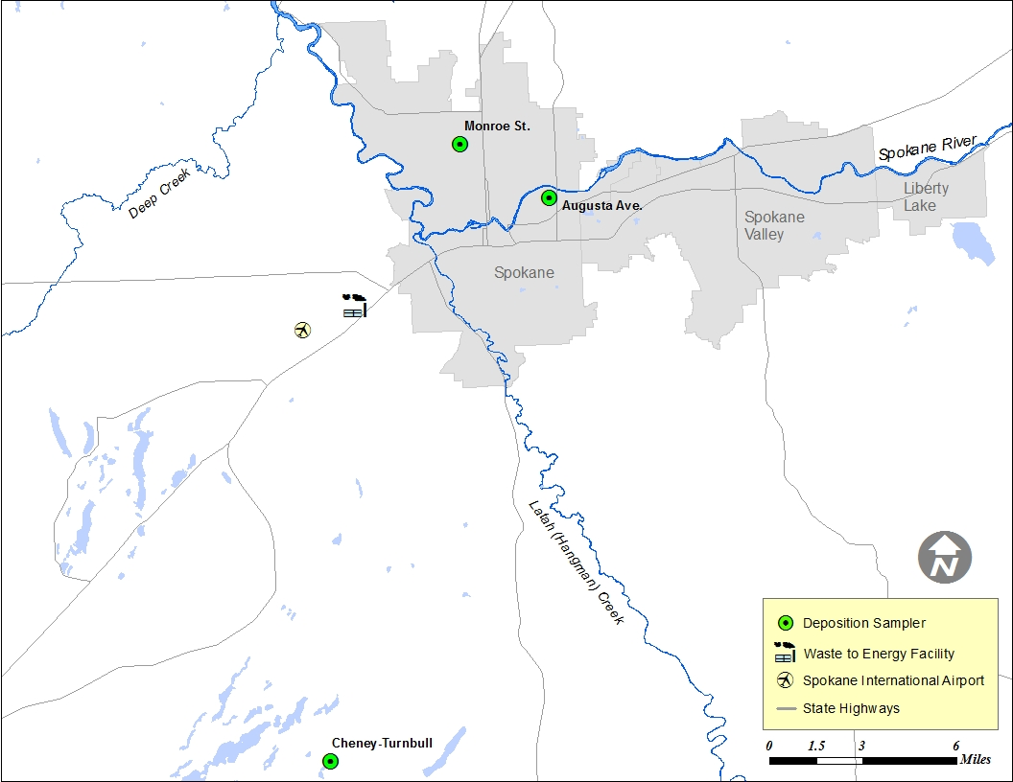

Figure 2. Map showing monitoring locations.

The Water Resource Inventory Area (WRIA) and 8-digit Hydrologic Unit Code (HUC) numbers for the study area are:

* WRIA 54
* HUC number 17010307

## 4.6 Tasks required

* Purchase of materials and fabrication of the bulk deposition samplers.
* Prepare all materials needed for sampling (e.g., decontamination of sampling equipment, bottles, labels, and paperwork).
* Submit a bid solicitation through Manchester Laboratory for analysis of PCB congeners to be conducted by a contract laboratory. The contract laboratory will be required to use a SB-Octyl column or equivalent.
* Hold meeting with the contract laboratory to discuss details of analysis and QA/QC plan for project samples and the preliminary PM10 laboratory study.
* Acquire PM10 archive filter samples from the Augusta Ave. monitoring station for preliminary laboratory study of the PM10 matrix.
* Meet the Ecology Air Quality Program (AQP) scientists’ Clint Bowman and Ranil Dhammapala to ensure that they write and run a script to receive data from the University of Washington’s WRF weather model during the project period.
* Meet with project technical advisor, Will Hobbs, and AQP scientist, Ranil Dhammapala to make sure all the necessary data is collected to run the plume dispersion model AERMOD and calculate air mass back trajectories and residence times.

## 4.7 Practical constraints

Substantial differences in PCB flux for bulk deposition samples can occur at small spatial scales. The Duwamish River studies showed significant differences in dioxin/furans in urban stations located 0.3 miles apart (King County, 2015). A field replicate sample for bulk deposition will be sampled at one monitoring station each sampling quarter for the Spokane River Study to describe variability at the site level.

Total rain amounts over the quarterly bulk deposition collection periods during the wet months have the potential to reach 10 inches (see Appendix A, figure A-3). Using a 30 cm (12 inch) diameter stainless steel bowl sampler with a 20 liter stainless steel sampling container will accommodate 10 inches of rain over a 3-month period (~ 19 liters). The King County studies used larger (45 cm) diameter bowl samplers during the dry months and smaller (23 cm) diameter bowls during the wet months, but they also had 1 – 3 week collection periods (King County, 2015).

Background contamination for PCB congeners using high resolution method EPA 1668c can be an issue for any environmental matrix. A significant portion of the laboratory budget for the Spokane River PCBs in Atmospheric Deposition study will be spent on field blanks, equipment blanks and other QA/QC samples to address this possible concern.

Accommodation for extreme weather conditions (i.e. snow, ice and hot temperatures) will be considered during design and construction of the bulk atmospheric deposition samplers. Heat tape will be used to melt snow and prevent freezing. Sample containers will be placed inside refrigerators during the deployment period to provide insulation.

The air quality monitoring stations used for this study are owned by either Ecology or SRCAA and are secure sites. Access to the stations outside of normal working hours may need to be considered for the project.

The project manager will need assistance from Ecology’s AQP to obtain data needed for running AERMOD (plume dispersion model), calculating air-mass residence times and creating wind roses.

## 4.8 Systematic planning process

This quality assurance project plan is sufficient systematic planning for the project.

# Organization and Schedule

## 5.1 Key individuals and their responsibilities

Table 5. Organization of project staff and responsibilities.

| Person | Title | Responsibilities |
| --- | --- | --- |
| Adriane Borgias  Water Quality Program  ERO  Phone: 509-329-3515 | EAP Client | Clarifies scope of the project. Provides internal review of the QAPP and approves the final QAPP. |
| Brandee Era-Miller  Toxics Studies Unit, SCS  Phone: 360-407-6771 | Project Manager and Acting Supervisor for the Toxics Studies Unit. | Writes the QAPP. Oversees field sampling and transportation of samples to the laboratory. Conducts QA review of data, analyzes and interprets data, and enters data into EIM. Writes the draft report and final report.  As acting unit supervisor, approves budget and final QAPP. |
| William Hobbs  Toxics Studies Unit, SCS  Phone: 360-407-7512 | Technical Advisor | Reviews QAPP and Report. Provides input on project development and data analysis and reporting. |
| Siana Wong  Toxics Studies Unit, SCS  Phone: 360-407-6432 | Field Assistant | Helps collect samples and records field information. |
| Dale Norton  Toxics Studies Unit, SCS  Phone: 360-407-6765 | Previous Unit Supervisor for the Project Manager | Provides internal review of the QAPP |
| Jessica Archer  SCS  Phone: 360-407-6596 | Section Manager for the Project Manager | Reviews the project scope and budget, tracks progress, reviews the draft QAPP, and approves the final QAPP. |
| Thomas Mackie  Eastern Operations Section  Phone: 509-457-7136 | Section Manager for the Study Area | Reviews the project scope and budget, tracks progress, reviews the draft QAPP, and approves the final QAPP. |
| Joel Bird  Manchester Environmental Laboratory  Phone: 360-871-8801 | Director | Reviews and approves the final QAPP. |
| Contract Laboratory | Project Manager | Reviews QAPP, coordinates with MEL QA Coordinator and Project Manager |
| Karin Feddersen  Phone: 360-871-8829 | MEL QA Coordinator | Helps project manager work with contract laboratory for contracting and conducts a QA review of data packages from the contract laboratory. |
| William R. Kammin  Phone: 360-407-6964 | Ecology Quality Assurance  Officer | Reviews and approves the draft QAPP and the final QAPP. |
| Ranil Dhammapala  Ecology AQP – Olympia  Phone: 360-407-6807 | Air Quality Scientist | Reviews QAPP and provides assistance with plume dispersion modeling and calculating air mass back trajectories and residence times. |
| Clint Bowman  Ecology AQP – Olympia  Phone: 360-407-6815 | Air Quality Scientist | Creates and runs a script to receive data from the University of Washington’s WRF weather model for the project duration. |
| Mark Rowe  SRCAA | Air Quality Scientist | Provides PM10 filter samples and conducts a weekly check on the bulk deposition sampler at the Augusta Avenue and Turnbull NWR sites. He is a general contact for SRCAA and provides air quality and other data related to these air quality monitoring stations. |
| Neil Hodgson  Ecology AQP - ERO  Eastern Regional Office  Phone: 509-329-3486 | Air Quality Scientist | Conducts a weekly check on the bulk deposition sampler at the Monroe Street site. He is the general contact for air quality and other data related to this station. |

AQP: Air Quality Program

EAP: Environmental Assessment Program

EIM: Environmental Information Management database

ERO: Eastern Regional Office

QAPP: Quality Assurance Project Plan

SCS: Statewide Coordination Section

SRCAA: Spokane Regional Clean Air Agency

## 5.2 Special training and certifications

The project lead, Brandee Era-Miller, has over 15 years of experience conducting toxics studies and writing reports for Ecology’s EAP Toxics Studies Unit.

Use of AERMOD, a steady-state plume dispersion model, for modeling potential impacts on atmospheric deposition from the Waste to Energy incinerator in Spokane will be conducted with assistance from Ecology’s AQP. The AQP scientists are trained in air quality modeling.

## 5.3 Organization chart

Not Applicable

## 5.4 Project schedule

Table 6 lays out the proposed schedule for field work and data analysis for the project. Table 7 shows the schedule for completion of the field and laboratory work, project data entry into EIM,   
and subsequent draft and final reports.

The preliminary laboratory study of PCBs in archive and blank PM10 filter samples will occur in early April 2016 in order to inform collection of PM10 filters. Bulk deposition sampling will occur on a quarterly basis for 1 year starting in mid-April 2016.

Some data preparation for the plume dispersion modeling (using AERMOD) can be conducted early on and throughout the project schedule as shown in Table 7. As results come in for the PCB laboratory analyses and electronic data become available from the various sources (UW WRF model, meteorological data, etc.) calculations can be made for quarterly bulk deposition fluxes, wind roses, air-mass residence time and PM2.5-PCB correlations.

Table 6. Proposed schedule for field work and data analysis.



Table 7. Proposed schedule for completing field and laboratory work, data entry into EIM,   
and reports.

|  |  |  |
| --- | --- | --- |
| Field and laboratory work | Due date | Lead staff |
| Field work completed | April 2017 | Brandee Era-Miller |
| Laboratory analyses completed | June 2017 | |
| Environmental Information System (EIM) database | |  |
| EIM Study ID | BERA0013 | |
| Product | Due date | Lead staff |
| EIM data loaded | October 2017 | Brandee Era-Miller |
| EIM data entry review | November 2017 | Siana Wong |
| EIM complete | December 2017 | Brandee Era-Miller |
| Final report | |  |
| Author lead / Support staff | Brandee Era-Miller / William Hobbs / Siana Wong | |
| Schedule | | |
| Draft due to supervisor | September 2017 | |
| Draft due to client/peer reviewer | October 2017 | |
| Draft due to external reviewer(s) | November 2017 | |
| Final (all reviews done) due to publications coordinator (Joan) | January 2018 | |
| Final report due on web | February 2018 | |

## 5.5 Limitations on schedule

The air quality monitoring stations used for this study are owned by either Ecology or SRCAA and are secure. Access to the stations outside of normal working hours may need to be considered for the project.

The project manager will utilize expertise from Ecology’s AQP to obtain data needed for running AERMOD (plume dispersion model), calculating air-mass residence times and creating wind roses. Availability of AQP staff could impact when this work is completed, however a formal request has been submitted for some of AQP staff time.

## 5.6 Budget and funding

The cost for the project is **$46,000** (Table 8). Five thousand has been allocated to cover materials and fabrication of the bulk atmospheric deposition samplers and the rest of the budget (41k) will cover contract laboratory analysis of PCB congeners in bulk deposition and PM10 composite filter samples.

Table 8. Project budget and funding.



1 = Manchester Laboratory 25% contracting and QA fee

# Quality Objectives

## 6.1 Decision Quality Objectives (DQOs)

A major quality objective for this project is to obtain data of sufficient quality to minimize uncertainty. A large number and variety of Quality Control / Quality Assurance (QA/QC) samples will be analyzed to help minimize uncertainty in sampling efficiency and background contamination. Details of the QA/QC sampling schedule is covered in *Section 10 – Quality Control Procedures* of this QA Project Plan.

The contract laboratory is expected to meet the measurement quality objectives (MQOs) commonly used for PCB congener analysis with EPA Method 1668c and as specified in this project plan. The MQOs that will be used for the project are shown in Table 9.

## 6.2 Measurement Quality Objectives

The MQOs shown in Table 9 are specific to analytical method EPA 1668c. These MQOs will be used for the both the dry and bulk deposition (aqueous) sample matrices. Rain and snow can be very heterogeneous or “noisy” matrices for chemical analysis (R. Grace, personal communication). With the potential exception of the dry season quarterly samples, it is likely that precipitation will constitute most the sample volume for the bulk deposition samples. The potential heterogeneous nature of the bulk deposition matrix and unknown heterogeneity of the PM10 dry deposition matrix could make meeting these MQOs a challenge.

Table 9. Measurement Quality Objectives (MQOs) for PCB Congener Analysis.

|  |  |  |  |
| --- | --- | --- | --- |
| Analytical Method | Lab Control Samples  (% Recovery) | Lab Duplicate Samples  (RPD) | Surrogate Recoveries  (% Recovery) |
| EPA 1668c | 50 – 150† | ≤50% | 25 – 150a |

† Per Method for Ongoing Precision and Recovery (OPR), internal standards, and labeled compounds

a labeled congeners

EPA: the Environmental Protection Agency

RPD: relative percent difference

### 6.2.1 Targets for Precision, Bias, and Sensitivity

#### 6.2.1.1 Precision

Precision is a measure of the variability in the results of replicate measurements due to random error. Precision for two replicate samples is measured as the relative percent difference (RPD) between the two results.

The PCB congener MQO for the precision of laboratory duplicate samples is ≤ 50% (Table 9). At least one field replicate for bulk atmospheric deposition sampling will also be conducted during each of the 4 sampling quarters. Matrix spike and matrix spike duplicate samples are not conducted for EPA 1668c since labeled surrogate compounds are analyzed with each sample.

#### 6.2.1.2 Bias

Bias is the difference between the population mean and the true value. For this project, bias is measured as acceptable % recovery. Acceptance limits for laboratory control samples (LCS), Ongoing Precision and Recovery (OPR), internal standards, labeled compounds, and surrogates are shown in Table 9.

#### 6.2.1.3 Sensitivity

Sensitivity is a measure of the capability of a method to detect a substance above the background noise of the analytical system. The laboratory reporting limits (RLs) for this project are described in *Section 9.2*.

### 6.2.2 Targets for Comparability, Representativeness, and Completeness

#### 6.2.2.1 Comparability

*Section 8.1* lists the standardized operating procedures (SOPs) to be followed for field sampling. All analytical methods used for the project are approved methods commonly used by Ecology, SRRTTF and other entities in the Spokane River watershed for monitoring of toxics.

#### 6.2.2.2 Representativeness

Bulk atmospheric deposition samples will be collected with passive samplers deployed for 3 months at a time over the course of 1 year. Bulk deposition will therefore be representative of an entire year’s deposition at the selected monitoring locations. Dry deposition is collected at the Augusta Ave. monitoring location every 6 days for 24 hours. Quarterly dry deposition samples will be composited from multiple samples to represent the same window of collection as the bulk deposition samples at Augusta Ave. One rotating field replicate for bulk deposition will be collected for each 4 sampling quarters. These replicate samples will help describe monitoring site variability and thus site representativeness.

#### 6.2.2.3 Completeness

The data for this project will be considered complete if 95% of the planned samples were collected and analyzed acceptably.

# Sampling Process Design (Experimental Design)

## 7.1 Study Design

### Bulk Atmospheric Deposition

Bulk atmospheric deposition will be collected from passive samplers on a quarterly basis (3 month deployment periods) for 1 year at 2 urban locations and at 1 regional background location in the Spokane River Watershed (Table 10). All 3 locations have established air quality monitoring stations that are run by either Ecology or SRCCA. Using established air quality monitoring sites has several important advantages:

* Security
* Power source
* Availability of other air quality (e.g., continuous PM2.5 and filter-based PM10) and meteorological data

Table 10. Stations for the Spokane River Watershed PCBs in Atmospheric Deposition Study.

|  |  |  |  |
| --- | --- | --- | --- |
| Station Name | Owner | Landuse Type | Deposition Collected |
| Augusta Avenue | SRCAA | Urban / industrial | Bulk and PM10 |
| Monroe Street | Ecology | Urban / residential | Bulk |
| Cheney-Turnbull NWR | SRCAA | Regional background | Bulk |

Bulk atmospheric samplers consist of 34 cm diameter brushed stainless steel bowls (with a 5 cm diameter hole in the bottom) that sit outside in the weather for a set deployment period and collect dry and wet deposition that falls on to them. A stainless steel funnel is spot welded to the bottom of the stainless steel bowl. The funnel is connected to the sampling container below with ½ inch Teflon® tubing. Silicone/vinyl pump tubing is used to connect the Teflon® tubing to the funnel. The Teflon® tubing will fit snug so that silicone/vinyl pump tubing should not come into contact the sample.

Sampling containers will consist of a 20 liter stainless steel canister with an intake and pressurized outlet. A 20 liter canister will be able to accommodate at least 8 inches of rain over the 3-month sampling period (8 inches = ~18 liters with a 34 cm diameter bowl). Collection canisters will reside inside of a refrigerator during the collection periods, insulating them from extreme cold and hot temperatures. Snow and freezing temperatures that could impact the ability of the samplers to continuously collect deposition will be addressed by placing heat tape around the funnel, Teflon tubing and sample containers as shown in figure 3.

The stainless steel bowl and funnel are supported on top of the refrigerator by a wooden structure. With the height of the refrigerator and wooden support structure combined, the bulk deposition sampler is approximately 6 feet off the ground. The stainless steel bowl and funnel design and the overall sampler height is similar to the bulk deposition samplers used for the Puget Sound and Duwamish River Studies (Ecology, 2010a; King County, 2015).

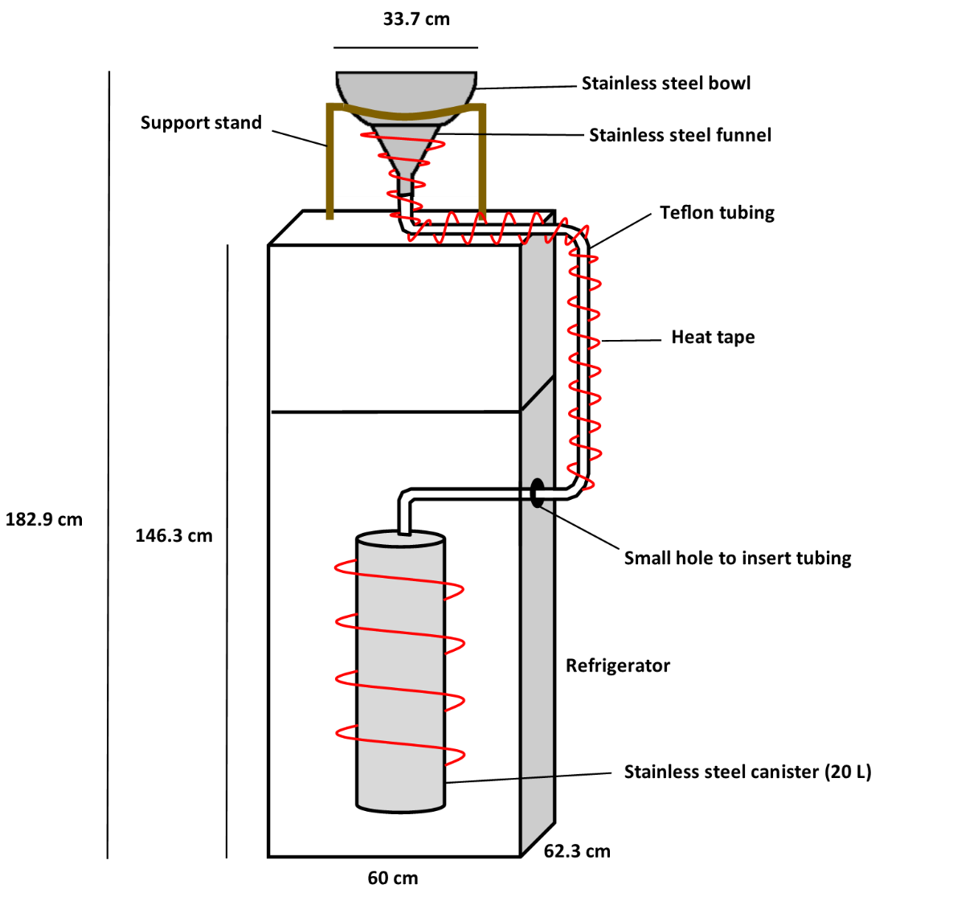

Figure 3. Schematic of Bulk deposition sampler.

Some type of bird deterrent will be used in the design of the bulk deposition samplers and may include spikes on the wooden structure supporting the bowl.

### Dry Deposition

Particle bound dry deposition will be collected by SRCAA at the Augusta Ave. (urban-industrial) monitoring station with a PM10 high volume sampler designed to collect ambient particulate matter with an aerodynamic diameter of 10 microns or less. SRCAA follows the procedures laid out by the Ecology Air Quality Program’s High Volume PM10 sampling procedures document (Rauh, 2003). PM10 high volume air samplers are constructed according to the guidelines outlined in 40 CFR appendix J to part 50 and designated as a federal reference method (FRM) sampler under designation number 0202-141. More information on the samplers can be found at: <https://tisch-env.com/high-volume-air-sampler/pm10>.

The PM10 sampler at the Augusta Ave. monitoring station runs for a 24 hour period every 6 days and SRCAA collects and archives a PM10 filter sample on an 8 x 10 inch high purity quartz microfiber filter every 6 days. The high volume sampler’s flow rate is 1.13 m3/min and with a sample run time of 24 hours, the total volume of air sampled is about 1,627 m3. The 24-hour average PM10 mass concentration for the Augusta Ave. monitoring station has had a mean value of 21 ug/m3 for the past five years. This comes out to approximately 0.03 grams of mass per filter on average (M. Rowe, personal communication).

Particulate matter will be composited from all the filters collected in the same 3 month deployment period as the bulk deposition sample collection. Since samples are collected every 6 days, this comes out to roughly 15 PM10 filters per quarter. A PM10 filter sample is shown in figure 4 (the dark area on the halved filter in the picture is from PM10).

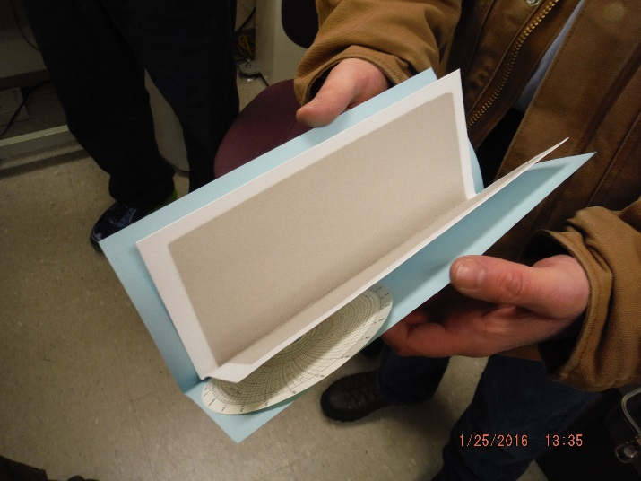

Figure 4. PM10 Filter Sample.

The contract laboratory conducting the bulk deposition PCB congener analysis will also perform analysis on the PM10. Compositing will be conducted by the lab. Prior to analysis of PM10 samples collected during the study period, the lab will perform a preliminary study on PM10 using archived PM10 filters from the Augusta Ave. monitoring station. This will help inform analysis of the study samples. The preliminary laboratory study will also include analysis of clean PM10 filters to characterize any background contamination in the collection and sampling process.

### Plume Dispersion Modeling

As part of a 2001 health risk assessment conducted for the City of Spokane’s Waste-to-Energy Facility (SWE), PCB emission levels from the facility were modeled to determine PCB flux in the local air shed that included the city of Spokane (PIONEER Technologies Corporation, 2001).

For the 2016 atmospheric deposition study, Ecology will use EPA’s plume dispersion model AERMOD to determine if SWE is a potential source of PCBs to atmospheric deposition in the Spokane River Watershed using the most recent (2013 – 2015) stack test PCB emission data from the facility. Any useful data from the modeling conducted for the earlier health risk assessment will be considered for use in conjunction with AERMOD.

More information on AERMOD is available on EPA’s website at:

<http://www3.epa.gov/scram001/dispersion_prefrec.htm>.

Parameters that are needed to run AERMOD are listed in *Section 4.3*, Table 4, of this QA Project Plan. Ecology’s AQP will assist with the modeling.

### Wind Rose

A wind rose is created with information on the direction, speed and frequency of wind in a given area. They depict the prevailing wind direction and speed during the sampling period. Wind roses will be created for each of the monitoring stations on a quarterly and annual basis. Only the Monroe St. station does not have on-site meteorological station, but wind data for creating a wind rose for Monroe St. can come from either the Spokane International Airport or from another nearby meteorological station (Table 11).

Table 11. Wind Data Sources

|  |  |
| --- | --- |
| Station Name | Wind Data Source |
| Augusta Avenue | Ecology internet site: <https://fortress.wa.gov/ecy/enviwa/StationInfo.aspx?ST_ID=120> |
| Monroe Street | Spokane International Airport (NOAA site): <http://www.wrh.noaa.gov/mesowest/getobext.php?wfo=mso&sid=KGEG&num=48&raw=0&dbn=m>  or other local weather station |
| Cheney-Turnbull NWR | NOAA RAWS: <http://www.wrh.noaa.gov/mesowest/getobext.php?wfo=mso&sid=TWRW1&num=48&raw=0&dbn=m> |

NOAA = National Ocean and Atmospheric Administration

RAWS = Remote Automatic Weather Stations

### Back-Trajectories and Air Mass Residence Times

Back trajectories and residence time calculations for the air masses moving over the study area during the project will be compiled with assistance from Ecology’s AQP using modeled data from the UW’s WRF model. Back-trajectories show the modeled path of air masses to the sample site and give an indication of whether sampled air masses passed through possible contaminant sources.

### 7.1.1 Field measurements

Supporting data will be collected during deployment and collection of the bulk atmospheric deposition samplers. Supporting data include date/time, any relevant QA/QC information such as the volume of lab reagent water used to rinse and clean dry deposition from the funnels into the sample collection containers. See Section 8 (*Sampling Procedures*) and Section 9 (*Measurement Methods*) of this QA Project Plan for more detail.

### 7.1.2 Sampling location and frequency

Bulk atmospheric deposition will be collected from passive samplers co-located at 2 urban air quality monitoring stations located within the City of Spokane and at a regional background air quality monitoring station situated in the Turnbull National Wildlife Refuge. See Figure 2 for these study locations. Passive samplers for bulk atmospheric deposition will be deployed seasonally for approximately 1 quarter (3 months) and collected quarterly for 1 year starting in April of 2016. The samplers will be checked by regional staff from Ecology and SRCAA on a weekly basis to ensure that equipment is functioning properly. The project manager or field lead will also provide periodic checks on the equipment as needed.

Both the urban and background air monitoring stations are established air quality monitoring stations used by Ecology and SRCAA and as such have a lot of current and historical air quality and meteorological data available. These locations also provide a secure environment for placing passive samplers.

PM10 filter samples are collected every 6 days for 24 hours at the Augusta Avenue air quality monitoring station. The samples are then archived. If the preliminary laboratory study of PCBs in historic PM10 filter samples from the Augusta Avenue station shows that PM10 samples are useful for detecting and quantifying PCBs, then filters archived during the bulk atmospheric deposition study period will be analyzed for PCBs. The PM10 filters will be composited and analyzed as quarterly samples.

### 7.1.3 Parameters to be determined

All 209 PCB congeners will be analyzed in bulk atmospheric deposition and composite PM10 filter samples with method EPA 1668c.

## 7.2 Maps or diagram

A map of the Spokane River watershed is shown in Figure 1. A map with the proposed sampling locations is shown in Figure 2. Bulk deposition samplers will be co-located with either Ecology-owned or SRCAA-owned air monitoring stations at 2 locations within the city limits of Spokane at 1) Monroe Street (Ecology) and 2) Augusta Avenue (SRCAA). A 3rd bulk sampler will be co-located at the air monitoring station at Turnbull National Wildlife Refuge (SRCAA) to represent regional background atmospheric conditions. PM10 filter samples will be taken from the Augusta Avenue station only.

## 7.3 Assumptions underlying design

This project will represent 1 year of atmospheric deposition data. Environmental conditions can vary significantly among seasons and years. It is important to realize the limitations of having only 1 years’ worth of monitoring data for any type of study. In addition, fluxes for bulk deposition data will be determined on a quarterly basis (3 months). As such, any potential individual spikes in atmospheric deposition concentrations like those created with one storm event, dust storm, or wild fire may be muted by the seasonal averaging period. There is also a chance that individual events could be missed entirely by PM10 collection, since it is only collected every 6 days.

Knowing that there can be high variability among atmospheric samples collected only short distances a part (e.g., several city blocks), there is an assumption that only 2 urban monitoring sites will be indicative of general urban PCB concentrations for the urban land use type in the Spokane River Watershed. This study is first study of its kind for eastern Washington, should the study results indicate that atmospheric deposition is an important source of PCBs to the Spokane River Watershed, future studies can cover any data gaps generated from this study.

There is an assumption that PCB concentrations in the bulk and dry atmospheric samples will be detectable above the analytical and sampling system background noise. Following sampling methods carefully, deploying clean techniques and analyzing sufficient QA/QC samples will ensure that useable data showing a clear environmental signal are generated from this study.

## 7.4 Relation to objectives and site characteristics

Not applicable.

## 7.5 Characteristics of existing data

There is a large data gap for PCBs and for toxics in general in atmospheric deposition for the eastern portion of Washington. Only studies conducted in King County and in the Puget Sound region have measured this (King County, 2013a; King County, 2015; Ecology, 2010a; Ecology 2010b). The Spokane River PCBs atmospheric deposition study will start to fill in this data gap and give useful data to source identification and control efforts for PCBs in the Spokane River Watershed.

# Sampling Procedures

## 8.1 Field measurement and field sampling SOPs

Ecology does not have a SOP for collection of bulk atmospheric deposition using passive samplers. The field sampling method that will be used for this study is an adaption of King County’s SOP for Air Deposition Sample Collection (KCEL, 2011). King County staff involved in the atmospheric deposition studies in Duwamish River watershed were also consulted in the development of the QA Project Plan for the Spokane River PCBs atmospheric deposition study.

### Bulk Atmospheric Deposition Collection Procedure:

Bulk atmospheric deposition samplers are passive samplers that will sit outside in the weather for 3 months and collect dry and wet deposition that falls on to them. The sampler set-up consists of a 34 cm (13 inch) diameter, 8 quart, stainless steel bowl with a 5 cm hole in the middle that is spot welded to a stainless steel funnel underneath. The funnel is connected to a sample container with Teflon® tubing. The sample container will be a 20-liter stainless steel canister.

At the time of collection, 500 mL of reagent water from the laboratory conducting the PCB congener analysis will be used to clean adhering debris on the sampler bowl with a natural bristle brush.  Sample volume will be determined by weighing the sample container at the laboratory and subtracting the weight of 500 mL of rinse water (500 grams) from the weight of the sample container.  The laboratory will predetermine sample container weights during their decontamination process.  Sample containers will also be batch proofed for PCBs by the laboratory each sampling quarter.

Samples will be homogenized at the laboratory and a 2-liter aliquot will be analyzed for each sample.  Whenever the total volume of the sample exceeds 4 liters, which is likely for most of the sampling periods, a second 2-liter aliquot sample will be analyzed from one of the samples to serve as a laboratory duplicate sample.  A 2-liter aliquot sample from each of the remaining samples will be archived in case additional analyses are needed. An equivalent percentage of the solvent rinse from the sample container will be divided evenly among each of the 2-liter samples.

The EAP decontamination SOP EAP090 – *Decontaminating Field Equipment for Sampling Toxics in the Environment* (Friese, 2014) will be used for decontamination of all collection items touching the samples. Items include the stainless steel bowl and funnel, Teflon tubing and natural bristle brushes used to clean adhering debris from the sampler.

Briefly, the decontamination procedure will include a hot water rinse, brushing with Liquinox soap, hot water rinse, rinse with deionized water, dry under clean fume hood, acetone rinse, dry again, hexane rinse, and finally dry again under fume hood. Once dry, collection items will then be covered with aluminum foil (dull side in) until deployment in the field. New scrubbing brushes will purchased for solely the project.

### Dry Deposition (PM10) Collection Procedure:

PM10 filters will be obtained from SRCAA from the August Ave. monitoring station. The particulate matter will be composited from all the filters collected in the same 3 month deployment period as the bulk deposition sample collection. Since samples are collected every 6 days, this comes out to roughly 15 PM10 filters per quarter.

The contract laboratory conducting the bulk deposition PCB congener analysis will also perform analysis on the PM10. Compositing will be conducted by the lab. They will perform a preliminary study on PM10 using archive PM10 filters from the Augusta Ave. monitoring station. This will help inform analysis of the study samples. The preliminary laboratory study will also include analysis of clean PM10 filters to characterize any background contamination in the collection and sampling process.

According to SRCAA an average of 0.03 grams of mass is available on each of their archived PM10 filters (M. Rowe, pers. commun). For 15 filters, the total composited PM10 mass comes out to 0.45 grams. This is a reasonable amount of dry mass for a laboratory to work with, though common method reporting limits are based on >1 gram (*see Table 13 in Section 9.2*).

## 8.2 Containers, preservation methods, holding times

Bulk deposition samples will be collected, stored, and transported in 20 liter stainless steel canisters. (Table 12).

Table 12. Sample containers, preservation and holding times.

|  |  |  |  |  |
| --- | --- | --- | --- | --- |
| Parameter | Matrix | Container | Preservation | Holding Time |
| PCB congeners | Bulk Deposition | 20 L canister | Cool to 6°C | 1 year |
| PCB congeners | Composited Dry mass from  PM10 Filters | Delivered to contract lab in individual archived packaging per FRM | Room temperature and enclosed in plastic bag after collection. | 1 year once extracted |

FRM = Federal Reference Method (see Rauh, 1993)

## 8.3 Invasive species evaluation

Field personnel for this project are required to be familiar with and follow the procedures described in SOP EAP070, *Minimizing the Spread of Invasive Species*. However, this study does not include sampling in any waterbodies, so spread of invasive species will be very minimal. The only potential transport would be through vehicles and foot travel on land.

## 8.4 Equipment decontamination

All of the sampling equipment that comes into contact with the samples will be need to be decontaminated. Decontamination procedures will follow Ecology’s SOP EAP090 – *Decontaminating Field Equipment for Sampling Toxics in the Environment* (Friese, 2014) and King County Environmental Laboratory’s SOP for Air Deposition Sample Collection (KCEL, 2011).

Before deployment, stainless steel funnels and Teflon® tubing will be cleaned with Liquinox soap and hot water, rinsed with deionized water and allowed to dry in a vented hood. This equipment will then be rinsed with pesticide-grade acetone, dried, rinsed with hexane and then dried again. The funnels and tubing will then be covered with clean aluminum foil (dull side in) until deployment in the field.

Proof of cleanliness for PCB congeners for the 20-liter canisters and 4-liter amber jugs will be required by the contract laboratory.

## 8.5 Sample ID

Sample numbers will be assigned by MEL by way of a work order number for each monitoring event. Sample numbers will follow chronologically after the work order number (e.g., 1501027 -1, 1501027 -2, etc.). Sample IDs will be assigned by the project manager for each sampling event prior to collection.

## 8.6 Chain-of-custody, if required

Chain of custody will be maintained for all samples throughout the project.

## 8.7 Field log requirements

Field data will be recorded in a bound, waterproof notebook on Rite in the Rain paper. Corrections will be made with single line strikethroughs, initials, and date. See Appendix C, table C-1 for example of field data sheet that will be used to record field data.

The following information will be recorded in the project field log:

* Name and location of project
* Field personnel
* Sequence of events
* Any changes or deviations from the QA Project Plan
* Environmental conditions
* Date, time, location, ID, and description of each sample
* Field measurements
* Identity of QC samples collected
* Unusual circumstances that might affect interpretation of results

## 8.8 Other activities

Not Applicable. Necessary activities are detailed in other sections of this QA Project Plan.

# Measurement Methods

## 9.1 Field procedures table/field analysis table

Field data will only be formally collected during deployment and retrieval of quarterly bulk atmospheric deposition samplers. See Appendix C, table C-1 for example of field data sheet.

## 9.2 Lab procedures table

Table 13 shows the laboratory procedures for method EPA 1668c and the matrices that will be analyzed for the study. The expected range of results for the bulk deposition samples are based on a review of the data from lower Duwamish Watershed deposition studies (King County, 2015). This data set had a wide range of concentrations with the highest concentration of 26,500 pg/L for coeluting congeners PCB-20/28. A wide range of concentrations is possible for the Spokane River study because of the inclusion of a regional background station (Cheney-Turnbull NWR) in addition to the highly urbanized stations.

The expected range of results for the PM10 samples is unknown and the numbers shown in table 13 are based on results from suspended sediments collected from the Spokane River in 2012 and 2013 (Era-Miller, 2014). Though the suspended sediment results were reported from the laboratory in dry weight, the sediments were submitted as wet samples. These samples also contained varying grain sizes. PM10 samples will be smaller grain size (< 10 microns) in general and submitted as dry samples.

Table 13. Laboratory Methods and Sample Information.

|  |  |  |  |  |  |  |
| --- | --- | --- | --- | --- | --- | --- |
| Matrix | UOM | Number of Samples | Number of QA Samples | Total Number of Samples | Expected Range of Results | Laboratory Reporting Limits |
| Bulk Deposition | pg/L | 16 | 13 | 29 | 0.5 - 30,000 per congener† | 1 |
| PM10 | pg per sample | 5 | 7 | 12 | 0.5 – 2,000 per congener | 4 |

† Based on results from the Duwamish River bulk deposition studies; maximum result is based on concentration of co-eluting congeners (King County, 2015).

\* Based on a 1 gram of sample

### 9.2.1 Analyte

PCB congeners (all 209 possible)

### 9.2.2 Matrix

* Bulk atmospheric deposition (dry + precipitation); water samples
* Dry deposition from composited PM10 filter samples; particulates less than 10 microns

### 9.2.3 Number of samples

See Table 13.

### 9.2.4 Expected range of results

See Table 13.

### 9.2.5 Analytical method

EPA 1668c – High Resolution Mass Spectrometry (HRMS) for PCB congeners

### 9.2.6 Sensitivity/Method Detection Limit (MDL)

The reporting limits shown in Table 13 are the estimated detection limits (EDLs) for method EPA 1668c in surface water (based on a 1 liter sample) and sediment (based on a 10 gram sample).

The composite PM10 filter samples will be only a fraction of a gram of solid material, which will effectively raise detection limits. However, preliminary analysis of archive PM10 filters will aid in determining if congeners can be detected in these samples, and if so, what detection limits might be for the composite PM10 filter matrix.

## 9.3 Sample preparation method(s)

The preparation and extraction methods for EPA 1668c are described in the analytical methods. Bulk deposition samples will be extracted and analyzed as a water sample. Dry deposition samples will be analyzed as a solid material (soil or sediment). The preparation methods of the contract laboratory under EPA 1668c will be appropriate for these matrices.

## 9.4 Special method requirements

Analysis of water and solid (sediment and soil) samples by method EPA 1668c should be routine for those contract laboratories accredited for this method, however, the bulk deposition (water matrix) and dry deposition (solid particulate matter) matrices could be somewhat heterogeneous and “noisy” matrices to analyze. The contract laboratory should be prepared to handle this reality. Good homogenization of samples and keeping archive samples for contingency will be followed by the project manager and contract laboratory.

The contract laboratory will need to provide proofed sample containers (20 liter), proofed solvent-soaked residue wipes (for sample removal efficiency), and labeled congener spiked samples for field spike blanks for the bulk deposition sample collection.

In addition, the contract laboratory will need to conduct a preliminary study on PM10 samples composited from archive samples and on clean PM10 filters to rule out potential background contamination from the filters.

## 9.5 Lab(s) accredited for method(s)

All laboratories for the project will be accredited, and all the analyses will be standard published methods.

# Quality Control (QC) Procedures

## 10.1 Table of field and lab QC required

With the exception of the method blank, all the laboratory QC samples shown in tables 14 and 15 have MQOs associated with them that are shown in table 9 of *Section 6.2*. The MQO criteria for the laboratory QC samples must be met to obtain useable data. Table 14 lists all the laboratory and field collection QC samples that will be analyzed for the entire project. Table 15 is a schedule of when QC samples will be collected for bulk deposition sampling.

Table 14. Field and Laboratory Quality Control Samples for the Project.

|  |  |  |  |  |  |  |  |  |  |  |
| --- | --- | --- | --- | --- | --- | --- | --- | --- | --- | --- |
| Matrix | Laboratory | | | | | Field and Sample Collection | | | | |
| Lab Control Sample | Surrogate Recoveries | OPR Analysis | Lab Duplicate (Split Sample) | Method Blank | Field Replicate | Wipe Sample | Field Spike | 20 Liter Proof | Equipment Blank |
| Bulk Deposition | 1/batch | all samples | 1/batch | 2/project | 1/batch | 1/batch | 3/project | 2/project | 2/project | 1/batch |
| PM10 | 1/batch | all samples | 1/batch | 2/project | 1/batch | NA | NA | NA | NA | 2/project |

Batch: One analytical batch that is conducted for each quarterly sampling event (4/year)

OPR: Ongoing Precision and Recovery, often referred to as a “blank spike”

NA: Not applicable; does not apply to the PM10 samples

Table 15. Quality Control Sample Collection Schedule for Bulk Deposition.

|  |  |  |  |  |  |
| --- | --- | --- | --- | --- | --- |
| QC Sample Type | Spring 2016 | Summer 2016 | Fall 2016 | Winter 2017 | Sample Total |
| Lab duplicate | 1 |  |  | 1 | 2 |
| Field replicate | 1 | 1 | 1 | 1 | 4 |
| Wipe sample | 1 | 1 | 1 |  | 3 |
| Field spike blank | 1 | 1 |  |  | 2 |
| 20 liter canister proof sample | 1 | 1 |  |  | 2 |
| Equipment blank | 1 | 1 | 1 | 1 | 4 |
| Total number of QC Samples | | | | | 17 |

The following are the definitions, purposes and possible outcomes for the field and sample collection QC samples listed in tables 14 and 15:

* **Lab duplicate –** Whenever the total volume of the bulk deposition sample exceeds 4 liters, which is likely for most of the sampling periods except the summer quarter, a second 2-liter aliquot sample will be analyzed from one of the samples to serve as a laboratory duplicate sample. Any additional sample volume left over after 4 liters is used for the sample and lab duplicate analyses will be archived.
* **Field wipe** – A solvent soaked wipe used to measure bulk deposition removal efficiency on the stainless steel sample funnels directly after sample collection in the field. The PCB mass on the wipe is compared to the PCB mass of the associated sample. The Duwamish River study found that only 0.1% of the mass measured in the associated sample was detected on the wipe meaning the funnel-cleaning protocol efficiency was almost 100% (King County, 2013b). However, this was only based on 1 field wipe sample.
* **Field spike** – Two field spikes will be deployed during the study in order to measure the potential loss of PCBs occurring from volatilization and other processes such as adhesion to the bulk deposition sample container during deployment. This will be done by spiking 10 liters of lab reagent water with labeled PCB compounds into a clean 20 liter canister and having it sit alongside the field samples during the collection period. The field spike sample will be treated as similarly to the field samples as possible in order to simulate field sample conditions.

The Duwamish River study determined that lighter weight congeners generally had a lower recovery than heavy weight congeners, but that average recovery was 85% suggesting that on a total PCB basis, there was only a small bias on PCB flux. This finding was based on the average of 2 spiked samples each spiked with 32 congeners (King County, 2013b). Being that deployment periods were 1 – 3 weeks in the Duwamish River study, it is likely that recoveries will be different for the Spokane study since deployment periods will be approximately 3 months.

* **Field replicate** – One replicate bulk deposition sampler will be deployed right next to 1 of the other samplers each quarter. The replicate sampler will be set up exactly the same as the other samplers and will move to a different location each quarter. The bulk deposition field replicate will account for the combined variability of both the sampling and analytical variability. The Duwamish River study found that total PCB fluxes were “moderately variable” with RPDs ranging from 12 – 68% for 3 replicate pairs (King County, 2013b). The field replicate sample for the PM10 samples will be a “split sample” where the sample will be split and extracted and analyzed as 2 separate samples, provided enough sample is attained.
* **Equipment blank** – After the bulk deposition collection equipment is decontaminated, the sample collection process will be simulated in the cleaning room at Ecology Headquarters in Lacey, Washington. Approximately 500 mL of laboratory reagent water will be used to scrub 1 of the stainless steel bowl samplers with a natural bristle brush. The reagent water will then go through Teflon® tubing and into the 20 liter canister. The equipment rinse sample will be refrigerated at Ecology Headquarters under chain of custody and later shipped with the field samples for analysis in the same batch. Equipment blank contamination in the samples from the Duwamish River studies ranged from 0.18 – 116% with a median of 3.5% in (King County, 2013b). The authors recommend more collection and analysis of equipment blanks to better characterize this variability.

Equipment blanks for PM10 will be the analysis of clean PM10 filters. Just 1 clean PM10 filter analysis is planned for the preliminary laboratory study and 1 for the field study.

* **20 liter canister proof sample –** After the 20 liter canisters are decontaminated for study use by the contract lab, they will run additional solvent through all the canisters, composite the solvent and analyze it for PCBs. This will provide an indication of any PCBs in the decontaminated canisters prior to sampling.

## 10.2 Corrective action processes

The laboratory analysts will document whether project data meet method QC criteria. Any departures from normal analytical methods will be documented by the laboratory and described in the data package from the laboratory and also in the draft and final reports for the project.

As described in the *Sampling Procedures* for bulk deposition, whenever the total volume of the bulk deposition sample exceeds 4 liters, additional 2-liter aliquot samples will be used for laboratory duplicate analysis and for archive in case additional analyses are needed. The same applies to PM10 samples if any material remains after sample and QA/QC analysis.

# Data Management Procedures

## 11.1 Data recording/reporting requirements

Field data will be recorded in a bound, waterproof notebook on Rite in the Rain paper. Corrections will be made with single line strikethroughs, initials, and date. Data will be transferred to Microsoft Excel for creating data tables and figures and for basic statistical analysis. A copy of the field data sheet that will be used for bulk atmospheric sample deployment and collection is included in Appendix C, table C-1.

## 11.2 Laboratory data package requirements

The data deliverables required by the contract laboratory will be detailed in the bid solicitation for the contract laboratory work. This bid solicitation will be written by MEL in consultation with the project manager.

## 11.3 Electronic transfer requirements

The contract laboratory will be required to have an EDD (electronic data deliverable) that is compatible with EIM data requirements and that will meet the requirements of this project. These requirements will be detailed in the bid solicitation for the contract laboratory work.

## 11.4 Acceptance criteria for existing data

All existing data are stored in EIM and as such are acceptable for use as described under the data quality descriptions in EIM.

## 11.5 EIM/STORET data upload procedures

All completed project data will be entered into Ecology’s EIM database for availability to the public and interested parties. Data entered into EIM follow a formal data review process where data are reviewed by the project manager, the person entering the data, and an independent reviewer.

EIM can be accessed on Ecology’s website at http://www.ecy.wa.gov/eim/index.htm. The project will be searchable under Study ID BERA0013.

# Audits and Reports

## 12.1 Number, frequency, type, and schedule of audits

The laboratories contracted through MEL and Ecology are also routinely audited as part of their internal procedures and as part of their accreditation.

## 12.2 Responsible personnel

The Quality Assurance Coordinator for MEL, Karin Feddersen, and the project manager will be responsible for review of the contract laboratory data packages.

## 12.3 Frequency and distribution of report

A report will be written after all the data from this year-long project are received and finalized.

Once the draft report is reviewed by the client for the project, Ecology Eastern Regional Office Water Quality Program (ERO WQP), it will be sent to the Spokane River Regional Toxics Task Force (SRRTTF) and Spokane Tribe of Indians for their reviews.

## 12.4 Responsibility for reports

Brandee Era-Miller, project manager and principal investigator, will write a final report as lead author for the Spokane Atmospheric PCBs study. Siana Wong, field assistant, and William Hobbs, technical advisor, will contribute to the draft and final reports as well.

# Data Verification

## 13.1 Field data verification, requirements, and responsibilities

Data verification for all field-generated data will be conducted by the project manager and field assistant.

## 13.2 Lab data verification

Data verification for the contract laboratory data will be conducted by the project manager and Karin Feddersen, the Quality Assurance Coordinator at MEL.

## 13.3 Validation requirements, if necessary

Third party data validation will not be required for this project.

# Data Quality (Usability) Assessment

## 14.1 Process for determining whether project objectives have been met

The project manager will determine if the project data are useable by assessing whether the data have met the MQOs outlined in Table 9. Based on this assessment, the data will either be accepted, accepted with appropriate qualifications, or rejected and re-analysis considered.

## 14.2 Data analysis and presentation methods

In order to standardize results so that they can be compared among sites and to data collected in other studies, PCB concentrations in bulk deposition samples will be converted to flux. The equation used to convert PCB concentrations to flux is:

*Concentration (ug/L) x (Precipitation volume (L) + Sample rinse volume (L)) / Funnel area (m2) / Deployment duration (days) = Flux (ug/m2-day)*

Basic statistical analyses such as correlation coefficients, mean/max/min/median value calculations and the creating box and whisker plots will be conducted using Microsoft Excel (Microsoft, 2007)

## 14.3 Treatment of non-detects

Non-detected data (data with a “U” or “UJ” flag designated by the lab) will not be used for summation of PCB homologue groups or total values.

For summing of totals, non-detected results will be assigned a value of zero. If only non-detected results comprise a total value, then the final total result was simply reported as “ND” for not detected. Sample totals will be assigned a qualifier of “J” (estimated) if more than 10% of the result concentrations are composed of results containing “J” qualifiers.

**Data Qualifier Definitions**

U The analyte was not detected at or above the reported sample quantitation limit.

UJ The analyte was not detected at or above the reported sample quantitation limit. However, the reported quantitation limit is approximate and may or may not represent the actual limit of quantitation necessary to accurately measure the analyte in the sample.

J The analyte was positively identified; the associated numerical value is the approximate

concentration of the analyte in the sample.

NJ The analyte has been “tentatively identified” and the associated numerical value represents its approximate concentration.

ND Not Detected.

### Censoring for Method Blank Contamination

Individual PCB congener results will be reported twice using 2 different censoring methods for blank contamination using the laboratory method blank conducted for each batch of samples:

1. A congener will be considered as a non-detect (“U” or “UJ”) if the concentration is less than 3 times the concentration of the associated laboratory method blank.
2. A congener will be considered as a non-detect (“U” or “UJ”) if the concentration is less than 10 times the concentration of the associated laboratory method blank.

The result values (qualified as non-detects) will then be reported at the estimated quantitation limit (EQL) or at the level of detection, whichever is higher.

### 

### Censoring for Tentatively Identified Analytes

Results that do not meet the isotopic abundance ratio and retention time criteria for positive identification will be qualified by MEL with an “NJ” and considered to be tentatively identified. For reporting purposes, the project manager will report all “NJ” qualified data. This follows the quality assurance protocols set by SRRTTF (Limnotech, 2014).

## 14.4 Sampling design evaluation

Sampling and collection methods for the project are designed to be time-integrated such that quarterly seasonal total fluxes and an annual total flux can be determined for all of the air monitoring study locations. If the project as currently designed yields acceptable data, then the data can be used to generally characterize PCB flux data for urban and regional background landuse types in the Spokane River Watershed.

## 14.5 Documentation of assessment

This will occur in the final report.

# References

City of Spokane, 2015. Draft Quality Assurance Project Plan – Cochran Basin DO TMDL Stormwater Sampling. Prepared by the City of Spokane Wastewater Management for the Department of Ecology Water Quality Program, Spokane WA.

Colton, Jenée. 2015. King County Water and Land Resources Division. Seattle, Washington. Personal Communication.

Davies, H. 2015. PCB Chemical Action Plan. Washington State Department of Ecology, Olympia, WA. Publication No. 15-07-002. <https://fortress.wa.gov/ecy/publications/documents/1507002.pdf>

Ecology, 2010a. Control of Toxic Chemicals in Puget Sound, Phase 3: Study of Atmospheric Deposition of Air Toxics to the Surface of Puget Sound. Prepared for the Washington State Department of Ecology, Olympia, WA. Publication No. 10-02-012.

<https://fortress.wa.gov/ecy/publications/SummaryPages/1002012.html>

Ecology, 2010b. Appendix G - Study of Atmospheric Deposition of Air Toxics to the Surface of Puget Sound, PCB Atmospheric Deposition Rates and Loads. Prepared for the Washington State Department of Ecology, Olympia, WA. Publication No. 10-02-012appendixg. <https://fortress.wa.gov/ecy/publications/SummaryPages/1002012appendixg.html>

Era-Miller, B. 2011. Technical Memo: Toxics Atmospheric Deposition in Eastern Washington State – Literature Review. Prepared for Elaine Snouwaert, November 15, 2011. Project Code 10-124. 29 p.

Era-Miller, B. 2014. Technical Memo: Spokane River Toxics Sampling 2012-2013 – Surface Water, C.L.A.M. and Sediment Trap Results. Washington State Department of Ecology, Olympia, WA. EAP internal tracker code: 12-027.

Friese, M., 2014. Standard Operating Procedure for Decontaminating Field Equipment for Sampling Toxics in the Environment. Washington State Department of Ecology, Olympia, WA. SOP Number EAP090. [www.ecy.wa.gov/programs/eap/quality.html](http://www.ecy.wa.gov/programs/eap/quality.html)

Grace, Richard. 2015. AXYS Laboratory. Personal Communication.

Hobbs, W. 2015. Technical Memo: Statewide Atmospheric Deposition Review and Scoping Study. Prepared for Cheryl Niemi, Susan Braley, and Melissa Gildersleeve – Water Quality Program, July 29, 2015. Project Code 15-041. 52 p.

Hopkins, B., D. Clark, M. Schlender, and M. Stinson, 1985. Basic Water Monitoring Program Fish Tissue and Sediment Sampling for 1984. Washington State Department of Ecology, Olympia, WA. Publication No. 85-7. <https://fortress.wa.gov/ecy/publications/summarypages/857.html>

KCEL, 2011. Standard Operating Procedure for Air Deposition Sample Collection. King County Environmental Laboratory. Seattle, Washington. SOP # 243v0.

King County, 2013a. Estimating PCB and PBDE loadings to the Lake Washington watershed: data report. Prepared by Richard Jack and Jenée Colton, Water and Land Resources Division, Seattle, Washington, for US EPA Region 10.

King County, 2013b. Lower Duwamish Waterway Source Control: Bulk Atmospheric Deposition Study Data Report. Prepared by Jenée Colton, Carly Greyell and Richard Jack. King County Department of Natural Resources and Parks, Water and Land Resources Division, Science Section. Seattle, Washington.

King County. 2015. Lower Duwamish Waterway Source Control: Supplemental Bulk Atmospheric Deposition Study Final Data Report. Prepared by Jenée Colton, Martin Grassley, and Richard Jack. King County Department of Natural Resources and Parks, Water and Land Resources Division, Science and Technical Support Section. Seattle, Washington.

Kruger, Robert. 2015. King County Environmental Laboratory. Seattle, Washington. Personal Communication.

LimnoTech, 2014. Quality Assurance Project Plan – Spokane River Toxics Reduction Strategy Study. Prepared for the Spokane River Regional Toxics Task Force. Approved by SRRTTF: July 23, 2014.

LimnoTech, 2015. Spokane River Regional Toxics Task Force Phase 2 Technical Activities

Report: Identification of Potential Unmonitored Dry Weather Sources of PCBs to the

Spokane River. Prepared for Spokane River Regional Toxics Task Force, Spokane WA.

August, 2015.

MacInnis, J., B. Lackaff, R. Beose, G. Stevens, S. King, and R. Lindsay, 2009. The Spokane Valley-Rathdrum Prairie Aquifer Atlas 2009 Update. Spokane Washington, City of Spokane.

Microsoft, 2007. Microsoft Office XP Professional, Version 10.0. Microsoft Corporation.

PIONEER Technologies Corporation. 2001. Final Spokane Waste-To-Energy Facility Human Health Risk Assessment. Report submitted to the City of Spokane – Spokane Technical Oversight Committee. Chapter 2 (air quality model & emission rate & deposition data).

Rauh, Stan. 1993. High Volume PM10 Volumetric Flow Controlled Procedures. Washington State Department of Ecology, Air Quality Program, Olympia WA. Publication No. 95-201D.

Rowe, Mark. 2016. Spokane Regional Clean Air Agency. Spokane, Washington. Personal Communication.

Serdar, D., B. Lubliner, A. Johnson, and D. Norton, 2011. Spokane River PCB Source Assessment, 2003-2007. Washington State Department of Ecology, Olympia, WA. Publication No. 11-03-013. <https://fortress.wa.gov/ecy/publications/summarypages/1103013.html>.

US Census Bureau, 2015. State and County Quick Facts. Population Estimates for 2014. Accessed November 25, 2015. <http://quickfacts.census.gov/qfd/states/53/5367000.html>.

# Figures

The figures in this QAPP are inserted after they’re first mentioned in the text.

# Tables

The tables in this QAPP are inserted after they’re first mentioned in the text.

# Appendices

## Appendix A. Historical Meteorological Data

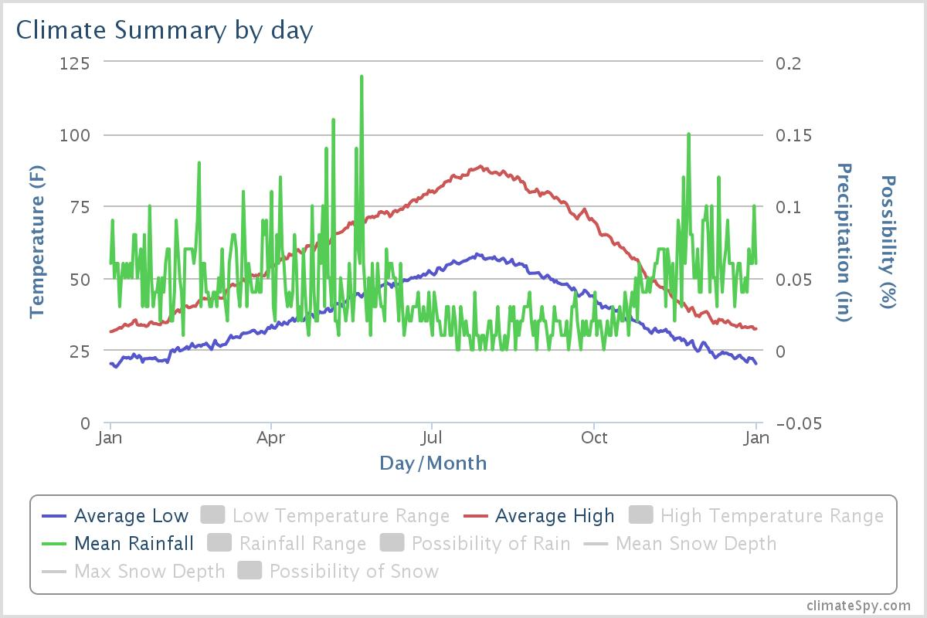

Figure A-1. Average Daily Temperatures and Rainfall for Spokane.

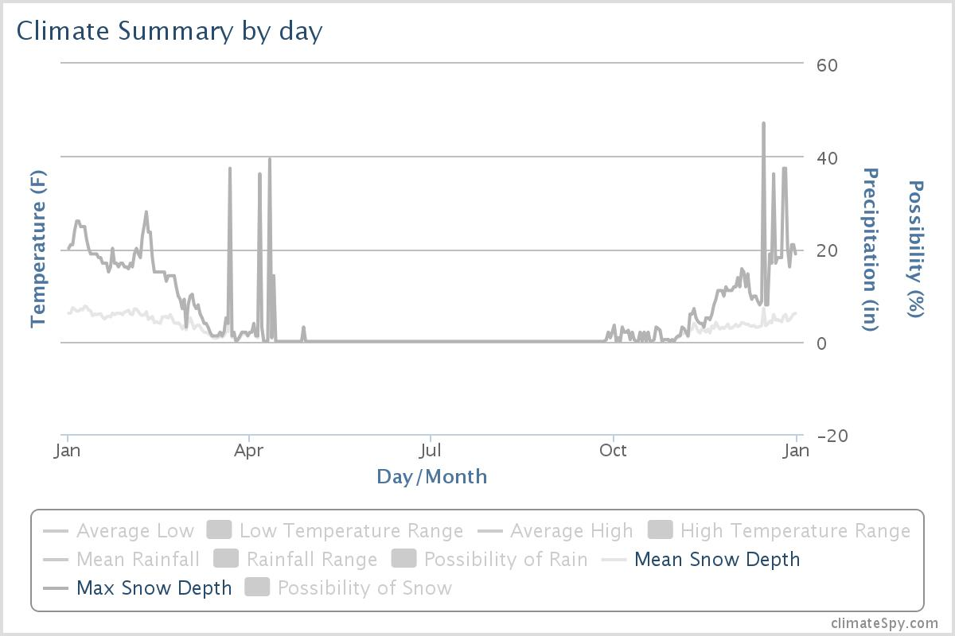

Figure A-2. Average Daily Mean and Maximum Snow Depths for Spokane.

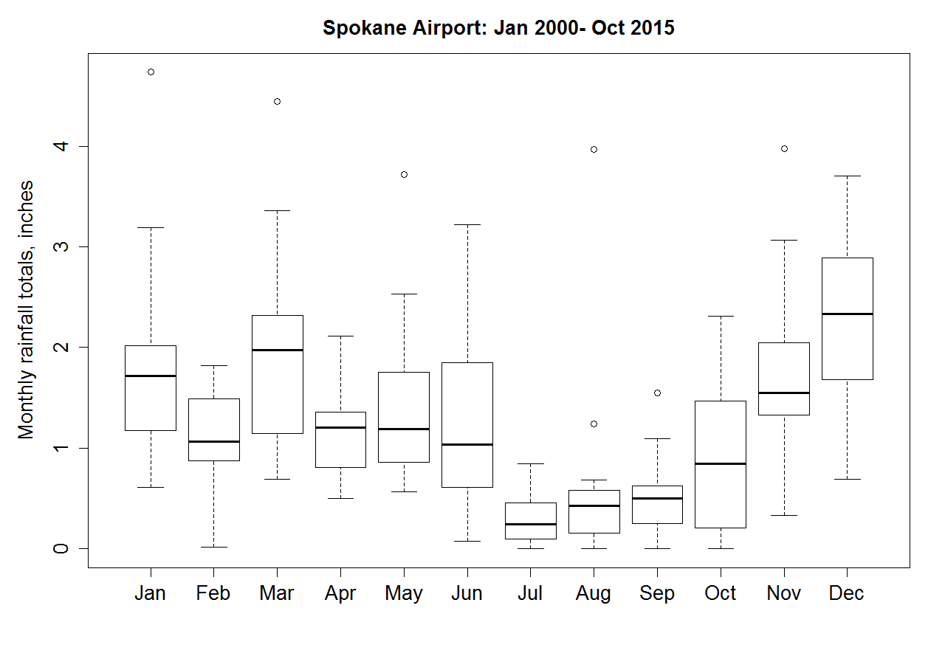

Figure A-3. Monthly Rainfall Statistics for the Spokane International Airport.

## Appendix B. Glossaries, Acronyms, and Abbreviations

Glossary of General Terms

**Ambient:** Background or away from point sources of contamination. Surrounding environmental condition.

**Anthropogenic:** Human-caused.

**Baseflow:** The component of total streamflow that originates from direct groundwater discharges   
to a stream.

**Clean Water Act:** A federal act passed in 1972 that contains provisions to restore and maintain the quality of the nation’s waters. Section 303(d) of the Clean Water Act establishes the TMDL program.

**Dissolved oxygen (DO):** A measure of the amount of oxygen dissolved in water.

**Flux:** Deposition rate expressed as a known amount of material per area in given amount of time.

**Nonpoint source:** Pollution that enters any waters of the state from any dispersed land-based or water-based activities, including but not limited to atmospheric deposition, surface-water runoff from agricultural lands, urban areas, or forest lands, subsurface or underground sources, or discharges from boats or marine vessels not otherwise regulated under the NPDES program.Generally, any unconfined and diffuse source of contamination. Legally, any source of water pollution that does not meet the legal definition of “point source” in section 502(14) of the Clean Water Act.

**Pollution:** Contamination or other alteration of the physical, chemical, or biological properties of any waters of the state. This includes change in temperature, taste, color, turbidity, or odor of the waters. It also includes discharge of any liquid, gaseous, solid, radioactive, or other substance into any waters of the state. This definition assumes that these changes will,   
or are likely to, create a nuisance or render such waters harmful, detrimental, or injurious to   
(1) public health, safety, or welfare, or (2) domestic, commercial, industrial, agricultural, recreational, or other legitimate beneficial uses, or (3) livestock, wild animals, birds, fish, or other aquatic life.

**Reach:** A specific portion or segment of a stream.

**Sediment:** Soil and organic matter that is covered with water (for example, river or lake bottom).

**Stormwater:** The portion of precipitation that does not naturally percolate into the ground or evaporate but instead runs off roads, pavement, and roofs during rainfall or snow melt. Stormwater can also come from hard or saturated grass surfaces such as lawns, pastures, playfields, and from gravel roads and parking lots.

**Streamflow:** Discharge of water in a surface stream (river or creek).

**Total Maximum Daily Load (TMDL):**  A distribution of a substance in a water body designed to protect it from not meeting (exceeding) water quality standards. A TMDL is equal to the sum of all of the following: (1) individual wasteload allocations for point sources, (2) the load allocations for nonpoint sources, (3) the contribution of natural sources, and (4) a margin of safety to allow for uncertainty in the wasteload determination. A reserve for future growth is also generally provided.

**Watershed:** A drainage area or basin in which all land and water areas drain or flow toward a central collector such as a stream, river, or lake at a lower elevation.

**303(d) list:** Section 303(d) of the federal Clean Water Act, requiring Washington State to periodically prepare a list of all surface waters in the state for which beneficial uses of the water – such as for drinking, recreation, aquatic habitat, and industrial use – are impaired by pollutants. These are water quality-limited estuaries, lakes, and streams that fall short of state surface water quality standards and are not expected to improve within the next two years.

#### Acronyms and Abbreviations

Following are acronyms and abbreviations used frequently in this report.

AERMOD A steady-state plume model supported by EPA

Ecology Washington State Department of Ecology

e.g. For example

EIM Environmental Information Management database

EPA U.S. Environmental Protection Agency

et al. And others

GIS Geographic Information System software

i.e. In other words

MEL Manchester Environmental Laboratory

MQO Measurement quality objective

NPDES (See Glossary above)

NTR National Toxics Rule

PBT persistent, bioaccumulative, and toxic substance

PCB polychlorinated biphenyls

QA Quality assurance

RPD Relative percent difference

RSD Relative standard deviation

SOP Standard operating procedures

WQA Water Quality Assessment

WRIA Water Resource Inventory Area

*Units of Measurement*

°C degrees centigrade

cfs cubic feet per second

dw dry weight

ft feet

g gram, a unit of mass

kg kilograms, a unit of mass equal to 1,000 grams

kg/d kilograms per day

km kilometer, a unit of length equal to 1,000 meters

l/s liters per second (0.03531 cubic foot per second)

m meter

mm millimeter

mg milligram

mg/d milligrams per day

mg/Kg milligrams per kilogram (parts per million)

mg/L milligrams per liter (parts per million)

mg/L/hr milligrams per liter per hour

mL milliliter

ng/g nanograms per gram (parts per billion)

ng/Kg nanograms per kilogram (parts per trillion)

ng/L nanograms per liter (parts per trillion)

pg/g picograms per gram (parts per trillion)

pg/L picograms per liter (parts per quadrillion)

ug/Kg micrograms per kilogram (parts per billion)

um micrometer

Quality Assurance Glossary

**Accreditation:** A certification process for laboratories, designed to evaluate and document a lab’s ability to perform analytical methods and produce acceptable data.For Ecology, it is“Formal recognition by (Ecology)…that an environmental laboratory is capable of producing accurate analytical data.” [WAC 173-50-040] (Kammin, 2010)

**Accuracy:** The degree to which a measured value agrees with the true value of the measured property. USEPA recommends that this term not be used, and that the terms precision and bias be used to convey the information associated with the term accuracy. (USGS, 1998)

**Analyte:**  An element, ion, compound, or chemical moiety (pH, alkalinity) which is to be determined. The definition can be expanded to include organisms, e.g., fecal coliform, Klebsiella. (Kammin, 2010)

**Bias:** The difference between the population mean and the true value. Bias usually describes a systematic difference reproducible over time, and is characteristic of both the measurement system, and the analyte(s) being measured. Bias is a commonly used data quality indicator (DQI). (Kammin, 2010; Ecology, 2004)

**Blank:** A synthetic sample, free of the analyte(s) of interest. For example, in water analysis, pure water is used for the blank. In chemical analysis, a blank is used to estimate the analytical response to all factors other than the analyte in the sample. In general, blanks are used to assess possible contamination or inadvertent introduction of analyte during various stages of the sampling and analytical process. (USGS, 1998)

**Calibration:** The process of establishing the relationship between the response of a measurement system and the concentration of the parameter being measured. (Ecology, 2004)

**Check standard:** A substance or reference material obtained from a source independent from the source of the calibration standard; used to assess bias for an analytical method. This is an obsolete term, and its use is highly discouraged. See Calibration Verification Standards, Lab Control Samples (LCS), Certified Reference Materials (CRM), and/or spiked blanks. These are all check standards, but should be referred to by their actual designator, e.g., CRM, LCS. (Kammin, 2010; Ecology, 2004)

**Comparability:** The degree to which different methods, data sets and/or decisions agree or can be represented as similar; a data quality indicator. (USEPA, 1997)

**Completeness:** The amount of valid data obtained from a project compared to the planned amount. Usually expressed as a percentage. A data quality indicator. (USEPA, 1997)

**Continuing Calibration Verification Standard (CCV):** A QC sample analyzed with samples to check for acceptable bias in the measurement system. The CCV is usually a midpoint calibration standard that is re-run at an established frequency during the course of an analytical run. (Kammin, 2010)

**Control chart:** A graphical representation of quality control results demonstrating the performance of an aspect of a measurement system. (Kammin, 2010; Ecology 2004)

**Control limits:** Statistical warning and action limits calculated based on control charts. Warning limits are generally set at +/- 2 standard deviations from the mean, action limits at +/- 3 standard deviations from the mean. (Kammin, 2010)

**Data Integrity:** A qualitative DQI that evaluates the extent to which a data set contains data that is misrepresented, falsified, or deliberately misleading. (Kammin, 2010)

**Data Quality Indicators (DQI):** Commonly used measures of acceptability for environmental data. The principal DQIs are precision, bias, representativeness, comparability, completeness, sensitivity, and integrity. (USEPA, 2006)

**Data Quality Objectives (DQO):**  Qualitative and quantitative statements derived from systematic planning processes that clarify study objectives, define the appropriate type of data, and specify tolerable levels of potential decision errors that will be used as the basis for establishing the quality and quantity of data needed to support decisions.

(USEPA, 2006)

**Data set:** A grouping of samples organized by date, time, analyte, etc. (Kammin, 2010)

**Data validation:**  An analyte-specific and sample-specific process that extends the evaluation of data beyond data verification to determine the usability of a specific data set. It involves a detailed examination of the data package, using both professional judgment, and objective criteria, to determine whether the MQOs for precision, bias, and sensitivity have been met. It may also include an assessment of completeness, representativeness, comparability and integrity, as these criteria relate to the usability of the data set. Ecology considers four key criteria to determine if data validation has actually occurred. These are:

* Use of raw or instrument data for evaluation.
* Use of third-party assessors.
* Data set is complex.
* Use of EPA Functional Guidelines or equivalent for review.

Examples of data types commonly validated would be:

* Gas Chromatography (GC).
* Gas Chromatography-Mass Spectrometry (GC-MS).
* Inductively Coupled Plasma (ICP).

The end result of a formal validation process is a determination of usability that assigns qualifiers to indicate usability status for every measurement result. These qualifiers include:

* No qualifier, data is usable for intended purposes.
* J (or a J variant), data is estimated, may be usable, may be biased high or low.
* REJ, data is rejected, cannot be used for intended purposes (Kammin, 2010; Ecology, 2004).

**Data verification:**  Examination of a data set for errors or omissions, and assessment of the Data Quality Indicators related to that data set for compliance with acceptance criteria (MQOs). Verification is a detailed quality review of a data set. (Ecology, 2004)

**Detection limit** (limit of detection)**:** The concentration or amount of an analyte which can be determined to a specified level of certainty to be greater than zero. (Ecology, 2004)

**Duplicate samples:** Two samples taken from and representative of the same population, and carried through and steps of the sampling and analytical procedures in an identical manner. Duplicate samples are used to assess variability of all method activities including sampling and analysis. (USEPA, 1997)

**Field blank:** A blank used to obtain information on contamination introduced during sample collection, storage, and transport. (Ecology, 2004)

**Initial Calibration Verification Standard (ICV):** A QC sample prepared independently of calibration standards and analyzed along with the samples to check for acceptable bias in the measurement system. The ICV is analyzed prior to the analysis of any samples. (Kammin, 2010)

**Laboratory Control Sample (LCS):** A sample of known composition prepared using contaminant-free water or an inert solid that is spiked with analytes of interest at the midpoint of the calibration curve or at the level of concern. It is prepared and analyzed in the same batch of regular samples using the same sample preparation method, reagents, and analytical methods employed for regular samples. (USEPA, 1997)

**Matrix spike:** A QC sample prepared by adding a known amount of the target analyte(s) to an aliquot of a sample to check for bias due to interference or matrix effects. (Ecology, 2004)

**Measurement Quality Objectives** (MQOs)**:** Performance or acceptance criteria for individual data quality indicators, usually including precision, bias, sensitivity, completeness, comparability, and representativeness. (USEPA, 2006)

**Measurement result:** A value obtained by performing the procedure described in a method. (Ecology, 2004)

**Method:** A formalized group of procedures and techniques for performing an activity (e.g., sampling, chemical analysis, data analysis), systematically presented in the order in which they are to be executed. (EPA, 1997)

**Method blank:**  A blank prepared to represent the sample matrix, prepared and analyzed with a batch of samples. A method blank will contain all reagents used in the preparation of a sample, and the same preparation process is used for the method blank and samples. (Ecology, 2004; Kammin, 2010)

**Method Detection Limit (MDL):** This definition for detection was first formally advanced in 40CFR 136, October 26, 1984 edition. MDL is defined there as the minimum concentration of an analyte that, in a given matrix and with a specific method, has a 99% probability of being identified, and reported to be greater than zero. (Federal Register, October 26, 1984)

**Percent Relative Standard Deviation (%RSD):** A statistic used to evaluate precision in environmental analysis. It is determined in the following manner:

**%RSD = (100 \* s)/x**

where s is the sample standard deviation and x is the mean of results from more than two replicate samples (Kammin, 2010)

**Parameter:** A specified characteristic of a population or sample. Also, an analyte or grouping of analytes. Benzene and nitrate + nitrite are all “parameters.” (Kammin, 2010; Ecology, 2004)

**Population:** The hypothetical set of all possible observations of the type being investigated. (Ecology, 2004)

**Precision:**  The extent of random variability among replicate measurements of the same property; a data quality indicator. (USGS, 1998)

**Quality Assurance (QA):** A set of activities designed to establish and document the reliability and usability of measurement data. (Kammin, 2010)

**Quality Assurance Project Plan (QAPP):** A document that describes the objectives of a project, and the processes and activities necessary to develop data that will support those objectives. (Kammin, 2010; Ecology, 2004)

**Quality Control (QC):** The routine application of measurement and statistical procedures to assess the accuracy of measurement data. (Ecology, 2004)

**Relative Percent Difference (RPD):**  RPD is commonly used to evaluate precision. The following formula is used:

**[Abs(a-b)/((a + b)/2)] \* 100**

where “Abs()” is absolute value and a and b are results for the two replicate samples. RPD can be used only with 2 values. Percent Relative Standard Deviation is (%RSD) is used if there are results for more than 2 replicate samples (Ecology, 2004).

**Replicate samples:** Two or more samples taken from the environment at the same time and place, using the same protocols. Replicates are used to estimate the random variability of the material sampled. (USGS, 1998)

**Representativeness:** The degree to which a sample reflects the population from which it is taken; a data quality indicator. (USGS, 1998)

**Sample (field):** A portion of a population (environmental entity) that is measured and assumed to represent the entire population. (USGS, 1998)

**Sample (statistical):**  A finite part or subset of a statistical population. (USEPA, 1997)

**Sensitivity:** In general, denotes the rate at which the analytical response (e.g., absorbance, volume, meter reading) varies with the concentration of the parameter being determined. In a specialized sense, it has the same meaning as the detection limit. (Ecology, 2004)

**Spiked blank:**  A specified amount of reagent blank fortified with a known mass of the target analyte(s); usually used to assess the recovery efficiency of the method. (USEPA, 1997)

**Spiked sample:**  A sample prepared by adding a known mass of target analyte(s) to a specified amount of matrix sample for which an independent estimate of target analyte(s) concentration is available. Spiked samples can be used to determine the effect of the matrix on a method’s recovery efficiency. (USEPA, 1997)

**Split sample:** A discrete sample that is further subdivided into portions, usually duplicates. (Kammin, 2010)

**Standard Operating Procedure (SOP):** A document which describes in detail a reproducible and repeatable organized activity. (Kammin, 2010)

**Surrogate:**  For environmental chemistry, a surrogate is a substance with properties similar to those of the target analyte(s). Surrogates are unlikely to be native to environmental samples. They are added to environmental samples for quality control purposes, to track extraction efficiency and/or measure analyte recovery. Deuterated organic compounds are examples of surrogates commonly used in organic compound analysis. (Kammin, 2010)

**Systematic planning:**  A step-wise process which develops a clear description of the goals and objectives of a project, and produces decisions on the type, quantity, and quality of data that will be needed to meet those goals and objectives. The DQO process is a specialized type of systematic planning. (USEPA, 2006)

**References for QA Glossary**

Ecology, 2004. Guidance for the Preparation of Quality Assurance Project Plans for Environmental Studies. <https://fortress.wa.gov/ecy/publications/SummaryPages/0403030.html>

Kammin, B., 2010. Definition developed or extensively edited by William Kammin, 2010. Washington State Department of Ecology, Olympia, WA.

USEPA, 1997. Glossary of Quality Assurance Terms and Related Acronyms. U.S. Environmental Protection Agency. <http://www.ecy.wa.gov/programs/eap/quality.html>

USEPA, 2006. Guidance on Systematic Planning Using the Data Quality Objectives Process EPA QA/G-4. U.S. Environmental Protection Agency.   
<http://www.epa.gov/quality/qs-docs/g4-final.pdf>

USGS, 1998. Principles and Practices for Quality Assurance and Quality Control. Open-File Report 98-636. U.S. Geological Survey. <http://ma.water.usgs.gov/fhwa/products/ofr98-636.pdf>

## Appendix C. Forms

Table C-1. Bulk Deposition Field Data Collection Form

|  |
| --- |
| **Location: \_\_\_\_\_\_\_\_\_\_\_\_\_\_\_\_\_\_\_\_\_\_\_\_\_\_\_\_\_\_\_\_\_\_\_\_\_\_\_\_\_\_\_\_\_\_\_** |
|  |
| **Deployment** |
| Date: \_\_\_\_\_\_\_\_\_\_\_\_\_\_\_ |
| Time: \_\_\_\_\_\_\_\_\_\_\_\_\_\_\_ |
| Staff: \_\_\_\_\_\_\_\_\_\_\_\_\_\_\_ |
| Weather: \_\_\_\_\_\_\_\_\_\_\_\_\_\_\_\_\_\_\_\_\_\_\_\_\_\_\_\_\_\_\_\_\_\_\_\_\_\_\_\_\_\_\_\_\_\_ |
| \_\_\_\_\_\_\_\_\_\_\_\_\_\_\_\_\_\_\_\_\_\_\_\_\_\_\_\_\_\_\_\_\_\_\_\_\_\_\_\_\_\_\_\_\_\_ |
| \_\_\_\_\_\_\_\_\_\_\_\_\_\_\_\_\_\_\_\_\_\_\_\_\_\_\_\_\_\_\_\_\_\_\_\_\_\_\_\_\_\_\_\_\_\_ |
|  |
| Canister Weight (g): \_\_\_\_\_\_\_\_\_\_\_\_\_\_\_ |
| (provided by Lab) |
|  |
| Notes: \_\_\_\_\_\_\_\_\_\_\_\_\_\_\_\_\_\_\_\_\_\_\_\_\_\_\_\_\_\_\_\_\_\_\_\_\_\_\_\_\_\_\_\_\_\_\_\_ |
| \_\_\_\_\_\_\_\_\_\_\_\_\_\_\_\_\_\_\_\_\_\_\_\_\_\_\_\_\_\_\_\_\_\_\_\_\_\_\_\_\_\_\_\_\_\_\_\_ |
| \_\_\_\_\_\_\_\_\_\_\_\_\_\_\_\_\_\_\_\_\_\_\_\_\_\_\_\_\_\_\_\_\_\_\_\_\_\_\_\_\_\_\_\_\_\_\_\_ |
| \_\_\_\_\_\_\_\_\_\_\_\_\_\_\_\_\_\_\_\_\_\_\_\_\_\_\_\_\_\_\_\_\_\_\_\_\_\_\_\_\_\_\_\_\_\_\_\_ |
| \_\_\_\_\_\_\_\_\_\_\_\_\_\_\_\_\_\_\_\_\_\_\_\_\_\_\_\_\_\_\_\_\_\_\_\_\_\_\_\_\_\_\_\_\_\_\_\_ |
|  |
|  |
| **Retrieval** |
| Date: \_\_\_\_\_\_\_\_\_\_\_\_\_\_\_ |
| Time: \_\_\_\_\_\_\_\_\_\_\_\_\_\_\_ |
| Staff: \_\_\_\_\_\_\_\_\_\_\_\_\_\_\_ |
| Weather: \_\_\_\_\_\_\_\_\_\_\_\_\_\_\_\_\_\_\_\_\_\_\_\_\_\_\_\_\_\_\_\_\_\_\_\_\_\_\_\_\_\_\_\_\_\_ |
| \_\_\_\_\_\_\_\_\_\_\_\_\_\_\_\_\_\_\_\_\_\_\_\_\_\_\_\_\_\_\_\_\_\_\_\_\_\_\_\_\_\_\_\_\_\_ |
| \_\_\_\_\_\_\_\_\_\_\_\_\_\_\_\_\_\_\_\_\_\_\_\_\_\_\_\_\_\_\_\_\_\_\_\_\_\_\_\_\_\_\_\_\_\_ |
|  |
| Canister Weight (g): \_\_\_\_\_\_\_\_\_\_\_\_\_\_\_ |
| (provided by Lab) |
| Volume of Rinsate: \_\_\_\_\_\_\_\_\_\_\_\_\_\_\_ |
| (~500 mL) |
|  |
| Notes: \_\_\_\_\_\_\_\_\_\_\_\_\_\_\_\_\_\_\_\_\_\_\_\_\_\_\_\_\_\_\_\_\_\_\_\_\_\_\_\_\_\_\_\_\_\_\_\_ |
| \_\_\_\_\_\_\_\_\_\_\_\_\_\_\_\_\_\_\_\_\_\_\_\_\_\_\_\_\_\_\_\_\_\_\_\_\_\_\_\_\_\_\_\_\_\_\_\_ |
| \_\_\_\_\_\_\_\_\_\_\_\_\_\_\_\_\_\_\_\_\_\_\_\_\_\_\_\_\_\_\_\_\_\_\_\_\_\_\_\_\_\_\_\_\_\_\_\_ |
| \_\_\_\_\_\_\_\_\_\_\_\_\_\_\_\_\_\_\_\_\_\_\_\_\_\_\_\_\_\_\_\_\_\_\_\_\_\_\_\_\_\_\_\_\_\_\_\_ |
| \_\_\_\_\_\_\_\_\_\_\_\_\_\_\_\_\_\_\_\_\_\_\_\_\_\_\_\_\_\_\_\_\_\_\_\_\_\_\_\_\_\_\_\_\_\_\_\_ |