Take-Back Programs
Description: | This action consists of programs designed to accept and properly dispose of PCB-containing items, preventing legacy non-fixed building sources such as small appliances and lamp ballasts from potentially being disposed of improperly.
Type: | Institutional -- government practices.
Reduction Efficiency: | The overall efficiency is of this control action is unknown. While it is theoretically 100% effective in controlling the release of PCBs from items that would otherwise be improperly disposed, the number of PCB-containing items that are currently being improperly disposed (as well as the fraction of this number that take-back programs would affect) is unknown.
Significance of Pathway: | This control action is targeted towards legacy non-fixed building sources, which have been identified as one of the largest source areas of PCBs with an estimated mass range of 50 to 40,000 kg. Conversely, the primary mechanism delivering this source area to the river is discharging stormwater, which totals 15 to 94 mg/day. Due to the uncertainty in the number of appliances improperly disposed, as well as the ultimate fate of those PCBs, the significance of this pathway is considered unknown, but likely a moderate contributor.  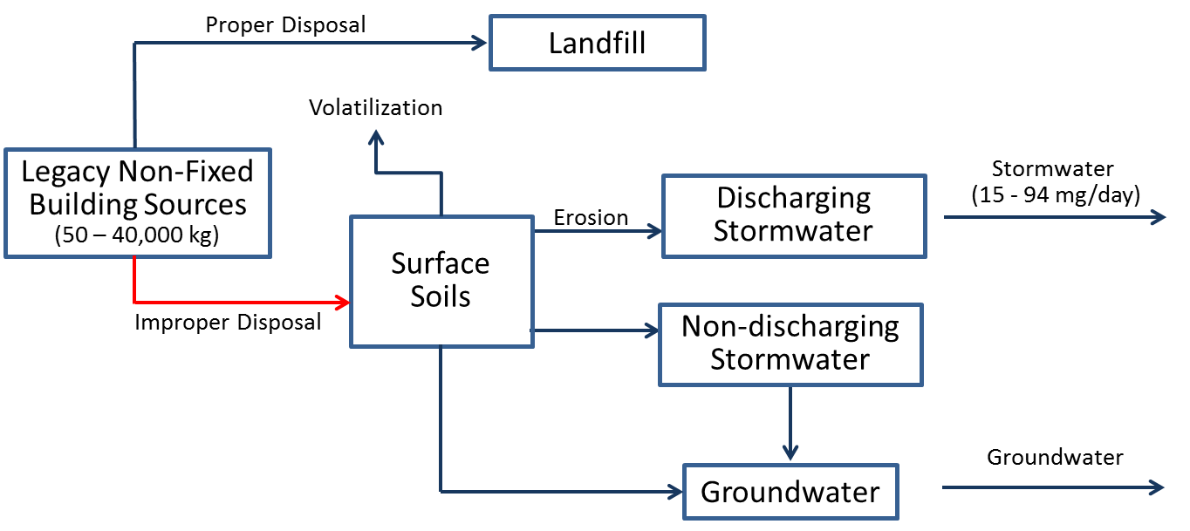
Cost: | This program, when applied to take-back of mercury containing lights, was estimated to cost $8.7 million for five years. The total cost included setting up collection centers, a public education campaign, and transporting the collected lights to recyclers. The mercury program was statewide, so the cost for just the Spokane watershed would be a fraction of $8.7 million required statewide, likely more than $100,000 but less than $1 million.
Implementing Entity: | The action could be implemented either through local governments (i.e. City/County waste disposal) or non-profit run programs.
PP Hierarchy: | This control action is intermediate in the Pollution Prevention hierarchy, as it is designed to manage PCBs that are currently in place in the watershed.
Existing Efforts: | The primary mechanism delivering this source area to the river is discharging stormwater, which comes mostly from the City of Spokane. The City is developing control actions for PCBs as part of their Integrated Clean Water Plan, and is in a better position to evaluate this action than the Task Force. This Control Action may be beneficial for other communities with stormwater discharges, although the size of their service area is relatively small.
Ancillary Benefit: | This action may provide some limited ancillary benefit in terms of promoting proper disposal of electrical equipment, and preventing environmental release of other harmful materials contained in them, but overall ancillary benefit is believed to be small.

Low Impact Development Ordinance
Description: | This action consists of programs designed to create and implement land use/development ordinances or standards that encourage Low Impact Development and decrease impervious surfaces.
Type: | Institutional government practices
Reduction Efficiency: | Because PCBs in runoff are largely bound to soil particles, the efficiency of this control action can be estimated from the observed efficiency of Low Impact Development on removing solids from runoff, which ranges from 40 to 88%.
Significance of Pathway: | This control action is designed to minimize runoff from impervious surfaces and the PCBs that are contained in that runoff. It will only effect delifery to the river from those sources that are linked to discharging stormwater systems. The primary mechanism delivering this source area to the river is discharging stormwater, which totals 15 to 94 mg/day. Due to the uncertainty in the extent that this action can be implemented, the significance of this pathway is not fully known, but is likely a moderate contributor.  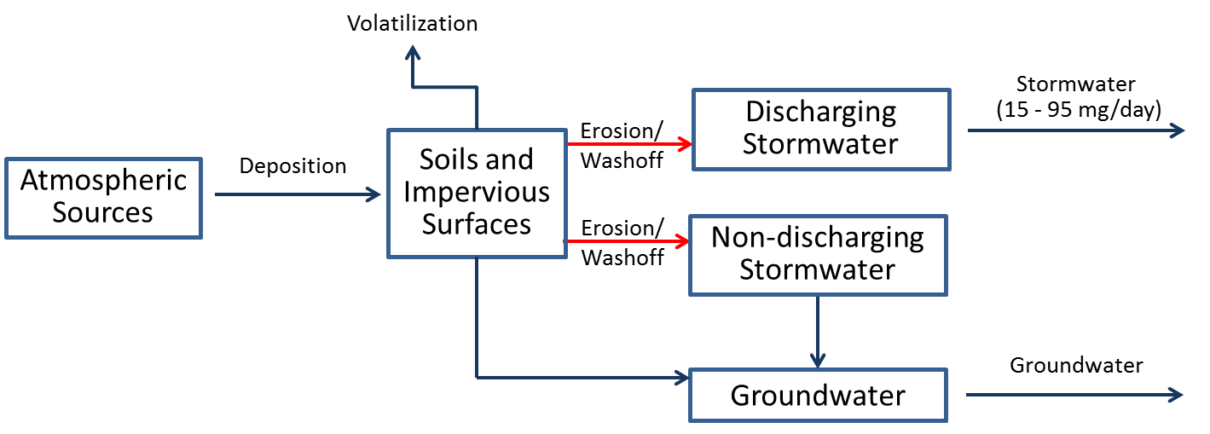
Cost: | Development and adoption of the ordinance would likely be minimal for the City of Spokane (based on the experience with the purchasing ordinance), but related education and outreach efforts could be much more expensive (more detail for that control action on the PCBs education fact sheet).
Implementing Entity: | This action is typically applied by the local agency responsible for managing land development.
PP Hierarchy: | This control action is intermediate in the Pollution Prevention hierarchy, as it is designed to manage PCBs that are currently in place in the watershed.
Existing Efforts: | The primary mechanism delivering this source area to the river is discharging stormwater, which comes mostly from the City of Spokane. The City is developing control actions for PCB as part of their Integrated Clean Water Plan, and is in a better position to evaluate this action than the Task Force. It may be beneficial for other communities with stormwater discharges, although the size of their service area is relatively small.
Ancillary Benefit: | This control action will provide a moderate amount of other water quality benefits by reducing the loading of many other pollutants that are associated with solids and impervious surfaces (e.g. metals, bacteria).

MS4 Source Tracking
Description: | This action consists of identifying businesses that are likely to contribute PCBs to the MS4, and working with such businesses and the appropriate regulatory agencies to develop and implement appropriate control actions.
Type: | Institutional - government practices
Reduction Efficiency: | This action in and of itself will not have immediate impacts on PCB loads but will be a step towards better source area identification and targeted Control Action implementation.
Significance of Pathway: | This action affects the largest known source areas (i.e. building sources), and could limit the extent that they contribute to the 15 - 94 mg/day of PCBs currently delivered to the river via stormwater. Due to the uncertainty in the extent that this action will identify controllable sources, the significance of this pathway is no fully known, but is likely a moderate contributor.  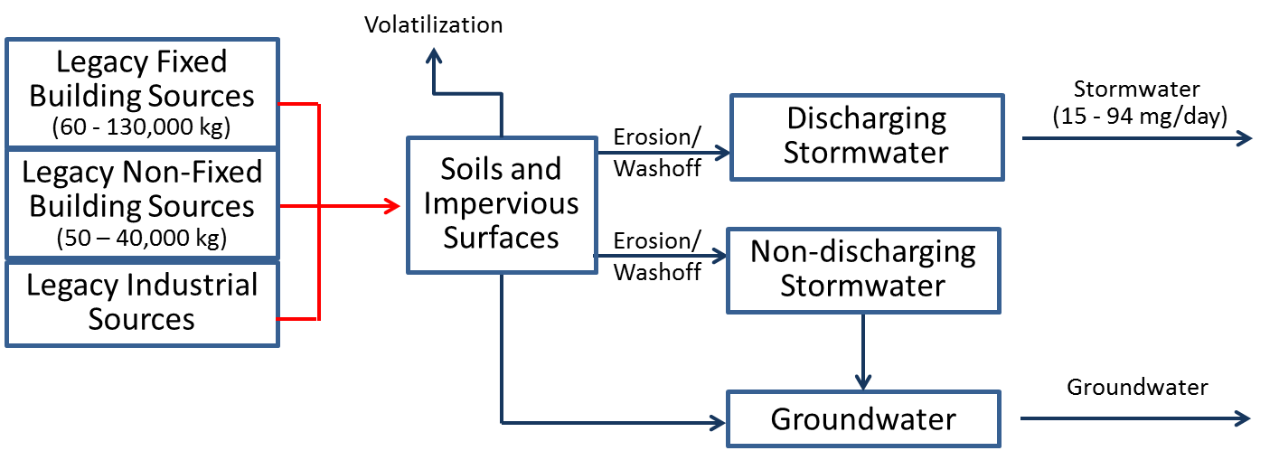
Cost: | Information being gathered.
Implementing Entity: | This effort is currently being undertaken by the Spokane Regional Health District
PP Hierarchy: | This control action is intermediate in the Pollution Prevention hierarchy, as it is designed to manage PCBs that are currently in place in the watershed.
Existing Efforts: | This effort is currently being undertaken by the Spokane Regional Health District.
Ancillary Benefit: | This action may provide some limited ancillary benefit in terms reducing the environmental release of other pollutants that are co-located with legacy PCBs, but overall additional benefit is expected to be small.

Leaf Removal
Description: | This action consists of programs designed to enhance current municipal leaf removal programs since foliage is a receptor of atmospheric PCB loadings. Removal of leaf litter prior to it being discharged to the river could reduce loading PCB associated with this source area.
Type: | Institutional - government practices
Reduction Efficiency: | The overall efficiency is of this control action is not fully known. While it is theoretically 100% effective in controlling the release of PCBs from collected leaf litter, the fraction of overall leaf litter that would be captured by improved removal is currently unknown.
Significance of Pathway: | This control action is targeted towards the portion of PCB contamination in soils and impervious surfaces that arise due to deposition from atmospheric sources. The overall magnitude of the stormwater delivery pathway is 15-94 mg/day, and the portion of this load attributable to leaf litter is expected to be small.  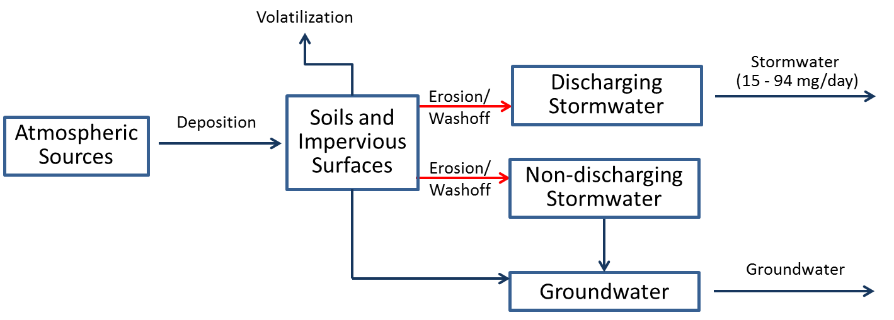
Cost: | The cost of implementation of leaf removal is relatively low on annual basis, but is judged moderate over the long term because this is a recurring activity.
Implementing Entity: | As discussed below, leaf removal is already being conducted by many communities in the watershed.
PP Hierarchy: | This control action is intermediate in the Pollution Prevention hierarchy, as it is designed to manage PCBs that are currently in place in the watershed.
Existing Efforts: | The opportunity for expanded implementation for this control action within the watershed is limited, because leaf removal is already a government-provided service in the City of Spokane (seasonal), Spokane county (leaves can go in green bins collected by Waste Management), and Post Falls (last two weekends in April and September).
Ancillary Benefit: | This action provides secondary benefits beyond PCB removal by reducing the loading to the Spokane River of nutrients and oxygen-demanding material contained in leaf litter.

Street sweeping
Description: | This action consists of programs designed to modify current street sweeping frequency and area covered to specifically target source areas of PCBs, or when/where more material is washing down streets to prevent it from entering storm drains.
Type: | Institutional - government practices
Reduction Efficiency: | Studies to assess the ability of street sweeping to improve concentrations of particle-bound pollutant in stormwater have reported widely varying effectiveness. Several studies showed no significant differences in stormwater concentration in response to street sweeping (e.g. USGS, 2007) while other (e.g. Sutherland, 2009) have reported decreases in concentration of more than 50%. Given this wide range of reported reduction efficiencies, street sweeping is rated as a moderately suitable in terms of reduction efficiency.
Significance of Pathway: | This control action is targeted towards the portion of PCB contamination in stormwater runoff that accumulates on street surfaces. The primary mechanism delivering this source area to the river is discharging stormwater, which totals 15 to 94 mg/day. Due to the uncertainty in the extent of the stormwater load arising from street surfaces, the significance of this pathway is no fully known, but is likely a moderate contributor.
Cost: | The City of Seattle sweeps every other week at a cost of $7/curb-mile for planning and a total cost of $64/curb-mile which included performance tracking and disposal costs. The City of Olympia had a total of 3,328 curb-miles swept per year and total cost of $50/curb-mile. The City of Oakland employed 20 mechanical broom sweepers and completed 7,000/ miles/sweeper/year at a total cost of $33/curb-mile. The annual budget was $4.5 million. The City of Richmond (CA) completed 7,000/ miles/sweeper/year at a total cost of $81/curb-mile. The annual budget was $1.7 million including the cost of the sweepers. Costs for these examples can be extrapolated to Spokane. The City has 2220 “lane-miles” including arterials and residential streets. Using the examples above the cost range would be about $73,000. Other costs to consider would be additional sweepers and costs due to change in frequency. Mechanical sweepers are cheaper (about $80,000) and considered less efficient than regenerative and high efficiency sweepers (about $200-300,000). Long term costs are judged to be moderate.
Implementing Entity: | Municipal Public Works Departments
PP Hierarchy: | This control action is intermediate in the Pollution Prevention hierarchy, as it is designed to manage PCBs that are currently in place in the watershed.
Existing Efforts: | This control action is primarily applicable to the City of Spokane, as they are responsible for the large majority of watershed area contributing to discharging stormwater systems. The City is currently developing and implementing an Integrated Clean Water Plan designed to control PCB loading from their stormwater systems, so independent development of Control Actions by the Task Force is considered redundant to this effort. It may be beneficial for other communities with stormwater discharges, although the size of their service area is relatively small.
Ancillary Benefit: | This action provides significant secondary benefits by reducing the loading to the Spokane River of pollutants typically associated with impervious surfaces, such as phosphorus.

Catch basin/pipe cleanout
Description: | This action consists of programs designed to increase the frequency of catch basin and pipe cleanout to specifically remove PCB-contaminated sediment.
Type: | Institutional - government practices
Reduction Efficiency: | While the exact reduction efficiency on the PCB overall loading rate is uncertain, the Control Action is effective in removing PCBs that could otherwise be delivered to the system. The City of Spokane removed 32.4 grams PCBs removed from their catch basins between 2010 and 2012 (Schmidt, 2015). This action also assists in source identification if PCB concentrations of the removed sediments are measured, as catch basins with higher PCB concentrations indicated elevated source areas in their drainage basis. Given the uncertain in reduction efficiency, this action is rated as moderately suitable.
Significance of Pathway: | This control action is targeted towards all pathways that deliver PCBs to discharging stormwater systems. The overall magnitude of the stormwater delivery pathway is 15-94 mg/day. Because this Control Action has the potential to affect the majority of delivered stormwater loads, the action is rated as highly suitable in terms of pathway.  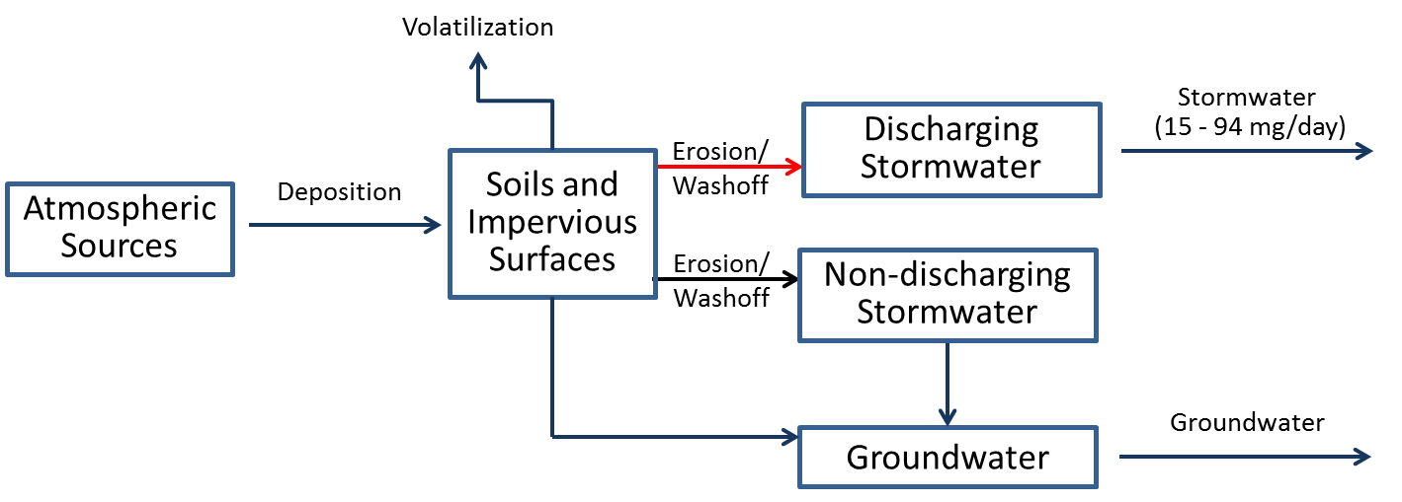
Cost: | Information being gathered.
Implementing Entity: | Municipal Public Works Departments
PP Hierarchy: | This control action is intermediate in the Pollution Prevention hierarchy, as it is designed to manage PCBs that are currently in place in the watershed.
Existing Efforts: | This control action is primarily applicable to the City of Spokane, as they are responsible for the large majority of watershed area contributing to discharging stormwater systems. The City is currently developing and implementing an Integrated Clean Water Plan designed to control PCB loading from their stormwater systems, so independent development of Control Actions by the Task Force is considered redundant to this effort.
Ancillary Benefit: | This action provides secondary benefits by reducing the loading to the Spokane River of pollutants typically associated with solids (e.g. metals, bacteria) that are captured be catch basins. More frequent catch basin cleanout can also prevent flooding.

Purchasing standards
Description: | This action consists of local regulation designed to reduce or totally eliminate the purchase of products that contain PCBs. It could also potentially include working with manufacturers to get them to create alternative products that do not contain PCBs, and would be more desirable for purchase.
Type: | Institutional - government practices
Reduction Efficiency: | The overall efficiency is of this control action is unknown. Theoretically, it can reduce the contribution of affected inadvertent sources by 100%, if products currently containing PCBs can be replaced with PCB-free products. For this reason, it is rated as highly suitable in terms of reduction efficiency.
Significance of Pathway: | This control action is targeted towards the source area of inadvertently produced PCBs, which are being imported into the watershed at a rate of 0.2 to 450 mg/day. Although its exact significance is unknown, it has the potential to affect the significant delivery pathways of wastewater (54-2923 mg/day) and stormwater (15-94 mg/day) loading. For this reason, the action is rated as highly suitable in terms of pathway.  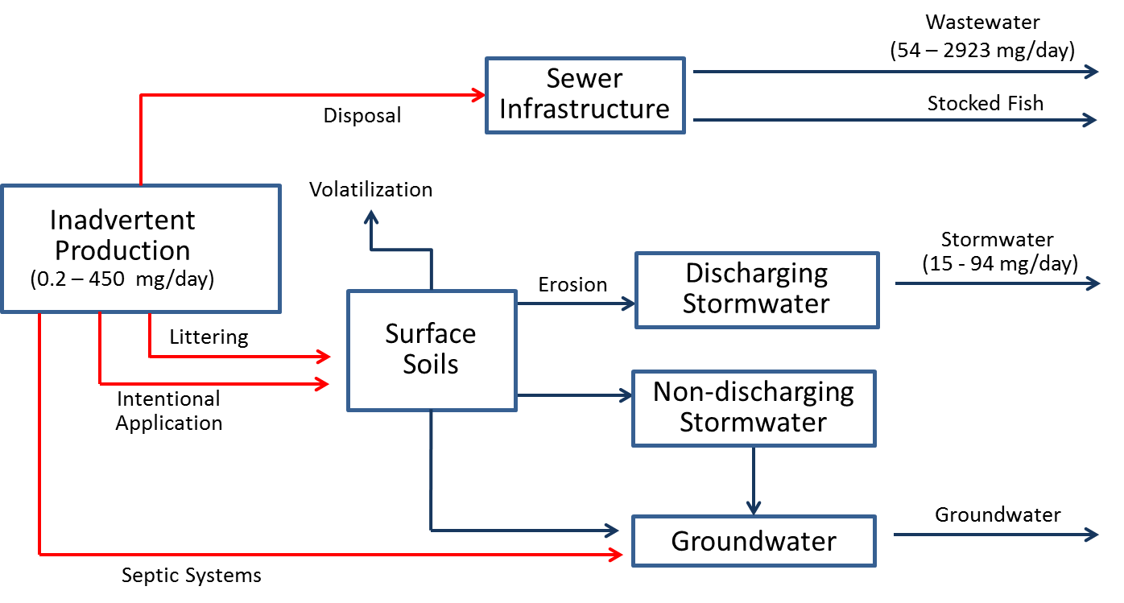
Cost: | Development and adoption of the ordinance was minimal (a few labor hours) for the City of Spokane, but related education and outreach efforts were much more expensive (more detail for that control action on the PCBs education fact sheet).
Implementing Entity: | Local governments.
PP Hierarchy: | This control action in high on the Pollution Prevention hierarchy, as it is designed to reduce the use of inadvertently produced PCBs.
Existing Efforts: | Washington State Senate Bill 6086 (passed in 2014) requires State agencies to establish a purchasing and procurement policy that provides a preference for products that do not contain PCBs. (http://apps.leg.wa.gov/billinfo/summary.aspx?bill=6086&year=2013). Spokane County passed Resolution #2014-1022 in December 2014.The City of Spokane’s ordinance requires City departments to purchase PCB-free items (defined as less than the practical quantification limit using EPA Method 1668) if a feasible alternative is available at less than a 25% cost increase (Spokane Municipal code 07.06.172).
Ancillary Benefit: | None.

Survey of Local Utilities for Electrical Equipment
Description: | Conduct a survey of local utilities and other owners of electrical equipment to document the presence/amount of PCBs in transformers.
Type: | Institutional - education
Reduction Efficiency: | This action in and of itself will not have immediate impacts on PCB loads but will be a step towards better source area identification and targeted Control Action implementation.
Significance of Pathway: | The action focuses on the potential for leaks or spills from industrial equipment, which has been estimated to be small (0.001 – 0.02 mg/day).  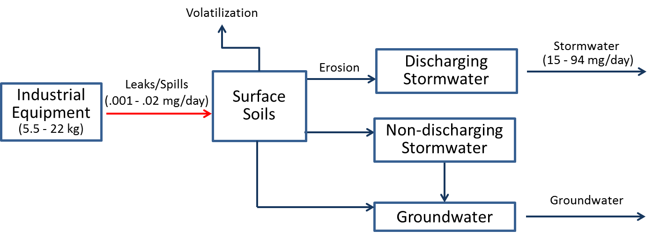
Cost: | An estimate to implement this control action at a statewide level in Washington Department of Ecology (2015) was less than $50,000 over two years. This was based on one FTE working 25% time on this project. At the watershed scale, it would likely be even less.
Implementing Entity: | Not immediately identified.
PP Hierarchy: | This control action is intermediate in the Pollution Prevention hierarchy, as it is designed to manage PCBs that are currently in place in the watershed.
Existing Efforts: | A survey of local utilities was conducted as part of early stages of Comprehensive Plan development, and found that these utilities have already taken significant measures to reduce the PCB content in their equipment. This action is therefore considered largely redundant.
Ancillary Benefit: | None.

Regulation Of Waste Disposal
Description: | This action consists of programs designed to review local/regional laws regulating waste disposal (including oil burning) and illegal dumping, and revise as necessary (e.g. enforcing fines/other penalties for improperly disposing of PCBs,)
Type: | Institutional--government practices
Reduction Efficiency: | The reduction efficiency of this Control Action is unknown, but is likely small in terms of reducing the overall loading magnitude of any given pathway.
Significance of Pathway: | This action potentially affects a wide range of pathways.
Cost: | The cost of this Control Action is unknown, but is expected to be less than $100,000
Implementing Entity: | Local governments.
PP Hierarchy: | This control action is intermediate in the Pollution Prevention hierarchy, as it is designed to manage PCBs that are currently in place in the watershed.
Existing Efforts: | None.
Ancillary Benefit: | This action may provide some limited ancillary benefit, by controlling improper disposal/release of other pollutants associated with illegal disposal.

Removal of Carp from Lake Spokane
Description: | This action involves removing carp from Lake Spokane. Carp in the lake are known to be contaminated with PCBs, and removing them would prevent further cycling in the watershed.
Type: | Institutional--government practices
Reduction Efficiency: | This is action is 100% efficient in removing PCBs from those carp that are in the lake, which have an estimated PCB content of 0.0015 – 0.0041g PCBs per carp.
Significance of Pathway: | No pathway.
Cost: | Unknown at this point, though a pilot study is underway/planned.
Implementing Entity: | Avista Utilities and Washington Department of Ecology
PP Hierarchy: | This control action at the bottom on the Pollution Prevention hierarchy, as it is designed to remove PCBs that are currently in the lake.
Existing Efforts: | This Control Action is being investigated independently of the PCB Comprehensive Plan.
Ancillary Benefit: | This Control Action provides significant ancillary benefits, as removal of carp will also lead to a reduction in sediment phosphorus release caused by carp stirring up bottom

Building Demolition Control Actions
Description: | This Control Action consists of managing PCB‐containing materials and waste during building demolition and renovation.
Type: | Institutional - government practices
Reduction Efficiency: | The efficiency of this action is currently being investigated, but it is believed that it will be moderately effective in reducing loads.
Significance of Pathway: | This Control Action is targeted towards legacy fixed building sources, which have been identified as one of the largest source areas of PCBs with an estimated mass range of 60 to 130,000 kg. Klosterhaus et al (2014) summarize the available literature that demonstrates that the rate that legacy PCBs can be delivered to surrounding soils during demolition and renovation, while uncertain, is likely very significant.  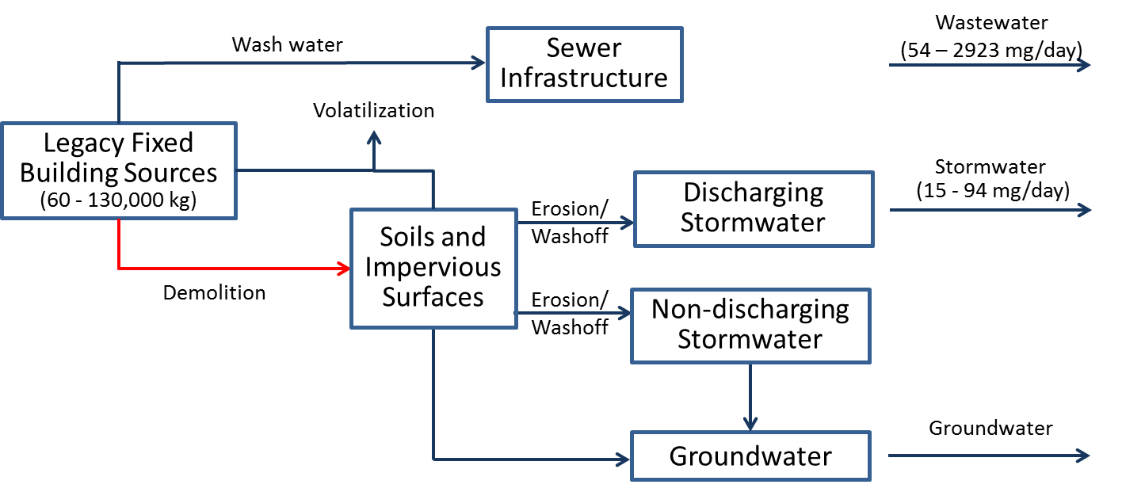
Cost: | Costs for the entire control action are unknown. Estimated costs just to cut and remove caulk, and to scarify or remove adjacent substrates could range from $30-$50 per linear foot
Implementing Entity: | Local governments.
PP Hierarchy: | This control action is intermediate on the Pollution Prevention hierarchy, as it is designed to manage PCBs that are currently in place in the watershed.
Existing Efforts: | None known.
Ancillary Benefit: | This action may provide some limited ancillary benefit, by controlling improper disposal/release of other pollutants associated with building demolition.

PCB-Product Labeling Law
Description: | This action consists of developing and passing an ordinance that requires labeling products that contain PCBs, similar to the 2014 law for labeling construction materials that contain asbestos (RCW 70.310.030).
Type: | Institutional--government practices
Reduction Efficiency: | The effectiveness of product labels to affect consumer behavior has been shown to vary widely based on many factors (Cox et al, 1997), such that the reduction efficiency is considered unknown at this time.
Significance of Pathway: | This control action is targeted towards the source area of inadvertently produced PCBs, which are being imported into the watershed at a rate of 0.2 to 450 mg/day. Although its exact significance is unknown, it has the potential to affect the significant delivery pathways of wastewater (54-2923 mg/day) and stormwater (15-94 mg/day) loading. For this reason, the action is rated as highly suitable in terms of pathway.
Cost: | Cost is unknown, but expected to be under $100,000.
Implementing Entity: | Washington Department of Ecology
PP Hierarchy: | This control action is high on the Pollution Prevention hierarchy, as it is designed to reduce the use of inadvertently produced PCBs.
Existing Efforts: | None known.
Ancillary Benefit: | None.

Leak Prevention/Detection In Electrical Equipment
Description: | This action consists of implementation of state and/or local ordinance to require a leak prevention/detection system in any PCB-containing transformer or capacitor.
Type: | Institutional--government practices
Reduction Efficiency: | This action is expected to be highly effective, as it requires implementation of a system specifically designed to control this pathway.
Significance of Pathway: | The action focuses on the potential for leaks or spills from industrial equipment, which has been estimated to be small (0.001 – 0.02 mg/day).
Cost: | The cost creating an ordinance is expected to be under $100,000, although costs to utilities to implement the program will be higher.
Implementing Entity: | Washington Department of Ecology; local governments
PP Hierarchy: | This control action is intermediate on the Pollution Prevention hierarchy, as it is designed to manage PCBs that are currently in place in the watershed.
Existing Efforts: | A survey of local utilities was conducted as part of Comprehensive Plan development, and found that these utilities have already taken measures to reduce the PCB content in their equipment. This action is therefore considered largely redundant.
Ancillary Benefit: | Ancillary benefits associated with this action are expected to be small.

Environmental Monitoring
Description: | This action consists of expanded environmental monitoring to identify the significance of uncertain source areas and pathways.
Type: | Institutional -- government practices
Reduction Efficiency: | This action in and of itself will not have immediate impacts on PCB loads but will be a step towards better source area identification and targeted Control Action implementation.
Significance of Pathway: | This action affects potentially all pathways.
Cost: | The cost of individual monitoring projects conducted to date by the Task Force have been small ($100,000) to moderate ($100,000 to $1,000,000).
Implementing Entity: | Spokane River Regional Toxics Task Force, Washington Department of Ecology
PP Hierarchy: | This control action is intermediate on the Pollution Prevention hierarchy, as it is designed to assess PCBs that are currently in place in the watershed.
Existing Efforts: | While several monitoring programs are currently in place, they are only addressing a small subset of the total number of uncertain source areas and pathways. Future studies would be targeted at investigating different source areas and pathways, such that there should be little overlap between new monitoring and existing monitoring.
Ancillary Benefit: | The ancillary benefit provided by monitoring will depend on the specific nature of the monitoring project, and could vary from negligible to significant.

Accelerated Sewer Construction
Description: | This action consists of acceleration of sewer construction to replace septic systems.
Type: | Institutional--government practices
Reduction Efficiency: | This action will be nearly 100% efficient in removing loads from those septic systems that are connected to the sewer system. Connection to the sewer system will transfer these loads to wastewater treatment plants, which will be effective in removing the PCBs.
Significance of Pathway: | The source areas that contribute PCBs to septic systems are large. The ultimate delivery of these PCBs to the river and lake, while uncertain, is likely to be small.  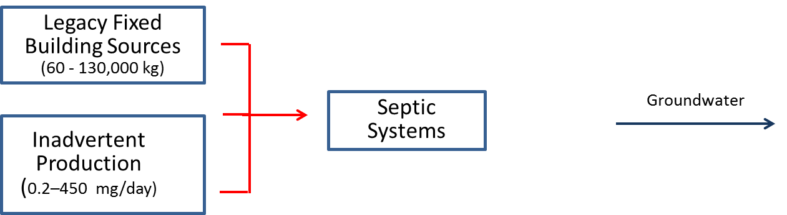
Cost: | The cost for sewer construction is expected to be significant (i.e. much higher than the current $1M threshold used for evaluation).
Implementing Entity: | Local municipalities.
PP Hierarchy: | This control action is intermediate on the Pollution Prevention hierarchy, as it is designed to manage PCBs that are currently in place in the watershed.
Existing Efforts: | Spokane County has a mandatory septic tank elimination program for septic tanks within the Urban Growth Area (UGA), requiring connection within a year of notification and enforcement through the Prosecutor’s office. There is some overlap between the UGA and the Critical Aquifer Recharge Area (CARA), but still plenty of area where sewer construction could help eliminate discharge to the CARA.
Ancillary Benefit: | This action will provide significant ancillary benefits, by removing the loading of a wide range of pollutants to the aquifer.

PCB Identification During Inspections
Description: | This action consists of identifying PCB-containing materials as part of other regular inspections (e.g., building permits, IDDE, facility inspections). It involves training inspectors to identify materials and what to do next (safe disposal, encapsulation, etc.).
Type: | Institutional -- government practices
Reduction Efficiency: | This action in and of itself will not have immediate impacts on PCB loads but will be a step towards better source area identification and targeted Control Action implementation.
Significance of Pathway: | This control action is targeted towards legacy non-fixed building sources, which have been identified as one of the largest source areas of PCBs with an estimated mass range of 50 to 40,000 kg. Due to the uncertainty in the number of appliances improperly disposed, as well as the ultimate fate of those PCBs, the significance of this pathway is considered unknown but likely significant.
Cost: | San Mateo County (CA) estimated their total cost to add PCB product identification to a regular building inspector’s task list to be about $5,500/year (planning was $1500/year and operating expenses were $4,000/year). Operating costs assumes 2 hours training/year plus 8 hours reporting/year per person for 5 people at $80/hr salary. This assumes that planning costs are good for a 10 year period. Based on this example, the cost to implement this control action in Spokane County would be relatively inexpensive, and definitely less than $100,000.
Implementing Entity: | Local governments.
PP Hierarchy: | This control action is intermediate on the Pollution Prevention hierarchy, as it is designed to manage PCBs that are currently in place in the watershed.
Existing Efforts: | None known.
Ancillary Benefit: | This action is expected to provide little ancillary benefit beyond PCB control.

Regulatory Rulemaking
Description: | This action consists of statutory reform of TSCA and FDA’s food packaging law (21 CFR 109) to re-visit currently allowed concentration of PCBs in chemical processes; enact legislation to reduce the creation of inadvertently generated PCB; and Federal rulemaking to reassess the current use authorizations for PCBs.
Type: | Institutional -- government practices
Reduction Efficiency: | The overall efficiency is of this control action is unknown. Theoretically, it can reduce the contribution of affected inadvertent sources by 100%, if products currently containing PCBs can eliminated. For this reason, it is rated as highly suitable in terms of reduction efficiency.
Significance of Pathway: | This control action is targeted towards the source area of inadvertently produced PCBs, which are being imported into the watershed at a rate of 0.2 to 450 mg/day. Although its exact significance is unknown, it has the potential to affect the significant delivery pathways of wastewater (54-2923 mg/day) and stormwater (15-94 mg/day) loading. For this reason, the action is rated as highly suitable in terms of pathway.
Cost: | There is no direct cost associated with regulatory reform, although there are costs associated with attempting to educate legislators on the need for revision that are likely small (<$100,000) to moderate ($100,000 to $1,000,000).
Implementing Entity: | The regulatory rulemaking will be implemented by State and Federal governments and agencies (e.g. EPA).
PP Hierarchy: | This control action is high on the Pollution Prevention hierarchy, as it is designed to reduce the creation of inadvertently produced PCBs. Federal rulemaking to reassess the current use authorizations for PCBs is intermediate on the Pollution Prevention hierarchy, as it is designed to manage the use of existing PCBs.
Existing Efforts: | A coalition of conservation groups, tribal organizations, cities, counties, business, industry, regulatory agencies, legislators, academics, Labor, trade organizations and many others have been working to get new rules introduced, but efforts to date have been unsuccessful.
Ancillary Benefit: | None.

Regulatory Policy and Implementation
Description: | This action consists requiring stricter adherence to existing rules and/or modification of how these rules are being implemented to reduce the creation and use of inadvertently produced PCBs. Potential activities include enforcement of existing TSCA rules to ensure imported products are complying with allowable PCB levels and limitations/controls of the use of certain products known to contain PCBs.
Type: | Institutional--government practices
Reduction Efficiency: | The overall efficiency is of this control action is unknown. Theoretically, it can reduce the contribution of affected inadvertent sources by 100%, if products currently containing PCBs can eliminated. For this reason, it is rated as highly suitable in terms of reduction efficiency.
Significance of Pathway: | This control action is targeted towards the source area of inadvertently produced PCBs, which are being imported into the watershed at a rate of 0.2 to 450 mg/day. Although its exact significance is unknown, it has the potential to affect the significant delivery pathways of wastewater (54-2923 mg/day) and stormwater (15-94 mg/day) loading. For this reason, the action is rated as highly suitable in terms of pathway.
Cost: | There is no direct cost associated with regulatory reform, although there are costs associated with attempting to educate legislators on the need for revisions that are likely small (<$100,000) to moderate ($100,000 to $1,000,000).
Implementing Entity: | Federal and State governments.
PP Hierarchy: | This control action is high on the Pollution Prevention hierarchy, as it is designed to reduce the creation and use of inadvertently produced PCBs.
Existing Efforts: | A coalition of conservation groups, tribal organizations, cities, counties, business, industry, regulatory agencies, legislators, academics, Labor, trade organizations and many others have been working to influence regulatory policy. Progress has been made in this regard, such as with the State of Washington’s PCB Chemical Action Plan.
Ancillary Benefit: | None.

Support Green Chemistry Alternatives
Description: | This action consists of working with chemical manufacturers to either develop alternative (non-chlorinated) products or develop products with reduced levels of PCBs.
Type: | Institutional - government practices
Reduction Efficiency: | The overall efficiency is of this control action is unknown. Theoretically, it can reduce the contribution of affected inadvertent sources by 100%, if products currently containing PCBs can eliminated. For this reason, it is rated as highly suitable in terms of reduction efficiency.
Significance of Pathway: | This control action is targeted towards the source area of inadvertently produced PCBs, which are being imported into the watershed at a rate of 0.2 to 450 mg/day. Although its exact significance is unknown, it has the potential to affect the significant delivery pathways of wastewater (54-2923 mg/day) and stormwater (15-94 mg/day) loading. For this reason, the action is rated as highly suitable in terms of pathway.
Cost: | There is no direct cost associated with supporting green chemistry alternatives, although there are costs associated with coordination with chemical manufactures that are likely small (<$100,000) to moderate ($100,000 to $1,000,000).
Implementing Entity: | Chemical manufacturers.
PP Hierarchy: | This control action is high on the Pollution Prevention hierarchy, as it is designed to reduce the use of inadvertently produced PCBs.
Existing Efforts: | Discussions have been initiated with some chemical manufacturers.
Ancillary Benefit: | None.

Survey of PCB-containing materials in Schools/Public Buildings
Description: | This action consists of programs designed to survey PCB-containing materials in schools/public buildings and enact a program to dispose of them properly or implement encapsulation.
Type: | Institutional - educational
Reduction Efficiency: | This action in and of itself will not have immediate impacts on PCB loads but will be a step towards better source area identification and targeted Control Action implementation.
Significance of Pathway: | This control action is targeted towards legacy non-fixed building sources, which have been identified as one of the largest source areas of PCBs with an estimated mass range of 50 to 40,000 kg. Due to the uncertainty in the number of appliances improperly disposed, as well as the ultimate fate of those PCBs, the significance of this pathway is considered unknown but potentially significant.
Cost: | Information being gathered.
Implementing Entity: | Information being gathered.
PP Hierarchy: | This control action is intermediate on the Pollution Prevention hierarchy, as it is designed to manage PCBs that are currently in place in the watershed.
Existing Efforts: | None known.
Ancillary Benefit: | This action is expected to reduce elevated human health exposure to PCBs within the affected schools and public buildings.

Education about PCB Sources
Description: | Conduct public education and outreach campaigns to spread information about the potential sources of PCBs, what to do with them if discovered (e.g., avoid pouring paint down the drain), and safer alternatives.
Type: | Institutional--educational
Reduction Efficiency: | This control action’s reduction efficiency is likely small though it may prevent some improper disposal of PCBs and also may reduce the amount of PCB-containing products from being purchased in the long term.
Significance of Pathway: | This action potentially affects a wide range of pathways.
Cost: | Based on the Spokane County example (below), education specifically about PCBs would likely be les than $100,000 per year.
Implementing Entity: | Local government, Ecology, or Task Force-led effort
PP Hierarchy: | This control action is intermediate in the Pollution Prevention hierarchy, as it is designed to manage PCBs that are currently in place in the watershed, but it may also limit the use of inadvertently produced PCBs as well.
Existing Efforts: | Two years ago, Spokane County hired a water resources specialist specifically tasked with developing an education/outreach program to implement the County’s NPDES permit-mandated Toxics Management Plan. Approximately 1/3 of that person’s time was devoted to those activities, including web site development, preparation of outreach materials (mailers, posters, etc.), participation in the outreach workgroup, and other Water Resource Center programs. Estimated cost per year was about $35,000 including salary and outreach materials/postage.  Department of Ecology also has many education efforts that involve PCBs but mainly consist of general information on their website, and not a formal communication plan or materials production. Limited outreach has been conducted in coordination with release of the Chemical Action Plan and the purchasing law.
Ancillary Benefit: | This control action could be a joint effort among Task Force members to education the public/businesses about a range of pollutants and watershed health/protection in general.

Education About Filtering of Post-Consumer Paper Products
Description: | Conduct public education and outreach campaigns to inform the public about separating recycling materials that are paper w/yellow inks/pigments into the garbage stream rather than recycle bin (educational sticker on bins).
Type: | Institutional - educational
Reduction Efficiency: | The reduction efficiency associated with this control action is currently unknown.
Significance of Pathway: | This control action is targeted towards the source area of inadvertently produced PCBs, which are being imported into the watershed at a rate of 0.2 to 450 mg/day. Although its exact significance is unknown, it has the potential to affect the significant delivery pathways of wastewater (54-2923 mg/day) and stormwater (15-94 mg/day) loading. For this reason, the action is rated as highly suitable in terms of pathway.  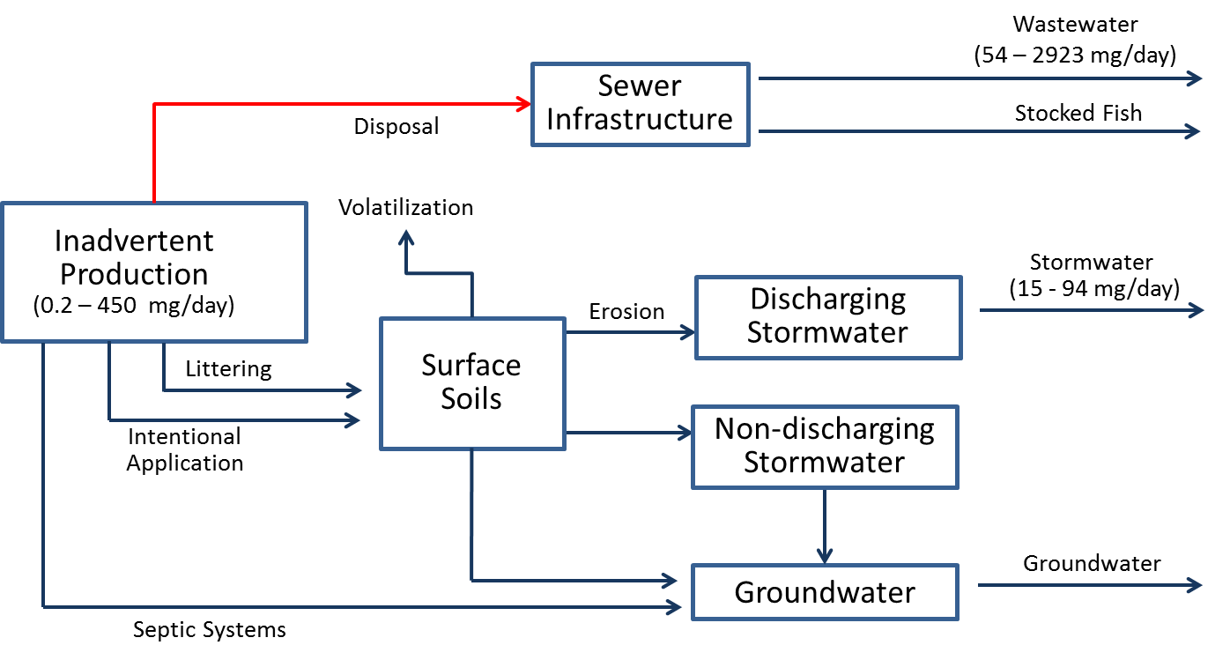
Cost: | It is expected that the cost of this activity will be less than $100,000.
Implementing Entity: | Local governments.
PP Hierarchy: | This control action is intermediate on the Pollution Prevention hierarchy, as it is designed to manage PCBs that are currently in place in the watershed.
Existing Efforts: | This Control Action does not overlap with any other existing efforts.
Ancillary Benefit: | None known.

PCB Product Information
Description: | This Control Action consists of further study of the extent to which commercial products contain inadvertently produced PCBs, as well as creation of a database to store the collected information.
Type: | Institutional--education
Reduction Efficiency: | This action in and of itself will not have immediate impacts on PCB loads but will be a step towards better source area identification and targeted Control Action implementation.
Significance of Pathway: | This control action is targeted towards the source area of inadvertently produced PCBs, which are being imported into the watershed at a rate of 0.2 to 450 mg/day. Although its exact significance is unknown, it has the potential to affect the significant delivery pathways of wastewater (54-2923 mg/day) and stormwater (15-94 mg/day) loading. For this reason, the action is rated as highly suitable in terms of pathway.  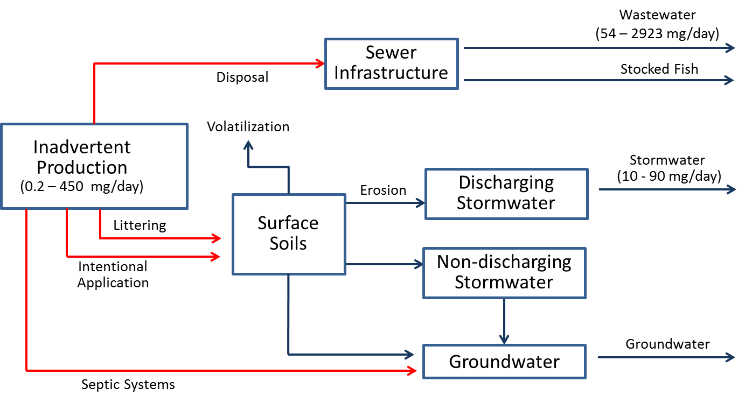
Cost: | The cost of this action will depend on the number of materials evaluated. It is reasonable to assume that sampling of a diverse range of materials, in conjunction with creation of a data base, will be intermediate (i.e. between $100,000 and $1,000,000) in cost.
Implementing Entity: | This action could be implemented by a range of entities, including Washington Department of Ecology, local governments, or the Spokane River Regional Toxics Task Force.
PP Hierarchy: | This control action in high on the Pollution Prevention hierarchy, as it is designed to reduce the use of inadvertently produced PCBs.
Existing Efforts: | Initial efforts in measuring PCB content of commercial products
Ancillary Benefit: | None known.

Stormwater Treatment - Pipe Entrance
Description: | This sub-category of control actions is designed to capture/treat stormwater onsite before it enters storm pipes, and can consist of: infiltration control actions such as trenches, basins, dry wells; bioretention control actions such as swales and buffer strips; filters; screens; wet vault; and hydrodynamic separator.
Type: | Stormwater Treatment - Pipe Entrance
Reduction Efficiency: | Infiltration control actions can have very high removal of TSS which should be correlated to PCB load reduction. Tetra Tech (2010) reported 60-100% removal of TSS in various infiltration control actions in the Boston area. Washington State Department of Transportation (2008) also indicated high removal efficiency potential of infiltration control actions for both TSS and organic contaminants.
Significance of Pathway: | This control action is targeted towards PCB contamination in stormwater. The primary mechanism delivering this source area to the river is discharging stormwater, which totals 15 to 94 mg/day and is considered a significant contributor.  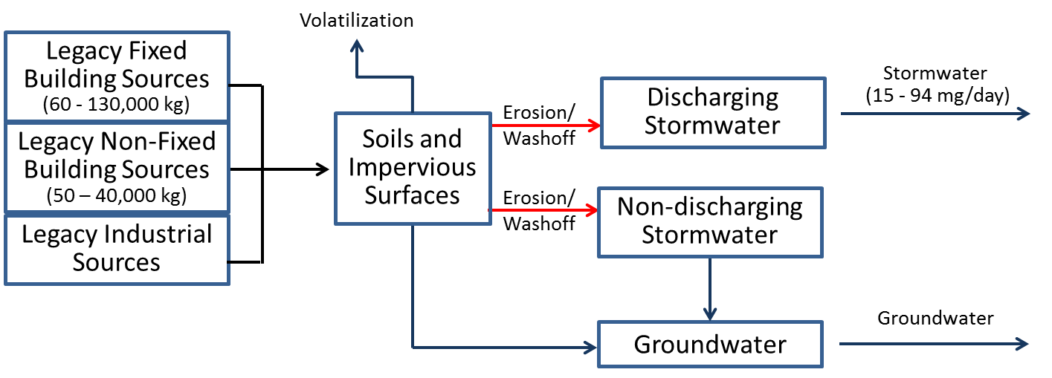
Cost: | Costs vary across specific Control Actions, but can generally be expected to be significant (i.e. >$1,000,000) for any widespread application.
Implementing Entity: | Local municipalities.
PP Hierarchy: | This control action is intermediate on the Pollution Prevention hierarchy, as it is designed to manage PCBs that are currently in place in the watershed.
Existing Efforts: | The primary mechanism delivering this source area to the river is discharging stormwater, which comes mostly from the City of Spokane. The City is developing control actions for PCBs as part of their Integrated Clean Water Plan, and is in a better position to evaluate this action than the Task Force. It may be beneficial for other communities with stormwater discharges, although the size of their service area is relatively small.
Ancillary Benefit: | This Control Action will reduce the loading of other pollutants associated with stormwater, such as nutrients.

Stormwater Treatment – Pipe System
Description: | This sub-category of control actions is installed in the MS4 infrastructure (e.g., pipes, storm drain inlets). These actions usually have higher maintenance requirements (compared to other stormwater control actions) and can sometimes impede flow when not maintained properly. Options include: 1) Screens that trap contaminated solids and larger debris to prevent discharge of that material to receiving waterbodies; 2) Filters or “socks”, like screens, that trap contaminated solids and prevent discharge of that material to receiving waterbodies; 3) Wet vaults, consisting of a permanent pool of water in a vault that rises and falls with storms and has a constricted opening to let runoff out. Its main treatment mechanism is settling of solids that are contaminated; and 4) Hydrodynamic separators that use cyclonic separation to trap solids and debris as stormwater flows through them before being discharged to receiving waterbodies
Type: | Stormwater Treatment - Pipe System
Reduction Efficiency: | Information being gathered.
Significance of Pathway: | This control action is targeted towards PCB contamination in stormwater. The primary mechanism delivering this source area to the river is discharging stormwater, which totals 15 to 94 mg/day and is considered a significant contributor.  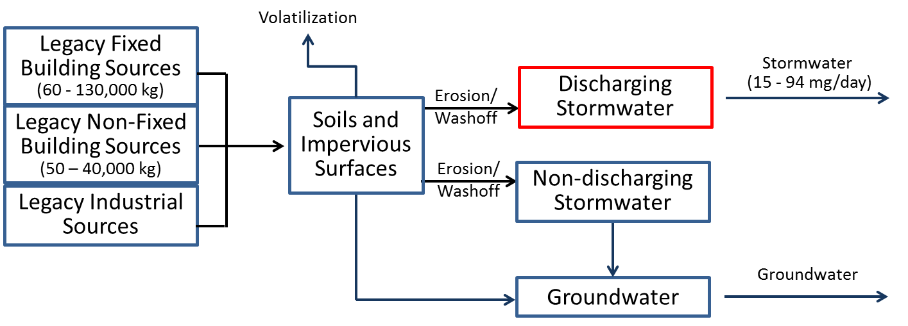
Cost: | Costs vary across specific Control Actions, but can generally be expected to be significant (i.e. $1,000,000 for any widespread application.
Implementing Entity: | Local municipalities.
PP Hierarchy: | This control action is intermediate on the Pollution Prevention hierarchy, as it is designed to manage PCBs that are currently in place in the watershed.
Existing Efforts: | The primary mechanism delivering this source area to the river is discharging stormwater, which comes mostly from the City of Spokane. The City is developing control actions for PCBs as part of their Integrated Clean Water Plan, and is in a better position to evaluate this action than the Task Force. It may be beneficial for other communities with stormwater discharges, although the size of their service area is relatively small.
Ancillary Benefit: | This Control Action will reduce the loading of other sediment-bound pollutants associated with stormwater, such as nutrients.

Stormwater Treatment - End of Pipe
Description: | This sub-category of control actions is installed at the end of the MS4 infrastructure. Options include: 1) Constructed wetlands, 2) Sedimentation basins, 3) Discharge to ground/dry well, 4) Diversion to treatment plant, and 5) Fungi (mycoremedation) or biochar incorporated into stormwater treatment.
Type: | Stormwater Treatment – End of Pipe
Reduction Efficiency: | Information being gathered.
Significance of Pathway: | This control action is targeted towards PCB contamination in stormwater. The primary mechanism delivering this source area to the river is discharging stormwater, which totals 15 to 94 mg/day and is considered a significant contributor.  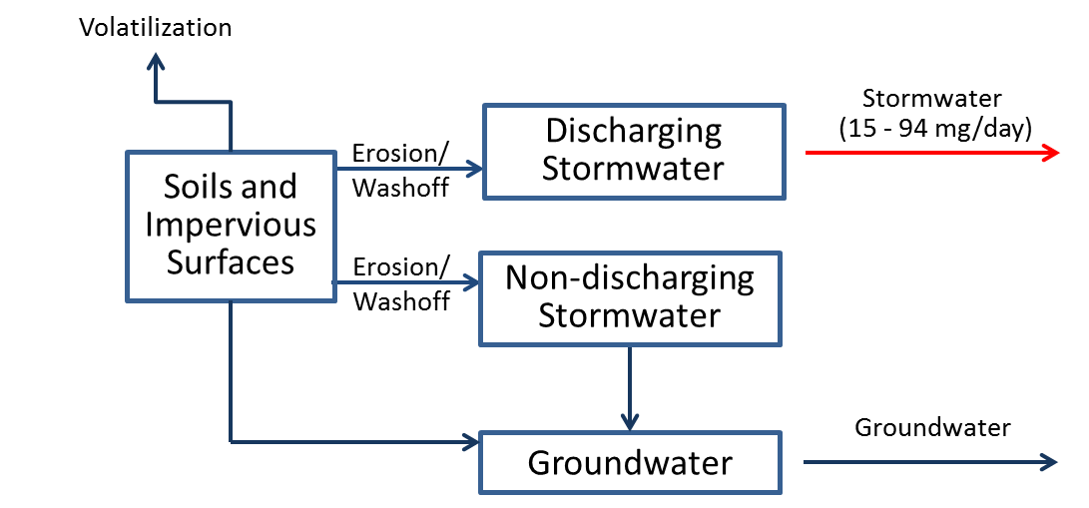
Cost: | Costs vary across specific Control Actions, but can generally be expected to be significant (i.e. $1,000,000 for any widespread application.
Implementing Entity: | The primary mechanism delivering this source area to the river is discharging stormwater, which comes mostly from the City of Spokane. The City is developing control actions for PCBs as part of their Integrated Clean Water Plan, and is in a better position to evaluate this action than the Task Force. It may be beneficial for other communities with stormwater discharges, although the size of their service area is relatively small.
PP Hierarchy: | This control action is lowest on the Pollution Prevention hierarchy, as it is designed to treat PCBs immediately before they are being discharged to the system.
Existing Efforts: | The primary mechanism delivering this source area to the river is discharging stormwater, which comes mostly from the City of Spokane. The City is developing control actions for PCBs as part of their Integrated Clean Water Plan, and is in a better position to evaluate this action than the Task Force. It may be beneficial for other communities with stormwater discharges, although the size of their service area is relatively small.
Ancillary Benefit: | This Control Action will reduce the loading of other pollutants associated with stormwater, such as nutrients.

Wastewater Treatment
Description: | This sub-category of control actions correspond to reducing pollutant loading from wastewater treatment plans. Options include: 1) Development of a Toxics Management Action Plan, 2) Implementation of a source tracking program, 3) Chemical fingerprinting or pattern analysis, 4) Remediation and/or mitigation of individual sources, 5) Elimination of PCB-containing equipment, 6) Public outreach and communications, 7) Review of procurement ordinances, 8) Pretreatment regulations.
Type: | Waste water Treatment – End of Pipe
Reduction Efficiency: | Wastewater treatment has the potential to achieve high rates of PCB removal.
Significance of Pathway: | This control action is targeted towards PCB contamination in wastewater, which delivers a total load of 54 to 2923 mg/day and is considered a significant contributor.  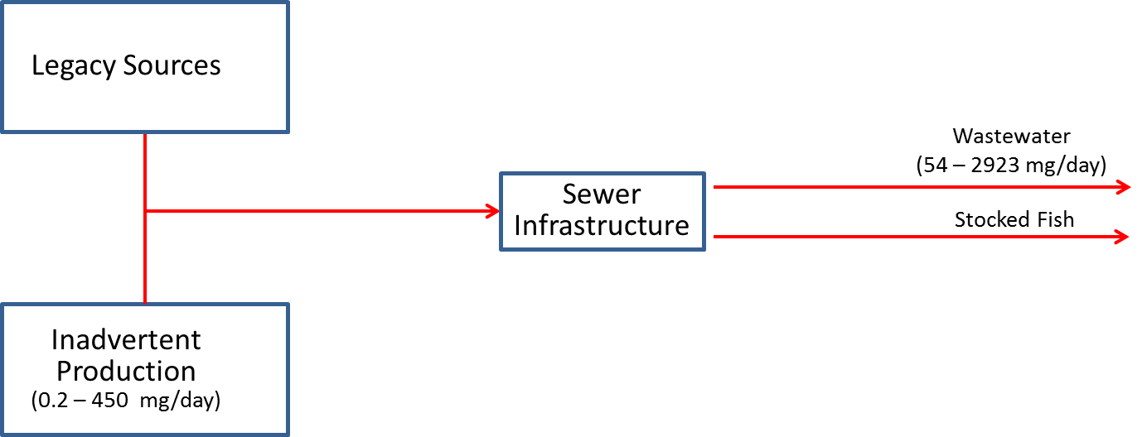
Cost: | Costs vary across specific Control Actions, but can generally be expected to be significant (i.e. $1,000,000 for any widespread application.
Implementing Entity: | The primary mechanism delivering this source area to the river is discharging stormwater, which comes mostly from the City of Spokane. The City is developing control actions for PCBs as part of their Integrated Clean Water Plan, and is in a better position to evaluate this action than the Task Force. It may be beneficial for other communities with stormwater discharges, although the size of their service area is relatively small.
PP Hierarchy: | This control action is lowest on the Pollution Prevention hierarchy, as it is designed to treat PCBs immediately before they are being discharged to the system.
Existing Efforts: | The primary mechanism delivering this source area to the river is discharging stormwater, which comes mostly from the City of Spokane. The City is developing control actions for PCBs as part of their Integrated Clean Water Plan, and is in a better position to evaluate this action than the Task Force. It may be beneficial for other communities with stormwater discharges, although the size of their service area is relatively small.
Ancillary Benefit: | This Control Action will reduce the loading of other pollutants associated with stormwater, such as nutrients.

Contaminated Sites
Description: | This control action consists of the identification and subsequent cleanup of contaminated sites.
Type: | Contaminated Sites
Reduction Efficiency: | Cleanup activities are able to achieve a high degree of pollutant load reduction.
Significance of Pathway: | This control action is targeted towards contaminated sites, which are currently estimated to deliver a total load of 60 - 300 mg/day and is considered a significant contributor.  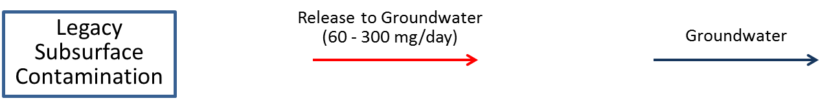
Cost: | Costs vary across specific Control Actions, but can generally be expected to be significant (i.e. $1,000,000 for any widespread application.
Implementing Entity: | Ecology, Kaiser
PP Hierarchy: | This control action is intermediate on the Pollution Prevention hierarchy, as it is designed to manage PCBs that are currently in place in the watershed.
Existing Efforts: | Cleanup efforts are in place at known contaminated sites. The potential exists for identifying other contaminated sites contributing PCBs throughout the watershed.
Ancillary Benefit: | Cleanup of contaminated PCB sites can provide moderate ancillary benefits, as other pollutants often co-occur with PCB contamination.

