Disposal Assistance for PCB-Containing Items
Description: | This action consists of programs (targeted at household consumers and businesses that generate small quantity hazardous waste) designed to accept and properly dispose of PCB-containing items, preventing legacy non-fixed building sources such as small appliances and lamp ballasts from potentially being disposed of improperly.
Type: | Institutional -- government practices.
Significance of Pathway: | This control action targets legacy non-fixed building sources, which have been identified as one of the largest source areas of PCBs with an estimated mass range of 50 to 40,000 kg. The primary mechanisms delivering this source area to the river are stormwater and atmospheric deposition following waste incineration, both through improper disposal. The total stormwater load is 15 to 94 mg/day and the atmospheric load is not currently known. The specific portion of the total stormwater and atmospheric load contributed by legacy non-fixed building sources is also unknown, due to uncertainty in the number of appliances in the watershed, the percentage that may be improperly disposed, and the ultimate fate of those PCBs.  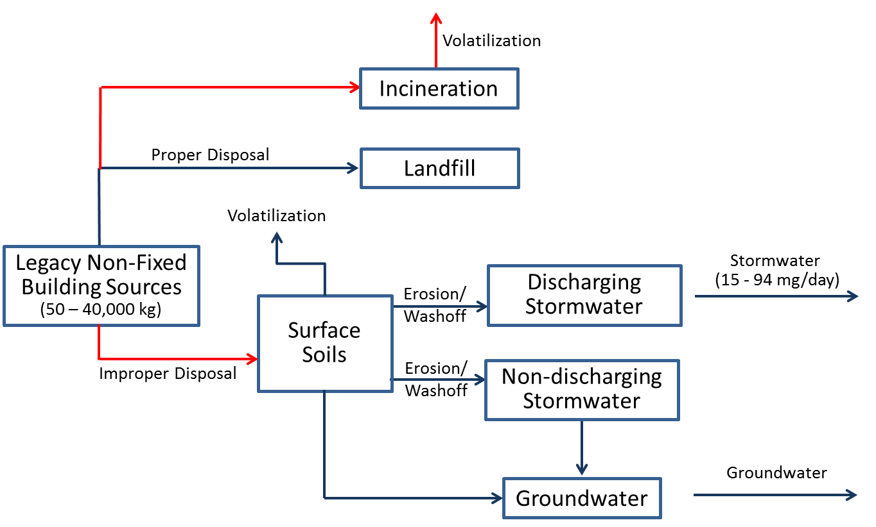
Reduction Efficiency: | This control action is theoretically 100% effective in controlling the release of PCBs from items that would otherwise be improperly disposed. The overall efficiency is of this control action is unknown. However, increasing public education and awareness of existing recycling and household hazardous waste facilities would increase the number of PCB-containing items that are properly disposed.
Cost: | The infrastructure for this program largely exists in Washington via take-back programs for mercury-containing lights, such that costs to include PCB-containing products would consist largely of: 1) outreach and education programs for the general consumer and business community, and 2) additional costs associated with managing PCB wastes. Efforts to initiate such a program in Idaho would be greater. Because the cost of the statewide mercury take-back program was $8.7 million dollars for five years, the cost for application to the Spokane watershed (including Idaho) would be a fraction of that, likely more than $100,000 and less than $1 million.
Implementing Entity: | This action is currently being implemented by a number of organizations in Washington: Department of Ecology Hazardous Waste and Toxics Reduction program – Urban Waters Initiative; Spokane County Regional Health District; Spokane River Forum – Envirostars; local waste disposal vendors and local businesses that accept fluorescent lamps for recycling. Specific activities that that the Task Force could undertake include: 1) Making recommendations to organizations currently providing waste disposal assistance as to how they can help achieve their goals, and 2) Raise public awareness on how to identify and dispose of PCB-containing items.
PP Hierarchy: | This control action is intermediate in the Pollution Prevention hierarchy, as it is designed to manage PCBs that are currently in place in the watershed.
Existing Efforts: | As discussed above, this action is available and could be better integrated with existing Control Actions targeted toward CFL lamp recycling and household hazardous waste collection.
Ancillary Benefit: | This action provides some ancillary benefits because PCB light ballasts and small capacitors are often associated with other items that have harmful materials in them (mercury containing lights). Outreach on this topic also promotes proper disposal of these items, and preventing environmental release of other harmful materials contained in them.
Time Frame: | Programs can likely be developed within two years, although it is not expected that measurable reductions in PCB loads will be observed with five years.

Low Impact Development (LID) Ordinance
Description: | This action consists of creating and implementing land use/development ordinances or standards that encourage Low Impact Development (LID) and decrease impervious surfaces.
Type: | Institutional government practices
Significance of Pathway: | This control action is designed to prevent and minimize runoff from impervious surfaces and the PCBs that are contained in that runoff. The pathway for this action is primarily discharging stormwater systems, which delivers a total of 15 to 94 mg/day, This estimate is based upon loading from the City of Spokane, which contributes the majority of stormwater load to the river. This Control Action may be beneficial for other communities with stormwater discharges, although their contribution of PCBs to stormwater is not known.  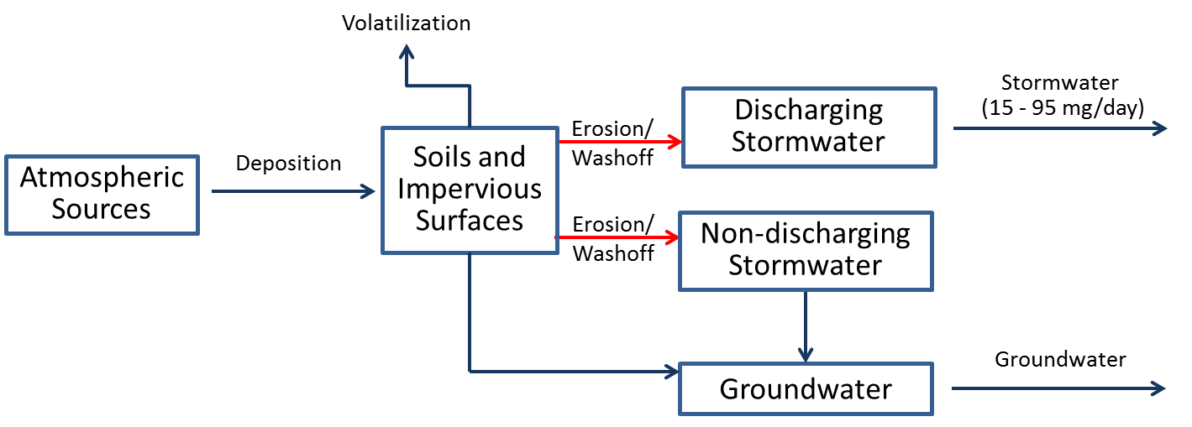
Reduction Efficiency: | Because PCBs in runoff are largely bound to soil particles, the efficiency of this control action can be estimated from the observed efficiency of LID on removing solids from runoff, which ranges from 40 to 88%. LID can also prevent stormwater from becoming contaminated by infiltrating it before it contacts contaminated surfaces such as roads. The portion of this load to the Spokane River that could be controlled by LID is unknown.
Cost: | Development and adoption of the ordinance in other communities (besides the City of Spokane which already has this type of ordinance) would likely be minimal (<$100,000) based on the information from the City of Spokane with their purchasing ordinance. However, related education and outreach efforts could be much more expensive ($100,000-$1million or more, depending on scope). Installation costs for Low Impact Development projects are project specific and would need to be evaluated with the ancillary benefits that offset the cost.
Implementing Entity: | This action is typically applied by the local agency responsible for managing land development (cities or counties). The City of Spokane LID program could serve as a model for implementation in other communities in the watershed.
PP Hierarchy: | This control action is intermediate in the Pollution Prevention hierarchy, as it is designed to manage PCBs that are currently in place in the watershed.
Existing Efforts: | A Low Impact Development ordinance has already been developed by the City of Spokane. Ecology has developed a guidance document to assist other jurisdictions with developing and implementing something similar. The Washington State Stormwater Center also has technical information and training resources for implementing low impact development projects in Eastern Washington.
Ancillary Benefit: | LID manages both stormwater and land use in a way that minimizes disturbance of the hydrologic processes, and uses on-site natural features that are integrated into an overall design so that stormwater practices include the use of natural processes such as transpiration, conservation, and infiltration. In addition to improved water quality, LID can reduce flooding, restore aquatic habitat, improve groundwater recharge, and enhance neighborhood beauty. This control action will provide other water quality benefits by reducing the loading of many other pollutants that are associated with solids and impervious surfaces (e.g. metals, bacteria).
Time Frame: | While LID ordinances can likely be developed within two years, the time frame for observing measurable reductions in PCBs is unknown.

Leaf Removal
Description: | This action consists of programs designed to enhance current municipal leaf removal programs since foliage is a receptor of atmospheric PCB loadings, and the organic matter in leaves can adsorb PCBs from other sources in runoff. Removal of leaf litter prior to it being discharged to the river could reduce loading PCB associated with this source area.
Type: | Institutional - government practices
Significance of Pathway: | This control action is theoretically 100% effective in controlling the release of PCBs from collected leaf litter. The fraction of overall leaf litter that would be captured by improved removal and the overall efficiency is of this control action is not fully known.  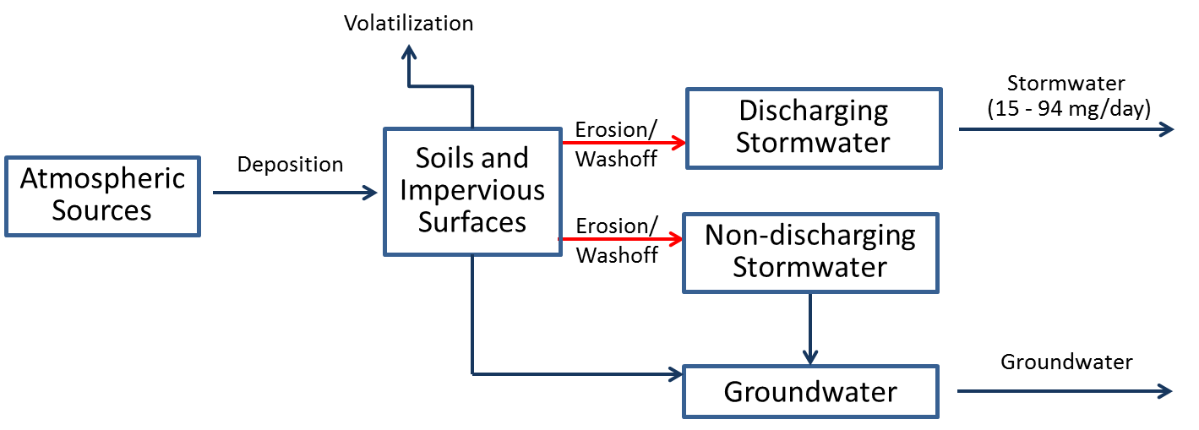
Reduction Efficiency: | The overall efficiency is of this control action is not fully known. While it is theoretically 100% effective in controlling the release of PCBs from collected leaf litter, the fraction of overall leaf litter that would be captured by improved removal is currently unknown.
Cost: | This control action is generally being implemented, such that costs would consist of further expansion of the program and/or evaluation to see if leaf removal can be more efficient or effective. Costs associated with public outreach that encourage local residents to collect leaf litter and dispose of it as green waste through existing solid waste system could mitigate current program expenses.
Implementing Entity: | Municipalities and other local governments.
PP Hierarchy: | This control action is intermediate in the Pollution Prevention hierarchy, as it is designed to manage PCBs that are currently in place in the watershed.
Existing Efforts: | Leaf removal is already a government-provided service in the City of Spokane (seasonal), Spokane county (leaves can go in green bins collected by Waste Management), and Coeur d’Alene (last two weekends in April and September).
Ancillary Benefit: | This action provides secondary benefits beyond PCB removal by reducing the loading to the Spokane River of nutrients and oxygen-demanding material contained in leaf litter.
Time Frame: | While programs can likely be developed within two years, it is expected that measurable reductions in PCB loads will not be observed within five years.

Street sweeping
Description: | This action consists of programs designed to modify current street sweeping frequency and area covered to specifically target source areas of PCBs, or when/where more material is washing down streets to prevent it from entering storm drains.
Type: | Institutional - government practices
Significance of Pathway: | This control action is targeted towards the portion of PCB contamination in stormwater runoff that accumulates on street surfaces. The primary mechanism delivering this source area to the river is discharging stormwater, which totals 15 to 94 mg/day. Due to the uncertainty in the extent of the stormwater load arising from street surfaces, the significance of this pathway is not fully known, but is likely a moderate contributor.
Reduction Efficiency: | Studies to assess the ability of street sweeping to improve concentrations of particle-bound pollutant in stormwater have reported widely varying effectiveness. Several studies showed no significant differences in stormwater concentration in response to street sweeping (e.g. USGS, 2007) while other (e.g. Sutherland, 2009) have reported decreases in concentration of more than 50% and Contra Costa County, CA reported removal of 1 kg of PCBs via street sweeping. Ecology (2007) reported an average of 74% removal efficiency for TSS for street sweeping based on two studies conducted outside of WA state. Although there is a wide range of reported reduction efficiencies, street sweeping is rated as a highly suitable in terms of reduction efficiency.
Cost: | Spokane Valley’s 2016 estimated street sweeping costs are $490,000, however there are no known provisions in the contract that specify practices (e.g., area swept, equipment used, frequency) to target PCBs in addition to the usual objectives. Based on this cost, any modification to current sweeping practices in order to specifically target PCB source areas would likely be a fraction of this cost and certainly <$100,000. Long term costs are judged to be moderate. For example, purchasing a new, high efficiency sweeper could cost $200,000-$300,000.
Implementing Entity: | Municipal Public Works Departments, State Departments of Transportation
PP Hierarchy: | This control action is intermediate in the Pollution Prevention hierarchy, as it is designed to manage PCBs that are currently in place in the watershed.
Existing Efforts: | This control action is primarily applicable to the City of Spokane, as they are responsible for the large majority of watershed area contributing to discharging stormwater systems. The City is currently developing and implementing an Integrated Clean Water Plan designed to control PCB loading from their stormwater systems, which includes street sweeping. It may be beneficial for other communities with stormwater discharges, although the size of their service area is relatively small.
Ancillary Benefit: | This action provides significant secondary benefits by reducing the loading to the Spokane River of pollutants typically associated with impervious surfaces, such as phosphorus.
Time Frame: | This control action can likely be developed within two years. Because street sweeping is already being applied, it is unlikely that modification to existing practices will show measureable benefits within the next five years.

Catch basin/pipe cleanout
Description: | This action consists of programs designed to increase the efficiency or effectiveness of catch basin and pipe cleanout to specifically remove PCB-contaminated sediment.
Type: | Institutional - government practices
Significance of Pathway: | This control action is targeted towards all pathways that deliver PCBs to discharging stormwater systems. The overall magnitude of the stormwater delivery pathway is 15-94 mg/day. Because this Control Action has the potential to affect the majority of delivered stormwater loads, the action is rated as highly suitable in terms of pathway.  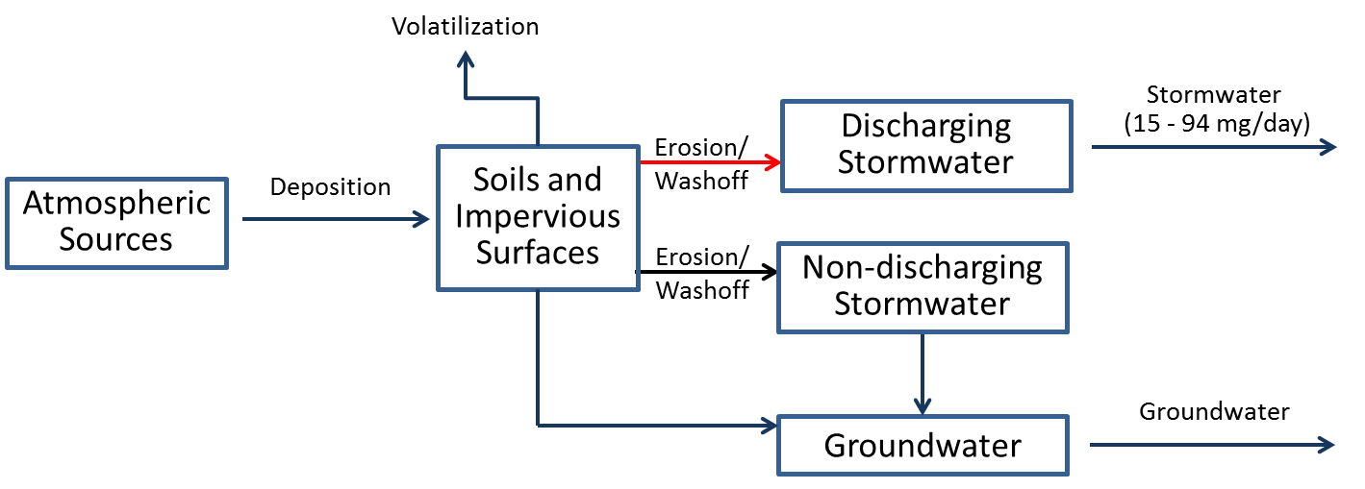
Reduction Efficiency: | While the exact reduction efficiency on the PCB overall loading rate is uncertain, the Control Action is effective in removing PCBs that could otherwise be delivered to the system. The City of Spokane removed 32.4 grams PCBs removed from their catch basins between 2010 and 2012 (Schmidt, 2015). This action also assists in source identification if PCB concentrations of the removed sediments are measured, as catch basins with higher PCB concentrations indicated elevated source areas in their drainage basis. Given the amount of PCB mass removed relative to overall stomwater loading, this action is rated as highly suitable.
Cost: | The City of Spokane spent just over $1 million on routine catch basin pumping each year (including staff, administration, dumping fees, and equipment). Increasing the frequency or changing the type of cleaning administered to catch basins in order to more effectively target PCB reduction would likely be a fraction of the total cost, or <$100,000 per year. Other communities’ costs can be estimated based on the size of the city and number of catch basins. In 2015 the City checked 15,716 catch basins (of a total over 21,000) and pumped 1,723. The area they inspect includes the CSO area and drywells.
Implementing Entity: | Municipal Public Works Departments, Department of Transportation
PP Hierarchy: | This control action is intermediate in the Pollution Prevention hierarchy, as it is designed to manage PCBs that are currently in place in the watershed.
Existing Efforts: | This control action is primarily applicable to the City of Spokane, as they are responsible for the large majority of watershed area contributing to discharging stormwater systems. The City is currently developing and implementing an Integrated Clean Water Plan designed to control PCB loading from their stormwater systems, so independent development of Control Actions by the Task Force is considered redundant to this effort.
Ancillary Benefit: | This action provides secondary benefits by reducing the loading to the Spokane River of pollutants typically associated with solids (e.g. metals, bacteria) that are captured be catch basins. More frequent catch basin cleanout can also prevent flooding.
Time Frame: | This control action is currently being implemented. The extent to which additional catch basin and pipe cleanout will result in observable near-term reductions in stormwater PCB loads is unknown.

Purchasing standards
Description: | This action consists of using existing local and state regulations to reduce or eliminate the purchase of products that contain PCBs. When wholistically implemented, it would include: 1) gathering information about PCB content in purchased products; 2) working with manufacturers to identify products with preferentially low concentrations of PCB; 3) preparing contract specifications for government purchased products in accordance with State law; and 4) providing public access to information and specifications that encourage the purchase of products with no or minimal concentrations of PCB.
Type: | Institutional - government practices
Significance of Pathway: | This control action is targeted towards the source area of inadvertently produced PCBs, which are estimated as entering the watershed at a rate of 0.2 to 450 mg/day. This class of PCBs is essentially unregulated so that it has the potential to significantly affect the delivery pathways for wastewater (54-2923 mg/day) and stormwater (15-94 mg/day) loading, although the specific contribution of inadvertent sources to these pathways is unknown.  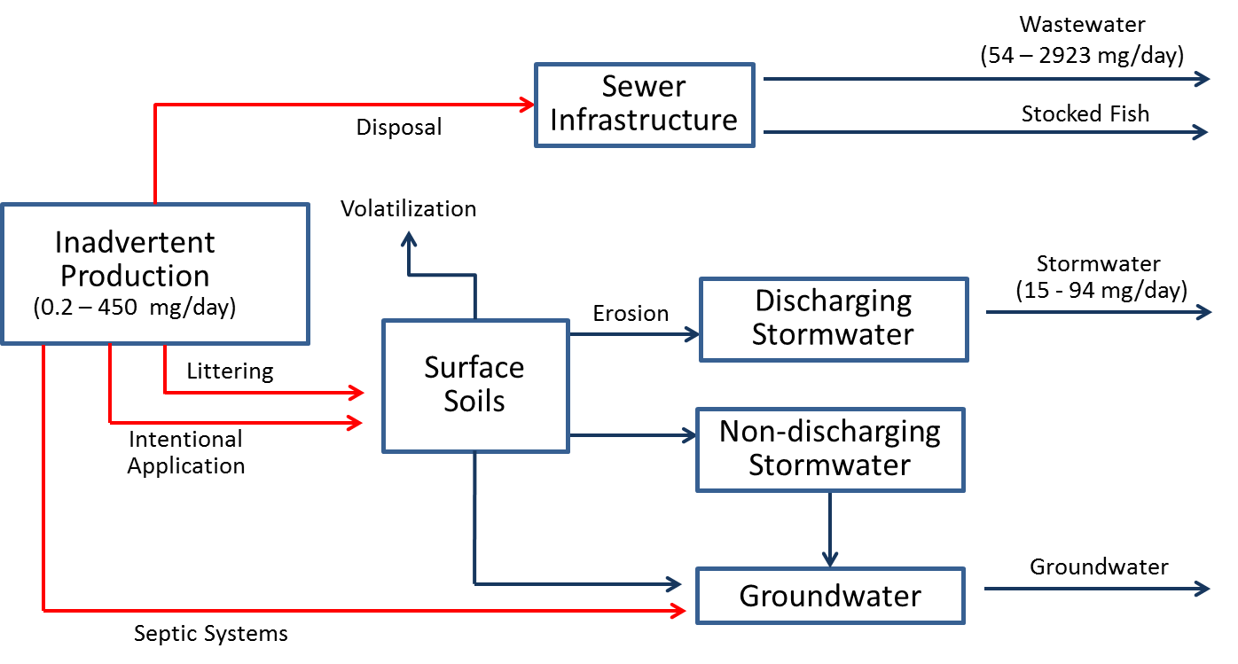
Reduction Efficiency: | This control action can theoretically reduce the contribution of affected inadvertent sources by 100%, if products currently containing PCBs can be replaced with PCB-free products. For this reason, it is rated as highly suitable in terms of reduction efficiency.
Cost: | The costs associated with this control action include: 1) Product identification and sampling; 2) Manufacturer outreach, 3) Contract specifications development and 4) public outreach. These costs are expected to be shared by implementing entities, depending on needs and funding availability.
Implementing Entity: | State governments (Departments of Ecology, Environmental Protection, Enterprise Services, Transportation), local jurisdictions within the watershed.
PP Hierarchy: | This control action in high on the Pollution Prevention hierarchy, as it is designed to reduce the use of inadvertently produced PCBs.
Existing Efforts: | Washington State Senate Bill 6086 (passed in 2014) requires State agencies to establish a purchasing and procurement policy that provides a preference for products that do not contain PCBs. (http://apps.leg.wa.gov/billinfo/summary.aspx?bill=6086&year=2013). Spokane County passed Resolution #2014-1022 in December 2014.The City of Spokane’s ordinance requires City departments to purchase PCB-free items (defined as less than the practical quantification limit using EPA Method 1668) if a feasible alternative is available at less than a 25% cost increase (Spokane Municipal code 07.06.172).
Ancillary Benefit: | This control action supports Governor Inslee’s Reducing Toxic Pollution efforts http://www.ecy.wa.gov/toxics/docs/ToxicsChemicals.pdf and Washington State Department of Ecology’s “Reducing Toxic Threats” strategy: http://www.ecy.wa.gov/toxics/index.htm which aims at controlling the small but steady releases of toxic chemicals contained in everyday products that enter the environment and cause pollution. This control action creates market incentives to reduce PCBs found in products, which has a broader benefit than the Spokane watershed.
Time Frame: | Purchasing controls can be implemented in the short term. Given the time lag between implementing purchase controls and: 1) exhausting the supplies of previously purchased materials, and 2) having inadvertently produced PCBs make their way through the watershed to the Spokane River, it is not expected that noticeable improvements would be seen within five years.

Survey of Local Utilities for Electrical Equipment
Description: | Conduct a survey of local utilities and other owners of electrical equipment to document the presence/amount of PCBs in transformers. Identify PCB-containing equipment (nominal 1 ppm concentration) that has a reasonable pathway to the river, if spilled, and target for removal.
Type: | Institutional - education
Significance of Pathway: | The action focuses on the potential for leaks or spills from industrial equipment, which has been estimated to be small (0.001 – 0.02 mg/day).  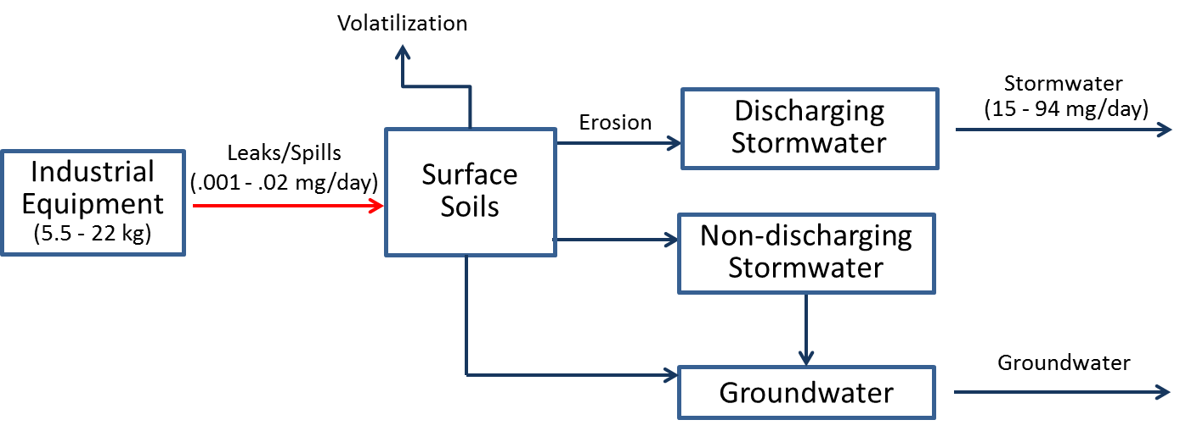
Reduction Efficiency: | This action in and of itself will have no immediate impacts on PCB loads. If local utilities use this information to target and remove PCB-containing electrical equipment, it will be a step towards better source area identification and targeted Control Action implementation.
Cost: | An estimate to implement this control action at a statewide level in Washington Department of Ecology (2015) was less than $50,000 over two years. This was based on one FTE working 25% time on this project. At the watershed scale, it would likely be even less.
Implementing Entity: | States, Local utilities, industries with privately owned electrical equipment. The control action could be a regulatory requirement or voluntary action on the part of the utility. The latter is preferable as it meets the collaborative spirit of the Task Force.
PP Hierarchy: | This control action is intermediate in the Pollution Prevention hierarchy, as it is designed to manage PCBs that are currently in place in the watershed.
Existing Efforts: | A survey of local utilities was conducted as part of early stages of Comprehensive Plan development, and found that these utilities have already taken significant measures to reduce the PCB content in their equipment.
Ancillary Benefit: | This control action has the ancillary benefit of replacing older equipment, which is more likely to fail, with newer equipment; potentially reducing the number of spills and improving reliability.
Time Frame: | Given the very small magnitude of the source area, this Control Action is not expected to result in noticeable improvements in the next five years.

Regulation Of Waste Disposal
Description: | This action consists of programs designed to review local/regional laws regulating waste disposal (including oil burning) and illegal dumping, and revise as necessary (e.g. enforcing fines/other penalties for improperly disposing of PCBs.)
Type: | Institutional--government practices
Significance of Pathway: | This action potentially affects a wide range of pathways, although the magnitude contributed by illegal disposal to any of these pathways is unknown.
Reduction Efficiency: | The reduction efficiency of this Control Action is unknown, but is likely small in terms of reducing the overall loading magnitude of any given pathway.
Cost: | The cost of this Control Action is unknown, but is expected to be less than $100,000
Implementing Entity: | Local governments.
PP Hierarchy: | This control action is intermediate in the Pollution Prevention hierarchy, as it is designed to manage PCBs that are currently in place in the watershed.
Existing Efforts: | None.
Ancillary Benefit: | This action may provide some limited ancillary benefit, by controlling improper disposal/release of other pollutants associated with illegal disposal.
Time Frame: | This Control Action is not expected to result in noticeable improvements in the next five years.

Removal of Carp from Lake Spokane
Description: | This action involves removing carp from Lake Spokane. Carp in the lake are known to be contaminated with PCBs, and removing them would prevent further cycling in the watershed.
Type: | Institutional--government practices
Significance of Pathway: | Removal of carp does not fall into the previously addressed delivery pathways, as those pathways all addressed external loads of PCBs to the system while carp represent a receptor of PCBs that have already been delivered. Nonetheless, this action can account for a significant amount of PCBs being removed, as removal of 1000 carp yields ranges of 1.5 – 4.1 grams of PCBs that could potentially be removed from Lake Spokane. If conducted on an annual basis, this corresponds to slightly less than 1% of the estimated load to the Spokane River.
Reduction Efficiency: | This is action is 100% efficient in removing PCBs from those carp that are harvested from in the lake, though 100% removal of carp in Lake Spokane is likely impracticable.
Cost: | Unknown at this point, though a pilot study is underway/planned.
Implementing Entity: | Avista Utilities and Washington Department of Ecology
PP Hierarchy: | This control action is at the bottom on the Pollution Prevention hierarchy, as it is designed to remove PCBs that are currently in the lake.
Existing Efforts: | This Control Action was suggested as a complement to existing studies conducted by Avista regarding removal of carp from Lake Spokane for the purposes of phosphorus removal. Should this effort be undertaken by Avista, there will be a direct removal of PCBs from the watershed and lake environment.
Ancillary Benefit: | This Control Action provides significant ancillary benefits. Removal of carp will also lead to a reduction in sediment phosphorus release caused by carp stirring up bottom sediments.
Time Frame: | This Control Action is not expected to result in noticeable improvements in the next five years.

Building Demolition Control Actions
Description: | This Control Action consists of establishing regulations or local ordinances that require management of PCB‐containing materials and waste during building demolition and renovation.
Type: | Institutional - government practices
Significance of Pathway: | This Control Action is targeted towards legacy fixed building sources, which have been identified as one of the largest source areas of PCBs with an estimated mass range of 60 to 130,000 kg. Klosterhaus et al (2014) summarize the available literature that demonstrates that the rate that legacy PCBs can be delivered to surrounding soils during demolition and renovation, while uncertain, is likely very significant. Furthermore, PCBs liberated through renovation can be delivered through wash water to the sewer infrastructure. The delivery pathways by which these PCBs reach the river are large (stormwater systems at 15 to 94 mg/day; wastewater at 54 to 2923 mg/day). While the exact amount of PCBs which could be reduced by this action contribute to these delivery pathways is unknown, the magnitude of the source area and delivery pathways are so large that this may be a significant pathway.  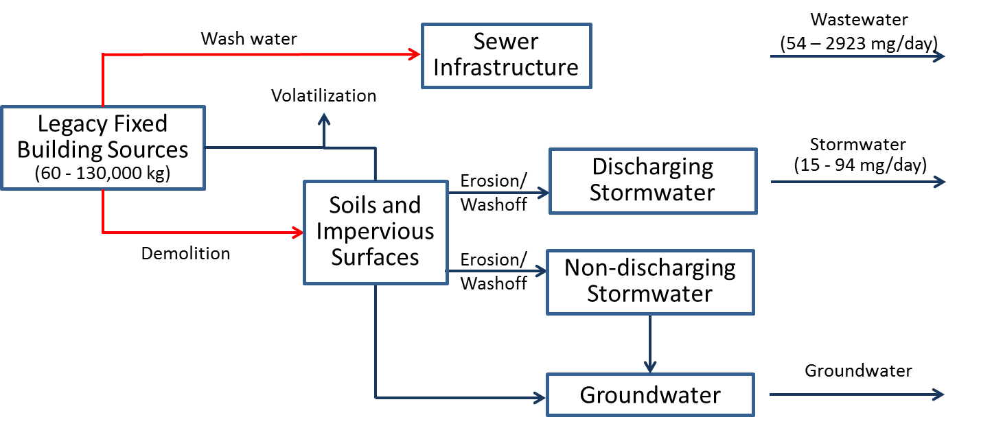
Reduction Efficiency: | The efficiency of this action is currently being investigated. Given that some regulations (e.g. Environ, 2014) require removal/remediation of all building materials with PCB concentrations greater than 50 ppb, this action has the potential to be highly effective in reducing loads.
Cost: | Costs to implement institutional-government programs would be associated with regulations, local ordinances or codes associated with managing demolition and removal projects and expected to be similar to the PCB-purchasing regulations and codes that were passed recently. In addition, there would be costs associated with public outreach and education to entities engaging in demolition and renovation. Costs to manage PCB-containing materials and debris are project specific and unknown. Estimated costs just to cut and remove caulk, and to scarify or remove adjacent substrates could range from $30-$50 per linear foot
Implementing Entity: | EPA, state, local governments.
PP Hierarchy: | This control action is intermediate on the Pollution Prevention hierarchy, as it is designed to manage PCBs that are currently in place in the watershed.
Existing Efforts: | While specific regulations are not currently in place EPA (2015) recommends that future MS4 permits should require that construction projects requiring a building permit contain requirements that the permit applicant implement specific Control Actions to minimize PCB release.
Ancillary Benefit: | This action may provide some limited ancillary benefit, by controlling improper disposal/release of other pollutants associated with building demolition. For example, a demolition practice that manages lead paint or asbestos may potentially be used to manage PCBs and vice versa.
Time Frame: | The time frame by which Building Demolition Control Actions would achieve noticeable reductions in loading is unknown.

PCB-Product Labeling Law
Description: | This action consists of developing and passing an ordinance that requires labeling products that contain PCBs, similar to the 2014 law for labeling construction materials that contain asbestos (RCW 70.310.030).
Type: | Institutional--government practices
Significance of Pathway: | This control action is targeted towards the source area of inadvertently produced PCBs, which are being imported into the watershed at a rate of 0.2 to 450 mg/day. It has the potential to affect the significant delivery pathways of wastewater (54-2923 mg/day) and stormwater (15-94 mg/day) loading, although the specific contribution of inadvertent sources to these pathways is unknown.
Reduction Efficiency: | The effectiveness of product labels to affect consumer behavior has been shown to vary widely based on many factors (Cox et al, 1997), such that the reduction efficiency is considered unknown at this time.
Cost: | Costs to be considered include regulatory rulemaking and public outreach. While the exact cost is unknown, it is expected to be under $100,000.
Implementing Entity: | Washington Department of Ecology, local governments
PP Hierarchy: | This control action is high on the Pollution Prevention hierarchy, as it is designed to reduce the use of inadvertently produced PCBs.
Existing Efforts: | There are currently no existing efforts regarding labeling products for PCBs. However, this control action is similar to an initiative taken by the Spokane Regional Clean Air Agency for asbestos in construction products.
Ancillary Benefit: | This control action raises public awareness about PCBs in products and supports Ecology’s Reducing Toxics Threats initiative.
Time Frame: | Given the time lag between implementing product labeling and: 1) exhausting the supplies of previously purchased materials, and 2) having inadvertently produced PCBs make their way through the watershed to the Spokane River, it is not expected that noticeable improvements would be seen within five years.

Leak Prevention/Detection In Electrical Equipment
Description: | This action consists of implementation of state and/or local ordinance to require a leak prevention/detection system in any PCB-containing transformer or capacitor.
Type: | Institutional--government practices
Significance of Pathway: | The action focuses on the potential for leaks or spills from industrial equipment, which has been estimated to be small (0.001 – 0.02 mg/day).
Reduction Efficiency: | This action is expected to be highly effective, as it requires implementation of a system specifically designed to control this pathway.
Cost: | The cost creating an ordinance is expected to be under $100,000, although costs to utilities to implement the program will be higher.
Implementing Entity: | Washington Department of Ecology; local governments, utilities, electrical equipment owners
PP Hierarchy: | This control action is intermediate on the Pollution Prevention hierarchy, as it is designed to manage PCBs that are currently in place in the watershed.
Existing Efforts: | A survey of local utilities was conducted as part of Comprehensive Plan development, and found that these utilities have already taken measures to reduce the PCB content in their equipment. This action is therefore considered largely redundant.
Ancillary Benefit: | This control action has the ancillary benefit of replacing older equipment, which is more likely to fail, with newer equipment; potentially reducing the number of spills and improving reliability
Time Frame: | Given the very small magnitude of the source area, this Control Action is not expected to result in noticeable improvements in the next five years.

Environmental Monitoring
Description: | This is not technically a control action; rather, it consists of expanded environmental monitoring to identify the significance of uncertain source areas and pathways.
Type: | Institutional -- government practices
Significance of Pathway: | This action affects potentially all pathways.
Reduction Efficiency: | This action in and of itself will not have immediate impacts on PCB loads but will be a step towards better source area identification and targeted Control Action implementation.
Cost: | The cost of individual monitoring projects conducted to date by the Task Force have been small ($100,000) to moderate ($100,000 to $1,000,000).
Implementing Entity: | Spokane River Regional Toxics Task Force, Washington Department of Ecology, other entities
PP Hierarchy: | Depending upon that nature of the monitoring, this action could provide information on Control Actions throughout the entire range of the hierarchy.
Existing Efforts: | While several monitoring programs are currently in place, they are only addressing a small subset of the total number of uncertain source areas and pathways. Future studies would be targeted at investigating different source areas and pathways, such that there should be little overlap between new monitoring and existing monitoring.
Ancillary Benefit: | The ancillary benefit provided by monitoring will depend on the specific nature of the monitoring project, and could vary from negligible to significant. In addition to addressing data gaps needed to employ new control actions, monitoring can assess the effectiveness of individual control actions as well as the cumulative effectiveness of the comprehensive plan.
Time Frame: | This Control Action is not expected to result in noticeable improvements in the next five years.

Accelerated Sewer Construction
Description: | This action consists of acceleration of sewer construction to replace septic systems.
Type: | Institutional--government practices
Significance of Pathway: | The source areas that contribute PCBs to septic systems are large. The ultimate delivery of these PCBs to the river and lake, while uncertain, is likely to be small.  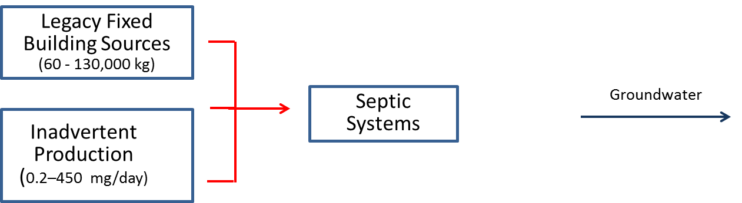
Reduction Efficiency: | This action will be nearly 100% efficient in removing loads from those septic systems that are not connected to a sewer system. Connection to a sewer system will transfer these loads to wastewater treatment plants, which will be effective in removing the PCBs. The PCB removal efficiency of a septic system is unknown, and may be equally effective as centralized wastewater treatment.
Cost: | The cost for sewer construction is expected to be significant (i.e. much higher than the current $1M threshold used for evaluation).
Implementing Entity: | Local municipalities and governments.
PP Hierarchy: | This control action is intermediate on the Pollution Prevention hierarchy, as it is designed to manage PCBs that are currently in place in the watershed.
Existing Efforts: | Spokane County has a mandatory septic tank elimination program for septic tanks within the Urban Growth Area (UGA) in areas that have sewer available, requiring connection within a year of notification and enforcement through the Prosecutor’s office. There is some overlap between the UGA and the Critical Aquifer Recharge Area (CARA), but still a large amount of area where sewer construction could help eliminate discharge to the CARA.
Ancillary Benefit: | This action will provide significant ancillary benefits, by removing the loading of a wide range of pollutants to the aquifer.
Time Frame: | Given the very small magnitude of the source area, this Control Action is not expected to result in noticeable improvements in the next five years.

PCB Identification During Inspections
Description: | This action consists of identifying PCB-containing materials as part of other regular inspections (e.g., building permits, IDDE, facility inspections). It involves training inspectors to identify materials and what to do next (safe disposal, encapsulation, etc.).
Type: | Institutional -- government practices
Significance of Pathway: | This control action is targeted towards legacy non-fixed building sources, which have been identified as one of the largest source areas of PCBs with an estimated mass range of 50 to 40,000 kg. Due to the uncertainty in the number of appliances improperly disposed, as well as the ultimate fate of those PCBs, the significance of this pathway is considered unknown.  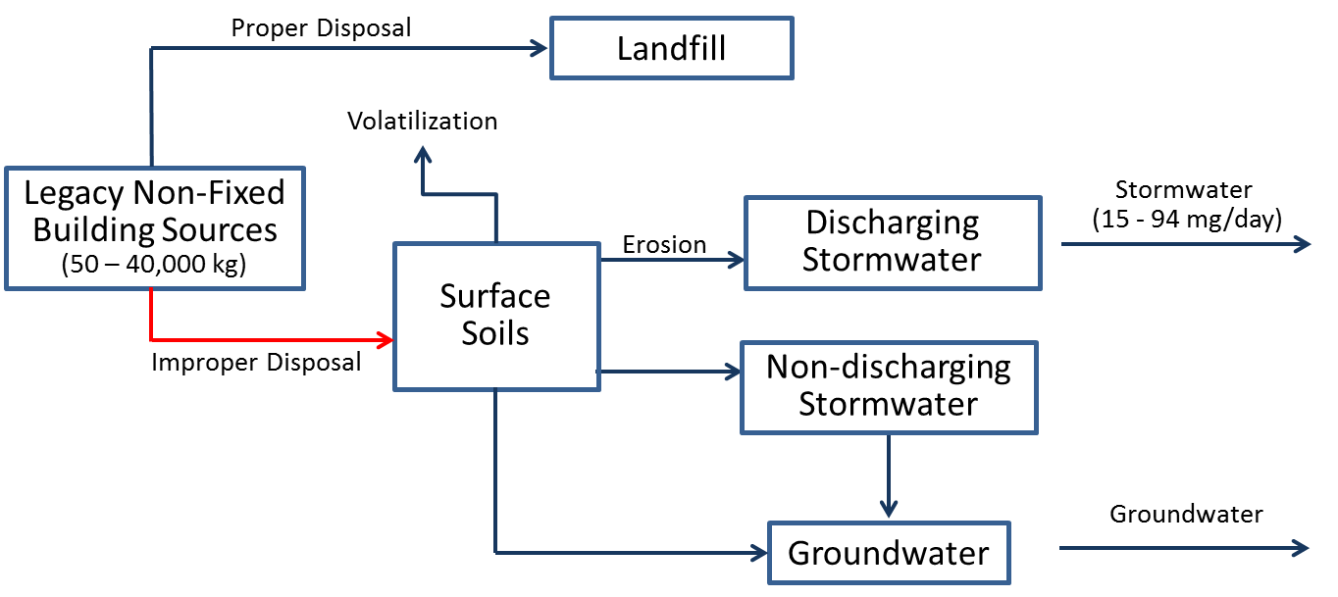
Reduction Efficiency: | This action in and of itself will not have immediate impacts on PCB loads but will be a step towards better source area identification and targeted Control Action implementation.
Cost: | San Mateo County (CA) estimated their total cost to add PCB product identification to a regular building inspector’s task list to be about $5,500/year (planning was $1500/year and operating expenses were $4,000/year). Operating costs assumes 2 hours training/year plus 8 hours reporting/year per person for 5 people at $80/hr salary. This assumes that planning costs are good for a 10 year period. Based on this example, the cost to implement this control action in Spokane County would be relatively inexpensive, and definitely less than $100,000.
Implementing Entity: | Local governments.
PP Hierarchy: | This control action is intermediate on the Pollution Prevention hierarchy, as it is designed to manage PCBs that are currently in place in the watershed.
Existing Efforts: | The Washington Legislature recognized distressed urban waters (including the Spokane River) and created the Urban Waters Initiative (implemented by Ecology) and Local Source Control Program  s (implemented by Regional County Health District). These programs regularly inspect hazardous waste generators and the works with local businesses to identify potential problems and provide technical assistance in correcting them.
Ancillary Benefit: | This action provides some ancillary benefit by identifying and helping to correct pollution sources other than PCB control.
Time Frame: | This Control Action is not expected to result in noticeable improvements in the next five years.

Regulatory Rulemaking
Description: | This action consists of regulatory reform of Federal TSCA and FDA’s food packaging regulations (21 CFR 109) to 1) re-visit currently allowed concentration of PCBs in chemical processes; 2) eliminate or reduce the creation of inadvertently generated PCB; and 3) reassess the current use authorizations for PCBs.
Type: | Institutional -- government practices
Significance of Pathway: | This control action is targeted towards legacy sources as well as inadvertently produced PCBs, which are being imported into the watershed at a rate of 0.2 to 450 mg/day. It has the potential to affect the significant delivery pathways of wastewater (54-2923 mg/day) and stormwater (15-94 mg/day) loading, although its exact significance is unknown.
Reduction Efficiency: | The overall efficiency is of this control action is unknown. Theoretically, it can reduce the contribution of affected inadvertent sources by 100%, if products currently containing PCBs can eliminated. In addition, the definition of PCBs under current use authorizations could be redefined to a number less than 50 ppm, which would help in the management of legacy PCB sources. For this reason, it is rated as highly suitable in terms of reduction efficiency.
Cost: | The costs associated with this control action include costs needed to effectively engage with federal agencies (meetings, white papers, etc.) and costs incurred by the federal agencies to revise the regulations. These costs are unknown but could be substantial.
Implementing Entity: | The regulatory rulemaking will be implemented by Federal governments and agencies (e.g. EPA).
PP Hierarchy: | This control action is high on the Pollution Prevention hierarchy, as it is designed to reduce the creation of inadvertently produced PCBs. Federal rulemaking to reassess the current use authorizations for PCBs is intermediate on the Pollution Prevention hierarchy, as it is designed to manage the use of existing PCBs.
Existing Efforts: | A coalition of conservation groups, tribal organizations, cities, counties, business, industry, regulatory agencies, legislators, academics, Labor, trade organizations and many others have been working to get new rules introduced, but efforts to date have been unsuccessful. EPA currently has two use authorizations rulemakings underway that are relevant to this control action. The FDA does not have a similar rulemaking. However, the FDA rules are extremely old, with standards dating back to the early 1980s.
Ancillary Benefit: | If the FDA standards are revisited, this could potentially result in reducing exposure to PCBs in food sources and also in fish meal used by fish hatcheries.
Time Frame: | Given the time lag between implementing regulations and: 1) exhausting the supplies of previously purchased materials, and 2) having inadvertently produced PCBs make their way through the watershed to the Spokane River, it is not expected that noticeable improvements would be seen within five years.

Compliance with PCB Regulations
Description: | This control action consists requiring stricter accountability for compliance with existing rules. Potential activities include enforcement of existing TSCA rules to ensure imported and manufactured products are complying with allowable PCB levels, and enforcement of rules related to oil burning.
Type: | Institutional--government practices
Significance of Pathway: | This control action is targeted towards the source area of inadvertently produced PCBs, which are being imported into the watershed at a rate of 0.2 to 450 mg/day. It has the potential to affect the significant delivery pathways of wastewater (54-2923 mg/day) and stormwater (15-94 mg/day) loading, although its exact significance is unknown.
Reduction Efficiency: | The overall efficiency is of this control action is unknown, due to uncertainty in the extent to which compliance with regulations currently exists.
Cost: | There is no direct cost to the Task Force associated with regulatory reform, although there are costs associated with attempting to educate legislators on the need for revisions that are likely small (<$100,000) to moderate ($100,000 to $1,000,000). Additional costs for this control action involve expenses associated with compliance and enforcement activities.
Implementing Entity: | Federal government.
PP Hierarchy: | This control action is high on the Pollution Prevention hierarchy, as it is designed to reduce the creation and use of inadvertently produced PCBs.
Existing Efforts: | The Task Force has requested this control action from the USEPA. The request remains relevant.
Ancillary Benefit: | A compliance program signals to producers of products that contain inadvertently produced PCBs (such as pigments) that violation of the TSCA manufacturing and import rules are not acceptable. This has the ancillary benefit of companies self-monitoring their own operations and reducing the overall production of this type of PCB.
Time Frame: | Given the time lag between requiring stricter accountability and: 1) exhausting the supplies of previously purchased materials, and 2) having inadvertently produced PCBs make their way through the watershed to the Spokane River, it is not expected that noticeable improvements would be seen within five years.

Support Green Chemistry Alternatives
Description: | This action consists of working with chemical manufacturers to either develop alternative (non-chlorinated) products or develop products with reduced levels of PCBs. The Task Force could support existing efforts by providing guidance and feedback to Ecology, and reaching out to other parties such as EPA and universities.
Type: | Institutional - government practices
Significance of Pathway: | This control action is targeted towards the source area of inadvertently produced PCBs, which are being imported into the watershed at a rate of 0.2 to 450 mg/day. Although its exact significance is unknown, it has the potential to affect the significant delivery pathways of wastewater (54-2923 mg/day) and stormwater (15-94 mg/day) loading. For this reason, the action is rated as highly suitable in terms of pathway.
Reduction Efficiency: | The overall efficiency is of this control action is unknown. Theoretically, it can reduce the contribution of affected inadvertent sources by 100%, if products currently containing PCBs can eliminated. For this reason, it is rated as highly suitable in terms of reduction efficiency.
Cost: | There is no direct cost associated with supporting green chemistry alternatives, although there are costs associated with coordination with chemical manufactures that are likely small (<$100,000) to moderate ($100,000 to $1,000,000).
Implementing Entity: | Chemical manufacturers.
PP Hierarchy: | This control action is high on the Pollution Prevention hierarchy, as it is designed to reduce the use of inadvertently produced PCBs.
Existing Efforts: | Ecology provides a range of technical support and expertise to educators looking to incorporate green chemistry into teaching materials, manufacturers looking to understand the potential impacts of the ingredients in their products, and to the general public who want to know which are safer choices for products (such as the “Safer Choice” label). Ecology has partnered with Northwest Green Chemistry on some of these information resources and tools.
Ancillary Benefit: | Green chemistry has many ancillary benefits including the reduction of harm associated with improper disposal. Green chemicals either degrade to innocuous products or are recovered for further use. TSCA regulatory reform will be easier if there are green chemistry alternatives to pigments that have inadvertently generated PCBs.
Time Frame: | Given the time lag between implementing green chemistry practices and: 1) exhausting the supplies of previously purchased materials, and 2) having inadvertently produced PCBs make their way through the watershed to the Spokane River, it is not expected that noticeable improvements would be seen within five years.

Survey of PCB-containing materials in Schools/Public Buildings
Description: | This action consists of programs designed to survey PCB-containing materials in schools/public buildings and enact a program to dispose of them properly or implement encapsulation.
Type: | Institutional - educational
Significance of Pathway: | This control action is targeted towards legacy non-fixed building sources, which have been identified as one of the largest source areas of PCBs with an estimated mass range of 50 to 40,000 kg. Due to the uncertainty in the number of appliances improperly disposed, as well as the ultimate fate of those PCBs, the significance of this pathway is considered unknown but potentially significant.
Reduction Efficiency: | This action in and of itself will not have immediate impacts on PCB loads but will be a step towards better source area identification and targeted Control Action implementation.
Cost: | Ecology (2015) estimated that a state-wide survey of schools for PCB-containing materials would cost $68,198/year for 2 years for a total cost of $136,396. If this effort were scaled down to the Spokane River watershed it would certainly fall in the <$100,000 cost category.
Implementing Entity: | Ecology; Spokane County Regional Health District (and equivalent agencies for Idaho communities)
PP Hierarchy: | This control action is intermediate on the Pollution Prevention hierarchy, as it is designed to manage PCBs that are currently in place in the watershed.
Existing Efforts: | None known.
Ancillary Benefit: | This action is expected to reduce elevated human health exposure to PCBs within the affected schools and public buildings.
Time Frame: | This Control Action is not expected to result in noticeable improvements in the next five years.

Education/outreach about PCB Sources
Description: | Conduct public education and outreach campaigns to spread information about the potential sources of PCBs, what to do with them if discovered (e.g., avoid pouring paint down the drain), and safer alternatives.
Type: | Institutional--educational
Significance of Pathway: | This action potentially affects a wide range of pathways, although the specific magnitudes to be addressed by education are unknown.
Reduction Efficiency: | This control action’s reduction efficiency is likely small though it may prevent some improper disposal of PCBs and also may reduce the amount of PCB-containing products from being purchased in the long term.
Cost: | Based on the Spokane County example (below), education specifically about PCBs would likely be less than $100,000 per year.
Implementing Entity: | Local government, Ecology, or Task Force-led effort
PP Hierarchy: | This control action is intermediate in the Pollution Prevention hierarchy, as it is designed to manage PCBs that are currently in place in the watershed, but it may also limit the use of inadvertently produced PCBs as well.
Existing Efforts: | Two years ago, Spokane County hired a water resources specialist specifically tasked with developing an education/outreach program to implement the County’s NPDES permit-mandated Toxics Management Plan. Approximately 1/3 of that person’s time was devoted to those activities, including web site development, preparation of outreach materials (mailers, posters, etc.), participation in the outreach workgroup, and other Water Resource Center programs. Estimated cost per year was about $35,000 including salary and outreach materials/postage.  Department of Ecology also has many education efforts that involve PCBs but mainly consist of general information on their website, and not a formal communication plan or materials production. Limited outreach has been conducted in coordination with release of the Chemical Action Plan and the purchasing law.
Ancillary Benefit: | This control action could be a joint effort among Task Force members to education the public/businesses about a range of pollutants and watershed health/protection in general.
Time Frame: | This Control Action is not expected to result in noticeable improvements in the next five years.

Education about discharge through septic systems
Description: | Educate on-site septic system owners located over the aquifer recharge area on proper disposal of wastes (e.g., not “down the drain”) and on the environmental and functional benefits of regular tank pumping
Type: | Institutional - educational
Significance of Pathway: | The source areas that contribute PCBs to septic systems are large. The ultimate delivery of these PCBs to the river and lake, while uncertain, is likely to be small.
Reduction Efficiency: | The reduction efficiency associated with this control action is currently unknown.
Cost: | It is expected that the cost of this activity will be less than $100,000.
Implementing Entity: | Local governments.
PP Hierarchy: | This control action is intermediate on the Pollution Prevention hierarchy, as it is designed to manage PCBs that are currently in place in the watershed.
Existing Efforts: | This Control Action does not overlap with any other existing efforts.
Ancillary Benefit: | This Control Action could provide ancillary benefit by limiting the extent that other undesirable material are disposed through septic systems.
Time Frame: | Given the likely small magnitude of the delivery pathway, this Control Action is not expected to result in noticeable improvements in the next five years.

Education About Filtering of Post-Consumer Paper Products
Description: | Conduct public education and outreach campaigns to inform the public about separating recycling materials that are paper w/yellow inks/pigments into the garbage stream rather than recycle bin (educational sticker on bins).
Type: | Institutional - educational
Significance of Pathway: | This control action is targeted towards the source area of inadvertently produced PCBs, which are being imported into the watershed at a rate of 0.2 to 450 mg/day. It has the potential to affect the significant delivery pathways of wastewater (54-2923 mg/day) and stormwater (15-94 mg/day) loading, although its contribution to these pathways is unknown. Conversely, it has the potential to re-route PCBs to the atmosphere as these products are incinerated.  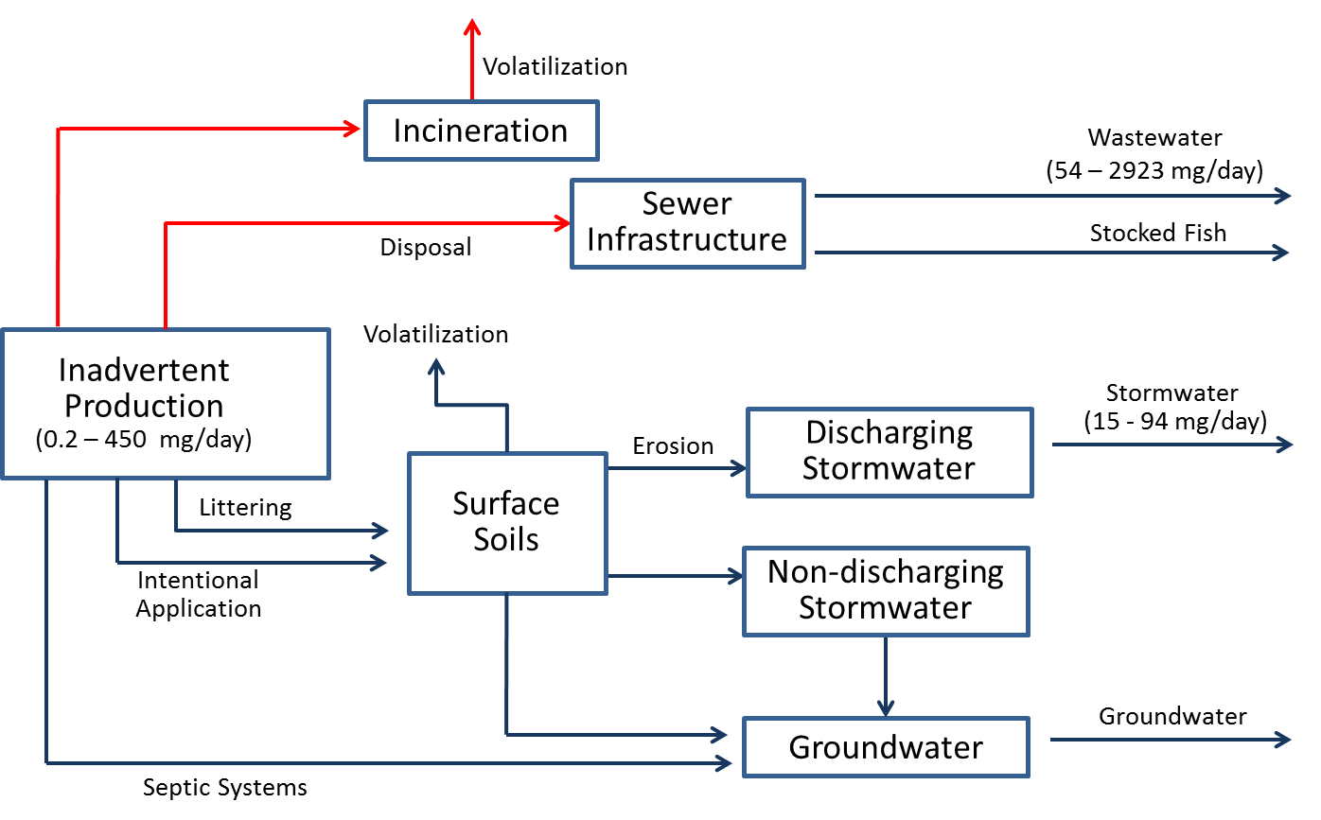
Reduction Efficiency: | The reduction efficiency associated with this control action is currently unknown.
Cost: | It is expected that the cost of this activity will be less than $100,000.
Implementing Entity: | Local governments.
PP Hierarchy: | This control action is intermediate on the Pollution Prevention hierarchy, as it is designed to manage PCBs that are currently in place in the watershed.
Existing Efforts: | This Control Action does not overlap with any other existing efforts.
Ancillary Benefit: | None known.
Time Frame: | This Control Action is not expected to result in noticeable improvements in the next five years.

PCB Product Testing
Description: | This Control Action consists of further study of the extent to which commercial products contain inadvertently produced PCBs, as well as creation of a database to store the collected information. It could also include public education on products containing PCBs.
Type: | Institutional--education
Significance of Pathway: | This control action is targeted towards the source area of inadvertently produced PCBs, which are being imported into the watershed at a rate of 0.2 to 450 mg/day. It has the potential to affect the significant delivery pathways of wastewater (54-2923 mg/day) and stormwater (15-94 mg/day) loading, although its exact significance is unknown.  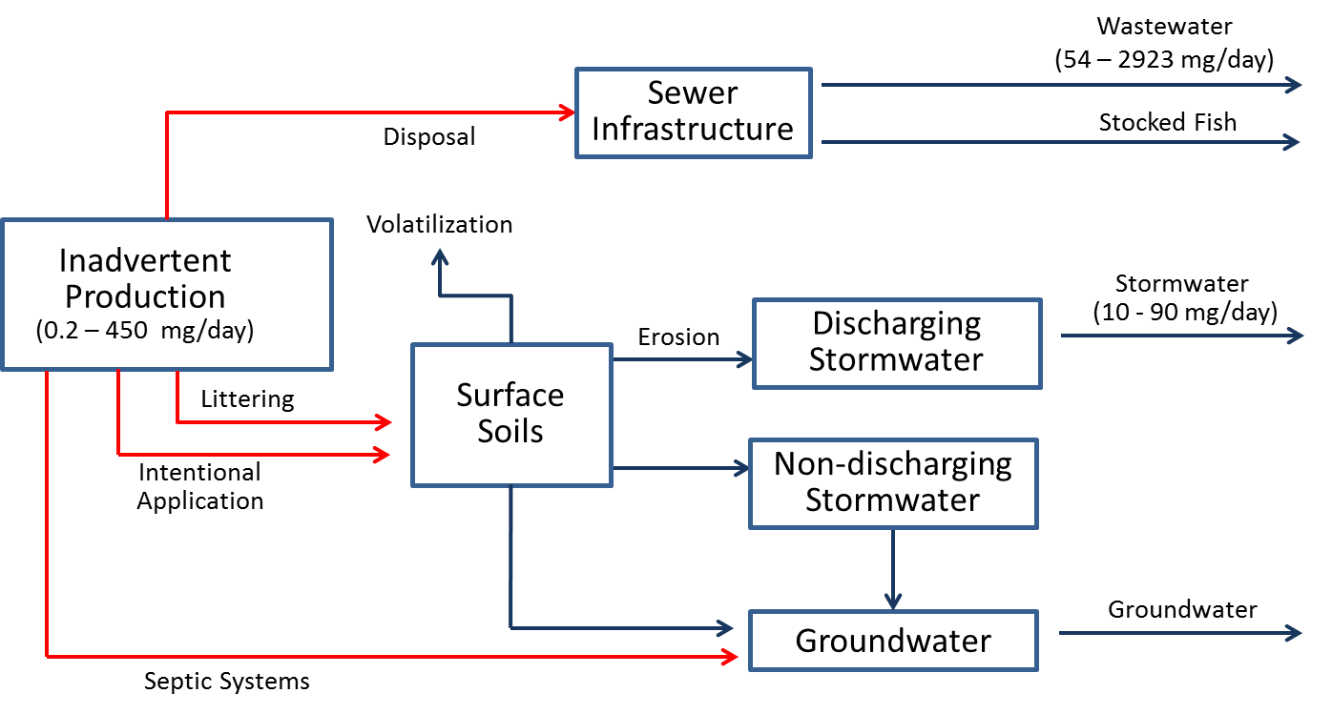
Reduction Efficiency: | This action in and of itself will not have immediate impacts on PCB loads but will be a step towards better source area identification and targeted Control Action implementation.
Cost: | The cost of this action will depend on the number of materials evaluated. It is reasonable to assume that sampling of a diverse range of materials, in conjunction with creation of a data base, will be intermediate (i.e. between $100,000 and $1,000,000) in cost.
Implementing Entity: | This action could be implemented by a range of entities, including Washington Department of Ecology, local governments, or the Spokane River Regional Toxics Task Force.
PP Hierarchy: | This control action in high on the Pollution Prevention hierarchy, as it is designed to reduce the use of inadvertently produced PCBs.
Existing Efforts: | Initial efforts in measuring PCB content of commercial products have been conducted by Ecology and the City of Spokane, although these studies have only evaluated a subset of the thousands of products potentially of concern.
Ancillary Benefit: | This action provides some ancillary benefit by supporting Ecology’s Toxic Threats reduction activities.
Time Frame: | Given the time lag between understanding existing PCB content and: 1) exhausting the supplies of previously purchased materials, and 2) having inadvertently produced PCBs make their way through the watershed to the Spokane River, it is not expected that noticeable improvements would be seen within five years.

Stormwater Treatment - Pipe Entrance
Description: | This sub-category of control actions is designed to capture/treat stormwater onsite before it enters storm pipes, and can consist of: infiltration control actions such as trenches, basins, dry wells; bioretention control actions such as swales and buffer strips; filters; screens; wet vault; and hydrodynamic separator.
Type: | Stormwater Treatment - Pipe Entrance
Significance of Pathway: | This control action is targeted towards PCB contamination in stormwater. The primary mechanism delivering this source area to the river is discharging stormwater, which totals 15 to 94 mg/day and is considered a significant contributor.  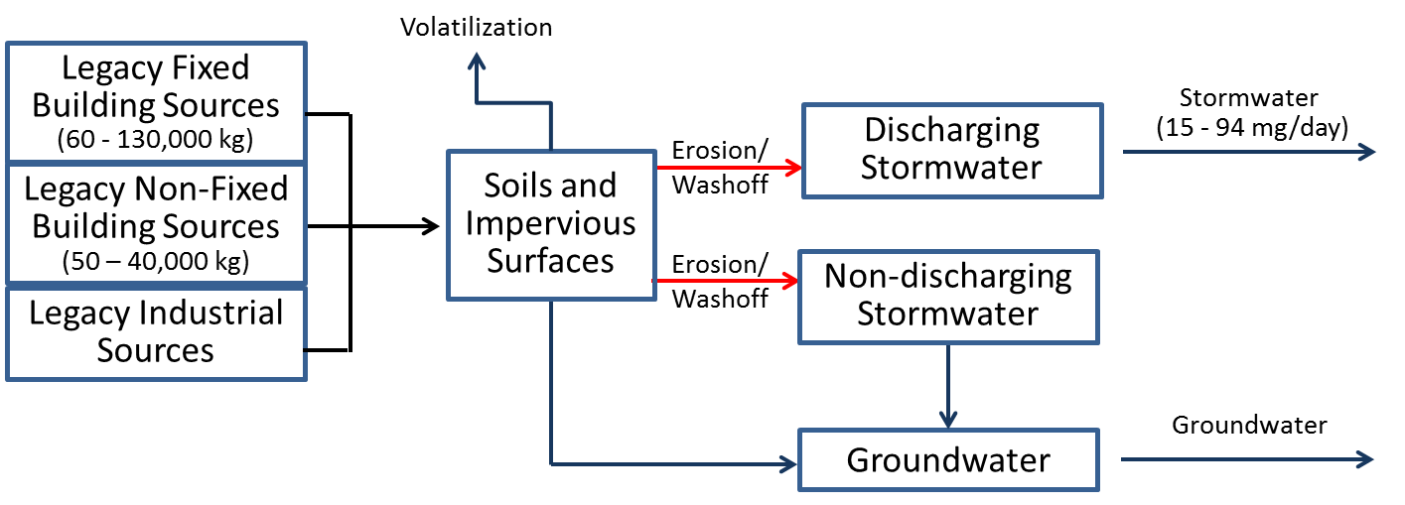
Reduction Efficiency: | Infiltration control actions can have very high removal of TSS which should be correlated to PCB load reduction. Tetra Tech (2010) reported 60-100% removal of TSS in various infiltration control actions in the Boston area. Washington State Department of Transportation (2008) also indicated high removal efficiency potential of infiltration control actions for both TSS and organic contaminants. Ecology (2007) reported 64% removal efficiency for TSS in filter strips, 71% for porous pavement, 51% for vegetated swales, and 85% for infiltration basins.
Cost: | Costs vary across specific Control Actions, but can generally be expected to be significant (i.e. >$1,000,000) for any widespread application.
Implementing Entity: | Local municipalities.
PP Hierarchy: | This control action is intermediate on the Pollution Prevention hierarchy, as it is designed to manage PCBs that are currently in place in the watershed.
Existing Efforts: | The primary mechanism delivering this source area to the river is discharging stormwater, which comes mostly from the City of Spokane. The City is developing control actions for PCBs as part of their Integrated Clean Water Plan, and is in a better position to evaluate this action than the Task Force. It may be beneficial for other communities with stormwater discharges, although the size of their service area is relatively small.
Ancillary Benefit: | This Control Action will reduce the loading of other pollutants associated with stormwater, such as nutrients.
Time Frame: | Depending upon the nature of the controls implemented, noticeable improvements could be expected within two to five years.

Stormwater Treatment – Pipe System
Description: | This sub-category of control actions is installed in the MS4 infrastructure (e.g., pipes, storm drain inlets). These actions usually have higher maintenance requirements (compared to other stormwater control actions) and can sometimes impede flow when not maintained properly. Options include: 1) Screens that trap contaminated solids and larger debris to prevent discharge of that material to receiving waterbodies; 2) Filters or “socks”, like screens, that trap contaminated solids and prevent discharge of that material to receiving waterbodies; 3) Wet vaults, consisting of a permanent pool of water in a vault that rises and falls with storms and has a constricted opening to let runoff out. Its main treatment mechanism is settling of solids that are contaminated; and 4) Hydrodynamic separators that use cyclonic separation to trap solids and debris as stormwater flows through them before being discharged to receiving waterbodies
Type: | Stormwater Treatment - Pipe System
Significance of Pathway: | This control action is targeted towards PCB contamination in stormwater. The primary mechanism delivering this source area to the river is discharging stormwater, which totals 15 to 94 mg/day and is considered a significant contributor.  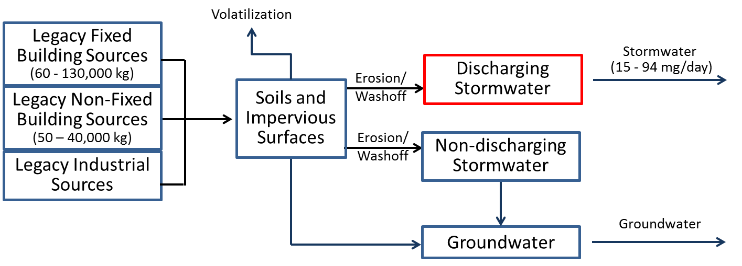
Reduction Efficiency: | Infiltration control actions can have very high removal of TSS which can be correlated to PCB load reduction. Washington State Department of Transportation (2008) indicated high removal efficiency potential of wet ponds for both TSS and organic contaminants. Ecology (2007) reported 12% removal efficiency for TSS in centrifugal separators and 34% for filters.
Cost: | Costs vary across specific Control Actions, but can generally be expected to be significant (i.e. $1,000,000 for any widespread application.
Implementing Entity: | Local municipalities.
PP Hierarchy: | This control action is intermediate on the Pollution Prevention hierarchy, as it is designed to manage PCBs that are currently in place in the watershed.
Existing Efforts: | The primary mechanism delivering this source area to the river is discharging stormwater, which comes mostly from the City of Spokane. The City is developing control actions for PCBs as part of their Integrated Clean Water Plan, and is in a better position to evaluate this action than the Task Force. It may be beneficial for other communities with stormwater discharges, although the size of their service area is relatively small.
Ancillary Benefit: | This Control Action will reduce the loading of other sediment-bound pollutants associated with stormwater, such as nutrients.
Time Frame: | Depending upon the nature of the controls implemented, noticeable improvements could be expected within two to five years.

Stormwater Treatment - End of Pipe
Description: | This sub-category of control actions is installed at the end of the MS4 infrastructure. Options include: 1) Constructed wetlands, 2) Sedimentation basins, 3) Discharge to ground/dry well, 4) Diversion to treatment plant, and 5) Fungi (mycoremedation) or biochar incorporated into stormwater treatment.
Type: | Stormwater Treatment – End of Pipe
Significance of Pathway: | This control action is targeted towards PCB contamination in stormwater. The primary mechanism delivering this source area to the river is discharging stormwater, which totals 15 to 94 mg/day and is considered a significant contributor.  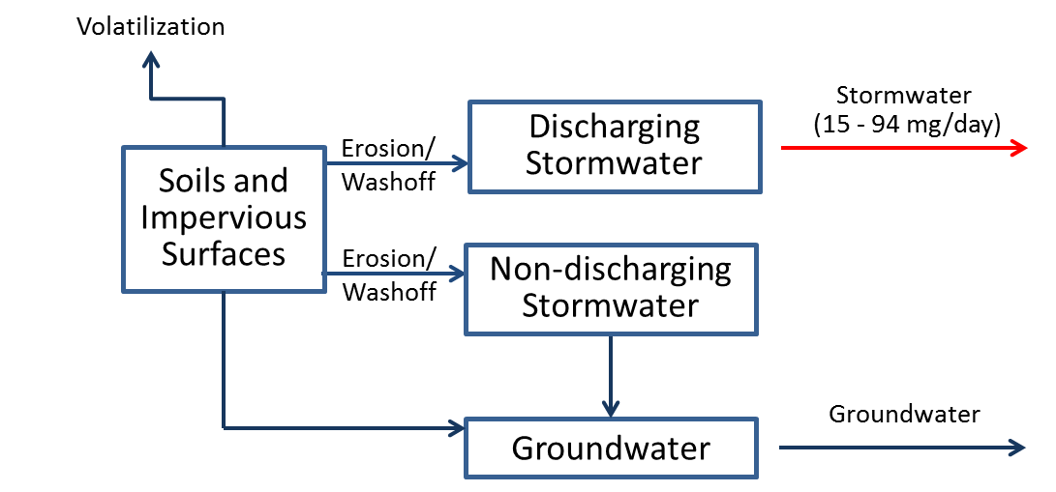
Reduction Efficiency: | Infiltration control actions can have very high removal of TSS which can be correlated to PCB load reduction. Washington State Department of Transportation (2008) indicated high removal efficiency potential of stormwater wetlands for both TSS and organic contaminants. Detention basins had high removal efficiency for TSS and medium removal efficiency for organic contaminants. Tetra Tech (2010) reported TSS removal efficiency of 30-85% for wet ponds and 20-50% for dry ponds in the Boston Area. Ecology (2007) reported 72% removal efficiency for TSS in constructed wetlands and 25-69% for dry ponds (higher efficiency for vegetated ponds).
Cost: | Costs vary across specific Control Actions, but can generally be expected to be significant (i.e. $1,000,000 for any widespread application.
Implementing Entity: | The primary mechanism delivering this source area to the river is discharging stormwater, which comes mostly from the City of Spokane. The City is developing control actions for PCBs as part of their Integrated Clean Water Plan, and is in a better position to evaluate this action than the Task Force. It may be beneficial for other communities with stormwater discharges, although the size of their service area is relatively small.
PP Hierarchy: | This control action is lowest on the Pollution Prevention hierarchy, as it is designed to treat PCBs immediately before they are being discharged to the system.
Existing Efforts: | The primary mechanism delivering this source area to the river is discharging stormwater, which comes mostly from the City of Spokane. The City is developing control actions for PCBs as part of their Integrated Clean Water Plan, and is in a better position to evaluate this action than the Task Force. It may be beneficial for other communities with stormwater discharges, although the size of their service area is relatively small.
Ancillary Benefit: | This Control Action will reduce the loading of other pollutants associated with stormwater, such as nutrients.
Time Frame: | Depending upon the nature of the controls implemented, noticeable improvements could be expected within two to five years.

Wastewater Treatment
Description: | This sub-category of control actions correspond to reducing pollutant loading from wastewater treatment plans. Options include: 1) Development of a Toxics Management Action Plan, 2) Implementation of a source tracking program, 3) Chemical fingerprinting or pattern analysis, 4) Remediation and/or mitigation of individual sources, 5) Elimination of PCB-containing equipment, 6) Public outreach and communications, 7) Review of procurement ordinances, 8) Pretreatment regulations.
Type: | Waste water Treatment – End of Pipe
Significance of Pathway: | This control action is targeted towards PCB contamination in wastewater, which delivers a total load of 54 to 2923 mg/day and is considered a significant contributor.  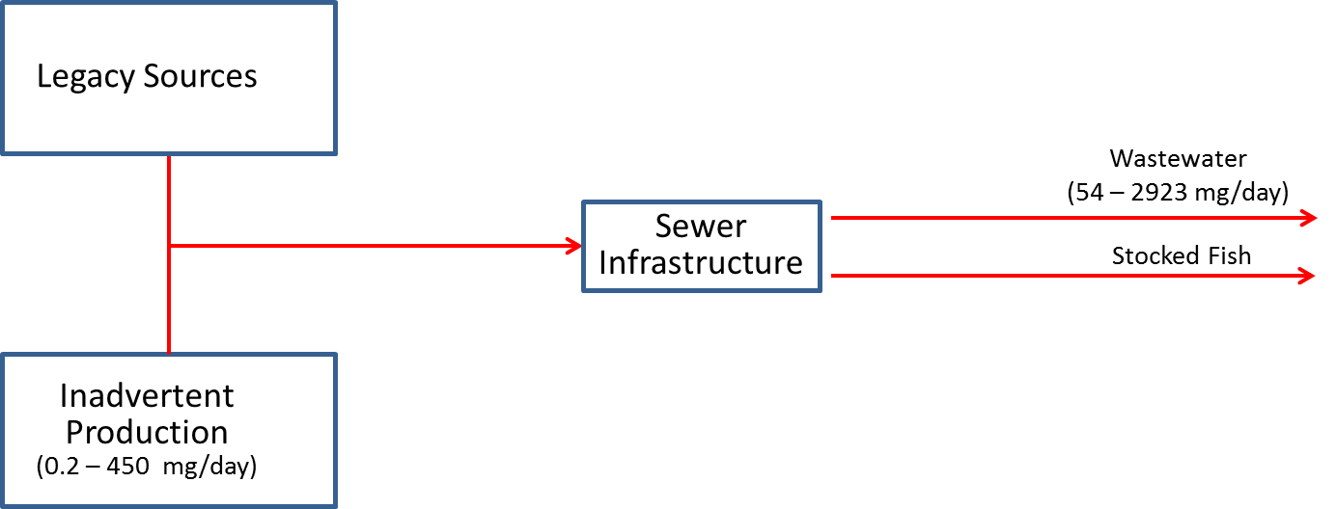
Reduction Efficiency: | Wastewater treatment has the potential to achieve high rates of PCB removal.
Cost: | Costs vary across specific Control Actions, but can generally be expected to be significant (i.e. $1,000,000 for any widespread application.
Implementing Entity: | NPDES permits are written by Ecology and EPA, while controls are implemented by municipalities and industries with NPDES permits.
PP Hierarchy: | This control action is lowest on the Pollution Prevention hierarchy, as it is designed to treat PCBs immediately before they are being discharged to the system.
Existing Efforts: | These actions are currently included as requirement in existing NPDES permits. These permits will continue to dictate wastewater treatment requirements, not the Comprehensive Plan
Ancillary Benefit: | This Control Action will reduce the loading of other pollutants associated with wastewater, such as nutrients.
Time Frame: | Depending upon the nature of the controls implemented, noticeable improvements could be expected within two to five years.

Contaminated Site Identification
Description: | This control action consists of the identification of contaminated sites that could be contributing PCBs to the Spokane River.
Type: | Contaminated Sites
Significance of Pathway: | This control action is targeted towards contaminated sites beyond those that are currently being remediated. The PCB loading from these sources is unknown, although the mass balance assessment conducted by the Task Force indicates that they could potentially be a significant contributor.
Reduction Efficiency: | This action does not reduce pollutant loads, but can contribute to future load reduction by identifying sites that contribute PCB loads that can be addressed by remediation.
Cost: | Costs will depend upon the amount of additional data collected to support investigations, but should generally be less than $100,000.
Implementing Entity: | Ecology, Task Force.
PP Hierarchy: | This control action is intermediate on the Pollution Prevention hierarchy, as it is designed to manage PCBs that are currently in place in the watershed.
Existing Efforts: | Ecology (2015) performed preliminary research to review existing groundwater and soil data to identify contaminated sites and evaluate their current status, and rated sites in terms of their potential for contributing PCBs to the river.
Ancillary Benefit: | Cleanup of contaminated PCB sites can provide moderate ancillary benefits, as other pollutants often co-occur with PCB contamination.
Time Frame: | This action will not directly result in load reductions, but could serve to identify additional candidate sites for the subsequent Control Action of Contaminated Site Remediation.

Contaminated Site Remediation
Description: | This control action consists of the cleanup of contaminated sites.
Type: | Contaminated Sites
Reduction Efficiency: | Cleanup activities are able to achieve a high degree of pollutant load reduction.
Significance of Pathway: | This control action is targeted towards contaminated sites, which are currently estimated to deliver a total load of 60 - 300 mg/day and is considered a significant contributor.  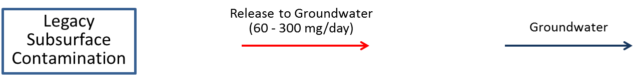
Cost: | Costs vary across specific Control Actions, but can generally be expected to be significant (i.e. $1,000,000 for any widespread application.
Implementing Entity: | Ecology, identified responsible parties
PP Hierarchy: | This control action is intermediate on the Pollution Prevention hierarchy, as it is designed to manage PCBs that are currently in place in the watershed.
Existing Efforts: | Cleanup efforts are in place at known contaminated sites. These efforts include assessment of the effectiveness of prior remediation actions (e.g. Upriver Dam and Donkey Island, City Parcel, and General Electric) sites and ongoing remediation at the Kaiser site.
Ancillary Benefit: | Cleanup of contaminated PCB sites can provide moderate ancillary benefits, as other pollutants often co-occur with PCB contamination.
Time Frame: | The time frame by which noticeable improvements could be observed is currently unknown.

