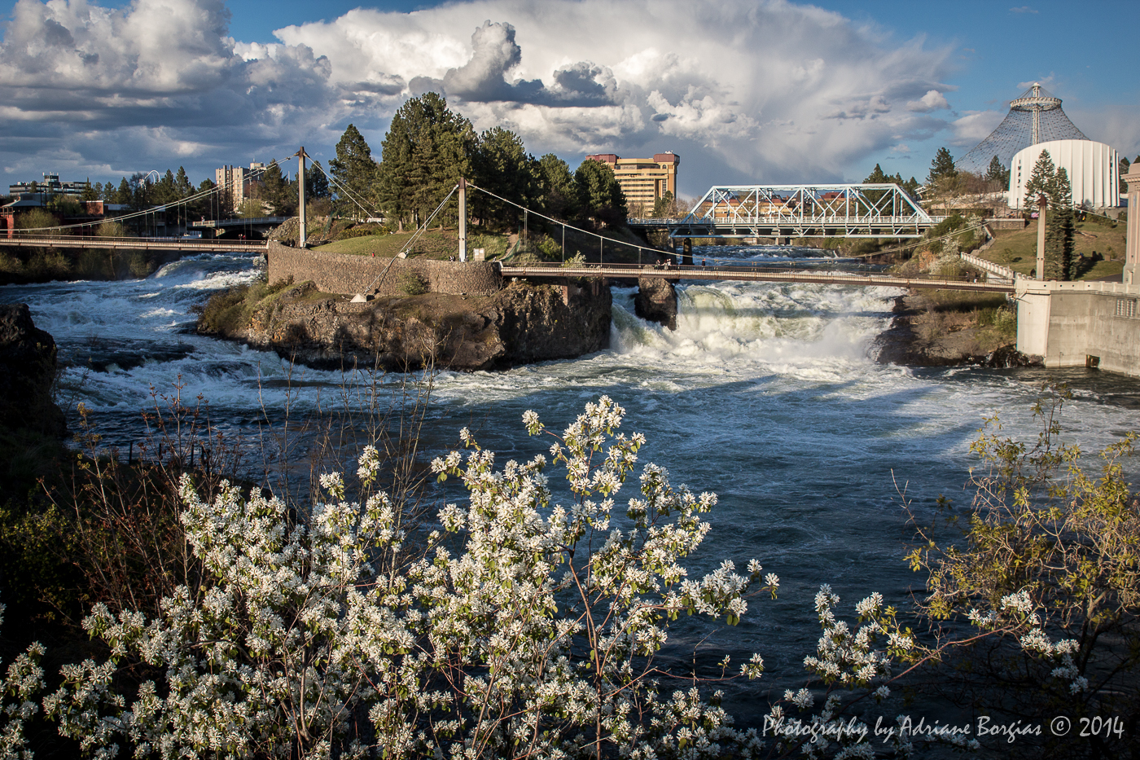

**Prepared for:**

**Spokane River Regional Toxics Task Force**

**October 24, 2016 REDLINE DRAFT**

**Comprehensive Plan to Reduce Polychlorinated Biphenyls (PCBs) in the Spokane River**

*Cover photograph courtesy of Adriane Borgias*

Comprehensive Plan to Reduce   
Polychlorinated Biphenyls (PCBs) in the Spokane River

REDLINE DRAFT

Prepared for:

Spokane River Regional Toxics Task Force

October 24, 2016

Blank page

Table of Contents

Executive Summary ES-1

1 Introduction 1

1.1 Creation and Membership of the SRRTTF 1

1.2 Comprehensive Plan 2

2 Watershed Characterization 3

2.1 Study Area 3

2.2 Hydrology 4

2.3 Land Use and Population 5

2.4 Available Data 6

2.4.1 2013 Data Compilation 6

2.4.2 Data Collected After 2013 7

2.5 Impairment status 9

3 PCB Source Assessment 11

3.1 PCBs Source Areas 11

3.2 Delivery Mechanisms of PCBs to the Spokane River 13

3.3 Transport Pathways between Source Areas and Delivery 15

4 PCB Control Actions 19

4.1 Inventory of Control Actions to Be Evaluated 19

4.2 Evaluation of Control Action Cost and Effectiveness 22

4.3 Review Factors 22

4.4 Review Findings 24

4.5 Selection of Control Actions for Inclusion in the Comprehensive Plan 26

5 Implementation Plan 31

5.1 Category A: Wastewater Treatment 31

5.1.1 Idaho Municipal Permits 31

5.1.2 Washington Municipal Permits 32

5.1.3 Fish Hatchery General Permit 34

5.1.4 Schedule and Monitoring Program 34

5.2 Category A: Remediate Known Contaminated Sites 34

5.2.1 Spokane River Upriver Dam and Donkey Island 35

5.2.2 General Electric Co. 35

5.2.3 City Parcel 35

5.2.4 Kaiser Aluminum 36

5.2.5 Schedule and Monitoring Program 36

5.3 Category A: Stormwater Controls 36

5.3.1 NPDES permits for MS4s 36

5.3.2 City of Spokane’s Integrated Clean Water Plan 37

5.3.3 Schedule and Monitoring Program 38

5.4 Category A: Low Impact Development Ordinance 38

5.4.1 Schedule and Monitoring Program 38

5.5 Category A: Street Sweeping 38

5.5.1 Schedule and Monitoring Program 39

5.6 Category A: Purchasing Standards 39

5.6.1 Schedule and Monitoring Program 39

5.7 Category B: Support of Green Chemistry 39

5.7.1 Existing Actions 39

5.7.2 New Actions 40

5.7.3 Schedule and Monitoring Program 40

5.8 Category B: PCB Product Testing Information 40

5.8.1 Existing Actions 40

5.8.2 New Actions 41

5.8.3 Schedule and Monitoring Program 41

5.9 Category B: Waste Disposal Assistance 41

5.9.1 Existing Actions 41

5.9.2 New Actions 42

5.9.3 Schedule and Monitoring Program 42

5.10 Category B: Regulatory Rulemaking 42

5.10.1 Existing Actions 42

5.10.2 New Actions 42

5.10.3 Schedule and Monitoring Program 43

5.11 Category B: Compliance with PCB Regulations 43

5.11.1 Existing Actions 43

5.11.2 New Actions 43

5.11.3 Schedule and Monitoring Program 43

5.12 Category B: Emerging End of Pipe Stormwater Technologies 44

5.12.1 Existing Actions: 44

5.12.2 New Actions: 44

5.12.3 Schedule and Monitoring Program 44

5.13 Category C: Building Demolition and Renovation Control 45

5.13.1 Actions 45

5.13.2 Schedule and Monitoring Program 45

5.14 Category C: Identification of Sites of Concern for Contaminated Groundwater 46

5.14.1 Actions 46

5.14.2 Schedule and Monitoring Program 49

6 Future Activities 51

6.1 Implementation Effectiveness Assessment 51

6.2 Consideration of Control Additional Actions 51

6.2.1 Education on Septic Disposal 52

6.2.2 Survey Schools and Public Buildings 52

6.2.3 Accelerated Sewer Construction 52

6.2.4 Emerging Wastewater Technology 52

6.2.5 Survey Electrical Equipment 52

6.2.6 Leak Prevention/ Detection 52

6.2.7 Regulation of Waste Disposal 53

6.2.8 Stormwater Source Tracing 53

6.2.9 Removal of Carp from Lake Spokane 53

6.2.10 PCB Identification during Inspections 53

6.2.11 Compliance with PCB Regulations for Imported Products 53

6.3 Studies to Address Data Gaps 53

6.3.1 Fish 53

6.3.2 Sediments 54

7 References 55

List of Figures

Figure 1. Spokane River Watershed 4

Figure 2. Land Use in the Area of Focus for the Comprehensive Plan 6

Figure 3. Estimated Range of Mass of PCB in each Source Area Category (Note the large difference in scale between the two embedded graphs) 13

Figure 4. Estimated Range of PCB Loading Rates (mg/day) for each Delivery Mechanism 15

Figure 5. Estimated Magnitudes (kg/yr) for Watershed Mobilization Pathways 16

Figure 6. Homolog Distribution of Groundwater Monitoring Data Collected form Kaiser Plume (top) and Up-Gradient/Cross-Gradient Wells (bottom) 47

List of Tables

Table 1. Mass of PCB Estimated in each Source Area Category 12

Table 2. PCB Loading Rates Estimated for each Delivery Mechanism 14

Table 3. Menu of Control Actions Identified as Potentially Applicable for Reducing PCB Loads to the Spokane River and Lake Spokane 21

Table 4. Initial Summarization of Control Actions 25

Table 5. Summary of Control Options Presented at July 27, 2016 Workshop 27

Table 6. Milestones, Timelines and Effectiveness Metrics for Green Chemistry 40

Table 7. Milestones, Timelines and Effectiveness Metrics for PCB Product Testing Information 41

Table 8. Milestones, Timelines and Effectiveness Metrics for Waste Disposal Assistance 42

Table 9. Milestones, Timelines and Effectiveness Metrics for Regulatory Rulemaking 43

Table 10. Milestones, Timelines and Effectiveness Metrics for Compliance with PCB Regulations 44

Table 11. Milestones, Timelines and Effectiveness Metrics for Emerging End of Pipe Stormwater Technologies 45

Table 12. Milestones, Timelines and Effectiveness Metrics for Building Demolition and Renovation Control 46

Table 13. Milestones, Timelines and Effectiveness Metrics for Identification of Sites of Concern for Contaminated Groundwater 49

Executive Summary

The Spokane River begins in northern Idaho at the outlet of Coeur d’Alene Lake and flows west 112 miles to the Columbia River. Sections of the Spokane River and Lake Spokane have been placed on the EPA 303(d) list of impaired waters because fish tissue concentrations of polychlorinated biphenyls (PCBs) that exceed a fish tissue equivalent concentrations for applicable water quality standards, as well as for other pollutants. The Spokane River Regional Toxics Task Force (SRRTTF), comprised of NPDES permittees, state and local agencies, environmental groups, tribal sovereigns, EPA and other stakeholders, was formed with the goal to develop a comprehensive plan to bring the Spokane River into compliance with applicable water quality standards for PCBs ([SRRTTF, 2012b](http://srrttf.org/wp-content/uploads/2012/10/SRRTTF-Work-Plan-First-Draft-Adopted-10-24-12-CLEAN1.pdf)). This document presents that Comprehensive Plan.

This Plan is based on of data drawn from studies by the Washington State Department of Ecology (Ecology) and recent monitoring efforts by the Task Force. The Task Force analyzed these data to estimate the mass of PCBs currently present in various source areas throughout the watershed, as well as the loading rate of PCBs to the Spokane River from various delivery mechanisms. In addition, data (2014–2016) for ambient surface water conditions at eight SRRTTF river monitoring locations shows that the central tendencies of the data ranges from 17 pg/L to 154 pg/L as compared to the current water quality standard of 170 pg/L.

PCBs produced intentionally through 1979, termed legacy PCBs, in buildings (i.e. small capacitors, sealants) and legacy soil contamination are estimated to be the largest source areas of PCBs in the watershed. The primary delivery mechanisms of PCBs to the Spokane River were determined to be cumulative loading across all wastewater treatment plants, contaminated groundwater, and stormwater/combined sewer overflows. PCB loading from Lake Coeur d’Alene and Spokane River tributaries are of similar magnitude to the other primary delivery mechanisms, due to much higher flow rates but with much lower concentrations of PCBs.

A range of Control Actions (defined as “any activity which prevents, controls, removes or reduces pollution”) will be needed to reduce PCB loading from a number of different source areas and delivery mechanisms, A range of Control Actions (defined as “any activity which prevents, controls, removes or reduces pollution”) will be needed to reduce PCB levels and ultimately attain water quality standards. The Task Force identified 45 Control Actions considered potentially applicable to address PCBs in the Spokane River were identified, and assessed in terms of costs and effectiveness. The specific Control Actions to be included in the Comprehensive Plan were determined at a SRRTTF workshop held in Spokane on July 27, 2016. Discussion of Control Actions at that workshop was divided into tiers of: 1) Control Actions already being implemented, some of which are addressed by existing regulatory mechanisms and 2) Potential new Control Actions. Existing Control Actions were placed by the group into one of two categories. The first category contained the following Control Actions, where the group decided to maintain current efforts, and document those efforts in the Plan:

* Wastewater Treatment
* Remediate Known Contaminated Sites
* Stormwater Controls
* Low Impact Development Ordinance
* Street Sweeping
* Purchasing Standards

The second category contained existing Control Actions where the group identified improvements that could be made to current efforts. These consisted of:

* Support of Green Chemistry Alternatives
* PCB Product Testing Information
* Waste Disposal Assistance
* Regulatory Rulemaking
* Compliance with PCB Regulations
* Emerging End of Pipe Stormwater Technologies

Potential new Control Actions were reviewed next, with two actions identified for inclusion in the Comprehensive Plan and a commitment to implementation:

* Identification of Sites of Concern for Contaminated Groundwater
* Building Demolition and Renovation Control

Finally, eleven other new Control Actions were identified as being worthy of consideration in the future.

The Implementation Plan portion of this document lists milestones, timelines, and metrics to assess effectiveness for each of the new or expanded Control Actions. The effectiveness of SRRTTF’s implementation of Control Actions will be assessed, in part, via annual preparation of an Implementation Review report which will compare actions conducted over the prior year to the timelines and effectiveness metrics spelled out in the Implementation Plan. The implementation review will provide flexibility to adapt strategies, phase out actions that are not working, and phase in new Control Actions as appropriate. In addition to annual review of the implementation of individual Control Actions, the Comprehensive Plan includes a five year review to assess overall PCB loading and system response in terms of observed PCB concentrations in the river.

The Comprehensive Plan concludes with a section on Future Studies, which describes additional Control Actions worthy of future consideration, as well as potential studies to be conducted to fill known data gaps about continuing PCB sources, delivery mechanisms, and environmental response.

This Comprehensive Plan does not constitute an agreement by any agency or member of the SRRTTFF to fund or participate in implementation of the Control Actions or Future Studies. The Memorandum of Agreement under which the SRRTTF has a set term through the termination date of the Washington NPDES permits in 2016. Implementation of this Plan will be addressed in any amendment to the Memorandum of Agreement that provides for an extension of the Task Force.

# 1 Introduction

The goal of the Spokane River Regional Toxics Task Force (SRRTTF, referred to herein as “Task Force”) is to develop a comprehensive plan to bring the Spokane River into compliance with applicable water quality standards for PCBs ([SRRTTF, 2012b](http://srrttf.org/wp-content/uploads/2012/10/SRRTTF-Work-Plan-First-Draft-Adopted-10-24-12-CLEAN1.pdf)). This document presents that Comprehensive Plan, and this introductory section provides background information on the Task Force and the content of the Plan.

## 1.1 Creation and Membership of the Task Force

Washington NPDES wastewater discharge permits issued in 2011 by the Washington State Department of Ecology (Ecology) for facilities discharging into the Spokane River included the requirement for the creation of a Regional Toxics Task Force. The permits state that the goal of the Task Force is to “develop a Comprehensive Plan to bring the Spokane River into compliance with applicable water quality standards for PCBs. Should the Task Force fail to make measurable progress towards this goal, then Ecology is “obligated to proceed with a TMDL in the Spokane River for PCBs or determine an alternative to ensure that water quality standards are met.” Ecology conducts the measurable progress evaluation at the end of the permit cycle. Actions taken in this Comprehensive Plan would be once aspect of Ecology’s evaluation for measurable progress. These permits also stated that the Task Force membership should include the NPDES permittees in the Spokane River Basin, conservation and environmental interests, the Spokane Tribe of Indians, Spokane Regional Health District, Ecology, and other appropriate interests. NPDES permittees who discharge to the Spokane River in Idaho subsequently agreed to participate in the Task Force, and their participation is now similarly required in their NPDES permits.

The organization and governance of the Spokane River Regional Toxics Task Force was created under and is governed under a 2012 i Memorandum of Agreement ([SRRTTF, 2012a](http://srrttf.org/wp-content/uploads/2012/07/SRRTTF-MOA-Final-1-23-2012.pdf)). The MOA guides participation in a regional effort to make measurable progress toward meeting applicable water quality criteria for PCBs. It provides an organizational structure, identification of the roles and responsibilities of the membership, and governance structure for formation of the Task Force. The Task Force includes voting members (representing NPDES permittees, health agencies, and environmental groups.) Ecology, tribes sovereigns, and EPA participate in the Task Force as non-voting advisory members. The Task Force currently consists of the following parties:

* Spokane County
* Liberty Lake Sewer and Water District
* Inland Empire Paper Company
* Kaiser Aluminum
* City of Spokane
* Spokane Regional Health District
* Washington State Department of Health
* Lake Spokane Association
* The Lands Council
* Spokane Riverkeeper
* Kootenai Environmental Alliance
* City of Coeur d’Alene
* Avista
* City of Post Falls
* Washington State Department of Fish and Wildlife
* Washington Department of Ecology
* United States Environmental Protection Agency
* Spokane Tribe of Indians
* State of Idaho: Represented by the Department of Environmental Quality
* Coeur d’Alene Tribe
* Hayden Area Regional Sewer Board
* Idaho Conservation League
* Sierra Club Trout Unlimited

## 1.2 Comprehensive Plan

The Task Force Work Plan ([SRRTTF, 2012](http://srrttf.org/wp-content/uploads/2012/10/SRRTTF-Work-Plan-First-Draft-Adopted-10-24-12-CLEAN1.pdf)b) provides for a Comprehensive Plan that describes the data, analytical process, and the outcome of the analytical process regarding sources of PCBs to the Spokane River. In addition, the Plan identifies potentially applicable PCB Control Actions, assesses the effectiveness of potential Control Actions to reduce PCBs, and recommends a plan for implementation of Control Actions to reduce PCB loading to the Spokane River watershed.

The Comprehensive Plan is divided into sections describing:

* **Watershed Characterization:** Describes the environmental setting, available data, and impairment status of the Spokane River and its contributing watershed.
* **PCB Source Assessment:** Defines all known PCB sources and pathways and their respective magnitudes, the analyses used to determine these magnitudes, and key data gaps.
* **PCB Control Actions:** Defines the management practices under consideration to control PCBs, and the expected costs and removal efficiency of each option.
* **Implementation Plan:** Defines the specific PCB management practices recommended for implementation, the recommended schedule for their implementation and measurable milestones to assess implementation effectiveness.
* **Future Studies:** Describes future activities designed to assess implementation effectiveness, identify additional Control Actions worthy of future consideration, and fill identified data gaps. The implementation effectiveness will estimate pollutant loading into the watershed and the expected load reductions, establish reasonable time limits for correcting the specific problem, including interim targets when appropriate.

# 2 Watershed Characterization

Development of a Comprehensive Plan requires an understanding of the environmental setting, available data, and impairment status. This section presents that information, divided into sub-sections of:

* Study Area
* Hydrology
* Land Use and Population
* Available data
* Impairment status

## 2.1 Study Area

The Spokane River begins in northern Idaho at the outlet of Coeur d’Alene Lake and flows west 112 miles to Franklin D. Roosevelt Lake, a reservoir in the Columbia River (Figure 1). The watershed covers more than 6,000 square miles (15,500 km2) in Washington and Idaho. This Comprehensive Plan focuses on the portion of the watershed draining to the Spokane River downstream of Coeur d’Alene Lake and upstream of Long Lake Dam (Figure 2). This segment of the watershed and river has been chosen to be the focus of the Task Force’s initial efforts for several reasons:

* Discharges from all of the major municipal and industrial sources in the watershed are located in this section of the river;
* Virtually all urban area storm runoff in the watershed enters the river in this section;
* This section of the river contains numerous river flow gaging stations, which allow for the determination of in‐stream loadings at multiple locations through semi-quantitative mass balance calculations;
* The vast majority of the aquifer/river interchange occurs in this section of the river, and the impact of this interchange on PCB concentration has not been quantified by previous studies;
* The likelihood of making near term source contribution reductions is greatest in this section of the river given the concentration of point source and storm runoff locations and the significant level of unidentified source contribution; and
* The ability to monitor and assess the effectiveness of PCB reductions is enhanced by the ability to track in‐stream loadings with the infrastructure present (gaging stations) in this section of the river.

There are four entities with Clean Water Act authorities within this study area. These include the two states, Washington and Idaho, as well as two tribes, the Spokane Tribe and the Coeur d’Alene Tribe.

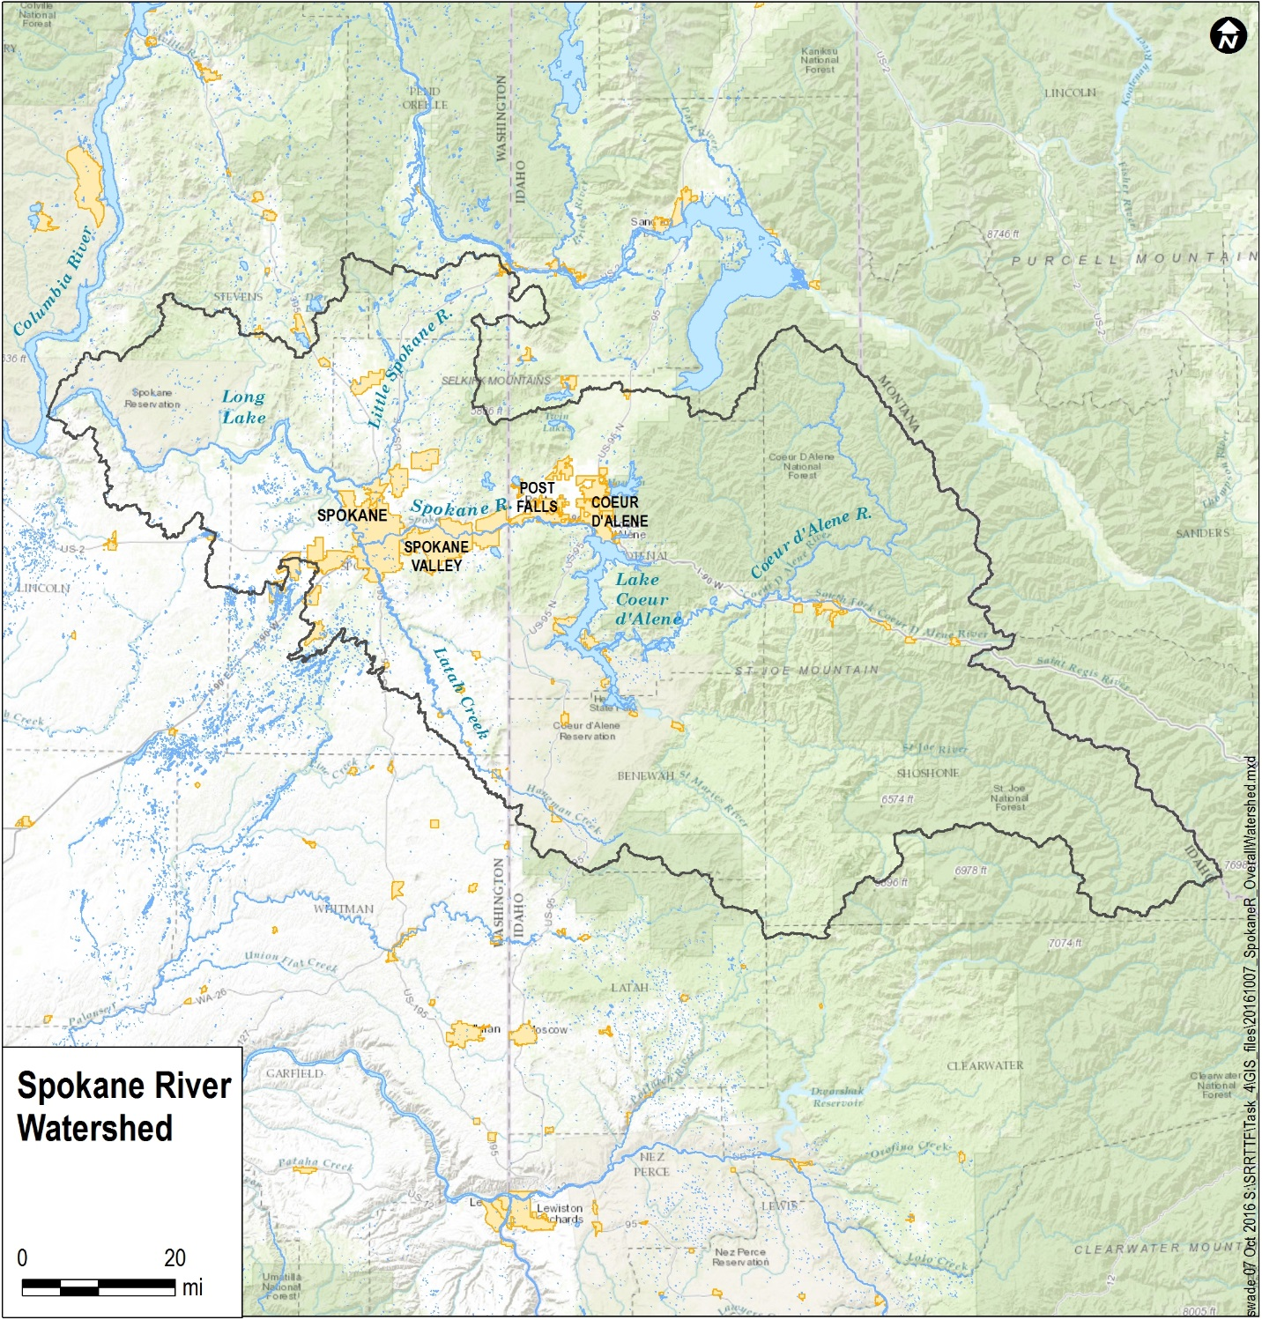

Figure . Spokane River Watershed

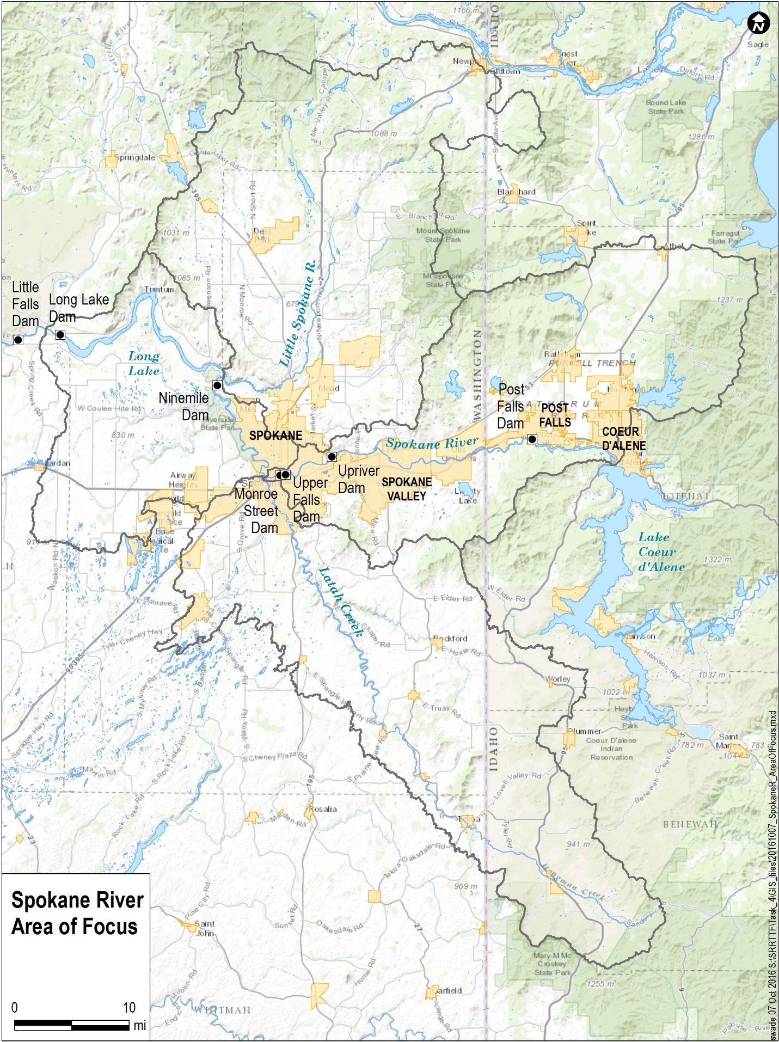

Figure 2. Spokane River Area of Focus

## 2.2 Hydrology

The hydrologic characteristics of the Spokane River watershed were described by Ecology (Serdar et al, 2011), which serves as the basis for the following description. The flow regime in the Spokane River is dictated largely by freezing temperatures in the winter followed by spring snowmelt, and is also partially controlled by operation of the Post Falls Dam. The annual mean flow for the years 1969-2016 was approximately 175,933 L/sec (6,213 cfs) at Post Falls. Average flows increased to 181,738 L/sec (6,418 cfs) at the Spokane Gage, reflecting the influx of groundwater through this river reach. Prior to 1969 there were un-quantified agricultural diversions for irrigation from the Spokane River in the vicinity of Post Falls.

There are seven dams along the Spokane River (Figure 2):

1. Post Falls Dam (RM 100.8), which controls the level of Lake Coeur d’Alene;
2. Upriver Dam (RM 80.2);
3. Upper Falls Dam (RM 74.5);
4. Monroe Street Dam (RM 74.0);
5. Ninemile Dam (RM 58.1);
6. Lake Spokane (Long Lake) Dam (RM 33.9), which controls the level of Lake Spokane; and
7. Little Falls Dam (RM 29.3).

The dams create a series of pools which vary in length, the largest being 23-mile long Lake Spokane (also known as Long Lake, herein referred to as Lake Spokane). Downstream from Lake Spokane, the Spokane River forms the southern boundary of the Spokane Tribe of Indians reservation from Chamokane Creek (RM 32.5) to the Columbia River at RM 639.0.

The Spokane River is largely underlain by, and significantly interacts with, the Spokane Valley-Rathdrum Prairie Aquifer. Nearly one billion gallons of water per day flows into and out of the aquifer, with roughly half of this amount due to exchange with the Spokane River. The aquifer also serves as the sole source of water for most people in the study area (Spokane Valley-Rathdrum Prairie Aquifer Atlas, 2009)

## 2.3 Land Use and Population

The portion of the Spokane River watershed under focus for this Comprehensive Plan contains a diverse mixture of land uses (Figure 3). Approximately 11% of the focus area is in developed land use; 39% of the area is forested; 23% of the area is in agricultural use; and the remainder primarily in shrub/herbaceous, wetlands, or water. The river flows through the smaller cities of Post Falls and Coeur d’Alene in Idaho and large urban areas of the Spokane Valley and Spokane in Washington.

Total population in the Study Area watershed was estimated from 2011 census block group data obtained in GIS data format from the U.S. Census Bureau (<https://www.census.gov/geo/maps-data/data/tiger-data.html>). Population per acre was calculated for each census block group. The block groups were intersected with known watershed boundary delineations, with the area of each block group portion located inside a basin was multiplied by the population density. Those products were summed for each basin to obtain total population. The overall 2011 population for the Study Area watershed was estimated to be 571,045. Of this total, 401,976 people lived in watershed areas draining directly to the Spokane River; 57,669 people lived in watershed areas draining to Latah Creek; and 111,400 people lived in watershed areas draining to the Little Spokane River.

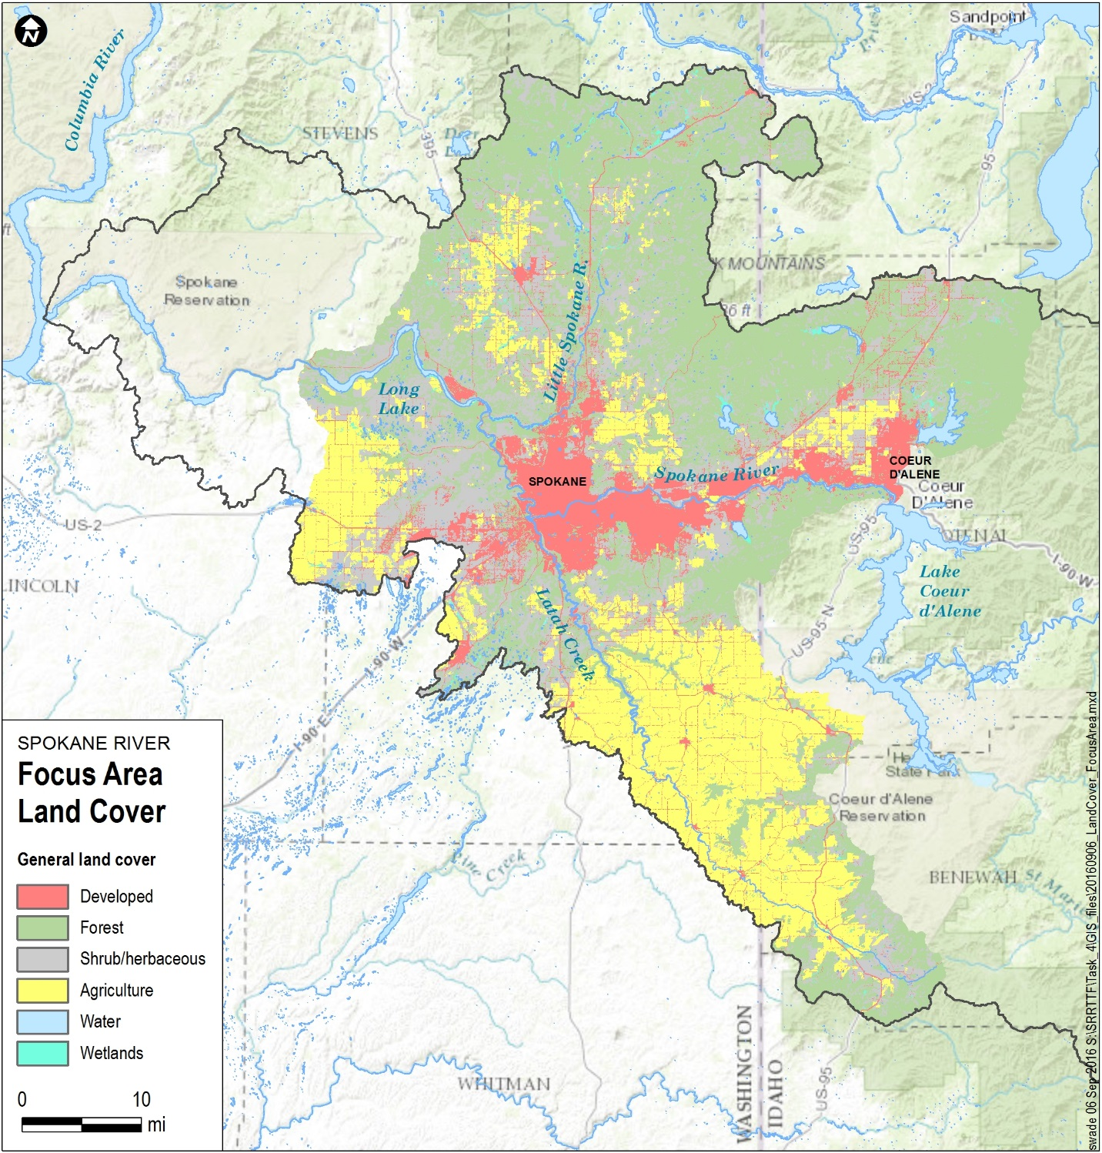

Figure . Land Use in the Area of Focus for the Comprehensive Plan

## 2.4 Available Data

A large amount of PCB-related data exists for development of the Comprehensive Plan. The available data are summarized here, in separate sections discussing a data compilation conducted in 2013 and data collected subsequent to that compilation.

### 2.4.1 2013 Data Compilation

Initial Task Force efforts included identification and collection of available data to define existing PCB sources and sinks. The intent of that work was to evaluate the quality and credibility of the available data relative to satisfying identified data needs, and to store the resulting data in a database facilitating its use later in the project. Approximately 45 data sets were obtained. All data were reviewed to determine whether they met data quality objectives, as the data that were gathered were collected under a wide range of QA/QC procedures. A graded approach was taken with the data review, with data quality divided into categories ranging from “highest quality, fully acceptable for subsequent use” to “lesser quality, suitable only for supporting ‘weight of evidence’ approaches.” Information was collected for the following categories:

* Climate
* Commercial buildings constructed between 1950 and 1980
* Identified contaminated sites
* Illegal dumping/spills
* Number and size of smelters and incinerators
* Number of Vehicle Registrations
* Numbers and sizes of auto dismantlers, computer and electronics recyclers, transfer stations, landfills, metal recyclers, and white goods recyclers
* PCB and PCDD/F emissions from incineration activities
* PCBs and PCDD/Fs in Combined Sewer Overflows
* PCBs in fish tissue
* PCBs in groundwater
* PCBs in sediment
* PCBs in soil
* PCBs and PCDD/Fs in stormwater
* Spokane River and tributary water column measurements (e.g., temperature)
* Stormwater loads
* Stream flow information for Spokane River and tributaries
* Wastewater treatment plant loads
* Water column
* measurements of PCB and PCDD/F concentrations

All relevant data collected during were evaluated and stored in a Microsoft Access database, which was provided to the Task Force. A more complete description of the data collected and the evaluation process is provided in [LimnoTech (2013)](http://srrttf.org/wp-content/uploads/2014/05/SRRTTF_DataReviewMemo_2013_08_30_final.pdf).

### 2.4.2 Data Collected After 2013

Several additional studies providing data relevant to the Comprehensive Plan were conducted after the 2013 data compilation discussed above. These studies are:

* SRRTFF 2014 Monitoring ([LimnoTech, 2015](http://srrttf.org/wp-content/uploads/2015/08/SRRTTF_Phase_2_Final_Report_2015_08_12_without-appendices.pdf)): This report documents Task Force Phase 2 technical activities, which focused on carrying out a synoptic survey to identify potential unmonitored dry weather sources of PCBs to the Spokane River. The survey was successfully conducted between August 12 and 24, 2014. Sampling locations included seven Spokane River stations between Lake Coeur d’Alene and Ninemile Dam, one station in Latah Creek, and seven point source discharges. Analysis of the data identified a likely large (i.e. as large as any other single dry weather source) incremental PCB load entering the Spokane River between Barker Road and the Trent Avenue Bridge near Plantes Ferry. There is also the possibility of an incremental PCB load entering the Spokane River between Greene Street and the Spokane USGS gage (near N. Cochran St. in Spokane). This report also provides PCB data collected at two locations in the Spokane River in May, 2014.
* Task Force 2015 Monitoring ([LimnoTech, 2016](http://srrttf.org/wp-content/uploads/2015/08/SRRTTF_2015-Technical-Activities-Report_Draft_2016_06_30.pdf)c): This report documents a follow-up survey designed to confirm the findings of the 2014 survey and provide greater detail on the location of the unmonitored PCB source. The follow-up survey was successfully conducted from August 18 to 22, 2015. Sampling locations included five Spokane River stations between Barker Rd. and the Spokane USGS Gage, and three point source discharges. The presence of a large incremental PCB load entering the Spokane River between Barker Road and the Trent Avenue Bridge was confirmed, with the location of where the majority of the load enters the river narrowed down to between Mirabeau Point (upper end of Mirabeau Park, downstream of Sullivan Road) and the Trent Avenue Bridge near Plante’s Ferry. Homolog-specific mass balance analyses indicated the potential presence of another groundwater loading source entering the river downstream of the Trent Avenue Bridge.
* Spokane River Toxics Sampling 2012-2013 – Surface Water, CLAM and Sediment Trap Results ([Era-Miller, 2014](https://aqualytical.com/documents/Technical-Info-Library/Testing/WA-DOE-Study.pdf)): Ecology conducted a study to evaluate several types of sample collection methods and analytical methods for toxics monitoring in the Spokane River during fall 2012 through spring 2013. Surface water composite grabs samples was not a good monitoring tool for low level PCBs in the Spokane River, as the PCB congener sample data in general did not give a clear environmental signal above the analytical background noise. The CLAM collection method was judged to be a good surrogate for grab sampling for PCB congeners in the Spokane River, however more recent studies by Ecology have shown that the CLAM collection method may be problematic for low-level analyses of PCBs in surface water. Sediment trap sampling was rated “good” for PCB analysis.
* PCBs in Municipal Products ([City of Spokane, 2015](http://srrttf.org/wp-content/uploads/2015/03/Revised-Prduct-Testing-Report-7-21-15.pdf)a): More than 40 product samples were collected and analyzed for PCBs using EPA Method 1668C. The majority of samples were composed of roadway, pipe, and vehicle maintenance products. Because PCBs are also ubiquitously detected in sanitary wastewater samples, five personal care products were sampled as well. PCBs were detected in 39 of the 41 product samples, with a wide range of congener patterns. PCB-11 was one of the most frequently detected congeners. Because it is generally found in pigments and not found in Aroclor mixes, pigments are likely a common source of inadvertently produced PCBs in the products sampled.
* PCBs in General Consumer Products ([Ecology, 2014](https://fortress.wa.gov/ecy/publications/documents/1404035.pdf)b): Ecology evaluated the presence of PCBs in general consumer products, with particular emphasis placed on products likely to be contaminated with PCBs due to the inadvertent production of PCBs in the manufacturing process (e.g. paints, newspapers, glossy magazines, cereal boxes, and yellow plastic bags). 68 products were tested for PCBs. PCB-11 was found in a wide range of product types and at measurable concentrations, indicating that consumer products are a continuing source of PCB contamination and that generation of PCB-11 is mostly an unregulated source of PCB contamination.
* Hydroseed Pilot Project ([SRRTTF, 2015](http://srrttf.org/wp-content/uploads/2015/09/Hydroseed-Pilot-Project-Report_Draft_082715.pdf)): In response to high levels of PCBs in Hydroseed identified during initial product testing by the City of Spokane ([2015](http://srrttf.org/wp-content/uploads/2015/03/Revised-Prduct-Testing-Report-7-21-15.pdf)a), the Task Force undertook a Hydroseed Analysis and Reformulation PCB Removal Pilot Project. The purpose of this study was to confirm the elevated levels observed from the City’s original analysis and to identify specific component(s) that may be contributing to these elevated levels. Results from this analysis are intended to be used to assist manufacturers of Hydroseed to develop specifications and/or reformulations with reduced levels of PCBs.
* PCB Characterization of Spokane Regional Vactor Waste Decant Facilities ([City of Spokane, 2015](http://srrttf.org/wp-content/uploads/2015/09/2015-9-11-REPORT-Vactor-Decant-Facility-Characterization-FINAL.pdf)b): Stormwater runoff has been identified as contributor of PCBs to the Spokane River. The Eastern Washington Phase II Municipal Permit requires that stormwater catch basins be periodically cleaned out to remove buildup of solids. Previous testing by the City of Spokane had shown that catch basin sediment can contain orders of magnitude greater PCB content than the stormwater itself. Stormwater sediment is removed from catch basins in the Spokane area by using vacuum eductor trucks (vactors). Environmental concerns were raised in recent years about how this material was being handled. The primary goal of this project was to characterize the PCB content of the material at regional decant facilities.
* Screening Survey of PCBs in Little Spokane River Water, Sediment, and Fish Tissue ([Ecology, 2016](https://fortress.wa.gov/ecy/publications/documents/1603001.pdf)): The lower section of the Little Spokane River has been listed as being water quality-impaired for PCBs in fish tissue. The objectives of this study were to verify the level of PCB contamination in fish tissue fillets in 2014-2015 and attempt to spatially characterize the extent of potential PCB contamination in the Little Spokane River. Three fish species – rainbow trout, mountain whitefish, and northern pikeminnow – were analyzed as fillet composites at three sites. Although PCB levels were lower than those measured in 1994 and 1996, most fish tissue samples still exceeded the fish tissue equivalent National Toxics Rule human health criterion for PCBs.
* 2012 Freshwater Fish Contaminant Monitoring Program ([Ecology, 2014](https://fortress.wa.gov/ecy/publications/publications/1403020.pdf)a): This report summarizes results from Ecology’s Freshwater Fish Contaminant Monitoring Program in 2012 for three areas in Washington: the Spokane River, Pend Oreille River, and North Cascades National Park. The sampling goals were to: (1) characterize contaminant levels in fish, and (2) determine spatial and temporal patterns in contaminant levels in Spokane River fish. Results showed that levels of PCBs in fish from the Spokane River remain elevated compared to most areas in Washington. Tissue concentrations show a general decrease between 2005 and 2012, but statistically significant decreases were only observed for 2 of 11 (18%) pairs of matched fish species and locations.
* Long Term Monitoring at the Spokane River Spokane Tribal Boundary ([Ecology, 2016](http://srrttf.org/wp-content/uploads/2016/07/Spokane-LT-Prelim-data-update-for-7-8-16.pdf)c): This progress report provides a summary of Preliminary Findings to Date surface water monitoring at the Spokane Tribal boundary (just upstream of Chamokane Creek) during three hydrologic periods in 2015 – 2016. The final report for this study is slated for publication in early 2017.
* Task Force 2016 Monitoring: In progress sampling of river locations to obtain data on other than low flow river conditions. Sampling events were completed in March, April, May, and June. Additional sampling events are scheduled for October and December.
* PCBs in Lake Spokane Carp ([Ecology, 2015](https://fortress.wa.gov/ecy/publications/documents/1503022.pdf)b): Ecology conducted a study to characterize PCB concentrations in common carp, intended to support estimation of the mass of PCBs removed from Lake Spokane as a part of Avista Utilities’ proposed carp population reduction project.

### 2.4.3 Current River Status

Based upon sampling events conducted by the Task Force in 2014, 2015, and through June 2016, Table a provides a summary of the central tendencies of the ambient surface water data collected during these sampling events (after appropriate blank correction) at the eight monitoring locations on the Spokane River. Table 1 provides the number of samples taken during each sampling event as well as the average concentration during the event. The arithmetic and geometric means utilize all individual data points.

Table 1. Summary of Existing Spokane River Water Column PCB Concentrations

|  |  |  |  |  |  |  |  |  |  |  |  |  |  |  |  |  |  |  |  |  |  |  |  |  |  |  |  |  |  |  |  |  |  |  |  |  |  |  |  |  |  |  |  |  |  |  |  |  |  |  |  |  |  |  |  |  |  |  |  |  |  |  |  |  |  |  |  |  |  |  |  |  |  |  |  |  |  |  |  |  |  |  |  |  |  |  |  |  |  |  |  |  |  |  |  |  |  |  |  |  |  |  |  |  |  |  |  |  |  |  |  |  |  |  |  |  |  |  |  |  |  |  |  |  |  |  |  |  |  |  |  |  |  |  |  |  |  |  |  |  |  |  |  |  |  |  |  |  |  |  |  |  |  |  |  |  |  |  |  |  |  |  |  |  |  |  |  |  |  |  |  |  |  |  |  |  |  |  |  |  |  |  |  |  |  |  |  |  |  |  |  |  |  |  |  |  |  |  |  |  |  |  |  |  |  |  |  |  |  |  |  |  |  |  |  |  |  |  |  |  |  |  |  |  |  |  |  |  |  |  |  |  |  |  |  |  |  |  |  |  |  |
| --- | --- | --- | --- | --- | --- | --- | --- | --- | --- | --- | --- | --- | --- | --- | --- | --- | --- | --- | --- | --- | --- | --- | --- | --- | --- | --- | --- | --- | --- | --- | --- | --- | --- | --- | --- | --- | --- | --- | --- | --- | --- | --- | --- | --- | --- | --- | --- | --- | --- | --- | --- | --- | --- | --- | --- | --- | --- | --- | --- | --- | --- | --- | --- | --- | --- | --- | --- | --- | --- | --- | --- | --- | --- | --- | --- | --- | --- | --- | --- | --- | --- | --- | --- | --- | --- | --- | --- | --- | --- | --- | --- | --- | --- | --- | --- | --- | --- | --- | --- | --- | --- | --- | --- | --- | --- | --- | --- | --- | --- | --- | --- | --- | --- | --- | --- | --- | --- | --- | --- | --- | --- | --- | --- | --- | --- | --- | --- | --- | --- | --- | --- | --- | --- | --- | --- | --- | --- | --- | --- | --- | --- | --- | --- | --- | --- | --- | --- | --- | --- | --- | --- | --- | --- | --- | --- | --- | --- | --- | --- | --- | --- | --- | --- | --- | --- | --- | --- | --- | --- | --- | --- | --- | --- | --- | --- | --- | --- | --- | --- | --- | --- | --- | --- | --- | --- | --- | --- | --- | --- | --- | --- | --- | --- | --- | --- | --- | --- | --- | --- | --- | --- | --- | --- | --- | --- | --- | --- | --- | --- | --- | --- | --- | --- | --- | --- | --- | --- | --- | --- | --- | --- | --- | --- | --- | --- | --- | --- | --- | --- | --- | --- | --- | --- | --- | --- | --- | --- | --- | --- | --- | --- |
| |  |  |  | | --- | --- | --- | | **Lake Coeur d’Alene (SR-15)** | | | | Sample Month | Samples | Concentration | | May 2014 | 6 | 23 pg/L | | August 2014 | 7 | 13 pg/L | | August 2015 |  |  | | March 2016 | 2 | 14 pg/L | | April 2016 | 1 | 15 pg/L | | May 2016 | 1 | 72 pg/L | | June 2016 | 1 | 3 pg/L | | **Arithmetic Mean – 17 pg/L**  **Geometric Mean - 14 pg/L** | | |  |  |  |  | | --- | --- | --- | | **Post Falls (SR-12)** | | | | Sample Month | Samples | Concentration | | May 2014 |  |  | | August 2014 | 8 | 21 pg/L | | August 2015 |  |  | | March 2016 |  |  | | April 2016 |  |  | | May 2016 |  |  | | June 2016 |  |  | | **Arithmetic Mean – 21 pg/L**  **Geometric Mean - 18 pg/L** | | |  |  |  |  | | --- | --- | --- | | **Greenacres/Barker Rd. (SR-9)** | | | | Sample Month | Samples | Concentration | | May 2014 |  |  | | August 2014 | 8 | 19 pg/L | | August 2015 | 6 | 32 pg/L | | March 2016 |  |  | | April 2016 |  |  | | May 2016 |  |  | | June 2016 |  |  | | **Arithmetic Mean – 24 pg/L**  **Geometric Mean – 14 pg/L** | | |  |  |  |  | | --- | --- | --- | | **Mirabeau Point (SR-8a)** | | | | Sample Month | Samples | Concentration | | May 2014 | 10 | 33 pg/L | | August 2014 |  |  | | August 2015 | 6 | 44 pg/L | | March 2016 |  |  | | April 2016 |  |  | | May 2016 |  |  | | June 2016 |  |  | | **Arithmetic Mean – 37 pg/L**  **Geometric Mean - 18 pg/L** | | | | |  |  |  | | --- | --- | --- | | **Trent Bridge (Plante’s Ferry) (SR-7)** | | | | Sample Month | Samples | Concentration | | May 2014 |  |  | | August 2014 | 8 | 172 pg/L | | August 2015 | 6 | 148 pg/L | | March 2016 | 1 | 51 pg/L | | April 2016 | 2 | 16 pg/L | | May 2016 | 1 | 112 pg/L | | June 2016 | 1 | 65 pg/L | | **Arithmetic Mean – 133 pg/L**  **Geometric Mean – 107 pg/L** | | |  |  |  |  | | --- | --- | --- | | **Greene Street Bridge (SR-4)** | | | | Sample Month | Samples | Concentration | | May 2014 |  |  | | August 2014 | 8 | 128 pg/L | | August 2015 | 5 | 153 pg/L | | March 2016 | 1 | 67 pg/L | | April 2016 | 1 | 76 pg/L | | May 2016 | 2 | 57 pg/L | | June 2016 | 1 | 78 pg/L | | **Arithmetic Mean – 118 pg/L**  **Geometric Mean – 105 pg/L** | | |  |  |  |  | | --- | --- | --- | | **Spokane Gage (SR-3)** | | | | Sample Month | Samples | Concentration | | May 2014 |  |  | | August 2014 | 8 | 202 pg/L | | August 2015 | 5 | 175 pg/L | | March 2016 | 1 | 65 pg/L | | April 2016 | 1 | 57 pg/L | | May 2016 | 1 | 50 pg/L | | June 2016 | 2 | 57 pg/L | | **Arithmetic Mean – 154 pg/L**  **Geometric Mean – 131 pg/L** | | |  |  |  |  | | --- | --- | --- | | **Nine Mile Dam (SR-1)** | | | | Sample Month | Samples | Concentration | | May 2014 |  |  | | August 2014 | 8 | 163 pg/L | | August 2015 |  |  | | March 2016 | 1 | 100 pg/L | | April 2016 | 1 | 68 pg/L | | May 2016 | 1 | 187 pg/L | | June 2016 | 1 | 62 pg/L | | **Arithmetic Mean – 144 pg/L**  **Geometric Mean – 132 pg/L** | | | |

## 2.5 Impairment status

Portions of the Spokane River and Lake Spokane have been placed on the State of Washington’s 303(d) list of impaired waters because of concentrations of polychlorinated biphenyls (PCBs), as well as other other pollutants, that exceed water quality standards. The Spokane River and Lake Spokane exceed the water quality standard (170 pg/L – based on a fish consumption rate of 6.5 g/day) for PCBs. Nineteen waterbody segments of the Spokane River and Lake Spokane and one segment of the Little Spokane River are on the 2014 303(d) list for exceeding human health water quality criteria for PCBs. It is noted that the PCB concentrations utilized to place these waters on the 303(d) list were derived from fish tissue equivalent concentrations (FTECs), the concentration of a contaminant in fish tissue that Washington equates to the National Toxics Rule water quality criterion for the protection of human health, rather than direct water column measurements. FTECs are a basis for 303(d) listing under Department of Ecology Policy 1-11 but they are not water quality standards. A range of fish tissue collection studies were used as the basis of the current listing. Some segments are listed based on data as old as 1993, while others include are based on data as recent as 2005 (<http://www.ecy.wa.gov/programs/wq/303d/currentassessmt.html>).

The Spokane Tribe of Indians have EPA approved water quality standards with a PCB criterion of 1.3 pg/L that applies to tribal waters below Lake Spokane. The Spokane River in Idaho is not listed for PCB’s in the State of Idaho 2012 Integrated Report.

Blank Page

# 3 PCB Source Assessment

The intent of a PCB source assessment is to define the magnitudes of PCB sources and pathways to identify key sources that can be reduced via the implementation of Control Actions. The source assessment is also designed to identify key data gaps contributing to uncertainty in estimates of these sources and pathways, to help guide future monitoring efforts. The source assessment for PCBs in the Spokane River was conducted in two steps:

* Define the range of potentially important sources of PCBs in the Spokane River watershed and the pathways by which these PCBs are delivered to the river
* Define the magnitude of the sources and pathways identified above, along with key data gaps.

Determination of the sources and pathways of PCBs in the Spokane River Watershed is described in detail in LimnoTech ([2016](http://srrttf.org/wp-content/uploads/2016/04/SRRTTF_SourcesPathways_2016_0316.pdf)a). The calculation of the magnitude of these sources and pathways is described in detail in LimnoTech ([2016](http://srrttf.org/wp-content/uploads/2016/04/SRRTTF_MagnitudeSourcesPathways_2016_06-22-16.pdf)b.

Sources and pathways were represented through the use of conceptual models. A conceptual model is a graphic depiction of all of the processes believed to be potentially significant in effecting pollutant concentrations. Conceptual models provide a means to convey complicated processes and relationships in a simplified manner to a wide audience, and allows non-technical reviewers to understand and provide input on the sources and pathways to be considered. An example conceptual model of PCB sources and pathways for San Francisco Bay is shown in Figure 4.

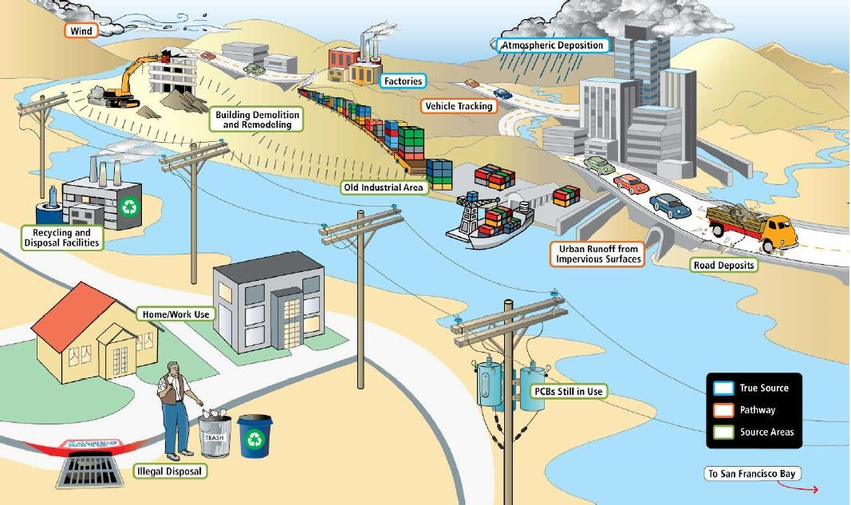

Figure 4. Example Conceptual Model of PCB Sources and Pathways (from SFEI, 2010)

Conceptual models can also be drawn as “box and arrow” diagrams, with boxes representing environmental compartments and arrows representing processes that transfer PCBs between compartments. An example box and arrow diagram summarizing PCB fate processes in the Spokane River and its sediments is shown in Figure 5.

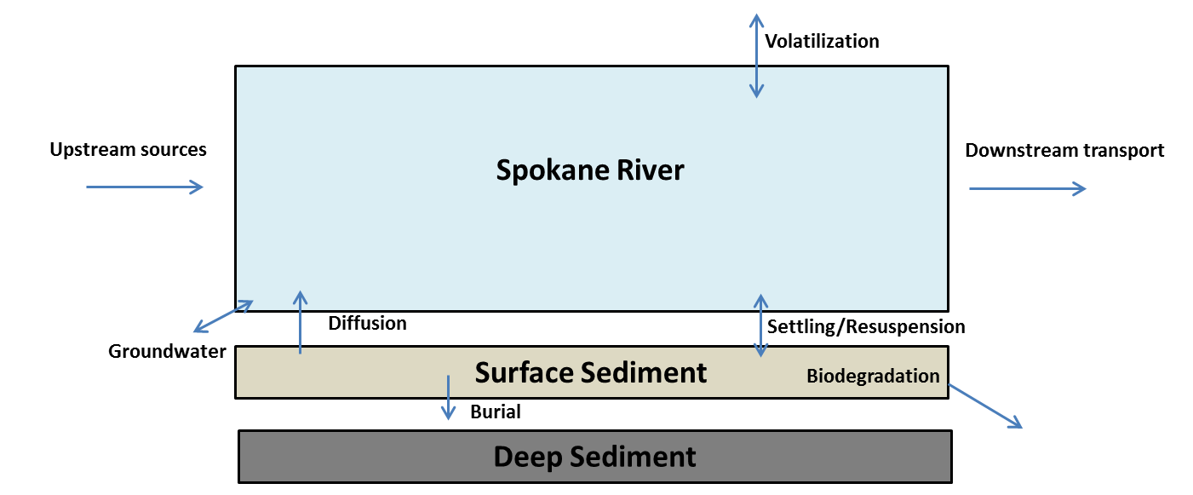

Figure 5. Example Box and Arrow Conceptual Model

The remainder of this section summarizes how these sources and pathways were determined, and how their magnitudes were estimated. It is divided into three sub-sections, corresponding to:

* PCBs Source Areas
* Delivery mechanisms of PCBs to the Spokane River
* Transport pathways between sources and delivery

Proposed actions and studies needed to fill data gaps are described in Section 6, “Future Actions.”

## 3.1 PCBs Source Areas

It is important to use proper nomenclature when discussing PCB sources, as the term “sources” when referring to other pollutants commonly refers to the true origin of the contaminant. In the case of PCBs, the dominant source was intentional production by Monsanto through 1979. Although this source no longer exists, those legacy PCBs now exist throughout the environment. The Comprehensive Plan follows the nomenclature of the San Francisco Estuary Institute (SFEI, 2010) and uses the term “source areas” to represent those environmental compartments containing PCBs. Source areas are defined as the places where PCBs were used, inadvertently released, systematically discarded or accumulated. Source areas of PCBs are divided into three broad categories in this Plan, based on refinement of earlier PCB source characterization done for San Francisco Bay (SFEI, 2010) and Spokane ([LimnoTech, 2013](http://srrttf.org/wp-content/uploads/2014/05/SRRTTF_DataReviewMemo_2013_08_30_final.pdf)). Source areas of PCBs are divided into three broad categories for purposes of discussion here:

* Legacy source areas of PCBs currently present in the Spokane watershed
* Ongoing source areas of PCBs continuing to be introduced to the watershed via inadvertent production in commercial products
* Environmental transport of non-local PCBs into the watershed study area

### Legacy Source Areas

Legacy source areas correspond to PCBs that were brought into the Spokane watershed in the past, but are no longer produced. “Legacy PCBs,” as defined in this plan, were produced by Monsanto and marketed as Aroclors which were used in machine oils, transformers, etc. As shown in Table 2, legacy source areas can be further divided into categories of buildings, environmental, and industrial equipment. Building source areas can either be fixed to the building itself (e.g., paint, caulk) or non-fixed and removable (e.g., light ballasts). Legacy environmental source areas of PCBs correspond to contaminated surface soils, contaminated subsurface soils/groundwater, and in-place aquatic sediments in the Spokane River and Lake Spokane. Historically produced PCBs are also still contained in various forms of electrical equipment such as transformers and hydraulic equipment.

Table 2. Categories of Legacy Source Areas of PCBs in the Spokane Watershed

|  |  |  |
| --- | --- | --- |
| **Buildings** | **Environmental** | **Industrial Equipment** |
| • Fixed • NonFixed | * Surface soils * Subsurface soil/ groundwater * Aquatic Sediments | * Electrical Equipment * Hydraulic Equipment |

### Building Source Areas

Building source areas are sub-categorized as either fixed to the building itself (e.g., paint, caulk), or non-fixed and removable (e.g. lamp ballasts).

#### Fixed Building Source Areas

PCBs were commonly used in building sealants such as caulks from the 1950s to the 1970s (Robson et al. 2010), to improve the flexibility of the material, increase the resistance to mechanical erosion, and improve adherence to other building materials (Andersson et al., 2004). As such, building constructed from the 1950s to the 1970s may still contain caulks with elevated levels of PCBs. Positive matrix factorization analysis has shown that a significant fraction of the influent loading to the Spokane County Regional WRF has a congener profile consistent with legacy PCBs in building materials. No Spokane-specific data exists defining the quantity of PCBs still present in fixed building source areas. However, many studies have been conducted estimating this magnitude for other communities, and these studies can provide a template for Spokane estimates. The methods used vary in terms of complexity, as demonstrated below. Shanahan et al (2015) used the most rigorous approach, estimating the mass of PCBs present in Chicago-area building source areas by:

* Examining the building footprint, age, number of stories for each individual land parcel
* Calculating the volume of all buildings constructed between 1940 and 1979 from the building footprint and height data
* Assuming the mass of sealants per unit building volume from literature sources
* Assuming the PCB concentrations in caulk for buildings built between 1940 and 1979 from literature sources
* Assuming the percentage of buildings constructed from 1940 to 1979 contained PCB sealants from literature sources

Ecology (2011) estimated the quantity of PCBs in building sealants in in the Puget Sound Basin based upon:

* Reviewing the available literature for information on the types and ages of buildings most likely to contain caulking with PCBs.
* Sampling available county assessor’s information to estimate the volume of candidate buildings and develop an inventory of caulking material likely to contain PCBs within the Study Area.
* Reviewing the available literature for data on PCB concentrations in caulking material.
* Applying literature values to estimate the mass of PCBs contained in caulk.

Diamond et al (2011), used a range of calculation methodologies, including providing estimates for PCBs in caulk on a per capita basis, calculated as 5.2 metric tons per million people of population. Lacking readily available information on volume of structures in the Spokane watershed built during the time of PCB use, the Diamond et al (2011) per capita will be used in conjunction with the Spokane watershed population. Population in census block groups was obtained in GIS data format from the U.S. Census Bureau estimates for 2011 (<https://www.census.gov/geo/maps-data/data/tiger-data.html>). Population per acre was calculated for each block group, and this information merged with watershed boundary delineations obtained from the Watershed Boundary Dataset (WBD). This results in a population estimate for the contributing watershed of 571,045, leading to an estimate of PCBs in caulk throughout the watershed of 2969 kg. This number should be considered very uncertain. The literature sources used to support this calculation cited a factor of ten uncertainty in their calculations. Because the Spokane calculation in based on a per capita estimate rather than actual building age, it is likely that this estimate is only accurate with a factor of fifty, resulting in an uncertainty range of 60 to 130,000 kg.

#### Non-Fixed Building Source Areas

Non-fixed and removable PCBs are contained in small capacitors in a number of non-fixed building related items, such as appliances and lamp ballasts. PCB-containing ballasts were commonly used in public schools, and EPA (2001) recommends removal of all pre-1979 fluorescent light ballasts in schools to prevent accidental exposure of students, teachers, and other school personnel to PCBs. No Spokane-specific data are available defining the mass of PCBs in this category, but the method applied by Ecology (2011) to estimate the mass of PCBs contained in small capacitors in the Puget Sound watershed can be applied to Spokane. Ecology (2011) described their approach as follows:

A typical small capacitor unit contains 0.1-0.6 pounds (45 - 270 grams) of PCB oil, with lamp ballasts typically containing about 45 - 70 grams per ballast (EPA, 1982). Globally, one-third of all PCB production may have gone into lamp ballasts (Panero et al., 2005). In 1992 the University of Illinois estimated that 10-25% of U.S. household white goods (major appliances) contained capacitors with PCBs (Panero et al., 2005). Though it is known that many small PCB capacitors were manufactured prior to 1978, estimates of the number still in use vary. EPA (1982) estimated that historically there were 870 million small capacitors in use throughout the U.S. in 1977 in industrial machines and small appliances. EPA (1987) also estimated a 10% annual disposal rate in 1982.

Estimates for PCB lamp ballasts currently in use are an order of magnitude higher than the 1982 EPA estimate for small capacitors. These estimates place the number of ballast units remaining in use nationally between roughly 300 million (U.S. Army, 2001) and 500 million (Missoula County, 2010). In 1998, the EPA cited an unnamed industry source that estimated one billion ballasts were currently in use (EPA, 1998). The EPA (1998) reference suggests that the current number of PCB-containing ballasts in use nationally would be somewhere between 280 million, assuming a mean annual disposal rate of 10% from 1998 to 2010, and 69 million, assuming a mean annual disposal rate of 20% from 1998 to 2010.

Applying annual disposal rates of 10 and 20% to the national estimates and scaling to the Spokane study area by local population yields a range of 1,000 t0 500,000 total small capacitors (including ballasts) remaining in use. This information, combined with an assumed PCB concentration of 45 – 75 g PCB per capacitor, results in total PCB mass in the Spokane watershed of 50 – 40,000 kg.

### Environmental Source Areas

Environmental source areas consist of contaminated surface soils, contaminated subsurface soils/groundwater, and in-place aquatic sediments in the Spokane River and Lake Spokane.

#### Contaminated Surface Soils

Meijer et al (2003) concluded that soil may be one of the largest global PCB repositories, due to deposition from manufacturing, leaching from building materials or landfills, and the application of wastewater treatment plant biosolids. Insufficient site-specific data are available defining PCB concentrations in soils throughout the Spokane River watershed. An estimate of the total stock of PCBs in Spokane-area soils was made following the approach used by Shanahan et al (2015), who estimated the soil PCB mass reservoir in the Chicago area from:

* the amount of urban area, based upon parcel data
* a literature based soil:air exchange depth of 0.12 m.
* an average PCB concentration in urban soils estimated from 15 cities of 50 ng/g dry weight (from a range of 3−220 ng/g)
* the average bulk density of urban soils

Applying that approach to the Spokane watershed results in an estimate of the PCB mass reservoir of 5,500 kg. Given that the range of observed PCB concentration in urban soils varies by approximately a factor of plus or minus ten, it is reasonable to assume that the Spokane-specific mass estimate is also only accurate to a factor of ten, resulting in an estimated rand of 550 to 55,000 kg.

#### Contaminated Sub-Surface Soils

Marti and Maggi (2015) searched Ecology databases for sites that could be contributing PCB contamination to the Spokane River via groundwater, and identified 31 cleanup sites. Soils at 27 of the sites had been analyzed for PCBs using method SW8082, with 23 of these sites having had confirmed releases to soils. Of these 23 sites, 13 have undergone cleanups and received No Further Action (NFA) designation although they may still have detectable PCB concentrations using method 1668. Contaminated soils were removed at twelve of the sites. On-site containment was used at one site. Of the ten remaining sites with confirmed releases of PCB, six are undergoing cleanups, two are in performance monitoring status, and two are awaiting cleanups. Marti and Maggi (2015) prioritized these sites in terms of: 1) confirmed or suspected release of PCBs to the environment, and 2) site status with regard to cleanup activities. While an extensive data base exists defining soil PCB concentrations at these sites, this information has not been compiled in a manner that provided a quantitative estimate of the total mass of PCBs across the sites.

#### River and Lake Sediments

The bottom sediments of the Spokane River and Lake Spokane provide another potential reservoir of PCB contamination. An estimate of the total mass associated with this category was made using data from Ecology (2011), Ecology (2015a), Golder (2005), Ecology (2005), Johnson and Norton, (2001) and Era-Miller (2014). Separate estimates were made for the Spokane River and Lake Spokane, further sub-divided into estimates for surface and deep sediments in each system.

Ecology (2011) discussed the general lack of bottom sediments in the Spokane River:

One particular macro characteristic of the Spokane River is the general lack of fine depositional sediments in most of the river. Lake Coeur d’Alene acts as a settling basin for sediments transported in the upper watershed, and there are no tributaries to the river between the outlet of the lake and Latah Creek. Spokane River is essentially a free-stone stream environment. Although the dams break the river into a series of pools, there are few areas of placid water above Lake Spokane. The river velocities are high enough and the sediment load low enough to scour the bed or prevent settling of significant fine particulate matter, even immediately behind the dams. As a result, almost the entire riverbed upstream of Lake Spokane (the largest reservoir) is composed of gravel, cobble, and boulders with the finer sediment reserved for limited locations behind the dams, interstitial spaces within the river bed, isolated shoreline deposits, and certain fluvial bar features. One notable exception is the narrow band of fine, organic carbon rich sediments found near the Upriver Dam reservoir.

Calculation of surface sediment PCB mass in the Spokane River was based upon measured PCB and sediment concentrations, and modeled fraction of river containing depositional sediment. Ecology (2011) reported surface sediment PCB concentrations above Monroe St. of 6.7 ng/g. Era-Miller (2014) reported PCB concentrations from sediment traps at Upriver Dam of 25.4 to 28.5 ng/g and 13.7 to 17.2 ng/g at Ninemile Dam. Ecology (2015b) reported surface sediment PCB concentrations at undetectable levels (detection limit ~10 ng/g) in their reassessment of the Upriver Dam and Donkey Island PCB sediment site. The solids concentrations of the bed sediments were taken from measurement reported by Johnson and Norton (2001), and an assumed sediment solids density of 2.6. Golder (2005) reports that approximately 20% of the Spokane River above Ninemile Dam is considered depositional. The Spokane River is unique in this regard, as most systems with known PCB contamination (e.g. Delaware River, San Francisco Bay) are dominated by depositional areas. Combining the above information and assuming an average of the observed PCB concentrations (15 ng/g) results in a mass estimate of 0.032 kg.

The Spokane River also contains historical PCB contamination in deep sediments at the Upriver Dam and Donkey Island PCB Sediment Site. The mass of PCB buried in deep sediments was calculated from the PCB concentration depth profiles provided in Ecology (2005), surface area provided in Ecology (2015b), and bed sediment solids concentrations provided in Johnson and Norton, (2001). Combining the above information and assuming an average of the observed PCB concentrations (6587.5 ng/g) results in a mass estimate of 19.2 kg. Ecology (2011) also reported sediment PCB concentrations at two locations in Lake Spokane. Concentrations in the upper 10 cm ranged from 8 to 33 ng/g in the upper portion of the Lake to 28 to 75 ng/g in the lower portion of the lake. Johnson and Norton, (2001) provided solids concentrations of the bed sediments and three locations in the lake, upper mid-lake, and lower. Combining the observed concentration data at each location (18 ng/g in the upper lake, 41 ng/g in the lower lake), an assumed concentration at mid-lake as the average of the upper and lower lake concentrations 29 ng/g), and an assumed sediment solids density of 2.6 results in a mass estimate of 2.24 kg in surficial Lake Spokane sediments.

The mass of PCB buried in deep Lake Spokane sediments was calculated from the PCB concentration depth profiles provided in Ecology (2011), and bed sediment solids concentrations provided in Johnson and Norton (2001). Combining the observed concentration data at each location (37 ng/g in the upper lake, 4442 ng/g in the lower lake), assumed concentration at mid-lake as the average of the upper and lower lake concentrations (240 ng/g), and an assumed sediment solids density of 2.6, results in a mass estimate of 40.6 kg. Because estimates of the system-wide mass reservoir is being based on a relatively small number of discrete measurements, it is reasonable to assume that these estimate are only accurate within a factor of five, resulting in an uncertainty range of 8 to 200 kg.

### Industrial Equipment Source Areas

The primary source areas of legacy PCBs contained in industrial equipment correspond to transformers and large (over three pounds total) capacitors. In addition, hydroelectric dams have been identified as a potential ongoing source of PCBs in the Columbia River, due to historical leaks and spills of PCB-contaminated oils. Information on the presence and PCB content of these sources was gained by direct contact with the utilities who are responsible for the generation and transmission of electricity in the Spokane region. These consisted of Avista Utilities, Inland Power and Light Company, Modern Electric Water Company, Vera Water and Power, Kootenai Electric Cooperative, and Bonneville Power Administration. Avista operates approximately 24,754 overhead transformers within the Spokane region, with a total oil content of approximately 117,000 gallons. By the end of 2016, Avista will have no detectable levels (EPA method 8082) of PCBs in their overhead transformers. Using an assumed PCB concentration of 0.5 ppm (half the detection limit of 1 ppm), this corresponds to a total PCB mass of 0.20 kg. Inland Power and Light Company operates approximately 30,000 transformers, and has replaced all transformers that had 45 ppm or more PCBs. Using 22.5 ppm (half the replacement concentration), this corresponds to a PCB mass of 10.8 kg. Vera Water and Power operates 137 transformers containing PCB concentration between 2 ppm and 43 ppm, with an average concentration of 8 ppm. These transformers contain approximately 3430 gallons of oil. This corresponds to a total PCB mass of 0.09 kg. Kootenai Electric Cooperative has 1,926 transformers in their system that potentially contain PCBs. They do not have an estimate of PCB content, but do have a two year plan to remove all transformers with PCBs. in them. Using average values for quantity of oil and PCB content results in a total mass of 1.7 kg. Modern Electric Water Company operates 2,665 transformers and in the past 20 years has replaced all transformers with PCB concentrations greater than 10 ppm. They estimate roughly 10% of the transformers contain PCBs at a concentration less than 10 ppm. Using an average of 25 gallons oil/transformer and 5 ppm to provide an average PCB concentration, this corresponds to a mass of 0.11 kg. Bonneville Power Administration (BPA) has no high voltage PCB capacitors in their system. No other information is available from them.

The sum of transformer PCB mass across all utilities is approximately 12.8 kg. This estimate should be accurate within a factor of two, as the volume of oil is well known and the concentration values are specified as a midpoint between zero and the maximum possible value. This results in an uncertainty range of 6.4 to 25 kg, which is specified below in Table 4.

None of the utilities continue to use PCB-containing capacitors over three pounds, so the estimated PCB content for this source area category is zero.

Hydroelectric facilities were identified as another potential source of PCBs to the Spokane River, based on past releases of PCB-containing electric oil from Army Corps of Engineers’ hydroelectric facilities in the Columbia River basin. With the exception of Upriver Dam (which is operated by the City of Spokane), Avista Utilities operates all hydroelectric facilities in the Spokane River study area. Neither Avista nor the City of Spokane use PCB containing oil in these facilities. The PCB mass contained in hydropower facilities was therefore considered negligible.

Even though EPA banned production of PCBs in 1979, EPA still allows PCBs to be inadvertently produced in the chemical synthesis of many commercial products. These sources are divided into categories in Table 3. Pigments in printed materials/fabrics (Guo et al, 2013) and paints (Hu and Hornbuckle, 2010) have been identified as a primary category of inadvertent production. It is recognized that inadvertent PCB production occurs in other categories of products as well, although the magnitude of these other sources is largely unknown.

|  |  |  |
| --- | --- | --- |
| **Pigments in Printed**  **Materials/Fabrics** | **Paints** | **Other** |
| * Newsprint * Commercial Packaging * Colored Clothing | * Architectural paint * Road paint | * Motor oil * Agricultural chemicals |

Table 3. Categories of Ongoing Sources of PCB Production

Studies have been conducted that test the levels of PCBs in a wide range of products (e.g. City of Spokane, 2015; Ecology, 2014; Hu and Hornbuckle, 2010.) The number of products tested, however, in conjunction with a lack of information on the quantity of goods being imported into the watershed by category, prevent calculation of category-specific magnitude estimates. Work conducted as part of the Ecology and DOH (2015) PCB Chemical Action Plan provides a template for estimating of the overall magnitude of all inadvertent sources being imported into the watershed:

The US market consumes approximately 20% of global organic pigments (Guo et al. 2014). Washington is approximately 2% of the US population, which leads to an estimate for Washington’s share of PCB-11 from yellow pigment of 0.02 and 31 kg per year. This is the amount of PCB-11 in products, with an unknown amount entering the environment. The Color Pigments Manufacturers Association (CPMA) estimated that the total annual amount of these pigments (phthalocyanine and diarylide) imported or manufactured in the US is about 90 million lbs (41,000 metric tons). They further estimated inadvertently generated PCBs in these pigments with an upper bound of 1.1 tons per year and a more reasonable estimate of 1000 lbs per year (CPMA 2010). Using the lower annual estimate of 1000 lbs (450 kb), leads to an estimate of 9 kg per year in Washington, that is within the range of the estimate above.

Scaling the above estimate to the population of the Spokane watershed leads to a loading estimate for Spokane of 0.86 kg/yr. In order to convert this rate into a mass, assumption need to be made regarding how long these inadvertently-produced remain in the watershed before leaving either via the atmosphere or being transported downstream by the Spokane River. A lower-bound estimate of a residence time one year results in a mass estimate of 0.86 kg, while an upper-bound estimate of a residence time 20 years results in a mass estimate 17.2 kg. The mid-point of these values is 9 kg/yr. The overall uncertainty in this estimate reflects uncertainty in both the rate of PCBs being imported to the watershed as well as their residence time, such that this value is likely accurate only within a factor of fifty, resulting in a range from 0.2 – 450 kg.

### Environmental Source Areas Located outside of the Study Focus Area

PCBs also enter the Spokane watershed study area via environmental source areas located outside of the study focus area. These non-local source areas can either be delivered via the atmosphere or enter the river from Lake Coeur d’Alene. The term “non-local” is used to distinguish source areas that originate outside of the watershed from atmospheric sources that originate from the volatilization of PCBs in the Spokane watershed. LimnoTech (2015a) divided non-local environmental source areas into categories of:

* Atmospheric: Atmospheric sources originating outside of the watershed
* Up-watershed: Entering the river from Lake Coeur d’Alene.

#### Atmospheric

No definitive information exists on the specific amount of PCBs delivered to the Spokane area from atmospheric sources, regardless of origin. Era-Miller (2011) in a literature review of toxics atmospheric deposition in Eastern Washington State, found no data available for atmospheric PCBs in eastern Washington. The closest relevant reference site with atmospheric PCB data was from Summerland, British Columbia, with a measured annual PCB concentration of 4.4 ng/PAS (Passive Air Sampler). Era-Miller’s review showed a range of reported significance of non-local sources compared to local sources. An atmospheric deposition model of PCBs in the Willamette River Basin suggested that PCBs came primarily from non-local sources and local soil sources, while a second source in that review (Simonich, cited as personal communication) suggested that the contribution of trans-Pacific sources to PCB, PBDE, and PCDD/F deposition in Eastern Washington was less than 2%. Ecology’s Environmental Assessment Program is currently undertaking a study that will provide information on this source area category.

#### Up-Watershed

PCB loading from Lake Coeur d’Alene represents the aggregate contributions of PCBs from the upper watersheds after travelling through the lake. An estimate of PCB load currently present in Lake Coeur d’Alene was calculated by multiplying the volume of the lake (2.79 km3) by the average PCB concentration in the lake, represented by data collected by the SRRTTF during confidence testing and synoptic surveys. It is recognized, however, that the analytical results utilized to estimate this concentration are below concentrations at which PCBs can be measured with confidence in the environment. The average total PCB concentration of 17 pg/L is less than the average of field blanks from the same confidence testing and synoptic survey, corrected in the same manner (27 pg/L). In addition, available PCB concentration data are dominated by summer measurements, although no significant difference in concentrations were observed between seasons. To account for this uncertainty in lake concentrations, the mass calculation was conducted for a range of PCB concentrations from near zero to 17 pg/L. The resulting mass estimate is from near zero to 0.047 kg.

### Summary of Mass in each Source Area Category

The amount of mass contained in each PCB source area described above are provided in Table 4 and Figure 6 specified as ranges, sometimes covering an order (or orders) of magnitude, because of the extensive reliance on literature values. Although uncertain, these estimates are still worthwhile in distinguishing between source areas as likely significant or relatively unimportant in developing the Comprehensive Plan. For example, legacy PCBs in buildings (e.g. small capacitors, caulks) and legacy soil contamination are estimated to be the largest source areas of PCBs in the watershed.

Table . Mass of PCB Estimated in each Source Area Category

| Source Area Category | PCB Mass (kg) |
| --- | --- |
| **Legacy** |  |
| Building sources |  |
| Non-fixed[1] | 50 – 40,000 |
| Fixed[2] | 60 - 130,000 |
| Environmental |  |
| Watershed soils | 550 - 55,000 |
| Sub-surface soils – cleanup sites | Not currently estimated |
| Spokane R. deep sediments | 4 -100 |
| L. Spokane deep sediments | 8 - 200 |
| L. Spokane shallow sediments | 0.4 - 10 |
| Spokane R. shallow sediments | 0.06 – 0.15 |
| Industrial equipment | 6.4 - 25 |
| **Ongoing** |  |
| Inadvertent production | 0.2 – 450 |
| **Environmental Source Areas Located outside of the Study Focus Area** |  |
| Lake Coeur d’Alene | ~0 – 0.047 |
| Atmospheric | Unknown |

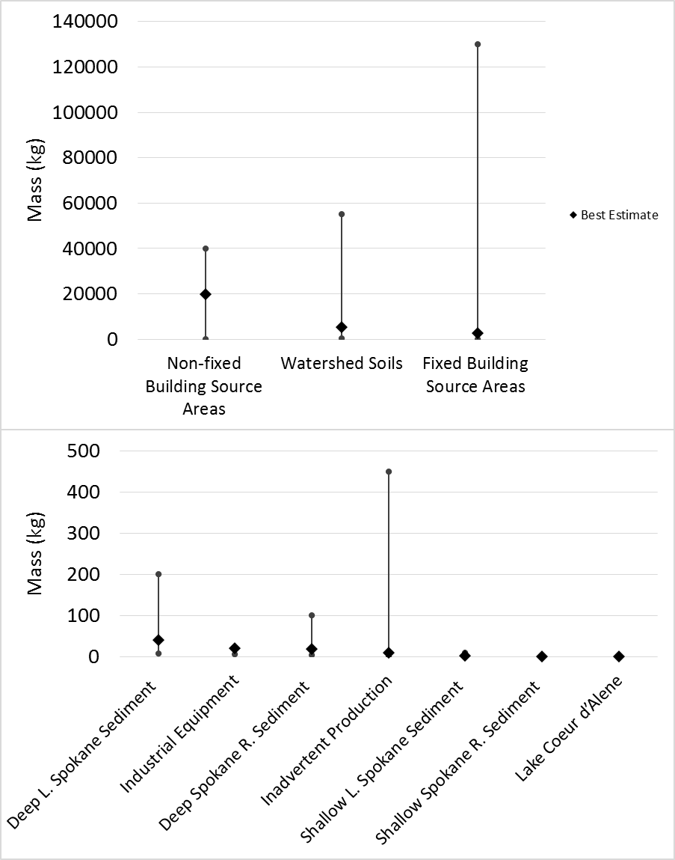

Figure . Estimated Range of Mass of PCB in each Source Area Category   
(Note the large difference in scale between the two embedded graphs)

## 3.2 Delivery Mechanisms of PCBs to the Spokane River

PCBs were determined by LimnoTech ([2016](http://srrttf.org/wp-content/uploads/2016/04/SRRTTF_SourcesPathways_2016_0316.pdf)a) to be delivered to the Spokane River study area via a number of mechanisms, as depicted in Figure 7. Categories of delivery consist of:

* Transport of PCBs from upstream sources through Lake Coeur d’Alene
* Atmospheric deposition
* Groundwater loading
* Stormwater runoff, either as part of an MS4 stormwater system or via direct drainage
* Combined sewer overflows (CSOs)
* Tributaries
* Discharge from municipal and industrial wastewater treatment plants
* Discharge of waste water and stocking of fish from fish hatcheries
* Diffusion or resuspension of PCBs from bedded sediments in the Spokane River and Lake Spokane

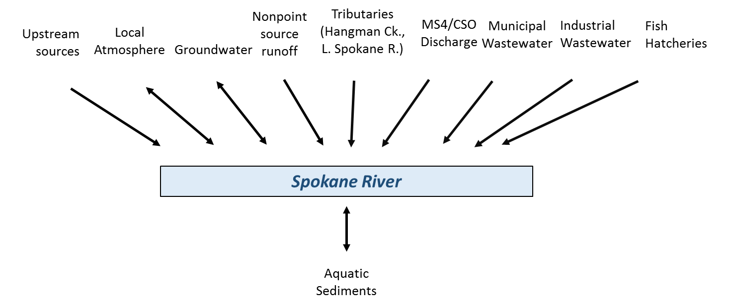

Figure 7. Categories of Delivery of PCBs to the Spokane River

The mass loading rate for PCBs estimated in each source category was estimated using available data and literature values, with the specific calculations provided in LimnoTech ([2016](http://srrttf.org/wp-content/uploads/2016/04/SRRTTF_SourcesPathways_2016_0316.pdf)a) and results provided below in Table 5 and Figure 8. The primary delivery mechanisms of PCBs to the Spokane River were determined to be cumulative loading across all wastewater treatment plants, contaminated groundwater, and stormwater/combined sewer overflows. PCB loading from Lake Coeur d’Alene and Spokane River tributaries is of similar magnitude to the primary delivery mechanisms listed above. The loading from Lake Coeur d’Alene and Spokane River is relatively large because they have much higher flow rates than other delivery mechanisms, albeit with lower much concentrations of PCBs.

Table . PCB Loading Rates Estimated for each Delivery Mechanism

|  |  |
| --- | --- |
| Delivery Mechanism | PCB Loading Rate (mg/day) |
| WWTPs |  |
| Total Municipal | 51 - 125 |
| Total Industrial | 126 - 165 |
| Groundwater loading | 60 - 300 |
| Upstream sources (Lake Coeur d’Alene) | 33 - 444 |
| Tributaries |  |
| Latah Creek | ~0 - 215 |
| Little Spokane River | 15-200 |
| MS4 stormwater/CSOs | 15 - 94 |
| Bottom sediments | 0.2 - 20 |
| Fish hatcheries | Unknown |
| Atmospheric deposition to surface water | <0 |

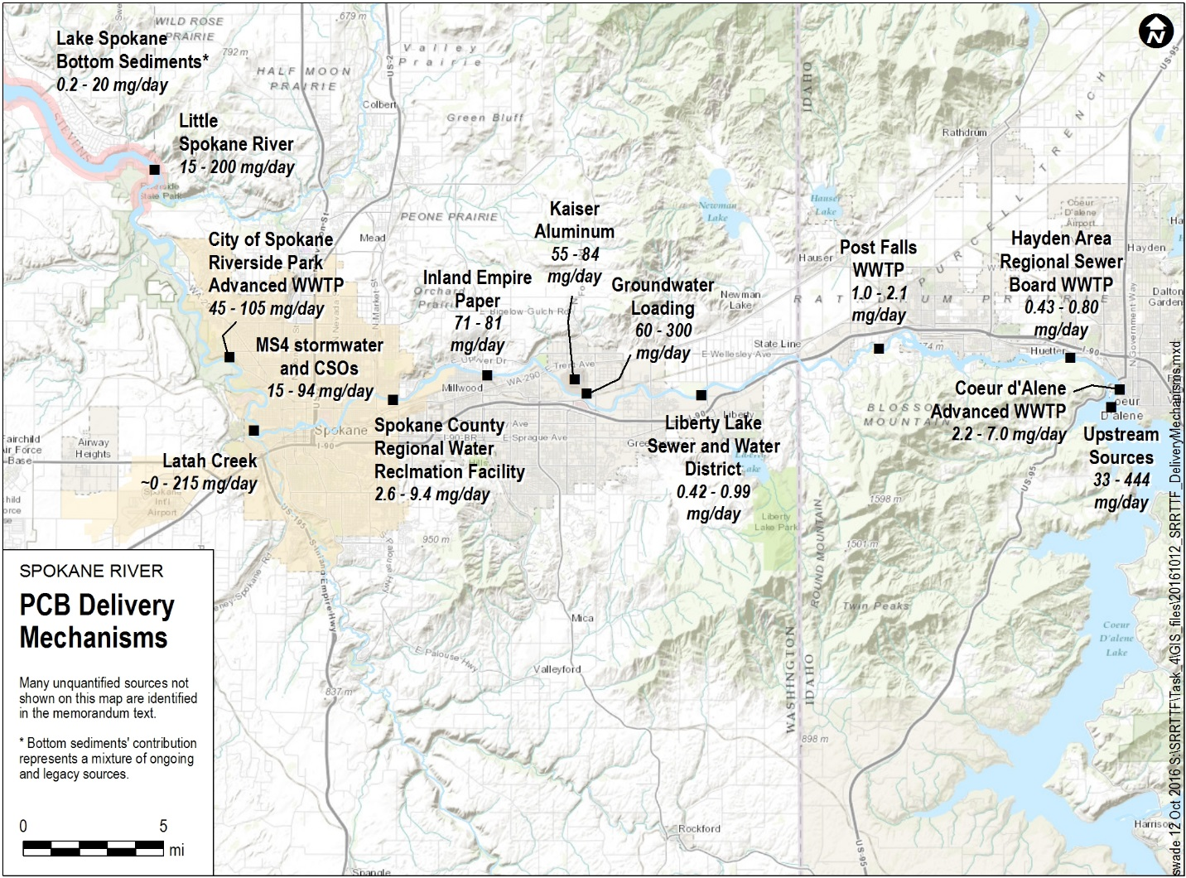

Figure . Estimated Range of PCB Loading Rates (mg/day) for each Delivery Mechanism

The remainder of this section describes how each of these estimates was determined.

### Transport of PCBs from Upstream Sources through Lake Coeur d’Alene

Transport of PCBs from upstream sources through Lake Coeur d’Alene was estimated using the observed distribution of PCB concentrations measured during Task Force confidence testing and synoptic surveys, in conjunction with the observed distribution of flow out of the lake to produce estimates of the 25th and 75th percentile loading rates, which were calculated to be 33 to 444 mg/day.

### Atmospheric Deposition Directly to Water Bodies

PCBs can be delivered directly to surface waters from atmospheric sources via three mechanisms: wet deposition, dry deposition, and gas deposition. Wet deposition consists of PCBs contained in precipitation. Dry deposition consists of PCBs attached to airborne particulate matter that settle onto the surface water. Gas deposition occurs as a transfer across the air-water interface when atmospheric gas-phase PCB concentrations exceed the equivalent dissolved phase PCB concentrations in the water column. Research (Miller et al, 2001) has shown that the primary mechanism for atmospheric PCBs to enter surface waters is through gas-phase exchange, so the calculations that follow focus solely on gas deposition as the dominant component of atmospheric PCB loading.

The magnitude of gas deposition is determined by three primary factors, the atmospheric gas phase PCB concentration, the water column PCB concentration and the mass transfer coefficients that control the rate at which PCB concentrations pass through the air-water interface. Screening-level calculations of gas phase PCB exchange for Spokane focused on Lake Spokane itself, which provides the large majority of overall surface area. Gas-phase atmospheric PCB concentrations were estimated from a population-based regression of Venier and Hites (2010) as 0.121 ng/m3. The water column PCB concentration was specified as 163.2 pg/L, based upon the average concentration observed at Nine Mile Dam during the 2014 synoptic survey. Representative mass transfer coefficients were taken from Chapra (1996). These values lead to a net movement of PCBs out of the water column and into the atmosphere, i.e. no net loading of PCBs from the atmosphere to the water column.

The magnitude of gas deposition is determined by three primary factors, the atmospheric gas phase PCB concentration, the water column PCB concentration and the mass transfer coefficients that control the rate at which PCB concentrations pass through the air-water interface.  Screening-level calculations of gas phase PCB exchange for Spokane focused on Lake Spokane itself, which provides the large majority of overall surface area. Gas-phase atmospheric PCB concentrations were estimated from a population-based regression of Venier and Hites (2010) as 0.121 ng/m3. The water column PCB concentration was specified as 163.2 pg/L, based upon the average concentration observed at Nine Mile Dam during the 2014 synoptic survey.  Other values used in the calculation, including representative mass transfer coefficients taken from Chapra (1996), are shown in Table 6.

Table 6. Inputs Used in Calculating Gas Phase Deposition

|  |  |  |
| --- | --- | --- |
| **Description** | **Value** | **Units** |
| Molecular Weight | 288 | g/mol |
| Henry's Constant | 5.60E-04 | atm m3/mol |
| Gas Law Constant | 8.206E-05 | atm m3/(K mol) |
| Air Temperature | 4.11 | Celsius |
| Oxygen Transfer Coefficient | 0.8655 | m/day |
| Wind Speed | 10 | mph |

These values were input into Equation 1 (where the net transfer velocity is a function of air temperature, the oxygen transfer coefficient, the ratio of PCB molecular weight to oxygen molecular weight, the ratio of PCB molecular weight to water molecular weight, and wind speed):

Mass Flux = Net Transfer Velocity x (Partial Pressure in air / Henry’s Constant – Concentration in water) (1)

Application of Equation 1 results in a net movement of PCBs out of the water column and into the atmosphere, i.e. no net loading of PCBs from the atmosphere to the water column.

### Groundwater Loading

The synoptic water quality survey conducted by the SRRTTF in August, 2014 identified a significant groundwater loading source entering the river between Greenacres (Barker Rd.) and the Trent Avenue Bridge, with an estimated loading rate of 170 mg/day. A second synoptic survey conducted in August, 2015 confirmed the presence of this load, and estimated its magnitude at 130 mg/day. Uncertainty analyses conducted in conjunction with the loading assessment (LimnoTech, 2015b, <http://srrttf.org/wp-content/uploads/2015/08/SRRTTF_Phase_2_Final_Report_2015_08_12_without-appendices.pdf>) indicate that this loading estimate can range between 60 and 300 mg/day.

### MS4 Stormwater Runoff/Combined Sewer Overflows (CSOs)

Stormwater/CSO loading estimates are based solely on available data for the City of Spokane. Consistent with the assumptions of Ecology (2011), direct stormwater runoff draining to the Spokane River from areas other than the City of Spokane’s MS4 system is assumed to be small. It is noted, however, that one percent (28.6 acres) of Post Falls’ impervious surface area contributes to MS4 discharges to the Spokane River, and the City of Coeur d’Alene has five MS4 outfalls to the Spokane River and seven to Lake Coeur d’Alene. Stormwater runoff drainage to tributaries will be reflected in the tributary loading estimates for Latah Creek and the Little Spokane River.

Initial sampling of the City of Spokane stormwater/CSO discharges for PCBs first occurred for single event in 2004 by the City of Spokane, followed in 2007 by more extensive sampling by Ecology and Parsons (Parsons, 2007). Ecology (2011) used these concentration data in conjunction with average annual stormwater flow predicted by the Simple Method to generate an annual average loading estimate of 691 mg/day.

From 2012 through 2014, the City of Spokane monitored three MS4 stormwater basins (Cochran, Union, Washington) and two CSO basins (CSO34 and CSO06) on a near-monthly basis. Hobbs (2015) reviewed the available data and calculated mass loading of PCBs to the river for individual storms.

Donovan (2015) generated annual loading estimates for MS4 and CSO sources, based upon:

* Annual rainfall of 18 inches
* Site-specific regression of discharge from the Cochran basin to rainfall
* Ratio of impervious area in other basins to impervious area in Cochran basin
* Average stormwater PCB concentration observed in Cochran basin to represent all basins except Union and Washington
* Average stormwater PCB concentration observed in Union basin
* Average stormwater PCB concentration observed in Washington basin
* 2005 actual CSO flow
* Average CSO 6 PCB concentration to represent CSO 6
* Average CSO 34 PCB concentration to represent CSO 34
* Average of CSO 34 and CSO 6 PCB concentration to represent all other CSOs

The above information resulted in an annual loading rate of 29.9 mg/day for MS4 stormwater, 7.6 mg/day for CSO, and a total of 37.6 mg/day. The estimate of Donovan (2015) is believed to be the most accurate value available. There is still uncertainty in this estimate, due primarily to uncertainty in stormwater flow. Based on best professional judgement, the loading estimate is accurate within a factor of 2.5. This results in an estimated loading rate range of 15 to 94 mg/day.

### Tributaries

Two tributaries enter the Spokane River within the study area, Latah Creek and the Little Spokane River. Each are discussed below.

#### Latah Creek

An annual PCB loading estimate for Latah Creek was obtained using long-term average observed creek flow (6.5 m3/sec) and the average concentration observed during the 2014 SRRTTF synoptic survey (89 pg/L), resulting in an annual loading estimate of 50 mg/day). This loading estimate was calculated by excluding one observed concentration measurement of 2444 pg/L observed during the 2014 Synoptic Survey, due to the fact no indication of concentrations of that magnitude were seen in the composite sample taken during that same synoptic period. Repeating the analysis with that one potentially unrepresentative sample from the calculation results in an average concentration of 383 pg/L and a loading estimate of 215 mg/day. Serdar et al (2011), based upon the absence of detectable levels of PCBs in Latah Creek sediments, assumed that the PCB contribution to the Creek was negligible. The range of estimated loading is based upon the range of these reported and calculated values, and is set as being from near zero to 215 mg/day.

#### Little Spokane River

A PCB loading estimate for the Little Spokane was originally provided by Serdar et al (2011), based upon and average Little Spokane PCB concentration data from 2003-2004 (199 pg/L) and harmonic mean at the USGS Station 12431000 at Dartford. Their concentration was derived from sampling with a semi-permeable membrane device (SPMD), which is an indirect measurement of water column PCB concentrations. Data collected in 2013-2014 reported by Friese and Coots (2016) suggest much lower river concentrations, with all observed River concentrations being less than 30 pg/L. Blank contamination issues prevented Friese and Coots (2016) from providing a quantitative estimate of concentration. Assuming an concentration of 114 pg/L, representing the average of the observed Serdar et al (2011) concentrations and Friese and Coots (2016) reported concentrations for the Painted Rocks station, in conjunction with the reported long term average flow (11.8 m3/sec) results in a loading estimate of 116 mg/day. Because the average flow from the river is much better understood than average river concentration, the uncertainty in this estimate is likely driven by the uncertainty in the average river concentration estimated above. Using 15 pg/L as a lower bound and 200 pg/L as an upper bound results in a load range of 15 to 120 mg/day.

### Discharge from Municipal and Industrial Wastewater Treatment Plants

Loading estimates for municipal and industrial wastewater treatment plants were calculated from effluent data collected by the plants during routine monitoring, along with data obtained during the SRRTTF synoptic surveys to assist in source identification. Observed concentrations are shown in Figures 9 through 11. These concentrations are presented in multiple formats due to differences in objectives, blank correction methodology, and monitoring design between the SRRTTF synoptic surveys and routine discharger effluent monitoring. The SRRTTF recognizes that the selection of blank correction methodology is dependent on the use of the data and conducted synoptic effluent monitoring with the objective of collecting the necessary data to conduct a semi‐quantitative PCB mass balance assessment in the Spokane River.  For the purposes of calculating total PCB concentrations for this study, the SRRTTF did not use any individual congener in a field sample that was less than three times the concentration of that congener in the method blank associated with the field sample (LimnoTech 2014, <http://srrttf.org/wp-content/uploads/2013/05/QAPP_FINAL_081114.pdf>). This is commonly referred to as “3x blank correction.” For routine effluent monitoring, the majority of dischargers currently exclude any individual congener in a sample that is less than ten times the concentration of that congener in the method blank associated with the sample (i.e. 10x correction). Differences in reported concentrations between the synoptic surveys and routing monitoring may also be explained by the sampling methods used, as routine monitoring is primarily conducted with composite samples while the synoptic surveys used grab samples. The number of samples available also differ between routine monitoring and the synoptic surveys.

Figure 9 presents PCB concentrations from municipal and industrial WWTPs calculated from synoptic survey data, which used a 3x blank correction. Figure 10 presents PCB concentrations from municipal and industrial WWTPs calculated from routine monitoring data using a 3x blank correction. Figure 11 presents PCB concentrations from municipal and industrial WWTPs calculated from routine monitoring data using a 10x blank correction. The figures show minimum, median and maximum concentrations, as well interquartile (i.e. 25th and 75th percentile) values. This presentation is useful in identifying the influence of anomalously high individual concentrations, such as a single concentration from the City of Spokane that is an order of magnitude higher than all other measurements.

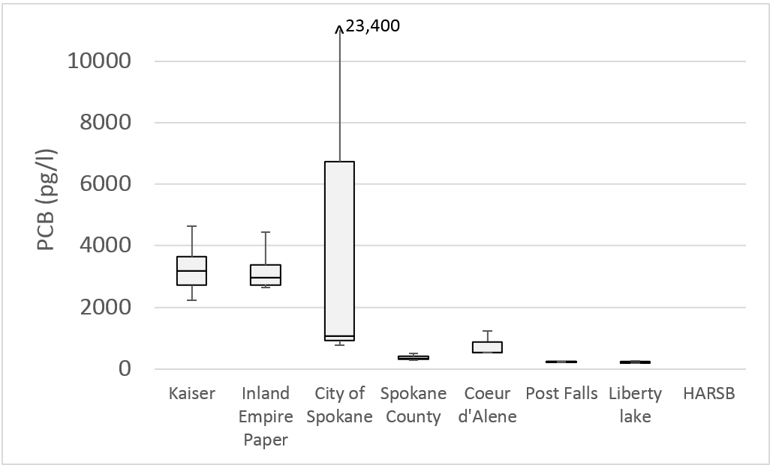

Figure 9. PCB Concentrations from Municipal and Industrial WWTPs Calculated from Synoptic Survey Data, Using 3x Blank Correction

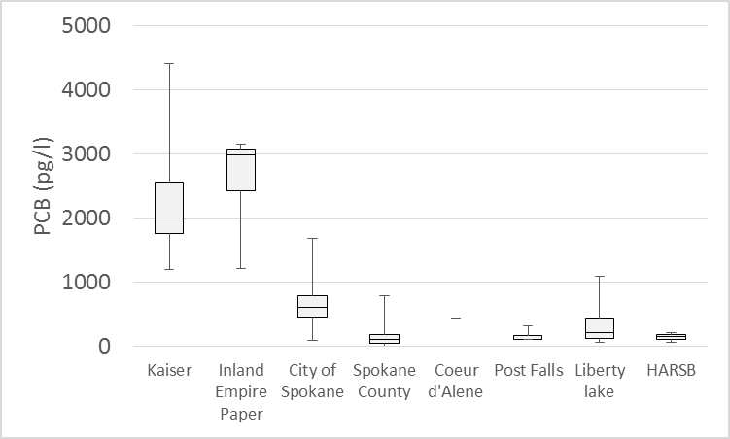

Figure 10. PCB Concentrations from Municipal and Industrial WWTPs Calculated from Routine Monitoring Data, Using 3x Blank Correction

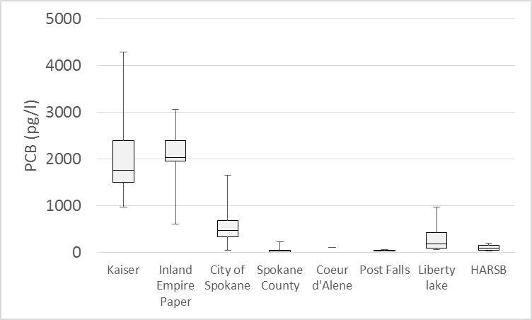

Figure 11. PCB Concentrations from Municipal and Industrial WWTPs Calculated from Routine Monitoring Data, Using 10x Blank Correction

The loading rate was calculated for each discharge by combining estimated total PCB concentration using 3x blank correction with observed discharge flow. Uncertainty in loading estimates was represented using the calculated 25th and 75th percentile values. Results are presented below in Table 7. The estimated total loading rate ranges from 126 to 165 mg/day for the industrial discharges and 51 to 125 mg/day for the municipal discharges.

Table 7. Calculated 25th and 75th Percentile Loading Rates from all Municipal and Industrial Wastewater Treatment Plants Using 3x Blank Correction.

|  |  |  |
| --- | --- | --- |
| WWTP | 25th Percentile Value | 75th Percentile Value |
| **Industrial** |  |  |
| Kaiser | 55.12 | 83.58 |
| Inland Empire Paper | 70.86 | 81.41 |
| Total | 125.98 | 164.99 |
| **Municipal** |  |  |
| City of Spokane | 44.78 | 105.14 |
| Spokane County | 2.62 | 9.41 |
| Coeur d'Alene | 2.15 | 6.98 |
| Post Falls | 1.04 | 2.07 |
| Liberty lake | 0.42 | 0.99 |
| HARSB | 0.43 | 0.80 |
| Total | 51.44 | 125.4 |

### Discharge of Waste Water and Stocking of Fish from Fish Hatcheries

PCB contributions to Spokane River from fish hatcheries can arise from the stocking of PCB-contaminated fish and discharge of effluent from the Washington Department of Fish and Wildlife’s Spokane Fish Hatchery to the Little Spokane River. Approximately 170,000 rainbow trout are planted annually to Lake Spokane and the Spokane River. The fish raised are in two different hatcheries, Troutlodge in Soap Lake, and the Spokane Fish Hatchery. Serdar et al (2006) found PCB concentrations of 6.5 ug/kg in hatchery trout from the Spokane Fish Hatchery and 14.4 ug/kg in fish fillets from the Troutlodge facility. Fish feed from the Spokane hatchery was analyzed by Serdar et al (2006) with a result of 16.4 ug/kg. No quantitative data exists for PCB loading from discharge of waste water and stocking of fish from these hatcheries. Ecology (2016) is conducting a study to provide specific estimates of loading from fish hatcheries.

### Diffusion or Resuspension of PCBs from Bedded Sediments in the Spokane River and Lake Spokane

No site-specific data were available to define the magnitude of pore water diffusion and/or resuspension of PCBs into the study areas from bed sediments. Given that the calculations above show that the mass of PCB in lake sediments is more than 100x greater than river sediments, it can be reasonably assumed that overall flux from bedded sediments is dominated by flux from lake sediments. The magnitude of pore water diffusion from lake bed sediments was estimated based on a combination of physical-chemical properties taken from the development of the MICHTOX Lake Michigan Mass Balance Project (USEPA, 2006; Endicott, 2005; and Endicott et al., 2005) with study area-specific measurements of sediment PCB concentrations. The resulting gross PCB diffusive flux from the lake sediments was estimated at 1.01 mg/day. Lake Spokane is known to have a significant carp population (Avista and Golder, 2012), and carp feeding mechanisms are known to churn bottom sediments and increase the flux of sediment-bound pollutants such as PCBs from via bioturbation (Canfield and Farquhar, 2009.) No quantitative data exists describing the effect of carp bioturbation on sediment flux, such that the actual rate of flux could be significantly higher than typical literature values. Conversely, much of the carp bioturbation activities occur in the shallower headwaters of Lake Spokane (Avista, 2015), where sediment PCB concentrations are lower than the sediments near the dam. Given this uncertainty, the estimate of the flux rate from Lake Spokane sediments is assumed to be accurate only within a factor of twenty, resulting in a range of 0.05 to 20 mg/day.

## 3.3 Transport Pathways between Source Areas and Delivery

It is recognized that there are a number of intermediate pathways by which the pollutant sources listed above get transported to the delivery mechanisms shown above in Figure 7. The primary categories transport pathways linking PCB source areas to delivery mechanisms are depicted in Figure 12 under the broad categories of:

* Mobilization in the watershed
* Volatilization to the atmosphere
* Delivery to sewer infrastructure
* Contribution to groundwater

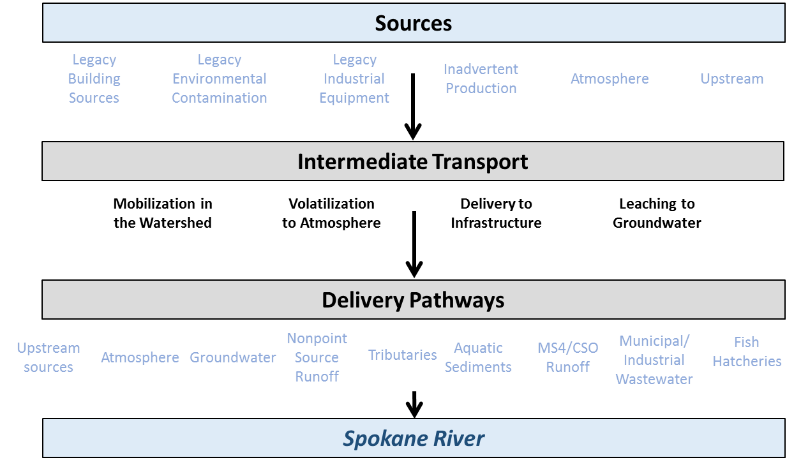

Figure 12. Intermediate Transport Pathways for Delivery of PCBs

Each of these pathways contains multiple components, which are described below.

### Mobilization in the Watershed

Many of the watershed source areas of PCBs are not immediately available for transport to the river, and must first undergo a mobilization step. Mobilization in the watershed occurs via several mechanisms. These sources, and the routes in which they are mobilized, are depicted in Figure 13. Fixed building sources can be released to surface soil during building demolition, or transferred to recycling facilities. The primary routes of watershed mobilization for non-fixed building sources are transfer to recycling facilities. PCBs contained in industrial sources can be mobilized via spills to surrounding soils, or through delivery to recycling facilities. PCBs in consumer products can be mobilized in surface soils via littering or processing at recycling facilities. Local atmospheric sources can contribute to watershed contamination via deposition and gas transfer. Finally, inadvertently produced PCBs can be directly applied to watershed soils via hydro-seed, de-icer, herbicides and pesticides, and biosolids or fertilizer applications.

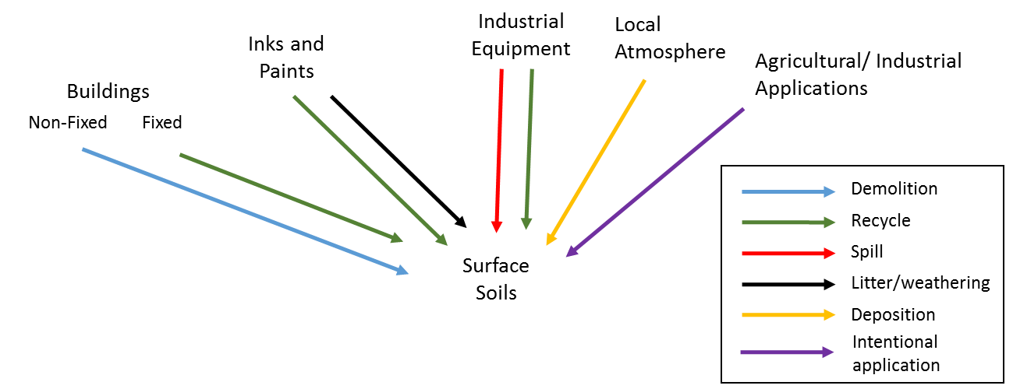

Figure 13. Mobilization of Sources in the Watershed

### Mobilization to the Atmosphere

Numerous sources contribute to local atmospheric concentrations of PCBs via volatilization, i.e. conversion into a gas phase. Most of these pathways consist of volatilization directly from one of the previously listed source categories (i.e., buildings, surface soils, industrial equipment). Combustion sources include internal combustion engines, incinerators, used oil burning and residential burning. Shanahan, et al. (2015) also identified volatilization of PCBs from sludge drying at wastewater treatment plants as an important source of atmospheric PCBs. The final source of local atmospheric sources is transport of PCBs generated outside of the watershed (Figure 14).

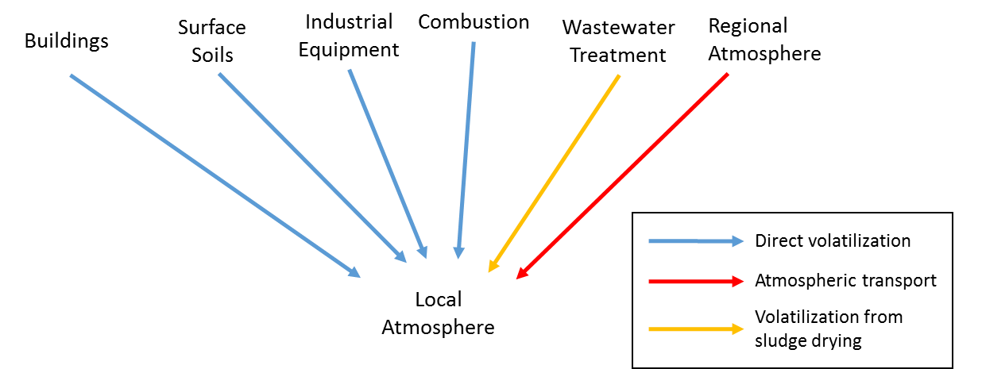

Figure 14. Mobilization of Sources to the Atmosphere

### Delivery to Sewer Infrastructure

The Spokane watershed contains a range of sewer infrastructure capable of delivering PCBs, either directly or indirectly, to the river. This infrastructure can be broadly divided into categories of stormwater and wastewater. Stormwater infrastructure can be further divided into categories of systems that directly discharge to the river and those that do not directly discharge (e.g., dry wells). Wastewater infrastructure can be divided into categories of municipal wastewater and industrial/other (i.e., Kaiser Aluminum, Inland Empire Paper, and the Spokane fish hatchery) and private septic systems. The mechanisms by which PCBs are delivered to the infrastructure are depicted in Figure 15.

### 

Figure 15. Delivery of Sources to Sewer Infrastructure

Potential sources of PCBs to the stormwater network are erosion of contaminated surface soils and infiltration of contaminated subsurface flow. Municipal wastewater treatment plants can get PCBs from human waste, infiltration of contaminated surface soils, as well as from printed materials/fabrics and legacy sources in their influent. Septic systems can receive PCBs from human waste, infiltration of contaminated surface soils, printed materials/fabrics and legacy sources. The industrial/other wastewater treatment plants receive PCBs in their influent, with the specific nature of the PCB source depending upon the facility.

### Contribution to Groundwater

The final intermediate transport pathway is contribution to groundwater, with specific transport mechanisms shown in Figure 16. Subsurface soils can contribute to groundwater either via legacy contamination, landfill disposal of PCB-containing products or private septic systems. Surface soils can also contribute to groundwater contamination via infiltration. A special case is included in Figure 16 to consider detention of stormwater in the non-discharging system such as drywells, as this mechanism has the potential to be a larger source of PCBs than infiltration from other soil areas.

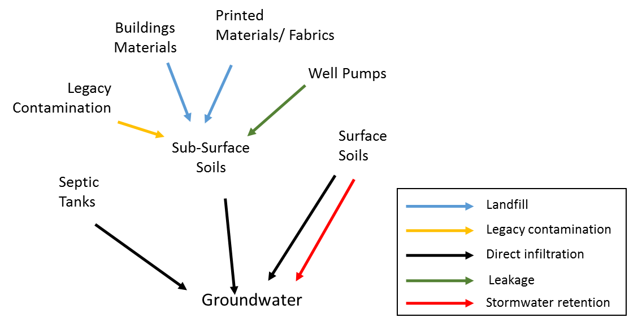

Figure 16. Delivery of Sources to Groundwater

The magnitudes of these individual mobilization pathways were estimated to the extent possible, with calculated magnitudes discussed below. Mobilization from fixed building sources appears to be a significant transport pathway, and mobilization from non-fixed building sources, consumer product, and land application also identified as potentially important pathways. Insufficient data exist to define the magnitude of pathways between this initial mobilization step and delivery to the Spokane River.

Numerous sources contribute to local atmospheric concentrations of PCBs via volatilization, i.e. conversion into a gas phase. Most of these pathways consist of volatilization directly from one of the previously listed source categories (i.e., buildings, surface soils). Volatilization from contaminated surface soils was determine to be the dominant pathway of PCBs to the atmosphere, with an estimated volatilization load of 16-1600 kg/yr. Potential combustion sources (e.g., incinerators, residential burning) were estimated to contribute an atmospheric load of 17 kg/yr. Volatilization of land-applied wastewater treatment sludge was determined to be negligible. Little definitive information exists on the specific amount of PCBs delivered to the Spokane area from atmospheric source areas. Ecology’s Environmental Assessment Program ([Ecology, 2016](https://fortress.wa.gov/ecy/publications/documents/1603112.pdf)b) is currently undertaking a study that will provide information on this transport pathway.

The Spokane watershed contains a range of sewer infrastructure capable of delivering PCBs, either directly or indirectly, to the river. This infrastructure can be broadly divided into categories of stormwater and wastewater. Stormwater infrastructure can be further divided into categories of systems that directly discharge to the river and those that do not directly discharge (e.g., dry wells). No quantitative estimate exists defining the quantity of PCBs being delivered to the stormwater system A lower bound estimate of loading to the City of Spokane’s MS4 system can be obtained from the stormwater loading estimate from that stormwater system provided above in Table 5 (15 mg/day, or 0.01 kg/year). No information exists to estimate PCB loading to non-discharging stormwater systems (e.g. dry wells). An estimate of PCBs delivered to municipal wastewater systems was derived from observed influent PCB concentrations, and calculated at 0.77 kg/yr.

The final intermediate transport pathway is contribution to groundwater. Subsurface soils can contribute to groundwater either via legacy contamination, landfill disposal of PCB-containing products, leaking submersible well pumps, or private septic systems. The Magnitude of Source Areas section above concluded that insufficient data exist to estimate the total mass of legacy subsurface PCB contamination; correspondingly, insufficient data are available to estimate the rate at which this legacy subsurface contamination contributes to groundwater. A lower bound estimate can be gained from the groundwater loading calculation presented above in Section 3.2, Delivery Mechanisms of PCBs to the Spokane River, which estimated the groundwater loading in the river section between Mirabeau Point (upper end of Mirabeau Park, downstream of Sullivan Road) and the Trent Avenue Bridge near Plante’s Ferry at 60 to 300 mg/day (0.022 to 0.11 kg/year. This is considered a lower bound estimate because it only considers legacy contamination loading from a portion of the aquifer. A search for data describing groundwater PCB loading from landfills provided no results, although modern landfills are designed and operated to prevent any adverse effects to groundwater. No quantitative information was available describing the rate of leakage from submersible well pumps or the rate at which private septic systems are delivering PCBs to the groundwater.

Blank Page

# 4 PCB Control Actions

As discussed above, PCBs are introduced to the Spokane River from a number of different source areas, transport pathways, and delivery mechanisms. This diversity of sources and pathways requires the application of a diverse range of Control Actions to reduce PCB levels and ultimately attain water quality standards. In the context of the Spokane River Comprehensive Plan, Control Actions are defined consistent with SFEI (2010) as “any activity, technology, process, operational method or measure, or engineered system, which when implemented prevents, controls, removes or reduces pollution.” These Control Actions have commonly been referred to as Best Management Practices (BMPs) in other studies.

The specific Control Actions to be included in the Comprehensive Plan were determined at a Task Force workshop help in Spokane on July 27, 2016. This section describes how these Control Actions were identified, evaluated, and selected for inclusion in the Comprehensive Plan. It is divided into three sub-sections, corresponding to:

* Inventory of Control Actions to be evaluated
* Evaluation of Control Action cost and effectiveness
* Selection of Control Actions for inclusion in the Comprehensive Plan

In addition, there are a wide range of PCB Control Actions that have been applied elsewhere for various source areas and pathways, that may or may not be applicable for Spokane.

The inventory of Control Actions to be evaluated in the Spokane River watershed is described in detail in LimnoTech ([2016](http://srrttf.org/wp-content/uploads/2016/04/SRRTTF_SourcesPathways_2016_0316.pdf)b), which is included as Appendix C to this Comprehensive Plan. The evaluation of the cost and effectiveness of each of PCB Control Actions under consideration is described in detail in LimnoTech ([2016](http://srrttf.org/wp-content/uploads/2016/04/Effectiveness_of_Control_Actions_0706_2016_draft.docx)e), which is included as is included as Appendix D.

## 4.1 Inventory of Control Actions to Be Evaluated

Identification of the universe of Control Actions that have the potential to reduce PCB loading to the Spokane River is a necessary first step in the development of the Comprehensive Plan. The Control Actions identified for consideration in the Comprehensive Plan were obtained from several sources:

* BMP Toolbox for the San Francisco Bay Area (SFEI, 2010)
* Stormwater Management Manual for Eastern Washington (Washington Department of Ecology, 2004)
* Spokane Regional Stormwater Manual (Spokane County, City of Spokane, and City of Spokane Valley, 2008)
* Spokane River Regional Toxics Task Force February 6-8, 2016 Workshop
* PCB Chemical Action Plan (Washington Department of Ecology, 2015a)
* Discussions within the Task Force BMP subgroup

For purposes of initial assessment, Control Actions were divided into the following four groups based upon discussions of the Task Force BMP planning group.

* Institutional
* Stormwater Treatment
* Wastewater Treatment
* Site Remediation

Institutional Control Actions include information sharing/educational campaigns and governmental practices to help businesses and the general public identify, avoid, clean up and/or properly dispose of products containing PCBs. These control actions require the least amount of infrastructure, engineering work, maintenance, and disturbance of existing land because their intent is to avoid the continued use, inadvertent production, or release of PCBs. Institutional Control Actions can be further broken down into two sub-groups, government practices and educational control actions. Governmental practices can include regulatory actions that restrict the use or disposal of PCB-containing items, as well as providing incentives for voluntary programs such as hazardous waste take-back programs. Educational control actions consists of activities that will indirectly reduce loading of PCBs, by altering public behavior and/or providing information to help direct future PCB reduction efforts. Stormwater treatment Control Actions are engineered options to be installed or built with the existing storm sewer infrastructure to capture soil and water containing PCBs and prevent it from being discharged to the Spokane River. Wastewater treatment Control Actions are those intended to reduce the loading of PCB from municipal and industrial wastewater treatment plants (WWTPs), either by actions to reduce the amount of PCBs being delivered via influent to the WWTP or increasing the rate of PCB removal with the WWTP itself. Site remediation Control Actions involve: 1) identifying, and 2) cleaning up soil/groundwater that have been contaminated from past use of PCBs, before they can be mobilized and transported to the river.

A total of 45 Control Actions considered potentially applicable to address PCBs in the Spokane River were identified. Each Control Action ultimately considered is listed by group in Table 8. Summary descriptions of each of these Control Actions are provided in Appendix A of this Plan.

Table . Menu of Control Actions Identified as Potentially Applicable for Reducing PCB Loads to the Spokane River and Lake Spokane

|  |  |  |
| --- | --- | --- |
| Group | Sub-Group | Control Action |
| Institutional | Governmental Practices  (Regulatory Actions and/or Incentivized Voluntary Programs) | Waste disposal assistance |
| Low Impact Development (LID) Ordinance |
| Leaf removal |
| Street sweeping |
| Catch basin/pipe cleanout |
| Purchasing standards |
| Survey of local electrical equipment |
| Regulation of waste disposal |
| Removal of carp from Lake Spokane |
| Building demolition and renovation control actions |
| PCB product labeling law |
| Leak prevention/detection in electrical equipment |
| Accelerated sewer construction |
| PCB identification during inspections |
| Regulatory rulemaking |
| Compliance with PCB regulations |
| Support of green chemistry alternatives |
| Educational | Survey schools/public buildings |
| Education/outreach about PCB sources |
| Education on septic systems disposal |
| Education on filtering post-consumer paper |
| PCB product testing |

Table 8 (continued). Menu of Control Actions Identified as Potentially Applicable for Reducing PCB Loads to the Spokane River and Lake Spokane

|  |  |  |
| --- | --- | --- |
| Group | Sub-Group | Control Action |
| **Stormwater Treatment** | **Pipe Entrance and Pipe System** | Infiltration control actions |
| Retention and reuse control actions |
| Bioretention control actions |
| Isolation of contaminated source areas from the MS4 |
| Filters |
| Screens |
| Wet vault |
| Hydrodynamic separator |
| **End of Pipe** | Constructed wetlands |
| Sedimentation basin |
| Discharge to ground/dry well |
| Diversion to treatment plant |
| Fungi (mycoremedation) or biochar incorporated into stormwater treatment |
| **Wastewater Treatment** |  | Development of a Toxics Management Action Plan |
| Implementation of a source tracking program |
| Chemical fingerprinting or pattern analysis |
| Remediation and/or mitigation of individual sources |
| Elimination of PCB-containing equipment |
| Public outreach and communications |
| Review of procurement ordinances |
| Pretreatment regulations |
| **Site Remediation** |  | Identification of contaminated sites |
| Clean up of contaminated sites |

## 4.2 Evaluation of Control Action Cost and Effectiveness

The second step in identifying those Control Action that may be most appropriate for inclusion in the Comprehensive Plan consisted of a detailed review of the inventory of Control Actions listed above. This section summarizes that review, and is divided into sections of Review Factors and Findings.

### 4.2.1 Review Factors

Each Control Action was reviewed with respect to the following factors:

* Magnitude of pathway
* Reduction efficiency
* Cost
* Implementing entity
* Pollution prevention hierarchy
* Potential overlap with existing efforts
* Ancillary benefit
* Timeframes for implementation and results

The information gathered for this review indicated that many of the reviewed Control Actions have no quantitative information available on costs or effectiveness. In addition, the magnitude of the transport pathways between many source areas and delivery mechanisms had been determined to be either highly uncertain, or unknown. Because quantitative information was lacking or highly uncertain for many aspects of this review, a qualitative or semi-quantitative scoring system was used. The definition of each aspect of the review, as well as the ranking system used, is described below.

“Magnitude of Pathway” describes the importance of the pathway in terms of delivering PCBs to the river or lake from the source area or pathway being targeted by the Control Action. Control Actions that interrupt significant pathways may be very effective in preventing PCB sources from contributing PCBs to the system. Even though many intermediate transport pathways are uncertain or not quantified, sufficient information exists to allow at least a qualitative understanding of the importance of many pathways. As such, Control Actions were rated as follows:

* Highly suitable: Pathway provides >1% of the total PCB load delivered to the system
* Moderately suitable: Pathway provides 0.1- 1% of the total PCB load delivered to the system
* Less suitable: Pathway provides <0.1% of the total PCB load delivered to the system

“Reduction Efficiency” is a primary consideration in terms of prioritizing Control Actions, as it describes the extent to which a given action is expected to reduce PCB movement from its targeted source area or pathway. Although quantitative information defining reduction efficiency was not available for many Control Actions, sufficient information exists to allow the majority of Control Action to be rated as follows:

* Highly suitable: >50% reduction in targeted source area or pathway
* Moderately suitable: 10-50% reduction in targeted source area or pathway
* Less suitable: <10% reduction in targeted source area or pathway

“Cost” describes the expected long-term cost of implementing the Control Action, considering both capital and operating costs. Control Actions that remove PCBs at lower costs will be preferred over Control Actions that remove similar amounts of PCBs at greater costs. Even in the absence of quantitative data, a qualitative understanding exists regarding the costs of many Control Actions, and they are rated as follows:

* Highly suitable: <$100,000
* Moderately suitable: $100,000-$1,000,000
* Less suitable: >$1,000,000

“Implementing Entity” describes the extent to which there is a clearly identified responsible party for implementing the control action due to their enrollment in a regulatory or voluntary program, along with an assessment of their willingness to do so. It is rated as follows:

* Highly suitable Entity identified and willing to implement
* Moderately suitable: Entity identified, willingness uncertain
* Less suitable: No willing entity identified

Experience with a wide range of pollutants has shown that preventing the creation or release of a pollutant is far more effective than controlling it once released. “Pollution Prevention Hierarchy” describes where the Control Action is located on the spectrum from limiting production and use of PCBs to treating PCBs prior to their release to the river or lake. It is rated as follows:

* Highly suitable: Controls production or use of PCBs
* Moderately suitable: Manages the mobility of PCBs in the environment
* Less suitable: Performs “end-of-pipe” treatment of PCBs prior to discharge

“Existing Efforts” describes the extent to which a given Control Action relates with existing PCB control efforts that are required by state or federal law or currently being conducted under voluntary programs. It is rated as follows:

* Highly suitable: Addresses a source area or pathway that is not currently being addressed
* Moderately suitable: Expands upon existing controls of a source area or pathway
* Less suitable: Redundant with existing efforts

“Ancillary Benefit” describes the extent to which a given Control Action provides benefits beyond removal of PCBs from the system. It is rated as follows:

* Highly suitable: Provides significant additional benefits beyond reduction of PCB loads
* Moderately suitable: Provides some additional benefits beyond reduction of PCB loads
* Less suitable: Provides minimal additional benefit beyond reduction of PCB loads

“Timeframe for implementation and results” assesses the amount of time it will take for a given Control Action to be implemented, as well time for a system response to be observed. It is rated separately for implementation and results as follows:

* Highly suitable: Expected within two year timeframe
* Moderately suitable: Expected within five year timeframe
* Less suitable: Expected after more than five years

### 4.2.2 Review Findings

Table 9 summarizes the findings of the above review, using a simple shading scheme to identify whether each aspect of each Control Action is:

* Highly suitable
* Moderately suitable
* Less suitable
* Unable to be evaluated, due to a lack of information

Table . Initial Summarization of Control Actions



One key observation made from this review was that the most significant delivery mechanisms of PCBs all have existing Control Actions in various phases of development. Specific PCB-related Control Actions underway in Spokane are:

* Most wastewater treatment plants discharging to the Spokane River are required to develop and install treatment systems to reduce nutrient loading that will likely concurrently result in reductions of PCB loading. In addition, each wastewater facility has developed a Toxics Management Action Plan that includes a PCB source identification study and associated control actions. These treatment plants are operated by:
* City of Coeur d’Alene - City of Post Falls
* City of Spokane - Liberty Lake Sewer and Water District
* Kaiser Aluminum - Inland Empire Paper
* Spokane County - Hayden Area Regional Sewer Board
* Remediation activities for known contaminated sites in Washington are being implemented and managed under the jurisdiction of the Model Toxics Control Act (MTCA). Marti and Maggi ([2015](http://srrttf.org/wp-content/uploads/2015/10/Tech-Memo-PCBs-in-Spokane-Valley-GW-Marti-9-16-15-FINAL-2.pdf)) searched for sites in Spokane that could be contributing PCB contamination to groundwater in the area of the Spokane River. They identified 31 clean-up sites, three of which have confirmed release of PCBs and subject to MTCA remediation. They are:
* Spokane River Upriver Dam and Donkey Island
* Kaiser Aluminum
* General Electric Company, E. Mission Ave.

Contamination at the Spokane River Upriver Dam and Donkey Island sites was the result of PCBs in the river and were not a “new” source like the others.

* The City of Spokane is actively addressing stormwater and CSO loading of PCBs as part of their Integrated Clean Water Plan. Other entities are also controlling their stormwater loads under NPDES stormwater permits, including:
* Idaho Transportation Department - City of Coeur d’Alene
* City of Post Falls - Post Falls Highway District
* Spokane County - City of Spokane Valley
* Washington Department of Transportation - Lakes Highway District
* The large majority of stormwater in the remainder of the watershed (including Spokane County and the City of Spokane Valley) is being diverted to groundwater, as opposed to direct surface discharge to the River. This activity is consistent with many of the PCB Control Actions discussed previously under the sub-groupof “Stormwater Treatment--Pipe Entrance,” and is regulated under the State of Washington’s and the Idaho Department of Water Resources’ Underground Injection Control Programs for UIC wells (e.g. drywells).
* Local electric utilities have replaced their transformer oils with essentially PCB-free oils, and eliminated the use of large capacitors.

## 4.3 Selection of Control Actions for Inclusion in the Comprehensive Plan

The results of the evaluation of Control Actions presented above were discussed at a Task Force workshop held in Spokane on July 27, 2016. The objective of this workshop was to define, in a consensus-based manner among Task Force members, the specific Control Actions to be included in the Comprehensive Plan. A summary of the Control Actions under consideration were presented in spreadsheet format as shown in Table 10. The 45 Control Actions originally identified were condensed into 27 categories, primarily by grouping individual stormwater controls into categories corresponding to their location (i.e. pipe entrance, in the pipe system, or end of pipe). Discussion of Control Actions at the workshop was divided into tiers of:

* Control Actions already being implemented
* Potential new Control Actions

Table . Summary of Control Options Presented at July 27, 2016 Workshop





Existing Control Actions were discussed first, and placed by the group into one of two categories. The first category (called Category A) contained Control Actions where the group decided to maintain current efforts, and document those efforts in the Plan. The following Control Actions were identified as   
Category A:

* Wastewater Treatment
* Remediate Known Contaminated Sites
* Stormwater Controls
* Low Impact Development Ordinance
* Street Sweeping
* Purchasing Standards

The second category (called Category B) contained Control Actions where the group identified improvements that could be made to existing efforts. The following Control Actions were identified as Category B:

* Support of Green Chemistry Alternatives
* PCB Product Testing Information
* Waste Disposal Assistance
* Regulatory Rulemaking
* Compliance with PCB Regulations
* Emerging End of Pipe Stormwater Technologies

Potential new Control Actions were reviewed next, and placed into one of three categories by the group:

1. Include in Comprehensive Plan and commit to implementation
2. Include in Comprehensive Plan as an activity worth exploring in the future
3. Do not include in Comprehensive Plan

Two Control Actions were identified as Category C for inclusion in the Comprehensive Plan with a commitment to implementation: Identification of Sites of Concern for Contaminated Groundwater and Building Demolition and Renovation Control. The following nine Control Actions were identified as Category D, to be included in the Comprehensive Plan as an activity worth exploring in the future:

* Survey Schools and Public Buildings
* Accelerated Sewer Construction
* Emerging Wastewater Technology
* Survey of Local Electrical Equipment
* Leak Prevention/ Detection in Electrical Equipment
* Regulation of Waste Disposal
* Removal of Carp from Lake Spokane
* PCB Identification during Inspections
* Compliance with PCB Regulations for Imported Products
* Education on Septic Disposal
* Stormwater Source Tracing

Three Control Actions were identified as Category E, and not considered for future implementation:

* Leaf Removal
* PCB Product Labeling Law
* Education on Filtering Post-Consumer Paper

Blank Page

# 5 Implementation Plan

This section discusses the specific Control Actions selected to be undertaken to reduce PCBs in the Spokane River. It contains sections corresponding to each of the Category A, B, and C Control Actions identified in the previous section, then follows with the recommended schedule for their implementation and measurable milestones to assess their implementation effectiveness. Category D Control Actions (i.e. ones intended for future consideration) are discussed later in this document. Long-term effectiveness in reducing PCBs in the river and fish tissue is addressed in Section 6.

## 5.1 Category A: Wastewater Treatment

Category A Control Actions consist of existing actions where the group decided to maintain current efforts, and document those efforts in the Plan. The first Category A Control Action corresponds to wastewater treatment. NPDES permits regulate discharges from wastewater and industrial facilities in Washington and Idaho, as well as fish hatcheries (under a general permit). The Washington and Idaho (EPA) NPDES permits require each wastewater facility discharging to the Spokane River to develop and install treatment systems to reduce nutrient loading that will concurrently result in reductions of PCB loading. Additional permit requirements that relate to the monitoring and reduction of PCB loads are described for the following categories of permits: Idaho Municipal Permits, Washington Municipal Permits, Washington Industrial Permits, and the Upland Fin-Fish Hatching and Rearing General Permit. The information that follows is based on the most current permits as of September 2016, and does not include information in draft permits that have not yet been approved.



### Idaho Municipal Permits

The City of Coeur d’Alene (ID0022853), City of Post Falls (ID0025852), and Hayden Area Regional Sewer Board (ID0026590) all have NPDES permits with numerous PCB-related requirements. These permits were all made effective as of December 1, 2014 and all expire of November 30, 2019. They all have very similar, if not identical requirements to monitor PCB congeners at influent, effluent and instream locations and participate in the Task Force. Other requirements that are common to these three permits and which will reduce PCB loads to the Spokane River are:

* Submit a Toxics Management Plan to EPA and IDEQ, with the goal of reducing loadings of PCBs to the Spokane River to the maximum extent practicable. The Toxics Management Plan must address source control and elimination as follows:
* From contaminated soils, sediments, storm water and groundwater entering the POTW collection system via inflow and infiltration
* From industrial and commercial sources, including compliance with pre-treatment regulations for industrial users indirect discharges of PCBs that cause pass through or interference
* From any person discharging PCBs to the POTW water in excess of applicable pre-treatment local limit established by the POTW, or 3 ug/L, whichever is less.
* By means of eliminating existing sources that are within direct control of the permittee.
* By means of changing the permittee’s procurement practices, control and minimize the future generation and release of PCBs that are within the direct control of the permittee, including preferential use of PCB free substitutes for those products containing PCBs below the regulated level of 50 ppm
* Develop and implement a public education program to educate the public about: the difference between products free of PCBs and those labeled non-PCB but which contain PCBs below the TSCA regulatory threshold of 50 ppm; and proper disposal of waste products that may contain PCBs including those containing PCBs below the TSCA regulatory threshold of 50 ppm and the hazards associated with improper disposal.
* Distribute appropriate educational materials to target audiences at least once per year.
* At least once a year, prepare and distribute information relevant to the TMP to a newspaper, and make all relevant TMP documents available to the public.
* Submit an annual report to EPA and IDEQ that contains: PCB monitoring results, copies of educational materials, ordinances, inventories, guidance materials or other products produced as part of the TMP.
* Description and schedule for implementation of additional actions that may be necessary, based on monitoring results, to ensure compliance with applicable water quality standards
* Summary of actions taken to reduce discharges of PCBs during the previous 12-month period, and a separate summary of actions planned for the next reporting cycle

### Washington Municipal Permits

There are three Washington municipal permits. Permit WA-002447-3, which covers the City of Spokane Riverside Park WRF and CSOs, and Spokane County Pretreatment Program, was effective as of July 1, 2011 with an expiration date of June 30, 2016. Permit WA-0045144 which covers the Liberty Lake Sewer and Water District, was also effective as of July 1, 2011 with an expiration date of June 30, 2016. The third permit (WA-0093317) covers the Spokane County Regional WRF, and was effective as of December 1, 2011 with an expiration date of November 31, 2016. These permits are similar to each other with regards to PCBs, and are also similar to the Idaho municipal permits. Requirements common to the three Washington municipal permits are listed below with a few differences noted.

Each permit includes requirements to monitor PCB congeners at minimum specified frequencies in raw sewage and final effluent and participate in the Task Force. PCBs sampling and analysis must be in accordance with the quality assurance plan and scope of work submitted to the Department of Ecology. The quality assurance plan will be reviewed annually and revised if needed. (The QAPP language is slightly different for the County permit). The effluent monitoring results will be compiled and analyzed by Ecology for the purpose of establishing a performance-based PCB effluent limitation for the following permit cycle. The Spokane County and City of Spokane permits additionally require biosolids PCB monitoring.

A report[3] must be submitted to Ecology annually, containing a report of the sampling results. Annually, the permittee and Ecology will review the data, including pattern analysis of homologs, detection limits, QA/QC procedures and a draft action plan (The Toxics Management Plan) listing identified sources, potential sources suggested by data analysis and future source identification activities. Annually the permittee and Ecology will confer and revise locations and frequency of raw sewage PCB sampling in the collection system.

Similar to the Idaho municipal permits, the goals of the Toxics Management Plan are to reduce loadings of PCBs to the Spokane River to the maximum extent practicable realizing statistically significant reductions in the influent concentration of toxicants to the treatment plants over the next 10 years, and reduce PCBs in the effluent to the maximum extent practicable to bring the Spokane River into compliance with WQS for PCBs. The Toxics Management Plan must address source control and elimination of PCBs from:

* Contaminated soils and sediments,
* Storm water entering the wastewater collection system,
* Industrial and commercial sources. As an element of the Spokane City and Spokane County permitted pretreatment programs (not Liberty Lake), the scope of their inspections and monitoring will be expanded to include PCBs. The PCB monitoring must follow a QAPP.
* By means of eliminating active sources such as: older machinery, older electrical equipment and components, construction material content, commercial materials
* By means of changing procurement practices and ordinances control and minimize toxics, including preferential use of PCB free substitutes for those products containing PCBs below the regulated level of 5 ppm, in sources such as: construction material content, commercial materials, soaps and cleaners.
* The Permittee must also prepare public media educating the public about the difference between products free of PCBs and those labeled non-PCB but which contain PCBs below the TSCA regulatory threshold of 5 ppm.

### Washington Industrial Permits

There are two Washington industrial permits, the Inland Empire Paper Company permit (WA-000082-5) and the Kaiser Aluminum permit (WA0000892).

The Inland Empire Paper Company permit contains monitoring requirements for PCB congeners, but does not contain PCB effluent limits. After Inland Empire Paper Company collects total PCB data according to the initial testing frequency, Ecology intends to modify the permit to set an interim numeric effluent limit for total PCBs.

This permit also includes requirements to submit a scope of work for a PCB Source Identification Study, and completion of that study after approval by the Department. The scope of work for the PCB Source Identification Study should include raw materials used at the facility that may contain PCBs, a site review where PCB containing equipment was/may have been used, a sampling plan with proposed sampling locations, quality control protocols, sampling protocols and PCB text methods.

Following approval of the scope of work, Inland Empire Paper Company shall submit a report of the results and incorporate findings into the PCB BMP Plan. The PCB BMP plan shall include:

* A list of members of a cross-functional team responsible for developing the BMP plan, including the name of a designated team leader.
* A description of current and past source identification, source control, pollution prevention, and wastewater reduction efforts and their effectiveness.
* Identification of technical/economical evaluation of new BMPs. BMPs should include, but are not limited to: modification of equipment, facilities, technology, processes, and procedures; source control; remediation of any contaminated areas, etc.
* A schedule for implementation of economically feasible BMPs.
* Methods used for measuring progress towards the BMP goal and updating the BMP plan.
* Results from testing of any waste streams for PCBs taken in support of the PCB BMP plan and PCB Source Identification Study.

Following initial submission of the PCB BMP plan, an annual report is due to the Department and shall include: a) all BMP plan monitoring results for the year; b) a summary of effectiveness of all BMPs implemented to meet the BMP plan goal; and c) any updates to the BMP plan.

The Kaiser Aluminum permit requires use of a walnut shell filtration system to aid in removing PCBs from the process wastewater. This system was constructed in response to an Agreed Order issued by Ecology, which was subsequently amended in October, 2005, to require influent sampling to the BWS to verify that the design PCB loadings to the filters were being maintained (among other requirements). The permit specifies PCB influent sampling and loading limits for the walnut shell filtration system inlet, to verify that the design PCB loadings to the filters are being maintained. This permit also requires continued PCB source identification and cleanup actions that were initiated under Amended Order No. 2868, to reduce PCBs in the effluent to the maximum extent practicable to bring the Spokane River into compliance with applicable water quality standards for PCBs. Among other things, the Amended Order required Kaiser Aluminum investigate the high levels of PCBs discharged in 2002 and identify and remove PCBs still remaining in the wastewater treatment and collection systems. In addition, Kaiser Aluminum is required to prepare a scope of work for additional source identification efforts that utilizes information from a 2012 report, and which includes a sampling plan with proposed sampling locations, sampling protocols, PCB test methods and a work schedule. A report summarizing the status of the PCB source identification and cleanup must be provided semiannually to Ecology.

### Upland Fin-Fish Hatching and Rearing General Permit

The general NPDES permit (WAG137007), Upland Fin-Fish Hatching and Rearing General Permit, has an effective date of April 1, 2016 and an expiration date of March 31, 2021. This permit applies to upland aquaculture facilities or operations that discharge fish rearing water to a surface water body or a system that drains to a surface water body, which meet specific coverage requirements described in the permit.

The permit describes PCB Reduction Activities and BMPs to eliminate, to the maximum extent possible, the release of PCBs from any known sources in the facility, including paint, caulk, or feed that come in contact with water. New and existing facilities have different timelines, but the same requirements. These requirements are summarized below.

The permittee must assess the facility for the presence of paint or caulk manufactured prior to 1980 and evaluate if any of these sources come in contact with water and could contribute to a discharge of PCBs to surface waters. A copy of the assessment report must be submitted to Ecology and include information regarding pre-1980 caulk and paint usage and location in the facility, amounts of stored caulk or paint at the facility, and PCB material removed from hatchery use but still on-site. The permitee must then submit a plan that is consistent with [USEPA guidance](http://www.epa.gov/epawaste/hazard/tsd/pcbs/pubs/caulk/guide/guide-sect4a.htm) for the proper removal and disposal of all pre-1980 paint and caulk that comes in contact with water or occurs as waste on-site, and also submit documentation to Ecology. The paint and caulk removal plan may contain documentation that paint or caulk onsite does not contain PCBs as an alternative to their removal, or has no chance of coming in contact with water and being discharged to surface water.

The Permittee is required to use any available product testing data to preferentially purchase paint, caulk, and construction materials with the lowest practicable total PCB concentration.

The permittee must develop and implement, submit a plan to Ecology to reduce PCBs in the facility discharge, from fish feed and feeding activities. The plan must contain purchasing procedures that give preference for fish food that contains the lowest amount of PCBs that is economically and practically feasible, fish feeding practices that minimize the discharge of unconsumed food, and methods to reduce and remove accumulated fish feed regularly to keep feed out of the discharge. Additionally, permittees must request PCB content information from fish food suppliers and include this in the Best Management Practices Plan.

State run facilities must comply with RCW 39.26.280(2) that prohibits a state agency of knowingly purchasing products containing PCBs above quantitation levels unless it is not cost effective or feasible to do so.

Within the site-specific Pollution Prevention Plan, which is submitted to Ecology, permittees must address ongoing PCB reduction activities, as they relate to food, construction, operational and equipment purchases, including paint and caulk.

## 5.2 Category A: Remediate Known Contaminated Sites

Ecology’s Toxics Cleanup Program (TCP) is responsible for overseeing the remediation of known contaminated sites, working under regulatory authority from Washington’s Model Toxics Control Act (MTCA). Four contaminated sites with potential to contribute PCBs to the Spokane River are in various stages of remediation:

* Spokane River Upriver Dam and Donkey Island
* General Electric Co.
* City Parcel
* Kaiser Aluminum

The status of each site is discussed below.

### 5.2.1 Spokane River Upriver Dam and Donkey Island

Historical discharges of PCBs to the Spokane River upstream of the Upriver Dam and Donkey Island led to contamination of river sediments. Two PCB deposits in river-bottom sediments were investigated and cleaned up from 2003 to 2007 in accordance with a consent decree Ecology entered into with Avista. The remedy involved the removal and containment of PCB-contaminated sediments. Due to the design of the selected remedy to cap contaminated sediments in place, PCBs remain in sediments at concentrations exceeding the selected cleanup level for the site. Post-remediation surface and subsurface sediment sampling were required to be performed as part of the Cleanup Action Plan. Surface grab samples were collected from material on top of the cap and subsurface sediment profile cores were collected from the cap extending into the material below the cap. In addition, a bathymetric survey was conducted prior to each sampling event to evaluate cap thickness and help select locations for the surface and subsurface sediment samples. Avista completed the scheduled monitoring of the engineered cap during Year 2 (2008) and Year 4 (2010) following cap construction. Bathymetric comparisons, visual observations, and chemical analyses performed during the monitoring events verified the integrity and protectiveness of the cap, including through a 25-year flood event.

Ecology has determined, based upon review of the collected data, that: 1) the cleanup remedy implemented at the Site is currently protective of human health and the environment; and 2) monitoring of the effectiveness of the remedial action and the integrity of the cap should continue in the future at a rate of once every five years to ensure long-term protectiveness ([Ecology, 2015](https://fortress.wa.gov/ecy/gsp/DocViewer.ashx?did=52440)a). It is noted that there were some other smaller identified sediment deposits not remediated, with concentrations between 28 and 40 ug/Kg. While these concentrations were below the cleanup level of 60 ug/Kg, these sediments could be a significant source of PCB contamination at the much lower level of water column concentrations of potential concern.

### 5.2.2 General Electric Co.

The General Electric Co. site is approximately 1200 feet south of the Spokane River in Spokane, and less than two acres in size. The site was used by General Electric to operate a transformer service shop from 1961 to 1980. Oils containing PCBs were released to soils during service operations. Investigations in the mid to late 1980s confirmed the presence of PCBs in soils and groundwater. Cleanup actions began in 1991. Remedies accepted as complete in 1999 included vitrification, removal, containment, groundwater monitoring, and institutional controls. Institutional controls include fencing the General Electric property, inspecting and maintaining an asphalt cap, and recording of restrictive covenants. Cleanup is now considered complete and monitoring continues to ensure protection of human health and the environment. Periodic reviews have been conducted in 2003, 2008, and 2013 and have included the evaluation of groundwater data, inspection of the reports on the asphalt cap, and existing institutional controls. The most recent review concludes that the site cleanup continues to be protective of human health and the environment. Groundwater monitoring in seven of eight monitoring wells are in compliance with specified clean-up levels of 0.1 ug/l, with concentrations at the remaining well observed at up to 0.21 ug/l ([Ecology, 2013](https://fortress.wa.gov/ecy/gsp/DocViewer.ashx?did=19457)). As discussed in the Future Actions section below, these clean-up levels are more than 500 times larger than the current PCB water quality criterion.

### 5.2.3 City Parcel

The City Parcel site covers just over half an acre. Spokane Transformer, Inc. repaired and recycled transformers at the site from 1961 through 1979. In 1979, the site was sold to City Parcel, Inc., a package delivery service. Soil samples collected between 1976 and 1997 consistently contained PCB contamination at concentrations exceeding both residential and industrial standards. Groundwater has been sampled multiple times, and no contamination was detected after 2002 . Ecology conducted a state-funded feasibility study and developed a cleanup action plan in 2004 that included removing the building, contaminated soil, all drain lines and dry wells and an underground storage tank. In 2009, the building was demolished, and contaminated debris were removed. Contaminated soil was also excavated and disposed off-site at this time. Soil samples taken following this revealed PCB contamination along the northern and western fence lines surrounding the property. The fence on the northern edge was removed, and PCB-contaminated soil was excavated and backfilled with clean soil in 2014. Similar work to clean up the contamination on the western boundary of the property was completed in 2015. Ecology will conduct periodic reviews at least every five years to ensure site uses continue to protect human health and the environment ([Ecology web site](https://fortress.wa.gov/ecy/gsp/Sitepage.aspx?csid=1023)).

### 5.2.4 Kaiser Aluminum

The Kaiser Aluminum Fabricated Products facility had in the past used hydraulic oils containing high concentrations of PCBs for aluminum casting operations. Kaiser’s past use and storage of PCB-contaminated oils contaminated the soil and underlying groundwater with PCBs. Since 2005, Kaiser has conducted a series of investigation and cleanup activities for soil and groundwater under the authority and requirements of Ecology’s cleanup regulations, the state’s MTCA. In 2012, Ecology issued an Amended Agreed Order requiring excavation of shallow soils and capping of deeper soil to address PCB contamination; these actions have been completed, resulting in the removal of 540 tons of soil that contained elevated levels of PCBs. The 2012 order also required Kaiser to initiate a PCB groundwater treatment pilot study by October 30, 2015. The contamination of groundwater underlying the Kaiser facility is primarily associated with the Casting Area of the facility, with PCB levels exceeding 500,000 pg/L (Hart Crowser, 2012). After completion of this pilot study, Ecology will issue a cleanup action plan that will specify the actions that Kaiser must take to remediate the PCB-contaminated groundwater. Clean-up levels in the plan will likely be guided by applicable surface water quality standards, although contribution from up-gradient PCB sources (discussed subsequently in Section 5.14) may be a confounding factor. Ecology estimates that this groundwater treatment system will be operational by 2020 ([EPA, 2015](http://srrttf.org/wp-content/uploads/2015/07/EPA-plan-for-PCBs-in-response-to-court-order.pdf)).

## 5.3 Category A: Stormwater Controls

Many of the communities in the Spokane River watershed are regulated by Municipal Separate Storm Sewer System (MS4) permits that will restrict discharges of PCBs to the river. While most of these regulations are not PCB-specific, the practices they require will indirectly reduce PCB loads via reduction in stormwater volume and/or reduction in suspended solids (a known carrier of PCBs) concentrations in stormwater. In addition to MS4 permits, the City of Spokane has committed to an Integrated Clean Water Plan. These existing stormwater control actions are described below.

### 5.3.1 NPDES Stormwater Permits for MS4s

The Washington communities of City of Spokane, City of Spokane Valley and Spokane County are covered under the Eastern Washington general MS4 Phase 2 stormwater permit. This permit has an effective date of August 1, 2014, and expires July 31, 2019. Washington State Department of Transportation (DOT) has a separate MS4 permit that was effective as of August 1, 2013. The Idaho communities and highway districts (City of Post Falls, City of Coeur d’Alene, Post Falls Highway District, Lakes Highway District, and Idaho Transportation Department, District 1) will all be covered under the forthcoming general permit for all regulated MS4s in Idaho. The preliminary draft permit and fact sheet were issued in April 2016.

The Eastern Washington general permit requires permittees to allow Low Impact Development (LID) stormwater management techniques in new development and redevelopment projects, where feasible. Second, the permit features new requirements for permittees to cooperatively develop and conduct Ecology‐approved studies to assess effectiveness of permit‐required stormwater management program activities and “best management practices” (City of Spokane’s Clean Water Plan 2014). Other components of existing MS4 permits that will lead to reduction of PCBs in stormwater include (from [Ecology, 2012](http://www.ecy.wa.gov/programs/wq/stormwater/municipal/phaseiiEwa/5YR/EWAPhaseIIPermit2014REDLINED.pdf)):

* All new development and redevelopment projects meeting a specified threshold must preserve natural drainage systems to the extent possible at the site.
* Stormwater collection and conveyance system, including catch basins, stormwater sewer pipes, open channels, culverts, structural stormwater controls, and structural runoff treatment and/or flow control facilities. The Operation and Maintenance (O&M) Plan shall address, but is not limited to: regular inspections, cleaning, proper disposal of waste removed from the system in accordance with street waste disposal requirements, and record keeping. No later than 180 days prior to the expiration date of this permit, Permittees shall implement catch basin cleaning, stormwater system maintenance, scheduled structural BMP inspections and maintenance, and pollution prevention/good housekeeping practices. Decant water shall be disposed of in accordance with street waste disposal requirements.
* The O&M Plan shall address for roads, highways, and parking lots: deicing, anti-icing, and snow removal practices; snow disposal areas and runoff from snow storage areas; material (e.g. salt, sand, or other chemical) storage areas; and all-season BMPs to reduce road and parking lot debris and other pollutants from entering the MS4. No later than 180 days prior to the expiration date of this permit, Permittees shall implement all pollution prevention/good housekeeping practices established in the O&M Plan for all roads, highways, and parking lots with more than 5,000 square feet of pollutant generating impervious surface that are owned, operated, or maintained by the Permittee.
* A minimum of 95% of all known stormwater treatment and flow control facilities (except catch basins) owned, operated or maintained by the Permittee shall be inspected at least once every two years before the expiration date of this permit, with problem facilities identified during inspections to be inspected more frequently.
* All catch basins and inlets owned or operated by the Permittee shall be inspected at least once by December 31, 2018 and every two years thereafter. Catch basins must be cleaned if the inspection indicates cleaning is needed to comply with maintenance standards.

The Idaho general MS4 permit ([EPA, 2016](https://www3.epa.gov/region10/pdf/permits/stormwater/Idaho-MS4GP-Preliminary-Draft-FactSheet-04082016.pdf)) lists low impact development as a topic to consider when permittees are developing their education and outreach programs. More specific to PCBs, there is required monitoring of stormwater discharges and catch basin sediments for PCBs at least twice per year for the Idaho permittees in the Spokane River watershed listed above. Permittees must report the total concentration of dioxin-like PCB congeners and use EPA method 1668C for analysis. Two or more permittees may cooperate to conduct any of the required monitoring.

### 5.3.2 City of Spokane’s Integrated Clean Water Plan

The City of Spokane (2014) Clean Water Plan included the following measures that will reduce PCB loads to the Spokane River:

* The Cochran basin project “focuses on reducing the discharge of stormwater through infiltration, potentially using centralized bioinfiltration facilities located either near the TJ Meenach Bridge and/or near the existing Downriver Disc Golf Course. Estimated to cost $34 million, it will include an infiltration pond, piping, disc golf infiltration, near river biofiltration, 1.25 MG storage tank. Estimated average load of PCBs removed in the treatment layer of the facility is 4.688 g/yr and estimated PCB load diverted (pollutants that aren’t removed in the facility and enter the vadose zone) is 0.29 g/yr. (City of Spokane, 2014)
* Section 6.2 of the plan describes the City’s “Long-Term Approach to Reduce Stormwater Pollution” and focuses on the implementation of green infrastructure (GI) to intercept stormwater before reaching the combined sewer system. “Because of the multiple benefits provided by GI, the City of Spokane has adopted a long‐term approach to implementing GI by coupling these improvements with other public infrastructure projects, and by encouraging use of its LID ordinance on private projects” (City of Spokane 2014).
* The City is also working to reduce or eliminate CSOs for their 20 NPDES‐permitted outfalls, and has a performance standard that it is required to meet by 2017. Of the 20 outfalls, six have been addressed through implementation of CSO storage facilities. Additional efforts to control CSOs include elimination of one outfall 20 and construction of storage tanks at three other outfalls. Additional CSO construction activities are scheduled for 2017 (City of Spokane 2014).

### 5.3.3 Schedule and Monitoring Program

Because this is a Category A Control Action (maintain existing activities), this Comprehensive Plan is not specifying additional scheduling or monitoring requirements beyond the long-term implementation effectiveness monitoring discussed in Section 6 of this Plan.

## 5.4 Category A: Low Impact Development Ordinance

Low-impact development (LID) describes a land planning and engineering design approach to manage stormwater runoff. LID uses on-site natural features to replicate the pre-development hydrologic regime of watersheds through infiltrating, filtering, storing, evaporating, and detaining runoff close to its source. By reducing runoff volume, implementation of LID will ultimately lead to reduction in stormwater PCB load. The City of Spokane enacted a low impact development ordinance in 2013 as part of the requirements of a consent decree entered into with the Spokane Riverkeeper as part of commitments made to improve water quality. It does not have any firm requirements, but simply encourages the use of these stormwater practices: “Low impact development is encouraged for site development and redevelopment” (ORD C35021 Section 11). The ordinance also officially adopts the Eastern Washington Low Impact Development Guidance Manual as a technical reference for developers. There is a financial incentive for developers as they will be granted a 10% discount on their stormwater fee for implementing LID practices into new or re-developed projects.

### 5.4.1 Schedule and Monitoring Program

Because this is a Category A Control Action (maintain existing activities), this Comprehensive Plan is not specifying additional scheduling or monitoring requirements beyond the long-term implementation effectiveness monitoring discussed in Section 6 of this Plan.

## 5.5 Category A: Street Sweeping

Street sweeping is designed to remove debris and particulate matter from street surfaces for subsequent disposal, thus preventing these materials from being washed into the stormwater system during wet weather and delivered to the river. Because PCBs are strongly associated with particulate material, street sweeping can reduce PCB loading from stormwater. Several communities in the Spokane River watershed conduct regular street sweeping.

The City of Spokane primarily conducts street sweeping during summer through fall with a priority on arterial roads, followed by residential areas. The downtown business district is swept every other Thursday morning. To pick up the heavy and fine debris and dust, each crew has a mechanical broom, regenerative air broom, a street flusher and a hauling truck. Street sweeping in Spokane Valley is done by a contractor with frequency determined by specified priority areas. Highest priority areas are authorized to be swept twice a month. Priority two areas are authorized to be swept once during the month. All other areas will be authorized by the City as determined necessary. The Contractor uses regenerative air type sweepers for arterial sweeping.  Sweeping along curbs is done using a high‐efficiency vacuum sweeper.  Residential streets in Coeur d’Alene are swept an average of four times yearly and all arterials are swept twice monthly. Two sweepers are employed at a time and they work from spring to fall. Street sweeping in Post Fallsis accomplished by rotating the sections of city four days a week from May through September. Liberty Lake cleans arterial roads once monthly and residential roads twice yearly. Spokane County conducts street sweeping in the spring and early summer to remove the gravel that has been applied to icy roads. Street sweeping waste is disposed of either through transfer to decant facilities or transport to landfill.

### 5.5.1 Schedule and Monitoring Program

Because this is a Category A Control Action (maintain existing activities), this Comprehensive Plan is not specifying additional scheduling or monitoring requirements beyond the long-term implementation effectiveness monitoring discussed in Section 6 of this Plan.

## 5.6 Category A: Purchasing Standards

The State of Washington enacted legislation in 2014 that directed the Washington Department of Enterprise Services to “establish purchasing and procurement policies that provide a preference for products and products in packaging that does not contain polychlorinated biphenyls.” RCW 39.26.280. The legislation also precluded other State agencies from knowingly purchasing “products or products in packaging containing polychlorinated biphenyls above the practical quantification limit except when it is not cost-effective or technically feasible to do so.” Id. This legislation was adopted, in part, as a result of Task Force efforts to discourage use of products containing PCBs. In June of 2014, the City of Spokane enacted a similar municipal ordinance providing a preference in City purchases for products and products in packaging that do not contain PCBs.  Spokane County passed an almost identical resolution (#2014-1022) in December 2014. Implementation of the municipal ordinances should reduce the introduction of materials containing PCBs, and also facilitate the development of an economic market with reduced amounts of PCBs ([EPA, 2015](http://srrttf.org/wp-content/uploads/2015/07/Spokane-TMDLNotice_of_Filing_EPA-Response_to_Remand_filed_7.14.15.pdf)).

### 5.6.1 Schedule and Monitoring Program

Because this is a Category A Control Action (maintain existing activities), this Comprehensive Plan is not specifying additional scheduling or monitoring requirements beyond the long-term implementation effectiveness monitoring discussed in Section 6 of this Plan.

## 5.7 Category B: Support of Green Chemistry Alternatives

Category B Control Actions consist of those actions where the group identified improvements that could be made to existing efforts. The first Category B Control Action corresponds to Support of Green Chemistry Alternatives, which is designed to reduce inadvertent PCB production through the development of alternative (non-chlorinated) products or products with reduced levels of PCBs.

### 5.7.1 Existing Actions

Washington State Department of Ecology provides a range of technical support and expertise to educators (<http://www.ecy.wa.gov/greenchemistry/edumain.html>) looking to incorporate green chemistry into teaching materials, manufacturers looking to understand the potential impacts of the ingredients (<http://www.ecy.wa.gov/greenchemistry/chazassess.html>) in their products, and to the general public who want to know which are [safer choices](http://www.ecy.wa.gov/greenchemistry/saferchoice.html) (<http://www.ecy.wa.gov/greenchemistry/saferchoice.html>) for products such as the EPA “Safer Choice” label. Ecology also provides training and other educational resources about safer chemical alternatives and green chemistry (<http://www.ecy.wa.gov/programs/hwtr/shoptalkonline/current_issue/story_three.html>).

Ecology has partnered with [Northwest Green Chemistry](http://www.northwestgreenchemistry.org/) (<http://www.northwestgreenchemistry.org/>) on some of these information resources and tools, including organization of a session called "Green Chemistry Design for a Rainbow of Colorants," at the Green Chemistry and Engineering Conference held in Portland (OR) in June, 2016. EPA also supports Green Chemistry, via funding of research and support of activities such as the Presidential Green Chemistry Challenge (<https://www.epa.gov/greenchemistry>).

### 5.7.2 New Actions

The Task Force will provide additional support to existing Green Chemistry efforts as follows:

* Provide guidance and feedback to Ecology related to current and potential ongoing Green Chemistry efforts
* Contact other parties, including EPA and universities, to provide feedback on existing efforts and/or solicit participation in future Green Chemistry efforts.

### 5.7.3



## 5.8 Category B: PCB Product Testing

This Control Action consists of further study of the extent to which commercial products contain inadvertently produced PCBs, as well as creation of a database to store the collected information. This Control Action also includes public education on products containing PCBs, providing consumers the opportunity to select products with lower PCB content.

### 5.8.1 Existing Actions

As discussed above in the section on Available Data, many project have been conducted and/or are ongoing related to testing of PCBs in commercial or consumer products. The City of Spokane ([2015](http://srrttf.org/wp-content/uploads/2015/03/Revised-Prduct-Testing-Report-7-21-15.pdf)a) collected and analyzed nearly 50 product samples to determine PCB content in various municipal products. The SRRTTF ([2015](http://srrttf.org/wp-content/uploads/2015/09/Hydroseed-Pilot-Project-Report_Draft_082715.pdf)) Hydroseed Pilot Project analyzed specific component(s) of hydroseed that may be contributing to elevated PCB levels. Ecology [(2014](https://fortress.wa.gov/ecy/publications/documents/1404035.pdf)b) evaluated the presence of PCBs in 68 general consumer products and is preparing a forthcoming PCB product testing report analyzing 201 consumer products.

### 5.8.2 New Actions

The Task Force will provide additional support to existing Product Testing efforts as follows:

* Provide guidance and feedback to Ecology, including comments on the forthcoming PCB product testing report
* Support development of a centralized clearinghouse containing PCB product testing information.
* Conduct public education on products containing PCBs



## 5.9 Category B: Waste Disposal Assistance

This Control Action consists of programs (targeted at household consumers and businesses that generate small quantities of PCBs) designed to accept and properly dispose of PCB-containing items, thus preventing legacy non-fixed building sources such as small appliances and lamp ballasts from potentially being disposed of improperly.

### 5.9.1 Existing Actions

Several voluntary programs currently exist to assist consumers and businesses in properly disposing waste materials. The Spokane River Forum sponsors a Waste Directory (<http://spokaneriver.net/wastedirectory/>) that provides information describing which waste products may contain PCBs, as well as providing information on proper methods for disposing these materials. Spokane EnviroStars (<http://spokaneenvirostars.org/>) is a voluntary program that certifies local small businesses having practices and policies in place demonstrating proper management and reduction of hazardous and other waste.

In addition, the State of Washington has established a Mercury-Containing Lights Product Stewardship Program (Chapter 173-910 WAC) to collect and properly dispose of mercury-containing lights. While this program is currently targeted towards control of mercury, it could be adapted to also consider PCB-containing wastes. The States of Washinton (<http://www.ecy.wa.gov/programs/swfa/eproductrecycle/>) and Idaho (<http://www.deq.idaho.gov/waste-mgmt-remediation/hazardous-waste/electronic-waste/>) also support programs to recycle electronic waste, which could address PCBs in small capacitors.

### 5.9.2 New Actions

The Task Force will provide additional support to existing Waste Disposal Assistance efforts as follows:

* Provide recommendation to implementing organizations as to how they can better control PCB-containing wastes
* Raise public awareness on how to identify and dispose of PCB-containing items



## 5.10 Category B: Regulatory Rulemaking

This Control Action consists of regulatory reform of Federal TSCA and FDA’s food packaging regulations to: 1) re-visit currently allowed concentration of PCBs in chemical processes; 2) eliminate or reduce the creation of inadvertently generated PCB; and 3) reassess the current use authorizations for PCBs.

### 5.10.1 Existing Actions

The Task Force and individual members have had continuing engagement with State and federal agencies to lobby for reform of existing regulations, including providing evaluation and comment on rulemaking activities.

### 5.10.2 New Actions

Paint manufacturers providing road paint to transportation agencies are currently required to use pigments compliant with a strictly-controlled “color box”. These color box requirements can only be met through the use of PCB-containing diarylide pigments. The Task Force will seek to attain State/federal level changes to color box requirements for road paints, allowing the use of PCB-free (or essentially PCB-free) pigments in these paints.



## 5.11 Category B: Compliance with PCB Regulations

This Control Action consists of requiring stricter accountability for compliance with existing rules. Potential activities include enforcement of existing TSCA rules to ensure imported and manufactured products are complying with allowable PCB levels, and enforcement of rules related to used oil burning.

### 5.11.1 Existing Actions

The Task Force and individual members have had continuing engagement with State and federal agencies providing comments related to draft NPDES permits (e.g. the recent general hatchery permit), Clean Water Act compliance activities, and waterbody assessments such as 303(d) lists.

### 5.11.2 New Actions

Ecology’s Environmental Assessment Program (Ecology, 2016b) is currently undertaking a study that will provide information on atmospheric transport of PCBs. The Task Force will review results of this study when it becomes available to assess the need for regulatory control of used oil burning.



## 5.12 Category B: Emerging End of Pipe Stormwater Technologies

While many options currently exist for controlling stormwater PCB loads, they typically focus on activities to capture PCBs, but not destroy them. Newer technologies, such as mycoremediation, are being investigated that could lead to actual PCB destruction.

### 5.12.1 Existing Actions:

The Lands Council has begun an innovative mycology project which uses a native species of fungi, called white rot fungi, to break down persistent PCBs from stormwater. Because PCBs are chemically similar to the wood that these fungi naturally eat, the fungi can break down these chemicals without experiencing toxic effects. White rot fungi have been shown to break down PCBs under laboratory conditions, and The Lands Council is seeking to test this utility on a much larger scale in the field in order to identify the potential for WRF to be used to prevent PCBs from entering the Spokane River. If successful, this novel method could have broad implications for cost‐effective cleanup at contaminated sites. The Lands Council currently has a contract with the City of Spokane for an initial mycoremediation experiment, which is looking at ‘fungal treatment’ of vactor waste on a small scale. This experiment is ongoing, with results expected in early spring of 2017.

### 5.12.2 New Actions:

The existing experiment could be considered Phase 1 of a larger study. Specific activities to be conducted in upcoming phases will depend upon results of Phase 1. The Task Force will review Phase 1 findings and identify and/or support additional phases of research projects that meet Task Force goals. The specific nature of this support will be determined after Phase 1, and could include identification of grant opportunities, support to the Lands Council of pursuit of these grant opportunities, and/or other funding.



## 5.13 Category C: Building Demolition and Renovation Control

Category C Control Actions consist of news actions. The first Category C Control Action corresponds to building demolition and renovation control. Fixed building sources have been identified as one of the largest source areas of PCBs in the Spokane watershed. Building demolition and renovation activities provide the potential to mobilize these fixed PCBs, making them more amenable to transport to the Spokane River. This Control Action consists of providing educational materials that inform contractors of proper methods of management of PCB‐containing materials and waste during building demolition and renovation.

The San Francisco Estuary Institute (SFEI) conducted a study to estimate the total content of PCBs in caulk in buildings throughout the Bay Area and the potential load of PCBs from demolition and remodeling sources to San Francisco Bay (Klosterhaus et al., 2011). A companion project was led by the San Francisco Estuary Project (SFEP) and focused on how to reduce this load of PCBs (SFEP, 2011). They developed descriptions of several different management practices for managing PCBs in caulk during building demolition or remodeling, related to:

* Building Occupant Notification: communication of health and safety goals prior to beginning a project
* Worker Training: proper identification, handling and disposal of PCB-contaminated materials
* Personal Protective Equipment (PPE): protection of human health and limit the spread of contaminated materials
* Work Area Containment: prevention of the spread of contaminated dust
* Tools and Equipment: selection of appropriate tools that minimize dust generation
* Demolition: includes dust management, discharge of wastewater, and removal of other hazardous materials
* Site Erosion and Sediment Controls
* Work Area Housekeeping and End of Project
* Transport and Disposal

### 5.13.1 Actions

The specific actions to be implemented by the Task Force relative to Building Demolition and Renovation Control are:

1. Adapt the SFEP document to make it suitable for use as a guidance document for Spokane-area building contractors
2. Work with relevant local government agencies responsible for permitting to ensure that the guidance document be distributed as part of all building permits related to building demolition and renovation



## 5.14 Category C: Identification of Sites of Concern for Contaminated Groundwater

As discussed above in the section Remediate Known Contaminated Sites, Ecology has identified and initiated remediation activities on several sites believed to be contributing PCBs to the Spokane River. Activities conducted on behalf of the Task Force have identified the potential for additional sites of potential concern; specifically:

* Assessment of groundwater PCB data collected up-gradient of the known Kaiser groundwater contamination indicates the potential for a significant groundwater loading source independent of the Kaiser remediation ([LimnoTech, 2016](http://srrttf.org/wp-content/uploads/2016/07/SRRTTF_UpdatedGroundwater_2016_08_03.pptx)f)
* Homolog-specific mass balance analyses conducted with the 2015 and 2016 synoptic river survey data indicate the potential presence of a groundwater PCB loading source entering the river downstream of the Trent Avenue Bridge ([LimnoTech, 2016](http://srrttf.org/wp-content/uploads/2015/08/SRRTTF_2015-Technical-Activities-Report_Draft_2016_06_30.pdf)d).
* Cleanup targets for many TCP sites are based on levels necessary to protect groundwater as a drinking water supply (adjusted for the Practical Quantitation Limit), and are not necessarily protective of river water quality standards. For example, the groundwater cleanup target concentration at the City Parcel and GE sites (0.1 ug/L) is approximately 600 times higher than the river water quality standard of 170 pg/l. Given that sites that have received No Further Action (NFA) designation may still contain groundwater PCB concentrations orders of magnitude higher than safe river concentrations, these sites have the potential to contribute to water quality standard violations in the Spokane River. Marti and Maggi ([2015](http://srrttf.org/wp-content/uploads/2015/10/Tech-Memo-PCBs-in-Spokane-Valley-GW-Marti-9-16-15-FINAL-2.pdf)) identified 23 TCP sites with confirmed releases of PCBs to soil and/or groundwater that may merit further investigation in terms of potential to contribute problematic levels of PCBs to the Spokane River. There is also an EPA Superfund site consisting of a former oil recycling facility in Kootenai County, Idaho, near Rathdrum, where PCBs were a contaminant. Post-removal (1991) concentrations of PCBs (Aroclor 1260) in surface soil samples were generally non-detect, but there was one detection at 0.075 mg/kg.

Because these additional sites have the potential to cause or contribute to PCB impairment of the Spokane River, it is important to: 1) Determine whether they have the potential to be significant contributors of PCBs, and 2) Develop a plan for additional follow-up actions related to any source determined to be a potential contributor.

### 5.14.1 Actions

The Task Force will implement the following three-step process to identify sites of concern for contaminated groundwater:

1. Mine existing data
2. Consult with TCP
3. Determine next action (e.g. targeted monitoring)

#### Mine existing data

Initial activities will consist of compiling and reviewing available data to assess the potential significance of new groundwater sites to contributing PCBs to the Spokane River. Separate activities will be conducted for each of the three categories of sites described immediately above.

With respect to the potential source up-gradient of Kaiser, existing data have largely been mined to the extent necessary to define that a source exists and that its magnitude is potentially of concern. Recent evaluations of hydrogeological and groundwater quality information collected by Kaiser show that there likely is an up-gradient source of PCBs entering via groundwater within the gaining portion of the river from just downstream of Sullivan Road to Kaiser monitoring well MW-15 (approximately 1.1. miles). This conclusion is based on available PCB homolog data collected from Kaiser monitoring wells, which show a difference between the PCB homolog patterns between the Kaiser site related monitoring well data and up-gradient and cross-gradient monitoring well data collected outside these areas ([LimnoTech, 2016](http://srrttf.org/wp-content/uploads/2016/07/SRRTTF_UpdatedGroundwater_2016_08_03.pptx)f). The Kaiser site related data are dominated by the tri- and tetra- homolog groups, while the up-gradient/cross-gradient PCB data are dominated by the tetra-, penta- and hexa- homolog groups (data shown in Figure 17 for locations shown in Figure 18).

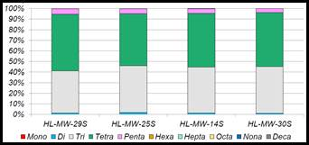

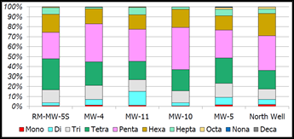cid:image009.jpg@01D20A98.FAFA2550

Figure 17. Homolog Distribution of Groundwater Monitoring Data Collected from Kaiser Plume (top) and Up-Gradient/Cross-Gradient Wells (bottom)



Figure 18. Kaiser Site Map Showing Location of Kaiser Plume (Blue Circle) and Up-Gradient/Cross-Gradient Wells (Red Circles)

For this stretch of the river, an initial up-gradient PCB loading estimate of 14 to 55 mg/day was calculated, assuming a representative seepage rate of 0.01 cfs per linear foot of river (Kahle and Bartolina, 2007), and representative average up-gradient PCB concentrations ranging from 0.1 to 0.384 ng/L. Although this analysis is not rigorous enough to prove that a significant up-gradient source exists, it is rigorous enough to show that up-gradient sources merit additional consideration.

The source of the up-gradient PCB groundwater loads is unknown, but the Spokane Industrial Park area may be one contributor.  This observation is based on:

* The up-gradient location of the Industrial Park relative to the Kaiser boundary monitoring wells.  These wells historically have shown detectable concentrations of PCBs up to 6 ng/L (median = 0.1 ng/L).
* Ecology’s Urban Waters Initiative has identified the Industrial Park as a likely source of PCBs prior to 1994 (<http://www.ecy.wa.gov/urbanwaters/spokaneriver.html>)
* Past use of the area as a Naval Supply Depot
* The presence of approximately 500 Underground Injection Control (UIC) wells which are registered in the UIC database as non-municipal stormwater wells that generally are 7 to 10 feet deep (EAP, September 16, 2015).

With respect to the suspected source downstream of the Trent Avenue Bridge, data mining activities will consist of more detailed homolog-specific mass balance assessments to estimate the magnitude of the load. The mass balance assessments conducted to date at this site have only considered river concentration data and stream flow to determine that a net loading of penta‐ through hepta‐ chloro PCB homologs occurs. The specific magnitude of this potential loading source was not assessed further due to the confounding effects of groundwater exchange mechanisms which are more complex than assumed in the original mass balance assessment. Data mining activities to be conducted under the Comprehensive Plan will consist of:

* Estimating groundwater gains and losses for the stream reach from available hydrogeologic data. Data related to this has been provided by Spokane County.
* Conducting a mass balance analysis for 2014 and 2015 synoptic survey data, using the gross gaining and losing flow estimates for this reach. This is in contrast to the prior mass balance assessment that only considered net groundwater flow to the reach.
* Calculate estimated loading rate and congener distribution of the potential source.
* Review existing TCP site information to identify potential contributing sites.

With respect to other TCP sites, data mining activities will consist of estimating the potential magnitude of loading from the 23 TCP sites with confirmed releases of PCBs identified by Marti and Maggi ([2015](http://srrttf.org/wp-content/uploads/2015/10/Tech-Memo-PCBs-in-Spokane-Valley-GW-Marti-9-16-15-FINAL-2.pdf)). This will be done by:

* Calculating the amount of area potentially containing PCB concentrations at cleanup target concentration, both in soil and groundwater.
* Reviewing existing hydrogeologic information to estimate groundwater seepage rates and flow paths for each site. Existing groundwater models from the USGS and the City of Spokane can be used to support this assessment.
* Merging areal extent, seepage rate and concentration estimates to calculate a potential loading contribution for each site

#### Package information for and consult with TCP

The results of the above data mining activities will be documented in a technical report, and shared with Ecology TCP staff. The Task Force will schedule a meeting (or meetings) with TCP to present and discuss results. Findings will be compared to those obtained by TCP (e.g. TCP will be conducting a separate assessment of the magnitude of the loading up-gradient of the Kaiser site). Result of the meeting(s) will feed directly in to the next step, determining subsequent actions.

#### Determine next action

Based on the above findings and discussions, the Task Force will work with TCP to determine appropriate next steps, and the party (or parties) responsible for conducting them. Depending on findings from the data mining, next steps could include:

* Determining that certain sites are contributing to the impairment of the river, and identifying potential remediation actions
* Targeted monitoring to better define the contribution of sites determined to be potentially important
* Exclusion of certain sites that are determined to be insignificant contributors to the impairment of the river

Should previously identified sites be determine to be contributing to impairment in the Spokane River, it is important to note that if a site has settled its liability, met cleanup levels and a remedy has not failed, TCP will not re-open activities at the site. EPA, however, may be able to provide assistance if this situation occurs.



## 

## 5.15 Schedule and Monitoring Program

This section presents the schedule by which each of the Category B (expansion of existing action) and C (new actions) Control Actions will be implemented, and lists specific milestones and effectiveness metrics. This Comprehensive Plan is not specifying additional scheduling or monitoring requirements Category A Control Action (maintain existing activities), beyond the long-term implementation effectiveness monitoring discussed in Section 6 of this Plan.

For purposes of scheduling, the Task Force divided the implementation activities into tiers of:

* Actions that can be implemented immediately
* Actions that will require development of new work plans

### 5.15.1 Actions that Can Be Implemented Immediately

The Task Force determined that the following control actions can be implemented immediately:

* Support of Green Chemistry Alternatives
* PCB Product Testing
* Compliance with PCB Regulations
* Emerging Stormwater Technologies

Milestones, timelines, and effectiveness metrics for each of these Control Actions are provided below in Table 11.

Table 11. Milestones, Timelines and Effectiveness Metrics for Actions that Can Be Implemented Immediately

|  |  |  |  |
| --- | --- | --- | --- |
| Control Action | Milestone | Timeline | Effectiveness Metric |
| PCB Product Testing | Provide comments on the PCB product testing report | Within three months of issuance of draft report | Comments provided |
| PCB Product Testing | Support Ecology efforts towards development of a clearinghouse | Within one year of issuance of Comprehensive Plan | Demonstrated support, reassessed annually |
| PCB Product Testing | Development of clearinghouse | Within two years of issuance of Comprehensive Plan | Has clearinghouse been developed? |
| PCB Product Testing | Public education | Ongoing annual assessment | Has outreach been conducted? |
| PCB Product Testing | Public education | Within five years of issuance of Comprehensive Plan | Measurable change in public behavior |
| Compliance with PCB Regulations | Comments on recurring regulatory issues | Ongoing annual assessment | Recommendations provided, reassessed annually |
| Compliance with PCB Regulations | Review of Ecology atmospheric transport study | Within one year of issuance of study | Determination of need for more regulatory control of oil burning |
| Compliance with PCB Regulations | Changes in used oil burning control (if appropriate) | Within five years of issuance of Comprehensive Plan | Measurable change in regulatory control |
| Emerging Stormwater Technologies | Assessment of Phase 1 results | Within one year of completion of Phase 1 report | Feedback provided |
| Emerging Stormwater Technologies | Phase 2 support | Within one year of completion of Phase 1 report | Level of support defined and provided |

For the Control Action PCB Product Testing, the first milestone consists of the provision of comments on Ecology’s PCB product testing report within three months of issuance of the draft report. The second milestone consists of demonstrated tangible outreach to Ecology, regarding development of a PCB product testing clearinghouse. Initial outreach will be conducted within one year of issuance of Comprehensive Plan, and future schedules assessed as part of the Implementation Review report. The third milestone is development of a clearinghouse within two years of issuance of the Comprehensive Plan. Public education will be evaluated annually, with an expectation of a measurable change in public behavior within five years of issuance of the Comprehensive Plan.

For the Control Action Compliance with PCB Regulations, the first milestone consists of maintaining existing activity in terms of providing comments on recurring regulatory issues. Comments will be provided on an ongoing as-needed basis, and assessed as part of the Implementation Review report. The second milestone consists of review of the Ecology atmospheric transport study, and a determination made regarding the need for more regulatory control of used oil burning. Should oil burning be identified as a significant contributor of PCBs, the final milestone consists of a measurable change in regulatory control over this practice.

For the Control Action Emerging End of Pipe Stormwater Technologies, the first milestone consists of the Task Force reviewing the Phase 1 results of the Lands Council works and providing feedback on next steps. The second milestone consists of identification of the appropriate level of Phase 2 support, and provision of that support. Both of these milestones will be accomplished within one year of completion of the Phase 1 report.

### 5.15.2 Actions That Require Development of New Work Plans

The Task Force determined that the following Control Actions were important to implement, but will require additional consideration and development of specific work plans before schedules can be developed for them.

* Support of Green Chemistry Alternatives
* Waste Disposal Assistance
* Regulatory Rulemaking
* Building Demolition and Renovation Control
* Identification of Sites of Concern for Contaminated Groundwater

Work plans containing milestones, timelines, and effectiveness metrics for each of these Control Actions will be developed within one year of issuance of the Comprehensive Plan.

Blank Page

# 6 Future Activities

In addition to the Implementation Activities described above, the Task Force intends to conduct additional activities in the future to assess implementation effectiveness, and to consider additional Control Actions and studies to fill identified data gaps.

## 6.1 Implementation Effectiveness Assessment

The Implementation Plan section above contains effectiveness metrics specific to each Control Action, designed to assess whether each action is being implemented and performing as planned. The effectiveness of the Task Force’s implementation of Control Actions will be assessed annually through the preparation of an Implementation Review report. The report will determine the extent to which each individual milestone listed in this section was attained, and will provide flexibility to adapt strategies, phase out actions that are not working, and phase in new Control Actions as appropriate.

In addition to the annual Implementation Review, the Task Force will also conduct a broader implementation effectiveness assessment within five years, designed to review all available data to assess:

* PCB loading to the Spokane River from the primary delivery mechanisms, and changes in loading over the evaluation period
* Spokane River PCB concentrations, and changes in concentration over the evaluation period

PCB loading will be assessed for the primary delivery mechanisms described previously, as follows. PCB loading from wastewater treatment plants will be assessed via review of all effluent monitoring data collected by each plant as part of their NPDES permit requirements. Groundwater loading near Kaiser will be assessed via review of data collected by Kaiser as part of their ongoing remediation efforts. Stormwater/CSO loading will be assessed via review of post-implementation performance data to be collected by the City of Spokane as part of their Integrated Clean Water Plan. Changes in loading from Lake Coeur d’Alene will be assessed via review of observed Spokane River PCB concentrations in Idaho being collected as a requirement of NPDES permits in Idaho.

In-river concentrations will be assessed via review of long-term river monitoring data to be collected by the Task Force and/or Ecology. Statistical tests will be applied as appropriate to determine if statistically significant reductions have occurred in loads and in-river concentrations. In addition to assessment of the change in River concentrations, river concentrations will also be compared to existing water quality standards.

The above assessment will be conducted five years after the issuance of this Comprehensive Plan. If PCB loads and/or concentrations are not decreasing, the Task Force may identify, evaluate, and select new Control Actions (or modify existing Control Actions) in an adaptive manner to ensure that reductions occur in the future. It is expected that the implementation effectiveness assessment will be repeated on a five year basis.

In addition to the Effectiveness Assessment conducted by the Task Force, Ecology will continue to conduct a Measurable Progress assessment at the end of each permit cycle, which will review the status of Control Actions as well as environmental conditions.

## 6.2 Consideration of Additional Control Actions

As discussed above, numerous Control Actions were placed in Category D, defined as “Include in Comprehensive Plan as an activity worth exploring in the future.” The commitment to these actions is to give them future consideration, but with no specific commitment towards implementation at this time. This section describes the following Control Actions identified as Category D:

* Survey Schools and Public Buildings
* Accelerated Sewer Construction
* Emerging Wastewater Technology
* Survey of Local Electrical Equipment
* Leak Prevention/ Detection in Electrical Equipment
* Regulation of Waste Disposal
* Stormwater Source Tracing
* Removal of Carp from Lake Spokane
* PCB Identification during Inspections
* Compliance with PCB Regulations for Imported Products

Each is described below. The Task Force will consider the need to implement any of these Control Actions as part of their annual implementation effectiveness assessment.

### 6.2.1 Education on Septic Disposal

This Control Action is designed to educate on-site septic system owners located over the aquifer recharge area on proper disposal of wastes (e.g., not “down the drain”) and on the environmental and functional benefits of regular tank pumping.

### 6.2.2 Survey Schools and Public Buildings

This action consists of programs designed to survey PCB-containing materials in schools/public buildings and enact a program to dispose of them properly or implement encapsulation.

### 6.2.3 Accelerated Sewer Construction

This action consists of acceleration of sewer construction to replace septic systems. Spokane County has completed its mandatory septic tank elimination program for septic tanks within the Urban Growth Area (UGA) in areas that have sewer available, requiring connection within a year of notification and enforcement through the Prosecutor’s office. There is currently no planned effort to eliminate every septic system within the UGA, due to reasons such as:

* Installation of sewers in low density areas is not cost effective
* Certain land uses are exempt by state law from the requirement to connect to sewer, even when available (e.g. manufactured home parks)

There are still areas in Kootenai County where septic tanks located over identified Critical Aquifer Recharge Areas could theoretically be connected to sewers.

### 6.2.4 Emerging Wastewater Technology

This action consists of regular outreach to researchers/contractors in the field of wastewater treatment in order to stay abreast of potential new technologies for PCB removal.

### 6.2.5 Survey of Local Electrical Equipment

This action would conduct a survey of local utilities and other owners of electrical equipment to document the presence/amount of PCBs in transformers. Identify PCB-containing equipment (nominal 1 ppm concentration) that has a reasonable pathway to the river, if spilled, and target for removal.

### 6.2.6 Leak Prevention/ Detection in Electrical Equipment

This action consists of implementation of state and/or local ordinance to require a leak prevention/detection system for any PCB-containing transformer or capacitor.

### 6.2.7 Regulation of Waste Disposal

This action consists of programs designed to review local/regional laws regulating waste disposal (including used oil burning) and illegal dumping, and revise as necessary (e.g. enforcing fines/other penalties for improperly disposing of PCBs.)

### 6.2.8 Stormwater Source Tracing

Through Ecology’s Urban Waters Initiative, a team of Ecology staff and specialists from the Spokane Regional Health District have sampled water and visited businesses along the river to identify sources of toxic chemicals, including PCBs (Ecology, 2012). These studies are designed to identify potential hot spots (i.e. areas contributing an inordinately high amount of PCBs) that could be controlled in the future. This action consists of considering these source tracing activities to identify significant sources of PCBs to the Spokane stormwater system.

### 6.2.9 Removal of Carp from Lake Spokane

This action involves removing carp from Lake Spokane. Carp in the lake are known to be contaminated with PCBs, and removing them would prevent further cycling in the watershed. This Control Action was suggested as a complement to existing studies conducted by Avista regarding removal of carp from Lake Spokane for the purposes of phosphorus removal.

### 6.2.10 PCB Identification during Inspections

This action consists of identifying PCB-containing materials as part of other regular inspections (e.g., building permits, IDDE, facility inspections). It involves training inspectors to identify materials and what to do next (safe disposal, encapsulation, etc.).

### 6.2.11 Compliance with PCB Regulations

This control action consists requiring stricter accountability for compliance with existing rules, specifically enforcement of existing TSCA rules to ensure imported and manufactured products are complying with allowable PCB levels.

## 6.3 Studies to Address Data Gaps

Due to the diffuse nature of PCB source area, poorly defined pathways between source areas and delivery mechanisms, and uncertain environmental response, the Task Force will contemplate additional studies to address some key data gaps. The Task Force will consider the need to conduct any of these studies as part of their routine implementation effectiveness assessment. It is noted that some of these studies may be conducted by Ecology’s Environmental Assessment Program, in which case the Task Force will provide review and comment.

### 6.3.1 Key Data Gaps

Key data gaps identified by the Task Force correspond to bioaccumulation of PCBs in fish and assessment of sediment PCB concentrations. Measured water column PCB concentrations in the Spokane River are currently at levels similar to, and often below, the listed water quality standard. Fish tissue concentrations, however, remain well above target levels.

There is also a commonly-held assumption that legacy bottom sediments are not a significant contributor to PCB impairment of the Spokane River, because: 1) The River is viewed as sediment-poor, with many non-depositional zones, and 2) Remediation activities have been conducted at areas of known legacy sediment contamination. This assumption may not be accurate, however, as there are known areas of sediment deposition in impounded sections of the river that have not been sufficiently sampled to provide a clear understanding of sediment PCB contributions. Furthermore, assessment of congener patterns in PCB sources, bottom sediments, and fish may provide insight on the sources most responsible for existing fish tissue levels.

**6.3.2 Study Plan**

The Task Force intends to address these key data gaps in a three step process, consisting of: 1) Screening-level mining of existing data, 2) Formatting of data, 3) More rigorous assessment. Sufficient data currently exist to support a high level assessment of the relationship between water column PCB concentration, sediment PCB concentration, and fish tissue PCB concentration. These screening-level studies would include an update of the bioaccumulation model applied in Serdar et al (2011) using more recent data, as well as simple congener pattern assessment. Available recent data currently consist of sediment trap measurements conducted near Ninemile and Upriver Dam in 2013 (Era-Miller, 2014), catch basin sediment data (Ecology, 2012), 2012 fish tissue data ([Ecology, 2014](https://fortress.wa.gov/ecy/publications/publications/1403020.pdf)a). Additional bottom sediment data include those collected as part of Ecology’s 2003-2007 PCB Source Assessment (Serdar et al, 2011), and sediment data collected as part of reassessment of the Upriver Dam and Donkey Island PCB sediment sites. Ecology has recently collected sediment PCB data in Lake Spokane, with results available in 2017. Some additional sediment PCB concentration data also exist (Johnson. and Norton, 2001), but are much older. Results of these analyses will inform understanding of the importance of water column vs. sediment sources in contributing to fish tissue contamination, and likely sources of PCBs to sediments and fish. These high level results will also help target areas where more rigorous assessment is needed.

Rigorous assessment of PCB congener patterns require the data to be stored in a particular format which is different than the format currently used to store the data. The second phase of work will consist of compiling and formatting all relevant data into a database into the required format. The final phase of work will consist of the implementation of more rigorous studies that are identified as part of the screening level assessment.

# 7 References

Era-Miller, B. 2014. Spokane River Toxics Sampling 2012-2013 – Surface Water, CLAM and Sediment Trap Results. Washington Department of Ecology, Environmental Assessment Program. May 30, 2014.

Ecology. 2004. Stormwater Management Manual for Eastern Washington. September 2004. Washington Department of Ecology. Publication Number 04-10-076

Ecology. 2012. Eastern Washington Phase II Municipal Stormwater Permit. August 1, 2012. Washington Department of Ecology.

Ecology. 2013. Third Periodic Review (Draft Final) General Electric Spokane Site. March 2013. Washington Department of Ecology Eastern Regional Office, Spokane, WA.

Ecology. 2014a. Freshwater Fish Contaminant Monitoring Program. May 2014. Washington Department of Ecology. Publication No. 14-03-020

Ecology. 2014b. Polychlorinated Biphenyls (PCBs) in General Consumer Products. June 2014. Washington Department of Ecology. Publication No. 14-04-035.

Ecology. 2015. PCB Chemical Action Plan. February 2015. Washington Department of Ecology. Publication No. 15-07-002

Ecology. 2016a. Little Spokane River PCBs Screening Survey of Water, Sediment, and Fish Tissue. March 2016. Washington Department of Ecology. Publication No. 16-03-001

Ecology. 2016b. Quality Assurance Project Plan Spokane River Atmospheric Deposition Study for PCBs. June 2016. Washington Department of Ecology. Publication No. 16-03-112

Ecology. 2016c. Project: Spokane River – PCBs and other Toxics – Long Term Monitoring at the Spokane Tribal Boundary. July 2016. Washington Department of Ecology.

EPA, 2015. EPA’s Plan for Addressing PCBs in the Spokane River. July 14, 2015 Case 2:11-cv-01759-BJR

EPA, 2016. Preliminary Draft Idaho MS4 General Permit #IDR040000. USEPA Region 10, Seattle, WA. April 8 2016. <https://www3.epa.gov/region10/pdf/permits/stormwater/Idaho-MS4GP-Preliminary-Draft-FactSheet-04082016.pdf>

Guo, J., P. Praipipat, and L. A. Rodenburg. 2013. PCBs in Pigments, Inks, and Dyes: Documenting the Problem. 17th Annual Green Chemistry & Engineering Conference. June 18-20, 2013.

HartCrowser. (2012). Final Site-Wide Groundwater Remedial Investigation, Kaiser Trentwood Facility, Spokane Valley, Washington, Volume I, prepared for Kaiser Aluminum Washington, LLC. May 2012.

Hu, D., and K. C. Hornbuckle. 2010. Inadvertent Polychlorinated Biphenyls in Commercial Paint Pigments. Environ. Sci. Technol. 2010, 44, 2822–2827.

Klosterhaus. S. D. Yee, A. Wong, L. Mckee, 2011. Polychlorinated Biphenyls in Sealants in San Francisco Bay Area Buildings: Estimated Stock in Currently Standing Buildings and Releases to Stormwater during Renovation and Demolition, October.

LimnoTech. 2013. Review and Evaluation of Existing Data - Final. Prepared for: Spokane River Regional Toxics Task Force, August 30, 2013.

LimnoTech. 2015. Phase 2 Technical Activities Report: Identification of Potential Unmonitored Dry Weather Sources of PCBs to the Spokane River. Prepared for: Spokane River Regional Toxics Task Force, August 12, 2015.

LimnoTech. 2016a. Sources and Pathways of PCBs in the Spokane River Watershed. Prepared for: Spokane River Regional Toxics Task Force, March 16, 2016.

LimnoTech. 2016b. DRAFT: Inventory of Control Actions to Be Evaluated for the Spokane River. Prepared for: Spokane River Regional Toxics Task Force, May 18, 2016.

LimnoTech. 2016c. DRAFT: Magnitude of Source Areas and Pathways of PCBs in the Spokane River Watershed. Prepared for: Spokane River Regional Toxics Task Force, June 22, 2016.

LimnoTech. 2016d. DRAFT: Spokane River Regional Toxics Task Force 2015 Technical Activities Report: Continued Identification of Potential Unmonitored Dry Weather Sources of PCBs to the Spokane River. Prepared for: Spokane River Regional Toxics Task Force, June 30, 2016.

LimnoTech. 2016e. Memorandum DRAFT: Cost/Effectiveness of PCB Control Actions for the Spokane River. Prepared for: Spokane River Regional Toxics Task Force, July 6, 2016.

LimnoTech. 2016f. Updated High Level Scoping for Groundwater Contamination Up-gradient of Kaiser. Presentation by: Dave Dilks and Joyce Dunkin. August 3, 2016 Presented to: SRRTTF Technical Track Work Group.

San Francisco Estuary Institute (SFEI), 2010. A BMP Tool Box for Reducing Polychlorinated Biphenyls (PCBs) and Mercury (Hg) in Municipal Stormwater. San Francisco Estuary Institute, Oakland, CA. <http://www.sfei.org/sites/default/files/biblio_files/A_BMP_toolbox__FINAL_04-04-10.pdf>

San Francisco Estuary Partnership (SFEP), 2011.Best Management Practices for Reducing PCBs in Runoff Associated with Demolition and Remodeling Projects. November, 2011.

Serdar, D., B. Lubliner, A. Johnson, and D. Norton. 2011. Spokane River PCB Source Assessment, 2003-2007. Washington Department of Ecology, Toxics Studies Unit, Environmental Assessment Program. Department of Ecology Publication No. 11-03-013.

Spokane, City of. 2014. Integrated Clean Water Plan Final. December 2014. <https://static.spokanecity.org/documents/publicworks/wastewater/integratedplan/integrated-spokane-clean-water-plan.pdf>

Spokane, City of. 2015a. PCBs in Municipal Products Revised. July 21, 2015. City of Spokane Wastewater Management Department. Grant No. G1400545

Spokane, City of. 2015b. Report: PCB Characterization of Spokane Regional Vactor Waste Decant Facilities. September, 2015

Spokane County, City of Spokane, and City of Spokane Valley 2008. Spokane Regional Stormwater Manual. <https://www.spokanecounty.org/DocumentCenter/View/1640>

Spokane River Regional Toxics Task Force, 2012a. Memorandum of Agreement Regarding Spokane River Regional Toxics Task Force January 23, 2012

Spokane River Regional Toxics Task Force, 2012b. First Draft Work Plan Adopted 10-24-2012

Spokane River Regional Toxics Task Force, 2015. Hydroseed Pilot Project Summary Report. July 31, 2015.

Spokane Valley-Rathdrum Prairie Aquifer Atlas, 2009. 2009 Update. <http://www.spokaneaquifer.org/wp-content/uploads/2012/05/AquiferAtlas.pdf>

Spokane Tribe of Indians, 2010. Surface Water Quality Standards, Resolution 2010‐173. February 25, 2010.

Washington Department of Ecology, 2004. Stormwater Management Manual for Eastern Washington. Publication No. 04-10-076. <https://fortress.wa.gov/ecy/publications/documents/0410076.pdf>

Washington Department of Ecology, 2012. Spokane River Urban Waters Source Investigation and Data Analysis Progress Report (2009-2011). Publication No. 12-04-025. <https://fortress.wa.gov/ecy/publications/documents/1204025.pdf>

Washington Department of Ecology, 2015a. PCB Chemical Action Plan. Publication 15-07-002. <https://fortress.wa.gov/ecy/publications/documents/1507002.pdf>

Washington Department of Ecology, 2015b. Lake Spokane: PCBs in Carp. July 2015. Publication No. 15-03-022.

Washington Department of Ecology, 2016. Quality Assurance Project Plan Spokane River Atmospheric Deposition Study for PCBs. June 2016. Publication No. 16-03-112.

# Appendix A: Control Action Fact Sheets

Blank Page

### Waste Disposal Assistance

|  |  |
| --- | --- |
| **Description:** | This action consists of programs (targeted at household consumers and businesses that generate small quantity hazardous waste) designed to accept and properly dispose of PCB-containing items, preventing legacy non-fixed building sources such as small appliances and lamp ballasts from potentially being disposed of improperly. |
| **Group:** | Institutional -- governmental practices. |
| **Significance of Pathway:** | This control action targets legacy non-fixed building sources, which have been identified as one of the largest source areas of PCBs with an estimated mass range of 50 to 40,000 kg. The primary mechanisms delivering this source area to the river are stormwater and atmospheric deposition following waste incineration, both through improper disposal. The total stormwater load is 15 to 94 mg/day and the atmospheric load is not currently known. The specific portion of the total stormwater and atmospheric load contributed by legacy non-fixed building sources is also unknown, due to uncertainty in the number of appliances in the watershed, the percentage that may be improperly disposed, and the ultimate fate of those PCBs. |
| **Reduction Efficiency:** | This control action is theoretically 100% effective in controlling the release of PCBs from items that would otherwise be improperly disposed. The overall efficiency is of this control action is unknown. However, increasing public education and awareness of existing recycling and household hazardous waste facilities would increase the number of PCB-containing items that are properly disposed. |
| **Cost:** | The infrastructure for this program largely exists in Washington via take-back programs for mercury-containing lights, such that costs to include PCB-containing products would consist largely of: 1) outreach and education programs for the general consumer and business community, and 2) additional costs associated with managing PCB wastes. Efforts to initiate such a program in Idaho would be greater. Because the cost of the statewide mercury take-back program was $8.7 million dollars for five years, the cost for application to the Spokane watershed (including Idaho) would be a fraction of that, likely more than $100,000 and less than $1 million. |
| **Implementing Entity:** | This action is currently being implemented by a number of organizations in Washington: Department of Ecology Hazardous Waste and Toxics Reduction program – Urban Waters Initiative; Spokane County Regional Health District; Spokane River Forum – Envirostars; local waste disposal vendors and local businesses that accept fluorescent lamps for recycling. Specific activities that that the Task Force could undertake include: 1) Making recommendations to organizations currently providing waste disposal assistance as to how they can help achieve their goals, and 2) Raise public awareness on how to identify and dispose of PCB-containing items. |
| **PP Hierarchy:** | This control action is intermediate in the Pollution Prevention hierarchy, as it is designed to manage PCBs that are currently in place in the watershed. |
| **Existing Efforts:** | As discussed above, this action is available and could be better integrated with existing Control Actions targeted toward CFL lamp recycling and household hazardous waste collection. |
| **Ancillary Benefit:** | This action provides some ancillary benefits because PCB light ballasts and small capacitors are often associated with other items that have harmful materials in them (mercury containing lights). Outreach on this topic also promotes proper disposal of these items, and preventing environmental release of other harmful materials contained in them. |
| **Time Frame:** | Programs can likely be developed within two years, although it is not expected that measurable reductions in PCB loads will be observed with five years. |

### Low Impact Development (LID) Ordinance

|  |  |
| --- | --- |
| **Description:** | This action consists of creating and implementing land use/development ordinances or standards that encourage Low Impact Development (LID) and decrease impervious surfaces. |
| **Group:** | Institutional government practices |
| **Significance of Pathway:** | This control action is designed to prevent and minimize runoff from impervious surfaces and the PCBs that are contained in that runoff. The pathway for this action is primarily discharging stormwater systems, which delivers a total of 15 to 94 mg/day, This estimate is based upon loading from the City of Spokane, which contributes the majority of stormwater load to the river. This Control Action may be beneficial for other communities with stormwater discharges, although their contribution of PCBs to stormwater is not known. |
| **Reduction Efficiency:** | Because PCBs in runoff are largely bound to soil particles, the efficiency of this control action can be estimated from the observed efficiency of LID on removing solids from runoff, which ranges from 40 to 88%. LID can also prevent stormwater from becoming contaminated by infiltrating it before it contacts contaminated surfaces such as roads. The portion of this load to the Spokane River that could be controlled by LID is unknown. |
| **Cost:** | Development and adoption of the ordinance in other communities (besides the City of Spokane which already has this type of ordinance) would likely be minimal (<$100,000) based on the information from the City of Spokane with their purchasing ordinance. However, related education and outreach efforts could be much more expensive ($100,000-$1million or more, depending on scope). Installation costs for Low Impact Development projects are project specific and would need to be evaluated with the ancillary benefits that offset the cost. |
| **Implementing Entity:** | This action is typically applied by the local agency responsible for managing land development (cities or counties). The City of Spokane LID program could serve as a model for implementation in other communities in the watershed. |
| **PP Hierarchy:** | This control action is intermediate in the Pollution Prevention hierarchy, as it is designed to manage PCBs that are currently in place in the watershed. |
| **Existing Efforts:** | A Low Impact Development ordinance has already been developed by the [City of Spokane](https://my.spokanecity.org/smc/?Section=17D.060.300). Ecology has developed a [guidance document](http://www.psp.wa.gov/downloads/LID_Guidebook/20120731_LIDguidebook.pdf) to assist other jurisdictions with developing and implementing something similar. The Washington State Stormwater Center also has technical [information](http://www.wastormwatercenter.org/low-impact/) and training resources for implementing low impact development projects in Eastern Washington. |
| **Ancillary Benefit:** | LID manages both stormwater and land use in a way that minimizes disturbance of the hydrologic processes, and uses on-site natural features that are integrated into an overall design so that stormwater practices include the use of natural processes such as transpiration, conservation, and infiltration. In addition to improved water quality, LID can reduce flooding, restore aquatic habitat, improve groundwater recharge, and enhance neighborhood beauty. This control action will provide other water quality benefits by reducing the loading of many other pollutants that are associated with solids and impervious surfaces (e.g. metals, bacteria). |
| **Time Frame:** | While LID ordinances can likely be developed within two years, the time frame for observing measurable reductions in PCBs is unknown. |

Leaf Removal

|  |  |
| --- | --- |
| **Description:** | This action consists of programs designed to enhance current municipal leaf removal programs since foliage is a receptor of atmospheric PCB loadings, and the organic matter in leaves can adsorb PCBs from other sources in runoff. Removal of leaf litter prior to it being discharged to the river could reduce loading PCB associated with this source area. |
| **Group:** | Institutional - government practices |
| **Significance of Pathway:** | This control action is theoretically 100% effective in controlling the release of PCBs from collected leaf litter. The fraction of overall leaf litter that would be captured by improved removal and the overall efficiency is of this control action is not fully known. |
| **Reduction Efficiency:** | The overall efficiency is of this control action is not fully known. While it is theoretically 100% effective in controlling the release of PCBs from collected leaf litter, the fraction of overall leaf litter that would be captured by improved removal is currently unknown. |
| **Cost:** | This control action is generally being implemented, such that costs would consist of further expansion of the program and/or evaluation to see if leaf removal can be more efficient or effective. Costs associated with public outreach that encourage local residents to collect leaf litter and dispose of it as green waste through existing solid waste system could mitigate current program expenses. |
| **Implementing Entity:** | Municipalities and other local governments. |
| **PP Hierarchy:** | This control action is intermediate in the Pollution Prevention hierarchy, as it is designed to manage PCBs that are currently in place in the watershed. |
| **Existing Efforts:** | Leaf removal is already a government-provided service in the City of Spokane (seasonal), Spokane county (leaves can go in green bins collected by Waste Management), and Coeur d’Alene (last two weekends in April and September). |
| **Ancillary Benefit:** | This action provides secondary benefits beyond PCB removal by reducing the loading to the Spokane River of nutrients and oxygen-demanding material contained in leaf litter. |
| **Time Frame:** | While programs can likely be developed within two years, it is expected that measurable reductions in PCB loads will not be observed within five years. |

### Street Sweeping

|  |  |
| --- | --- |
| **Description:** | This action consists of programs designed to modify current street sweeping frequency and area covered to specifically target source areas of PCBs, or when/where more material is washing down streets to prevent it from entering storm drains. |
| **Group:** | Institutional - government practices |
| **Significance of Pathway:** | This control action is targeted towards the portion of PCB contamination in stormwater runoff that accumulates on street surfaces. The primary mechanism delivering this source area to the river is discharging stormwater, which totals 15 to 94 mg/day. Due to the uncertainty in the extent of the stormwater load arising from street surfaces, the significance of this pathway is not fully known, but is likely a moderate contributor. |
| **Reduction Efficiency:** | Studies to assess the ability of street sweeping to improve concentrations of particle-bound pollutant in stormwater have reported widely varying effectiveness. Several studies showed no significant differences in stormwater concentration in response to street sweeping (e.g. [USGS, 2007](http://pubs.usgs.gov/sir/2007/5156/pdf/SIR_2007-5156.pdf)) while other ([e.g. Sutherland, 2009](http://www2.apwa.net/documents/Meetings/congress/2009/Handouts/4838.pdf)) have reported decreases in concentration of more than 50% and [Contra Costa County, CA](http://www.cccleanwater.org/_pdfs/StreetSweepingReportFinal.pdf) reported removal of 1 kg of PCBs via street sweeping. [Ecology (2007)](https://fortress.wa.gov/ecy/publications/documents/0703009.pdf) reported an average of 74% removal efficiency for TSS for street sweeping based on two studies conducted outside of WA state. Although there is a wide range of reported reduction efficiencies, street sweeping is rated as a highly suitable in terms of reduction efficiency. |
| **Cost:** | Spokane Valley’s 2016 estimated street sweeping costs are [$490,000](http://spokanevalley.granicus.com/MetaViewer.php?view_id=2&clip_id=393&meta_id=25823), however there are no known provisions in the contract that specify practices (e.g., area swept, equipment used, frequency) to target PCBs in addition to the usual objectives. Based on this cost, any modification to current sweeping practices in order to specifically target PCB source areas would likely be a fraction of this cost and certainly <$100,000. Long term costs are judged to be moderate. For example, purchasing a new, high efficiency sweeper could cost $200,000-$300,000. |
| **Implementing Entity:** | Municipal Public Works Departments, State Departments of Transportation |
| **PP Hierarchy:** | This control action is intermediate in the Pollution Prevention hierarchy, as it is designed to manage PCBs that are currently in place in the watershed. |
| **Existing Efforts:** | This control action is primarily applicable to the City of Spokane, as they are responsible for the large majority of watershed area contributing to discharging stormwater systems. The City is currently developing and implementing an Integrated Clean Water Plan designed to control PCB loading from their stormwater systems, which includes street sweeping. It may be beneficial for other communities with stormwater discharges, although the size of their service area is relatively small. |
| **Ancillary Benefit:** | This action provides significant secondary benefits by reducing the loading to the Spokane River of pollutants typically associated with impervious surfaces, such as phosphorus. |
| **Time Frame:** | This control action can likely be developed within two years. Because street sweeping is already being applied, it is unlikely that modification to existing practices will show measureable benefits within the next five years. |

### Catch Basin/Pipe Cleanout

|  |  |
| --- | --- |
| **Description:** | This action consists of programs designed to increase the efficiency or effectiveness of catch basin and pipe cleanout to specifically remove PCB-contaminated sediment. |
| **Group:** | Institutional - government practices |
| **Significance of Pathway:** | This control action is targeted towards all pathways that deliver PCBs to discharging stormwater systems. The overall magnitude of the stormwater delivery pathway is 15-94 mg/day. Because this Control Action has the potential to affect the majority of delivered stormwater loads, the action is rated as highly suitable in terms of pathway. |
| **Reduction Efficiency:** | While the exact reduction efficiency on the PCB overall loading rate is uncertain, the Control Action is effective in removing PCBs that could otherwise be delivered to the system. The City of Spokane removed 32.4 grams PCBs removed from their catch basins between 2010 and 2012 ([Schmidt, 2015](http://www.oracwa.org/documents/SpokaneToxicsTaskForce-LynnSchmidt-072215-.pdf)). This action also assists in source identification if PCB concentrations of the removed sediments are measured, as catch basins with higher PCB concentrations indicated elevated source areas in their drainage basis. Given the amount of PCB mass removed relative to overall stomwater loading, this action is rated as highly suitable. |
| **Cost:** | The City of Spokane spent just over $1 million on routine catch basin pumping each year (including staff, administration, dumping fees, and equipment). Increasing the frequency or changing the type of cleaning administered to catch basins in order to more effectively target PCB reduction would likely be a fraction of the total cost, or <$100,000 per year. Other communities’ costs can be estimated based on the size of the city and number of catch basins. In 2015 the City checked 15,716 catch basins (of a total over 21,000) and pumped 1,723. The area they inspect includes the CSO area and drywells. |
| **Implementing Entity:** | Municipal Public Works Departments, Department of Transportation |
| **PP Hierarchy:** | This control action is intermediate in the Pollution Prevention hierarchy, as it is designed to manage PCBs that are currently in place in the watershed. |
| **Existing Efforts:** | This control action is primarily applicable to the City of Spokane, as they are responsible for the large majority of watershed area contributing to discharging stormwater systems. The City is currently developing and implementing an Integrated Clean Water Plan designed to control PCB loading from their stormwater systems, so independent development of Control Actions by the Task Force is considered redundant to this effort. |
| **Ancillary Benefit:** | This action provides secondary benefits by reducing the loading to the Spokane River of pollutants typically associated with solids (e.g. metals, bacteria) that are captured be catch basins. More frequent catch basin cleanout can also prevent flooding. |
| **Time Frame:** | This control action is currently being implemented. The extent to which additional catch basin and pipe cleanout will result in observable near-term reductions in stormwater PCB loads is unknown. |

### Purchasing Standards

|  |  |
| --- | --- |
| **Description:** | This action consists of using existing local and state regulations to reduce or eliminate the purchase of products that contain PCBs. When wholistically implemented, it would include: 1) gathering information about PCB content in purchased products; 2) working with manufacturers to identify products with preferentially low concentrations of PCB; 3) preparing contract specifications for government purchased products in accordance with State law; and 4) providing public access to information and specifications that encourage the purchase of products with no or minimal concentrations of PCB. |
| **Group:** | Institutional - government practices |
| **Significance of Pathway:** | This control action is targeted towards the source area of inadvertently produced PCBs, which are estimated as entering the watershed at a rate of 0.2 to 450 mg/day. This class of PCBs is essentially unregulated so that it has the potential to significantly affect the delivery pathways for wastewater (54-2923 mg/day) and stormwater (15-94 mg/day) loading, although the specific contribution of inadvertent sources to these pathways is unknown. |
| **Reduction Efficiency:** | This control action can theoretically reduce the contribution of affected inadvertent sources by 100%, if products currently containing PCBs can be replaced with PCB-free products. For this reason, it is rated as highly suitable in terms of reduction efficiency. |
| **Cost:** | The costs associated with this control action include: 1) Product identification and sampling; 2) Manufacturer outreach, 3) Contract specifications development and 4) public outreach. These costs are expected to be shared by implementing entities, depending on needs and funding availability. |
| **Implementing Entity:** | State governments (Departments of Ecology, Environmental Protection, Enterprise Services, Transportation), local jurisdictions within the watershed. |
| **PP Hierarchy:** | This control action in high on the Pollution Prevention hierarchy, as it is designed to reduce the use of inadvertently produced PCBs. |
| **Existing Efforts:** | Washington State Senate Bill 6086 (passed in 2014) requires State agencies to establish a purchasing and procurement policy that provides a preference for products that do not contain PCBs. (<http://apps.leg.wa.gov/billinfo/summary.aspx?bill=6086&year=2013>). Spokane County passed Resolution #2014-1022 in December 2014.The City of Spokane’s ordinance requires City departments to purchase PCB-free items (defined as less than the practical quantification limit using EPA Method 1668) if a feasible alternative is available at less than a 25% cost increase (Spokane Municipal code 07.06.172). |
| **Ancillary Benefit:** | This control action supports Governor Inslee’s Reducing Toxic Pollution efforts <http://www.ecy.wa.gov/toxics/docs/ToxicsChemicals.pdf> and Washington State Department of Ecology’s “Reducing Toxic Threats” strategy: http://www.ecy.wa.gov/toxics/index.htm which aims at controlling the small but steady releases of toxic chemicals contained in everyday products that enter the environment and cause pollution. This control action creates market incentives to reduce PCBs found in products, which has a broader benefit than the Spokane watershed. |
| **Time Frame:** | Purchasing controls can be implemented in the short term. Given the time lag between implementing purchase controls and: 1) exhausting the supplies of previously purchased materials, and 2) having inadvertently produced PCBs make their way through the watershed to the Spokane River, it is not expected that noticeable improvements would be seen within five years. |

### Survey of Local Electrical Equipment

|  |  |
| --- | --- |
| **Description:** | Conduct a survey of local utilities and other owners of electrical equipment to document the presence/amount of PCBs in transformers. Identify PCB-containing equipment (nominal 1 ppm concentration) that has a reasonable pathway to the river, if spilled, and target for removal. |
| **Group:** | Institutional - education |
| **Significance of Pathway:** | The action focuses on the potential for leaks or spills from industrial equipment, which has been estimated to be small (0.001 – 0.02 mg/day). |
| **Reduction Efficiency:** | This action in and of itself will have no immediate impacts on PCB loads. If local utilities use this information to target and remove PCB-containing electrical equipment, it will be a step towards better source area identification and targeted Control Action implementation. |
| **Cost:** | An estimate to implement this control action at a statewide level in Washington Department of Ecology (2015) was less than $50,000 over two years. This was based on one FTE working 25% time on this project. At the watershed scale, it would likely be even less. |
| **Implementing Entity:** | States, Local utilities, industries with privately owned electrical equipment. The control action could be a regulatory requirement or voluntary action on the part of the utility. The latter is preferable as it meets the collaborative spirit of the Task Force. |
| **PP Hierarchy:** | This control action is intermediate in the Pollution Prevention hierarchy, as it is designed to manage PCBs that are currently in place in the watershed. |
| **Existing Efforts:** | A survey of local utilities was conducted as part of early stages of Comprehensive Plan development, and found that these utilities have already taken significant measures to reduce the PCB content in their equipment. |
| **Ancillary Benefit:** | This control action has the ancillary benefit of replacing older equipment, which is more likely to fail, with newer equipment; potentially reducing the number of spills and improving reliability. |
| **Time Frame:** | Given the very small magnitude of the source area, this Control Action is not expected to result in noticeable improvements in the next five years. |

### Regulation of Waste Disposal

|  |  |
| --- | --- |
| **Description:** | This action consists of programs designed to review local/regional laws regulating waste disposal (including oil burning) and illegal dumping, and revise as necessary (e.g. enforcing fines/other penalties for improperly disposing of PCBs.) |
| **Group:** | Institutional--government practices |
| **Significance of Pathway:** | This action potentially affects a wide range of pathways, although the magnitude contributed by illegal disposal to any of these pathways is unknown. |
| **Reduction Efficiency:** | The reduction efficiency of this Control Action is unknown, but is likely small in terms of reducing the overall loading magnitude of any given pathway. |
| **Cost:** | The cost of this Control Action is unknown, but is expected to be less than $100,000 |
| **Implementing Entity:** | Local governments. |
| **PP Hierarchy:** | This control action is intermediate in the Pollution Prevention hierarchy, as it is designed to manage PCBs that are currently in place in the watershed. |
| **Existing Efforts:** | None. |
| **Ancillary Benefit:** | This action may provide some limited ancillary benefit, by controlling improper disposal/release of other pollutants associated with illegal disposal. |
| **Time Frame:** | This Control Action is not expected to result in noticeable improvements in the next five years. |

### Removal of Carp from Lake Spokane

|  |  |
| --- | --- |
| **Description:** | This action involves removing carp from Lake Spokane. Carp in the lake are known to be contaminated with PCBs, and removing them would prevent further cycling in the watershed. |
| **Group:** | Institutional--government practices |
| **Significance of Pathway:** | Removal of carp does not fall into the previously addressed delivery pathways, as those pathways all addressed external loads of PCBs to the system while carp represent a receptor of PCBs that have already been delivered. Nonetheless, this action can account for a significant amount of PCBs being removed, as removal of 1000 carp yields ranges of 1.5 – 4.1 grams of PCBs that could potentially be removed from Lake Spokane. If conducted on an annual basis, this corresponds to slightly less than 1% of the estimated load to the Spokane River. |
| **Reduction Efficiency:** | This is action is 100% efficient in removing PCBs from those carp that are harvested from in the lake, though 100% removal of carp in Lake Spokane is likely impracticable. |
| **Cost:** | Unknown at this point, though a pilot study is underway/planned. |
| **Implementing Entity:** | Avista Utilities and Washington Department of Ecology |
| **PP Hierarchy:** | This control action is at the bottom on the Pollution Prevention hierarchy, as it is designed to remove PCBs that are currently in the lake. |
| **Existing Efforts:** | This Control Action was suggested as a complement to existing studies conducted by Avista regarding removal of carp from Lake Spokane for the purposes of phosphorus removal. Should this effort be undertaken by Avista, there will be a direct removal of PCBs from the watershed and lake environment. |
| **Ancillary Benefit:** | This Control Action provides significant ancillary benefits. Removal of carp will also lead to a reduction in sediment phosphorus release caused by carp stirring up bottom sediments. |
| **Time Frame:** | This Control Action is not expected to result in noticeable improvements in the next five years. |

### Building Demolition and Renovation Control Actions

|  |  |
| --- | --- |
| **Description:** | This Control Action consists of establishing regulations or local ordinances that require management of PCB‐containing materials and waste during building demolition and renovation. |
| **Group:** | Institutional - government practices |
| **Significance of Pathway:** | This Control Action is targeted towards legacy fixed building sources, which have been identified as one of the largest source areas of PCBs with an estimated mass range of 60 to 130,000 kg. [Klosterhaus et al (2014)](http://www.sfei.org/sites/default/files/biblio_files/Klosterhaus_and_McKee_et_al_2014_Polychlorinated_biphenyls_in_the_exterior_caulk_of_San_Francisco_Bay_Area_buildings_CA_USA.pdf) summarize the available literature that demonstrates that the rate that legacy PCBs can be delivered to surrounding soils during demolition and renovation, while uncertain, is likely very significant. Furthermore, PCBs liberated through renovation can be delivered through wash water to the sewer infrastructure. The delivery pathways by which these PCBs reach the river are large (stormwater systems at 15 to 94 mg/day; wastewater at 54 to 2923 mg/day). While the exact amount of PCBs which could be reduced by this action contribute to these delivery pathways is unknown, the magnitude of the source area and delivery pathways are so large that this may be a significant pathway. |
| **Reduction Efficiency:** | The efficiency of this action is currently being investigated. Given that some regulations (e.g. [Environ, 2014](http://www.smmusd.org/PublicNotices/PCBRemediationPlan070314.pdf)) require removal/remediation of all building materials with PCB concentrations greater than 50 ppb, this action has the potential to be highly effective in reducing loads. |
| **Cost:** | Costs to implement institutional-government programs would be associated with regulations, local ordinances or codes associated with managing demolition and removal projects and expected to be similar to the PCB-purchasing regulations and codes that were passed recently. In addition, there would be costs associated with public outreach and education to entities engaging in demolition and renovation. Costs to manage PCB-containing materials and debris are project specific and unknown. Estimated costs just to cut and remove caulk, and to scarify or remove adjacent substrates could range from $30-$50 per linear foot |
| **Implementing Entity:** | EPA, state, local governments. |
| **PP Hierarchy:** | This control action is intermediate on the Pollution Prevention hierarchy, as it is designed to manage PCBs that are currently in place in the watershed. |
| **Existing Efforts:** | While specific regulations are not currently in place [EPA (2015)](http://srrttf.org/wp-content/uploads/2015/07/Spokane-TMDLNotice_of_Filing_EPA-Response_to_Remand_filed_7.14.15.pdf) recommends that future MS4 permits should require that construction projects requiring a building permit contain requirements that the permit applicant implement specific Control Actions to minimize PCB release. |
| **Ancillary Benefit:** | This action may provide some limited ancillary benefit, by controlling improper disposal/release of other pollutants associated with building demolition. For example, a demolition practice that manages lead paint or asbestos may potentially be used to manage PCBs and vice versa. |
| **Time Frame:** | The time frame by which Building Demolition Control Actions would achieve noticeable reductions in loading is unknown. |

### PCB Product Labeling Law

|  |  |
| --- | --- |
| **Description:** | This action consists of developing and passing an ordinance that requires labeling products that contain PCBs, similar to the 2014 law for labeling construction materials that contain asbestos (RCW 70.310.030). |
| **Group:** | Institutional--government practices |
| **Significance of Pathway:** | This control action is targeted towards the source area of inadvertently produced PCBs, which are being imported into the watershed at a rate of 0.2 to 450 mg/day. It has the potential to affect the significant delivery pathways of wastewater (54-2923 mg/day) and stormwater (15-94 mg/day) loading, although the specific contribution of inadvertent sources to these pathways is unknown. |
| **Reduction Efficiency:** | The effectiveness of product labels to affect consumer behavior has been shown to vary widely based on many factors ([Cox et al, 1997](http://www.safetyhumanfactors.org/wp-content/uploads/2011/12/108CoxWogalterStokesMurff1997.pdf)), such that the reduction efficiency is considered unknown at this time. |
| **Cost:** | Costs to be considered include regulatory rulemaking and public outreach. While the exact cost is unknown, it is expected to be under $100,000. |
| **Implementing Entity:** | Washington Department of Ecology, local governments |
| **PP Hierarchy:** | This control action is high on the Pollution Prevention hierarchy, as it is designed to reduce the use of inadvertently produced PCBs. |
| **Existing Efforts:** | There are currently no existing efforts regarding labeling products for PCBs. However, this control action is similar to an initiative taken by the [Spokane Regional Clean Air Agency](https://www.spokanecleanair.org/asbestos/washingtons-asbestos-labeling-law) for asbestos in construction products. |
| **Ancillary Benefit:** | This control action raises public awareness about PCBs in products and supports Ecology’s Reducing Toxics Threats initiative. |
| **Time Frame:** | Given the time lag between implementing product labeling and: 1) exhausting the supplies of previously purchased materials, and 2) having inadvertently produced PCBs make their way through the watershed to the Spokane River, it is not expected that noticeable improvements would be seen within five years. |

### Leak Prevention/Detection in Electrical Equipment

|  |  |
| --- | --- |
| **Description:** | This action consists of implementation of state and/or local ordinance to require a leak prevention/detection system in any PCB-containing transformer or capacitor. |
| **Group:** | Institutional--government practices |
| **Significance of Pathway:** | The action focuses on the potential for leaks or spills from industrial equipment, which has been estimated to be small (0.001 – 0.02 mg/day). |
| **Reduction Efficiency:** | This action is expected to be highly effective, as it requires implementation of a system specifically designed to control this pathway. |
| **Cost:** | The cost creating an ordinance is expected to be under $100,000, although costs to utilities to implement the program will be higher. |
| **Implementing Entity:** | Washington Department of Ecology; local governments, utilities, electrical equipment owners |
| **PP Hierarchy:** | This control action is intermediate on the Pollution Prevention hierarchy, as it is designed to manage PCBs that are currently in place in the watershed. |
| **Existing Efforts:** | A survey of local utilities was conducted as part of Comprehensive Plan development, and found that these utilities have already taken measures to reduce the PCB content in their equipment. This action is therefore considered largely redundant. |
| **Ancillary Benefit:** | This control action has the ancillary benefit of replacing older equipment, which is more likely to fail, with newer equipment; potentially reducing the number of spills and improving reliability |
| **Time Frame:** | Given the very small magnitude of the source area, this Control Action is not expected to result in noticeable improvements in the next five years. |

### Environmental Monitoring

|  |  |
| --- | --- |
| **Description:** | This is not technically a control action; rather, it consists of expanded environmental monitoring to identify the significance of uncertain source areas and pathways. |
| **Group:** | Institutional -- government practices |
| **Significance of Pathway:** | This action affects potentially all pathways. |
| **Reduction Efficiency:** | This action in and of itself will not have immediate impacts on PCB loads but will be a step towards better source area identification and targeted Control Action implementation. |
| **Cost:** | The cost of individual monitoring projects conducted to date by the Task Force have been small ($100,000) to moderate ($100,000 to $1,000,000). |
| **Implementing Entity:** | Spokane River Regional Toxics Task Force, Washington Department of Ecology, other entities |
| **PP Hierarchy:** | Depending upon that nature of the monitoring, this action could provide information on Control Actions throughout the entire range of the hierarchy. |
| **Existing Efforts:** | While several monitoring programs are currently in place, they are only addressing a small subset of the total number of uncertain source areas and pathways. Future studies would be targeted at investigating different source areas and pathways, such that there should be little overlap between new monitoring and existing monitoring. |
| **Ancillary Benefit:** | The ancillary benefit provided by monitoring will depend on the specific nature of the monitoring project, and could vary from negligible to significant. In addition to addressing data gaps needed to employ new control actions, monitoring can assess the effectiveness of individual control actions as well as the cumulative effectiveness of the comprehensive plan. |
| **Time Frame:** | This Control Action is not expected to result in noticeable improvements in the next five years. |

### Accelerated Sewer Construction

|  |  |
| --- | --- |
| **Description:** | This action consists of acceleration of sewer construction to replace septic systems. |
| **Group:** | Institutional--government practices |
| **Significance of Pathway:** | The source areas that contribute PCBs to septic systems are large. The ultimate delivery of these PCBs to the river and lake, while uncertain, is likely to be small. |
| **Reduction Efficiency:** | This action will be nearly 100% efficient in removing loads from those septic systems that are not connected to a sewer system. Connection to a sewer system will transfer these loads to wastewater treatment plants, which will be effective in removing the PCBs. The PCB removal efficiency of a septic system is unknown, and may be equally effective as centralized wastewater treatment. While septic tank elimination has multiple benefits accelerated sewer construction may not result in the reduction of PCBs to the Spokane River. |
| **Cost:** | The cost for sewer construction is expected to be significant (i.e. much higher than the current $1M threshold used for evaluation). |
| **Implementing Entity:** | Local municipalities and governments. |
| **PP Hierarchy:** | This control action is intermediate on the Pollution Prevention hierarchy, as it is designed to manage PCBs that are currently in place in the watershed. |
| **Existing Efforts:** | Spokane County has a mandatory septic tank elimination program for septic tanks within the Urban Growth Area (UGA) in areas that have sewer available, requiring connection within a year of notification and enforcement through the Prosecutor’s office. There is some overlap between the UGA and the Critical Aquifer Recharge Area (CARA), but still a large amount of area where sewer construction could help eliminate discharge to the CARA. |
| **Ancillary Benefit:** | This action will provide significant ancillary benefits, by removing the loading of a wide range of pollutants (e.g. nitrogen) to the aquifer. |
| **Time Frame:** | Given the very small magnitude of the source area, this Control Action is not expected to result in noticeable improvements in the next five years. |

### PCB Identification during Inspections

|  |  |
| --- | --- |
| **Description:** | This action consists of identifying PCB-containing materials as part of other regular inspections (e.g., building permits, IDDE, facility inspections). It involves training inspectors to identify materials and what to do next (safe disposal, encapsulation, etc.). |
| **Group:** | Institutional -- government practices |
| **Significance of Pathway:** | This control action is targeted towards legacy non-fixed building sources, which have been identified as one of the largest source areas of PCBs with an estimated mass range of 50 to 40,000 kg. Due to the uncertainty in the number of appliances improperly disposed, as well as the ultimate fate of those PCBs, the significance of this pathway is considered unknown. |
| **Reduction Efficiency:** | This action in and of itself will not have immediate impacts on PCB loads but will be a step towards better source area identification and targeted Control Action implementation. |
| **Cost:** | San Mateo County (CA) estimated their total cost to add PCB product identification to a regular building inspector’s task list to be about $5,500/year (planning was $1500/year and operating expenses were $4,000/year). Operating costs assumes 2 hours training/year plus 8 hours reporting/year per person for 5 people at $80/hr salary. This assumes that planning costs are good for a 10 year period. Based on this example, the cost to implement this control action in Spokane County would be relatively inexpensive, and definitely less than $100,000. |
| **Implementing Entity:** | Local governments. |
| **PP Hierarchy:** | This control action is intermediate on the Pollution Prevention hierarchy, as it is designed to manage PCBs that are currently in place in the watershed. |
| **Existing Efforts:** | The Washington Legislature recognized distressed urban waters (including the Spokane River) and created the Urban Waters Initiative (implemented by Ecology) and Local Source Control Programs (implemented by Regional County Health District). These programs regularly inspect hazardous waste generators and the works with local businesses to identify potential problems and provide technical assistance in correcting them. |
| **Ancillary Benefit:** | This action provides some ancillary benefit by identifying and helping to correct pollution sources other than PCB control. |
| **Time Frame:** | This Control Action is not expected to result in noticeable improvements in the next five years. |

### Regulatory Rulemaking

|  |  |
| --- | --- |
| **Description:** | This action consists of regulatory reform of Federal TSCA and FDA’s food packaging regulations (21 CFR 109) to 1) re-visit currently allowed concentration of PCBs in chemical processes; 2) eliminate or reduce the creation of inadvertently generated PCB; and 3) reassess the current use authorizations for PCBs. |
| **Group:** | Institutional -- government practices |
| **Significance of Pathway:** | This control action is targeted towards legacy sources as well as inadvertently produced PCBs, which are being imported into the watershed at a rate of 0.2 to 450 mg/day. It has the potential to affect the significant delivery pathways of wastewater (54-2923 mg/day) and stormwater (15-94 mg/day) loading, although its exact significance is unknown. |
| **Reduction Efficiency:** | The overall efficiency is of this control action is unknown. Theoretically, it can reduce the contribution of affected inadvertent sources by 100%, if products currently containing PCBs can eliminated. In addition, the definition of PCBs under current use authorizations could be redefined to a number less than 50 ppm, which would help in the management of legacy PCB sources. |
| **Cost:** | The costs associated with this control action include costs needed to effectively engage with federal agencies (meetings, white papers, etc.) and costs incurred by the federal agencies to revise the regulations. These costs are unknown but could be substantial. |
| **Implementing Entity:** | The regulatory rulemaking will be implemented by Federal governments and agencies (e.g. EPA). |
| **PP Hierarchy:** | This control action is high on the Pollution Prevention hierarchy, as it is designed to reduce the creation of inadvertently produced PCBs. Federal rulemaking to reassess the current use authorizations for PCBs is intermediate on the Pollution Prevention hierarchy, as it is designed to manage the use of existing PCBs. |
| **Existing Efforts:** | A coalition of conservation groups, tribal organizations, cities, counties, business, industry, regulatory agencies, legislators, academics, Labor, trade organizations and many others have been working to get new rules introduced, but efforts to date have been unsuccessful. EPA currently has two use authorizations rulemakings underway that are relevant to this control action. The FDA does not have a similar rulemaking. However, the FDA rules are extremely old, with standards dating back to the early 1980s. |
| **Ancillary Benefit:** | If the FDA standards are revisited, this could potentially result in reducing exposure to PCBs in food sources and also in fish meal used by fish hatcheries. |
| **Time Frame:** | Given the time lag between implementing regulations and: 1) exhausting the supplies of previously purchased materials, and 2) having inadvertently produced PCBs make their way through the watershed to the Spokane River, it is not expected that noticeable improvements would be seen within five years. |

### Compliance with PCB Regulations

|  |  |
| --- | --- |
| **Description:** | This control action consists requiring stricter accountability for compliance with existing rules. Potential activities include enforcement of existing TSCA rules to ensure imported and manufactured products are complying with allowable PCB levels, and enforcement of rules related to oil burning. |
| **Group:** | Institutional--government practices |
| **Significance of Pathway:** | This control action is targeted towards the source area of inadvertently produced PCBs, which are being imported into the watershed at a rate of 0.2 to 450 mg/day. It has the potential to affect the significant delivery pathways of wastewater (54-2923 mg/day) and stormwater (15-94 mg/day) loading, although its exact significance is unknown. |
| **Reduction Efficiency:** | The overall efficiency is of this control action is unknown, due to uncertainty in the extent to which compliance with regulations currently exists. |
| **Cost:** | There is no direct cost to the Task Force associated with regulatory reform, although there are costs associated with attempting to educate legislators on the need for revisions that are likely small (<$100,000) to moderate ($100,000 to $1,000,000). Additional costs for this control action involve expenses associated with compliance and enforcement activities. |
| **Implementing Entity:** | Federal government. |
| **PP Hierarchy:** | This control action is high on the Pollution Prevention hierarchy, as it is designed to reduce the creation and use of inadvertently produced PCBs. |
| **Existing Efforts:** | The Task Force has requested this control action from the USEPA. The request remains relevant. |
| **Ancillary Benefit:** | A compliance program signals to producers of products that contain inadvertently produced PCBs (such as pigments) that violation of the TSCA manufacturing and import rules are not acceptable. This has the ancillary benefit of companies self-monitoring their own operations and reducing the overall production of this type of PCB. |
| **Time Frame:** | Given the time lag between requiring stricter accountability and: 1) exhausting the supplies of previously purchased materials, and 2) having inadvertently produced PCBs make their way through the watershed to the Spokane River, it is not expected that noticeable improvements would be seen within five years. |

### Support of Green Chemistry Alternatives

|  |  |
| --- | --- |
| **Description:** | This action consists of working with chemical manufacturers to either develop alternative (non-chlorinated) products or develop products with reduced levels of PCBs. The Task Force could support existing efforts by providing guidance and feedback to Ecology, and reaching out to other parties such as EPA and universities. |
| **Group:** | Institutional - government practices |
| **Significance of Pathway:** | This control action is targeted towards the source area of inadvertently produced PCBs, which are being imported into the watershed at a rate of 0.2 to 450 mg/day. Although its exact significance is unknown, it has the potential to affect the significant delivery pathways of wastewater (54-2923 mg/day) and stormwater (15-94 mg/day) loading. |
| **Reduction Efficiency:** | The overall efficiency is of this control action is unknown. Theoretically, it can reduce the contribution of affected inadvertent sources by 100%, if products currently containing PCBs can eliminated. For this reason, it is rated as highly suitable in terms of reduction efficiency. |
| **Cost:** | There is no direct cost associated with supporting green chemistry alternatives, although there are costs associated with coordination with chemical manufactures that are likely small (<$100,000) to moderate ($100,000 to $1,000,000). |
| **Implementing Entity:** | Chemical manufacturers. |
| **PP Hierarchy:** | This control action is high on the Pollution Prevention hierarchy, as it is designed to reduce the use of inadvertently produced PCBs. |
| **Existing Efforts:** | Ecology provides a range of technical support and expertise to [educators](http://www.ecy.wa.gov/greenchemistry/edumain.html) looking to incorporate green chemistry into teaching materials, manufacturers looking to understand the potential impacts of the [ingredients](http://www.ecy.wa.gov/greenchemistry/chazassess.html) in their products, and to the general public who want to know which are [safer choices](http://www.ecy.wa.gov/greenchemistry/saferchoice.html) for products (such as the “Safer Choice” label). Ecology has partnered with [Northwest Green Chemistry](http://www.northwestgreenchemistry.org/) on some of these information resources and tools. |
| **Ancillary Benefit:** | Green chemistry has many ancillary benefits including the reduction of harm associated with improper disposal. Green chemicals either degrade to innocuous products or are recovered for further use. TSCA regulatory reform will be easier if there are green chemistry alternatives to pigments that have inadvertently generated PCBs. |
| **Time Frame:** | Given the time lag between implementing green chemistry practices and: 1) exhausting the supplies of previously purchased materials, and 2) having inadvertently produced PCBs make their way through the watershed to the Spokane River, it is not expected that noticeable improvements would be seen within five years. |

### Survey Schools/Public Buildings

|  |  |
| --- | --- |
| **Description:** | This action consists of programs designed to survey PCB-containing materials in schools/public buildings and enact a program to dispose of them properly or implement encapsulation. |
| **Group:** | Institutional - educational |
| **Significance of Pathway:** | This control action is targeted towards legacy non-fixed building sources, which have been identified as one of the largest source areas of PCBs with an estimated mass range of 50 to 40,000 kg. Due to the uncertainty in the number of appliances improperly disposed, as well as the ultimate fate of those PCBs, the significance of this pathway is considered unknown but potentially significant. |
| **Reduction Efficiency:** | This action in and of itself will not have immediate impacts on PCB loads but will be a step towards better source area identification and targeted Control Action implementation. |
| **Cost:** | Ecology (2015) estimated that a state-wide survey of schools for PCB-containing materials would cost $68,198/year for 2 years for a total cost of $136,396. If this effort were scaled down to the Spokane River watershed it would certainly fall in the <$100,000 cost category. |
| **Implementing Entity:** | Ecology; Spokane County Regional Health District (and equivalent agencies for Idaho communities) |
| **PP Hierarchy:** | This control action is intermediate on the Pollution Prevention hierarchy, as it is designed to manage PCBs that are currently in place in the watershed. |
| **Existing Efforts:** | None known. |
| **Ancillary Benefit:** | This action is expected to reduce elevated human health exposure to PCBs within the affected schools and public buildings. |
| **Time Frame:** | This Control Action is not expected to result in noticeable improvements in the next five years. |

### Education/Outreach on PCB Sources

|  |  |
| --- | --- |
| **Description:** | Conduct public education and outreach campaigns to spread information about the potential sources of PCBs, what to do with them if discovered (e.g., avoid pouring paint down the drain), and safer alternatives. |
| **Group:** | Institutional--educational |
| **Significance of Pathway:** | This action potentially affects a wide range of pathways, although the specific magnitudes to be addressed by education are unknown. |
| **Reduction Efficiency:** | This control action’s reduction efficiency is likely small though it may prevent some improper disposal of PCBs and also may reduce the amount of PCB-containing products from being purchased in the long term. |
| **Cost:** | Based on the Spokane County example (below), education specifically about PCBs would likely be less than $100,000 per year. |
| **Implementing Entity:** | Local government, Ecology, or Task Force-led effort |
| **PP Hierarchy:** | This control action is intermediate in the Pollution Prevention hierarchy, as it is designed to manage PCBs that are currently in place in the watershed, but it may also limit the use of inadvertently produced PCBs as well. |
| **Existing Efforts:** | Two years ago, Spokane County hired a water resources specialist specifically tasked with developing an education/outreach program to implement the County’s NPDES permit-mandated Toxics Management Plan.  Approximately 1/3 of that person’s time was devoted to those activities, including web site development, preparation of outreach materials (mailers, posters, etc.), participation in the outreach workgroup, and other Water Resource Center programs.   Estimated cost per year was about $35,000 including salary and outreach materials/postage.  Department of Ecology also has many education efforts that involve PCBs but mainly consist of general information on their website, and not a formal communication plan or materials production. Limited outreach has been conducted in coordination with release of the Chemical Action Plan and the purchasing law. |
| **Ancillary Benefit:** | This control action could be a joint effort among Task Force members to education the public/businesses about a range of pollutants and watershed health/protection in general. |
| **Time Frame:** | This Control Action is not expected to result in noticeable improvements in the next five years. |

### Education on Septic Disposal

|  |  |
| --- | --- |
| **Description:** | Educate on-site septic system owners located over the aquifer recharge area on proper disposal of wastes (e.g., not “down the drain”) and on the environmental and functional benefits of regular tank pumping |
| **Group:** | Institutional - educational |
| **Significance of Pathway:** | The source areas that contribute PCBs to septic systems are large. The ultimate delivery of these PCBs to the river and lake, while uncertain, is likely to be small. |
| **Reduction Efficiency:** | The reduction efficiency associated with this control action is currently unknown. |
| **Cost:** | It is expected that the cost of this activity will be less than $100,000. |
| **Implementing Entity:** | Local governments. |
| **PP Hierarchy:** | This control action is intermediate on the Pollution Prevention hierarchy, as it is designed to manage PCBs that are currently in place in the watershed. |
| **Existing Efforts:** | This Control Action does not overlap with any other existing efforts. |
| **Ancillary Benefit:** | This Control Action could provide ancillary benefit by limiting the extent that other undesirable material are disposed through septic systems. |
| **Time Frame:** | Given the likely small magnitude of the delivery pathway, this Control Action is not expected to result in noticeable improvements in the next five years. |

**Education on Filtering Post-Consumer Paper**

|  |  |
| --- | --- |
| **Description:** | Conduct public education and outreach campaigns to inform the public about separating recycling materials that are paper w/yellow inks/pigments into the garbage stream rather than recycle bin (educational sticker on bins). |
| **Group:** | Institutional - educational |
| **Significance of Pathway:** | This control action is targeted towards the source area of inadvertently produced PCBs, which are being imported into the watershed at a rate of 0.2 to 450 mg/day. It has the potential to affect the significant delivery pathways of wastewater (54-2923 mg/day) and stormwater (15-94 mg/day) loading, although its contribution to these pathways is unknown. Conversely, it has the potential to re-route PCBs to the atmosphere as these products are incinerated. |
| **Reduction Efficiency:** | The reduction efficiency associated with this control action is currently unknown. |
| **Cost:** | It is expected that the cost of this activity will be less than $100,000. |
| **Implementing Entity:** | Local governments. |
| **PP Hierarchy:** | This control action is intermediate on the Pollution Prevention hierarchy, as it is designed to manage PCBs that are currently in place in the watershed. |
| **Existing Efforts:** | This Control Action does not overlap with any other existing efforts. |
| **Ancillary Benefit:** | None known. |
| **Time Frame:** | This Control Action is not expected to result in noticeable improvements in the next five years. |

### PCB Product Testing

|  |  |
| --- | --- |
| **Description:** | This Control Action consists of further study of the extent to which commercial products contain inadvertently produced PCBs, as well as creation of a database to store the collected information. It could also include public education on products containing PCBs. |
| **Group:** | Institutional--education |
| **Significance of Pathway:** | This control action is targeted towards the source area of inadvertently produced PCBs, which are being imported into the watershed at a rate of 0.2 to 450 mg/day. It has the potential to affect the significant delivery pathways of wastewater (54-2923 mg/day) and stormwater (15-94 mg/day) loading, although its exact significance is unknown. |
| **Reduction Efficiency:** | This action in and of itself will not have immediate impacts on PCB loads but will be a step towards better source area identification and targeted Control Action implementation. |
| **Cost:** | The cost of this action will depend on the number of materials evaluated. It is reasonable to assume that sampling of a diverse range of materials, in conjunction with creation of a data base, will be intermediate (i.e. between $100,000 and $1,000,000) in cost. |
| **Implementing Entity:** | This action could be implemented by a range of entities, including Washington Department of Ecology, local governments, or the Spokane River Regional Toxics Task Force. |
| **PP Hierarchy:** | This control action in high on the Pollution Prevention hierarchy, as it is designed to reduce the use of inadvertently produced PCBs. |
| **Existing Efforts:** | Initial efforts in measuring PCB content of commercial products have been conducted by [Ecology](http://www.ecy.wa.gov/toxics/testing.html) and the [City of Spokane](http://srrttf.org/wp-content/uploads/2015/03/Revised-Prduct-Testing-Report-7-21-15.pdf), although these studies have only evaluated a subset of the thousands of products potentially of concern. |
| **Ancillary Benefit:** | This action provides some ancillary benefit by supporting Ecology’s Toxic Threats reduction activities. |
| **Time Frame:** | Given the time lag between understanding existing PCB content and: 1) exhausting the supplies of previously purchased materials, and 2) having inadvertently produced PCBs make their way through the watershed to the Spokane River, it is not expected that noticeable improvements would be seen within five years. |

**Stormwater Treatment - Pipe Entrance**

|  |  |
| --- | --- |
| **Description:** | This sub-category of control actions is designed to capture/treat stormwater onsite before it enters storm pipes, and can consist of: infiltration control actions such as trenches, basins, dry wells; bioretention control actions such as swales and buffer strips; filters; screens; wet vault; and hydrodynamic separator. |
| **Group:** | Stormwater Treatment - Pipe Entrance |
| **Significance of Pathway:** | This control action is targeted towards PCB contamination in stormwater. The primary mechanism delivering this source area to the river is discharging stormwater, which totals 15 to 94 mg/day and is considered a significant contributor. |
| **Reduction Efficiency:** | Infiltration control actions can have very high removal of TSS which should be correlated to PCB load reduction. [Tetra Tech (2010)](https://www3.epa.gov/region1/npdes/stormwater/assets/pdfs/BMP-Performance-Analysis-Report.pdf) reported 60-100% removal of TSS in various infiltration control actions in the Boston area. [Washington State Department of Transportation (2008)](https://www.wsdot.wa.gov/NR/rdonlyres/195AF37F-1AA3-43AE-B776-B4A616CC5C7B/0/BMP_EffectivHwyRunoffWestWA.pdf) also indicated high removal efficiency potential of infiltration control actions for both TSS and organic contaminants. [Ecology (2007)](https://fortress.wa.gov/ecy/publications/documents/0703009.pdf) reported 64% removal efficiency for TSS in filter strips, 71% for porous pavement, 51% for vegetated swales, and 85% for infiltration basins. |
| **Cost:** | Costs vary across specific Control Actions, but can generally be expected to be significant (i.e. >$1,000,000) for any widespread application. |
| **Implementing Entity:** | Local municipalities. |
| **PP Hierarchy:** | This control action is intermediate on the Pollution Prevention hierarchy, as it is designed to manage PCBs that are currently in place in the watershed. |
| **Existing Efforts:** | The primary mechanism delivering this source area to the river is discharging stormwater, which comes mostly from the City of Spokane. The City is developing control actions for PCBs as part of their Integrated Clean Water Plan, and is in a better position to evaluate this action than the Task Force. It may be beneficial for other communities with stormwater discharges, although the size of their service area is relatively small. |
| **Ancillary Benefit:** | This Control Action will reduce the loading of other pollutants associated with stormwater, such as nutrients. |
| **Time Frame:** | Depending upon the nature of the controls implemented, noticeable improvements could be expected within two to five years. |

**Stormwater Treatment – Pipe System**

|  |  |
| --- | --- |
| **Description:** | This sub-category of control actions is installed in the MS4 infrastructure (e.g., pipes, storm drain inlets). These actions usually have higher maintenance requirements (compared to other stormwater control actions) and can sometimes impede flow when not maintained properly. Options include: 1) Screens that trap contaminated solids and larger debris to prevent discharge of that material to receiving waterbodies; 2) Filters or “socks”, like screens, that trap contaminated solids and prevent discharge of that material to receiving waterbodies; 3) Wet vaults, consisting of a permanent pool of water in a vault that rises and falls with storms and has a constricted opening to let runoff out. Its main treatment mechanism is settling of solids that are contaminated; and 4) Hydrodynamic separators that use cyclonic separation to trap solids and debris as stormwater flows through them before being discharged to receiving waterbodies |
| **Group:** | Stormwater Treatment - Pipe System |
| **Significance of Pathway:** | This control action is targeted towards PCB contamination in stormwater. The primary mechanism delivering this source area to the river is discharging stormwater, which totals 15 to 94 mg/day and is considered a significant contributor. |
| **Reduction Efficiency:** | Infiltration control actions can have very high removal of TSS which can be correlated to PCB load reduction. [Washington State Department of Transportation (2008)](https://www.wsdot.wa.gov/NR/rdonlyres/195AF37F-1AA3-43AE-B776-B4A616CC5C7B/0/BMP_EffectivHwyRunoffWestWA.pdf) indicated high removal efficiency potential of wet ponds for both TSS and organic contaminants. [Ecology (2007)](https://fortress.wa.gov/ecy/publications/documents/0703009.pdf) reported 12% removal efficiency for TSS in centrifugal separators and 34% for filters. |
| **Cost:** | Costs vary across specific Control Actions, but can generally be expected to be significant (i.e. $1,000,000 for any widespread application. |
| **Implementing Entity:** | Local municipalities. |
| **PP Hierarchy:** | This control action is intermediate on the Pollution Prevention hierarchy, as it is designed to manage PCBs that are currently in place in the watershed. |
| **Existing Efforts:** | The primary mechanism delivering this source area to the river is discharging stormwater, which comes mostly from the City of Spokane. The City is developing control actions for PCBs as part of their Integrated Clean Water Plan, and is in a better position to evaluate this action than the Task Force. It may be beneficial for other communities with stormwater discharges, although the size of their service area is relatively small. |
| **Ancillary Benefit:** | This Control Action will reduce the loading of other sediment-bound pollutants associated with stormwater, such as nutrients. |
| **Time Frame:** | Depending upon the nature of the controls implemented, noticeable improvements could be expected within two to five years. |

### Stormwater Treatment - End of Pipe

|  |  |
| --- | --- |
| **Description:** | This sub-category of control actions is installed at the end of the MS4 infrastructure. Options include: 1) Constructed wetlands, 2) Sedimentation basins, 3) Discharge to ground/dry well, 4) Diversion to treatment plant, and 5) Fungi (mycoremedation) or biochar incorporated into stormwater treatment. |
| **Group:** | Stormwater Treatment – End of Pipe |
| **Significance of Pathway:** | This control action is targeted towards PCB contamination in stormwater. The primary mechanism delivering this source area to the river is discharging stormwater, which totals 15 to 94 mg/day and is considered a significant contributor. |
| **Reduction Efficiency:** | Infiltration control actions can have very high removal of TSS which can be correlated to PCB load reduction. [Washington State Department of Transportation (2008)](https://www.wsdot.wa.gov/NR/rdonlyres/195AF37F-1AA3-43AE-B776-B4A616CC5C7B/0/BMP_EffectivHwyRunoffWestWA.pdf) indicated high removal efficiency potential of stormwater wetlands for both TSS and organic contaminants. Detention basins had high removal efficiency for TSS and medium removal efficiency for organic contaminants. [Tetra Tech (2010)](https://www3.epa.gov/region1/npdes/stormwater/assets/pdfs/BMP-Performance-Analysis-Report.pdf) reported TSS removal efficiency of 30-85% for wet ponds and 20-50% for dry ponds in the Boston Area. [Ecology (2007)](https://fortress.wa.gov/ecy/publications/documents/0703009.pdf) reported 72% removal efficiency for TSS in constructed wetlands and 25-69% for dry ponds (higher efficiency for vegetated ponds). |
| **Cost:** | Costs vary across specific Control Actions, but can generally be expected to be significant (i.e. $1,000,000 for any widespread application. |
| **Implementing Entity:** | The primary mechanism delivering this source area to the river is discharging stormwater, which comes mostly from the City of Spokane. The City is developing control actions for PCBs as part of their Integrated Clean Water Plan, and is in a better position to evaluate this action than the Task Force. It may be beneficial for other communities with stormwater discharges, although the size of their service area is relatively small. |
| **PP Hierarchy:** | This control action is lowest on the Pollution Prevention hierarchy, as it is designed to treat PCBs immediately before they are being discharged to the system. |
| **Existing Efforts:** | The primary mechanism delivering this source area to the river is discharging stormwater, which comes mostly from the City of Spokane. The City is developing control actions for PCBs as part of their Integrated Clean Water Plan, and is in a better position to evaluate this action than the Task Force. It may be beneficial for other communities with stormwater discharges, although the size of their service area is relatively small. |
| **Ancillary Benefit:** | This Control Action will reduce the loading of other pollutants associated with stormwater, such as nutrients. |
| **Time Frame:** | Depending upon the nature of the controls implemented, noticeable improvements could be expected within two to five years. |

### Wastewater Treatment

|  |  |
| --- | --- |
| **Description:** | This sub-category of control actions correspond to reducing pollutant loading from wastewater treatment plans. Options include: 1) Development of a Toxics Management Action Plan, 2) Implementation of a source tracking program, 3) Chemical fingerprinting or pattern analysis, 4) Remediation and/or mitigation of individual sources, 5) Elimination of PCB-containing equipment, 6) Public outreach and communications, 7) Review of procurement ordinances, 8) Pretreatment regulations. |
| **Group:** | Waste water Treatment – End of Pipe |
| **Significance of Pathway:** | This control action is targeted towards PCB contamination in wastewater, which delivers a total load of 54 to 2923 mg/day and is considered a significant contributor. |
| **Reduction Efficiency:** | Wastewater treatment has the potential to achieve high rates of PCB removal. |
| **Cost:** | Costs vary across specific Control Actions, but can generally be expected to be significant (i.e. $1,000,000 for any widespread application. |
| **Implementing Entity:** | NPDES permits are written by Ecology and EPA, while controls are implemented by municipalities and industries with NPDES permits. |
| **PP Hierarchy:** | This control action is lowest on the Pollution Prevention hierarchy, as it is designed to treat PCBs immediately before they are being discharged to the system. |
| **Existing Efforts:** | These actions are currently included as requirement in existing NPDES permits. These permits will continue to dictate wastewater treatment requirements, not the Comprehensive Plan |
| **Ancillary Benefit:** | This Control Action will reduce the loading of other pollutants associated with wastewater, such as nutrients. |
| **Time Frame:** | Depending upon the nature of the controls implemented, noticeable improvements could be expected within two to five years. |

### Contaminated Site Identification

|  |  |
| --- | --- |
| **Description:** | This control action consists of the identification of contaminated sites that could be contributing PCBs to the Spokane River. |
| **Group:** | Contaminated Sites |
| **Significance of Pathway:** | This control action is targeted towards contaminated sites beyond those that are currently being remediated. The PCB loading from these sources is unknown, although the mass balance assessment conducted by the Task Force indicates that they could potentially be a significant contributor. |
| **Reduction Efficiency:** | This action does not reduce pollutant loads, but can contribute to future load reduction by identifying sites that contribute PCB loads that can be addressed by remediation. |
| **Cost:** | Costs will depend upon the amount of additional data collected to support investigations, but should generally be less than $100,000. |
| **Implementing Entity:** | Ecology, Task Force. |
| **PP Hierarchy:** | This control action is intermediate on the Pollution Prevention hierarchy, as it is designed to manage PCBs that are currently in place in the watershed. |
| **Existing Efforts:** | Ecology ([2015](http://srrttf.org/wp-content/uploads/2015/10/Tech-Memo-PCBs-in-Spokane-Valley-GW-Marti-9-16-15-FINAL-21.pdf)) performed preliminary research to review existing groundwater and soil data to identify contaminated sites and evaluate their current status, and rated sites in terms of their potential for contributing PCBs to the river. |
| **Ancillary Benefit:** | Cleanup of contaminated PCB sites can provide moderate ancillary benefits, as other pollutants often co-occur with PCB contamination. |
| **Time Frame:** | This action will not directly result in load reductions, but could serve to identify additional candidate sites for the subsequent Control Action of Contaminated Site Remediation. |

### Contaminated Site Remediation

|  |  |
| --- | --- |
| **Description:** | This control action consists of the cleanup of contaminated sites. |
| **Group:** | Contaminated Sites |
| **Reduction Efficiency:** | Cleanup activities are able to achieve a high degree of pollutant load reduction. |
| **Significance of Pathway:** | This control action is targeted towards contaminated sites, which are currently estimated to deliver a total load of 60 - 300 mg/day and is considered a significant contributor. |
| **Cost:** | Costs vary across specific Control Actions, but can generally be expected to be significant (i.e. $1,000,000 for any widespread application. |
| **Implementing Entity:** | Ecology, identified responsible parties |
| **PP Hierarchy:** | This control action is intermediate on the Pollution Prevention hierarchy, as it is designed to manage PCBs that are currently in place in the watershed. |
| **Existing Efforts:** | Cleanup efforts are in place at known contaminated sites. These efforts include assessment of the effectiveness of prior remediation actions (e.g. Upriver Dam and Donkey Island, City Parcel, and General Electric) sites and ongoing remediation at the Kaiser site. |
| **Ancillary Benefit:** | Cleanup of contaminated PCB sites can provide moderate ancillary benefits, as other pollutants often co-occur with PCB contamination. |
| **Time Frame:** | The time frame by which noticeable improvements could be observed is currently unknown. |

1. PCBs in small capacitors in items such as appliances and lamp ballasts.
2. Building materials such as paints and sealants (e.g. caulks).
3. The Spokane City and Liberty Lake Sewer and Water District permits refer to this report as a “Receiving Water and Effluent Study,” whereas the Spokane County permit refers to it as a “Toxics Management Report.”