Memorandum
From: | Dave Dilks | Date: April 26, 2016  Project: SRRTTF
To: | SRRTTF
SUBJECT: DRAFT: Summary of SRRTTF-Compiled PCB Data Available for Pattern Analysis

Summary
This memorandum summarizes the amount of Method 1668 PCB data compiled by LimnoTech as part of work for the Spokane River Regional Toxics Task Force that could be used to support pattern analysis. Overall, there are:
- 117 Spokane River samples, with up to 35 more samples planned for collection and analysis in 2016
- Nine samples for Latah Creek, with up to seven more samples planned for collection and analysis in 2016
- 461 wastewater effluent samples, and approximately 100 municipal wastewater influent samples.
- 238 groundwater samples, and
- 151 stormwater samples.
This memorandum describes the sources of available data, then provides information on the location and timing of samples collected in surface water, wastewater, groundwater, and stormwater. Sampling locations and period of sampling is provided for each data category.

Data Sources
The number of samples described here is based on data compiled by LimnoTech as part of work for the Spokane River Regional Toxics Task Force, consisting of four categories of sources:
- Data collection initiated by the Task Force
- Recent discharger PCB data compiled in support of Comprehensive Plan development
- Kaiser groundwater data
- Data compiled as part of the 2013 data gap analysis

Data Collection Initiated by the Task Force
Four monitoring programs have been initiated by the Task Force, with three completed and a fourth underway:
- 2014 Confidence Testing: PCB data was collected in May of 2014 at two river stations, Lake Coeur d’Alene outlet and Mirabeau Park.
- 2014 Synoptic Survey: PCB data were collected in August of 2014 at seven Spokane River stations (Lake Coeur d'Alene, Post Falls, Barker Rd., Trent Ave., Greene St., Spokane Gage, NineMile Dam), the mouth of Latah Creek, and from seven wastewater treatment plants (Coeur d’Alene, Post Falls, Liberty Lake, Kaiser, IEP, Spokane County, and City of Spokane)
- 2015 Synoptic Survey: PCB data were collected in August of 2015 at seven Spokane River stations (Barker Rd., Mirabeau Park, Trent Ave., Greene St., and Spokane Gage), and from three wastewater treatment plants (Kaiser, IEP, and Spokane County)
- 2016 Monthly Sampling: PCB data are being collected on a monthly basis at six Spokane River sites (Lake Coeur d'Alene Outlet, Post Falls, Barker Rd., Mirabeau Park, Trent Bridge, Greene Street, Spokane Gage, and Nine Mile Dam) and the mouth of Latah Creek.
Figure 1 depicts the location of each sampling station.

Recent Discharger PCB Data Compiled in Support of Comprehensive Plan Development
LimnoTech has compiled NPDES permit required self-monitoring data from each of the discharges to the Spokane River, in support of development of the Comprehensive Plan. The data provided consist of effluent data from all facilities, and influent data for most of the municipal facilities.

Kaiser Groundwater Data
Kaiser Aluminum has provided a summary of groundwater data collected at their facility as part of their Remedial Investigation efforts. Available data include site background monitoring wells, deep supply wells, on-site monitoring wells, and on-site near river monitoring wells.

Data Compiled as Part of the 2013 Data Gap Analysis
LimnoTech conducted a data review in 2013 as part of a data gap analysis to define monitoring needs. The review collected 45 existing data sets, containing a range of information relevant to development of the Comprehensive Plan, and assembled them into a Microsoft Access database. That data base was queried to identify studies where PCBs were measured using Method 1668. Results are summarized in Table 2. The database contains a total of 98 stormwater samples, and 65 wastewater effluent samples, with the wastewater effluent samples being redundant with the discharge data described above.

Water Column Data
Table 1 summarizes the available water column data by location and sampling effort. 117 Spokane River samples are available, with up to 35 more samples planned for collection and analysis in 2016. Nine samples are available for Latah Creek, with up to seven more samples planned for collection and analysis in 2016.

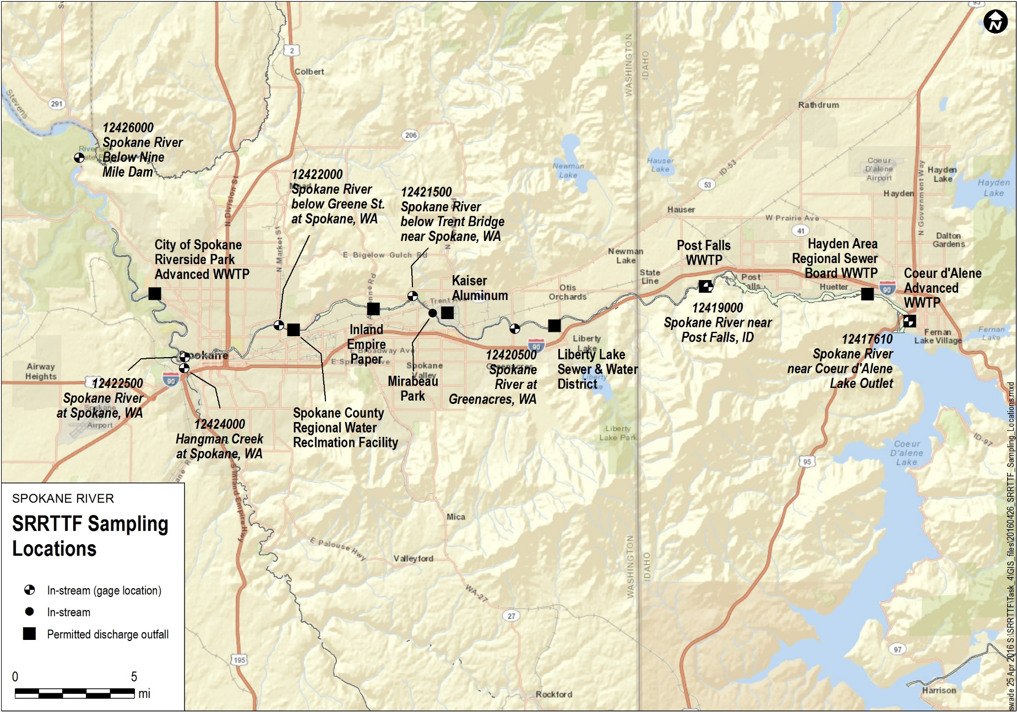
Figure 1. Location of Sampling Stations Monitored in SRRTTF Studies.

Table 1. Number of Water Column PCB Samples
ID No. | Location | 5/2014 Confidence Testing | 8/2014 Synoptic Sampling | 8/2015 Synoptic Sampling | 2016 Monthly Sampling
SR-1 | Nine Mile Dam | - | 9 | - | -
SR-3 | Spokane Gauge | - | 9 | 5 | 7*
HC-1 | Latah (Hangman) Creek | - | 9 | - | 7*
SR-4 | Greene Street Bridge | - | 9 | 5 | 7*
SR-7 | Trent Bridge (Plante's Ferry) | - | 9 | 6 | 7*
SR-8a | Mirabeau Park | 11 | - | 6 | -
SR-9 | Greenacres (Barker Rd.) | - | 9 | 6 | 7*
SR-12 | Post Falls | - | 9 | - | -
SR-15 | Lake Coeur d'Alene Outlet | 6 | 9 | - | 7*
*Not collected/analyzed yet

Wastewater Data
Table 2 summarizes the available wastewater effluent data. More than 400 wastewater effluent samples are available, with 87 samples from municipal facilities and the remainder from Kaiser and IEP. Although not fully compiled, approximately 100 municipal wastewater influent samples have also been identified.
Table 2. Number of Wastewater Effluent PCB Samples
 |  |  |  | NPDES Permit Required
ID No. | Location | 8/2014 Synoptic Sampling | 8/2015 Synoptic Sampling | Routine Monitoring | Period
SR-2 | City of Spokane WWTP | 5 | - | 27 | 2010-2015
SR-5 | Spokane County WWTP | 5 | 3 | 9 | 2012-2014
SR-6 | Inland Empire Paper | 5 | 4 | 18 | 2011-2016
SR-8 | Kaiser | 4 | 4 | 339 | 2003 - 2016
SR-10 | Liberty Lake WWTP | 4 | - | 17 | 2012-2016
SR-11 | Post Falls WWTP | 4 | - | 4 | 2015
SR-13 | HARSB | - | - | 4 | 2015-2016
SR-14 | Coeur d'Alene WWTP | 4 | - | 1 | 2016

Groundwater Data
Tables 3 through 6 summarize the Kaiser groundwater data. 84 measurements are available from site background monitoring wells (Table 3). 34 measurements are available from site deep supply wells (Table 4). 34 measurements are available from on-site monitoring wells (Table 5). 82 measurements are available from on-site near-river monitoring wells (Table 6).

Table 3. Summary of Groundwater Data from Site Background Monitoring Wells
Location | Number of Samples | Period
MW-4 | 17 | 2010 - 2015
MW-5 | 17 | 2010 - 2015
MW-10 | 17 | 2010 - 2015
MW-11 | 16 | 2010 - 2015
RM-MW-5S | 17 | 2010 - 2015

Table 4. Summary of Groundwater Data from Deep Supply Wells
Location | Number of Samples | Period
OH-EW-01 | 5 | 2006 - 2015
WW-EW-01 | 5 | 2006 - 2015
WW-EW-02 | 6 | 2001 - 2015
North Well | 18 | 2006 - 2015

Table 5. Summary of Groundwater Data from On-Site Monitoring Wells
Location | Number of Samples | Period
RM-MW-08S | 4 | 2007 - 2012
RM-MW-13S | 2 | 2007 - 2008
RM-MW-15S | 2 | 2007 - 2008
RM-MW-16S | 1 | 2008
RM-MW-17S | 4 | 2007 - 2012
RM-MW-01S | 2 | 2007 - 2008
HL-MW-17S | 2 | 2007 - 2008
HL-MW-26S | 2 | 2007 - 2008
HL-MW-29S | 4 | 2007 - 2012
HL-MW-5 | 2 | 2007 - 2008
HL-MW-7S | 2 | 2007 - 2008
HL-MW-25S | 2 | 2007 - 2008
HL-MW-14S | 4 | 2007 - 2012
HL-MW-30S | 5 | 2007 - 2012

Table 6. Summary of Groundwater Data from On-Site Near River Monitoring Wells
Location | Number of Samples | Period
MW-17 | 11 | 2007 - 2014
HL-MW-32S | 8 | 2010 - 2012
HL-MW-23S | 10 | 2007 - 2012
MW-12A | 11 | 2007 - 2014
MW-23S | 8 | 2010 - 2014
MW-27S | 13 | 2011 - 2015
MW-28S | 13 | 2011 - 2015
MW-15 | 8 | 2010 - 2014

Stormwater Data
The database compiled as part of the 2013 data gap analysis contains 98 stormwater samples from Ecology’s PCB TMDL stormwater analysis and Urban Waters efforts. In addition, the City of Spokane has collected 53 stormwater samples as part of their planning efforts (Table 7).
Table 7. Summary of Stormwater Data
Program | Number of Samples | Period
Spokane River PCB TMDL Stormwater Analysis | 45 | 2007
Ecology - Urban Waters | 53 | 2009-2012
City of Spokane | 53 | 2012-2014

