Memorandum
From: | Dave Dilks | Date: May 11, 2016  Project: SRRTTF
To: | Spokane River Regional Toxics Task Force
SUBJECT: DRAFT: Magnitude of Source Areas and Pathways of PCBs in the Spokane River Watershed

Summary
The Spokane River Regional Toxics Task Force (SRRTTF) is developing a comprehensive plan to bring the Spokane River into compliance with applicable water quality standards for polychlorinated biphenyls (PCBs). Development of the comprehensive plan will benefit from an understanding of the sources and pathways of PCBs in the Spokane River watershed, allowing the plan to target control of the most important sources and pathways. A prior memorandum (LimnoTech, 2015a, http://srrttf.org/wp-content/uploads/2016/03/SRRTTF_SourcesPathways_2016_0309_draft.pdf) qualitatively described potential source areas and transport mechanisms affecting PCBs in the Spokane River and its contributing watershed. This memorandum estimates the magnitude of those source areas and pathways to the extent possible, using site-specific data when available and literature sources otherwise. Many of the estimates are specified as ranges covering an order (or orders) of magnitude because of the extensive reliance on literature values. Although uncertain, these estimates are still worthwhile in distinguishing between source areas and pathways as likely significant or relatively unimportant in developing the comprehensive plan.
Legacy PCBs in buildings (e.g. small capacitors, caulks) and legacy soil contamination are estimated to be the largest source areas of PCBs in the watershed. Cumulative loading across all wastewater treatment plants, contaminated groundwater, and stormwater/combined sewer overflows are estimated to be the primary delivery mechanisms of PCBs to the Spokane River. PCB loading from Lake Coeur d’Alene and tributaries are of similar magnitude to these other primary delivery mechanisms, from large volumes of flow at very low concentrations. Insufficient data exists to make credible estimates of the magnitude of most transport pathways between the above source areas and delivery mechanisms.

Introduction
This memorandum quantifies, to the extent possible, the magnitude of source areas and pathways of PCBs to the Spokane River using a combination of site-specific data and literature sources. A prior memorandum (LimnoTech, 2015a) qualitatively described potential key source areas and transport mechanisms affecting PCBs in the Spokane River watershed. That memorandum showed that PCBs originate from many different source areas, and are delivered to the river via many different pathways. This memorandum is divided into sections discussing:

The memorandum is divided into sections of:
- Magnitude of source areas of PCBs
- Magnitude of delivery mechanisms of PCBs to the Spokane River
- Magnitude of intermediate transport pathways

Magnitude of Source Areas of PCBs
There is the potential for confusion when discussing PCB sources, as the term “sources” commonly refers to the true origin of the contaminant. In the case of PCBs, the dominant source was intentional production my Monsanto through 1979. Although this source no longer exists, those legacy PCBs now exist throughout the environment. This memorandum follows the nomenclature of SFEI (2010) and used the term “source areas” to represent those environmental compartments containing PCBs. Source areas are defined as the places where PCBs were used, inadvertently released, systematically discarded or accumulated. Source areas of PCBs are divided into three broad categories, based on refinement of earlier PCB source characterization done for San Francisco Bay (SFEI, 2010) and Spokane (LimnoTech, 2013).
- Legacy sources of PCBs currently present in the Spokane watershed
- Ongoing sources of PCBs continuing to be introduced to the watershed via inadvertent production
- Environmental transport of non-local PCBs into the watershed study area, which may either be legacy or continuing sources
The mass of PCB estimated in each source area category is listed in Table 1 and depicted in Figure 1.
Source Area Category | PCB Mass (kg) | Uncertainty in Estimate
Legacy
Building sources | 23,000
Non-fixed | 20,000 | Factor of 30
Fixed | 2,969 | Factor of 50
Environmental | 5,560
Watershed soils | 5,500 | Factor of 10
Spokane R. deep sediments | 19.2 | Factor of 5
L. Spokane deep sediments | 40.6 | Factor of 5
L. Spokane shallow sediments | 2.24 | Factor of 5
Spokane R. shallow sediments | 0.032 | Factor of 5
Industrial equipment | 20 | Factor of 5
Ongoing
Inadvertent production | 9.0 | Factor of 50
Non-Local Environmental
Lake Coeur d’Alene | 0.022 kg | Factor of 3
Atmospheric | Unknown | -
Table 1. Mass of PCB Estimated in each Source Area Category
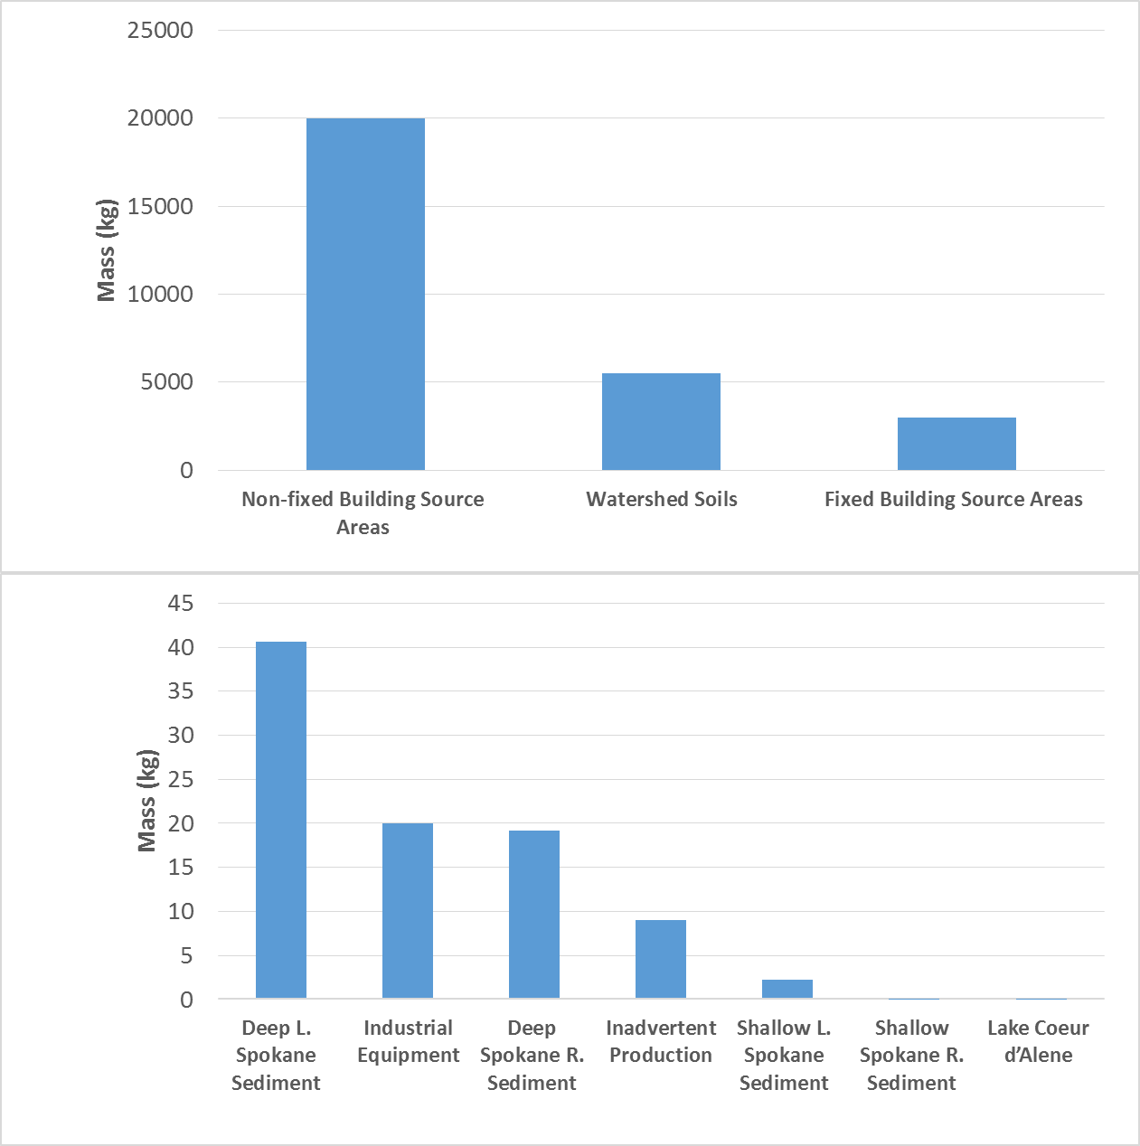
Table 1. Mass of PCB Estimated in each Source Area Category
The remainder of this section describes how each of these estimates was determined.

Legacy Sources
Legacy sources are defined as PCBs that were brought into the Spokane watershed in the past, but are not continuing to be produced. These were produced by Monsanto and marketed as Aroclors which were used in machine oils, transformers, building materials, and many other products. LimnoTech (2015a) divided legacy sources into source area categories of:
- Building sources areas: These sources were sub-categorized as either fixed to the building itself (e.g., paint, caulk), or non-fixed and removable (e.g., light ballasts)
- Environmental: These sources consist of contaminated surface soils, contaminated subsurface soils/groundwater, and in-place aquatic sediments in the Spokane River and Lake Spokane.
- Industrial equipment: These sources consist of PCBs contained in various forms of electrical equipment such as large transformers, and hydraulic equipment.

Building source areas
Building source areas are sub-categorized as either fixed to the building itself (e.g., paint, caulk), or non-fixed and removable (e.g. lamp ballasts).

Fixed Building Source Areas
PCBs were commonly used in building sealants such as caulks from the 1950s to the 1970s (Robson et al. 2010), to improve the flexibility of the material, increase the resistance to mechanical erosion, and improve adherence to other building materials (Andersson et al., 2004). As such, building constructed from the 1950s to the 1970s may still contain caulks with elevated levels of PCBs. No Spokane-specific data exists defining the quantity of PCBs still present in fixed building source areas. However, many studies have been conducted estimating this magnitude for other communities, and these studies can provide a template for Spokane estimates. The methods used vary in terms of complexity, as demonstrated below. Shanahan et al (2015) used the most rigorous approach, estimating the mass of PCBs present in Chicago-area building source areas by:
- Examining the building footprint, age, number of stories for each individual land parcel
- Calculating the volume of all buildings constructed between 1940 and 1979 from the building footprint and height data
- Assuming the mass of sealants per unit building volume from literature sources
- Assuming the PCB concentrations in caulk for buildings built between 1940 and 1979 from literature sources
- Assuming the percentage of buildings constructed from 1940 to 1979 contained PCB sealants from literature sources
Ecology (2011) estimated the quantity of PCBs in building sealants in in the Puget Sound Basin based upon:
- Reviewing the available literature for information on the types and ages of buildings most likely to contain caulking with PCBs.
- Sampling available county assessor’s information to estimate the volume of candidate buildings and develop an inventory of caulking material likely to contain PCBs within the Study Area.
- Reviewing the available literature for data on PCB concentrations in caulking material.
- Applying literature values to estimate the mass of PCBs contained in caulk.
Diamond et al (2011), used a range of calculation methodologies, including providing estimates for PCBs in caulk on a per capita basis, calculated as 5.2 metric tons per million people of population. Lacking readily available information on volume of structures in the Spokane watershed built during the time of PCB use, the Diamond et al (2011) per capita will be used in conjunction with the Spokane watershed population. Population in census block groups was obtained in GIS data format from the U.S. Census Bureau estimates for 2011 (https://www.census.gov/geo/maps-data/data/tiger-data.html). Population per acre was calculated for each block group, and this information merged with watershed boundary delineations obtained from the Watershed Boundary Dataset (WBD). This results in a population estimate for the contributing watershed of 571,045. This results in an estimate of PCBs in caulk throughout the watershed of 2969 kg. This number should be considered very uncertain. The literature sources used to support this calculation cited a factor of ten uncertainty in their calculations. Because the Spokane calculation in based on a per capita estimate rather than actual building age, it is likely that this estimate is only accurate with a factor of fifty.

Non-Fixed Building Source Areas
Non-fixed and removable PCBs are contained in small capacitors in a number of non-fixed building related items, such as appliances and lamp ballasts. No Spokane-specific data are available defining the mass of PCBs in this category, but the method applied by Ecology (2011) to estimate the mass of PCBs contained in small capacitors in the Puget Sound watershed can be applied to Spokane. Ecology (2011) described their approach as follows:
A typical small capacitor unit contains 0.1-0.6 pounds (45 - 270 grams) of PCB oil, with lamp ballasts typically containing about 45 - 70 grams per ballast (EPA, 1982). Globally, one-third of all PCB production may have gone into lamp ballasts (Panero et al., 2005). In 1992 the University of Illinois estimated that 10-25% of U.S. household white goods (major appliances) contained capacitors with PCBs (Panero et al., 2005). Though it is known that many small PCB capacitors were manufactured prior to 1978, estimates of the number still in use vary. EPA (1982) estimated that historically there were 870 million small capacitors in use throughout the U.S. in 1977 in industrial machines and small appliances. EPA (1987) also estimated a 10% annual disposal rate in 1982.
Estimates for PCB lamp ballasts currently in use are an order of magnitude higher than the 1982 EPA estimate for small capacitors. These estimates place the number of ballast units remaining in use nationally between roughly 300 million (U.S. Army, 2001) and 500 million (Missoula County, 2010). In 1998, the EPA cited an unnamed industry source that estimated one billion ballasts were currently in use (EPA, 1998). The EPA (1998) reference suggests that the current number of PCB-containing ballasts in use nationally would be somewhere between 280 million, assuming a mean annual disposal rate of 10% from 1998 to 2010, and 69 million, assuming a mean annual disposal rate of 20% from 1998 to 2010.
Applying annual disposal rates of 10 and 20% to the national estimates and scaling to the Spokane study area by local population yields a range of 1,000 t0 500,000 total small capacitors (including ballasts) remaining in use. This information, combined with an assumed PCB concentration of 45 – 75 g PCB per capacitor, results in total PCB mass in the Spokane watershed of 50 – 40,000 kg. Following the approach of Ecology (2011), a midpoint value of 20,000 kg was selected as an estimate. This estimate is assumed to be accurate within a factor of 30, given the range in mass estimates provided by Ecology (2011).

Environmental
Environmental source areas consist of contaminated surface soils, contaminated subsurface soils/groundwater, and in-place aquatic sediments in the Spokane River and Lake Spokane.

Contaminated Surface Soils
Meijer et al (2003) concluded that soil may be one of the largest global PCB repositories, due to deposition from manufacturing, leaching from building materials or landfills, and the application of wastewater treatment plant biosolids. Insufficient site-specific data are available defining PCB concentrations in soils throughout the Spokane River watershed. An estimate of the total stock of PCBs in Spokane-area soils was made following the approach used by Shanahan et al (2015), who estimated the soil PCB mass reservoir in the Chicago area from:
- the amount of urban area, based upon parcel data
- a literature based soil:air exchange depth of 0.12 m.
- an average PCB concentration in urban soils estimated from 15 cities of 50 ng/g dry weight (from a range of 3−220 ng/g)
- the average bulk density of urban soils
Applying that approach to the Spokane watershed results in an estimate of the PCB mass reservoir of 5,500 kg. Given that the range of observed PCB concentration in urban soils varies by approximately a factor of plus or minus ten, it is reasonable to assume that the Spokane-specific mass estimate is also only accurate to a factor of ten.

Contaminated Sub-Surface Soils
Marti and Maggi (2015) searched Ecology databases for sites that could be contributing PCB contamination to the Spokane River via groundwater, and identified 31 cleanup sites. Soils at 27 of the sites had been analyzed for PCBs using method SW8082, with 23 of these sites having had confirmed releases to soils. Of these 23 sites, 13 have undergone cleanups and received No Further Action (NFA) designation although they may still have detectable PCB concentrations using method 1668. Contaminated soils were removed at twelve of the sites. On-site containment was used at one site. Of the ten remaining sites with confirmed releases of PCB, six are undergoing cleanups, two are in performance monitoring status, and two are awaiting cleanups. Marti and Maggi (2015) prioritized these sites in terms of: 1) confirmed or suspected release of PCBs to the environment, and 2) site status with regard to cleanup activities. No quantitative information was available defining the total mass of PCBs contained at these sites.

River and Lake Sediment
The bottom sediments of the Spokane River and Lake Spokane provide another potential reservoir of PCB contamination. An estimate of the total mass associated with this category was made using data from Ecology (2011), Ecology (2015a), Golder (2005), Ecology (2005), Johnson and Norton, (2001) and Era-Miller (2014). Separate estimates were made for the Spokane River and Lake Spokane, further sub-divided into estimates for surface and deep sediments in each system.
Ecology (2011) discussed the general lack of bottom sediments in the Spokane River:
One particular macro characteristic of the Spokane River is the general lack of fine depositional sediments in most of the river. Lake Coeur d’Alene acts as a settling basin for sediments transported in the upper watershed, and there are no tributaries to the river between the outlet of the lake and Latah Creek. Spokane River is essentially a free-stone stream environment. Although the dams break the river into a series of pools, there are few areas of placid water above Lake Spokane. The river velocities are high enough and the sediment load low enough to scour the bed or prevent settling of significant fine particulate matter, even immediately behind the dams. As a result, almost the entire riverbed upstream of Lake Spokane (the largest reservoir) is composed of gravel, cobble, and boulders with the finer sediment reserved for limited locations behind the dams, interstitial spaces within the river bed, isolated shoreline deposits, and certain fluvial bar features. One notable exception is the narrow band of fine, organic carbon rich sediments found near the Upriver Dam reservoir.

Calculation of surface sediment PCB mass in the Spokane River was based upon measured PCB and sediment concentrations, and modeled fraction of river containing depositional sediment. Ecology (2011) reported surface sediment PCB concentrations above Monroe St. of 6.7 ng/g. Era-Miller (2014) reported PCB concentrations from sediment traps at Upriver Dam of 25.4 to 28.5 ng/g and 13.7 to 17.2 ng/g at Ninemile Dam. Ecology (2015b) reported surface sediment PCB concentrations at undetectable levels (detection limit ~10 ng/g) in their reassessment of the Upriver Dam and Donkey Island PCB sediment site. The solids concentrations of the bed sediments were taken from measurement reported by Johnson and Norton (2001), and an assumed sediment solids density of 2.6. Golder (2005) reports that approximately 20% of the Spokane River above Ninemile Dam is consider depositional. Combining the above information and assuming an average of the observed PCB concentrations (15 ng/g) results in a mass estimate of 0.032 kg.
The Spokane River also contains historical PCB contamination in deep sediments at the Upriver Dam and Donkey Island PCB Sediment Site. The mass of PCB buried in deep sediments was calculated from the PCB concentration depth profiles provided in Ecology (2005), surface area provided in Ecology (2015b), and bed sediment solids concentrations provided in Johnson and Norton, (2001). Combining the above information and assuming an average of the observed PCB concentrations (6587.5 ng/g) results in a mass estimate of 19.2 kg.
Ecology (2011) also reported sediment PCB concentrations at two locations in Lake Spokane. Concentrations in the upper 10 cm ranged from 8 to 33 ng/g in the upper portion of the Lake to 28 to 75 ng/g in the lower portion of the lake. Johnson and Norton, (2001) provided solids concentrations of the bed sediments and three locations in the lake, upper mid-lake, and lower. Combining the observed concentration data at each location (18 ng/g in the upper lake, 41 ng/g in the lower lake), an assumed concentration at mid-lake as the average of the upper and lower lake concentrations 29 ng/g), and an assumed sediment solids density of 2.6 results in a mass estimate of 2.24 kg in surficial Lake Spokane sediments.
The mass of PCB buried in deep Lake Spokane sediments was calculated from the PCB concentration depth profiles provided in Ecology (2011), and bed sediment solids concentrations provided in Johnson and Norton (2001). Combining the observed concentration data at each location (37 ng/g in the upper lake, 4442 ng/g in the lower lake) assumed concentration at mid-lake as the average of the upper and lower lake concentrations 240 ng/g), and an assumed sediment solids density of 2.6 results in a mass estimate of 40.6 kg.
Because estimates of the system-wide mass reservoir is being based on a relatively small number of discrete measurements, it is reasonable to assume that these estimate are only accurate within a factor of five.

Industrial equipment
The primary source areas of legacy PCBs contained in industrial equipment correspond to transformers and large (over three pounds total) capacitors. In addition, hydroelectric dams have been identified as a potential source of PCBs in the Columbia River, due to leaks and spills of PCB-contaminated oils. Information on the presence and PCB content of these sources was gained by direct contact with the utilities who are responsible for the generation and transmission of electricity in the Spokane region. These consisted of Avista Utilities, Inland Power and Light Company, Modern Electric Water Company, Vera Water and Power, Kootenai Electric Cooperative, and Bonneville Power Administration.
Avista operates approximately 24,754 overhead transformers within the Spokane region, with a a total oil content of approximately 117,000 gallons. By the end of 2016, Avista will have no detectable levels (EPA method 8082) of PCBs in their overhead transformers. Using a PCB detection limit of 1 ppm to provide an upper bound estimate, this corresponds to a total PCB mass of less than 0.7 kg. Inland Power and Light Company operates approximately 30,000 transformers, and has replaced all transformers with 45 ppm or more PCBs. Using a 45 ppm to provide an upper bound estimate of PCB mass, this corresponds to a mass of less than 38 kg. Vera Water and Power operates 137 transformers containing PCB concentration between 2 ppm and 43 ppm, with an average concentration of 8 ppm. These transformers contain approximately 3430 gallons of oil. This corresponds to a total PCB mass of 0.16 kg. Kootenai Electric Cooperative has 1,926 transformers in their system that potentially contain PCBs. They do not have an estimate of PCB content, but do have a two year plan to remove all transformers with PCBs. in them. Using average values for quantity of oil and PCB content results in a total mass of 5.4 kg Modern Electric Water Company did not have an estimate for number of transformers. Given that they have replaced all transformers with PCB concentrations greater than 10 ppm in the past 20 years, it is expected that the mass of PCBs in their transformers is small compared to some of the other utilities in the watershed. No information could be obtained from Bonneville Power.
The sum of transformer PCB mass across all utilities appears to be between 0 to 44 kg, with a range being specified to account for the fact that the majority of this sum was comprised of “less than” vales. The midpoint of this range, 22 kg, was specified in Table 1.
None of the utilities continue to use PCB-containing capacitors over three pounds, so the estimated PCB content for this source area category is zero.
Hydroelectric facilities were identified as another potential source of PCBs to the Spokane River, based on a lawsuit from the Columbia Riverkeeper regarding multiple releases of PCB-containing electric oil from Army Corps of Engineers’ hydroelectric facilities. Avista Utilities operates all hydroelectric facilities in the Spokane River study area, and does not use PCB containing oil in these facilities. The PCB mass contained in hydropower facilities was therefore considered negligible.

Ongoing Sources
Despite the ban on the intentional production of PCBs instituted in 1979, PCBs still continue to be inadvertently produced in the chemical synthesis of many commercial products. EPA promulgated a rule under the Toxics Substance Control Act for inadvertent generation of PCBs that are not in closed or controlled manufacturing processes. The concentration of inadvertently generated PCBs in products must have an annual average of <25 ppm, with a maximum of 50 ppm (40 CFR Section 761.3). LimnoTech (2015a) divided ongoing sources into source area categories of:
- Pigments in printed materials/fabrics: Newsprint, commercial packaging, colored clothing
- Paints: Architectural paint, road paint
- Other: Many products, including motor oil and agricultural chemicals
Studies have been conducted that test the levels of PCBs in a wide range of products (e.g. City of Spokane, 2015; Ecology, 2014; Hu and Hornbuckle, 2010.) The number of products tested, however, in conjunction with a lack of information on the quantity of goods being imported into the watershed by category, prevent calculation of category-specific magnitude estimates. Work conducted as part of the Ecology and DOH (2015) PCB Chemical Action Plan provides a template for estimating of the overall magnitude of all inadvertent sources being imported into the watershed:
The US market consumes approximately 20% of global organic pigments (Guo et al. 2014). Washington is approximately 2% of the US population, which leads to an estimate for Washington’s share of PCB-11 from yellow pigment of 0.02 and 31 kg per year. This is the amount of PCB-11 in products, with an unknown amount entering the environment. The Color Pigments Manufacturers Association (CPMA) estimated that the total annual amount of these pigments (phthalocyanine and diarylide) imported or manufactured in the US is about 90 million lbs (41,000 metric tons). They further estimated inadvertently generated PCBs in these pigments with an upper bound of 1.1 tons per year and a more reasonable estimate of 1000 lbs per year (CPMA 2010). Using the lower annual estimate of 1000 lbs (450 kb), leads to an estimate of 9 kg per year in Washington, that is within the range of the estimate above.
Scaling the above estimate to the population of the Spokane watershed leads to a loading estimate for Spokane of 0.86 kg/yr. In order to convert this rate into a mass, assumption need to be made regarding how long these inadvertently-produced remain in the watershed before leaving either via the atmosphere or being transported downstream by the Spokane River. A lower-bound estimate of a residence time one year results in a mass estimate 0.86 kg, while an upper-bound estimate of a residence time 20 years results in a mass estimate 17.2 kg. The mid-point of this range, 9 kg, is reported in Table 1. The overall uncertainty in this estimate reflects uncertainty in both the rate of PCBs being imported to the watershed as well as their residence time, such that this value is likely accurate only within a factor of fifty.

Non-Local Environmental Source Areas
PCBs also enter the Spokane watershed study area (presently defined as having an upstream boundary at Lake Coeur d’Alene) via non-local environmental sources. LimnoTech (2015a) divided non-local environmental source areas into categories of:
- Atmospheric: Atmospheric sources originating outside of the watershed
- Up-watershed: Entering the river from Lake Coeur d’Alene.

Atmospheric
No definitive information exists on the specific amount of PCBs delivered to the Spokane area from atmospheric sources, regardless of origin. Era-Miller (2011) in a literature review of toxics atmospheric deposition in Eastern Washington State, found no data available for atmospheric PCBs in eastern Washington. The closest relevant reference site with atmospheric PCB data was from Summerland, British Columbia, with a measured annual PCB concentration of 4.4 ng/PAS (Passive Air Sampler). Era-Miller’s review showed a range of reported significance of non-local sources compared to local sources. An atmospheric deposition model of PCBs in the Willamette River Basin suggested that PCBs came primarily from non-local sources and local soil sources, while a second source in that review (Simonich, cited as personal communication) suggested that the contribution of trans-Pacific sources to PCB, PBDE, and PCDD/F deposition in Eastern Washington was less than 2%. Ecology’s Environmental Assessment Program is currently undertaking a study that will provide information on this source area category.

Up-Watershed
PCB loading from Lake Coeur d’Alene represents the aggregate contributions of PCBs from the upper watersheds after travelling through the lake. An estimate of PCB load currently present in Lake Coeur d’Alene was calculated by multiplying the volume of the lake (2.79 km³) by the average PCB concentration in the lake, represented by data collected by the SRRTTF during confidence testing and synoptic surveys. It is recognized, however, that the analytical results utilized to estimate this concentration are below concentrations at which PCBs can be measured with confidence in the environment. The average total PCB concentration of 17 pg/l is less than the average of field blanks from the same confidence testing and synoptic survey, corrected in the same manner (27 pg/l). In addition, available PCB concentration data are dominated by summer measurements, although no significant difference in concentrations were observed between seasons. To account for this uncertainty in lake concentrations, the mass calculation was conducted for a range of PCB concentrations from 0 to 17 pg/l. The resulting load estimate is 0 to 0.047 kg. The mid-point value of this range, 0,024 kg, is presented in Table 1.

Magnitude of Delivery Mechanisms of PCBs to the Spokane River
The mechanisms that can deliver PCBs to the Spokane River study area were defined by LimnoTech (2015a) as:
- Transport of PCBs from upstream sources through Lake Coeur d’Alene
- Atmospheric deposition directly to water bodies
- Groundwater loading
- MS4 stormwater/combined sewer overflows (CSOs)
- Tributaries
- Discharge from municipal and industrial wastewater treatment plants
- Discharge of waste water and stocking of fish from fish hatcheries
- Diffusion or resuspension of PCBs from bedded sediments in the Spokane River and Lake Spokane
Consistent with the assumptions of Ecology (2011), direct stormwater runoff draining to the Spokane River from areas other than the City of Spokane’s MS4 system is assumed to be small. Stormwater runoff drainage to tributaries will be reflected in the tributary loading estimates for Latah Creek and the Little Spokane River.
The mass loading rate for PCBs estimated in each source category is provided in Table 2 and Figure 2.

Delivery Mechanism | PCB Loading Rate (mg/day) | Uncertainty in Estimate
WWTPs
Municipal | 108 | Factor of 2
Industrial | 174 | Factor of 2
Groundwater loading | 150 | Factor of 3
Upstream sources | 132 | Factor of 3
Tributaries
Latah Creek | 50 | Factor of 3
Little Spokane River | 116 | Factor of 3
MS4 stormwater/CSOs | 38 | Factor of 10
Bottom sediments | 1.01 | Factor of 20
Fish hatcheries | Unknown | -
Atmospheric deposition to surface water | <0 | -
Table 2. PCB Loading Rates Estimated for each Delivery Mechanism
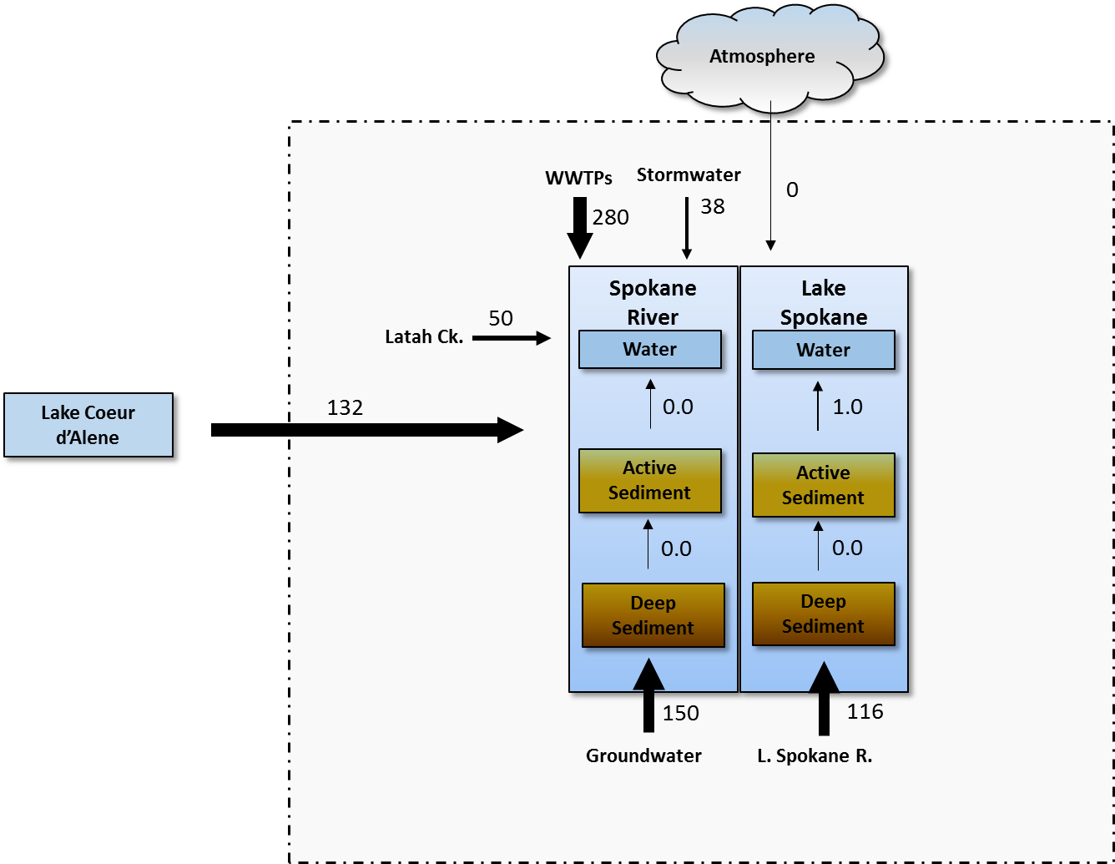
Figure 2. PCB Loading Rates (mg/day) Estimated for each Delivery Mechanism
The remainder of this section describes how each of these estimates was determined.

Transport of PCBs from Upstream Sources through Lake Coeur d’Alene
Transport of PCBs from upstream sources through Lake Coeur d’Alene was estimated using the assumed average concentration (8.5 pg/l) discussed in the previous section, in conjunction the annual average flow out of the lake (175 m³/sec) to produce an estimated loading rate of 132 mg/day.. Because the average flow out of the lake is much better understood than average lake concentration, this estimate is likely accurate to within a factor of three, consistent with the uncertainty in the average lake concentration estimated above.

Atmospheric Deposition Directly to Water Bodies
PCBs can be delivered directly to surface waters from atmospheric sources via three mechanisms: wet deposition, dry deposition, and gas deposition. Wet deposition consists of PCBs contained in precipitation. Dry deposition consists of PCBs attached to airborne particulate matter that settle onto the surface water. Gas deposition occurs as a transfer across the air-water interface when atmospheric gas-phase PCB concentrations exceed the equivalent dissolved phase PCB concentrations in the water column. Research (Miller et al, 2001) has shown that the primary mechanism for atmospheric PCBs to enter surface waters is through gas-phase exchange, so the calculations that follow focus solely on gas deposition as the dominant component of atmospheric PCB loading.
The magnitude of gas deposition is determined by three primary factors, the atmospheric gas phase PCB concentration, the water column PCB concentration and the mass transfer coefficients that control the rate at which PCB concentrations pass through the air-water interface. Screening-level calculations of gas phase PCB exchange for Spokane focused on Lake Spokane itself, which provides the large majority of overall surface area. Gas-phase atmospheric PCB concentrations were estimated from a population-based regression of Venier and Hites (2010) as 0.121 ng/m³. The water column PCB concentration was specified as 163.2 pg/L, based upon the average concentration observed at Nine Mile Dam during the 2014 synoptic survey. Representative mass transfer coefficients were taken from Chapra (1996). These values lead to a net movement of PCBs out of the water column and into the atmosphere, i.e. no net loading of PCBs from the atmosphere to the water column.

Groundwater Loading
The synoptic water quality survey conducted by the SRRTTF in August, 2014 identified a significant groundwater loading source entering the river between Greenacres (Barker Rd.) and the Trent Avenue Bridge, with an estimated loading rate of 170 mg/day. A second synoptic survey conducted in August, 2015 confirmed the presence of this load, and estimated its magnitude at 130 mg/day. The average of these two values, 150 mg/day, is entered in Table 2. Uncertainty analyses conducted in conjunction with the loading assessment (LimnoTech, 2015b) indicate that this estimate can be considered accurate within a factor of three.

MS4 Stormwater Runoff/Combined Sewer Overflows (CSOs)
Initial sampling of the City of Spokane stormwater/CSO discharges for PCBs first occurred for single event in 2004 by the City of Spokane, followed in 2007 by more extensive sampling by Ecology and Parsons (Parsons, 2007). Ecology (2011) used these concentration data in conjunction with average annual stormwater flow predicted by the Simple Method to generate an annual average loading estimate of 691 mg/day.
From 2012 through 2014, the City of Spokane monitored three MS4 stormwater basins (Cochran, Union, Washington) and two CSO basins (CSO34 and CSO06) on a near-monthly basis. Hobbs (2015) reviewed the available data and calculated mass loading of PCBs to the river for individual storms.
Donovan (2015) generated annual loading estimates for MS4 and CSO sources, based upon:
- Annual rainfall of 18 inches
- Site-specific regression of discharge from the Cochran basin to rainfall
- Ratio of impervious area in other basins to impervious area in Cochran basin
- Average stormwater PCB concentration observed in Cochran basin to represent all basins except Union and Washington
- Average stormwater PCB concentration observed in Union basin
- Average stormwater PCB concentration observed in Washington basin
- 2005 actual CSO flow
- Average CSO 6 PCB concentration to represent CSO 6
- Average CSO 34 PCB concentration to represent CSO 34
- Average of CSO 34 and CSO 6 PCB concentration to represent all other CSOs
The above information resulted in an annual loading rate of 29.9 mg/day for MS4 stormwater, 7.6 mg/day for CSO, and a total of 37.6 mg/day. The estimate of Donovan (2015) is believed to be the most accurate value available, and is presented in Table 2. The large variance between the original Ecology (2010) estimate and the more recent estimate indicates that there is still significant uncertainty in this estimate, perhaps as much as a factor or ten.

Tributaries
Two tributaries enter the Spokane River within the study area, Latah Creek and the Little Spokane River. Each are discussed below.

Latah Creek
An annual PCB loading estimate for Latah Creek was obtained using long-term average observed creek flow (6.5 m³/sec) and the average concentration observed during the 2014 SRRTTF synoptic survey (89 pg/l), resulting in an annual loading estimate of 50 mg/day). This loading estimate was calculated by excluding one observed concentration measurement of 2444 pg/l observed during the 2014 Synoptic Survey, due to the fact no indication of concentrations of that magnitude were seen in the composite sample taken during that same synoptic period. Repeating the analysis with that one potentially unrepresentative sample from the calculation results in an average concentration of 383 pg/l and a loading estimate of 215 mg/day. This higher loading estimate shows that uncertainty in Latah Creek concentrations results in an uncertainty in the loading estimate of up to factor of five.

Little Spokane River
A PCB loading estimate for the Little Spokane was originally provided by Serdar et al (2011), based upon and average Little Spokane PCB concentration data from 2003-2004 (199 pg/l) and harmonic mean at the USGS Station 12431000 at Dartford (5.6 m³/sec). Their concentration was derived from sampling with a semi-permeable membrane device (SPMD), which is an indirect measurement of water column PCB concentrations. Data collected in 2013-2014 reported by Friese and Coots (2016) suggest much lower river concentrations, with all observed River concentrations being less than 30 pg/l. Blank contamination issues prevented Friese and Coots (2016) from providing a quantitative estimate of concentration. For purposes of this report, a concentration of 114 pg/l is assumed, representing the average of the observed Serdar et al (2011) concentrations and Friese and Coots (2016) reported concentrations for the Painted Rocks station. Also, the harmonic mean flow was replaced by the long term average flow (11.8 m³/sec) which is more appropriate for use in calculating loads. This results in a loading estimate of 116 mg/day. Because the average flow from the river is much better understood than average river concentration, this estimate is likely accurate to within a factor of three, consistent with the uncertainty in the average river concentration estimated above.

Discharge from Municipal and Industrial Wastewater Treatment Plants
Loading estimates for municipal and industrial wastewater treatment plants were calculated from effluent data collected by the plants during routine monitoring, along with data obtained during the SRRTTF synoptic surveys. Results are summarized in Table 3. These loading estimates are presented as a range rather than one loading estimate. This is due to differences in blank correction methodology between the SRRTTF source identification studies and discharger effluent monitoring. The SRRTTF recognizes that the selection of blank correction methodology is dependent on the use of the data (LimnoTech 2014). The SRRTTF has determined that a “3x blank censoring” correction methodology is appropriate for source area identification studies. Ecology has indicated that a “10x blank censoring” correction methodology is appropriate for reporting effluent monitoring results. Differences in reported concentrations between the synoptic surveys and routing monitoring may also be explained by the sampling methods used, as routine monitoring is primarily conducted with composite samples while the synoptic surveys used grab samples. Therefore the loading estimates are based on a range bounded by the average of the values reported in the SRRTTF source area identification studies and the average of values reported for discharger effluent monitoring. The mid-point of the range is utilized as appropriate in other portions of this report.. The range in total loading rate is 250 – 315 mg/day, with a midpoint value of 282 mg/day.

 | PCB Concentration (pg/l) |  | Flow (cfs) | Load (mg/day)
 | Synoptic Survey  3x correction | Routine Monitoring  10x* correction
Industrial
Kaiser | 3264 | 2232* | 13.25 -18.46 | 101 – 105
Inland Empire Paper | 3180 | 2223 | 10.8 | 58.9 – 84.3
Municipal
City of Spokane | 975 | 729 | 44. 1 – 48.9 | 87.2 – 105
Spokane County | 361 | 30 | 11.5 | 0.87 – 10.4
Coeur d’Alene | 533 | 37 | 5.19 – 5.35 | 0.85 – 6.97
Post Falls | 213 | 163 | 3.88 – 3.89 | 1.55 – 2.03
Liberty Lake | 219 |  | 1.12 | 0.60 – 0.68
HARSB | - | 108 | 0 – 1.71 | 0.0 – 0.453
Total |  |  |  | 250 – 315
*Kaiser data is not blank corrected.
Table 3. PCB Loading Rates from Municipal and Industrial WWTPs

Discharge of Waste Water and Stocking of Fish from Fish Hatcheries
PCB contributions to Spokane River from fish hatcheries can arise from the stocking of PCB-contaminated fish and discharge of effluent from the Washington Department of Fish and Wildlife’s Spokane Fish Hatchery to the Little Spokane River. Approximately 170,000 rainbow trout are planted annually to Lake Spokane and the Spokane River. The fish raised are in two different hatcheries, Troutlodge in Soap Lake, and the Spokane Fish Hatchery. Serdar et al (2006) found PCB concentrations of 6.5 ug/kg in hatchery trout from the Spokane Fish Hatchery and 14.4 ug/kg in fish fillets from the Troutlodge facility. Fish feed from the Spokane hatchery was analyzed by Serdar et al (2006) with a result of 16.4 ug/kg. No quantitative data exists for PCB loading from discharge of waste water and stocking of fish from these hatcheries, although a rough estimate of loading from planted fish can be made. If it is assumed that planted fish weigh 0.2 pounds at planting, the introduction of 170,000 fish per year results in an average loading rate 0.3-0.6 mg/day. Ecology (2016) is conducting a study to provide specific estimates of loading from fish hatcheries.

Diffusion or Resuspension of PCBs from Bedded Sediments in the Spokane River and Lake Spokane
No site-specific data were available to define the magnitude of pore water diffusion and/or resuspension of PCBs into the study areas from bed sediments. Given that the calculations above show that the mass of PCB in lake sediments is more than 100x greater than river sediments, it can be reasonably assumed that overall flux from bedded sediments is dominated by flux from lake sediments. The magnitude of pore water diffusion from lake bed sediments was estimated based on a combination of physical-chemical properties taken from the development of the MICHTOX Lake Michigan Mass Balance Project (USEPA, 2006; Endicott, 2005; and Endicott et al., 2005) with study area-specific measurements of sediment PCB concentrations. The resulting gross PCB diffusive flux from the lake sediments was estimated at 1.01 mg/day. Lake Spokane is known to have a significant carp population (Avista and Golder, 2012), and carp feeding mechanisms are known to churn bottom sediments and increase the flux of sediment-bound pollutants such as PCBs from via bioturbation (Canfield and Farquhar, 2009.) No quantitative data exists describing the effect of carp bioturbation on sediment flux, such that the actual rate of flux could be significantly higher than typical literature values. Conversely, much of the carp bioturbation activities occur in the shallower headwaters of Lake Spokane, where sediment PCB concentrations are lower than the sediments near the dam. Given this uncertainty, the estimate of the flux rate from Lake Spokane sediments is assumed to be accurate only within a factor of twenty.

Magnitude of Intermediate Transport Pathways
It is recognized that there are a number of intermediate pathways by which PCBs from the source areas get transported to the delivery mechanisms described above. LimnoTech (2015a) divided these pathways under the categories of:
- Mobilization in the watershed
- Volatilization to the atmosphere
- Delivery to sewer infrastructure
- Contribution to groundwater

Mobilization in the Watershed
Many of the PCBs in source areas of are contained within products of some kind and must first undergo a mobilization step to allow them to be transported through the watershed and/or to the Spokane River. Watershed mobilization pathways defined in LimnoTech (2015a) consist of:
- Demolition from fixed building source areas
- Transfer of non-fixed building source areas to recycling facilities
- Spills/leaks of PCBs contained in industrial source areas
- Littering/recycling of PCBs in consumer products
- Deposition and gas transfer of atmospheric sources
- Application of PCB-containing materials to watershed

Figure 3 depicts estimated magnitudes for these pathways, and shows that magnitudes for many of these pathways cannot currently be estimated.
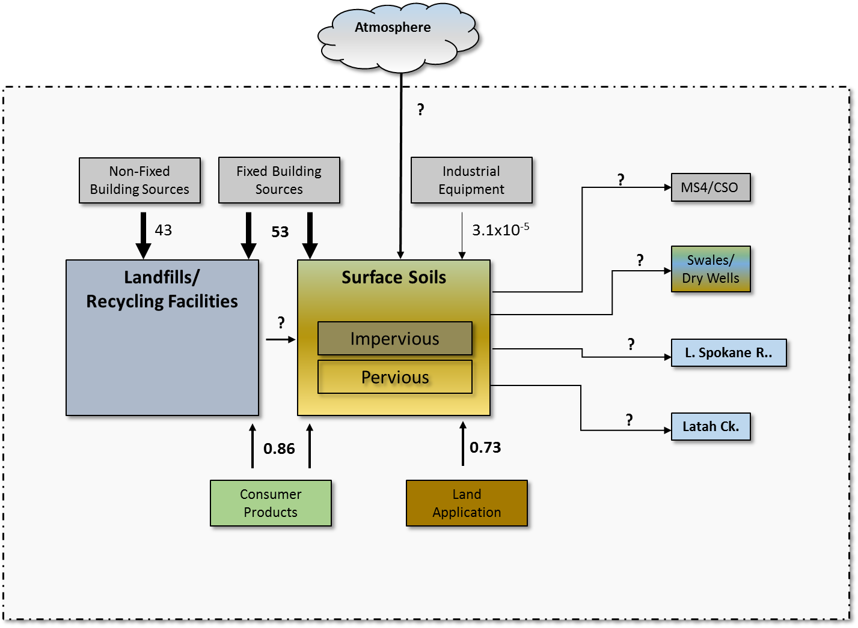
Figure 3. Estimated Magnitudes (kg/yr) for Watershed Mobilization Pathways

Fixed Building Source Areas: Demolition/Volatilization
Little information is available on the mobilization of PCBs from fixed building source areas, with many studies assuming that volatilization is the dominant mobilization method (e.g. Shanahan et al, 2015). Ecology (2011) notes, however, that volatilized PCBs may quickly attach to other media include adjoining materials, or dust and films. Weathering of caulk through fragmentation and abrasion may also release PCBs directly in particle form. For these reasons, mobilization from fixed building source areas has been combined into a lumped demolition/ volatilization category. Robson et al. (2010) calculated a long-term gross mean regional sealant PCB loss rate of 9% over 50 years of exposure, i.e. 0.018/yr. Combining this loss rate of PCBs with the total PCB mass estimated above of 2969 kg results in a release rate of 53.4 kg/yr. Given that that the PCB mass estimate was considered to only by accurate to a factor of 50, it is assumed that this release rate estimate has a similarly large range of uncertainty.

Transfer of Non-Fixed Building Source Areas to Recycling Facilities
No site-specific data are available describing the transfer of non-fixed building source areas to recycling facilities. Assumptions used for the Puget Sound Source Assessment (Ecology, 2011) were applied here. They estimated a release rate from small capacitors of approximately 1 to 1,000 kg/yr, with a mid-point of is 500 kg. Scaling that estimate by population to the Spokane watershed results in range of 0.1 to 95 kg/yr, with a mid-point of 48 kg/yr. This estimate is assumed to be accurate within a factor of 30, given the range in release rates provided by Ecology (2011).

Spills/Leaks of PCBs Contained in Industrial Source Areas
The prior section on magnitude of source areas concluded that the primary remaining reservoir of industrial PCB in the Spokane watershed was in the capacitors of some of the small utilities. Ecology (2015a) cited a SWAG/EEI (1982) study reporting that about 2% of all transformers had moderate leaks or spills each year, with an average amount of PCBs leaked/spilled per event of 18 mg – 2.27 g for mineral oil transformers. Avista maintains all large transformers in the watershed in controlled areas, and implements immediate remediation activities in the event of leakage that prevents the release of PCBs to the outside environment. As such, the above release rate was applied only to the transformers from the other utilities. The combination of above leakage rate and range of amount spilled results in an annual release estimate of 4.86x10⁻⁷ to 6.13 x10⁻⁵ kg/year, with a midpoint value of 3.1x10⁻⁵ kg/year. This estimate is considered accurate only to within a factor of twenty, given the wide range in the estimate of amount spilled per event and uncertainty in the failure rate.

Littering/Recycling of PCBs in Pigments in Consumer Products
No quantitative information is available for this pathway. An upper bound estimate can be made assuming that all inadvertently produced PCBs imported into the watershed over the course of the year become available through this pathway. As described above in the Magnitude of Source Areas section, this results in an upper bound release rate estimate for Spokane of 0.86 kg/yr. Given that that the PCB mass estimate was considered to only by accurate to a factor of 50, it is assumed that this release rate estimate has a similarly large range of uncertainty.

Deposition and Gas Transfer of Atmospheric Source Areas
As discussed in the Ongoing Source Areas section above, no definitive information exists on the specific amount of PCBs delivered to the Spokane area from atmospheric source areas. Ecology is currently undertaking a PCB atmospheric deposition study in Spokane to address this need.

Application of PCB-Containing Materials to Watershed
LimnoTech (2015a) identified that produced PCBs can be directly applied to the watershed via hydro-seed, de-icer, herbicides and pesticides, and biosolids or fertilizer applications. No quantitative data are available to estimate the overall magnitude of this pathway, although the application of biosolids may be an important component. Shanahan et al (2015) estimated the average concentration of PCBs in municipal sewage sludge at 1.0 mg/kg dry weight, based on the work of Rodenburg and Meng (2007) and Norström et al (2010), while the City of Spokane has reported biosolids PCB concentrations in the 0.08 – 0.25 mg/kg dry weight range. An upper bound estimate for PCB transport via sludge application can be made by assuming that all PCBs removed from municipal influents are land applied as sludge. As described below, the influent PCB load to municipal plants was estimated at 2108 mg/day. Table 3 showed that municipal plants discharge approximately 108 mg/day, resulting in an upper bound estimate for biosolids application of 2000 mg/day (0.73 kg/year). Influent PCB concentration estimates are likely accurate within a factor of two, with a similar level of uncertainty on the assumption that the mass of PCB exported via biosolids is equivalent to the mass of PCB in the plant influent.

Mobilization to the Atmosphere
Numerous source areas contribute to local atmospheric concentrations of PCBs via volatilization, i.e. conversion into a gas phase. Atmospheric mobilization pathways defined in LimnoTech (2015a) consist of:
- Volatilization directly from previously defined source area categories.
- Combustion sources
- Volatilization of PCBs from wastewater treatment sludge
- Transport of PCBs generated outside of the watershed

Volatilization Directly from Previously Defined Source Area Categories
Shanahan et al (2015) showed that volatilization from contaminated surface soils was the dominant source of atmospheric PCB load in the Chicago area. They estimated that a soil PCB mass of 2,200 kg resulted in a volatilization load of 64 kg/yr. Scaling their results to the mass load of 5,500 kg estimated above for the Spokane watershed results in a volatilization load of 160 kg/yr. Given that that the PCB mass estimate was considered to only by accurate to a factor of 10, it is assumed that this release rate estimate has a similarly large range of uncertainty.

Combustion Sources
Potential combustion sources include internal combustion engines, incinerators, used oil burning and residential burning. Of these, quantitative estimates were found in Ecology and DOH (2015) for residential trash burning and the Spokane Waste to Energy Plant. According to the most recent NEI for 2008, there were 199 kg of PCBs released to the air in Washington State from residential waste burning. Scaling this estimate by population results in a Spokane watershed estimate of 16.9 kg/yr. Ecology and DOH (2015), citing the Spokane Regional Clean Air Agency, reported about 1 lb of PCB emitted from the Spokane Waste to Energy Plant in 2011 (0.45 kg/yr). The upcoming Ecology PCB atmospheric deposition study in Spokane will provide more information on the significance of this source.

Volatilization of PCBs from Wastewater Treatment Sludge
Shanahan et al (2015) estimated that volatilization of wastewater treatment sludge was the second largest source of PCB release in the Chicago area. This estimate was determined to be inapplicable to the Spokane area, because biosolids from all municipal wastewater treatment plants are either: 1) incorporated into compost, or 2) land applied and directly incorporated (i.e. plowed) into the soil. Because neither of the above mechanisms are readily amenable to volatilization, it assumed that PCB release from this pathway is negligible.

Transport of PCBs Generated Outside of the Watershed
This category is the same as the non-local atmospheric source areas category discussed above in the section on Ongoing Source Areas. As discussed there, little definitive information exists on the specific amount of PCBs delivered to the Spokane area from atmospheric source areas. Ecology’s Environmental Assessment Program is currently undertaking a study that will provide information on this source area category.

Delivery to Sewer Infrastructure
The Spokane watershed contains a range of sewer infrastructure capable of delivering PCBs, either directly or indirectly, to the river. This infrastructure can be broadly divided into categories of stormwater and wastewater.

Stormwater
No quantitative estimate exists defining the quantity of PCBs being delivered to the stormwater system. A lower bound estimate of loading to the City of Spokane’s MS4 system can be obtained from the stormwater loading estimate provided above of 29.9 mg/day (0.01 kg/year). No information exists to estimate PCB loading to non-discharging stormwater systems.

Wastewater
An estimate of PCBs delivered to municipal wastewater systems can be obtained from observed influent PCB concentrations. Review of influent PCB data provided by the City of Spokane, Spokane County, and Post Falls show an average influent concentration of 13,000 pg/l. Multiplying this influent concentration by cumulative municipal discharge flow results in a loading rate of 2107.8 mg/day (0.77 kg/yr).

Contribution to Groundwater
The final intermediate transport pathway defined in LimnoTech (2015a) is contribution to groundwater, divided into categories of:
- Legacy contamination
- Landfill disposal of PCB-containing products
- Leaking well pumps
- Private septic systems
- UIC wells (referred to as Dry Wells in LimnoTech, 2015a)

Legacy contamination
The Magnitude of Source Areas section above concluded that insufficient data exist to estimate the total mass of legacy subsurface PCB contamination; correspondingly, insufficient data are available to estimate the rate at which this legacy subsurface contamination contributes to groundwater. A lower bound estimate can be gained from the groundwater loading calculation presented above in the Magnitude of Delivery Mechanisms section, which estimated the groundwater loading in the river section directly below Mirabeau Park at 148.7 mg/day (0.054 kg/year). This is considered a lower bound estimate because it only considers legacy contamination loading to a portion of the aquifer.

Landfill disposal of PCB-containing products
Similarly, no data were found describing groundwater PCB loading from landfills. Modern landfills are designed and operated to prevent any adverse effects to groundwater. Older landfills still exist in the watershed that were not designed or operated to modern standards. However, many of these older landfills suspected of contributing toxic materials to local groundwater have been named as National Priorities List (NPL) sites under the Comprehensive Environmental Response, Compensation and Liability Act, and have undergone remedial actions to address potential groundwater contamination (SCS, Engineers, 2015.)

Leaking well pumps
The Wisconsin Department of Natural Resources and Division of Health (WDNR, 2008) determined that certain submersible pumps used to draw water from wells may leak PCBs into ground water. The dielectric fluid in capacitors used in certain pump motors manufactured before 1979 was made of PCBs, with each capacitor containing up to five ounces of PCBs. These PCBs can gradually leak during normal wear-and-tear. No quantitative information was available describing the rate of leakage.

Private septic systems
There are over 45,000 private septic systems in Spokane County, with 200 to 300 new systems are added annually and 50 to 150 systems removed due to connection to sewer or abandonment. At least 10,000 systems are likely located over the aquifer contributing to the Spokane River (S. Phillips, personal communication). Furthermore, the USGS calculated an average hydraulic input to the entire aquifer of 23 cubic feet per second for the period 1990 to 2005 (USGS, 2007). Given observed PCB concentrations greater than 10,000 pg/l in municipal wastewater influent as discussed above, it is reasonable to assume that similarly high PCB concentrations are delivered to septic tanks. No quantitative information exists defining the rate at which these PCBs may be delivered to the groundwater contributing to the Spokane River.

UIC wells
Underground Injection Control (UIC) wells are manmade structures used to discharge fluids into the subsurface. Examples of UIC wells include dry wells, infiltration trenches with perforated pipe, and any structure deeper than the widest surface dimension (http://www.ecy.wa.gov/PROgrams/wq/grndwtr/uic/index.html). Marti and Maggi (2015) reviewed the abundance and use of UIC wells in Washington. Ecology’s Underground Injection Control (UIC) Program protects groundwater quality by regulating the disposal of fluids through UIC wells. Approximately 14,000 UICs have been registered in Spokane County, with an unknown number of unregistered wells. These wells receive stormwater runoff from paved areas, such as parking lots, streets, residential subdivisions, building roofs, and highways. USGS (2007) cited the work of Contor (Idaho State University, written communication), who used aerial photography and GIS coverages of precipitation and dry well locations to estimate recharge from impermeable surfaces to the Spokane Valley-Rathdrum Prairie aquifer. The estimated mean annual areal recharge (inflow) for 1990–2005 to the aquifer from permeable and impermeable surfaces was 233 cubic feet per second.
Marti and Maggi (2015) note that the potential for groundwater contamination from UICs depends upon the UIC wells’ construction and location, the type and quality of fluids being injected, and the geographic and subsurface setting in which the injection occurs. UICs used along roads and parking areas are not typically considered a high threat to groundwater if they have been built to meet the requirements of the Guidance for UIC Wells that Manage Stormwater (Ecology, 2006). UICs constructed before 2006 and used to manage stormwater are required to have a well assessment to determine if they pose a risk to groundwater. A well assessment evaluates the land use around the UIC, which may affect the quality of the discharge, and whether the UIC is located in a groundwater protection area. If a UIC well is considered a high threat to groundwater, the assessment may also include information on the local geology and depth to groundwater in relation to the UIC well. Beyond the control measures discussed immediately above, no quantitative information exists on the rate at which PCBs may be delivered to Spokane area groundwater from UIC wells.

Conclusions
This assessment of the magnitude of source areas and pathways of PCBs in the Spokane River watershed provides some useful information to support development of a Comprehensive Plan, but also identifies some important data gaps. Key conclusions can be summarized as follows:
- The source areas containing the largest mass of PCBs residing in the watershed have been identified
- Prior estimates of delivery mechanisms provided in Serdar et al (2011) have been updated
- The transport pathways between source areas and delivery mechanisms is poorly understood
The bulk of the PCB mass currently present in the Spokane River watershed corresponds to legacy PCBs contained in: 1) non-fixed building materials (such as appliances and light ballasts) built prior to 1978, 2) fixed building materials (paints, caulks), and 3) watershed soils. Although the specific mass of PCBs in each compartment may not be able to be estimated more accurately than by a factor of 50, the magnitude of PCBs in the above compartments are orders of magnitudes greater than the other compartments considered.
This memorandum generates estimates of the magnitude of delivery mechanisms of PCBs to the Spokane River that can be compared to similar estimates made by Serdar et al (2011) in their Spokane River PCB Source Assessment. This study estimates cumulative loading from Idaho sources of approximately 140 mg/day (with a factor of three uncertainty), compared to an estimate of 477 mg/day from Serdar et al. Cumulative loading from Washington wastewater treatment plants is similar, 280 mg/day in this study and 310 mg/day in Serdar et al. This study generates much lower estimates for stormwater/CSO contribution, with the currently estimated load of 38 mg/day being much less than the previously estimated 691 mg/day. This study did identify two loading pathways that were not quantified by Serdar et al.: 1) a groundwater loading with a magnitude of approximately 150 mg/day, and 2) loading from Latah Creek with a magnitude of approximately 50 mg/day.
Although quantitative estimates have been generated for the PCB mass currently residing in the watershed and for the magnitude of different delivery mechanisms to the Spokane River, much less information is available to quantify the transport pathways between these source areas and delivery mechanisms. This will pose a significant challenge when developing the Comprehensive Plan. As a hypothetical example, knowledge that a large amount of PCBs reside in home appliances does not necessarily mean that they should be a primary target for control; if there is no transport process by which those PCBs will reach the Spokane River, controls on them may not be effective in reducing PCB loads to the river. This issue is not unique to Spokane, as PCB control plans for other watersheds have been developed facing similar types of uncertainty.

References
Andersson, M., R. Ottesen, and I. Volden. Building materials as a source of PCB pollution inBergen, Norway. Sci Total Environ 325:139–44.
ASTDR (2000) Toxicological Profile for Polychlorinated Biphenyls (PCBs), Agency for Toxic Substances and Disease Registry, US Department of Health and Human Services. 948 pages, http://www.atsdr.cdc.gov/toxprofiles/tp17-p.pdf.
Avista and Golder, 2012. Lake Spokane Dissolved Oxygen Water Quality Attainment Plan. Spokane River Hydroelectric Project FERC Project No. 2545 Washington 401 Certification. Section 5.6. October 5, 2012.
Brown and Caldwell, 2015. 2015 Annual Toxics Management Report, Spokane County Regional Water Reclamation Facility NPDES Permit WA-0093317.
Canfield D. E. and J. Farquhar. 2009. Animal Evolution, Bioturbation and the Sulfate Concentration of the Oceans. Proceedings of the National Academy of Sciences of the United States of America 106:20 8123-8127 pp.
Chapra, S. C., 1990. Surface Water Quality Modeling, Edition 1. McGraw-Hill Higher Education. New York.
City of Spokane, 2015. PCBs in Municipal Products. City of Spokane Wastewater Management Department. Ecology Municipal Stormwater Grants of Regional or Statewide Significance Grant No. G1400545. Revised July 21, 2015.
Diamond, M. A., L. Melymuk, S. A. Csiszarand M. Robson. 2010. Estimation of PCB Stocks, Emissions, and Urban Fate: Will our Policies Reduce Concentrations and Exposure? Environ. Sci. Technol. 2010, 44, 2777–2783.
Donovan, J. 2015. Excel Spreadsheet “City of Spokane Stormwater Flow and PCB load Estimate JeffD 11-12-2015.xlsx” transmitted in November 19, 2015 email “RE: City of Spokane Stormwater Flow”
Ecology and DOH, 2015. PCB Chemical Action Plan. Prepared by Washington State Department of Ecology and Washington State Department of Health, Publication no. 15-07-002. February 2015.
Ecology, 2016. Quality Assurance Project Plan Spokane and Troutlodge Fish Hatchery PCB Evaluation. Prepared by Washington State Department of Ecology. Publication No. 16-03-104. March 2016.
Ecology, 2015a. Polychlorinated Biphenyls (PCBs) in General Consumer Products. Prepared by Washington State Department of Ecology. Publication No. 14-04-035. June 2014.
Ecology, 2015b. Periodic Review, Spokane River Upriver Dam and Donkey Island PCB Sediment Site. Prepared by Washington State Department of Ecology, Eastern Regional Office Toxics Cleanup Program. December, 2015.
Ecology, 2006. Guidance for UIC Wells that Manage Stormwater. Watershed Management Section. Washington State Department of Ecology, Pub #05-10-067.
Ecology, 2005. Draft Cleanup Action Plan Spokane River Upriver Dam PCB Site Spokane, WA. Prepared by Washington State Department of Ecology Toxics Cleanup Program. March 2005.
Endicott, D.D., 2005, 2002 Lake Michigan Mass Balance Project: modeling total polychlorinated biphenyls using the MICHTOX model. Part 2 in Rossmann, R. (ed.), MICHTOX: A Mass Balance and Bioaccumulation Model for Toxic Chemicals in Lake Michigan. U.S. Environmental Protection Agency, Office of Research and Development, National Health and Environmental Effects Laboratory, Mid-Continent Ecology Division, Large Lakes and Rivers Forecasting Research Branch, Large Lakes Research Station, Grosse Ile, Michigan. EPA/600/R-05/158, 140 pp.
Endicott, D.D., W.L. Richardson, and D.J. Kandt, 2005. 1992 MICHTOX: A Mass Balance and Bioaccumulation Model for Toxic Chemicals in Lake Michigan. Part 1 in Rossmann, R. (ed.), MICHTOX: A Mass Balance and Bioaccumulation Model for Toxic Chemicals in Lake Michigan. U.S. Environmental Protection Agency, Office of Research and Development, National Health and Environmental Effects Laboratory, Mid-Continent Ecology Division, Large Lakes and Rivers Forecasting Research Branch, Large Lakes Research Station, Grosse Ile, Michigan. EPA/600/R-05/158, 140 pp.EPA, 1982. 40 CFR Part 761 Polychlorinated Biphenyls (PCBs); Use in Electrical Equipment, Proposed Rule. Federal Register 47 (78), April 22.
EPA, 1987. Locating and Estimating Air Emissions from Sources of Polychlorinated Biphenyls (PCB). U.S. Environmental Protection Agency, Office of Air Quality Planning and Standards, Research Triangle, North Carolina. 74 pages. EPA-450/4-84-007n.
EPA, 1998. Implementing the Binational Toxics Strategy, Polychlorinated Biphenyls (PCBs) Workgroup: Background Information on PCB Sources and Regulations. Proceedings of he 1998 Stakeholder Forum.
Era-Miller, B. 2014. Technical Memo: Spokane River Toxics Sampling 2012-2013, Surface Water, CLAM, and Sediment Trap Results. Prepared for Elaine Adriane Borgias, May 30, 2014.
Era-Miller, B. 2011. Memo: Toxics Atmospheric Deposition in Eastern Washington State - Literature Review. Prepared for Elaine Snouwaert, November 15, 2011. Project code 10-124. 29 p.
Friese, M. and R. Coots. 2016. Little Spokane River PCBs, Screening Survey of Water, Sediment, and Fish Tissue. Washington State Department of Ecology, Environmental Assessment Program. Publication No. 16-03-001. March 2016.
Golder Associates, Inc., 2005. Report of Coeur d’Alene Lake and Spokane River Sediment Routing. Prepared for Avista Utilities. May 12, 2005.
Guo, J., P. Praipipat, and L. A. Rodenburg. 2013. PCBs in Pigments, Inks, and Dyes: Documenting the Problem. 17th Annual Green Chemistry & Engineering Conference. June 18-20, 2013.
Hobbs, W. 2015. Spokane Stormwater. Memorandum to Adriane Borgias, Water Quality Program, Ecology. October 15, 2015.
Hope, B. K. 2008. A Model for the Presence of Polychlorinated Biphenyls (PCBs) in the Willamette River Basin (Oregon). Environ. Sci. Technol., 42 (16), pp 5998–6006.
Hu, D., and K. C. Hornbuckle. 2010. Inadvertent Polychlorinated Biphenyls in Commercial Paint Pigments. Environ. Sci. Technol. 2010, 44, 2822–2827.
Johnson, A. and D. Norton, 2001. Chemical Analysis and Toxicity Testing of Spokane River Sediments Collected in October 2000. Washington State Department of Ecology, Olympia, WA. Publication No. 01-03-019.
LimnoTech, 2015a. Sources and Pathways of PCBs in the Spokane River Watershed. Prepared for the Spokane River Regional Toxics Task Force. Spokane, WA. http://srrttf.org/wp-content/uploads/2016/03/SRRTTF_SourcesPathways_2016_0309_draft.pdf
LimnoTech, 2015b. Spokane River Regional Toxics Task Force Phase 2 Technical Activities Report: Identification of Potential Unmonitored Dry Weather Sources of PCBs to the Spokane River Prepared for: Spokane River Regional Toxics Task Force. August 12, 2015.
LimnoTech, 2013. Initial Conceptual Models of PCBs and Dioxins in the Spokane River Watershed. Prepared for the Spokane River Regional Toxics Task Force. Spokane, WA. November 14, 2013.
Marti, P., and M. Maggi. 2015. Assessment of PCBs in Spokane River Groundwater. Memo to Adriane Borgias. Washington State Department of Ecology, Environmental Assessment Program. September 16, 2015.
Meijer, S. N., W. A. Ockenden, A. Sweetman, K. Breivik,; J. O. Grimalt, and K. C. Jones. 2003. Global distribution and budget of PCBs and HCB in background surface soils: Implications or sources and environmental processes. Environ. Sci. Technol., 37 (4), 667−672.
Miller, S.M., M.L. Green, J. V. DePinto, and K.C. Hornbuckle, 2001. Results from the Lake Michigan Mass Balance Study: Concentrations and Fluxes of Atmospheric Polychlorinated Biphenyls and trans-Nonachlor. Environmental Science and Technology. 35: 278-285.
Norström, K., G. Czub, M. S. McLachlan, D. Hu, P. S. Thorne, and K. C. Hornbuckle. 2010. External exposure and bioaccumulation of PCBs in humans living in a contaminated urban environment. Environ. Int., 36 (8), 855−861.
Panero, M., Boheme, S., and Muñoz, G. Pollution Prevention and Management Strategies for Polychlorinated Biphenyls in the New York/New Jersey Harbor. February 2005. New York Academy of Sciences, New York, NY. Available at: http://www.nyas.org/WhatWeDo/Harbor.aspx
Robson M, L Melymuk, S. A. Csiszar, A. Giang, M L. Diamond, and P.A. Helm. 2010. Continuing sources of PCBs: The significance of building sealants. Environment International 36: 506-513.
Rodenburg, L. A.; Meng, Q. Y. 2007. Source Apportionment of Polychlorinated Biphenyls in Chicago Air from 1996 to 2007. Environ. Sci. Technol. 2013, 47 (8), 3774−3780.
San Francisco Estuary Institute, 2010. A BMP Tool Box for Reducing Polychlorinated Biphenyls (PCBs) and Mercury (Hg) in Municipal Stormwater. San Francisco Estuary Institute, Oakland CA.
SCS Engineers. 2015. Spokane County Solid Waste and Moderate Risk Waste Management Plan. Prepared for Spokane County. January 2015. File No. 01214128.00
Serdar, D., K. Kinney, M. Mandjikov, and D. Montgomery, 2006. Persistent Organic Pollutants in Feed and Rainbow Trout from Selected Trout Hatcheries. Washington State Department of Ecology. Publication No. 06-03-017.
Serdar, D., B. Lubliner, A. Johnson, and D. Norton. 2011. Spokane River PCB Source Assessment, 2003-2007. Prepared by Toxics Studies Unit, Environmental Assessment Program, Washington State Department of Ecology. Publication No. 11-03-013. April, 2011.
Shanahan, C.E., S. N. Spak, A. Martinez, and K. C. Hornbuckle. 2015. Inventory of PCBs in Chicago and Opportunities for Reduction in Airborne Emissions and Human Exposure. Environ. Sci. Technol., 2015, 49 (23), pp 13878–13888.
Shen, L., F. Wania, Y. D. Lei, C. Teixeira, D. C.G. Muir, and H. Xiao. 2006. Polychlorinated Biphenyls and Polybrominated Diphenyl Ethers in the North American Atmosphere. Environmental Pollution 144:434-444.
U.S. Army, 2001. Fact Sheets and Information Papers: Disposal of PCB Capacitors from Light Ballasts. U.S. Army, Center for Health Promotion and Preventive Medicine. Aberdeen, MD.
USEPA, 2006. Results of the Lake Michigan Mass Balance Project: Polychlorinated Biphenyls Modeling Report. Rossmann, R. (Ed.) United States Environmental Protection Agency, Office of Research and Development, National Health and Environmental Effects Research Laboratory, Mid-Continent Ecology Division-Duluth, Large Lakes and Rivers Forecasting Research Branch, Large Lakes Research Station, Grosse Ile, Michigan. EPA-600/R-04/167, 579 pp.
USGS, 2007. Hydrogeologic Framework and Ground-Water Budget of the Spokane Valley-Rathdrum Prairie Aquifer, Spokane County, Washington, and Bonner and Kootenai Counties, Idaho. Scientific Investigations Report 2007–5041.
USWAG/EEI, 1982. The Utility Solid Waste Activities Group, the Edison Electric Institute, and the National Rural Electric Cooperative Association to the United States Environmental Protection Agency (1982). Comments and Studies on the Use of Polychlorinated Biphenyls in Response to an Order of the United States Court of Appeals for the District of Columbia Circuit. Four volumes.
Venier, M. and Hites, R. A., 2010.Regression Model of Partial Pressures of PCBs, PAHs, and Organochlorine Pesticides in the Great Lakes' Atmosphere, Environmental Science & Technology, 44 (2), 618–623.
Wisconsin Dept. of Natural Resources, 2008. Submersible Wells Pumps and Water Contamination. WI Dept. of Natural Resources, Pub #2008-05-02.

Building materials such as paints and sealants (e.g. caulks)
PCBs in small capacitors in items such as appliances and lamp ballasts.

