Memorandum

From: Kat Ridolfi, Dave Dilks | Date: June 1, 2016  Project: SRRTTF4
To: SRRTTF

SUBJECT: DRAFT: Cost/Effectiveness of PCB Control Actions for the Spokane River

Summary
The Spokane River Regional Toxics Task Force (SRRTTF) was created with the goal of developing a comprehensive plan to bring the Spokane River into compliance with applicable water quality standards for the toxic chemical polychlorinated biphenyls (PCBs). To accomplish that goal, the functions of the SRRTTF include preparing recommendations for controlling and reducing the sources of listed toxics in the Spokane River and review of proposed Toxic Management Plans, Source Control Plans and Control Actions. A previous memorandum (LimnoTech, 2016b, http://srrttf.org/wp-content/uploads/2016/05/SRRTTF_Inventory_of_Control_Actions_05182016_draft.pdf) identified and summarized a total of 41 control actions (or groups of Control Actions).
The intent of this memorandum is to provide information to assess the cost and reduction efficiency of the inventory of control actions in order to help identify those that may be most appropriate for reducing PCB loads to the Spokane River. It is divided into sections describing:
- Control Actions Considered
- Costs and Efficiencies
- Selecting Control Actions for the Comprehensive Plan
Some guiding principles are provided that may prove useful in prioritizing Control Actions for inclusion in the Comprehensive Plan, but it is clearly recognized that it is ultimately up to the discretion of the Task Force regarding which Control Actions to recommend for implementation.

Control Actions Considered
LimnoTech (2016b) identified a total of 41 control actions considered potentially applicable to address PCBs in the Spokane River. The control actions identified in that memorandum were obtained from several sources:
- BMP Toolbox for the San Francisco Bay Area (SFEI 2010)
- Stormwater Management Manual for Eastern Washington (Washington Department of Ecology 2004)
- Spokane Regional Stormwater Manual (Spokane County, City of Spokane, and City of Spokane Valley 2008)
- Spokane River Regional Toxics Task Force February 6-8, 2016 Workshop
- Discussions within the SRRTTF BMP subgroup
The control actions are summarized by category in Table 1.
Table 1. Menu of Control Actions Identified as Potentially Applicable for Reducing PCB Loads to the Spokane River and Lake Spokane
Category | Sub-Category | Control Action
Institutional | Government Practices | Take-back programs
 |  | Leaf removal
 |  | Street sweeping
 |  | Catch basin/pipe cleanout
 |  | Purchasing standards/product testing
 |  | Survey of PCB-containing materials
 |  | Review laws regulating waste disposal and illegal dumping
 |  | Removal of carp from Lake Spokane
 |  | Expand monitoring
 |  | Building demolition control actions including worker safety, containing contaminated materials and erosion control
 |  | PCB-product labeling law
 |  | Leak prevention/detection system ordinance for transformers and capacitors
 |  | Accelerate sewer construction to replace septic systems
 |  | PCBs identification during inspections
 |  | TSCA and food packaging law reform
 |  | Support green chemistry alternatives
 | Educational | Survey of electrical equipment containing PCBs
 |  | Education/outreach re: PCB sources
 |  | Education about discharge through septic systems in aquifer recharge area
 |  | PCB product information
Stormwater Treatment | Pipe Entrance | Infiltration control actions
 |  | Retention and reuse control actions
 |  | Bioretention control actions
 |  | Filters
 |  | Screens
 |  | Wet vault
 |  | Hydrodynamic separator
 | End of Pipe | Constructed wetlands
 |  | Sedimentation basin
 |  | Discharge to ground/dry well
 |  | Diversion to treatment plant
 |  | Fungi (mycoremedation) or biochar incorporated into stormwater treatment
Wastewater Treatment |  | Development of a Toxics Management Action Plan
 |  | Implementation of a source tracking program
 |  | Chemical fingerprinting or pattern analysis
 |  | Remediation and/or mitigation of individual sources
 |  | Elimination of PCB-containing equipment
 |  | Public outreach and communications
 |  | Review of procurement ordinances
 |  | Pretreatment regulations
Site Remediation |  | Identification of contaminated sites
 |  | Clean up of contaminated sites

Costs and Efficiencies
Information on Control Action costs and load reduction efficiencies was gathered from a range of sources including the literature, internet searches, and phone interviews with Task Force members. A summary of the information gathered is presented in Table 2 and grouped by type of control action. Specific information provided in Table 2 includes:
- Reference Number: Each Control Action identified is given a reference number, which is used subsequently in this memorandum to depicting where the action occurs along the pathways from Source Areas to Delivery Mechanisms.
- Control Action: Summary description of what the action entails.
- Type: The specific sub-category of Control Action, as provided in Table 1.
- Planning/Design Costs, Operating Costs, Total Costs: Cost of implementation.
- Load Reduction: The amount of PCB (or surrogate parameter) removed by the Control Action, in terms of percentage or mass.
- Potentially Responsible Party: Candidate parties to take responsibility for implementing the Control Action.
In some cases there are more than one example providing costs and/or load reduction efficiency for a given Control Action. Some of the Control Actions listed in Table 1 do not appear in Table 2, because no information was available on costs or effectiveness. A majority of the Control Actions in Table 2 are in the stormwater treatment category since that is the most common type of control action implemented that has cost and load reduction information. Institutional practices were more difficult to find already implemented, and in most cases the cost information was an estimate at best and load reduction data was impossible to estimate. Citations for each Control Action cited in Table 2 are provided in the Appendix to this memorandum.
Table 2. Potential Control Action Costs and Load Reduction Efficiencies (NA = Not Available)
Ref. No. | Control Action | Type | Planning/Design Costs | Operating Costs | Total Costs | Load Reduction | Potentially Responsible Party
1 | Building demolition control actions including worker safety, containing contaminated materials and erosion control | Institutional--government practices | NA | NA | NA | NA | Ecology; Municipalities
2a | Public Education campaign | Institutional--education | NA | NA | $92,957/year for five years | NA | Ecology; Municipalities
2b | Public Education campaign | Institutional--education | NA | NA | $35,000/year | NA | Municipalities
3 | Create or expand existing database of PCB-containing products | Institutional--education | NA | NA | NA | NA | Ecology; Municipalities
4 | Identification of PCBs during industrial inspections | Institutional--Government Practices | $1500/year | $4000/year | $5500/year | 0 | Municipal Building Departments
5 | Identify PCB-containing lamp ballasts in schools and other public buildings | Institutional--government practices | NA | NA | $68,198/year for 2 years | NA | Ecology; local school districts
6 | PCB product take-back program | Institutional--government practices | NA | NA | $8.7 million for five years | NA | Ecology; Municipalities
7 | Survey of PCB-containing materials in public buildings | Institutional--government practices | NA | NA | NA | NA | Ecology; Municipalities
8 | Review laws regulating waste disposal and illegal dumping | Institutional--government practices | NA | NA | NA | NA | Ecology; Municipalities
9 | Investigate alternatives to PCB-containing materials | Institutional--government practices | NA | NA | $470,000 for first year | NA | Ecology
10 | Purchasing standards | Institutional--government practices | NA | NA | Reported as “very little cost…a few labor hours” for development of the ordinance | NA | Idaho communities
11 | PCB-product labeling law | Institutional--government practices | NA | NA | NA | NA | Ecology
12 | TSCA and food packaging law reform | Institutional--government practices | NA | NA | NA | NA | EPA; US Congress
13 | Support green chemistry alternatives | Institutional--government practices | NA | NA | NA | NA | Ecology
14 | Survey of electrical equipment (historical) | Institutional--education | NA | NA | $22,733/year for 2 years | NA | Ecology
15 | Leak prevention/ detection system ordinance applied to transformers and other PCB-containing equipment | Institutional--government practices | NA | NA | NA | NA | Ecology; Municipalities
16 | Education about discharge through septic systems in aquifer recharge area | Institutional--education | NA | NA | NA | NA | Municipalities
17 | Accelerate sewer construction to replace septic systems; prioritize aquifer recharge areas | Institutional--government practices | NA | NA | NA | NA | Municipalities
18 | Remove carp from Lake Spokane | Institutional--government practices | NA | NA | NA | 0.0015 – 0.0041g PCBs per carp | Ecology and Avista
19 | Expand monitoring | Institutional--government practices | NA | NA | NA | NA | Ecology
20 | Leaf removal | Institutional--government practices | NA | NA | NA | NA | City of Couer d'Alene
21a | Enhanced Street Sweeping | Institutional--Government Practices | $7/curb-mile | NA | $64/curb-mile | NA | Municipal Public Works Depts.
21b | Enhanced Street Sweeping | Institutional--Government Practices | NA | NA | $50/curb-mile | NA | Municipal Public Works Depts.
21c | Enhanced Street Sweeping | Institutional--Government Practices | NA | NA | $33/curb-mile | NA | Municipal Public Works Depts.
21d | Enhanced Street Sweeping | Institutional--Government Practices | NA | NA | $81/curb-mile | NA | Municipal Public Works Depts.
22 | Storm Drain Line Cleanout | Institutional--Government Practices | NA | NA | $60,000/cleanout or $40/linear foot of pipe flushed | 7700 lbs of sediment removed | Municipal Public Works Depts.
23 | Hydrodynamic structures | Stormwater Treatment--Pipe Entrance | NA | NA | $5,631/year over 20 years | NA | Municipal Public Works Depts.; Private landowner
24a | Infiltration w/o sand | Stormwater Treatment--Pipe Entrance | NA | NA | $4,039/year over 20 years | NA | Municipal Public Works Depts.; Private landowner
24b | Infiltration w/ sand/veg | Stormwater Treatment--Pipe Entrance | NA | NA | $4,219/year over 20 years | NA | Municipal Public Works Depts.; Private landowner
24c | Infiltration trench | Stormwater Treatment--Pipe Entrance | NA |  | $65,024 ($95.95/square foot) | NA | Municipal Public Works Depts.; Private landowner
24d | Permeable pavement w/o sand, veg | Stormwater Treatment--Pipe Entrance | NA | NA | $14,167/year over 20 years | 55-85% TSS reduction | Municipal Public Works Depts.; Private landowner
24e | Permeable pavement w/ sand, veg | Stormwater Treatment--Pipe Entrance | NA | NA | $19,830/ year over 20 years | 55-85% TSS reduction | Municipal Public Works Depts.; Private landowner
24f | Porous pavement (infiltration control action) | Stormwater Treatment--Pipe Entrance | 63% of construction costs | $14.41/square foot | $0.02/square foot | NA | Municipal Public Works Depts.; Private landowner
25a | Filtering (sand, above ground) | Stormwater Treatment--Pipe Entrance | NA | NA | $4,131/year over 20 years | 80% TSS reduction | Municipal Public Works Depts.; Private landowner
25b | Filtering (sand, below ground) | Stormwater Treatment--Pipe Entrance | NA | NA | $4,431/year over 20 years | 80% TSS reduction | Municipal Public Works Depts.; Private landowner
26a | Bioswale | Stormwater Treatment--Pipe Entrance | NA | NA | $3,131/year over 20 years | 80% TSS reduction | Municipal Public Works Depts.; Private landowner
26b | Bioretention (retrofit-highly urban) | Stormwater Treatment--Pipe Entrance | NA | NA | $10,869/year over 20 years | 55-90% TSS reduction | Municipal Public Works Depts.; Private landowner
26c | Bioretention | Stormwater Treatment--Pipe Entrance | 67% of construction costs | $1.27/square foot | $31.61/square foot | NA | Municipal Public Works Depts.; Private landowner
26d | Grassed swale (infiltration control action) | Stormwater Treatment--Pipe Entrance | 51% of construction costs | $0.49/square foot | $4.59/square foot | NA | Municipal Public Works Depts.; Private landowner
26e | Green roof (retention and reuse control action) | Stormwater Treatment--Pipe Entrance | NA | $0.10/square foot | $33.06/square foot | NA | Municipal Public Works Depts.; Private landowner
26f | Rain barrel (retention and reuse control action) | Stormwater Treatment--Pipe Entrance | NA | $25.99 for installation | $174.49 | NA | Municipal Public Works Depts.; Private landowner
26g | Vegetative Filter Strip | Stormwater Treatment--Pipe Entrance | NA | NA | $1.28/square foot | NA | Municipal Public Works Depts.; Private landowner
26h | Lincoln Street SURGE | Stormwater Treatment--Pipe Entrance | $65,441 (10% of total cost) | NA | $1,632,753 | 86,000 gallons per rain fall event from sewer system | Municipal Public Works Depts.; Private landowner
26i | Broadway Ave SURGE | Stormwater Treatment--Pipe Entrance | NA | NA | $465,358 | NA | Municipal Public Works Depts.; Private landowner
26j | 99th St GI Project | Stormwater Treatment--Pipe Entrance | NA | NA | $4.6million | NA | Municipal Public Works Depts.; Private landowner
27 | Wet pond/vault | Stormwater Treatment--Pipe Entrance | 12% of construction costs | $0.03/cubic foot | $8.26/cubic foot | NA | Municipal Public Works Depts.; Private landowner
28 | Filters | Stormwater Treatment--Pipe Entrance | NA | NA | NA | NA | Municipal public works Depts.; private landowners
29 | Screens | Stormwater Treatment--Pipe Entrance | NA | NA | NA | NA | Municipal Public Works Depts.; private landowners
30 | Constructed wetland | Stormwater Treatment--End of Pipe | 23% of construction costs | NA | $8.81/square foot | NA | Municipal Public Works Depts.; Private landowner
31 | Sedimentation basin | Stormwater Treatment--End of Pipe | NA | NA | NA | NA | Municipal Public Works Depts.; private landowners
32 | Discharge to ground/dry well | Stormwater Treatment--End of Pipe | NA | NA | NA | NA | Municipal Public Works Depts.; private landowners
33 | Diversion to treatment plant | Stormwater Treatment--End of Pipe | NA | NA | NA | NA | Municipal Public Works Depts.; private landowners
34 | Mycoremediation | Stormwater Treatment--End of Pipe | NA | NA | NA | NA | Municipal Public Works Depts.; private landowners; Lands Council
35 | Biochar (incorporated into bioremediation control actions) | Stormwater Treatment--End of Pipe | NA | NA | NA | NA | Spokane city/county public works; private landowners

The transport pathways and/or delivery mechanisms affected by each of the Control Actions for each of the Source Areas identified previously are shown in Figures 1 through 7. Figure 1 shows the intermediate transport pathways between Legacy Fixed Building Sources and the various delivery mechanisms, and locations where Control Actions with available cost or effectiveness information may apply. Control Action 1, demolition controls, can reduce this source area prior to mobilization to surface soils. Control Actions 20 through 29 can reduce loads to the stormwater system, while Control Actions 30 through 35 can reduce loads at the end of the stormwater pipe.
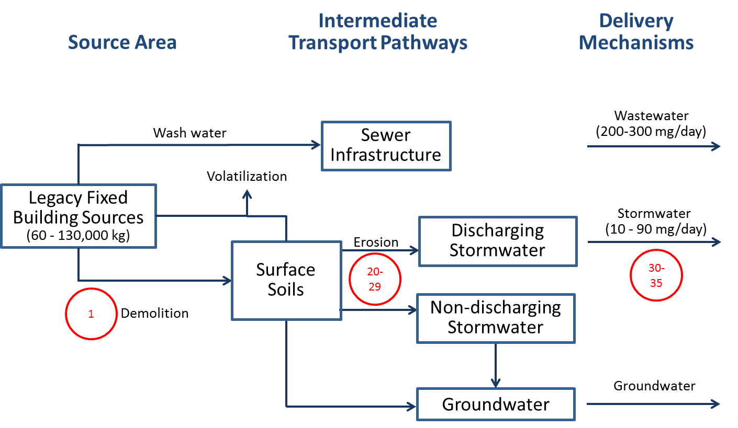
Figure 1.
Control Actions Potentially Applicable for Addressing Legacy Fixed Building Sources
Figure 2 shows the intermediate transport pathways between Legacy Non-Fixed Building Sources and the various delivery mechanisms, and locations where Control Actions with available cost or effectiveness information may apply. Control Actions 5 through 7 can reduce this source area prior to mobilization to any of the intermediate transport pathways, while Control Action 8 prevents this source area from contaminating surface soils. Control Actions 20 through 29 can reduce loads to the stormwater system, while Control Actions 30 through 35 can reduce loads at the end of the stormwater pipe.
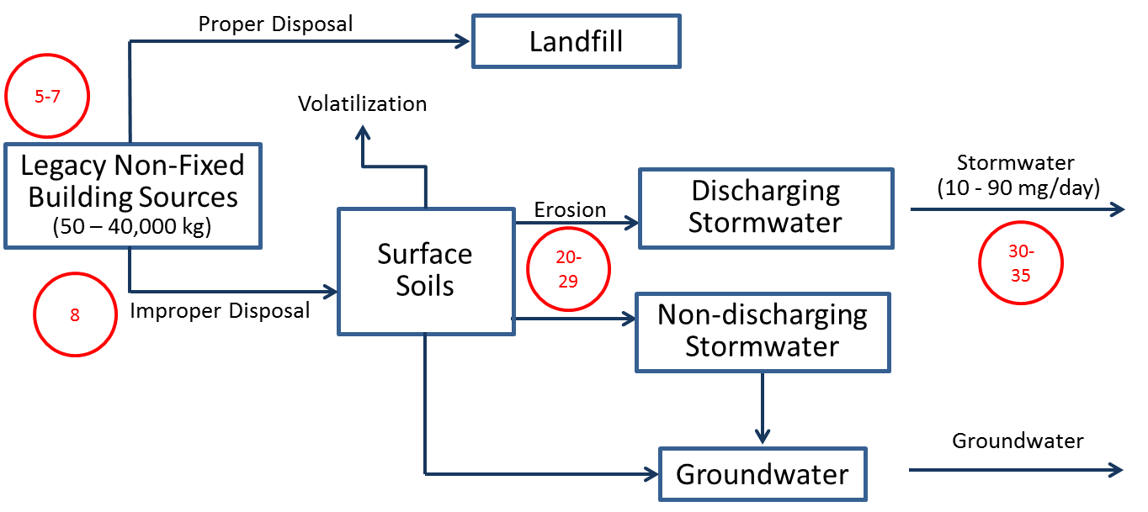
Figure 2.
Control Actions Potentially Applicable for Addressing Legacy Non-Fixed Building Sources
Figure 3 shows the intermediate transport pathways between Legacy Surface Soils and the various delivery mechanisms, and locations where Control Actions with available cost or effectiveness information may apply. Control Actions 20 through 29 can reduce loads to the stormwater system, while Control Actions 30 through 35 can reduce loads at the end of the stormwater pipe.

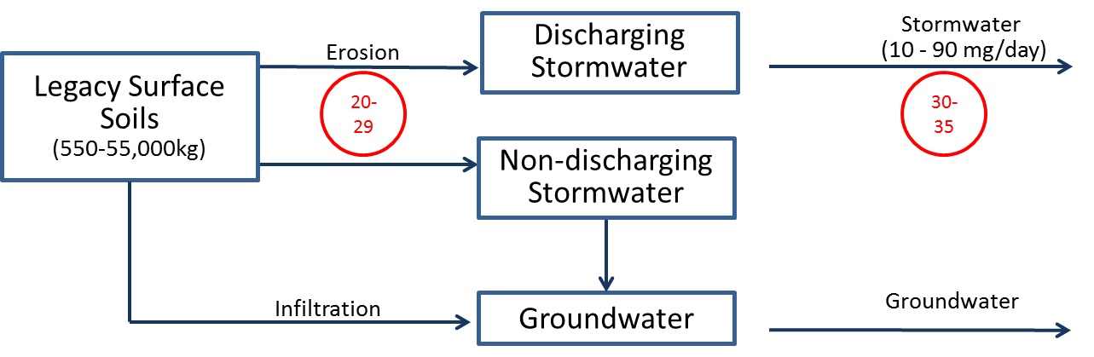
Figure 3.
Control Actions Potentially Applicable for Addressing Legacy Surface Soils
Figure 4 shows the intermediate transport pathway between Legacy Subsurface Soils and delivery to the Spokane River. Additional Control Actions are not currently under consideration for this source area, because Control Actions are being implemented under the jurisdiction of Washington’s Model Toxics Control Act Regulation.
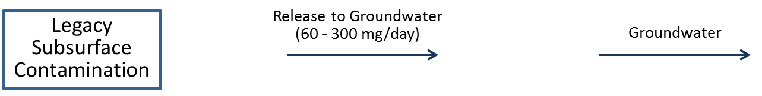
Figure 4.
Absence of Additional Control Actions for Addressing Legacy Subsurface Soils
Figure 5 shows the intermediate transport pathway between Legacy Aquatic Sediments and delivery to the Spokane River and Lake Spokane. While Control Actions relating to dredging and/or capping of contaminated sediments are potentially applicable here, they are not currently under consideration for this source area because Control Actions (along with natural sediment burial in Lake Spokane) have already been applied in sediment areas PCB concentrations were at levels of concern.
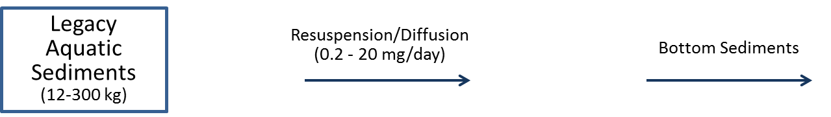
Figure 5.
Absence of Control Actions for Addressing Legacy Aquatic Sediments
Figure 6 shows the intermediate transport pathways between Industrial Equipment and the various delivery mechanisms, and locations where Control Actions with available cost or effectiveness information may apply. Control Actions 4, 14 and 15 can reduce this source area prior to mobilization to any of the intermediate transport pathways, while Control Action 15 prevents this source area from contaminating surface soils. Control Actions 20 through 29 can reduce loads to the stormwater system, while Control Actions 30 through 35 can reduce loads at the end of the stormwater pipe.

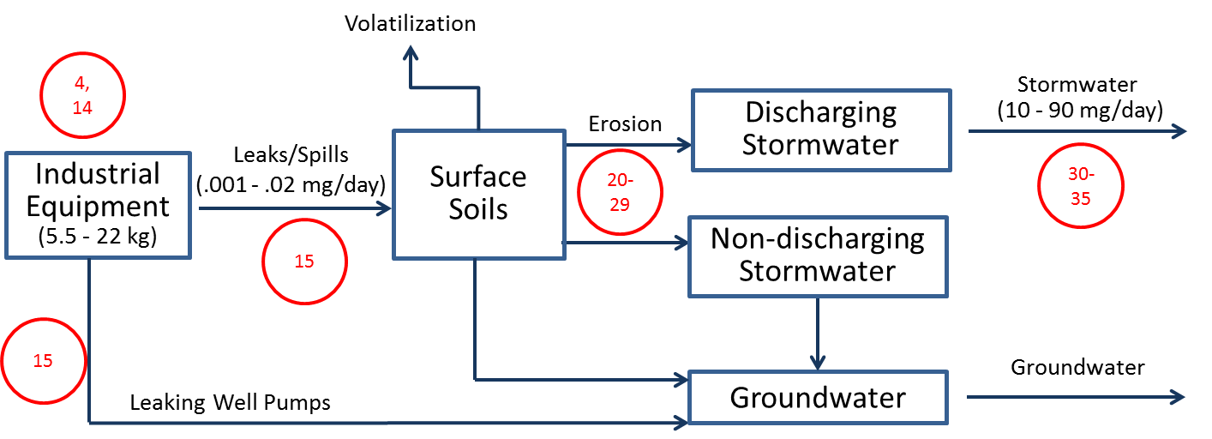
Figure 6.
Control Actions Potentially Applicable for Addressing Industrial Equipment
Figure 7 shows the intermediate transport pathways between Inadvertent Production and the various delivery mechanisms, and locations where Control Actions with available cost or effectiveness information may apply. Control Actions 9 through 13 can reduce this source area prior to mobilization to any of the intermediate transport pathways, while Control Action 2 can reducing loading to sewer infrastructure. Control Actions 16 and 17 reduce loading from this source area to groundwater. Control Actions 20 through 29 can reduce loads to the stormwater system, while Control Actions 30 through 35 can reduce loads at the end of the stormwater pipe.
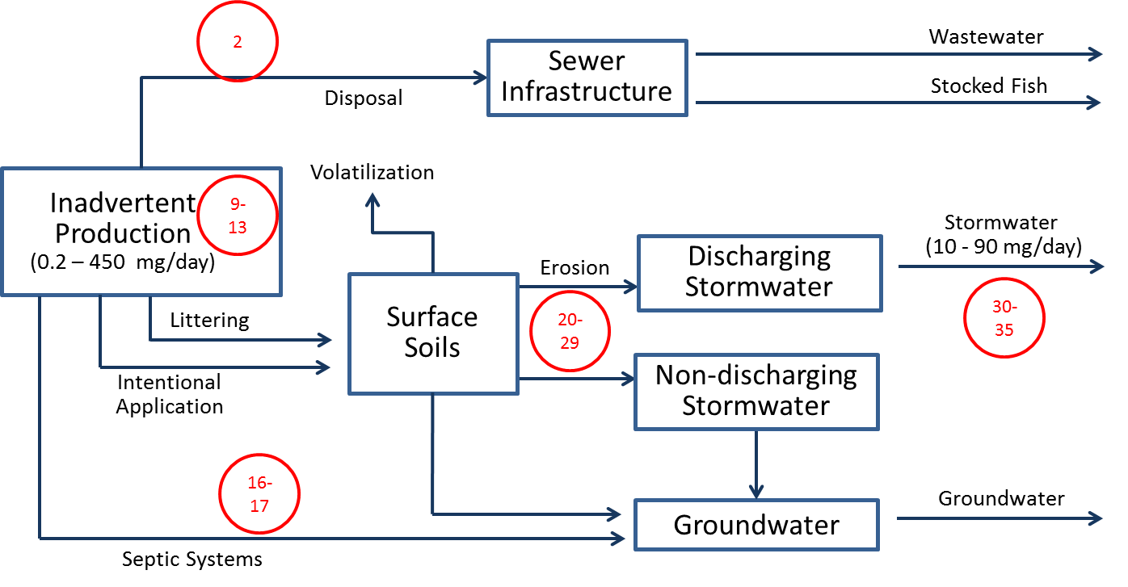
Figure 7.
Control Actions Potentially Applicable for Addressing Inadvertent Sources

Selecting Control Actions for the Comprehensive Plan
The ultimate goal of evaluating a range of Control Actions is to inform the Task Force in the prioritization and selection of specific actions to be included in the Comprehensive Plan. This section:
- Presents an idealized hypothetical example of how Control Actions could be prioritized.
- Discusses site-specific challenges that prevent the idealized case from being applied.
- Describes lessons that could be learned from other watershed-based PCB Control Actions.
- Provides some potential guiding principles to be considered for prioritization.

Idealized Case
In an ideal situation, there would be complete information on the cost and effectiveness of each Control Action, as well as on the magnitude of each source area and delivery pathway. This hypothetical idealized situation is shown in Figure 8, with three source areas of PCBs being considered: fixed sources, legacy contamination of surface soils, and loading of inadvertently produced PCBs from septic tanks. Fixed sources and legacy contamination of surface soils both reach the river via surface runoff to a stormwater system, contributing load to the river at rates of 5 and 10 mg/day, respectively. Inadvertently produced PCBs contributes loading via groundwater at a rate of 1 mg/day.
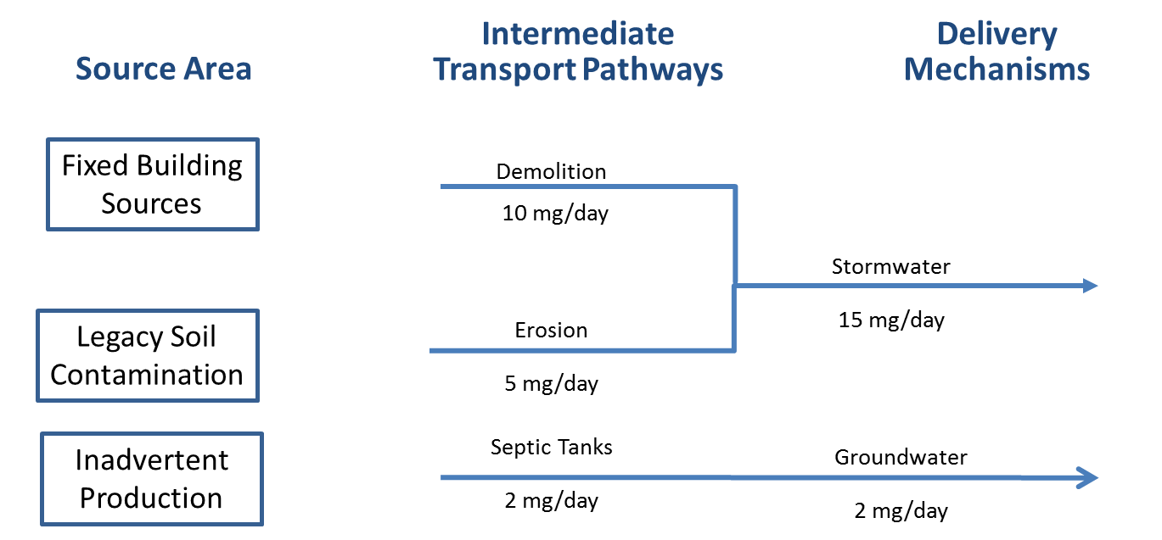
Figure 8.
Source Areas, Transport Pathways, and Delivery Mechanisms for Hypothetical Example
Three hypothetical Control Actions are available, with their costs and efficiencies identified in Table 3 and Figure 9. Demolition controls can reduce the transport of fixed sources to stormwater by 50%, at a cost of $2 million. Erosion controls can reduce the transport of contaminated soil to stormwater by 50%, at a cost of $2 million. Conversion to septic systems to sewers can reduce groundwater loading by 67%, at a cost of $2 million. Finally, end-of-pipe treatment can reduce stormwater loads by 10% at a cost of $6M.
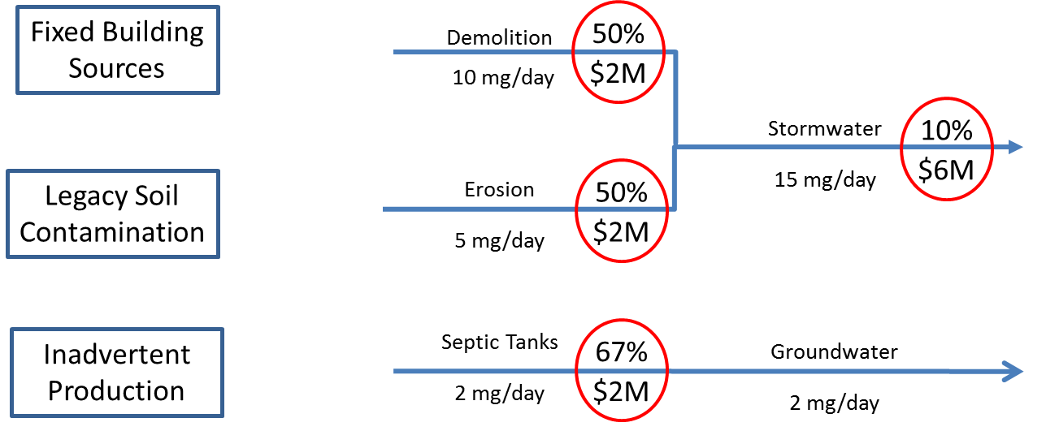
Figure 9.
Cost, Efficiencies and Pathways Affected by Control Actions for Hypothetical Example
Given the above information, it would be possible to calculate the unit cost per reduction of PCB load to the river for each Control Action, i.e. dollars per amount of PCB removed:
Cost Effectiveness ($ per mg/day) = Cost ÷ (Removal Efficiency x Magnitude of Pathway) (1)
Table 3. Costs and Efficiencies of Hypothetical Control Actions for Idealized Example
Control Action | Removal Efficiency | Cost | Magnitude of Pathway (mg/day) | Cost Effectiveness ($ per mg/day)
Demolition Controls | 50% | $2M | 5 | $800,000
Erosion Controls | 50% | $2M | 10 | $500,000
Stormwater Treatment | 10% | $6M | 15 | $4,000,000
Conversion to Sewers | 70% | $2M | 1 | $3,000,000
This type of information could then be used to prioritize selection of actions to include in the comprehensive plan. For this example, erosion controls are the most cost effective Control Action, by combining relatively high removal efficiency to a pathway that transports a relatively large load. Stormwater treatment is the least effective option in this example due to high cost and low removal efficiency, even though operating on a large pathway. Conversion of septics to sewers, on the other hand, is ineffective for this example despite low cost and cost removal efficiency, because it operates on a relatively small pathway.

Challenges
There are several challenges specific to PCBs in Spokane that prevent the idealized case described above from being directly applied for selecting Control Actions:
- Incomplete Information on Costs and Effectiveness: The information presented in Table 2 above indicates that, although available studies provide information on load reduction or cost, they rarely provide information on both load reduction and cost. Some potentially applicable Control Actions identified previously have no information available on costs or effectiveness.
- Uncertain Magnitudes of Transport Pathways: The magnitude of the transport pathways between source areas and delivery mechanisms assessed in (LimnoTech, 2016a, http://srrttf.org/wp-content/uploads/2016/05/SRRTTF_MagnitudeSourcesPathways_2016_0518_draft.pdf) were determined to be either highly uncertain, or unknown.
- Many Control Actions Currently Underway: Many stakeholders are already implementing PCB-related Control Actions.
  - Wastewater treatment plants discharging to the Spokane River are required to develop and install treatment systems to reduce nutrient loading that will concurrently result in reductions of PCB loading. In addition, each wastewater facility has developed a Toxics Management Action Plan that includes a PCB source identification study and control actions.
  - Remediation activities for known contaminated sites in Washington are being managed under the jurisdiction of the Model Toxics Control Act (MTCA).
  - The City of Spokane is actively addressing stormwater and CSO loading of PCBs as part of their Integrated Clean Water Plan.
  - Stormwater in most other communities is being diverted to groundwater as opposed to direct surface discharge to the River. This activity is consistent with many of the Control Actions discussed previously under the category of “Stormwater Treatment--Pipe Entrance.”

Lessons from Other Sites
The challenges discussed above regarding prioritization and selection of PCB control actions are not unique to Spokane. Essentially all other watershed-based PCB control programs have dealt with the issues of incomplete information on costs and effectiveness and uncertain magnitudes of transport pathways. The examples that follow illustrate different approaches to selection and implementation of PCB Control Actions in the face of incomplete information:
- San Francisco Bay TMDL: Urban stormwater controls are being adaptively selected and implemented over 20 years, beginning with permittees selecting and pilot testing their own BMPs to assess effectiveness and technical feasibility. Based on lessons learned during the pilot testing, additional controls will be implemented in strategic locations and will inform development of a plan to that will attain PCB load allocations.
- Delaware River PCB TMDL: The implementation plan adopted a non-numeric approach requiring pollutant minimization plans for point and nonpoint source dischargers to track down and reduce PCBs. Components of the pollutant minimization plans included source identification and reduction, monitoring and reporting, and remediation activities.
- Illinois Lake Michigan Nearshore PCB TMDL: Stormwater MS4 permittees were provided with a menu of BMPs to choose from, with no guidance on expected cost or effectiveness. Near-term permits will be process-based rather than performance based, i.e. permittees must demonstrate that BMPs will be implemented but will not be held to numeric limits.
- Lake Ontario Tributaries PCB TMDL: Affected dischargers are required to implement a PCB monitoring plan, establish an interim limit, and review monitoring data to determine where it would be appropriate to require a PCB minimization plan. NYSDEC’s PCB Minimization Program (PCBMP) states that permittees shall develop, implement and maintain PCBMPs for those outfalls which have been shown through monitoring that concentrations of PCBs in their discharge have a reasonable potential for being reduced. Where it can be shown that the PCBs present in a dischargers effluent is attributable to atmospheric deposition, the discharger will not be responsible to take actions.
These implementation plans are varied, but are based on adaptive management principles that provide flexibility in selecting and implementing controls, typically after additional data has been collected to better inform the decision.

Potential Guiding Principles for Prioritization
While no clear precedent exists for selecting PCB Control Actions (beyond what is currently being conducted in Spokane), some guiding principles may be useful in selecting specific Control Actions for implementation. Highest priority considerations include Control Actions that:
- Affect qualitatively significant pathways: Even though many intermediate transport pathways are uncertain or not quantified, sufficient information exists to allow at least a qualitative understanding of the importance of most pathways. Control Actions that affect larger pathways will be preferred over Control Actions that affect smaller pathways.
- Are qualitatively cost effective: Similar to above, a qualitative understanding likely exists regarding the cost effectiveness of many Control Actions, even in the absence of quantitative case examples. Control Actions that remove PCBs at lower costs will be preferred over Control Actions that remove PCBs at greater costs.
- Have a responsible party capable of implementation: Control Actions must be implemented in order to reduce PCB loads. The presence of a party capable of ensuring that the selected Control Action will be implemented is a necessary condition.
- Are Located Higher in the Pollution Prevention Hierarchy: The Pollution Prevention Act of 1990 explicitly recognized that source reduction is fundamentally different and more desirable than waste management or pollution control. This hierarchy has been refined for PCBs as “Don’t make it > Don’t use it > Use less of it > Manage it properly > Dispose of it properly > Treat it.” Control Action that are located higher in the pollution prevention hierarchy are preferable to ones that are located lower.
Secondary principles that may merit consideration would give higher priority to selecting Control Actions that:
- Leverage or support existing Control Actions: Any new Control Action that creates synergy with a currently planned Control Action would be desirable.
- Provide ancillary benefits: Control Actions that provide benefits beyond PCB load reduction will be preferable to those that address only PCBs.
- Address a pathway not currently covered by existing Control Actions: When qualitatively assessing significant pathways as discussed above, it will be worthwhile to consider the magnitude of that pathway after currently planned Control Actions are limited.
These guideline are presented solely to initiate discussion among Task Force members. It is recognized that it is ultimately up to the discretion of the Task Force regarding which Control Actions to recommend for implementation.

Conclusions
Cost and effectiveness information has been compiled for a wide range of potentially applicable PCB Control Actions. Application of this information to select Control Actions for near-term implementation will not be as straightforward as desired, due to: 1) incomplete information on cost or effectiveness for many Control Actions, and 2) uncertain magnitudes for many transport pathways. Other watershed-based PCB control efforts have taken an adaptive approach to selecting and implementing Control Actions, and provide little precedent for selection of specific Control Actions to implement. Some guiding principles are provided that may prove useful in prioritizing Control Actions, but it is recognized that it is ultimately up to the discretion of the Task Force regarding which Control Actions to recommend for implementation. The primary guiding principles are to give priority consideration to Control Actions that:
- Affect qualitatively significant pathways
- Are qualitatively cost effective
- Have a responsible party capable of implementation.
- Are Located Higher in the Pollution Prevention Hierarchy

References
Bay Area Stormwater Management Agencies Association (BASMAA) 2010. Inspecting Industrial/Commercial Facilities for Pollutants of Concern. Training Presentation provided to participating agencies and submitted as Attachment A7 to BASMAA 2009-10 annual report. http://slideplayer.com/slide/1674264/
City of Spokane (2015). PCBs in Municipal Products. City of Spokane Wastewater Management Department. https://static.spokanecity.org/documents/publicworks/wastewater/pcbs/pcbs - in-municipal-products-report-revised-2015-07-21.pdf
DRBC, 2003.Total Maximum Daily Loads for Polychlorinated Biphenyls (PCBs) for Zones 2 - 5 of the Tidal Delaware River. Delaware River Basin Commission. West Trenton, New Jersey. December 2003
LimnoTech, 2016a. DRAFT: Magnitude of Source Areas and Pathways of PCBs in the Spokane River Watershed. Prepared for Spokane River Regional Toxics Task Force. May 18, 2016.
LimnoTech, 2016b. DRAFT: DRAFT: Inventory of Control Actions to Be Evaluated for the Spokane River. Prepared for Spokane River Regional Toxics Task Force. May 18, 2016.
Marti, P. and M. Maggi. 2015. Assessment of PCBs in Spokane Valley Groundwater. Project Completion Memo. Washington Department of Ecology, Environmental Assessment Program. September 16, 2015.
San Francisco Estuary Institute (SFEI), 2010. A BMP Tool Box for Reducing Polychlorinated Biphenyls (PCBs) and Mercury (Hg) in Municipal Stormwater. San Francisco Estuary Institute, Oakland, CA. http://www.sfei.org/sites/default/files/biblio_files/A_BMP_toolbox FINAL_04-04- 10.pdf
Spokane County, City of Spokane, and City of Spokane Valley 2008. Spokane Regional Stormwater Manual. http://www.spokanecounty.org/data/engineers/srsm_apr08final/SRSM_April2008Final.pdf
USEPA 2015a. Laboratory Study of Polychlorinated Biphenyl (PCB) Contamination in Buildings Evaluation of the Encapsulation Method https://www.epa.gov/sites/production/files/2015-08/documents/pcb_encapsulation_fs.pdf
U.S. Environmental Protection Agency (USEPA) 2015b. Basics of Green Chemistry. https://www.epa.gov/greenchemistry/basics-green-chemistry#definition
Washington Department of Ecology 2004. Stormwater Management Manual for Eastern Washington. Publication No. 04-10-076. https://fortress.wa.gov/ecy/publications/documents/0410076.pdf
Washington Department of Ecology 2015. PCB Chemical Action Plan. Publication 15-07-002. https://fortress.wa.gov/ecy/publications/documents/1507002.pdf

Appendix. Reference Information for Control Actions
No. | Control Action | Location Implemented | Source
1 | Building demolition control actions including worker safety, containing contaminated materials and erosion control | NA | NA
2a | Public Education campaign | NA | Washington Department of Ecology CAP
2b | Public Education campaign | Spokane County | Washington Department of Ecology CAP
3 | Create or expand existing database of PCB-containing products | NA | NA
4 | Identification of PCBs during industrial inspections | San Mateo County, CA | SMCWPP Final 2014, p. D-7
5 | Identify PCB-containing lamp ballasts in schools and other public buildings | NA | Washington Department of Ecology CAP
6 | Investigate alternatives to PCB-containing materials | NA | Washington Department of Ecology CAP
7 | PCB product take-back program | NA | http://www.ecy.wa.gov/programs/swfa/mercurylights/pdf/MercuryPlan.pdf
8 | Survey of PCB-containing materials in public buildings | NA | NA
9 | Review laws regulating waste disposal and illegal dumping | NA | NA
10 | Purchasing standards | Spokane County | email from Rob Lindsay (Spokane County)
11 | Leaf removal | NA | NA
12 | PCB-product labeling law | NA | NA
13 | TSCA and food packaging law reform | NA | NA
14 | Support green chemistry alternatives | NA | NA
15 | Survey of electrical equipment (historical) | NA | Washington Department of Ecology CAP
16 | Leak prevention/detection system ordinance applied to transformers and other PCB-containing equipment | NA | NA
17 | Education about discharge through septic systems in aquifer recharge area | NA | NA
18 | Accelerate sewer construction to replace septic systems; prioritize aquifer recharge areas | NA | NA
19 | Remove carp from Lake Spokane | Lake Spokane | Ecology 2015 study
20 | Expand monitoring | NA | NA
21a | Enhanced Street Sweeping | Seattle, WA | SPU & Herrara 2009 in SMCWPP 2014, p. D-12
21b | Enhanced Street Sweeping | Seattle, WA | SPU & Herrara 2009 in SMCWPP 2014, p. D-12
21c | Enhanced Street Sweeping | Seattle, WA | SPU & Herrara 2009 in SMCWPP 2014, p. D-12
21d | Enhanced Street Sweeping | Seattle, WA | SPU & Herrara 2009 in SMCWPP 2014, p. D-12
22 | Storm Drain Line Cleanout | San Jose, CA | City of San Jose 2011 in SMCWPP 2014, p. D-16
23 | Hydrodynamic structures | Chesapeake Bay Region | King and Hagan 2011 in SMCWPP 2014, p. D-20
24a | Infiltration w/o sand | Chesapeake Bay Region | King and Hagan 2011 in SMCWPP 2014, p. D-20
24b | Infiltration w/ sand/veg | Chesapeake Bay Region | King and Hagan 2011 in SMCWPP 2014, p. D-20
24c | Infiltration trench | Puget Sound, WA | Herrera 2012
24d | Permeable pavement w/o sand, veg | Chesapeake Bay Region | King and Hagan 2011 in SMCWPP 2014, p. D-20
24e | Permeable pavement w/ sand, veg | Chesapeake Bay Region | King and Hagan 2011 in SMCWPP 2014, p. D-20
24f | Porous pavement (infiltration control action) | Puget Sound, WA | Herrera 2012
25a | Filtering (sand, above ground) | Chesapeake Bay Region | King and Hagan 2011 in SMCWPP 2014, p. D-20
25b | Filtering (sand, below ground) | Chesapeake Bay Region | King and Hagan 2011 in SMCWPP 2014, p. D-20
26a | Bioswale | Chesapeake Bay Region | King and Hagan 2011 in SMCWPP 2014, p. D-20
26b | Bioretention (retrofit-highly urban) | Chesapeake Bay Region | King and Hagan 2011 in SMCWPP 2014, p. D-20
26c | Bioretention | Puget Sound, WA | Herrera 2012
26d | Grassed swale (infiltration control action) | Puget Sound, WA | Herrera 2012
26e | Green roof (retention and reuse control action) | Puget Sound, WA | Herrera 2012
26f | Rain barrel (retention and reuse control action) | Puget Sound, WA | Herrera 2012
26g | Vegetative Filter Strip | Puget Sound, WA | Herrera 2012
26h | Lincoln Street SURGE | City of Spokane | http://www.wastormwatercenter.org/files/project/335967ff6178fdf1.pdf
26i | Broadway Ave SURGE | City of Spokane | Marcia Davis, city of Spokane
26j | 99th St GI Project | Clark County, WA | http://www.wastormwatercenter.org/files/project/fe253886311c0ba8.pdf
27 | Wet pond/vault | Puget Sound, WA | Herrera 2012
28 | Filters | NA | NA
29 | Screens | NA | NA
30 | Constructed wetland | Puget Sound, WA | Herrera 2012
31 | Sedimentation basin | NA | NA
32 | Discharge to ground/dry well | NA | NA
33 | Diversion to treatment plant | NA | NA
34 | Mycoremediation | Spokane County | Heidi Montaz, Lands Council
35 | Biochar (incorporated into bioremediation control actions) | City of Spokane | Aimee S. Navickis-Brasch, NB Stormwater Engineers

