**Task Force Releases Comprehensive Plan**

Companies used PCBs for industrial and commercial applications until 1979 when the EPA banned them in commercial manufacture. A 2011 study by the Washington Department of Ecology, found that PCB levels in the Spokane River had significantly dropped since the 1960s as sediments have been capped and sources from transformers and other electrical products removed.

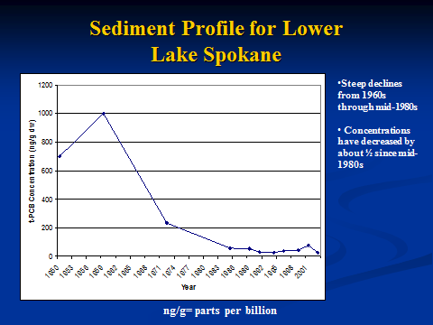

Source: www.spokaneriver.net/conf/presentations-2011/tuesday/Norton2.pptx

*The figure above illustrates the steep declines from the 1960s through the mid-1980s with concentrations decreased by about ½ since the 1980s to 1% or less of previous high levels.*

This comprehensive plan addresses the task of reducing the remaining PCBs in the Spokane River system. The Spokane River is cleaner than at any time in our lifetime, but PCBs are still pervasive and persistent and can exceed water quality standards that, in Washington state, are determined by fish tissue bioaccumulation (which occurs over many years of exposure). PCB’s are also created unintentionally during the production of many commonly manufactured goods, and once PCBs are in the environment, they do not readily break down. PCB’s move up the food chain, eventually reaching humans.

Current efforts to address PCB's center on the Spokane River Regional Toxics Task Force, charged with reducing PCB’s coming from all sources. This recently-released Comprehensive Plan is a roadmap to meet goals that will protect all river users. Formed in 2011, the Task Force has made substantial progress toward identifying and reducing toxics in the Spokane River. Among initial findings as documented herein, currently the Spokane River water column has very low PCB concentrations—many at or below detection limits in recent testing. Nonetheless, fish tissue concentrations, bio-accumulated over years of exposure, continue to exceed DOE and Spokane Tribal standards.

Water reclamation treatment plant upgrades already underway and/or planned will remove most of the PCBs that continue to find their way into our community wastewater systems. The major source remaining, storm water runoff, is also being targeted by improvements (also planned and/or underway) to reduce run off volume and pollutants, including PCBs, that storm water otherwise delivers into the river.

*As background, Polychlorinated Biphenyls (PCBs) are toxic, man-made chemicals that can severely damage both environmental and human health. According to the U.S. Department of Health and Human services, individuals who are continually exposed to PCBs are at increased risk of developing cancer and experiencing toxic effects on bodily systems. Portions of the Spokane River exceed Washington State’s human health water quality criteria for PCBs in edible fish tissue. The PCB levels in the Spokane River are particularly concerning because Spokane residents and the Spokane Tribe of Indians use this river daily for recreation and fishing purposes.*

*The Spokane River Regional Toxics Task Force meets the fourth Wednesday of every month, with meetings open to the public. Meeting details and other information online a*