Spokane River Regional Toxics Task Force
2016 Monthly Monitoring Report
Prepared for:
Spokane River Regional Toxics Task Force

May 4, 2017
DRAFT

Blank Page

Spokane River Regional Toxics Task Force
2016 Monthly Monitoring Report

Prepared for:
Spokane River Regional Toxics Task Force
May 4, 2017
DRAFT

Blank page

Table of Contents
EXECUTIVE SUMMARY 1
1 INTRODUCTION 3
2 Sampling Activities 5
2.1 Monitoring Locations 5
2.2 Monitoring Dates 5
2.3 Field Sampling Activities 7
2.4 Quality Assurance 7
2.4.1 Data Quality Assessment 7
2.4.2 Blank Correction 8
2.5 Non-Task Force sampling activities 8
2.5.1 March 2016 Stormwater Loading Assessment by City of Spokane 9
2.5.2 March and October Spokane River Sampling by Idaho Municipalities 9
3 Results 10
3.1 Total PCBs 10
3.2 Homolog Distributions 11
4 Data Interpretation 15
4.1 Seasonal variability 15
4.1.1 Total PCBs 15
4.1.2 Homolog Distributions 16
4.2 Loading contributions 16
4.2.1 Total PCBs 16
4.2.2 Homologs 20
5 REFERENCES 21
Appendix A: Synoptic Survey Results PCBs by Homolog and Conventional Parameters 1
Appendix B: Gravity Report 1
Appendix C: Quality Assurance Project Plan 1
Appendix D: Laboratory Results 1

List of Figures
Figure 1. Sampling Locations for 2016 Monthly Sampling 6
Figure 2. Spokane River Total PCB Concentrations Measured during 2016 Monthly Surveys (Measurements for Idaho Municipalities Shown as Hatched) 10
Figure 3. Blank-Corrected Homolog Concentrations for March, 2016 Sampling Event 11
Figure 4. Blank-Corrected Homolog Concentrations for April, 2016 Sampling Event 12
Figure 5. Blank-Corrected Homolog Concentrations for May, 2016 Sampling Event 12
Figure 6. Blank-Corrected Homolog Concentrations for June, 2016 Sampling Event 12
Figure 7. Blank-Corrected River Homolog Concentrations for October, 2016 Sampling Event 13
Figure 8. Blank-Corrected External Source Homolog Concentrations for October, 2016 Sampling Event 13
Figure 9. Blank-Corrected Homolog Concentrations for December, 2016 Sampling Event 13
Figure 10. Average Total PCB Concentrations in Washington at Different River Flows 16
Figure 11. Blank-Corrected Homolog Loads for March, 2016 Sampling Event 17
Figure 12. Blank-Corrected Homolog Loads for April, 2016 Sampling Event 17
Figure 13. Blank-Corrected Homolog Loads for May, 2016 Sampling Event 18
Figure 14. Blank-Corrected Homolog Loads for June, 2016 Sampling Event 18
Figure 15. Blank-Corrected Homolog Loads for October, 2016 Sampling Event 19
Figure 16. Blank-Corrected Homolog Loads for December, 2016 Sampling Event 19
Figure 17. Homolog Distributions for Hangman Creek and Stormwater for October, 2016 Sampling Event, Compared to Distributions for Most Commonly Produced Aroclors. 20

List of Tables
Table 1. Spokane River Total PCB Concentrations Measured during Monthly Surveys (Duplicate Samples in Parentheses) 11
Table 2. Spokane River and Latah Creek Flows (cfs) Observed during 2016 Monthly Monitoring 16

Blank page

EXECUTIVE SUMMARY
The Spokane River and Lake Spokane have been placed on the State of Washington’s 303(d) list of impaired waters because of concentrations of polychlorinated biphenyls (PCBs) that exceed water quality standards. To address these impairments, the Department of Ecology (Ecology) is pursuing a toxics reduction strategy that included the establishment of a Spokane River Regional Toxics Task Force (Task Force) to identify and reduce PCBs at their source in the watershed.
The Work Plan developed by the Task Force (SRRTTF, 2012) included collection of additional data and analysis of data to characterize and quantify PCB sources. Prior Task Force technical activities focused on carrying out synoptic surveys to assess the presence of unmonitored dry weather sources of PCBs to the Spokane River during summer low flow conditions. The Task Force subsequently desired an understanding of the seasonal variability in PCB concentrations in the river, and sponsored the study described in this report. River sampling was conducted at five Spokane River locations and at the mouth of Latah Creek in each of the months of March, April, May, June, October, and December of 2016. Survey activities were conducted in accordance with the Quality Assurance Project Plan (LimnoTech, 2016) developed for this phase of the project.
The following conclusions can be gathered from the data collected:
- River PCB concentrations remain less than 40 pg/l during all months at the outlet of Lake Coeur d’Alene, with minor exceptions.
- PCB concentrations tend to increase downstream as the river passes through the Spokane metropolitan area, with the amount of increase varying seasonally in response to river flow.
- October river concentrations near Spokane were slightly higher than in other months, in conjunction with wet weather conditions. Data collected by the City of Spokane during this event suggest that the City’s stormwater is a relatively small contributor to these increased concentrations, while historical combined sewer overflow (CSO) data suggest that CSO loads are of a magnitude consistent with the observed increase in concentration.
- An observed high PCB concentration at the mouth of Hangman (Latah) Creek during wet weather indicates the potential presence of a PCB loading source to this watershed. While this load is sufficient to cause high concentration in the Creek, its effect on the Spokane River was small due to the small amount flow in the Creek at the time the sample was taken.
Blank page

INTRODUCTION
The Spokane River and Lake Spokane have been placed on the State of Washington’s 303(d) list of impaired waters because of concentrations of polychlorinated biphenyls (PCBs) that exceed water quality standards. To address these impairments, the Department of Ecology (Ecology) is pursuing a toxics reduction strategy that included the establishment of a Spokane River Regional Toxics Task Force (Task Force) to identify and reduce PCBs at their source in the watershed. To address these impairments, the Department of Ecology (Ecology) is pursuing a toxics reduction strategy that included the establishment of a Spokane River Regional Toxics Task Force (Task Force) to identify and reduce PCBs at their source in the watershed. The stated objective of the Task Force is “to work collaboratively to characterize the sources of toxics in the Spokane River and identify and implement appropriate actions needed to make measurable progress towards meeting applicable water quality standards.” The Work Plan developed by the Task Force (SRRTTF, 2012) identified four phases of work:
- Phase 1: Review of existing data and reports, and development of a data gaps assessment with recommendations for additional sampling
- Phase 2: Collection of additional data
- Phase 3: Analysis of data to characterize and quantify PCB sources
- Phase 4: Assessment of potential control actions and development of a Comprehensive Plan
The majority of Phase 1 activities were completed in 2013, and are documented separately in LimnoTech (2013a, 2013b, 2013c, and 2013d). Phase 2 technical activities originally focused on assessing the presence of unmonitored dry weather sources of PCBs to the Spokane River during summer low flow conditions. Synoptic surveys were conducted in this regard in August, 2014 and August, 2015. The Task Force subsequently desired an understanding of the seasonal variability in PCB concentrations in the river, and sponsored the study described in this report. River sampling was conducted at five Spokane River locations and the mouth of Latah Creek in each of the months of March, April, May, June, October, and December of 2016. Survey activities were conducted in accordance with the Quality Assurance Project Plan (LimnoTech, 2016) developed for this phase of the project and included as an Appendix to this report.
This report documents the results of the above monitoring program and subsequent analyses. It is divided into sections of:
- Sampling activities
- Analytical results
- Data interpretation

Blank Page

Sampling Activities
The field monitoring program consisted of six one-day sampling events at five Spokane River locations and the mouth of Hangman (Latah) Creek. In addition, individual Task Force members collected additional PCB data under separate monitoring efforts that provide date useful for this assessment. Sampling activities are described below, divided into sections corresponding to:
- Monitoring locations
- Monitoring dates
- Field sampling activities
- Non-SRRTTF sampling activities

Monitoring Locations
Sampling locations (Figure 1) included five Spokane River stations, as well as at the mouth of Hangman (Latah) Creek. The stations were at the following locations (with latitudes and longitudes specified):
- Lake Coeur d'Alene Outlet (-116.7989162, 47.6816274)
- Spokane River below Trent Ave. Bridge near Plante’s Ferry (-117.2418, 47.69708)
- Spokane River below Greene St. Bridge (-117.3628, 47.67808)
- Spokane River at Spokane USGS Gage (-117.4497, 47.65888)
- Spokane River Gage Station below Ninemile Dam (-117.5397324, 47.21437906)
- Latah (Hangman) Creek Gage Station (-117.44986, 47.6528668)

Monitoring Dates
A total of six monitoring events were conducted, on the following dates:
- March 24, 2016
- April 19, 2016
- May 24, 2016
- June 16, 2016
- October 26, 2016
- December 13, 2016

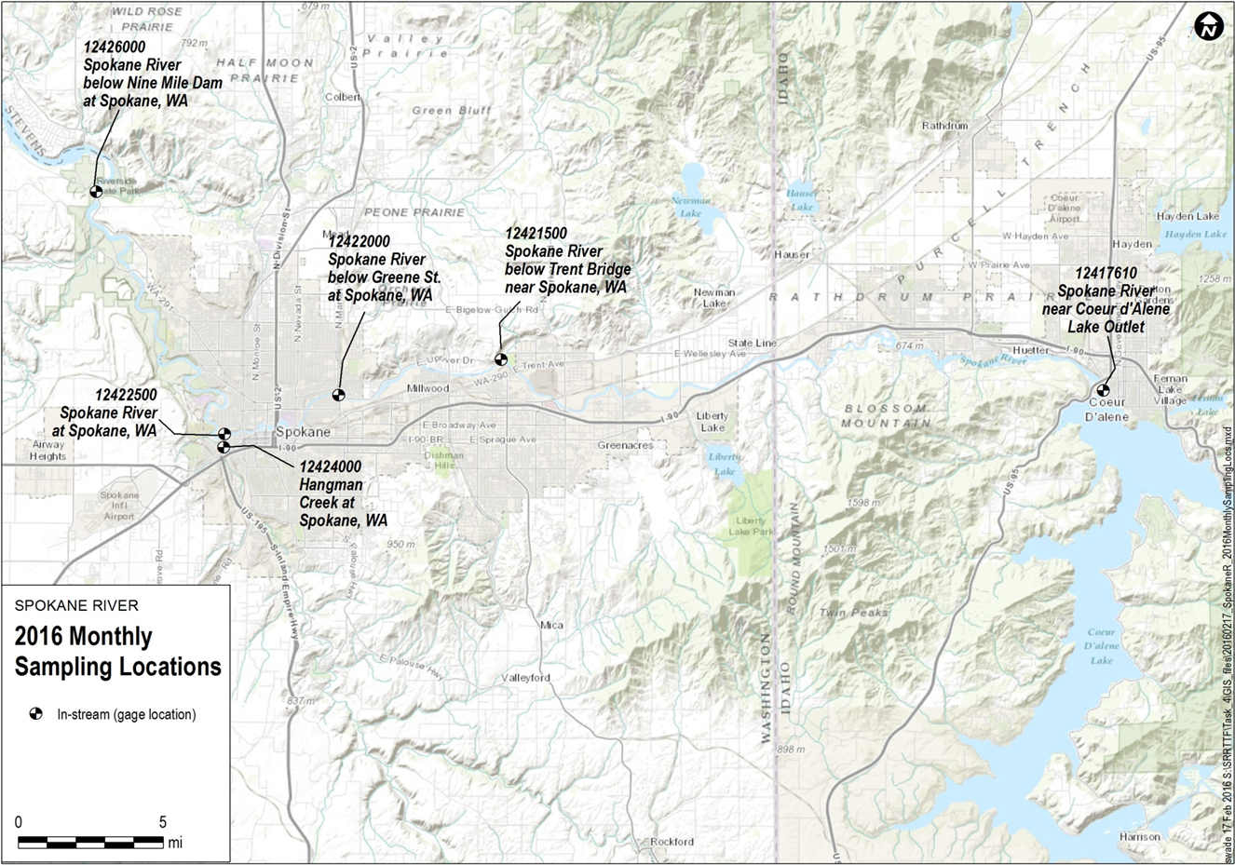
Figure 1. Sampling Locations for 2016 Monthly Sampling

Field Sampling Activities
The field sampling activities as planned and implemented are detailed in the project QAPP (LimnoTech, 2016), and Gravity (2017) field report, both of which are included as appendices to this report. This section summarizes those activities. Environmental specialists from Gravity Consulting conducted the sampling events. Grab samples were collected by hand using “clean hands” and “dirty hands” methodology combined with direct immersion techniques at the prescribed locations. These methods reduce the likelihood of any cross-contamination from direct (e.g., handling dirty equipment) or indirect (e.g., dust or air transport) sources.

Quality Assurance
Field samples were shipped to AXYS Analytical Laboratories, Ltd. in Sidney, British Columbia, for analysis of PCB concentrations. PCB concentrations for individual congeners were blank-corrected following the process defined in the QAPP (LimnoTech, 2016). A separate set of samples were taken to SVL Analytical, Inc. in Coeur d’Alene, ID for analysis of total dissolved solids, total suspended solids, total organic carbon, dissolved organic carbon.

Data Quality Assessment
All data were reviewed for quality assurance in accordance with the project QAPP and as noted in the laboratory EDD-Excel files provided in the appendix. Data quality indicators evaluated for PCBs included the following:
- Daily Calibration Verification
- Lab Control Sample Recovery
- Sample and Method Blank Surrogate Recovery
- Matrix Spike Sample Recovery
- Duplicate sample relative percent differences (RPDs)
- Method blank concentrations
- Completeness
All reviewed quality control (QC) results for PCBs comply with QAPP data quality indicators, with the following exceptions:
- One surrogate recovery result was low for 3 samples. The out of control surrogate results are below the associated criteria range (25%-125%) for percent recovery specified in the QAPP. Sample results associated with the low surrogate recoveries are qualified as estimated using J/UJ data flags for positive/negative result values.
- Three duplicate sample pairs had a high relative percent difference (RPD) for individual congeners or congener groups (two pairs for congener PCB-001; one pair for congener groups PCB-044/047/065, PCB-045/051, and PCB-068.) The duplicate pair RPD results are above the QAPP-specified criteria (0-50% for congeners >10 times the detection limit). Duplicate pair results associated with the high RPDs are qualified as estimated using the J data flag.
- A number of December field samples were not reviewed because of unacceptably high PCB contamination in the laboratory method blank samples. The original laboratory analysis of all December samples was rejected due to laboratory blank contamination, and new analyses were conducted using archive samples from the December event. The archive samples were split among two separate laboratory batches, and one of those batches also was subject to unacceptably high method blank contamination. As a result, no December 2016 data are available for the Lake Coeur d’Alene outlet station or for the duplicate sample for the Spokane River at the Spokane USGS gage. These were the only two samples for the year that were lost, such that the QAPP completeness criterion of obtaining validated results for 95% of all samples was satisfied.
There are no changes to PCB result values as a result of this assessment, although data qualifiers were added to select samples subject to low surrogate recovery and high relative percent difference as described above.
Data quality indicators evaluated for conventional parameters included the following:
- Bias (laboratory control samples, matrix spikes, and blanks)
- Precision (RPD of matrix spikes and replicate samples)
- Completeness
All reviewed QC results for conventional parameters complied with QAPP data quality indicators.

Blank Correction
Total PCB concentrations were corrected for method blank contamination following the procedures defined in the QAPP. Specifically, individual congeners found in the sample at a concentration less than three times the associated blank concentration were flagged, and excluded from calculation of total PCB. It should be noted that there is no standard blank correction method, and numerous approaches are utilized, both nationally and within the Spokane River Basin. The selection of the most appropriate blank correction methodology must consider factors such as study objectives, sample matrix, sampling methodology, expected range of results, and tolerance for biased results.
No blank corrections were conducted on conventional parameters, as all blank samples for all conventional parameters were below the relevant detection limit.

Non-Task Force sampling activities
Two other monitoring activities occurred during 2016 which, although not directly sponsored by the Task Force, were conducted by individual Task Force members and provide valuable information towards the goals of this assessment:
- March 2016 Stormwater Loading Assessment by City of Spokane
- March and October Spokane River sampling by Idaho municipalities
Each are described below.

March 2016 Stormwater Loading Assessment by City of Spokane
In concurrence with the SRRTTF October river sampling, the City of Spokane measured the PCB concentration representing discharge from their Cochran stormwater basin. An automatic sampler began taking samples at 03:03 on October 26 and finished at 15:04 on the same day. Discharge flow was also monitored, providing for an estimate of stormwater PCB loading during the monitoring event. Discharge flow was also measured for combined sewer overflows (CSOs), although no CSO concentration measurements were made.

March and October Spokane River Sampling by Idaho Municipalities
As part of their NPDES permit requirements, the Idaho municipalities discharging to the Spokane River (i.e. Coeur d’Alene, Post Falls, and Hayden) conduct in-river monitoring of PCB concentrations twice per year. In 2016, this monitoring occurred on May 25 and October 27, each within one day of the SRRTTF monitoring dates. Samples were taken by Gravity Consulting at the following locations:
- Lake Coeur d’Alene outlet (-116.801974, 47.677349)
- Downstream of Coeur d’Alene (-116.820113, 47.696459)
- Downstream of Hayden/Upstream of Post Falls (-116.94737, 47.70338)
- Downstream of Post Falls (-117.037256, 47.694016)

Results
This section presents the results of the 2016 monitoring, in terms of concentrations of total PCBs and individual homologs. Furthermore, a detailed listing of PCB concentrations and conventional parameters for each date at each sampling location is provided in Appendix A, and full laboratory data sheets are provided in Appendix D.

Total PCBs
Total PCB concentrations across all months sampled are shown below for the Spokane River stations in Figure 2 and for all stations in Table 1. PCB concentrations are generally less than 40 pg/l leaving Lake Coeur d’Alene and throughout the Idaho sampling locations, and increase as the river passes through the Spokane metropolitan area. Additional interpretation of these data are provided subsequently in Section 4 of this report.
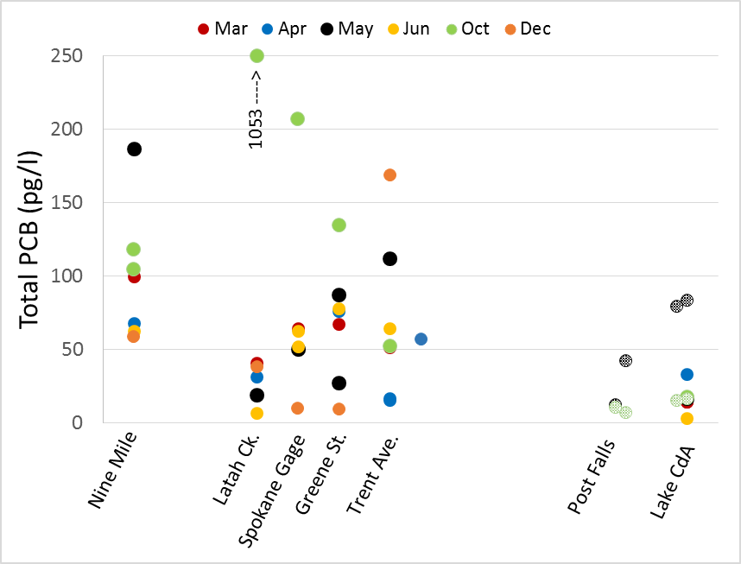
Figure 2. Spokane River Total PCB Concentrations Measured during 2016 Monthly Surveys (Measurements for Idaho Municipalities Shown as Hatched)

Table 1. Spokane River Total PCB Concentrations Measured during Monthly Surveys (Duplicate Samples in Parentheses)
 | March | April | May | June | October | December
Nine Mile | 100 | 68 | 187 | 62 | 105 (118) | 59
Hangman (Latah) Creek | 41 | 31 | 19 | 7 | 1053 | 38
Spokane Gage | 64 |  | 50 | 63 (52) | 207 | 10
Greene St. | 67 | 76 | 87 (27) | 78 | 135 | 9
Trent Ave. | 51 | 16 (17)* | 112 | 6 | 52 | 169
Lk. Coeur d’Alene | 14 (14) | 33 | 17 | 3 | 18
Idaho Sampling
Lk. Coeur d’Alene |  |  | 84 |  | 16
Downstream of Coeur d’Alene |  |  | 79 |  | 15
Upstream of Post Falls |  |  | 4 |  | 7
Downstream of Post Falls |  |  | 12 |  | 10
Cochran Basin Stormwater |  |  |  |  | 5198 (5744)
*April samples for Trent Avenue station collected at Barker Rd.

Homolog Distributions
Homolog distributions for all sampling events are shown in Figures 3 through 9, with the data provided in tabular format in Appendix A. Interpretation of these data are provided subsequently in Section 4 of this report.
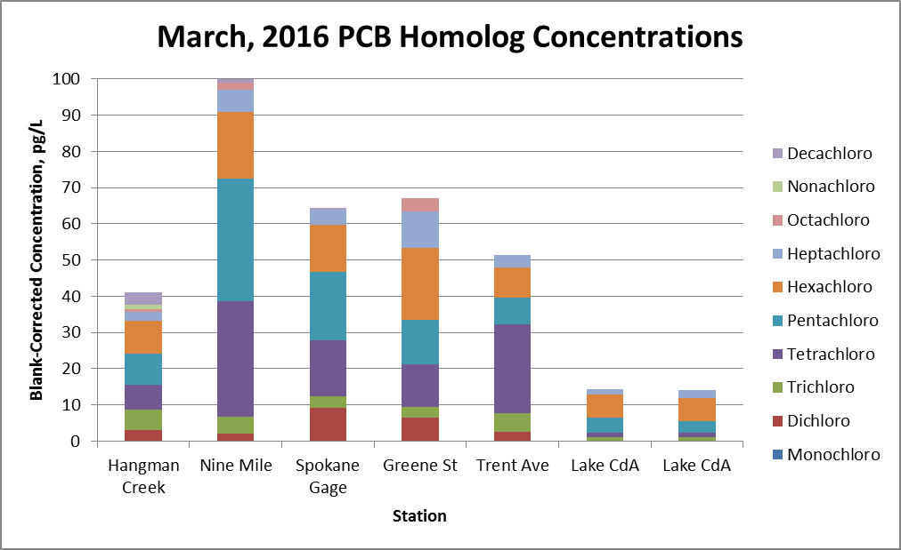
Figure 3. Blank-Corrected Homolog Concentrations for March, 2016 Sampling Event
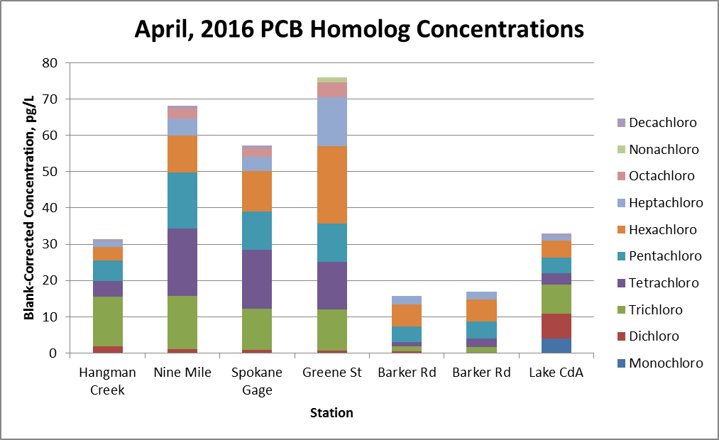
Figure 4. Blank-Corrected Homolog Concentrations for April, 2016 Sampling Event
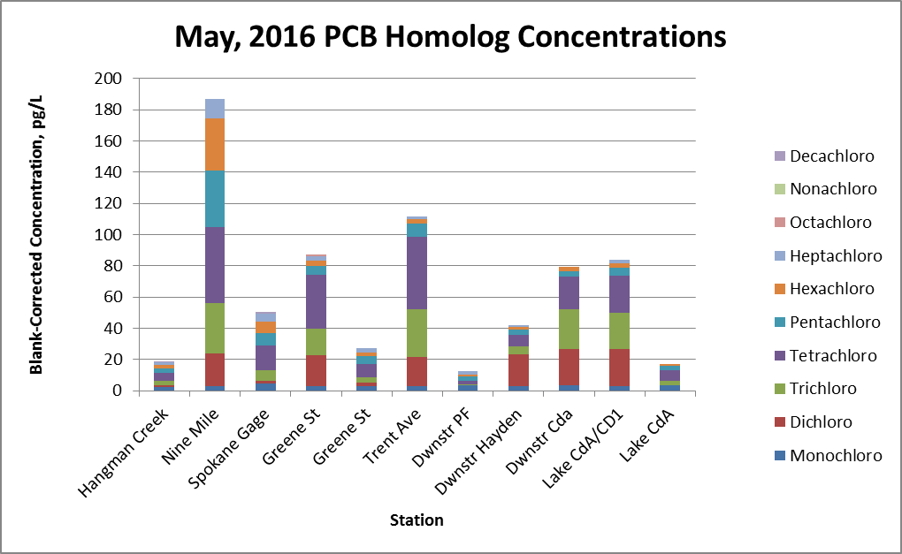
Figure 5. Blank-Corrected Homolog Concentrations for May, 2016 Sampling Event
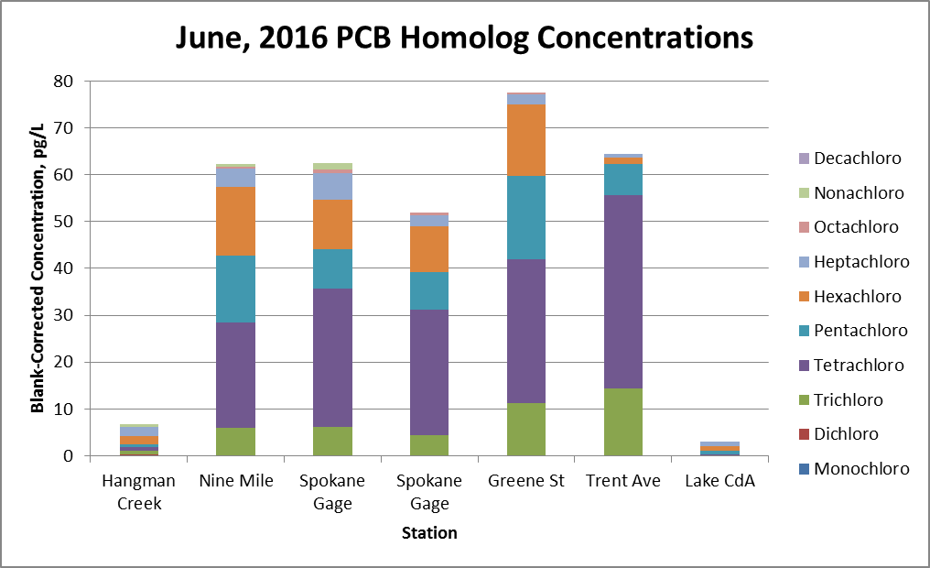
Figure 6. Blank-Corrected Homolog Concentrations for June, 2016 Sampling Event
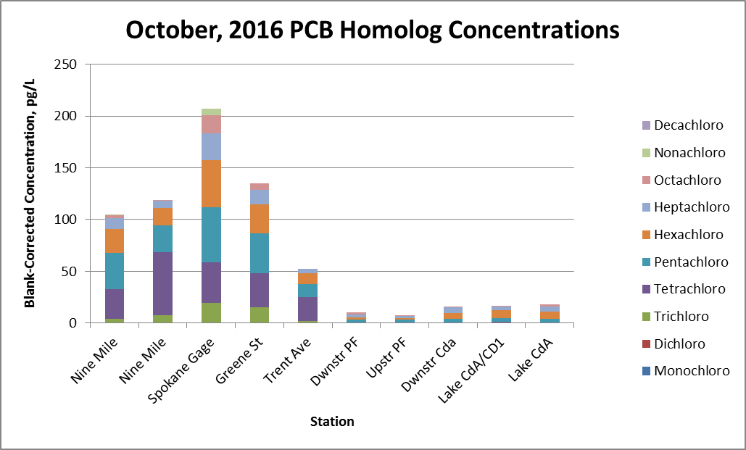
Figure 7. Blank-Corrected River Homolog Concentrations for October, 2016 Sampling Event
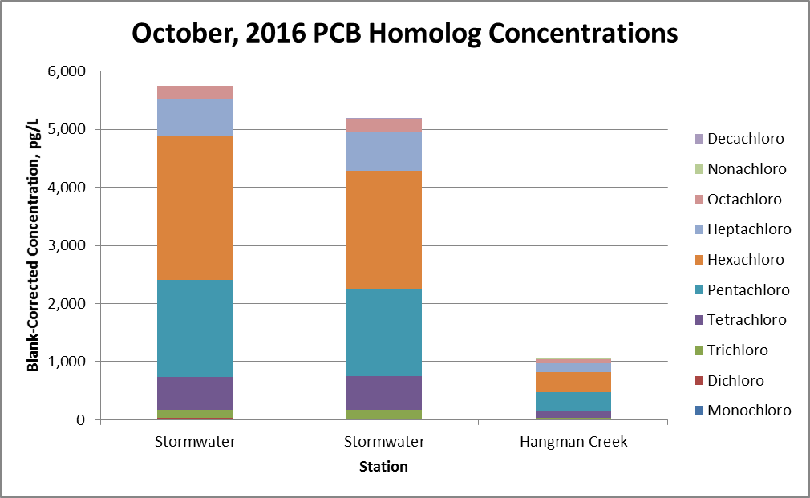
Figure 8. Blank-Corrected External Source Homolog Concentrations for October, 2016 Sampling Event
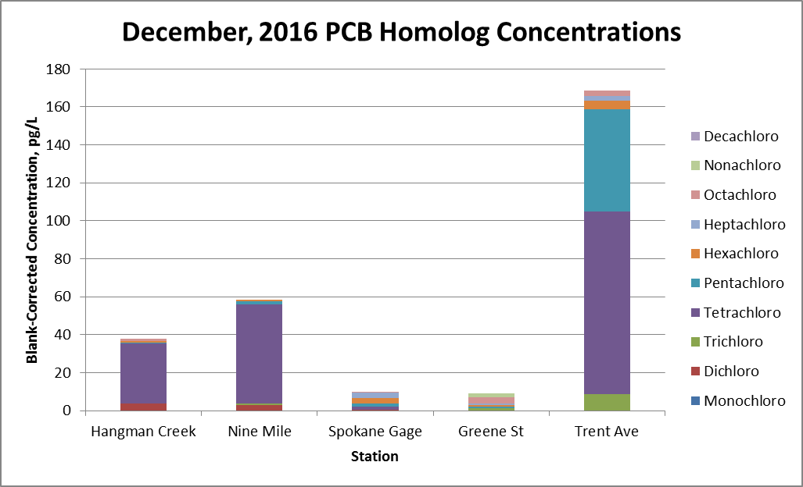
Figure 9. Blank-Corrected Homolog Concentrations for December, 2016 Sampling Event
Blank Page

Data Interpretation
The objective of the monthly water quality sampling, as stated in the Quality Assurance Project Plan (LimnoTech, 2016), is to determine the seasonal variability in PCB concentrations in the Spokane River. The concentrations are also reviewed in conjunction with available data on river flow to support a semi-quantitative assessment of PCB loading along the length of the River. This section provides an interpretation of the PCB results provided in Section 3 in term of:
- Seasonal variability
- Loading contributions

Seasonal variability
The seasonal variability of PCB concentrations are assessed, as well as the relationship of observed concentrations to river flow and wet weather conditions. The seasonal variation in homolog distributions is also discussed.

Total PCBs
In terms of total PCBs, concentrations leaving Lake Coeur d’Alene generally remained below 40 pg/l across all months. The only exception occurred during the monitoring conducted in May for the Idaho municipalities, where concentrations leaving the lake and immediately downstream of Coeur d’Alene were measured at 79 and 84 pg/l, respectively. These two concentrations may not be fully representative, as three other measured concentrations from similar times and locations (two locations from the same date taken downstream during the Idaho monitoring, and a sample from the same location taken one day earlier from the SRRTTF sampling) were all less than 20 pg/l.
Total PCB concentrations vary slightly across seasons, and show a weak negative correlation (Figure 10) to observed river flows (Table 2). This negative correlation is not unexpected, as the river receives many continuous PCB loads, such that higher river flow means more dilution by cleaner upstream water. It is noted that October had the highest observed average PCB concentration, and that October sampling occurred during a period of rainfall. In addition, the PCB concentration in Latah (Hangman) Creek of 1053 pg/l was more than an order of magnitude greater than any other concentration measured at that site during the remaining months. The Latah (Hangman) Creek concentrations show an interesting response to rainfall and flow. The March survey reflected antecedent wet weather conditions in the watershed, with 0.7 inches of rainfall occurring two days prior to the date of sampling. Creek flows were at 1680 cfs for this event, which was roughly an order of magnitude larger than the flows during other sampling events, yet PCB concentrations were only 41 pg/l. In October, where a total of 0.6 inches of rain fell in the day prior and during the event, Creek concentrations were 1053 pg/l, yet Creek flows were only 58 cfs.
The significance of wet weather loading is discussed further in Section 4.2.
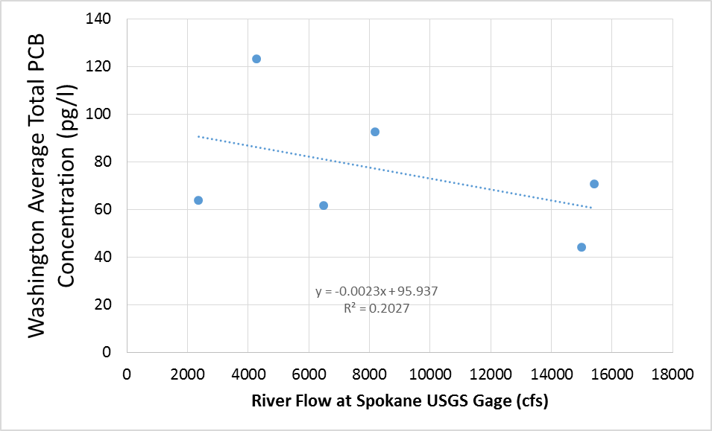
Figure 10. Average Total PCB Concentrations in Washington at Different River Flows

Table 2. Spokane River and Latah Creek Flows (cfs) Observed during 2016 Monthly Monitoring
 | 3/24 | 4/19 | 5/24 | 6/16 | 10/26 | 12/13
Spokane USGS Gage | 15400 | 15000 | 8180 | 2360 | 4280 | 6480
Latah Creek | 1680 | 178 | 91 | 21 | 58 | NA

Homolog Distributions
Some seasonal variability in homolog distributions were observed (shown previously in Figures 3 through 9). March PCB concentrations are dominated by the tetra- through hexa-chloro homologs, while April also shows an equal amount of tri-chloro homologs starting at Greene St. May distributions are dominated by tri- and tetra- chloro homologs, while the tetra-chloro homolog dominates in June. October concentrations are mostly comprised of tetra- through hexa-chloro homologs, while December is dominated by the tetra-chloro homolog at three of the five stations sampled. The near absence of the tetra-chloro homolog at the Greene St. and Spokane Gage stations in December, given its preponderance at Trent Ave. and Nine Mile Dam, calls into question the overall representativeness of the December data.

Loading contributions

Total PCBs
The observed PCB concentrations were combined with available USGS stream flow information to generate instream total PCB loads for each month sampled, shown in Figures 11 through 16 below. It should be noted that inference of external loading sources using these observed river loads (as was done for the 2014 and 2015 synoptic surveys) is speculative at best. An accurate mass balance assessment, which estimates loading sources to a river segment as the difference between observed river loads at the downstream and upstream ends of the segment, requires relatively stable flows and concentrations. These requirements were met during the prior synoptic surveys by conducting the assessment during stable low flows and collecting multiple PCB samples over several days to reduce sample-to-sample variability. Given the observed variability in stream flow during the monthly surveys, and collection of a single sample per station, results from any mass balance assessment should be viewed with caution.
Total PCB loads for March (Figure 11) were 500 mg/day leaving Lake Coeur d’Alene, increasing to 2,500 mg/day at the Spokane Gage, and further increasing to 4,000 mg/day at Nine Mile Dam. Hangman Creek was a minor contributor to the overall load, despite Creek flows during this event being an order of magnitude larger than the flows in the Creek for any other event.
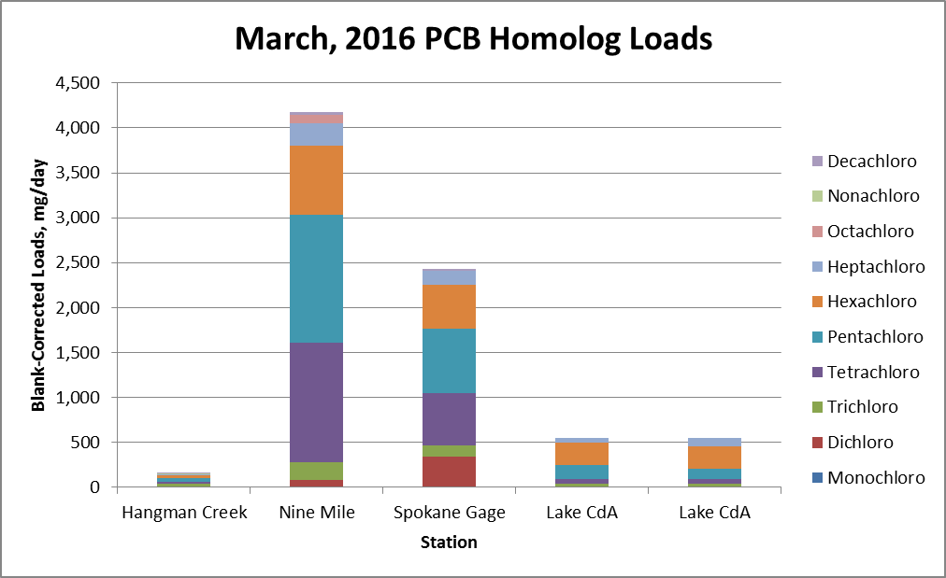
Figure 11. Blank-Corrected Homolog Loads for March, 2016 Sampling Event
Total PCB loads for April (Figure 12) were 1200 mg/day leaving Lake Coeur d’Alene, increasing to 2,100 mg/day at the Spokane Gage, and further increasing to 2,500 mg/day at Nine Mile Dam. Hangman Creek was again a minor contributor to the overall load.
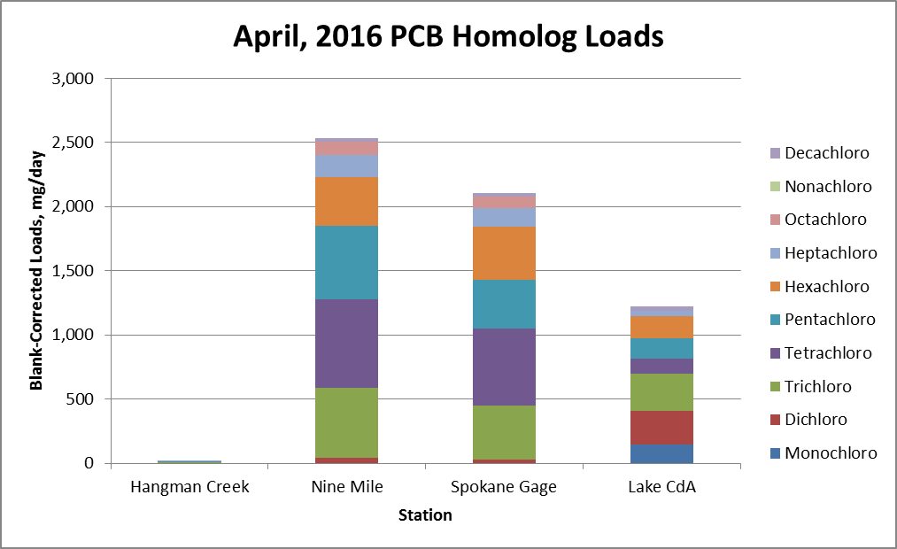
Figure 12. Blank-Corrected Homolog Loads for April, 2016 Sampling Event
Total PCB loads for May (Figure 13) were 400 mg/day leaving Lake Coeur d’Alene, increasing to 1,000 mg/day at the Spokane Gage, and further increasing to 3,700 mg/day at Nine Mile Dam. The Lake Coeur d’Alene load is much less than in prior months, due to a lesser volume of flow leaving the lake. The large load at Nine Mile Dam was due to a measured PCB concentration of 187 pg/l, and it is noted that a single sample may not adequately characterize actual concentrations. Hangman Creek was again a minor contributor to the overall load.
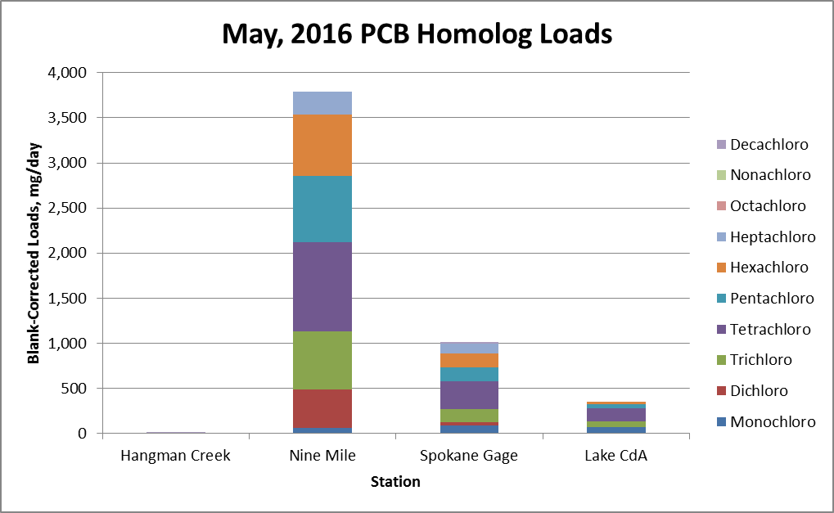
Figure 13. Blank-Corrected Homolog Loads for May, 2016 Sampling Event
Total PCB loads for June (Figure 14) were 20 mg/day leaving Lake Coeur d’Alene, increasing to 300 to 350 mg/day at the Spokane Gage, and 350 mg/day at Nine Mile Dam. The load leaving Lake Coeur d’Alene continues its seasonal decline, in response to a continued decrease in the volume of water leaving the lake.
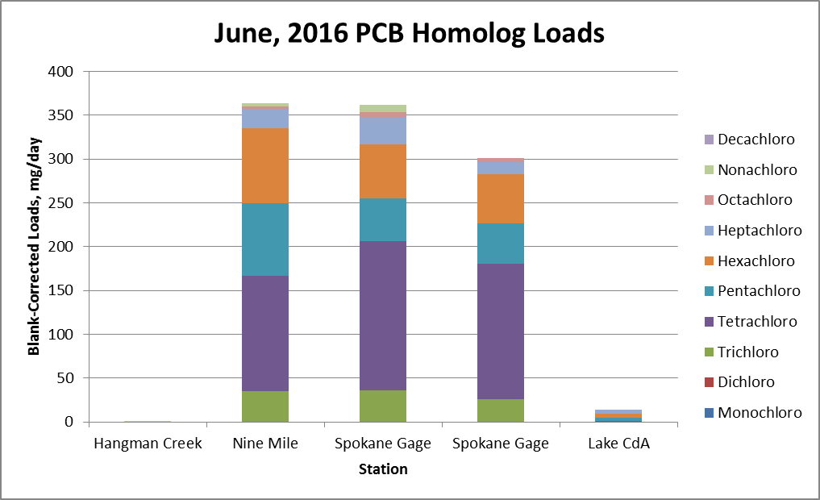
Figure 14. Blank-Corrected Homolog Loads for June, 2016 Sampling Event
Total PCB loads for October (Figure 15) were 200 mg/day leaving Lake Coeur d’Alene, increasing to 2,200 mg/day at the Spokane Gage, and decreasing to 1,100 to 1,300 mg/day at Nine Mile Dam. Stormwater loads were calculated using observed concentrations from the Cochran basin, and an estimated total stormwater flow calculated from observed Cochran flow times the ratio of total impervious cover to impervious cover in the Cochran basin. Loads from both stormwater and Hangman Creek are seen to be relatively minor contributors to the overall load. The City of Spokane also measured combined sewer overflow (CSO) discharge volume during the October event. This volume, when combined with historically observed CSO PCB concentrations, results in a loading estimate of 1160 mg/day. The estimated amount of wet weather loading is roughly consistent with the observed increase in instream loads.
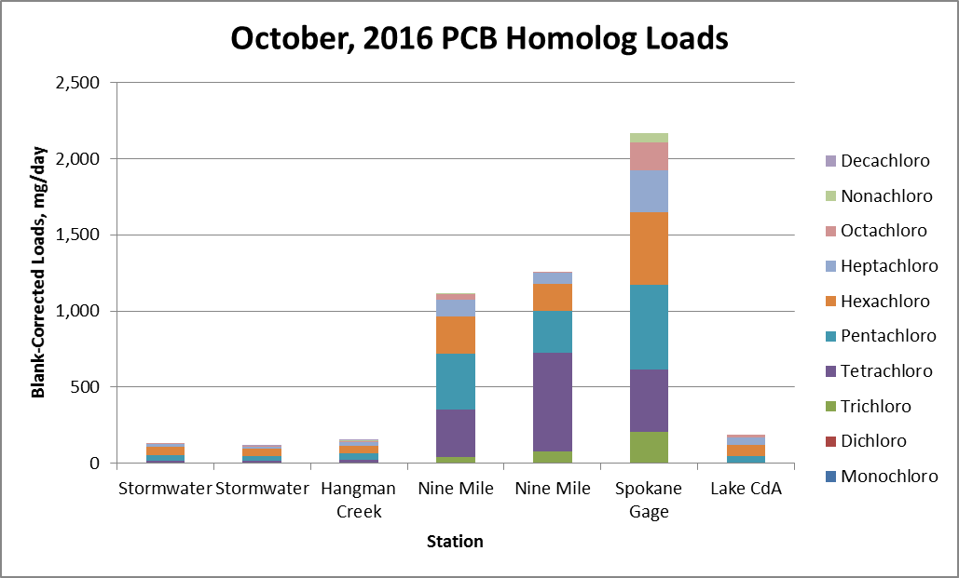
Figure 15. Blank-Corrected Homolog Loads for October, 2016 Sampling Event
Total PCB loads for December (Figure 16) were 150 mg/day at the Spokane Gage, increasing to 900 mg/day at Nine Mile Dam. The total PCB estimate at Nine Mile Dam is strongly influenced by the tetrachloro homolog, and may not be representative. No concentration data were available for Lake Coeur d’Alene in December, nor flow information for Hangman Creek.
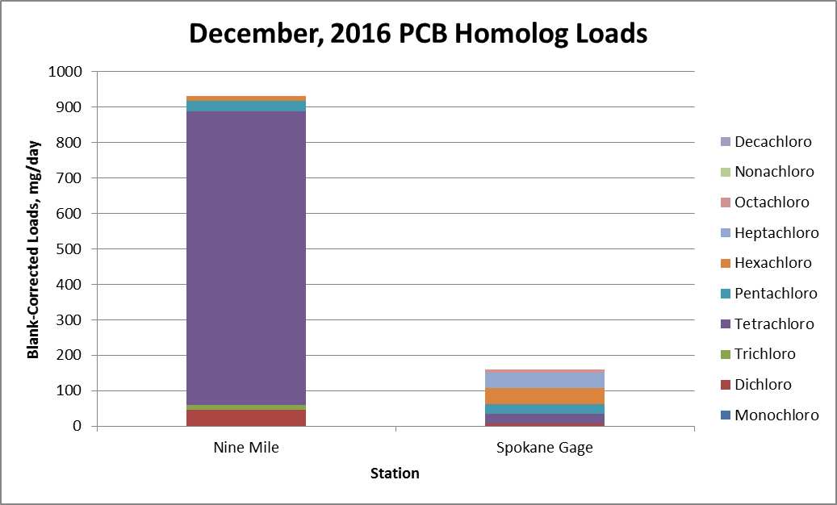
Figure 16. Blank-Corrected Homolog Loads for December, 2016 Sampling Event

Homologs
The observed PCB homolog distributions were combined with available USGS stream flow information to generate graphs of homolog loads for each month sampled, shown previously in Figures 11 through 16. Similar to the caveat given above in Section 4.2.1 for total PCBs, the inference of external homolog loading sources using these observed river loads is speculative at best.
In March and April, the increase in loads between Lake Coeur d’Alene and the Spokane Gage were primarily in the form of tetra- and penta-chloro homologs. In May, June, and October, tri- and hexa-chloro homologs also showed a noticeable increase in addition to the increases in tetra- and penta-chloro homologs. Little information can be gained from December results, given the absence of a Lake Coeur d’Alene sample and dominance of the tetrachloro homolog at Nine Mile dam.
The homolog distribution for the elevated October, 2016 Latah Creek PCB concentration was compared to homolog distributions for the October, 2016 stormwater sample, as well as to homolog distributions for the most for the most commonly produced Aroclor mixtures. A strong similarity is seen between the Latah Creek and stormwater homolog distributions, implying that stormwater may be the source of the elevated concentration. No strong similarity was seen with any of the Aroclors, with the homolog distribution for Aroclor 1254 being the most similar to the Latah Creek and stormwater distributions.
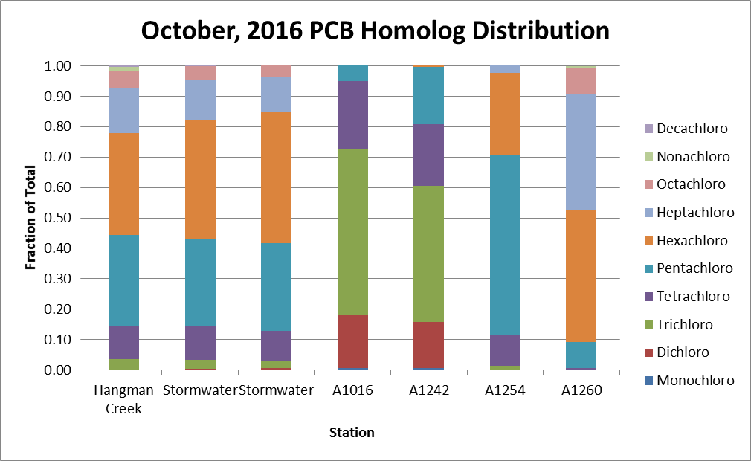
Figure 17. Homolog Distributions for Hangman Creek and Stormwater for October, 2016 Sampling Event, Compared to Distributions for Most Commonly Produced Aroclors.

REFERENCES
Gravity Consulting, L.L.C., 2017. DRAFT FINAL - 2016 Spokane River Field Sampling Report. Prepared for the Spokane River Regional Toxics Task Force. January, 2017.
LimnoTech. 2013a. Data Request Memorandum in Support of PCB and Dioxin Control. April 17, 2013. Prepared for the Spokane River Regional Toxics Task Force. April 17, 2013. http://srrttf.org/wp-content/uploads/2014/05/SRRTTF_DataRequestMemo_2013_04_17.pdf
LimnoTech. 2013b. Review of Standard Operating Procedures for PCB Data Collection and Analysis. Prepared for the Spokane River Regional Toxics Task Force. June, 28, 2013. http://srrttf.org/wp-content/uploads/2013/11/Spokane_QAPP_review_062813.pdf
LimnoTech. 2013c. Data Acquisition Contact Log. Prepared for the Spokane River Regional Toxics Task Force. August 30, 2013. http://srrttf.org/wp-content/uploads/2014/05/SRRTTF_DataGatheringStatus_20130830_final.pdf
LimnoTech. 2013d. Review and Evaluation of Existing Data ‐ Final. Prepared for the Spokane River Regional Toxics Task Force. August 30, 2013. http://srrttf.org/wp-content/uploads/2014/05/SRRTTF_DataReviewMemo_2013_08_30_final.pdf
LimnoTech. 2016. Quality Assurance Project Plan, Addendum 2. Spokane River Toxics Reduction Strategy Study. Prepared for: Spokane River Regional Toxics Task Force, February 29, 2016.
SRRTTF, 2012. Spokane River Regional Toxics Task Force (SRRTTF) First Draft Work Plan. Adopted 10-24-2012. http://srrttf.org/wp-content/uploads/2012/10/SRRTTF-Work-Plan-First-Draft-Adopted-10-24-12-CLEAN1.pdf
Blank page

Appendix A:
Synoptic Survey Results - PCBs by Homolog and Conventional Parameters

Blank Page

Table A-1: Blank-Corrected Analytical Results for Lake Coeur d’Alene Outlet
Station SR15 | March |  | April | May | June | October | December
Total PCBs (pg/l) | 14.279 | 14.213 | 32.978 | 16.818 | 3.029 | 17.783 | na
Total Monochloro Biphenyls (pg/l) | 0 | 0 | 4.01 | 3.318 | 0 | 0 | na
Total Dichloro Biphenyls (pg/l) | 0 | 0 | 6.95 | 0 | 0 | 0 | na
Total Trichloro Biphenyls (pg/l) | 1.153 | 1.142 | 7.857 | 3.196 | 0 | 0 | na
Total Tetrachloro Biphenyls (pg/l) | 1.168 | 1.15 | 3.271 | 6.744 | 0.31 | 0.653 | na
Total Pentachloro Biphenyls (pg/l) | 4.228 | 3.196 | 4.286 | 2.597 | 0.711 | 3.734 | na
Total Hexachloro Biphenyls (pg/l) | 6.42 | 6.333 | 4.613 | 0.963 | 1.015 | 6.72 | na
Total Heptachloro Biphenyls | 1.31 | 2.392 | 1.13 | 0 | 0.993 | 4.584 | na
Total Octachloro Biphenyls (pg/l) | 0 | 0 | 0 | 0 | 0 | 2.092 | na
Total Nonachloro Biphenyls (pg/l) | 0 | 0 | 0 | 0 | 0 | 0 | na
Total Decachloro Biphenyls (pg/l) | 0 | 0 | 0.861 | 0 | 0 | 0 | na
Total Dissolved Solids (mg/l) | 56 | 47 | 32 | 31 | 40 | 26 | 47
Total Suspended Solids (mg/l) | <5 | <5 | <5 | <5 | <5 | <5 | <5
Total Organic Carbon (mg/l) | 2 | 1.8 | 2.02 | 1.7 | 1.44 | 1.62 | 1.69
Dissolved Organic Carbon (mg/l) | 1.89 | 1.9 | 1.94 | 2.31 | 1.46 | 1.53 | 2.1

Table A-2: Blank-Corrected Analytical Results for Spokane River Below Trent Bridge
Station SR7 | March | April* |  | May | June | October | December
Total PCBs (pg/l) | 51.458 | 15.796 | 16.926 | 111.832 | 64.498 | 52.29 | 168.778
Total Monochloro Biphenyls (pg/l) | 0 | 0 | 0 | 2.634 | 0 | 0 | 0
Total Dichloro Biphenyls (pg/l) | 2.654 | 0.437 | 0 | 18.834 | 0 | 0 | 0
Total Trichloro Biphenyls (pg/l) | 5.159 | 1.466 | 1.601 | 30.411 | 14.43 | 1.835 | 8.724
Total Tetrachloro Biphenyls (pg/l) | 24.382 | 1.118 | 2.499 | 46.448 | 41.222 | 23.211 | 96.386
Total Pentachloro Biphenyls (pg/l) | 7.509 | 4.282 | 4.572 | 8.615 | 6.705 | 12.688 | 53.648
Total Hexachloro Biphenyls (pg/l) | 8.301 | 6.15 | 6.17 | 2.65 | 1.377 | 10.142 | 4.333
Total Heptachloro Biphenyls (pg/l) | 3.453 | 2.343 | 2.084 | 2.24 | 0.764 | 4.414 | 2.786
Total Octachloro Biphenyls (pg/l) | 0 | 0 | 0 | 0 | 0 | 0 | 2.901
Total Nonachloro Biphenyls (pg/l) | 0 | 0 | 0 | 0 | 0 | 0 | 0
Total Decachloro Biphenyls (pg/l) | 0 | 0 | 0 | 0 | 0 | 0 | 0
Total Dissolved Solids (mg/l) | 51 | 34 | 32 | 39 | 88 | 44 | 53
Total Suspended Solids (mg/l) | <5 | <5 | <5 | <5 | <5 | <5 | <5
Total Organic Carbon (mg/l) | 1.87 | 2.22 | 2.16 | 1.66 | 1.06 | 1.54 | 1.53
Dissolved Organic Carbon (mg/l) | 1.86 | 2.1 | 1.93 | 1.8 | 1.13 | 1.3 | 1.84

* April samples for station SR7 actually taken at Barker Rd.

Table A-3: Blank-Corrected Analytical Results for Spokane River Below Greene Street
Station SR4 | March | April | May |  | June | October | December
Total PCBs (pg/l) | 67.107 | 75.974 | 87.119 | 27.278 | 77.583 | 134.73 | 9.13
Total Monochloro Biphenyls (pg/l) | 0 | 0 | 3.101 | 2.643 | 0 | 0 | 0
Total Dichloro Biphenyls (pg/l) | 6.614 | 0.806 | 19.8 | 2.355 | 0 | 0.363 | 0
Total Trichloro Biphenyls (pg/l) | 2.894 | 11.3 | 16.7 | 3.437 | 11.318 | 14.862 | 1.37
Total Tetrachloro Biphenyls (pg/l) | 11.596 | 12.96 | 34.472 | 8.65 | 30.668 | 32.953 | 0
Total Pentachloro Biphenyls (pg/l) | 12.296 | 10.56 | 5.936 | 4.994 | 17.715 | 38.407 | 0.943
Total Hexachloro Biphenyls (pg/l) | 20.036 | 21.471 | 3.35 | 2.199 | 15.218 | 28.279 | 0.725
Total Heptachloro Biphenyls (pg/l) | 9.999 | 13.377 | 2.55 | 3 | 2.218 | 13.934 | 0.862
Total Octachloro Biphenyls (pg/l) | 3.672 | 4.18 | 1.21 | 0 | 0.446 | 5.929 | 3.11
Total Nonachloro Biphenyls (pg/l) | 0 | 1.32 | 0 | 0 | 0 | 0 | 2.12
Total Decachloro Biphenyls (pg/l) | 0 | 0 | 0 | 0 | 0 | 0 | 0
Total Dissolved Solids (mg/l) | 53 | 44 | 41 | 49 | 94 | 48 | 58
Total Suspended Solids (mg/l) | <5 | <5 | <5 | <5 | <5 | <5 | <5
Total Organic Carbon (mg/l) | 1.84 | 2.11 | 1.61 | 1.71 | 1.2 | 1.54 | 1.86
Dissolved Organic Carbon (mg/l) | 2.01 | 1.94 | 1.7 | 1.67 | 1.28 | 1.53 | 1.86

Table A-4: Blank-Corrected Analytical Results for Spokane River USGS Gage at Spokane
Station SR3 | March | April | May | June |  | October | December
Total PCBs (pg/l) | 64.498 | 57.244 | 50.441 | 62.561 | 51.993 | 206.85 | 10.056
Total Monochloro Biphenyls (pg/l) | 0 | 0 | 4.593 | 0 | 0 | 0 | 0
Total Dichloro Biphenyls (pg/l) | 9.207 | 0.812 | 1.41 | 0 | 0 | 0 | 0.417
Total Trichloro Biphenyls (pg/l) | 3.193 | 11.412 | 7.333 | 6.218 | 4.393 | 19.789 | 0
Total Tetrachloro Biphenyls (pg/l) | 15.372 | 16.27 | 15.599 | 29.387 | 26.848 | 38.932 | 1.83
Total Pentachloro Biphenyls (pg/l) | 18.888 | 10.454 | 7.821 | 8.527 | 7.885 | 53.043 | 1.706
Total Hexachloro Biphenyls (pg/l) | 13.1 | 11.203 | 7.314 | 10.599 | 9.776 | 45.602 | 2.835
Total Heptachloro Biphenyls (pg/l) | 4.103 | 3.874 | 5.445 | 5.499 | 2.429 | 25.964 | 2.683
Total Octachloro Biphenyls (pg/l) | 0 | 2.454 | 0 | 0.961 | 0.662 | 17.588 | 0.585
Total Nonachloro Biphenyls (pg/l) | 0 | 0 | 0 | 1.37 | 0 | 5.937 | 0
Total Decachloro Biphenyls (pg/l) | 0.635 | 0.765 | 0.926 | 0 | 0 | 0 | 0
Total Dissolved Solids (mg/l) | 55 | 41 | 46 | 103 | 92 | 52 | 57, 57
Total Suspended Solids (mg/l) | <5 | <5 | <5 | <5 | <5 | <5 | <5, <5
Total Organic Carbon (mg/l) | 1.88 | 2.05 | 1.72 | 1.18 | 1.15 | 1.65 | 1.55, 1.58
Dissolved Organic Carbon (mg/l) | 2 | 1.88 | 2.36 | 1.29 | 1.2 | 1.51 | 1.75, 1.95

Table A-5: Blank-Corrected Analytical Results for Hangman (Latah) Creek Mouth
Station HC1 | March | April | May | June | October | December
Total PCBs (pg/l) | 41.005 | 31.361 | 18.836 | 6.747 | 1053.4 | 37.986
Total Monochloro Biphenyls (pg/l) | 0 | 0 | 2.377 | 0 | 0 | 0
Total Dichloro Biphenyls (pg/l) | 2.953 | 1.873 | 1.3 | 0.411 | 0.737 | 3.592
Total Trichloro Biphenyls (pg/l) | 5.774 | 13.764 | 2.613 | 0.757 | 36.443 | 0
Total Tetrachloro Biphenyls (pg/l) | 6.929 | 4.187 | 5.027 | 0.806 | 116.58 | 31.65
Total Pentachloro Biphenyls (pg/l) | 8.421 | 5.697 | 2.93 | 0.485 | 314.05 | 0.662
Total Hexachloro Biphenyls (pg/l) | 9.25 | 3.777 | 1.941 | 1.782 | 352.26 | 0.968
Total Heptachloro Biphenyls (pg/l) | 2.255 | 1.227 | 1.798 | 1.924 | 156.95 | 0
Total Octachloro Biphenyls (pg/l) | 0.853 | 0 | 0 | 0 | 59.03 | 1.114
Total Nonachloro Biphenyls (pg/l) | 1.27 | 0 | 0 | 0.582 | 13.18 | 0
Total Decachloro Biphenyls (pg/l) | 3.3 | 0.836 | 0.85 | 0 | 4.12 | 0
Total Dissolved Solids (mg/l) | 165 | 145 | 183 | 212 | 201 | 167
Total Suspended Solids (mg/l) | 59 | <5 | <5 | <5 | 5 | <5
Total Organic Carbon (mg/l) | 6.83 | 5.8 | 4.24 | 3.94 | 8.44 | 5.23
Dissolved Organic Carbon (mg/l) | 7.14 | 5.6 | 5.12 | 3.72 | 6.51 | 5.63

Table A-6: Blank-Corrected Analytical Results for Spokane River Below Nine Mile Dam
Station SR1 | March | April | May | June | October |  | December
Total PCBs (pg/l) | 99.831 | 68.077 | 186.882 | 62.33 | 104.75 | 118.3 | 58.616
Total Monochloro Biphenyls (pg/l) | 0 | 0 | 2.856 | 0 | 0 | 0 | 0
Total Dichloro Biphenyls (pg/l) | 2.085 | 1.179 | 21.1 | 0 | 0 | 0 | 2.93
Total Trichloro Biphenyls (pg/l) | 4.691 | 14.667 | 31.888 | 5.981 | 3.737 | 7.444 | 0.771
Total Tetrachloro Biphenyls (pg/l) | 31.789 | 18.54 | 48.861 | 22.52 | 29.307 | 60.72 | 52.3
Total Pentachloro Biphenyls (pg/l) | 33.9 | 15.437 | 36.125 | 14.247 | 34.461 | 25.89 | 1.82
Total Hexachloro Biphenyls (pg/l) | 18.308 | 10.111 | 33.48 | 14.707 | 23.3 | 16.79 | 0.795
Total Heptachloro Biphenyls (pg/l) | 6.127 | 4.671 | 12.572 | 3.814 | 10.315 | 6.958 | 0
Total Octachloro Biphenyls (pg/l) | 2.077 | 2.82 | 0 | 0.491 | 3.36 | 0.481 | 0
Total Nonachloro Biphenyls (pg/l) | 0 | 0 | 0 | 0.57 | 0.266 | 0 | 0
Total Decachloro Biphenyls (pg/l) | 0.854 | 0.652 | 0 | 0 | 0 | 0 | 0
Total Dissolved Solids (mg/l) | 69 | 42 | 49 | 112 | 63 | 83 | 53
Total Suspended Solids (mg/l) | 6 | <5 | <5 | <5 | <5 | <5 | <5
Total Organic Carbon (mg/l) | 2.16 | 2.04 | 1.69 | 1.36 | 1.54 | 1.54 | 1.54
Dissolved Organic Carbon (mg/l) | 2.3 | 1.86 | 1.74 | 1.25 | 1.46 | 1.44 | 1.89

Table A-7: Blank-Corrected Analytical Results for Cochran Basin Stormwater
 | October | October
Total PCBs (pg/l) | 5197.81 | 5744.02
Total Monochloro Biphenyls (pg/l) | 10.12 | 11.51
Total Dichloro Biphenyls (pg/l) | 12.1 | 22.4
Total Trichloro Biphenyls (pg/l) | 145.79 | 132.51
Total Tetrachloro Biphenyls (pg/l) | 580.84 | 576.98
Total Pentachloro Biphenyls (pg/l) | 1492.6 | 1657.7
Total Hexachloro Biphenyls (pg/l) | 2036.37 | 2475.1
Total Heptachloro Biphenyls (pg/l) | 673.55 | 656.41
Total Octachloro Biphenyls (pg/l) | 234.64 | 211.41
Total Nonachloro Biphenyls (pg/l) | 0 | 0
Total Decachloro Biphenyls (pg/l) | 11.8 | 0

Appendix B:
Gravity Report
Provided separately as an electronic document

Blank Page

Appendix C:
Quality Assurance Project Plan
Provided separately as an electronic document
Blank Page

Appendix D:
Laboratory Results
Provided separately as electronic spreadsheets
Blank Page

PCB concentrations utilized to place the Spokane River and Lake Spokane on the 303(d) list were derived from fish tissue concentrations and a bioconcentration factor specified in the National Toxics Rule.
PCB concentrations utilized to place the Spokane River and Lake Spokane on the 303(d) list were derived from fish tissue concentrations and a bioconcentration factor specified in the National Toxics Rule.

