Memorandum

From: Dave Dilks, Joseph Helfand | Date: August 16, 2017
 | Project: SRRTTF6
To: Spokane River Regional Toxics Task Force | CC:
SUBJECT: REVIEW DRAFT: Homolog-Specific PCB Mass Balance for the Spokane River

Summary
Homolog-specific mass balance assessments were performed for all Spokane River segments that were previously assessed using a total PCB basis. Key finding of this analysis are:
- No significant groundwater loads were observed for any homologs between the outlet of Lake Coeur d’Alene and Barker Rd. (Greenacres).
- The groundwater load entering between Barker Rd. and Trent Ave. (Plante’s Ferry) consistently shows a pattern dominated primarily by tetrachloro homologs and secondarily by trichloro homologs.
- A loading source entering between Trent Avenue (Plante’s Ferry) and Greene St. is dominated primarily by hexachloro homologs, and secondarily by pentachloro and heptachloro homologs.
- The data show some inconsistencies that cannot be immediately resolved:
  - It is not clear whether a high river concentration observed below Mirabeau Point represents an ephemeral groundwater load or an anomalous measurement.
  - There is a consistent loss of tri- and tetra-chloro homologs between Trent Ave. (Plante’s Ferry) and Greene St. that cannot be explained via volatilization or alternate assumptions regarding groundwater flow.
The homolog distributions generated here will be compared to distributions observed in groundwater wells to assist in identifying the origin of groundwater loading to the river.

Introduction
The Spokane River Regional Toxics Task Force (Task Force) developed a Comprehensive Plan (LimnoTech, 2016a) to reduce polychlorinated biphenyls (PCBs) in the Spokane River, specifically. The Comprehensive Plan identified specific management actions that can be undertaken to identify and control pollutant loads such that water quality objectives can ultimately be attained. One action identified in the Comprehensive Plan consisted of a more refined identification of groundwater sources of PCBs. Synoptic water quality surveys of the Spokane River were conducted in 2014 and 2015 to identify potentially significant dry weather sources of PCBs to the Spokane River between Lake Coeur d’Alene and Nine Mile Dam. The results of these surveys, when considered in a mass balance framework, identified the presence of a groundwater source of total PCBs to the Spokane River between Barker Rd. (Greenacres) and Trent Ave. (Plante’s Ferry). Subsequent mass balance analyses conducted on a homolog-specific basis for a subset of the study area identified a potential additional groundwater PCB source below Plante’s Ferry.
The purpose of this memorandum is to document homolog-specific mass balance analyses throughout the study area to determine the presence of other potential groundwater sources, and to calculate homolog distributions for any identified sources. The memorandum is divided into sections of:
- Data Considered
- Mass Balance Assessment
- Discussion of Results

Data Considered

The homolog-specific mass balance analyses described here were all directly patterned after the total PCB mass balance analyses described in LimnoTech (2015) and LimnoTech (2016b). Station locations differed between the 2014 and 2015 surveys. In 2014, stations ranged from the Lake Coeur d’Alene outlet to Nine Mile Dam (Figure 1). The spatial extent of sampling was condensed in 2015 to focus on areas where significant groundwater loads were identified in 2014. The upstream boundary of the 2015 survey corresponded to Barker Rd., while the downstream boundary was located at the USGS gage in Spokane. One additional sampling station was added in 2015, located at Mirabeau Point between Barker Rd. and the Kaiser discharge (Figure 2).
All flows and PCB concentrations for the Spokane River and external sources have been provided in the above reports, with two exceptions discussed below. It is worth noting that the 2014 and 2015 mass balance analyses treated data defined as “outliers” differently, i.e. outliers were excluded from the 2014 mass balance and included in the 2015 mass balance. That same approach to outliers is maintained in this memorandum to provide consistency the earlier mass balance calculations.
There are two sources of information unique to the homolog-specific mass balance analyses:
- 2014 Homolog Concentrations
- 2014 Greene St. flows
Each are discussed below.

2014 Homolog Concentrations
The 2014 homolog concentrations reported in LimnoTech (2015) were not blank corrected, so an initial task in this work was to perform a blank correction on all samples consistent with the project QAPP (LimnoTech, 2017). Resulting blank corrected homolog concentrations are provided as an Appendix to this memorandum. As part of this updated blank correction, treatment of flagged data was conducted to be consistent with current Task Force practice of accepting NJ-flagged values.
2014 Greene St. Flows
No directly measured river flow data were available for Greene St. for the 2014 synoptic survey, such that previous mass balance calculations for this year were conducted on the Trent Ave. to Spokane USGS gage reach. In order to take full advantage of available Greene St. PCB concentration data, and provide greater spatial resolution in mass balance calculations (i.e. separate results for Trent Ave. to Greene St. and Greene St. to Spokane USGS Gage), 2014 Greene St. flows were estimated based upon the results of the USGS ground-water flow model for the Spokane Valley-Rathdrum Prairie Aquifer (Hsieh et al, 2007). Model results for August 2000, the period of time in groundwater model results that most closely matched 2014 flow conditions, showed a loss of 126 cfs in total river flow between Greene St. and the USGS gage. The Greene St. flow for the 2014 synoptic survey was estimated by subtracting 126 cfs from the observed river flow at the USGS gage, resulting in a flow of 1245 cfs.
It should be noted that, because these Greene St. flows are based on groundwater model predictions rather than direct flow measurements, mass balance results for 2014 in the affected reaches should be viewed with caution.

Mass Balance Assessment
This section describes a refinement made to the previously applied mass balance approach, then presents the results of the homolog-specific mass balance assessment, with separate discussions for the 2014 and 2015 synoptic surveys. While a formal uncertainty analysis was not included as part of this scope, scaling of the uncertainty analysis done for the total PCB assessment suggests that loading estimates less than 10 mg/day are well within the “noise” of the assessment, and that load estimates in the 10 to 5o mg/day range are strongly influenced by the uncertainty of the field and laboratory measurements.

Refinement to Approach
The mass balance assessment conducted here was directly patterned after the total PCB mass balance assessment described in LimnoTech (2015, 2016b), with one key refinement. The reach between Trent Ave. and Greene St. is comprised of a section that loses flow to the groundwater, as well as a section that gains groundwater. The original total PCB mass balance assessments did not differentiate between these individual losing/gaining sections and instead was conducted based upon the net change in flow over the length of the entire assessment. To address potential inaccuracies introduced using a “net flow” approach, the homolog specific mass balance dis-aggregated the Trent Ave. to Greene St. reach into two sections:
- The losing section from Plante’s Ferry to just downstream of Upriver Dam, and
- The gaining section from just downstream of Upriver Dam to Green Street.
This refined approach required specification of Spokane River flows just downstream of Upriver Dam. These flows were estimated for 2014 based upon the results of the USGS ground-water flow model for the Spokane Valley-Rathdrum Prairie Aquifer (Hsieh et al, 2007). Model results for August 2000, the period of time in groundwater model results that most closely matched 2014 flow conditions, showed a loss of approximately 140 cfs between Trent Ave and the break point near Upriver Dam, resulting in an assumed flow below Upriver Dam of 903 cfs. Flows below Upriver Dam for 2015 were based upon USGS flow measurements of 484 cfs from September 2, 2015 taken approximately ½ mile downstream of the Upriver Dam spillway. Given the temporal stability of flows in the Spokane River between August 18, 2015 and September 2, 2015 as measured at the Post Falls, Spokane, and Greene Street gages, it is reasonable to use this flow to represent conditions during the August 2015 synoptic survey.

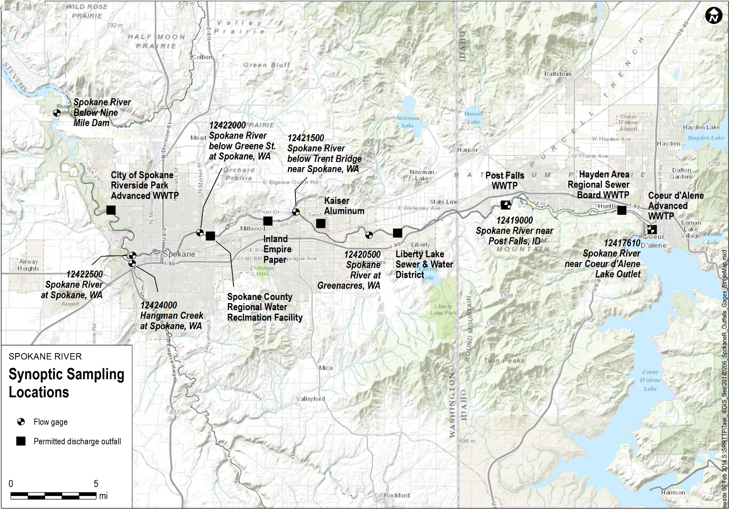
Figure 1. Sampling Locations for August 12-24, 2014 Synoptic Survey
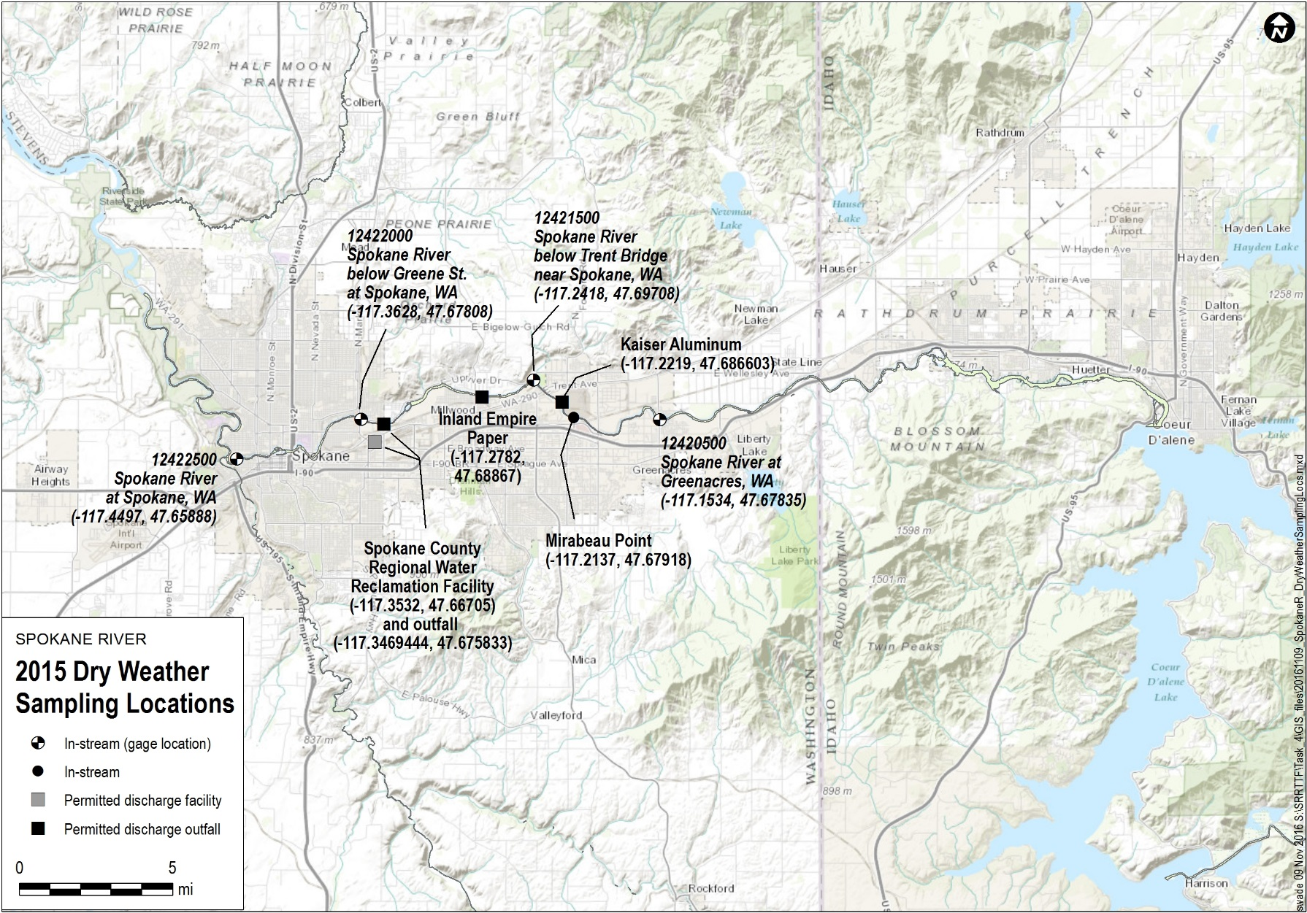
Figure 2. Sampling Locations for August 18-22, 2015 Synoptic Survey
Within the mass balance assessment, the amount of PCBs lost to the aquifer was calculated based upon the predicted concentration of each homolog in the losing section. As discussed below, two different assumptions were tested to bound the uncertainty in the groundwater PCB concentrations in the gaining section: 1) assuming that PCB concentrations in the groundwater inflow were identical to the concentrations in the losing reach, and 2) assuming that PCBs in the groundwater inflow were zero.

2014 Results
The estimated groundwater homolog loads for each river segment in 2014 are provided below in Table 1 and Figures 3 through 8. Table 1 also provides total PCB load by segment. Total PCB loads by reach vary somewhat from those presented in LimnoTech (2015), due to changes in homolog-specific blank correction described above.
Table 1. Estimated Groundwater Homolog Load (mg/day) by Reach for 2014
 | River Reach
Homolog | Lake CdA Outlet to Post Falls | Post Falls to Barker Rd. | Barker to Trent Bridge | Trent to Greene St. | Greene St. to Spokane Gage
Mono- | -0.4 | 1.5 | -1.8 | 0.8 | -1.5
Di- | -0.4 | 0.8 | -3.7 | 1.1 | 32.5
Tri- | -1.6 | 2.1 | 40.0 | -26.4 | -2.6
Tetra- | -4.4 | 0.7 | 119.8 | -61.0 | -6.4
Penta- | -5.6 | -0.3 | 22.1 | 2.3 | 53.7
Hexa- | -2.1 | -0.1 | -1.0 | 36.2 | 14.1
Hepta- | 0.1 | 0.4 | -1.6 | 18.5 | -2.8
Octa- | 0.8 | -0.3 | 0.2 | 4.7 | -1.6
Nona- | 0.2 | 0.0 | 0.0 | 1.9 | -1.5
Deca- | 0.3 | -0.1 | -0.1 | 0.4 | -0.4
Total | -13.1 | 4.6 | 174.0 | -21.5 | 83.4
Loads of individual homologs are relatively low (i.e. less than 10 mg/day) for the reaches between the Lake Coeur d’Alene outlet and Barker Rd. (Figures 3 and 4).
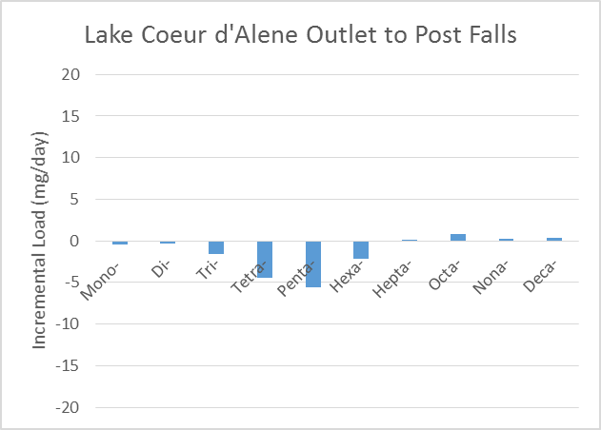
Figure 3. Estimated Groundwater Homolog Load (mg/day) for Lake CdA Outlet to Post Falls Reach for 2014
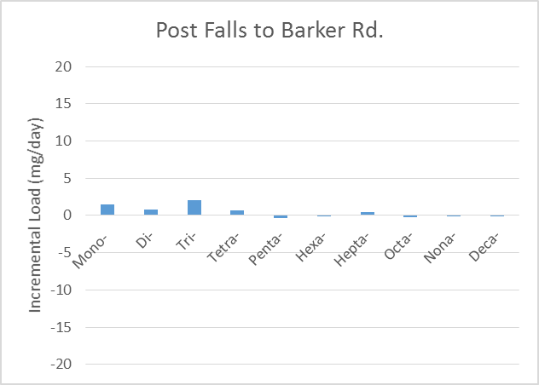
Figure 4. Estimated Groundwater Homolog Load (mg/day) for Post Falls to Barker Rd. Reach for 2014
The groundwater load entering between Barker Rd. and the Trent Ave. Bridge (Figure 5) is dominated by the tetrachloro homolog, with secondary contributions from the tri- and penta-chloro homologs.
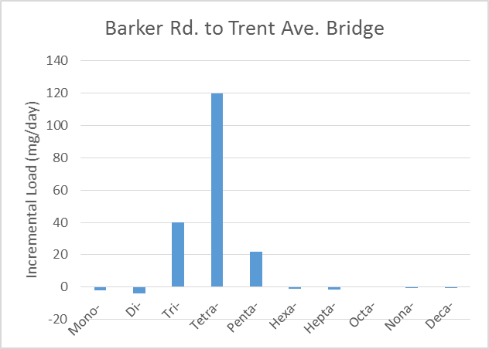
Figure 5. Estimated Groundwater Homolog Load (mg/day) for Barker Rd. to Trent Ave. Reach for 2014
The loads from individual homologs for the reach between Trent Ave. and Greene St. are shown in Figure 6. It is noted that this stream reach is comprised by portions that lose flow to the groundwater as well as portions that gain groundwater. The mass balance analysis for a “mixed losing /gaining” reach such as this requires an assumption about the nature of the groundwater that reenters the river below the losing portion of the reach. Specifically, the assessment must specify the groundwater PCB concentration entering the stream. In a mixed losing/gaining reach, the reentering groundwater could reflect the concentration that left the river upstream, or it could reflect new sources of groundwater from elsewhere in the aquifer. Lacking information on the exact nature of this re-entering groundwater, the mass balance assessment was conducted twice for this reach, with two alternate assumptions. The first assumption is that all water that was lost upstream from the river to the groundwater returns to the river immediately downstream at the same concentration as when it left the river. The second assumption is that none of the water that was lost upstream from the river to the groundwater reenters the river immediately downstream, and that groundwater inflow represents a new source of water with no PCBs. These two assumptions bracket the range of possibilities, such that the range of results represent the uncertainty in mass balance results caused by the uncertainty in groundwater behavior. As seen in Figure 6, the primary conclusions are not seriously affected by the by the uncertainty in groundwater behavior. For both assumptions, there is an apparent loss in the tri- and tetra-chloro homologs, and a gain in the hexa- and hepta-chloro homologs.
It is noted that results for Figures 6 and 7 have a greater degree of uncertainty than other reaches, due to the use of model-estimated river flows (rather than direct flow measurements) at Greene St. for 2014.
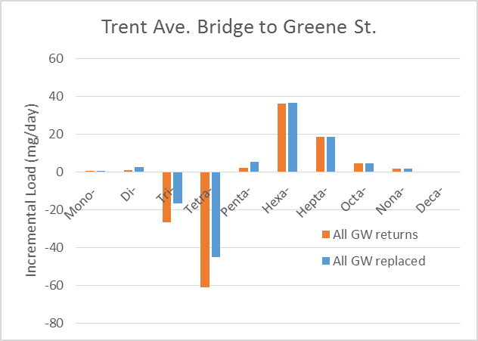
Figure 6. Estimated Groundwater Homolog Load (mg/day) for Trent Ave. to Greene St. Reach for 2014
The loads for individual homologs for the reach between Greene St. and the USGS Spokane gage are shown in Figure 7. Apparent groundwater loads are seem in the di-, penta-, and hexa-chloro homologs.
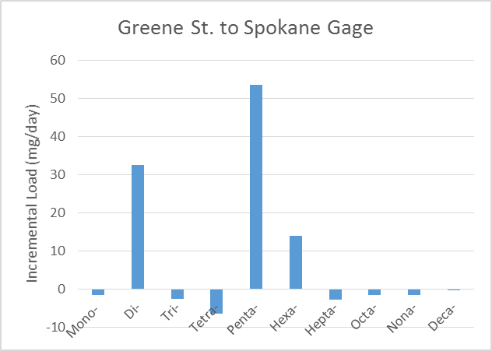
Figure 7. Estimated Groundwater Homolog Load (mg/day) for Greene St. to Spokane Gage Reach for 2014

2015 Results
The estimated groundwater homolog loads for 2015 are provided below in Table 2 and Figures 8 through 12. Table 2 also provides total PCB loads by reach; these loads are consistent with those presented in LimnoTech (2016b).

Table 2. Estimated Groundwater Homolog Load (mg/day) by Reach for 2015
 | River Reach
Homolog | Barker to Mirabeau | Mirabeau to Trent Bridge | Trent to Greene St. | Greene St. to Spokane Gage
Mono- | 0.0 | 0.0 | -1.2 | 4.1
Di- | 0.3 | -1.8 | -20.0 | -0.5
Tri- | -0.1 | 35.9 | -64.3 | 14.7
Tetra- | 1.3 | 77.9 | -41.8 | 15.1
Penta- | 12.2 | 3.8 | 33.9 | 25.7
Hexa- | 21.3 | -22.1 | 49.7 | -8.6
Hepta- | 6.2 | -5.7 | 16.8 | -4.3
Octa- | 0.7 | -0.6 | 3.5 | -1.9
Nona- | 0.3 | -0.3 | 3.8 | -3.6
Deca- | 0.0 | 0.0 | 0.3 | -0.3
Total | 42.2 | 87.0 | -19.2 | 40.5
The reach between Barker Rd. and Mirabeau Point show a potential load of penta- and hexa-chloro homologs (Figure 8). As was discussed in the SRRTTF 2015 Technical Activities Report (LimnoTech, 2016b), though, the calculated load in this reach is driven solely by a single elevated PCB sample at Mirabeau and it is not clear whether this represents an anomalous measurement or the presence of an ephemeral groundwater loading source.
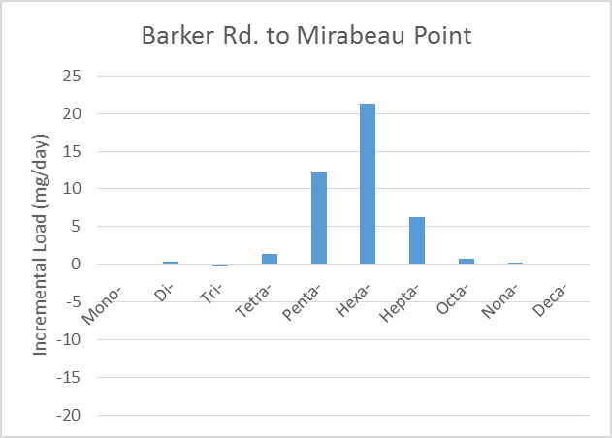
Figure 8. Estimated Groundwater Homolog Load (mg/day) for Barker Rd. to Mirabeau Point for 2015
The groundwater load entering between Mirabeau Point and the Trent Ave. Bridge (Figure 9) is dominated by the tetrachloro homolog, with a secondary contribution from the trichloro homolog.
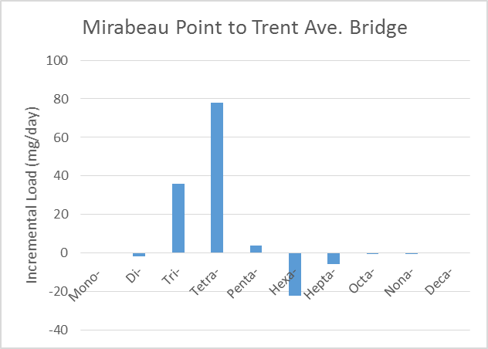
Figure 9. Estimated Groundwater Homolog Load (mg/day) for Mirabeau Point to Trent Ave. for 2015
The 2015 loads from individual homologs for the reach between Trent Ave. and Greene St. are shown in Figure 10. There is an apparent loss in the di-, tri- and tetra-chloro homologs, and a gain in the penta-, hexa- and hepta-chloro homologs, regardless of the assumption made regarding groundwater behavior in adjacent losing and gaining sections.
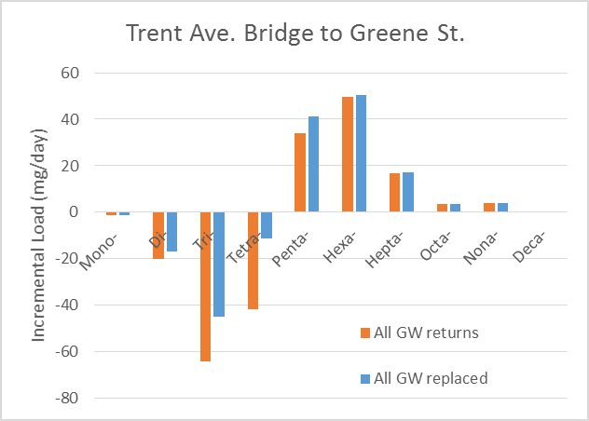
Figure 10. Estimated Groundwater Homolog Load (mg/day) for Trent Ave. to Greene St. for 2015
The 2015 loads from individual homologs for the reach between and Greene St. and the Spokane USGS gage are shown in Figure 11. The largest load comes from the pentachloro homolog, with additional loads coming from the tri- and tetra-chloro homologs.
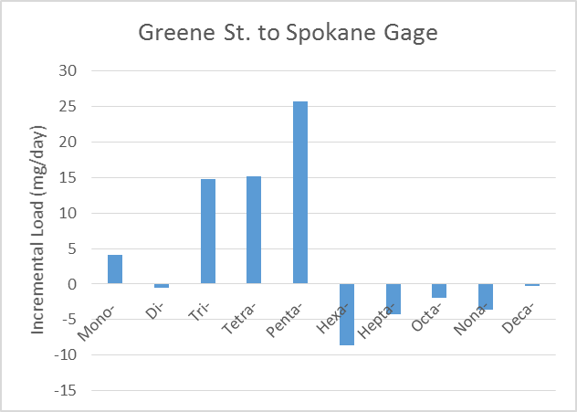
Figure 11. Estimated Groundwater Homolog Load (mg/day) for Greene St.to USGS Gage for 2015

Discussion of Results
Review of the homolog-specific mass balance results for 2014 and 2015 provides some clear conclusions, as well as some inconsistencies that cannot be immediately resolved. Each are discussed below.

Conclusions
Four primary conclusions can be drawn from this analysis. First, no significant groundwater loads were observed for any homologs between the outlet of Lake Coeur d’Alene and Barker Rd. (Greenacres). Estimated loadings for both the Lake Coeur d’Alene to Post Falls and Post Falls to Barker Rd. reaches were less than 5 mg/day for all homologs, and considered negligible considering the overall uncertainty of the assessment. Second, the groundwater load entering between Barker Rd. and Trent Ave. (Plante’s Ferry) shows a pattern dominated primarily by tetrachloro homologs and secondarily by trichloro homologs, with this pattern consistently displayed across the 2014 and 2015 synoptic surveys. Third, a loading source entering between Trent Avenue (Plante’s Ferry) and Greene St. is dominated primarily by hexachloro homologs, and secondarily by penta- and hepta-chloro homologs. Finally, dis-aggregation of the Trent Ave. to Greene St. reach into separate losing and gaining sections did not provide significantly different results than the previous lumped approach. Should better information on potential groundwater loading sources in this reach be desired, future synoptic surveys should include a sampling location downstream of Upriver Dam at the transition point between the losing and gaining sections of the river.
The homolog distributions generated for the above sources will be compared to homolog distributions observed in groundwater wells to assist in identifying the origin of groundwater loading to the river.

Inconsistencies
Three issues were identified as part of the mass balance where clear conclusions could not be drawn due to inconsistencies in the observed data, corresponding to: 1) loading above Mirabeau Point, 2) the apparent loss of lower chlorinated homologs below Trent Ave., and 3) the nature of the load below Greene St.
The reach between Barker Rd. and Mirabeau Point showed the presence of a potential load of penta- and hexa-chloro homologs in 2015, the only year in which measurements were available at Mirabeau Point. The load in this reach is driven solely by a single elevated PCB sample at Mirabeau Point, and it is not clear whether this represents an anomalous measurement or the presence of an ephemeral groundwater loading source. While no clear conclusion can be drawn from the currently available data, comparison of the calculated homolog distribution for this potential source to the homolog distributions observed at nearby groundwater wells may shed additional light on the nature of this loading source.
There is a consistent loss of tri- and tetra-chloro homologs below Trent Ave. (as well as the dichloro homolog in 2015) that cannot be explained via the mass balance assessment. Two potential fate processes were examined as possible explanation for this loss: 1) volatilization, and 2) loss to groundwater. Volatilization was proposed as one potential explanation, as the lower chlorinated homologs for which loss was evident have a greater propensity to volatilize as compared to higher chlorinated homologs. Volatilization loss rates were calculated for each homolog and each synoptic survey, based upon the Henry's law constant for each homolog and the time of passage and reaeration rate (taken from the Spokane River CE-QUAL-W2 model. Volatilization was ruled out as an explanation for the apparent loss of lower chlorinated homologs below Trent Ave. for two reasons. First the average amount of loss of lower chlorinated homologs over this segment was only 5%, which is insufficient to fully explain the decrease in observed river concentration. Second, the calculated difference in volatilization between lower and higher chlorinated homologs was only 10%, which insufficient to explain the apparent difference in loss rates observed across homologs. The second potential fate process examined to explain the apparent loss of lower chlorinated homologs below Trent Ave. was preferential loss to groundwater. The lower chlorinated homologs have a tendency to have a greater fraction in the dissolved phase, and could theoretically be more likely to leave the stream via loss to groundwater. This theory was tested by reviewing the suspended solids and organic carbon data for the Trent Ave. Bridge station, and calculating the expected percentage of PCBs in the dissolved phase for each of the homologs using literature values for homolog-specific partition coefficients. Because all suspended solids measurements were reported as “<5 mg/l”, the analysis was conducted assuming that solids concentrations were at half of the detection limit, i.e. 2.5 mg/l. This analysis showed that, because of the low solids concentrations, all homologs were primarily in the dissolved phase. Lower chlorinated homologs were only slightly more dissolved that higher chlorinated homologs (e.g. trichloro homologs were >99% dissolved; hexachloro homologs were 91% dissolved). This difference in percent dissolved is not enough to explain the apparent loss of the lower chlorinated homologs in this reach. As discussed above, future synoptic surveys that include a sampling location below Upriver Dam may provide better insight to the cause of this phenomenon.
The final inconsistency in the observed data corresponded to calculated load between Greene St. and the USGS Spokane Gage, as this load differs greatly in homolog pattern between the 2014 and 2015 surveys. The 2014 data showed a 30-50 mg/day load in di- and penta-chloro homologs; while the 2015 data showed a 10-25 mg/day load in tri-, tetra- and penta-chloro homologs. While a consistent pentachloro homolog load was observed between the two years, the remainder of the homolog distribution was quite different. Because the 2014 mass balance assessment for the Greene St. to USGS Spokane Gage reach was conducted using model-estimated river flows for Greene St., more credence should be given to the 2015 results.
Many of the above inconsistencies can be explained by the determination discussed at the beginning of the Mass Balance Assessment section made previously that individual loading estimates could be uncertain by up to 50 mg/day. As such, results of this analysis are not necessarily expected to provide a definitive “fingerprint” of the homolog distribution of groundwater loads. The results will still provide value, however, as part of a weight of evidence approach when considering the likelihood of groundwater from various sources contributing significant PCB contamination to the Spokane River.

References
Hsieh, P.A., M.E. Barber, B. A. Contor, M. A. Hossain, G. S. Johnson, J. L. Jones, and A. H. Wylie, 2007. Ground-Water Flow Model for the Spokane valley-Rathdrum Prairie Aquifer, Spokane County, Washington, and Bonner and Kootenai Counties, Idaho. USGS Scientific Investigations Report 2007–5044.
LimnoTech, 2015. Spokane River Regional Toxics Task Force Phase 2 Technical Activities Report: Identification of Potential Unmonitored Dry Weather Sources of PCBs to the Spokane River Prepared for the Spokane River Regional Toxics Task Force. August 12, 2015. http://srrttf.org/wpcontent/uploads/2015/08/SRRTTF_Phase_2_Final_Report_2015_08_12_without-appendices.pdf
LimnoTech, 2016a. 2016 Comprehensive Plan to Reduce Polychlorinated Biphenyls (PCBs) in the Spokane River. Prepared for the Spokane River Regional Toxics Task Force. Plan Accepted by the Task Force November 16, 2016. http://srrttf.org/wp-content/uploads/2016/04/2016_Comp_Plan_Final_Approved.pdf
LimnoTech, 2016b. Spokane River Regional Toxics Task Force 2015 Technical Activities Report: Continued Identification of Potential Unmonitored Dry Weather Sources of PCBs to the Spokane River. November 16, 2016.
LimnoTech, 2017. Quality Assurance Project Plan Addendum 4. Spokane River Toxics Reduction Strategy Study. Prepared for the Spokane River Regional Toxics Task Force. May 16, 2017 Draft.

Appendix: Blank-Corrected 2014 Homolog Concentrations

Table A-1: Analytical Results for Hangman Creek
Station HC1 | 8 / 12 | 8 / 14 | 8 / 16 | 8 / 16-R | 8 / 18 | 8 / 20 | 8 / 22 | 8 / 24
Total PCBs (pg/l) | 75.2 | 69.1 | 70.1 | 70.5 | 60.7 | 2447.7 | 269.1 | 21.9
Total Monochloro Biphenyls (pg/l) | 2.05 | 0.0 | 0.0 | 0.0 | 0.0 | 0.0 | 0.0 | 0.0
Total Dichloro Biphenyls (pg/l) | 3.7 | 1.0 | 0.0 | 0.0 | 0.0 | 41.9 | 12.1 | 0.0
Total Trichloro Biphenyls (pg/l) | 7.5 | 0.5 | 1.2 | 0.3 | 0.7 | 340.9 | 6.3 | 0.3
Total Tetrachloro Biphenyls (pg/l) | 14.3 | 0.80 | 5.20 | 6.4 | 5.3 | 673.8 | 20.0 | 0.6
Total Pentachloro Biphenyls (pg/l) | 24.1 | 33.8 | 28.1 | 25.3 | 25.4 | 705.8 | 94.1 | 5.7
Total Hexachloro Biphenyls (pg/l) | 15.6 | 23.3 | 25.7 | 29.1 | 18.2 | 443.1 | 83.8 | 8.3
Total Heptachloro Biphenyls (pg/l) | 5.7 | 5.1 | 6.5 | 5.4 | 7.3 | 184.3 | 34.2 | 2.3
Total Octachloro Biphenyls (pg/l) | 2.0 | 2.9 | 2.0 | 2.3 | 3.0 | 44.7 | 12.5 | 3.6
Total Nonachloro Biphenyls (pg/l) | 0.4 | 1.0 | 0.7 | 0.9 | 0.7 | 8.3 | 4.0 | 1.2
Total Decachloro Biphenyls (pg/l) | 0.0 | 0.7 | 0.8 | 0.8 | 0.0 | 5.1 | 2.2 | 0.0

Table A-2: Analytical Results for Spokane River below 9 Mile Dam
Station SR1 | 8 / 12 | 8/12-R | 8 / 14 | 8 / 16 | 8 / 18 | 8 / 20 | 8 / 22 | 8 / 24
Total PCBs (pg/l) | 177.5 | 211.6 | 200.4 | 209.3 | 190.8 | 233.4 | 84.9 | 81.3
Total Monochloro Biphenyls (pg/l) | 0.0 | 0.0 | 0.0 | 0.0 | 1.9 | 0.0 | 0.0 | 0.0
Total Dichloro Biphenyls (pg/l) | 52.2 | 52.6 | 37.6 | 35.4 | 30.3 | 26.7 | 25.0 | 26.7
Total Trichloro Biphenyls (pg/l) | 25.9 | 34.5 | 34.6 | 34.5 | 28.6 | 34.8 | 13.1 | 12.8
Total Tetrachloro Biphenyls (pg/l) | 39.0 | 49.6 | 44.6 | 50.9 | 44.3 | 56.9 | 16.8 | 12.2
Total Pentachloro Biphenyls (pg/l) | 33.0 | 40.9 | 43.2 | 37.7 | 45.9 | 56.9 | 20.3 | 21.0
Total Hexachloro Biphenyls (pg/l) | 19.0 | 23.2 | 27.8 | 32.7 | 26.4 | 37.9 | 4.7 | 4.0
Total Heptachloro Biphenyls (pg/l) | 6.5 | 7.9 | 8.1 | 13.4 | 9.8 | 15.8 | 1.9 | 1.6
Total Octachloro Biphenyls (pg/l) | 1.5 | 2.2 | 3.4 | 3.4 | 3.2 | 3.4 | 2.4 | 2.4
Total Nonachloro Biphenyls (pg/l) | 0.3 | 0.6 | 0.7 | 0.6 | 0.6 | 0.9 | 0.6 | 0.7
Total Decachloro Biphenyls (pg/l) | 0.0 | 0.0 | 0.5 | 0.8 | 0.0 | 0.0 | 0.0 | 0.0

Table A-3: Analytical Results for Liberty Lake Sewer & Water District
Station SR10 | 8 / 13 | 8 / 19 | 8 / 21
Total PCBs (pg/l) | 221.6 | 210.6 | 261.7
Total Monochloro Biphenyls (pg/l) | 13.5 | 12.3 | 19.2
Total Dichloro Biphenyls (pg/l) | 58.0 | 59.4 | 64.1
Total Trichloro Biphenyls (pg/l) | 41.0 | 40.9 | 52.6
Total Tetrachloro Biphenyls (pg/l) | 46.8 | 42.5 | 60.0
Total Pentachloro Biphenyls (pg/l) | 43.4 | 38.0 | 48.1
Total Hexachloro Biphenyls (pg/l) | 16.2 | 12.7 | 15.1
Total Heptachloro Biphenyls (pg/l) | 1.5 | 3.4 | 2.3
Total Octachloro Biphenyls (pg/l) | 0.6 | 1.4 | 0.3
Total Nonachloro Biphenyls (pg/l) | 0.4 | 0.0 | 0.0
Total Decachloro Biphenyls (pg/l) | 0.0 | 0.0 | 0.0

Table A-4: Analytical Results for Post Falls WWTP
Station SR11 | 8 / 13 | 8 / 19 | 8 / 21
Total PCBs (pg/l) | 257.4 | 242.6 | 238.1
Total Monochloro Biphenyls (pg/l) | 13.8 | 14.8 | 18.3
Total Dichloro Biphenyls (pg/l) | 31.9 | 31.9 | 5.8
Total Trichloro Biphenyls (pg/l) | 40.6 | 42.8 | 46.1
Total Tetrachloro Biphenyls (pg/l) | 62.5 | 54.4 | 66.3
Total Pentachloro Biphenyls (pg/l) | 58.5 | 57.6 | 52.5
Total Hexachloro Biphenyls (pg/l) | 33.0 | 26.4 | 31.3
Total Heptachloro Biphenyls (pg/l) | 13.1 | 11.3 | 15.5
Total Octachloro Biphenyls (pg/l) | 3.3 | 3.2 | 2.3
Total Nonachloro Biphenyls (pg/l) | 0.6 | 0.3 | 0.0
Total Decachloro Biphenyls (pg/l) | 0.0 | 0.0 | 0.0

Table A-5: Analytical Results for Spokane River at Post Falls
Station SR12 | 8 / 12 | 8 / 14 | 8 / 16 | 8 / 18 | 8 / 20 | 8 / 22 | 8 / 24 | 8/24-R
Total PCBs (pg/l) | 63.5 | 10.4 | 11.0 | 10.8 | 18.4 | 6.8 | 5.3 | 1.2
Total Monochloro Biphenyls (pg/l) | 0.0 | 0.0 | 0.0 | 0.0 | 0.0 | 0.0 | 0.0 | 0.0
Total Dichloro Biphenyls (pg/l) | 3.7 | 0.0 | 4.7 | 0.0 | 0.0 | 0.0 | 0.0 | 0.0
Total Trichloro Biphenyls (pg/l) | 7.3 | 0.3 | 0.6 | 0.5 | 0.6 | 0.0 | 0.3 | 0.2
Total Tetrachloro Biphenyls (pg/l) | 10.9 | 0.6 | 0.7 | 0.4 | 1.3 | 0.3 | 0.6 | 0.3
Total Pentachloro Biphenyls (pg/l) | 19.9 | 1.9 | 0.5 | 1.7 | 5.7 | 0.0 | 0.6 | 0.0
Total Hexachloro Biphenyls (pg/l) | 13.4 | 4.4 | 1.0 | 4.4 | 6.9 | 1.3 | 1.4 | 0.0
Total Heptachloro Biphenyls (pg/l) | 6.1 | 2.3 | 1.7 | 2.2 | 2.8 | 2.3 | 1.1 | 0.4
Total Octachloro Biphenyls (pg/l) | 1.6 | 0.0 | 0.9 | 0.9 | 1.1 | 2.7 | 1.2 | 0.3
Total Nonachloro Biphenyls (pg/l) | 0.6 | 0.3 | 0.3 | 0.0 | 0.0 | 0.3 | 0.2 | 0.0
Total Decachloro Biphenyls (pg/l) | 0.0 | 0.4 | 0.7 | 0.7 | 0.0 | 0.0 | 0.0 | 0.0

Table A-6: Analytical Results for Coeur d’Alene Advanced WWTP
Station SR14 | 8 / 13 | 8 / 19 | 8 / 21
Total PCBs (pg/l) | 1260.5 | 561.1 | 544.9
Total Monochloro Biphenyls (pg/l) | 7.7 | 9.0 | 6.4
Total Dichloro Biphenyls (pg/l) | 135.3 | 102.3 | 104.4
Total Trichloro Biphenyls (pg/l) | 126.7 | 85.8 | 87.2
Total Tetrachloro Biphenyls (pg/l) | 280.0 | 112.5 | 118.6
Total Pentachloro Biphenyls (pg/l) | 343.4 | 126.1 | 121.5
Total Hexachloro Biphenyls (pg/l) | 247.6 | 77.3 | 68.7
Total Heptachloro Biphenyls (pg/l) | 88.7 | 34.1 | 28.5
Total Octachloro Biphenyls (pg/l) | 26.3 | 10.9 | 8.2
Total Nonachloro Biphenyls (pg/l) | 4.7 | 1.9 | 1.4
Total Decachloro Biphenyls (pg/l) | 0 | 1.16 | 0.00

Table A-7: Analytical Results for Lake Coeur d’Alene Outlet
Station SR15 | 8 / 12 | 8 / 14 | 8 / 16 | 8 / 18 | 8 / 20 | 8 / 22 | 8 / 23
Total PCBs (pg/l) | 15.8 | 47.4 | 10.3 | 2.9 | 8.0 | 1.7 | 0.9
Total Monochloro Biphenyls (pg/l) | 0.0 | 1.3 | 0.0 | 0.0 | 0.0 | 0.0 | 0.0
Total Dichloro Biphenyls (pg/l) | 0.9 | 0.0 | 0.0 | 0.0 | 0.0 | 0.0 | 0.0
Total Trichloro Biphenyls (pg/l) | 1.0 | 1.7 | 0.5 | 0.2 | 0.5 | 0.3 | 0.0
Total Tetrachloro Biphenyls (pg/l) | 1.4 | 10.3 | 0.9 | 0.3 | 1.7 | 0.2 | 0.4
Total Pentachloro Biphenyls (pg/l) | 7.1 | 16.1 | 1.7 | 0.0 | 1.1 | 0.0 | 0.0
Total Hexachloro Biphenyls (pg/l) | 3.9 | 12.8 | 3.3 | 1.1 | 2.5 | 0.3 | 0.2
Total Heptachloro Biphenyls (pg/l) | 0.7 | 3.9 | 3.1 | 0.8 | 1.5 | 0.6 | 0.3
Total Octachloro Biphenyls (pg/l) | 0.8 | 1.3 | 0.8 | 0.0 | 0.7 | 0.0 | 0.0
Total Nonachloro Biphenyls (pg/l) | 0.0 | 0.0 | 0.0 | 0.0 | 0.0 | 0.2 | 0.0
Total Decachloro Biphenyls (pg/l) | 0.0 | 0.0 | 0.0 | 0.5 | 0.0 | 0.0 | 0.0

Table A-8: Analytical Results for City of Spokane Riverside Park Advanced WWTP
Station SR2 | 8 / 13 | 8/13-R | 8 / 19 | 8 / 21
Total PCBs (pg/l) | 799.9 | 982.3 | 23416.8 | 1193.5
Total Monochloro Biphenyls (pg/l) | 3.9 | 6.4 | 3.8 | 2.6
Total Dichloro Biphenyls (pg/l) | 78.2 | 81.2 | 140.7 | 100.8
Total Trichloro Biphenyls (pg/l) | 126.4 | 125.2 | 892.3 | 169.2
Total Tetrachloro Biphenyls (pg/l) | 174.5 | 222.0 | 3388.9 | 248.7
Total Pentachloro Biphenyls (pg/l) | 231.2 | 296.7 | 6257.8 | 352.6
Total Hexachloro Biphenyls (pg/l) | 133.3 | 175.6 | 6345.4 | 216.7
Total Heptachloro Biphenyls (pg/l) | 38.9 | 53.5 | 4529.5 | 77.7
Total Octachloro Biphenyls (pg/l) | 11.4 | 17.7 | 1693.1 | 21.0
Total Nonachloro Biphenyls (pg/l) | 2.0 | 4.0 | 149.7 | 4.3
Total Decachloro Biphenyls (pg/l) | 0.0 | 0.0 | 15.6 | 0.0

Table A-9: Analytical Results for at Spokane Gage
Station SR3 | 8 / 12 | 8 / 14 | 8/14-R | 8 / 16 | 8 / 18 | 8 / 20 | 8 / 22 | 8 / 24
Total PCBs (pg/l) | 176.5 | 169.1 | 159.6 | 324.9 | 216.3 | 177 | 403.5 | 78.3
Total Monochloro Biphenyls (pg/l) | 0.0 | 0.0 | 1.4 | 0.0 | 0.0 | 0.0 | 0.0 | 0.0
Total Dichloro Biphenyls (pg/l) | 27.8 | 29.7 | 20.7 | 36.2 | 29.1 | 0.0 | 19.3 | 17.4
Total Trichloro Biphenyls (pg/l) | 36.8 | 44.0 | 32.6 | 50.2 | 41.0 | 39.4 | 47.8 | 20.5
Total Tetrachloro Biphenyls (pg/l) | 46.0 | 51.3 | 42.7 | 75.7 | 54.9 | 59.7 | 84.7 | 17.0
Total Pentachloro Biphenyls (pg/l) | 36.7 | 24.3 | 33.0 | 81.9 | 46.5 | 42.8 | 122.1 | 14.6
Total Hexachloro Biphenyls (pg/l) | 21.9 | 13.9 | 20.0 | 50.5 | 28.9 | 25.4 | 88.1 | 5.8
Total Heptachloro Biphenyls (pg/l) | 6.2 | 3.8 | 7.6 | 19.3 | 11.7 | 8.2 | 30.6 | 1.4
Total Octachloro Biphenyls (pg/l) | 1.2 | 1.5 | 1.6 | 7.5 | 3.4 | 1.4 | 8.9 | 1.4
Total Nonachloro Biphenyls (pg/l) | 0.0 | 0.0 | 0.0 | 2.5 | 0.9 | 0.0 | 2.1 | 0.3
Total Decachloro Biphenyls (pg/l) | 0.0 | 0.5 | 0.0 | 1.1 | 0.0 | 0.0 | 0.0 | 0.0

Table A-10: Analytical Results for Spokane River at Greene Street Bridge
Station SR4 | 8 / 13 | 8 / 14 | 8 / 16 | 8 / 18 | 8/18-R | 8 / 20 | 8 / 22 | 8 / 24
Total PCBs (pg/l) | 188.8 | 209.5 | 117.5 | 128.9 | 117.4 | 197.6 | 63.0 | 49.3
Total Monochloro Biphenyls (pg/l) | 0.0 | 4.2 | 0.0 | 0.0 | 1.8 | 0.0 | 0.0 | 0.0
Total Dichloro Biphenyls (pg/l) | 21.6 | 23.2 | 9.8 | 8.2 | 6.2 | 4.3 | 1.5 | 1.5
Total Trichloro Biphenyls (pg/l) | 35.1 | 42.3 | 37.2 | 44.4 | 34.6 | 53.0 | 24.5 | 21.9
Total Tetrachloro Biphenyls (pg/l) | 48.9 | 57.1 | 49.2 | 54.8 | 43.7 | 76.6 | 29.8 | 19.7
Total Pentachloro Biphenyls (pg/l) | 31.8 | 16.2 | 5.8 | 6.9 | 14.5 | 32.0 | 4.5 | 4.0
Total Hexachloro Biphenyls (pg/l) | 27.5 | 34.1 | 10.9 | 9.3 | 12.2 | 19.7 | 0.7 | 1.2
Total Heptachloro Biphenyls (pg/l) | 15.0 | 22.3 | 3.6 | 4.1 | 4.0 | 8.8 | 1.3 | 0.7
Total Octachloro Biphenyls (pg/l) | 5.9 | 7.7 | 0.6 | 0.4 | 0.6 | 2.7 | 0.2 | 0.2
Total Nonachloro Biphenyls (pg/l) | 2.9 | 1.8 | 0.0 | 0.3 | 0.0 | 0.5 | 0.3 | 0.0
Total Decachloro Biphenyls (pg/l) | 0.0 | 0.6 | 0.4 | 0.6 | 0.0 | 0.0 | 0.0 | 0.0

Table A-11: Analytical Results for Spokane County Regional Water Reclamation Facility
Station SR5 | 8 / 13 | 8 / 19 | 8/19-R | 8 / 21
Total PCBs (pg/l) | 509.7 | 339.8 | 296.0 | 333.5
Total Monochloro Biphenyls (pg/l) | 2.7 | 2.8 | 3.2 | 0.0
Total Dichloro Biphenyls (pg/l) | 77.6 | 72.2 | 69.6 | 75.2
Total Trichloro Biphenyls (pg/l) | 81.0 | 92.2 | 88.5 | 97.8
Total Tetrachloro Biphenyls (pg/l) | 101.5 | 89.8 | 77.9 | 93.4
Total Pentachloro Biphenyls (pg/l) | 102.6 | 60.9 | 49.4 | 57.1
Total Hexachloro Biphenyls (pg/l) | 89.8 | 15.8 | 6.8 | 9.2
Total Heptachloro Biphenyls (pg/l) | 42.4 | 4.3 | 0.2 | 0.8
Total Octachloro Biphenyls (pg/l) | 11.0 | 1.5 | 0.0 | 0.0
Total Nonachloro Biphenyls (pg/l) | 1.1 | 0.4 | 0.2 | 0.0
Total Decachloro Biphenyls (pg/l) | 0.0 | 0.0 | 0.3 | 0.0

Table A-12: Analytical Results for Inland Empire Paper
Station SR6 | 8 / 13 | 8 / 19 | 8 / 21 | 8/21-R
Total PCBs (pg/l) | 4207.5 | 2999.5 | 2726.5 | 2705.5
Total Monochloro Biphenyls (pg/l) | 69.5 | 52.2 | 45.0 | 45.8
Total Dichloro Biphenyls (pg/l) | 1016.6 | 693.6 | 602.7 | 597.0
Total Trichloro Biphenyls (pg/l) | 1838.0 | 1389.4 | 1198.3 | 1208.1
Total Tetrachloro Biphenyls (pg/l) | 1042.4 | 685.1 | 624.2 | 622.3
Total Pentachloro Biphenyls (pg/l) | 178.2 | 137.1 | 151.7 | 147.6
Total Hexachloro Biphenyls (pg/l) | 43.1 | 27.5 | 62.4 | 51.8
Total Heptachloro Biphenyls (pg/l) | 13.6 | 9.0 | 27.9 | 22.7
Total Octachloro Biphenyls (pg/l) | 5.2 | 4.0 | 12.2 | 8.2
Total Nonachloro Biphenyls (pg/l) | 0.9 | 1.0 | 2.2 | 1.9
Total Decachloro Biphenyls (pg/l) | 0.0 | 0.8 | 0.0 | 0.0

Table A-13: Analytical Results for Spokane River Below Trent Bridge
Station SR7 | 8 / 12 | 8 / 14 | 8 / 16 | 8 / 18 | 8 / 20 | 8 / 20-R | 8 / 22 | 8 / 24
Total PCBs (pg/l) | 178.6 | 122.2 | 152.1 | 411.7 | 156.3 | 169.0 | 87.6 | 114.0
Total Monochloro Biphenyls (pg/l) | 0.0 | 0.0 | 0.0 | 0.0 | 0.0 | 0.0 | 0.0 | 0.0
Total Dichloro Biphenyls (pg/l) | 5.3 | 5.6 | 4.1 | 8.2 | 0.9 | 0.7 | 0.0 | 2.0
Total Trichloro Biphenyls (pg/l) | 40.9 | 40.1 | 47.1 | 95.7 | 45.6 | 49.6 | 23.4 | 39.7
Total Tetrachloro Biphenyls (pg/l) | 86.8 | 67.3 | 87.5 | 215.3 | 82.0 | 86.9 | 59.5 | 67.2
Total Pentachloro Biphenyls (pg/l) | 30.8 | 6.1 | 7.6 | 81.3 | 25.0 | 26.5 | 4.1 | 4.8
Total Hexachloro Biphenyls (pg/l) | 9.6 | 1.4 | 2.4 | 6.6 | 1.7 | 1.6 | 0.0 | 0.0
Total Heptachloro Biphenyls (pg/l) | 3.4 | 1.3 | 1.2 | 2.9 | 0.2 | 1.7 | 0.3 | 0.0
Total Octachloro Biphenyls (pg/l) | 1.8 | 0.0 | 1.2 | 1.2 | 0.8 | 1.8 | 0.2 | 0.2
Total Nonachloro Biphenyls (pg/l) | 0.0 | 0.0 | 0.5 | 0.0 | 0.0 | 0.2 | 0.0 | 0.0
Total Decachloro Biphenyls (pg/l) | 0.0 | 0.3 | 0.4 | 0.4 | 0.0 | 0.0 | 0.0 | 0.0

Table A-14: Analytical Results for Kaiser Aluminum
Station SR8 | 8 / 13 | 8 / 19 | 8 / 21
Total PCBs (pg/l) | 3284.7 | 4025.3 | 4656.9
Total Monochloro Biphenyls (pg/l) | 2.9 | 2.6 | 0.0
Total Dichloro Biphenyls (pg/l) | 216.6 | 221.7 | 231.4
Total Trichloro Biphenyls (pg/l) | 1372.7 | 1574.3 | 1861.6
Total Tetrachloro Biphenyls (pg/l) | 1414.0 | 1813.1 | 2124.1
Total Pentachloro Biphenyls (pg/l) | 234.3 | 322.0 | 377.5
Total Hexachloro Biphenyls (pg/l) | 31.9 | 53.9 | 42.4
Total Heptachloro Biphenyls (pg/l) | 9.2 | 25.0 | 13.9
Total Octachloro Biphenyls (pg/l) | 2.7 | 10.9 | 4.7
Total Nonachloro Biphenyls (pg/l) | 0.5 | 1.8 | 0.7
Total Decachloro Biphenyls (pg/l) | 0.0 | 0.0 | 0.6

Table A-15: Analytical Results for Spokane River at Barker Road Bridge
Station SR9 | 8 / 12 | 8 / 14 | 8 / 16 | 8 / 18 | 8 / 20 | 8 / 22 | 8/22-R | 8 / 24
Total PCBs (pg/l) | 21.8 | 9.2 | 9.6 | 41.2 | 8.7 | 1.1 | 17.4 | 7.1
Total Monochloro Biphenyls (pg/l) | 0.0 | 0.0 | 0.0 | 9.8 | 0.0 | 0.0 | 0.0 | 0.0
Total Dichloro Biphenyls (pg/l) | 1.7 | 0.0 | 1.9 | 8.9 | 0.0 | 0.0 | 0.0 | 0.0
Total Trichloro Biphenyls (pg/l) | 1.0 | 0.3 | 0.5 | 11.9 | 0.7 | 0.2 | 0.3 | 2.8
Total Tetrachloro Biphenyls (pg/l) | 4.1 | 0.3 | 1.2 | 3.8 | 1.3 | 0.2 | 0.3 | 1.6
Total Pentachloro Biphenyls (pg/l) | 7.9 | 1.2 | 1.1 | 1.1 | 1.2 | 0.0 | 0.0 | 1.1
Total Hexachloro Biphenyls (pg/l) | 4.4 | 3.6 | 2.1 | 3.2 | 1.9 | 0.0 | 7.4 | 0.7
Total Heptachloro Biphenyls (pg/l) | 1.0 | 3.2 | 2.1 | 2.0 | 2.6 | 0.4 | 6.0 | 0.4
Total Octachloro Biphenyls (pg/l) | 1.2 | 0.0 | 0.8 | 0.0 | 1.0 | 0.0 | 3.1 | 0.4
Total Nonachloro Biphenyls (pg/l) | 0.4 | 0.0 | 0.0 | 0.0 | 0.0 | 0.3 | 0.4 | 0.0
Total Decachloro Biphenyls (pg/l) | 0.0 | 0.7 | 0.0 | 0.5 | 0.0 | 0.0 | 0.0 | 0.0

