Suggested Content for
www.spokaneriverpcbfree.org

About PCBs

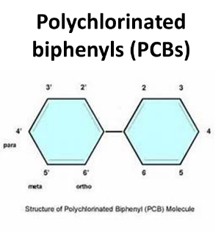
What are PCBs?
Polychlorinated biphenyls (PCBs) are a family of toxic human-made compounds that persist in the environment and accumulate in animal tissue. There are 209 different PCB molecules that range in toxicity. PCB mixtures vary, from thin and light-colored liquids to yellow or even black waxy solids.

Background on PCBs
PCBs were first produced in 1927 and became commercially manufactured in 1935 for their insulating and fire resistant properties. They were used in many products including: oil-based paints, hydraulic fluids, electrical equipment (transformers, capacitors, light ballasts, switches, and electromagnets) as well as adhesives and tapes, cable insulation, building caulking, and floor finish. When it was found that PCBs build up in the environment and result in serious health effects in animals and humans:
- Commercial production of PCBs was curtailed in 1977.
- The uncontained use of PCBs was banned in the United States in 1979 via the Toxics Substances Control Act (TSCA).
- There were no regulatory controls on PCB disposal before 1979 therefore legacy PCBs can still be found throughout the environment.
- In 1979, the estimated global inventory of PCBs was 1.5 million tons.

Health Effects of PCBs
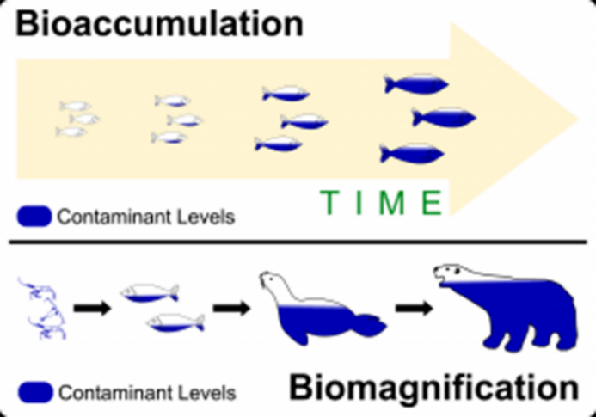
PCBs end up in our environment, including our lakes and rivers. Here they persist and travel up through the food chain, in some cases having ongoing impacts to humans and the environment. Low concentrations in the river build up (bioaccumulate) to higher concentrations in fish. This is a serious issue, particularly for people that consume fish from the Spokane River. Exposure to PCBs can result in skin ailments and liver damage, and they are a probable carcinogen. PCBs also have negative health effects on immune, reproductive, nervous, and endocrine systems. It is difficult to precisely calculate PCB source contributions due to low PCB concentrations and natural variability.

Bioaccumulation
Bioaccumulation occurs when an organism is exposed to a toxic over time. Biomagnification occurs as toxins build up in concentration up the food chain.

<< Consider finding another bioaccumulation graphic to put on the page…or create one. >>

Potential sources of PCBs in the Spokane River Watershed
PCBs are not manufactured in Spokane. There are many sources of PCBs to wastewater treatment plants. These include stormwater, human waste, industrial processes, consumer products, clothing dyes, and the inks in recycled newsprint. The wastewater treatment plants are effective in removing significant amounts PCBs from water but are unable to get down to the low levels of the water quality standards. While work is underway to reduce PCBs in contaminated soils, from stormwater systems, and in waste treatment plants, there are still unknown sources that need to be identified and addressed. Once sources are more clearly understood, identification of the best way to reduce the sources of PCB to the river can begin.

PCB Cleanup and Source Reduction
In the past 20 years, there has been a significant decrease of PCBs in the Spokane River because of cleanup and regulatory actions.
  - Remediation has directly removed significant sources of PCBs.
  - Natural reductions in PCBs have also occurred due to EPA bans on commercial production and restrictions on use.
More work is needed, however, if we are to have a clean river. To achieve the water quality goals for the river, we need to significantly reduce levels of PCBs. This will take a coordinated approach where everyone works together – locally, across the state, and at the national level – to achieve this goal.

PCB Reduction Challenge
PCBs are not only a legacy pollutant. US EPA regulations, under the Toxics Substances Control Act (TSCA), still allow for the production of “inadvertent” PCBs. This Federal allowance of 50 parts per million (ppm) is much larger than the Washington water quality standard for PCBs at 0.000000007 ppm, and the Spokane Tribal water quality standard of 0.0000000013 ppm. Recent testing by the Department of Ecology found that PCBs are present in commonly used consumer products. Forty-nine of 68 products tested contained PCBs (Dept. of Ecology, 2014). Ecology tested 133 more products in 2015 and found that 72% of the samples contained PCBs above 1 part per billion (Ecology, 2016). Conflicting regulations pertaining to PCBs and inadvertent production of PCBs can make it very difficult to fully address the PCB problem.

About SRRTTF

Product Information

Be a consumer and water advocate!
A key strategy to eliminating PCBs is to STOP ALLOWING PRODUCTS TO CONTAIN THEM. Because products are still allowed to contain PCBs, ask product suppliers if they know if their products contain PCBs? If enough people are bringing attention to it, more corporations might evaluate their products by asking the same question of the manufacturers. Just like organic foods and cage-free eggs have reached market viability, perhaps PCB-free products could reach the same point if the consumer demands it. When asking the question, anticipate that the employee won’t know the answer but the question simply raises awareness.
- Ask the oil change business you patronize if they would find out if their oil is PCB-free. If they say it is, ask if they have documentation to show that.
- When purchasing paints or dyes, check with them to see if they ask the product manufacturers about PCB content.
- Request plain packaging that uses less ink since a lot of common packaging contains PCBs due to inks and dyes.

Additionally, instead of solely targeting PCBs in the environment, we recommend a more comprehensive approach: reduce the purchase and use of all toxic chemicals, including PCBs. The links below provide a wealth of information to help each of us minimize our impact and reduce our personal toxic footprint.

Safer Choice Program
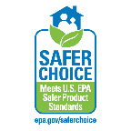
www.epa.gov/saferchoice
Safer Choice is an Environmental Protection Agency program which helps consumers, businesses, and purchasers find products that perform and are safer for human health and the environment.

Sustainable Packaging Coalition
https://sustainablepackaging.org
The Sustainable Packaging Coalition is a membership-based collaborative that believes in the power of industry to make packaging more sustainable. They are a leading voice on sustainable packaging and passionate about creating packaging that is good for people + the environment.

Safer Chemicals, Healthy Families
http://saferchemicals.org/
This coalition represents organizations and businesses united by a common concern about toxic chemicals in homes, places of work, and products used every day. They advocate for reform of outdated toxic chemical laws, working with retailers to phase out hazardous chemicals from the marketplace and educating the public about ways to protect one’s family from toxic chemicals.

Product Disposal

Spokane Waste Directory
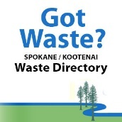
www.spokanewastedirectory.org
The Spokane-Kootenai Waste Directory helps you search for vendors near you that will manage specific waste types and is a guide to learning more about all types of waste.

Businesses

Green Screen for Safer Chemicals
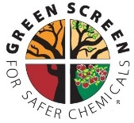
www.greenscreenchemicals.org
GreenScreen® for Safer Chemicals is a globally recognized tool that identifies hazardous chemicals and safer alternatives. Companies are using GreenScreen to innovate towards safer chemicals and create market efficiency in global supply chains.

CleanGredients
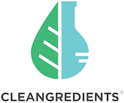
https://cleangredients.org
CleanGredients is a database of chemical ingredients used primarily to formulate residential, institutional, industrial, and janitorial cleaning products that have been pre-approved to meet the U.S. EPA’s Safer Choice Standard. CleanGredients is an indispensable purchasing resource for formulators who are seeking suppliers of chemical ingredients that will help them to obtain the Safer Choice label. Using CleanGredients helps formulators reduce risk to their business, save money, and get their products to market faster.

OTHER RESOURCES

Toxic-Free Future (formerly Washington Toxics Coalition)
https://toxicfreefuture.org/key-issues/clean-and-healthy-waters/
Striving to make complicated issues easy to understand for everyone, Toxic-Free Future advocates for the use of safer products, chemicals, and practices through advanced research, advocacy, grassroots organizing, and consumer engagement to ensure a healthier tomorrow.

