Control Action | Milestone | Action Timeline | Measurement Metric | Lead Group | Status 12/31/17
PCB Product Testing | Provide comments on the PCB product testing report | Within public comment period for draft report | Were comments provided? | Full Task Force | No draft report yet; Ecology lead (on 12/15/17) states “I plan to write individual short reports on the results for each product category: Fish Hatchery, Janitorial Supplies, Lubricants, Medical & Hospital Supplies, Flooring Material, and Fabrics…[no] dates scheduled for each report…plan is for all the reports to be finalized by the end of summer 2018.”
 | Provide input to Ecology in support of its efforts towards development of a clearinghouse | Initial effort within one year of issuance of Comprehensive Plan; evaluate effort needed annually | Was input provided? (see text for discussion) | Full Task Force or individual members | No draft product testing report yet; Ecology lead (on 12/15/17) states “I am not aware of a PCBs in products clearinghouse.” (With no report available as of 12/31/17, the Action Timeline to provide input to Ecology is not reachable.)
 | Provide public education on PCB containing products | Annual review of outreach activity | Has outreach been conducted? (see text for discussion) | Education and Outreach (E&O) Work Group | E&O Work Group produced SRRTTF poster (in Appendix). NPDES permittees conducted PCB outreach via multiple media. NOTE: limited activities by SRRTTF or permittees as of 12/31/17 on PCBs in products due to lack of specific information; appendices below contain info on permittee outreach.
Compliance with Existing PCB Regulations | Provide comments on identified regulatory issues | Within public comment period for issues that are identified | Were comments provided on identified issues? | TSCA Work Group or full Task Force as appropriate | Meeting 4/26/17 between SRRTTF & EPA staff on TSCA allowance for PCBs & water quality standard(s); SRRTTF response letter on Docket ID No. EPA-HQOA-2017-0190-TSCA Inadvertent PCB Allowance Discrepancy with Water Quality Standards, transmitted for SRRTTF to EPA by Ruckelshaus Center (submitted 5/11/17 online; hard copy mailed same day).
 | Review Ecology’s atmospheric deposition study results | Within public comment period for draft report | Was report reviewed and input provided? | Technical Track Work Group | No draft report available as of 12/31/17; draft report available for external review in May 2018
 | Support agencies on regulatory revisions that are driven by Ecology’s atmospheric deposition study | Within public comment period for draft report | Was input on regulatory revisions provided? | TSCA Work Group or full Task Force as appropriate | No draft report available as of 12/31/17; draft report available for external review in May 2018
Emerging Stormwater Technologies | Review of Phase 1 results | Within 12 months of receiving Phase 1 results report | Was report reviewed & comments provided? | Technical Track Work Group | Report sent to SRRTTF listserv 12/1/17; results of Phase 1 presented at 11/29/17 SRRTTF meeting. TTWG to set review timeline at 1/3/18 meeting.
 | Support Phase 2 if Phase 1 results warrant | Within three months of reviewing Phase 1 results report | Was support defined and provided if appropriate? | Technical Track Work Group | SRRTTF to decide 1/24/18 on allocating $15,000 to support Phase 2

Appendices: Information from NPDES Permittees on Outreach Related to PCBs (both in products and in general)
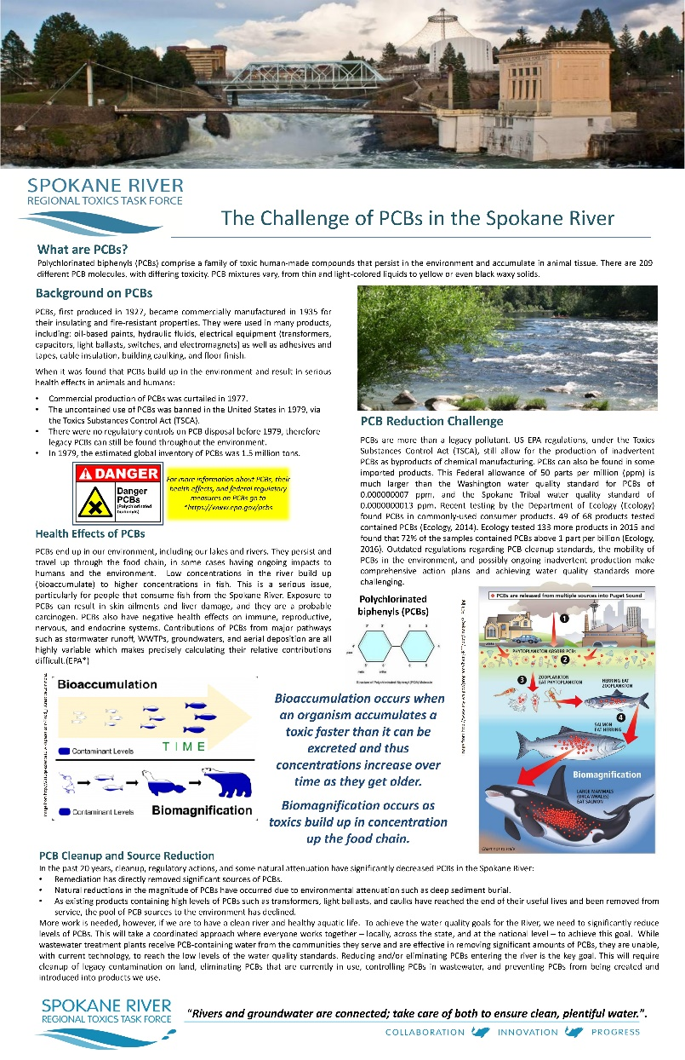
Appendix A: Spokane River Regional Toxics Task Force Outreach
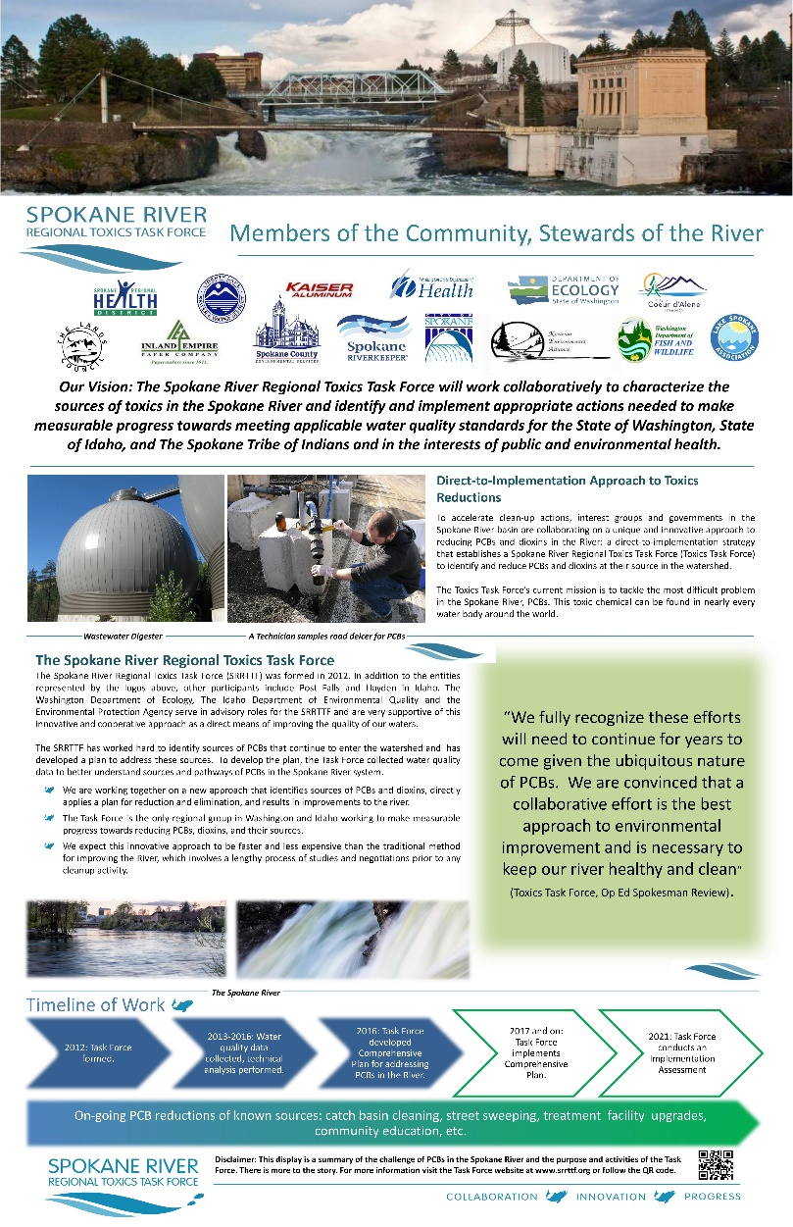

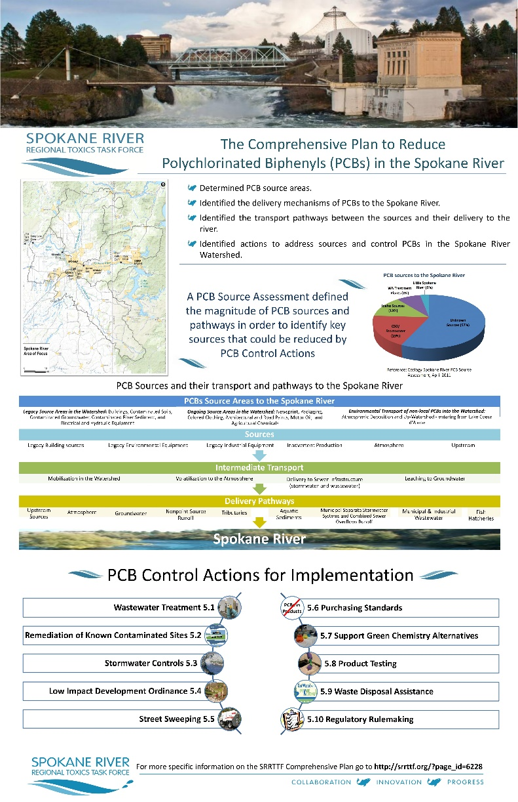
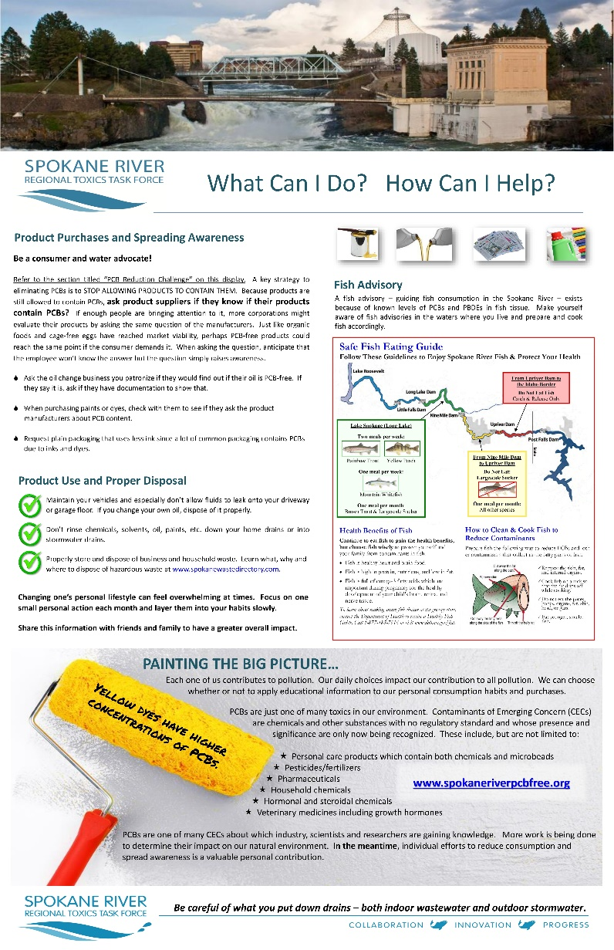
Appendix B: Spokane County Toxics Management Plan Sections on Public Outreach/Education
3.1.2 Application of Best Management Practices
Spokane County’s accomplishments during 2016 included public education, participation in the SRRTTF, and other activities as follows:
- Public education on toxics management: Public education is a critical component of the County’s ongoing efforts to reduce toxic pollutant loadings to the Facility. The County is an active participant in the SRRTTF, which is developing a targeted, regional public education program. In addition, the County has developed its own targeted, multimedia public outreach program for residential and commercial/industrial sewer customers. The program identifies commonly used products known to contain PCBs and informs customers about the existing health advisories, effects of PCBs on public health, and measures that they can take to reduce PCB releases to the environment. The education program also promotes proper handling and disposal practices of materials that are known to contain PCBs. Information has been disseminated via various mailings and utilities billings inserts, the County Utilities website, and public events at the Spokane County Water Resource Center. Product-specific information is limited but is developed and disseminated when appropriate and reliable information is available. The following specific activities were accomplished by the County in 2016:
- Updated a PCB informational poster for display in the Water Resource Center and other venues (approximately 200+ 8.5” x 11” versions of the poster were distributed in the community)
- Coordinated an open house event at the Water Resource Center, including PCB information
- Presented at several area conferences regarding the results thus far of the track-down sampling and treatment efficiency
- Provided input to the Washington Legislature regarding the Toxics Management Act
- Provided in-kind and financial support to the local EnviroStars program, a local source control/waste minimization program aimed at businesses
- Provided financial support for PCB monitoring and education by the SRRTTF
- Reformation of products: Supported industry-wide reformulation of products that can contain elevated concentrations of PCB-11 (e.g., diarylide yellow and other pigments used in printing and textiles), as well as commercial products that contain elevated PBDE concentrations (e.g., Bromkal).
- Elimination of older, County-owned, mechanical and electrical machinery: The County removed all known PCB-containing light ballasts and transformers from County-owned facilities in 1993 and 1995. The County Facilities Department will continue to remove and dispose of the remaining PCB- containing materials and equipment as they are encountered. These materials are profiled and disposed of during annual hazardous waste identification and disposal activities.
- SRRTTF Support: Played an active role in the SRRTTF, including financial support for administrative and technical tasks.
- Regional clearinghouse: The County continued to contribute data on observed PCB concentrations and patterns from the County’s monitoring program to the SRRTTF’s regional clearinghouse. The County data, in combination with data submitted by others, will increase understanding of the potential sources of PCBs in the region and help focus regional management efforts.
- Procurement policies: The County supported the SRRTTF in identifying commercial products that could contain inadvertently produced PCBs. In 2014, the County passed a revised procurement practices ordinance that allows for PCB testing of products and preferential purchasing of non-PCB equivalents within cost controls, similar to the city of Spokane and state of Washington.
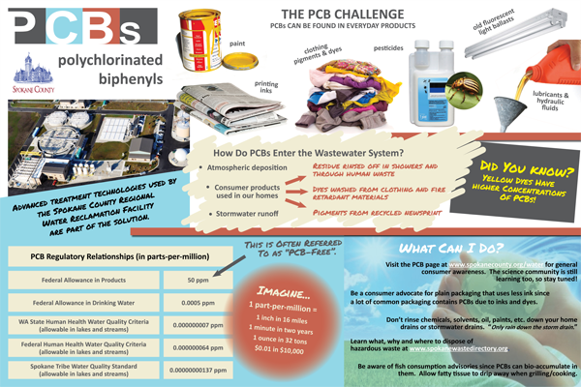
- Regional PCB Reduction Plan: County staff helped SRRTTF develop the Comprehensive Plan to Reduce PCBs in the Spokane River. The plan was adopted by SRRTTF in November 2016.
Figure 1 Spokane County PCB Poster

Spokane County 3.2 Toxics Management Action Plan for 2017
In 2017, the County will continue sampling of the two influent trunk lines (NVIPS and SVIPS) and the Facility effluent per the terms of the current Permit, and continue chemical fingerprinting analysis of the sample results.
The County will continue to apply the BMPs summarized in Section 3.1.2. These actions include active participation in the SRRTTF, implementing the targeted public education program, and ongoing removal of PCB-containing equipment and machinery.
The County plans to continue its public education program. Planned education activities for 2017 include:
- Having open houses at the Water Resource Center
- Ongoing collaboration with non-dischargers to disseminate toxics management information (e.g., Spokane Riverkeeper)
- Providing updates as warranted to wastewater treatment customers regarding new and useful PCB information that can provide consumer guidance
- Updating PCB information on the County website
- Presenting at area conferences and to citizen groups
- Providing input to the Washington Legislature regarding impending legislation regarding PCBs
- Continuing in-kind and financial support to the local EnviroStars program
Additionally, the County plans to:
- Continue to support industry-wide reformulation of products that can contain elevated concentrations of PCB-11 as well as commercial products that contain elevated PBDE concentrations (e.g., Bromkal)
- Continue to contribute data on PCB concentrations and sources to the SRRTTF’s regional clearinghouse to help increase understanding of the potential sources and to help regional management efforts
- Continue to play an active role in the SRRTTF including financial support for administrative and technical tasks
- Continue to support the SRRTTF in identifying commercial products that could contain inadvertently produced PCBs
- Begin implementing the applicable measures described in Section 5 of the Comprehensive Plan to Reduce PCBs in the Spokane River.

Appendix C: City of Spokane Toxics Management Plan Sections on Public Outreach/Education
The City of Spokane accomplishments during 2017 included public education, participation in the SRRTTF, and other activities as follows:
Public Education. “The City has completed several public education efforts which in turn should lead to increased protection of the Spokane River. The first of these was the promotion of Low Impact Development (LID). A utility bill insert, a brochure handed out with commercial building permit applications and available in the City’s permit center, and an associated web page on Wastewater Management’s web site (http://www.spokanewastewater.org/LID.aspx), highlighted ways to use natural features within development projects in order to filter and retain stormwater as close to where it falls as possible. An LID demonstration site was constructed at the Hazel’s Creek regional stormwater facility, where the public can take a self-guided tour to learn about the natural hydrology and LID. A brochure can be downloaded on our website at http://www.spokanewastewater.org/HazelsCreek.aspx. Implementation of LID will prevent PCB-contaminated runoff from entering both the CSO and MS4 systems within Spokane.
Storm drain markings continue to be installed throughout the city. The markings give a phone number to report illicit discharges and encourage “only rain down the drain.” Priority areas were developed where the markers would have the most effect. The markers were installed in these priority areas and are now being installed throughout the City as part of Wastewater Management’s maintenance activities.
A stormwater educational guide was developed by the City in collaboration with the Spokane Riverkeeper and Spokane River Forum. This guide informs industry and the public about how the stormwater system works, what can be done to prevent pollution from entering the system, and how to address stormwater requirements in the City’s commercial building permit and Ecology’s stormwater permit processes. It is available on the Spokane River Forum website (http://www.spokaneriver.net/?page_id=7688) and in hard copy at the City’s Development Services Center.
A public education presentation has been developed by the collaborating public information officers for the entities that make up the SRRTTF. This presentation was designed to be used for public meetings, presentations at schools, and possibly the city government cable TV station. The presentation will inform the public of the PCB issue, describe what actions the SRRTTF is doing to help combat the problem, and offer suggestions on how the public can help.
City staff and SRRTTF members have contributed to Spokesman Review newspaper articles surrounding PCBs and toxics in the river. Taskforce members have also made presentations at conferences and taken part in discussion panels surrounding the issue. A media specialist for the City has been working solely with the Utilities division on PCB and other related public outreach activities.
City staff participated in educating a group of WSU students in February 2014 on the PCB issue in the Spokane River. The students were part of a multidisciplinary competition entitled Saving the Spokane. The
goal of the competition was to look for innovative ways to reduce PCBs and other pollutants from entering the Spokane River. City staff led a group of students on a tour of the Union Basin and City Parcel cleanup site, Cochran Basin outfall, and the RPWRF outfall. Discussions on the tour centered on the background of the PCB issue and the City’s efforts in this area.
A PCB information page was added in 2015 to the City of Spokane website (https://my.spokanecity.org/publicworks/wastewater/pcbs/). The page outlines the PCB issue in the Spokane River, what the City is currently doing about it, and how the public can help.
A PCB information packet was developed in 2017 for distribution to City of Spokane Pretreatment Significant Industrial Users (SIUs). This info is attached in Appendix I. The packet is being mailed out and discussed with SIUs during the annual inspection process. The main goal with providing this information is to increase awareness among the City’s permitted industrial users of the PCB issue in Spokane, the steps that are being taken to address PCBs, and how dischargers to the sewer system can reduce PCBs. The packet was compiled from information developed by Ecology, Spokane County, SRRTTF, and the City of Spokane.”
Appendix D: Hayden Area Regional Sewer Board
PCBs and 2,3,7,8 TCDD Public Education Program
HARSB is an active participant and paying sponsor in the Spokane River Toxic Task Force (SRTTF). HARSB is not required to be a member of any nonprofit organization or other business entity affiliated with the Task Force a member. HARSB has supported the SRTTF public education program. HARSB has also developed and distributed it own PCB public education information and to educate the public about the following:
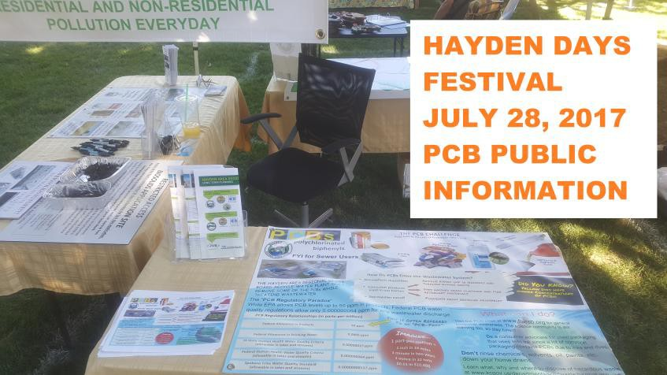
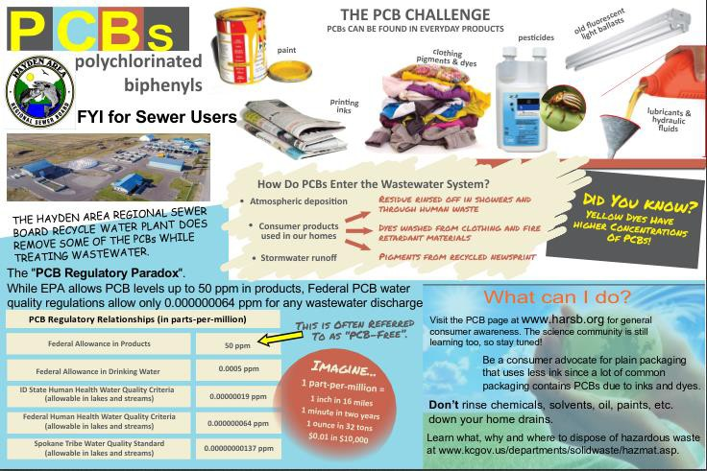
The difference between products free of PCBs and those labeled non-PCB but which contain PCBs below the TSCA regulatory threshold of 50 ppm. Proper disposal of waste products that may contain PCBs including those containing PCBs below the TSCA regulatory threshold of 50 ppm and the hazards associated with improper disposal.

HARSB PCB PUBLIC OUT REACH FLYER

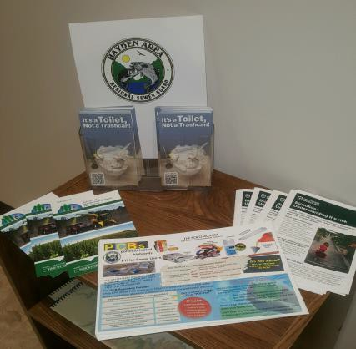
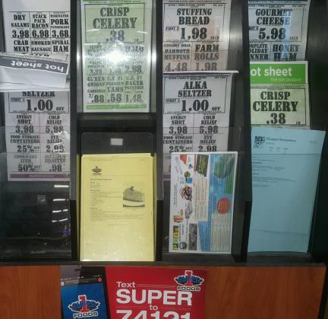
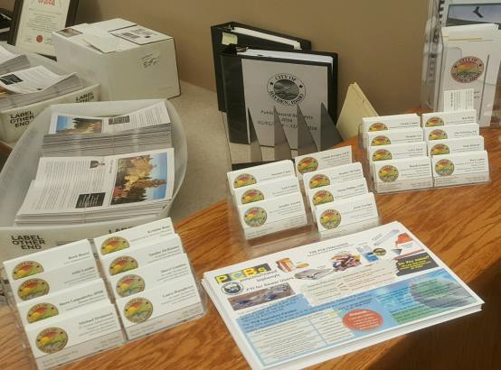
HARSB has distributed the educational materials its entity offices as part of the public outreach to the wastewater system users.

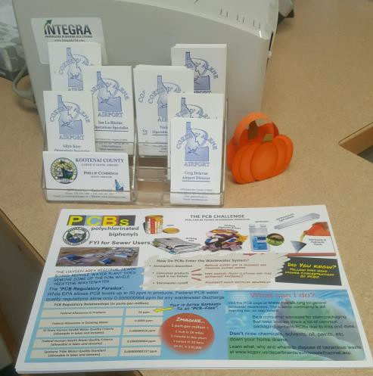
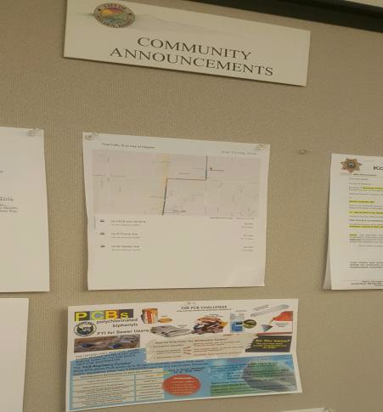
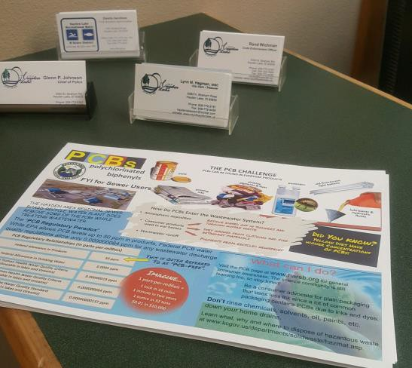
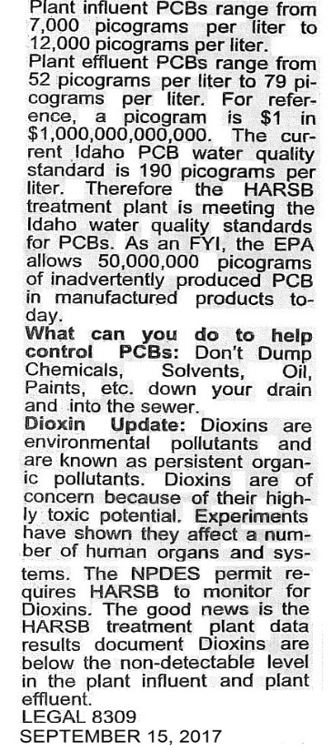
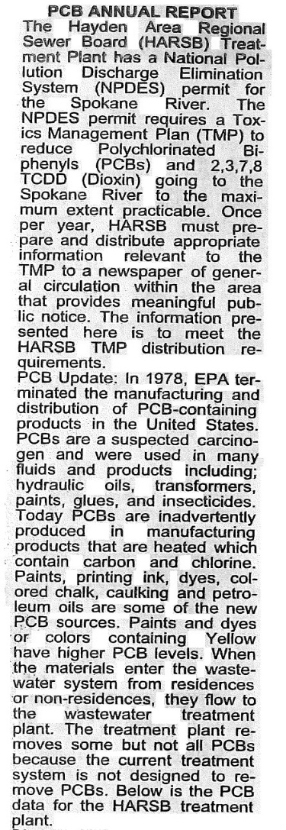
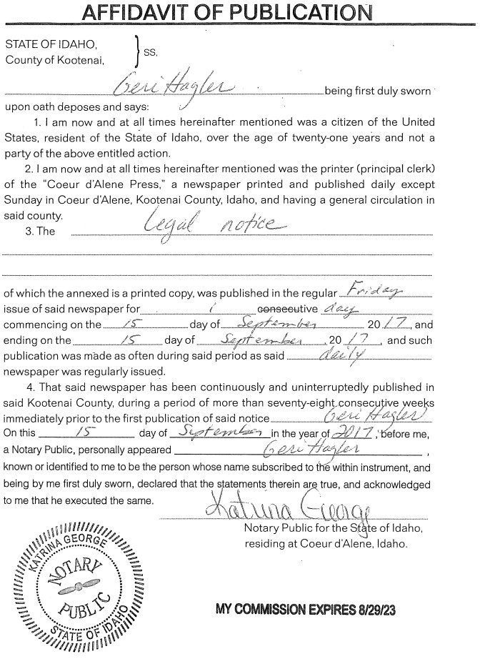
HARSB prepared and distributed PCB information and published it in the local newspaper for general circulation.

Appendix E: City of Coeur d’Alene accomplishments during 2017 included public education, participation in the SRRTTF, and other activities as follows:
The City of Coeur d’Alene developed educational materials as part of their TMP see below:

The City of Coeur d’Alene engaged in outreach through their amendment of Municipal City Code 13.20.2.1 (B) signed on February 7th, 2017. See below:
13.20.2.1: PROHIBITED DISCHARGE STANDARDS:

A. General Prohibitions: No user may introduce or cause to be introduced into the POTW any pollutant or wastewater which causes pass-through or interference. These general prohibitions apply to all users of the POTW whether or not they are subject to categorical pretreatment standards or any other national, State, or local pretreatment standards or requirements.
B. Specific Prohibitions: No user may introduce or cause to be introduced into the POTW the following pollutants, substances, or wastewater:
1. Pollutants which create a fire or explosive hazard in the POTW, including, but not limited to, waste streams with a closed cup flashpoint of less than one hundred forty degrees Fahrenheit (140°F) (60°C) using the test methods specified in 40 CFR 261.21; or
2. Wastewater having a pH less than 6 or more than 12, or otherwise causing corrosive structural damage to the POTW or equipment; or
3. Solid or viscous substances in amounts which will cause obstruction of the flow in the POTW resulting in interference but in no case solids greater than one-half inch (¹/₂"); or
4. Pollutants, including oxygen demanding pollutants (BOD, etc.), released in a discharge at a flow rate and/or pollutant concentration which, either singly or by interaction with other pollutants, will cause interference with the POTW; or
5. Wastewater having a temperature which will inhibit biological activity in the treatment plant resulting in interference, but in no case wastewater which causes the temperature at the introduction into the treatment plant to exceed one hundred four degrees Fahrenheit (104°F) (40°C) unless the approval authority, upon the request of the POTW, approves alternate temperature limits; or
6. Petroleum oil, non-biodegradable cutting oil, or products of mineral oil origin, in amounts that will cause interference or pass-through; or
7. Pollutants which result in the presence of toxic gases, vapors, or fumes within the POTW in a quantity that may cause acute worker health and safety problems; or
8. Trucked or hauled pollutants, except at discharge points designated by the City in accordance with section 13.20.2.12 of this chapter; or
9. Noxious or malodorous liquids, gases, solids, or other wastewater which, either singly or by interaction with other wastes, are sufficient to create a public nuisance or a hazard to life, or to prevent entry into the sewers for maintenance or repair; or
10. Wastewater which imparts color which cannot be removed by the treatment process, such as, but not limited to, dye wastes and vegetable tanning solutions, which consequently imparts color to the treatment plant's effluent, thereby violating the City's NPDES permit. Color (in combination with turbidity) shall not cause the treatment plant effluent to reduce the depth of the compensation point for photosynthetic activity by more than ten percent (10%) from the seasonably established norm for aquatic life; or
11. Wastewater containing any radioactive wastes or isotopes except as specifically approved by the Superintendent in compliance with applicable State or Federal regulations; or
12. Stormwater, surface water, groundwater, artesian well water, roof runoff, subsurface drainage, condensate greater than twenty (20) gallons per day, deionized water, noncontact cooling water greater than twenty (20) gallons per day, and unpolluted wastewater, unless specifically authorized by the Superintendent; or
13. Sludges, screenings, or other residues from the pretreatment of industrial wastes; or
14. Medical wastes, except as specifically authorized by the Superintendent; or
15. Wastewater causing, alone or in conjunction with other sources, the treatment plant's effluent to fail a toxicity test; or
16. Detergents, surface active agents, or other substances which may cause excessive foaming in the POTW; or
17. Any liquid, solids, or gases which by reason of their nature or quantity are, or may be, sufficient either alone or by interaction with other substances to cause fire or explosion or be injurious in any other way to the POTW or to the operation of the POTW. At no time shall two (2) successive readings on an explosion meter, at the point of discharge into the system (or at any point in the system), be more than five percent (5%) nor any single reading over ten percent (10%) of the lower explosive limit (LEL) of the meter; or
18. Grease, animal guts or tissues, paunch manure, bones, hair, hides or fleshings, entrails, whole blood, feathers, ashes, cinders, sand, spent lime, stone or marble dusts, metal, glass, straw, shavings, grass clippings, rags, spent grains, spent hops, wastepaper, wood, plastics, gas, tar asphalt residues, residues from refining or processing of fuel or lubricating oil, mud, or glass grinding or polishing wastes; or
19. Any substance which will cause the POTW to violate its NPDES and/or other disposal system permits; or
20. Any wastewater, which in the opinion of the Superintendent can cause harm either to the sewers, sewage treatment process, or equipment; have an adverse effect on the receiving stream; or can otherwise endanger life, limb, public property, or constitute a nuisance, unless allowed under special agreement by the Superintendent (except that no special waiver shall be given from categorical pretreatment standards); or
21. Wastewater containing substances not amenable to treatment or reduction by the sewage treatment processes employed, or are amenable to treatment only to such a degree that the sewage treatment plant effluent cannot meet the requirements of other agencies having jurisdiction over discharges to the receiving waters; or
22. The contents of any tank or other vessel owned or used by any person in the business of collecting or pumping sewage, effluent, septage, or other wastewater unless said person has first obtained testing and approval as may be generally required by the City and paid all fees assessed for the privilege of said discharge; or
23. Persistent pesticides and/or pesticides regulated by the Federal Insecticide Fungicide Rodenticide Act (FIFRA); or
24. Any hazardous wastes as defined in rules published by the State of Idaho or in 40 CFR part 261; or
25. Discharge of polychlorinated biphenyls (PCBs) in excess of 0.003 mg/l or any concentration of PCBs or 2,3,7,8-TCDD that causes pass through or interference; or
26. Wastewater containing fats, oils or grease (FOG) that causes or contributes to pass through, interference or otherwise causes the City to clean the collection system more frequently; or
27. Wastewater which contains grease or oil or any other substances that will solidify or become discernibly viscous at temperatures between thirty two degrees Fahrenheit (32°F) (0° Celsius) and one hundred fifty degrees Fahrenheit (150°F) (65.5° Celsius); or
28. Wastewater containing free or floating oil and grease, or any discharge containing animal fat or grease by-product in excess of one hundred fifty milligrams per liter (150 mg/l). This limit will not apply if the industrial user has installed and is properly operating and maintaining a gravity grease interceptor and implementing all required BMPs; or
29. Wastewater generated as a result of wastes pumped from gravity grease interceptors, hydromechanical grease interceptors or grease traps, sand-oil separators or other storage tanks or treatment units back into the POTW, either directly or indirectly, without approval of the City.
Pollutants, substances, or wastewater prohibited by this section may not be processed or stored in a manner that they could be discharged to the POTW. (Ord. 3558, 2017: Ord. 3374 §2, 2010)
The City of Coeur d’Alene also developed and distributed the following flyer to its customers:

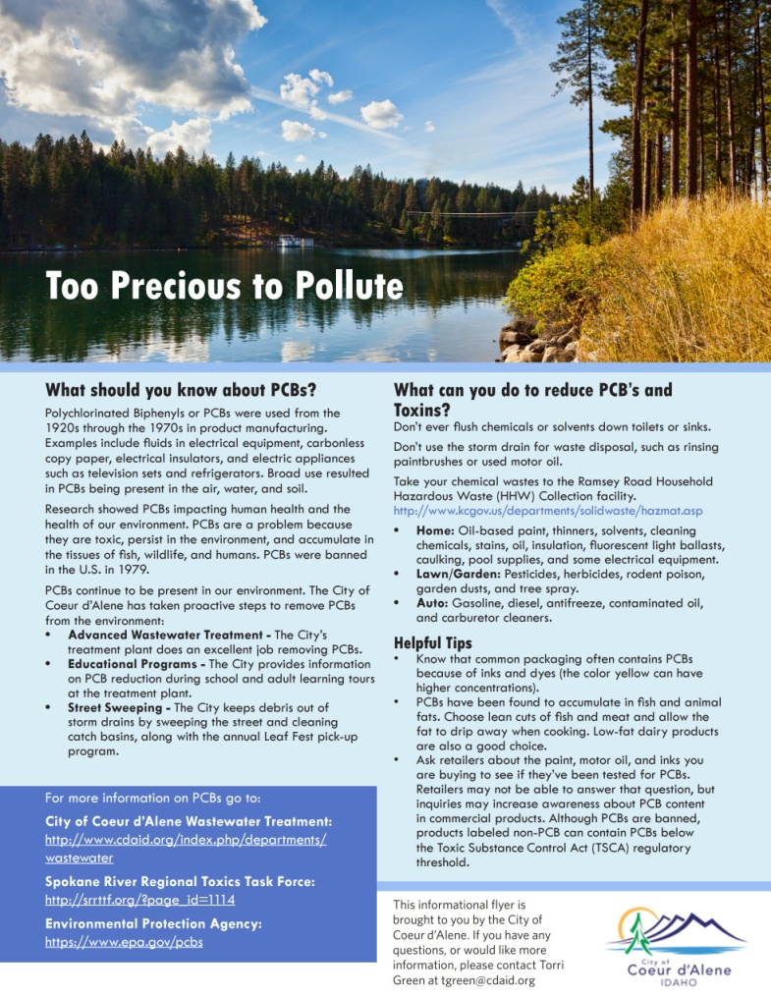
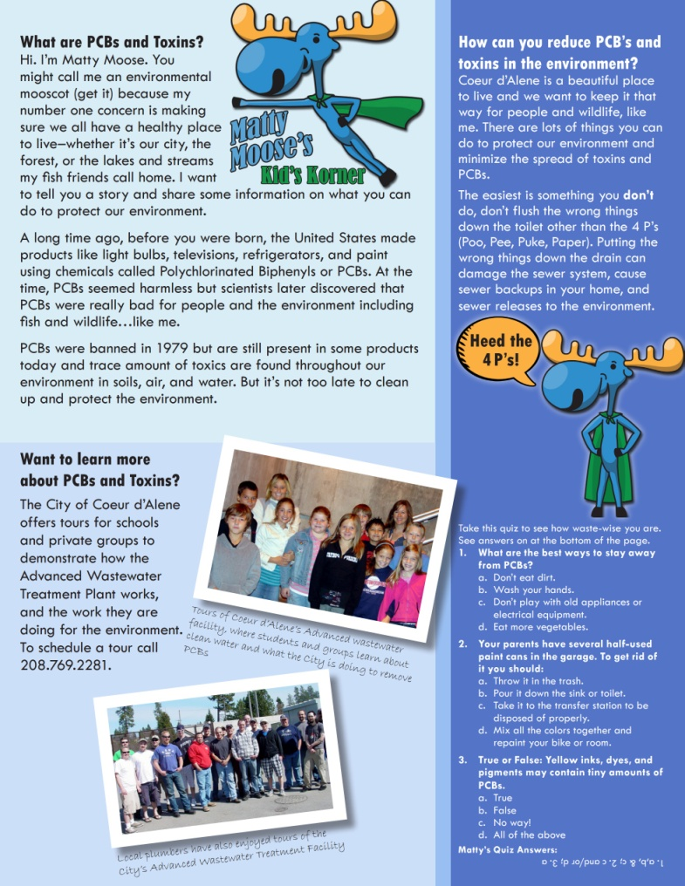

Appendix F: Liberty Lake Sewer and Water District
Liberty Lake Sewer & Water: “District has not done any education on PCBs in products specifically. We have done some education on PCBs in our wastewater, NPDES permitting, and removal.”

