ECOLOGO_W-C

*DRAFT – 02/01/2018*

Addendum 2 to

Quality Assurance Project Plan

Spokane River Source Trace Study

February 2018

Publication No. 18-0x-1xx

**Publication Information**

**Addendum**

This addendum is on the Department of Ecology’s website at <https://fortress.wa.gov/ecy/publications/SummaryPages/180x1xx.html>

This addendum is an addition to an original Quality Assurance Project Plan. It is not a correction (errata) to the original plan.

Data for this project will be available on Ecology’s Environmental Information Management (EIM) website at [www.ecy.wa.gov/eim/index.htm](http://www.ecy.wa.gov/eim/index.htm). Search Study ID JROSxxxx.

#### Original Document (Unpublished)

Spokane Basin Sampling and Analysis Plan (SAP) and Quality Assurance Project Plan (QAPP) for the Spokane River Source Trace Study Regarding PCB, PBDE, Metal, and Dioxin/Furan Contamination

**Authors and Contact Information**

James Ross

Water Quality Program

Washington State Department of Ecology

4601 N Monroe

Spokane, WA 99205

*Any use of product or firm names in this publication is for descriptive purposes only  
 and does not imply endorsement by the author or the Department of Ecology.*

*Accommodation Requests: To request ADA accommodation including materials in a format for   
the visually impaired, call Ecology at 360-407-6764. Persons with impaired hearing may call Washington Relay Service at 711. Persons with speech disability may call TTY at 877-833-6341.*

Addendum 2 to Quality Assurance Project Plan

Spokane River Source Trace Study

Hangman Watershed PCBs

February 2018

**Approved by:**

|  |  |  |
| --- | --- | --- |
| Signature: |  | Date: |
| James Ross, Author / Principal Investigator, ERO WQP |  |  |
| Signature: |  | Date: |
| Elaine Snouwaert, Author’s Unit Supervisor, ERO WQP |  |  |
| Signature: |  | Date: |
| Adriane Borgias, Author’s Section Manager, ERO WQP |  |  |
| Signature: |  | Date: |
| Alan Rue, Acting Director, Manchester Environmental Laboratory |  |  |
| Signature: |  | Date: |
| Chris Dudenhoeffer, WQP Quality Assurance Officer |  |  |
|  |  |  |
|  |  |  |
|  |  |  |
|  |  |  |

Signatures are not available on the Internet version.

ERO WQP: Eastern Region Office Water Quality Program

### Background

The purpose of the Spokane River Urban Waters initiative is to find sources of high priority contaminants of concern in the Spokane River Basin. Previous studies had shown random spikes in the concentration of PCBs in Hangman Creek, and homolog pattern analysis suggest a stormwater source.

Hangman Creek has two CSO outfalls, CSO 19 and CSO20. Stormwater from CSO 20 was sampled three times in 2007 during a study with total PCB concentrations ranging from 990 to 7700 pg/L. Recent efforts by Spokane City have eliminated any discharge from these outfalls since 2016. Monitoring near the mouth of Hangman Creek for the SRRTTF during 2014 and 2016 showed relatively low levels of PCBs except during two events. During the synoptic survey of 2014, the August 20th sample spiked from around 100 pg/L to 2450 pg/l. During the 2016 monthly monitoring study, the October sample spiked from averaging under 50 pg/L up to over 1000 pg/l. Both of these spikes occurred when streamflows were rising quickly from baseflow conditions. Other monthly sampling during the 2016 study occurred during much higher streamflows, but all other samples were taken during a period of declining streamflow.

### Project Description

The goal of this study is to identify stormwater sources of PCBs in the Lower Hangman Creek Basin. This project will collect samples for PCB congeners from Hangman Creek and three to five stormwater outfalls to the waterbody during storm events. Sampling will occur during the spring rainy season, and during summer storm events if possible. Sampling sites may be moved or added in order to bracket suspected PCB sources. A goal is to capture at least three storm events, at least two where the PCB source is “bracketed” by sampling locations. This QAPP addendum describes the planning for the execution of this project.

### Tasks required

The project is anticipated to begin when this addendum is approved and continue through fall 2018. The overall study approach is to:

* Procure a contract with independent lab for low level PCB congener analysis by EPA method 1668
* Collect stream and storm outfall samples during storm events through 2018 for low level PCB congener analysis and ship to selected laboratory.
* Analyze data, and produce technical memo detailing findings and next steps.

### Organization and Schedule

Table 1 Project Organization

| **Staff**  **(All EAP except client)** | **Title** | **Responsibilities** |
| --- | --- | --- |
| Jim Ross  Watershed Unit  ERO WQ  Phone: 509-329-3573 | Project Manager  Principal  Investigator | Writes the QAPP Addendum. Oversees field sampling and transportation of samples to the laboratory. Conducts QA review of data, analyzes and interprets data, and enters data into EIM. Writes the draft and final technical memo. |
| TBD | Field Assistant | Helps collect samples and records field information. |
| Elaine Snouwaert  Watershed Unit  ERO WQ  Phone: 509-329-3590 | Unit Supervisor for the Project Manager | Reviews the project scope and budget, tracks progress, provides internal review of the QAPP Addendum, and approves the final QAPP Addendum |
| Adriane Borgias  ERO WQ  Phone: 509-329-3515 | Regional Program Manager for the Project Manager | Reviews the project scope and budget, approves project budget. Reviews the draft QAPP Addendum, and approves the final QAPP Addendum. |
| Alan Rue  Manchester Environmental Laboratory  Phone: 360-871-8801 | Acting Director | Reviews and approves the final QAPP Addendum. |
| Spokane River Regional Toxics Task Force | Stakeholder Group | Reviews Draft QAPP Addendum |
| Contract Laboratory | Project Manager | Reviews draft QAPP Addendum, coordinates with MEL QA Coordinator |
| Chris Dudenhoeffer  Phone: 360-407-6445 | Water Quality Program Quality Assurance  Officer | Reviews and approves the draft QAPP Addendum and the final QAPP Addendum. |

### Proposed project schedule

Table 2 Project Schedule

|  |  |  |
| --- | --- | --- |
| **Field and laboratory work** | **Due date** | **Lead staff** |
| Field work completed | November 2018 | Jim Ross |
| Laboratory analyses completed | March 2019 | |
| **Environmental Information System (EIM) database** | |  |
| EIM Study ID | ID number | |
| EIM complete | September 2019 | Jim Ross |
| **Final report (tech memo)** | |  |
| Author lead | Jim Ross | |
| Draft due to supervisor | September 2019 | |
| Final report due on web | December 2019 | |

### Project Budget

Funding for this project will come from Ecology’s ERO Urban Waters Laboratory Budget, SIC F4260. It is expected that there will be three to five sampling events over the course of the project, with no more than three events in any fiscal year.

Table 3 Project Budget

|  |  |  |  |  |  |  |
| --- | --- | --- | --- | --- | --- | --- |
| **Parameter** | **Samples/ event** | **QA Samples / event** | **Total Samples** | **Cost Per Sample** | **Contract**  **Fee per sample** | **Cost/event** |
|  | | | | | | | |
| PCB (209 congeners)¹ | 5 | 2 | 7 | $800 | $200 | $7000 |
|  | | | | | | | |

FY 2018 $14,000-$21,000

FY 2019 $14,000-$21,000

Total Project $35,000

### Quality Objectives

### Targets for precision, bias, and sensitivity

### 

**Precision**

Precision is a measure of the variability in the results of replicate measurements due to random error. Precision will be measured as the relative percent difference (RPD) for replicate samples.

Quality objectives for precision, which include duplicate and matrix spike duplicate samples are detailed in Table 4

**Bias**

Bias is the difference between the population mean and the true value and will be measured as acceptable % recovery. Bias is the systematic error due to contamination, sample preparation, calibration, or the analytical process. Most sources of bias are minimized by adherence to established protocols for the collection, preservation, transportation, storage, and analysis of samples

Acceptance limits for bias, which include laboratory check standards, matrix spike and surrogate recovery are found in Table. 5

**Sensitivity**

Sensitivity is a measure of the capability of a method to isolate the concentration of a substance from the analytical method’s background noise. Sensitivity is commonly described as reporting limit, or detection limit. Laboratory Reporting Limits can be found in Table 4

Table 4 Project Precision and sensitivity targets

|  |  |  |  |  |  |
| --- | --- | --- | --- | --- | --- |
| Parameter | Analytical Method | Reporting limit pg/L | Expected concentrations pg/L | Duplicate Samples (RPD) | Matrix Spike Duplicates (RPD) |
| PCB Congeners | EPA 1668c | 1-5 | 20-2000 (total PCB) | ≤50% | <50% |

Table 5 Project Bias Targets

|  |  |  |  |  |  |
| --- | --- | --- | --- | --- | --- |
| Parameter | Analytical Method | Daily Calibration verification  (% Recovery) | Lab Control Samples  (% Recovery) | Matrix  Spike and surrogate  (% Recovery) | Lab (Method) Blank |
| PCBs | EPA 1668c | 50 – 150† | 50 – 150† | 25-150% | <150 pg/L (total PCB) |

### Targets for comparability, representativeness, and completeness

.

**Representativeness and Comparability**

Representativeness is the measure of how well a sample reflects environmental conditions. Ecology SOPs and sampling methods will be followed strictly to ensure representativeness is met. Comparability is the confidence with which one dataset can be compared to another. Using accredited laboratories, consistent EPA approved methods, in this case EPA 1668c, and achieving the reporting and blank limits in table will promote comparability.

**Completeness**

A minimum of 90% of proposed samples to be collected under this project is the goal for project completeness. The inability to control storm frequency and duration may prevent this goal from being met, but will not be cause for invalidating the overall project.

### Special method requirements

High resolution PCB congener analysis by EPA method 1668C analysis will be subcontracted out to an accredited independent lab to be selected in March 2018.

### Sampling locations and frequency

Table 7 (below) describes the proposed sample locations. Figure 1 illustrates the project area, highlighting sampling locations. Figure 2 illustrates the area near Interstate 90 where many sampling locations are in close proximity to each other. Table 8 indicates the proposed sampling frequency at each sample site. This table is for guidance only, as weather conditions and the presence or absence of discharge at each proposed site will dictate the actual sampling. In the event that all sites are discharging, the project manager will determine the five sites most suitable for sampling that meet the project objectives.

Table 9 illustrates the approximate times that sampling will be attempted, as with the frequency, weather conditions will be the determining factor on the actual field sampling trips.

### 

Table 7 Potential Project Sampling Locations

|  |  |  |  |
| --- | --- | --- | --- |
| Lat DD | Long DD | Station ID | Description |
| 47.644251 | -117.450933 | 56GAR-00.2 | Garden Springs at Fish Lake trail |
| 47.648524 | -117.446115 | 56MS4-I90RB1 | MS4 outfall 100' US of I-90, RB, concrete pipe |
| 47.648813 | -117.446282 | 56MS4-I90RB2 | MS4 outfall directly underneath I-90, RB, large corrugated pipe |
| 47.648534 | -117.446519 | 56MS4-I90LB | MS4 outfall 40' US of I-90, LB, concrete outfall with wing walls |
| 47.649288 | -117.446398 | 56CSO-19 | CSO #19 outfall DS of I-90, RB |
| 47.650254 | -117.448704 | 56MS4-Sunset | MS4 outfall DS Sunset Blvd., just off parking lot for High Bridge Pk. |
| 47.645832 | -117.447298 | 56MS4-11thAve | MS4 outfall at 11th Ave., DS RB, large corrugated pipe |
| 47.602950 | -117.405760 | 56HAN-06.2 | Hangman Creek @ Meadowlane Rd |
| 47.657000 | -117.464400 | 56MS4-GovWay | MS4 Outfall E of Govt Way nr Greenwood Rd |
| 47.617300 | -117.419800 | 56CSO-20 | CSO #20 nr Cheney Spokane Rd |
| 47.614138 | -117.425300 | 56MAR-00.0 | Marshall Creek at Mouth |

Table 8 Sampling Event Site Selection

|  |  |  |  |  |  |  |  |  |  |  |  |
| --- | --- | --- | --- | --- | --- | --- | --- | --- | --- | --- | --- |
|  | HAN6.2 | MAR0.0 | GAR0.2 | I90RB1 | I90RB2 | I90LB | Sunset | GovWay | 11th | CSO19 | CSO20 |
| 1st Spring | Y | Y | Y | Y | O | Y | O | O | O | O | O |
| 2nd Spring | Y | O | O | O | O | O | O | O | O | O | O |
| 3rd spring | Y | O | O | O | O | O | O | O | O | O | O |
| 1st Dry | Y | Y | Y | O | O | O | O | O | O | O | O |
| 2nd Dry | Y | Y | Y | O | O | O | O | O | O | O | O |
| 1st Fall | Y | Y | Y | Y | O | Y | O | O | O | O | O |

Y Site will be sampled, unless no flow

O Optional to sample, dependent on flow

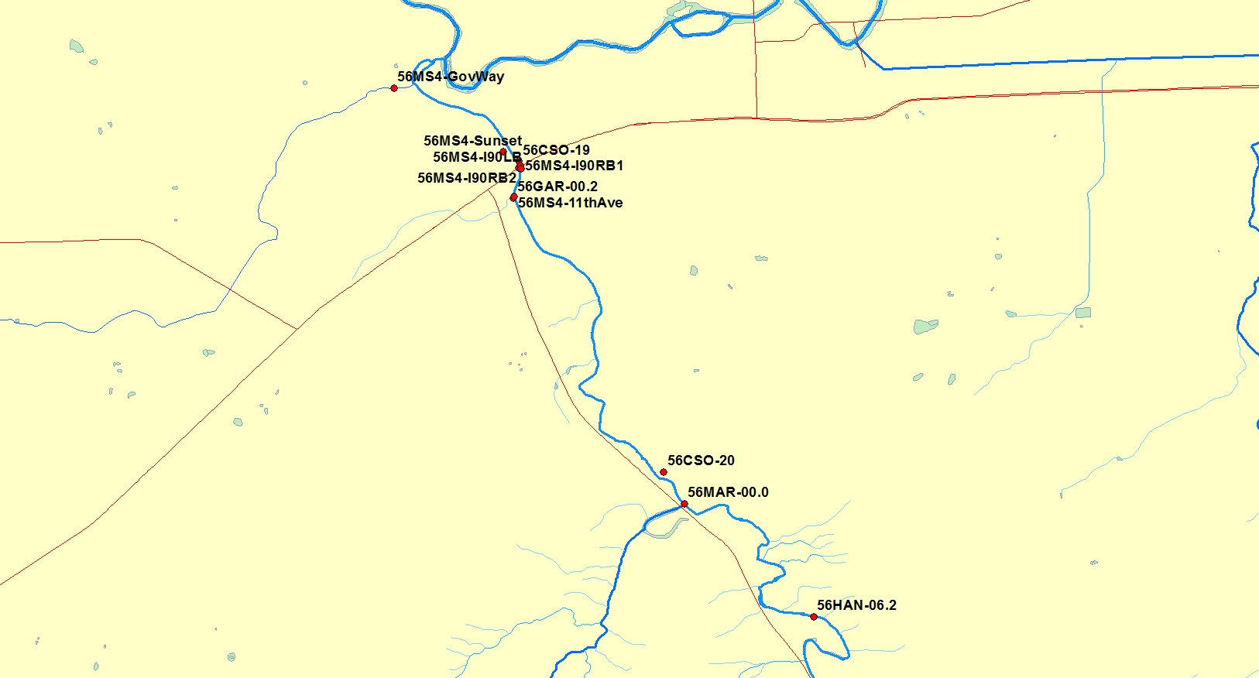

Figure 1 Lower Hangman Creek

Table 9 Sampling Event Schedule

MarAprMayJuneJuly AugSeptOct

First spring storm XXX

Second spring storm XXXX

Optional Third spring storm XXXX

First dry season storm XXX

Optional second dry season storm XX

First Fall storm XXX

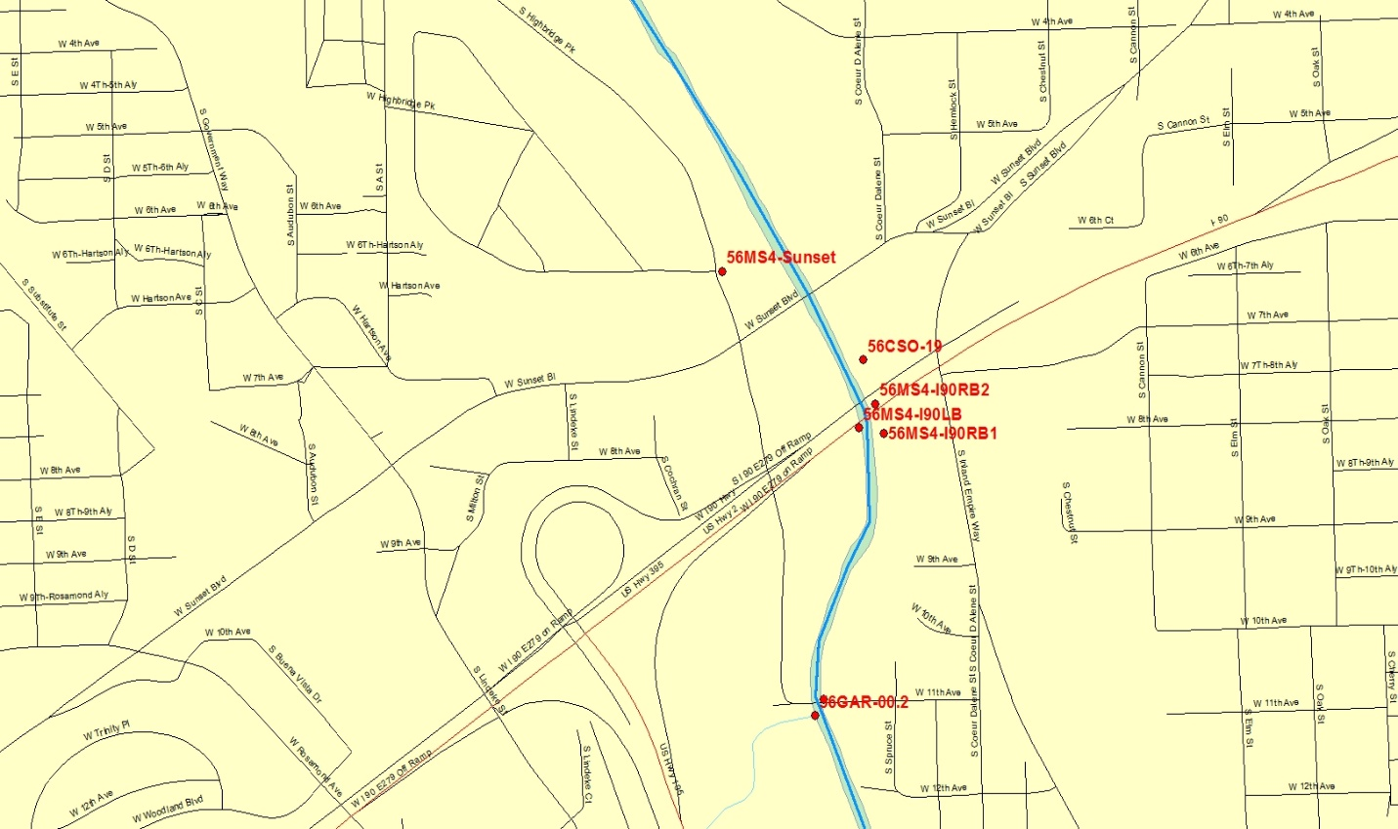

Figure 2 Hangman Creek I90 vicinity

### Possible challenges and contingencies

The study will target stormwater events; precipitation forecast is not an exact science and storm event sampling needs to be timed carefully to collect samples. To the maximum extent possible, all proposed stormwater monitoring will be completed. The optional sampling events noted in Table 9 (above) should provide adequate contingency for sampling an adequate number of storm events.

### Field Procedures

### Measurement and sampling procedures

The following Ecology Standard Operating Procedures (SOPs) will be used for this project:

• EAP003 – *Sampling of Pesticides in Surface Waters, Version 2.1* (Anderson, 2012).

• EAP070 – *Minimizing the Spread of Invasive Species* (Parsons et al., 2012).

• EAP090 – *Decontaminating Field Equipment for Sampling Toxics in the Environment* (Friese, 2014).

### Invasive species evaluation

Ecology’s Environmental Assessment Program developed a *Standard Operating Procedure to Minimize the Spread of Invasive Species* (Parsons et al., 2012)*.* This SOP must be followed if field work is conducted within a designated area of extreme concern for the spread of invasive species. It covers all field operations and also applies to contractors or organizations working jointly with Ecology. Hangman Creek watershed is not considered an area of extreme concern for the spread of invasive species.

Washington State law prohibits the transportation of noxious aquatic plants, animals, and many weeds. The SOP was developed to meet the law’s requirement and to minimize risk of spreading any organisms, especially aquatic invasive species (AIS), within or between water bodies or sites. All field operations, sample equipment, supplies, and gear are covered in the SOP.

### Equipment decontamination

Equipment used in the field for collection or processing of sediment and stormwater samples will be decontaminated using Ecology’s SOP, *Decontamination of Sampling Equipment for Use in Collecting Toxic Chemical Samples* (Friese, 2014). Before fieldwork, sample equipment will be washed thoroughly with hot tap water and Liquinox detergent, followed by sequential rinses of 10% nitric acid, de-ionized water, and pesticide-grade acetone. Equipment will then be air-dried under a fume hood and covered with aluminum foil, dull side contacting equipment. Sampling equipment that is reused between sites will be cleaned between locations by brushing off any deposits and thorough rinsing with deionized water.

Sampling will target the first 12 hours of the storm. Sampling will preferably be performed by direct sampling of stormwater without the use of intermediate equipment. In this approach, the stormwater outfall will be monitored by holding a sample container by gloved hand and plunging it directly into the outfall’s flow. This approach will be used only when sample flow can be safely accessed. In the event direct immersion sampling is not practical, intermediate equipment, such as a sampling pole, rope and bucket, or sampler will be used to collect the sample. In the event intermediate equipment is used, the sampling team will use the “clean hands, dirty hands” approach to minimize sample contamination. In this approach, one member is designated as “clean hands.” All operations involvement contact with the sample bottle and transfer of the sample from the sample collection device to the sample bottle are handled by “clean hands” The team member(s) designated “dirty hands” is responsible for preparation of the sampler and all other activities that do not involve direct contact with the sample. Clean non-powdered nitrile gloves are worn at all times when handling sampling equipment or sample containers. Sampling methods other than direct immersion will be noted on the field forms.

Field contamination will be assessed through the use of Trip Blanks or Transfer blanks as appropriate. A trip blank is a container of lab supplied pure water that will accompany the samples into the field and stored and shipped with the samples. A transfer blank is a similarly supplied water sample that is poured into a clean sample container in the field and stored and shipped with the samples.

All field samples and blanks will be placed in new zip lock bags, then wrapped with bubble wrap material to protect the bottles during shipping. Blue ice will be placed on top of the protected bottles, and any remaining space in the coolers will be filled with packing material.

### Containers, preservation methods, holding times

Table 10 Containers, Preservation and Holding Time

|  |  |  |  |
| --- | --- | --- | --- |
| Parameter | Container | Preservation | Holding Time |
| PCB congeners | 1Lor 2L Amber wide mouth precleaned | Cool < 6°C | 1 year |

### Corrective action processes

The project manager will work closely with the MEL QA Coordinator conducting data review for contracted analysis to examine any QC criteria discrepancies. The project manager will determine whether data should be re-analyzed, rejected, or used with appropriate qualification.

The laboratory analysts will document whether project data meets method QC criteria. Any departures from normal analytical methods will be documented by the laboratory and described in the data package from the laboratories and also in the final report for the project.

### Data recording and reporting requirements

All field forms used for collecting data and observations will be printed on water-proof paper and kept in a field notebook. All field data and observations will be recorded in Excel spreadsheets at the end of each round of sample events. Data entry will be checked by another member of the project team for accuracy. Field and laboratory data for the project will be entered into Ecology’s EIM system. Laboratory data will be uploaded into EIM using the EIM XML results template.

### Censoring for Method Blank Contamination

For high-resolution methods (EPA 1600 series for PCBs, PBDEs, and dioxins/furans), individual congener results will be considered non-detects (“U” or “UJ”) if the concentrations are less than 3 times the concentration of the associated laboratory method blanks. The result values (qualified as non-detects) will then be reported at the estimated quantitation limit (EQL) or at the level of detection, whichever is higher. For summing of totals, non-detected results will be assigned a value of zero. If only non-detected results comprise a total value, then the final total result was simply reported as “ND” for not detected. Sample totals will be assigned a qualifier of “J” (estimated) if more than 10% of the result concentrations are composed of results containing “J” qualifiers.

### Laboratory data package requirements

The data package from the contract lab will provide MEL with all the raw data which will include, but is not limited to, a text narrative; and analytical result reports; analytical sequence (run) logs, chromatograms, and spectra for all standards, environmental samples, and batch QC samples; and preparation bench sheets. In addition, all of the necessary quality assurance and control documentation will be provided, including results from matrix spikes, replicates, and blanks.

### Electronic transfer requirements

The contract laboratory will also have an EDD that meets the requirements of this project. These requirements will be detailed in the bid solicitation for the contract laboratory work.

### Responsibility for reports

The author of the final technical memo will be Ecology’s ERO Urban Waters Specialist.

The technical memo will document and present the project’s findings and next steps.