Inadvertent PCBs in Pigments: A Case for Collaborative Market Innovation for a Circular Economy
Draft Report

Prepared for:
The Spokane River Regional Toxics Task Force

Submitted by:
Northwest Green Chemistry
June 2018

Executive Summary
In an effort to decrease polychlorinated biphenyl (PCB) and other toxic chemical contamination in Washington waters, the Spokane River Regional Toxics Task Force (SRRTF) is working on multifaceted approaches to reduce loading that include both regulatory and voluntary initiatives. This project addresses inadvertently generated PCBs that are released into waterways, with a focus on PCBs in paper and packaging materials. Northwest Green Chemistry was contracted to prepare a white paper that could be used to inform external stakeholders and to suggest next steps using green chemistry, alternatives assessment and voluntary market-based strategies.
Whether or not the presence of inadvertent PCBs in pigments used on individual packages and newsprint presents a risk to users of those materials is not the focus of this paper. Rather, the issue is that these materials are ubiquitous and provide a steady flow of additional PCBs into products and the environment on a global scale. Pigments used on paper and packaging materials contaminate recycling streams that hinder both recycling businesses and our ability to achieve a safe and healthy circular economy. The continued discharge of PCBs into waterways decreases the effectiveness of expensive, ongoing remediation efforts while preventing further mitigation of these risks to human and environmental health. This is occurring at a time when China has announced that they will no longer be accepting international paper and plastic waste for recycling and there is growing awareness of damage from consumer product waste that is mismanaged and found to pollute the ocean and other water bodies. Calls for a circular economy that 1) designs out waste and pollution; 2) keeps products and materials in use and 3) regenerates natural systems is growing.
This paper and the accompanying presentation materials represent the first phase of work intended to inform and engage external stakeholders and to motivate them to take strategic action to identify and adopt inherently safer pigments that contain no or ultra-low inadvertent PCBs. It provides some background information on the scope of the problem including sources of inadvertent PCBs and regional inadvertent PCB control initiatives. It is based on reviews of media articles, presentations, scientific studies and interviews with stakeholders. It then offers a set of proposed next steps for discussion with the SRRTTF. The proposed next steps include targeted collaborations, green chemistry and engineering research projects, alternatives assessment, and procurement activities that can help drive substitution of those pigments containing the highest levels of inadvertent PCBs and adoption of safer alternatives.

Table of Contents
1. Executive Summary 2
2.1. List of Figures 4
2.2. List of Tables 4
3. Introduction 5
4. What are PCBs? 5
5. What are Legacy PCBs? 6
6. What are Inadvertent PCBs? 6
6.1. How are Inadvertent PCBs Formed? 7
7. Sources of Inadvertent PCBs 7
8. Inadvertent PCBs: Current Challenges 8
8.1. Human and Environmental Health Impacts 9
9. Products and Pigments that Contain Inadvertent PCBs 11
10. Regulatory Approaches 13
10.1. Federal Inadvertent PCB Requirements 13
10.2. Regional Water Quality Requirements 14
10.3. Area Case Studies 16
10.3.1. Delaware 16
10.3.2. San Francisco 16
10.3.3. Spokane 16
11. An Obstacle to a Circular Economy 17
12. Strategic Solutions and Next Steps 18
12.1. Targeted Collaborations 18
12.2. Green Chemistry and Engineering Research 21
12.3. Alternatives Assessment 21
12.4. Implementing Procurement Policies to Drive Substitution 23
13. Conclusion 24
14. References 25
15. Appendix A: PCB Trade Names 33
16. Appendix B: Manufacturing Processes 34
17. Appendix C: Exposure to PCBs 37
18. Appendix D: Pigment Manufacturers 38
19. Appendix E: PCB Control Actions 41
20. Appendix F: A Closer Look at PCB 11 43
21. Appendix G: PCB 11 Concentrations in Printed Materials 44
22. Appendix H: Initial Recommended Collaborators 45

List of Figures
Figure 1: A selection of PCB congeners 5
Figure 2: PCBs released into Puget Sound 10
Figure 3: Organic Pigments Found to Contain Inadvertent PCBs 11
Figure 4: Example conceptual model of PCB sources and pathways 16
Figure 5: Circular vs Contaminated Circular Economy 18

List of Tables
Table 1: Inadvertent PCBs above Federal Water Quality Standards 7
Table 2: Examples of Regionally Varying PCB Limits 15
Table A1: Table of international PCB trade names (United Nations Environment Programme (UNEP) Chemicals, 1999) 35
Table B1: US EPA list of manufacturing processes likely to generate inadvertent PCBs 36
Table B2: End products of manufacturing processes in which PCBs are incidentally generated 38
Table D1: Leading newsprint and packaging pigment manufacturers 40
Table E1: Control actions identified as potentially applicable for reducing PCB loads to the Spokane River and Lake Spokane 43
Table G1: PCB 11 Concentrations in printed materials worldwide 46
Table G2: PCB 11 concentrations in consumer goods 46
Table H1: Recommended collaborators 48

Introduction
Polychlorinated biphenyls (PCBs) were determined to create human and environmental health concerns worldwide. The intentional manufacture of PCBs was predominantly phased out, through both voluntary industry initiatives and as a result of regulatory action.
However, PCBs are still being discharged into the environment, prolonging the presence of this class of chemicals. They continue to be produced inadvertently as byproducts of dozens of manufacturing processes. There are limits in place for discharges of inadvertent PCBs, but legal requirements leave room for continued risk to humans - especially those who consume fish - and the environment. Pigments, including those used widely in packaging products, are a key source of inadvertent PCBs. In addition to having the potential to be persistent, bioaccumulative and toxic, PCBs hinder the circular economy by contaminating recycling streams.
Several regions have implemented programs to reduce the volume of inadvertent PCB discharges into waterways. The effectiveness of these programs is not well understood. In this report, we explore a number of possible solutions to PCB pollution from pigments with a focus on those used in packaging products. We also recommend specific next steps including targeted collaborations, green chemistry and engineering research, alternatives assessment, and procurement initiatives to drive substitution in the marketplace.

What are PCBs?
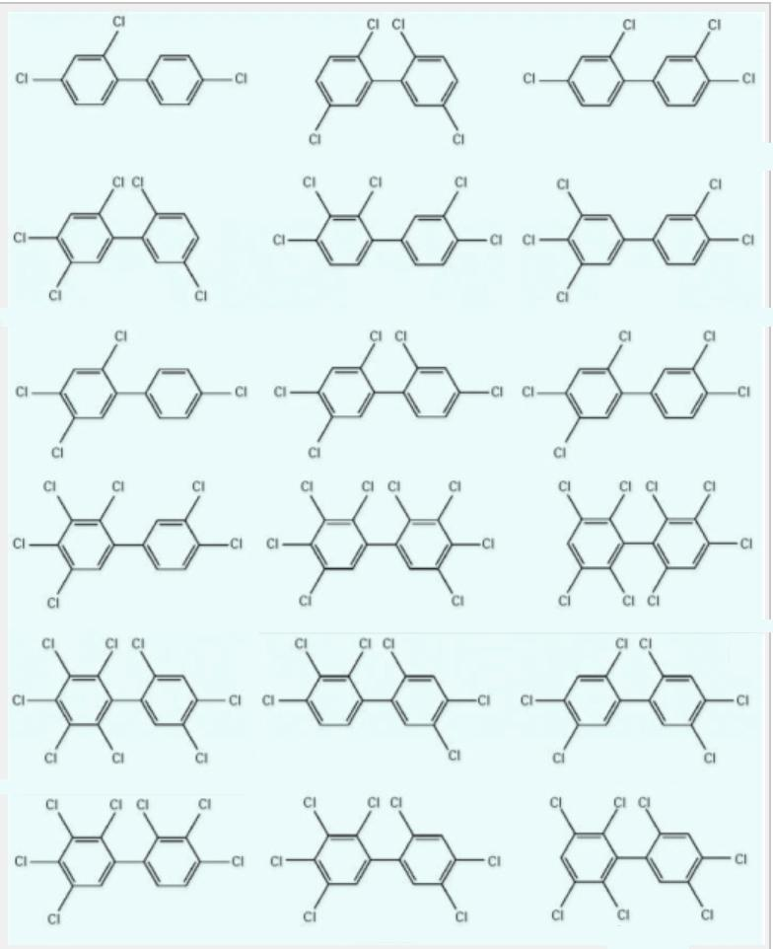
Polychlorinated Biphenyls (PCBs) are a class of man-made organic chemicals consisting of carbon, hydrogen and chlorine atoms. PCBs have no known taste or smell and range in consistency from an oil to a waxy solid. They have varying numbers (from 1 to 10) of chlorine atoms on a biphenyl backbone (United States Environmental Protection Agency, 2018). The number of chlorine atoms and their location in a PCB molecule determine many of the physical and chemical properties. Varying the number and locations of chlorine atoms on the biphenyl backbone results in 209 variations known as PCB congeners. Figure 1 shows a selection of example PCB congeners.
Congeners not only share a common structure but may also share chemical and toxicological properties (Borlakoglu & Walker, 1989).
Figure 1: A selection of PCB congeners (Plísková , et al., 2005)

PCBs typically occur as mixtures rather than as individual congeners. PCBs can be divided into two broad groups based on their origins: legacy and inadvertent PCBs. Legacy PCBs refer to those that were intentionally manufactured for use in products. Inadvertent PCBs refer to those that are produced as by-products or contaminants from manufacturing other products. In order to understand the scope of the problem of inadvertent PCBs, it is helpful to understand review a brief history of legacy PCBs and how they differ from inadvertent PCBs.

What are Legacy PCBs?
PCBs have desirable physical and chemical properties including “fire resistance, low electrical conductivity, high resistance to thermal breakdown, high degree of chemical stability, and resistance to many oxidants and other chemicals” (United Nations Environment Programme (UNEP) Chemicals, 1999). As a result of their versatility, millions of pounds of PCBs were once manufactured and used in products such as (United States Environmental Protection Agency, 2018):
- Transformers and capacitors
- Electrical equipment including voltage regulators
  - Switches
  - Re-closers
  - Bushings
  - Electromagnets
- Oil used in motors and hydraulic systems
- Fluorescent light ballasts
- Cable insulation
- Oil-based paint
- Caulking
- Plastics
- Carbonless copy paper

From 1929 until 1977, the Monsanto Chemical Company was the sole producer of PCBs in the United States. These mixtures were marketed under the “Aroclor” tradename, and legacy PCBs in the U.S. may simply be referred to as “Aroclors” (Kopp, 1976). Although Monsanto produced about half of the total volume worldwide, legacy PCBs were also made internationally under other trade names. See Appendix A, Figure A1 for a list of international trade names (Battelle Memorial Institute, 2012). In 1979, nations around the world took action to stop the manufacture of legacy PCBs. The US EPA introduced a ban on PCB manufacture, and PCBs were included on the Stockholm Convention list of twelve priority persistent organic pollutants (Daryl J. McGoldrick, McGoldrick, & Murphy, 2016).

What are Inadvertent PCBs?
Although manufacture of PCBs was banned in 1979, PCBs continue to be formed as unwanted byproducts in up to 200 manufacturing processes (Stone A. , 2014). Seventy of these processes have a high potential to create PCBs. See Appendix B, Figure B1 for the complete list.

How are Inadvertent PCBs Formed?
When chlorine, salts, and hydrocarbons or chlorinated hydrocarbon compounds are mixed and reacted at high temperatures, PCB impurities can result. While not every process that creates inadvertent PCBs has been documented, several congeners have been directly linked to the manufacture of pigments (for paints, inks, and dyes). Many of today’s pigment production processes require chlorine, which presents an inherent risk of creating inadvertent PCBs in unknown amounts (Rodenburg L. A., Guo, Du, & Cavallo, 2010).

Sources of Inadvertent PCBs
Despite national limits on PCBs in water, inadvertent PCBs continue to contribute to the accumulation of PCBs in certain waterways. For example, the Department of Environmental Sciences, Rutgers University, found that PCB limits in the Delaware River have been exceeded as a result of inadvertent PCB production (Rodenburg L. A., Guo, Du, & Cavallo, 2010). Additionally, this research showed that non-legacy PCBs are being generated from production processes, rather than as dechlorination products from legacy PCBs. The thorough documentation of legacy PCB congeners helps researchers discern which PCBs in the environment are from legacy sources and which continue to be generated inadvertently. This provides insight into where inadvertent PCBs are hindering decades of costly environmental remediation efforts related to legacy PCBs. Table 1 shows specific PCB congeners that have led to violations of Federal water quality standards in various regions.
Table 1: Inadvertent PCBs above Federal Water Quality Standards (Rodenburg L. A., Guo, Du, & Cavallo, 2010)
Inadvertent PCBs detected above Federal Water Quality Standard of 64 pg/L (pico-grams per liter) (ppq - parts per quadrillion)
PCB 11 | PCB 206+208+209
Halifax Harbor (40-126 pg/L) | Delaware River (~230 pg/L)
New York/New Jersey Harbor (over 100 pg/L) | Houston Ship Channel (~130 pg/L)
Delaware River (~20 pg/L- above local criterion)
Houston Ship Channel (~200 pg/L)
San Francisco Bay (~100 pg/L)

Inadvertent PCBs come from primary and secondary production sources, as well as primary (point) and secondary environmental sources.
- Primary production sources: facilities that directly generate inadvertent PCBs, such as some chemical and pigment manufacturers
- Secondary production sources: downstream users of chemicals and products that contain PCBs, such as printers and recyclers
- Primary environmental sources: inadvertent PCBs with identifiable sources, such as where discharge locations are known
- Secondary environmental sources: inadvertent PCBs from unidentified sources, such as where the region of production or correlated manufacturing process used is unknown
Primary production sources include (Oregon Department of Environmental Quality (DEQ)):
- Organic and inorganic pigment manufacture
- Production of chlorinated solvents
- Agricultural chemicals
- Detergent bars
- Wood treatment
Secondary production sources of inadvertent PCBs are typically associated with facilities that discharge effluent into rivers, streams, lakes and oceans. Potential sources for these inadvertent PCBs include (NGC interview with Doug Krapas, Environmental Manager at IEP):
- Paper Mills:
  - Newsprint pigments (inks and dyes)
  - Packaging pigments (inks and dyes)
- Wastewater Treatment (City of Spokane Wastewater Management Department, 2015):
  - Antibacterial hand soap
  - Antibacterial dish soap
  - Laundry detergent
  - Shampoo
  - Toothpaste
- Municipal Stormwater Runoff:
  - Road paints
  - Asphalt sealers
  - Pesticides
  - De-icers

Because primary producers of inadvertent PCBs can be more easily identified, it may be pragmatic to prioritize collaborations with those businesses that are known to generate inadvertent PCBs. Addressing inadvertent PCB production from primary sources should also reduce inputs from secondary sources.

Inadvertent PCBs: Current Challenges
Sources of legacy PCBs remain from still-in-use transformers, capacitors, caulking, paints, and other materials manufactured in the twentieth century. However, their potential regional impacts and concentration in the environment have been significantly reduced in the decades since the EPA ban (Chang, et al., 2012) (Estuary Partnership, 2014) (Daryl J. McGoldrick, McGoldrick, & Murphy, 2016).
Our collective understanding of environmental and human health impacts of PCBs as a chemical class is muddied by a number of factors, including:
- The existence of 209 congeners
  - The level of hazard of a specific PCB congener or mixture is related to the structure of the congener.
  - Each congener or mixture may contain more, fewer or equal hazards to those that have been previously documented with the health impacts discussed below.
- Industrially discharged PCBs may be documented accurately by facilities when they are first manufactured. But they are transformed in the environment (chemically and by microorganisms) as time passes. This results in PCBs in the environment that are different than the actual substances that were discharged (Beyer & Biziuk, 2009).
- Data gaps:
  - Ongoing research is building toxicological profiles for individual congeners and mixtures of inadvertent PCBs, with emphasis on congener-specific impacts.
  - iPCBs are formed as mixtures that have variable congener compositions depending on specific manufacturing process conditions and the quality and impurity profiles of the raw materials and intermediates.

Human and Environmental Health Impacts
PCBs are concerning due to their persistence (P) in the environment, ability to bioaccumulate (B) up the food chain, and their toxicity (T). They are considered persistent, bioaccumulative and toxic substances (PBTs). PBTs have spurred international action because of their compounding impacts to ecosystem health. As with other PBTs, PCBs are found in a vast array of products and in even the most remote regions of the world due to global transport.
Specific congeners of PCBs that have been studied in the greatest depth have come to represent the entire class. All congeners are therefore considered probable human carcinogens (United States Environmental Protection Agency, 2018) (Rodenburg L. A., Guo, Du, & Cavallo, 2010). Likewise, all PCBs are currently regulated as a group (Commonwealth of Massachusetts, 2018). This makes sense for inadvertent PCBs because the amount and pattern of different congeners formed is variable.
Studies have shown that inadvertent PCBs in food packaging could be transferred to skin during contact or ingested after migrating from packaging into food (Kuratsune & Masuda, 1972). PCBs in carbonless copy paper were banned as a result of evidence that dermal exposure occurred simply from handling the material. There is not currently enough research to assess the risk from unintended uses such as using PCB-containing paper packaging as impromptu plates or small children mouthing printed items. More common exposure pathways such consuming contaminated fish are well documented and associated impacts have been assessed.
Humans can be exposed to PCBs via air, water, soil, inhalation and ingestion. Exposure to PCBs via consumption of contaminated fish is a worldwide challenge, affecting nations as widespread as the United Kingdom, Pakistan, Brazil, China, and Nigeria, among others (Rose, Fernandes, Mortimer, & Baskaran, 2015) (Eqani, Cincinelli, Mehmood, Malik, & Zhang, 2015) (Miranda & Yogui, 2016) (Pan, et al., 2016) (Adeogun, Chukwuka, Okoli, & Arukwe, 2016). Local governments continue to advise against consumption of many regional fish populations due to their PCB content, even after decades of discontinued legacy PCB manufacture. Inadvertent PCBs in waterways are delaying safe consumption of these fish (San Francisco Bay Regional Water Quality Control Board, 2016). Figure 2 illustrates how PCBs are transferred throughout the food web with particular emphasis on marine ecosystems.

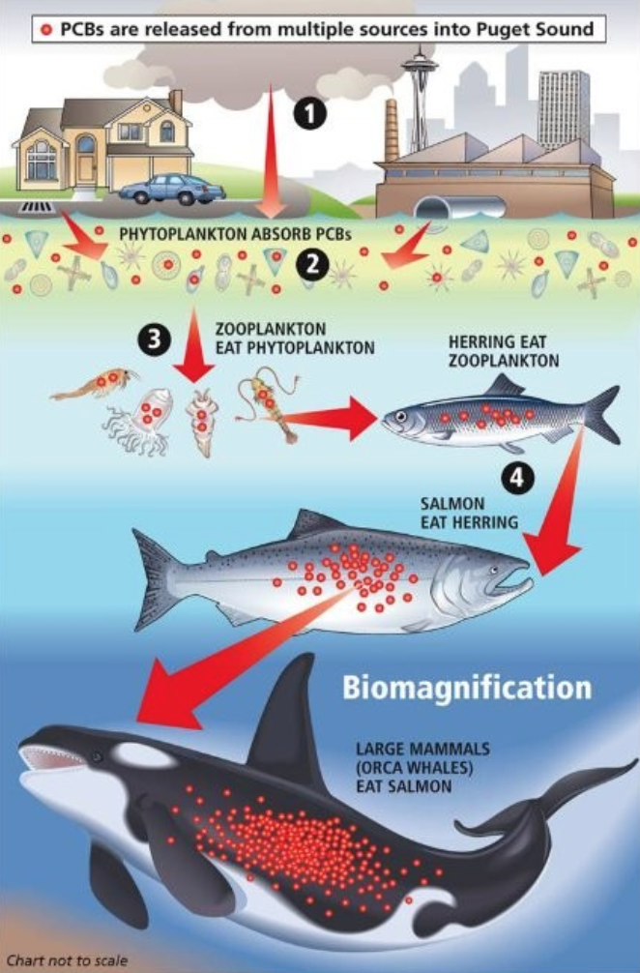
Figure 2: PCBs released into Puget Sound (Litten W. , 2014)
As PCBs bioaccumulate through contaminated food and water in humans and other organisms they pose health hazards that can include (Washington State Department of Ecology, 2015) (United States Environmental Protection Agency, 2018):
- Increased risk of cancer
- Immune deficiencies
- Nervous system harm
- Reproductive impacts
- Developmental effects
- Skin changes

These health impacts are exacerbated as PCBs accumulate in the body fat of living organisms faster than they can be broken down, resulting in widespread and long-term human exposure (Estuary Partnership, 2014). Consuming PCB-contaminated food facilitates the buildup of PCBs in body tissues, potentially compromising the healthy development of children. PCBs are able to cross the placental barrier between mother and child (United States Environmental Protection Agency, 2018). Another study found that children of mothers with high body burdens of PCBs exhibited short-term memory challenges and behavioral issues (Colborn, von Saal, & Soto, 1993). These extended exposures, resulting in developmental impacts (among others), create a systemic burden for whole ecosystems and communities.
For more details on exposure routes of PCBs, affected marine species, and how legacy PCBs continue to enter the environment, see Appendix C.
In addition to prolonged environmental exposure, successful remediation projects may be slowed due to the continued release of inadvertent PCBs into the environment (University of Iowa - IIHR Hydroscience and Engineering, 2015). Lengthening these projects will add to the cost - which is already billions of dollars - for businesses, consumers, regional and state governments, and the federal government. For example, General Electric alone reportedly spent $1.7 billion on a nine-year project to remove PCBs from the Hudson River (McKinley, 2016) (Wu, 2018).

Products and Pigments that Contain Inadvertent PCBs
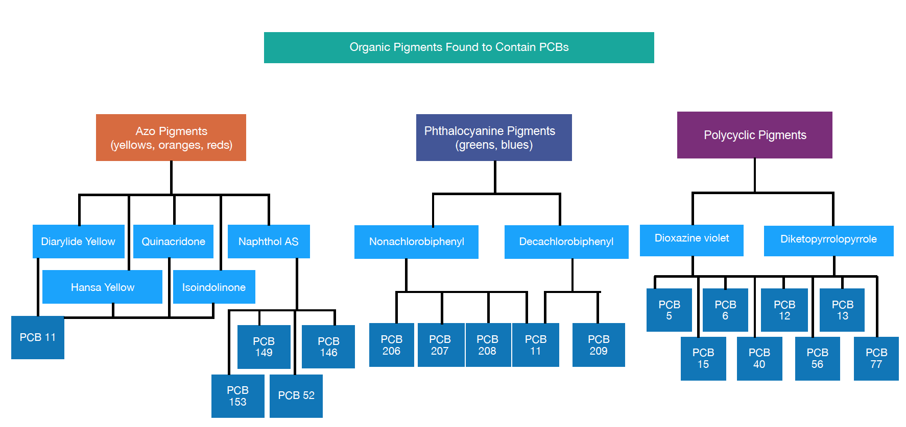
The Washington State Department of Ecology (WA DOE) conducted a preliminary study of inadvertent PCB concentrations in consumer materials. These products included packaging, paper products, paints and colorants, caulks, and miscellaneous items (e.g. printer inks and food) (Stone A. , 2014).

Figure 3: Organic Pigments Found to Contain Inadvertent PCBs

The study provided insight into how water becomes contaminated with PCBs from recycled food packaging and paper products. Inadvertent PCBs were detectable at appreciable levels (5-45 ppb) in all of the product categories investigated by WA DOE. Their findings point to dyed products - such as clothing, cosmetics, soaps, hand sanitizers, and household cleaning products - as probable sources of inadvertent PCBs. These packaging products are likely to leach PCBs into water (Guo, Capozzi, Kraeutler, & Rodenburg, 2014). For details on PCB concentrations measured by WA DOE, see Appendix G.
The production of at least three classes of organic pigments (Azo, Phthalocyanine and Polycyclic pigments) generate inadvertent PCBs. These pigments are used in packaging and newsprint. They cover the spectrum of yellows, oranges, reds, greens, blues and purples. Within the Azo pigment class there are diarylide, hansa, quinacridone, naphthol and isoindolinone subcategories that can potentially contain inadvertent PCBs. Figure 3 shows these pigments and inadvertent PCB congeners correlated to them. There could be more PCB congeners that have not been tested for or reported and more pigments that contain these contaminants (Hu & Hornbuckle, Inadvertent Polychlorinated Biphenyls in Commercial Paint Pigments, 2009) (Willy Herbst, 2004).
Diarylide yellow, a commonly used yellow pigment, is a key source of PCB 11. This pigment accounts for 62.5 million tons of annual organic pigment production worldwide (out of 250 million tons), generating about 1.5 million metric tons of PCB 11 each year (Rodenburg L. A., Guo, Du, & Cavallo, 2010). According to one report, a single cereal box can “contaminate nearly seven thousand liters of water at a level of 20 $pg L^{-1}$, the average PCB 11 concentration in the ambient waters of the Delaware River” (Rodenburg L. A., Guo, Du, & Cavallo, 2010). It’s possible that PCB 11 is therefore heavily responsible for the Delaware River exceeding PCB water quality limits.
In printed products, like paper, textiles and commercially available paints, inadvertent PCB 11 can be detected with extremely high consistency. It is present in as many as 86% of pigments (Bienkowski, 2014). A study evaluating food containers found PCB 11 in 66% of products tested (Muncke, 2014). The frequent use of diarylide yellow in packaging materials - 65% is used in printing - with resulting detectable levels of PCB 11 means it is a significant source of exposure to consumers and the environment. This makes PCB 11 an excellent candidate for further toxicological studies and mitigation strategies.
Inorganic pigments, such as titanium dioxide, can also contain inadvertent PCBs. Approximately 95% of all titanium mineral production is used to make titanium dioxide (United States Geological Survey, 2013). The white pigment adds vibrancy to a huge range of products, including paints, paper, plastic, and rubber. Its distinctive brightness and versatility has made it the leading pigment globally. More than a million tons are produced each year in the U.S. and millions more are made worldwide. It is widely marketed as a pigment for packaging inks and coatings and is even used directly in food applications (Titanium Dioxide Manufacturers Association, n.d.).
There are two industrial manufacturing processes for titanium dioxide. One relies on sulfate and the other relies on chlorine (European Commission, 2016) (The Essential Chemcial Industry - Online, 2016). The chlorinated process generates inadvertent PCBs while the sulfate process does not, and 30% titanium dioxide in Europe is produced by the chloride process. The production of titanium dioxide can generate at least three inadvertent PBCs - 206, 208 and 209 - when manufactured through chlorinated processes (Hu & Hornbuckle, Inadvertent Polychlorinated Biphenyls in Commercial Paint Pigments, 2009). These pigments have been found in the majority of packaging products tested for inadvertent PCBs.
Because titanium dioxide is ubiquitous, outreach and education on non-chlorinated titanium dioxide manufacture could be a valuable solution to reducing inadvertent PCB loads into the environment. It’s possible that similar alternative pathways exist for producing PCB-free organic pigments. Determining this will require additional research and development.
There are also non-pigment processes that produce inadvertent PCBs, such as the production of silicone rubber tubing. This process can produce PCBs 44 and 45. There are also scattered reports of some proprietary products and vinyl chloride creating inadvertent PCBs (Washington State Department of Ecology, 2015). In 1982, the EPA compiled a list of end products of manufacturing processes in which PCBs are incidentally generated (Moll, 1982). The complete list can be found in Appendix B, Figure B2.
In addition to being generated as byproducts of manufacturing, PCBs can form during breakdown (or weathering) of pigments. This presents a challenge for anyone who wishes to avoid PCB-containing materials, such as paper and packaging recyclers.

Regulatory Approaches

Federal Inadvertent PCB Requirements
Primary inadvertent PCB production is mostly unregulated at low levels. Current national and most international regulations allow inadvertent PCBs to be produced in pigments at maximum concentrations of 50ppm with an average of 25ppm. These requirements can create conflict with requirements of the Clean Water Act and more stringent local regulations such as Spokane River requirements (Washington State Department of Ecology, 2015). This creates discrepancy and disagreement about appropriate limits for inadvertent PCBs.
In 1984, non-governmental organizations, such as the Environmental Defense Fund, National Resources Defense Council and the American Chemistry Council worked together with the US EPA to set national limits on inadvertent PCB generation (Washington State Department of Ecology, 2015). Results of this meeting included the following limits on inadvertent PCB concentrations:
- 50 ppm of inadvertently generated PCBs in products and an annual average of <25 ppm
- Releases to ambient air must be <10 ppm.
- Discharges to water must be <0.1 ppm (except from recyclable paper, where the limit is 3 ppb total Aroclors).
- All wastes must be disposed of properly. Process wastes with PCB levels > 50 ppm must be disposed of in accordance with TSCA. The Clean Water Act, however, limits discharges to 170 ppb into regulated bodies of water.

There are chemical management guidelines for producers of inadvertent PCBs, however, the last reported EPA PCB report comes from 2011 (Washington State Department of Ecology, 2015) (Washington State Department of Ecology, 2015). This presents difficulties in determining current or precise records of locations, quantities, and frequency of PCB creation. It’s unclear what, if any, internal management practices beyond regulatory reporting are conducted by primary producers.
International inadvertent PCB production has implications for the packaging industry in the U.S. since imported products containing 50 ppm or lower amounts of inadvertent PCBs are not restricted (and likely not tested for PCBs) (United States Environmental Protection Agency, 2016). Paper and cardboard are a good example of the challenges imported PCBs present. In 2015, the United States imported 11,563 million metric tons of paper and cardboard (Statista, 2017). In the EU, 41% of all packaging waste is made up of paper and cardboard (European Commission), and it could be assumed that packaging waste has a similar composition in the U.S. In an analysis of PCBs in consumer products, WA DOE found inadvertent PCBs were present in all paper products tested, and there has long been concern over PCBs in cardboard food packaging materials (Kolbye, 1972). With PCB-containing paper products being created both domestically and entering packaging streams through imports, it is extremely challenging to measure the success of collaborative mitigation efforts conducted by businesses and governments.
Harmonizing regional and federal requirements for inadvertent PCB concentrations in products and manufacturer discharge limits is a considerable obstacle for mitigating the impacts of inadvertent PCBs. More stringent testing protocols could fill critical data gaps, such as what processes are resulting in inadvertent PCB and actual quantities being discharged. Risk assessments could facilitate determination and standardization of the most appropriate concentration limits. Finally, since a significant quantity of packaging materials are imported that may contain inadvertent PCBs, it is essential to set strict limits on and test for inadvertent PCBs in imported goods.

Regional Water Quality Requirements
Regional efforts are largely based on adaptive learning until best practices are developed. A common thread through regional management practices is significant initial data collection done in collaboration with local facilities to identify sources, types and concentrations of PCBs in water. As localities collect data and identify inadvertent PCB origins, pigment manufacturers and packaging and/or paper recyclers may be held increasingly accountable for PCBs produced.
The National Primary Drinking Water Regulations set the maximum contaminant level for PCBs in drinking water to 0.0005 mg/L (0.5 ppb) (United States Environmental Protection Agency, 2018). On the other hand, the Spokane Native American Tribe has a 3.37 pg/L (ppq) PCB limit for waterways, the strictest water quality standard in Washington (possibly the nation). The Spokane River has the highest PCB levels in the state, and the low limit was set to prevent additional river and salmon contamination (National Pollution Prevention Roundtable). Similarly, there are stringent limits for other areas with high PCB concentrations such as the Delaware River, where no more than 16 pg/L (ppq) are permitted (Delaware River Basin Commission, 2018). Table 5 gives examples of PCB limits by region. Ironically, drinking water standards are less restrictive than some river discharge limits for PCBs. This reflects the challenge of reducing levels of persistent, bioaccumulative and toxic substances in the environment.

Table 2: Examples of Regionally Varying PCB Limits
Region | mg/L (ppm)
National Primary Drinking Water Regulations | 5.0x10^-4
Spokane Native American Tribe | 3.37x10^-9
Delaware River | 1.6x10^-8
San Francisco Bay | 1.7x10^-6
State of Ohio Lake Erie Drainage Basin | 2.6x10^-8
State of New Jersey | 6.4x10^-5

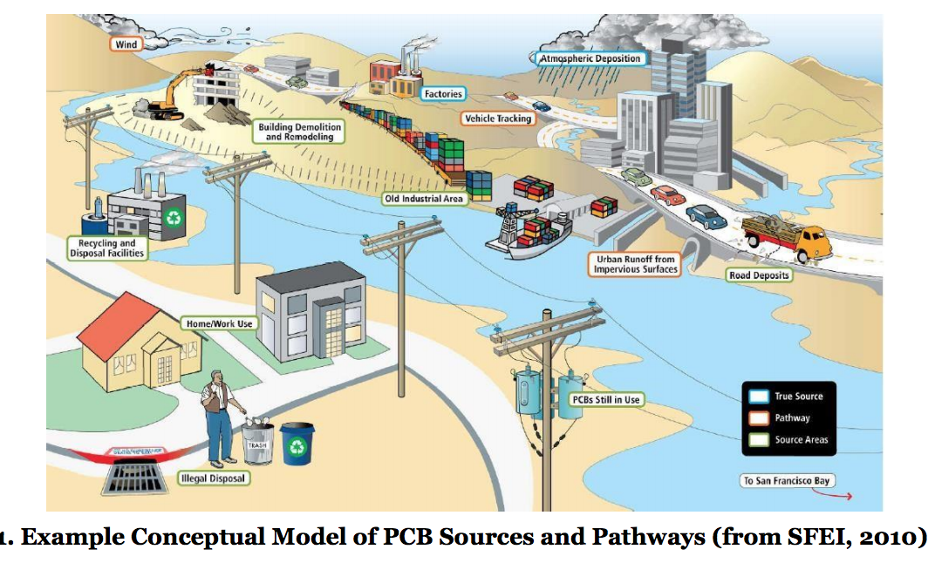
Current gas chromatography techniques can detect and differentiate between congeners and Aroclor PCBs at levels as low at 0.054 µg/L (ppb) in water and 57 µg/kg for soil (Clu-In, 2018). This is far below the maximum 50 ppm limit. Businesses at risk of producing inadvertent PCBs could increase the frequency of their testing as a preventative measure. Where PCBs are found, businesses can use analytical chemistry to benchmark progress on reducing PCB loading into waterways. At the same time, if even lower limits are required to reduce risk it may be necessary to develop more sensitive measurement techniques. Manufacturers that obtain third-party testing data could better inform procurement professionals’ product selection when they request PCB-free choices.
Figure 4: Example conceptual model of PCB sources and pathways (San Francisco Bay Regional Water Quality Control Board, 2016)
The case studies below demonstrate how different regions have attempted to address high levels of inadvertent PCBs in local waterways. Their strategies navigate around the complex regulations described above in an attempt to address high-priority polluted areas.

Area Case Studies

Delaware
In the Delaware River estuary, PCBs have been measured at 1,000 times above national water quality limits. In 2005, the Delaware River Basin Commission (DRBC) initiated a pollution minimization plan to identify both primary and secondary sources of inadvertent PCB loadings into the river. By collaborating with facilities that discharge, PCB loadings have dramatically reduced since 2005. This includes working with the top ten PCB dischargers, who collectively reduced their PCB loading by 76% (Delaware River Basin Commission, 2018).

San Francisco
As in Delaware, the State of California took action on PCBs after exceptionally high contamination was detected in the San Francisco Bay (San Francisco Bay Regional Water Quality Control Board, 2016). Much of this contamination is from legacy PCBs. Stormwater runoff, however, is contaminated with inadvertent PCBs. San Francisco has identified several sources of inadvertent PCBs, including manufacturing processes. They also identified construction sites where old building materials leach PCBs into the environment. San Francisco has implemented a new total maximum daily PCB load limit: and bans the introduction of PCBs into waterways at any concentration. While this goal is especially ambitious, it begins like other regional programs; the city must first identify low-concentration sources of PCBs and determine which are from legacy sources and which are inadvertent. From there strategic next steps can be decided.

Spokane
Another option for regional management of PCBs is to invest in water treatment facilities designed specifically to remove them. The Washington State Department of Health became concerned about the impacts on the community of consuming PCB-contaminated fish. Spokane County invested in a water treatment plant which “includes $20 million worth of state-of-the-art membrane technology designed to remove pollutants to very low levels. The wastewater entering the plant has PCB concentrations in the 10,000 to 20,000 parts per quadrillion (ppq) range, according to county data. Treated water leaves the plant with PCB concentrations of about 200 ppq” (Kramer, 2014). Of course, not every locality will be able to invest in such a facility. Other initiatives in Spokane include the Spokane River Regional Toxics Task Force, created to address problems of toxic chemicals such as PCBs. The SRRTTF identified 45 control actions to control PCB loading in their Comprehensive Plan to Reduce PCBs in the Spokane River report (Spokane River Regional Toxics Task Force 2016). See Appendix E.
The impacts of inadvertent PCB production are not limited to these regions in the U.S. There is growing concern about the production of inadvertent PCBs in China, where 2x10⁴ metric tons of organic yellow pigments are made each year, many of which are Diarylide yellows (Shang, et al., 2014). The Japanese Ministry of Economy, Trade and Industry, perhaps fueled by historical incidents with food contamination and PCBs, found that 242 pigments tested contained PCBs, including over 100 that exceeded the 0.05ppm limit. In fact, they were present above 0.5ppm, ten times above the allowable limit (Stone A. , 2014). Global collaborations can help identify sources of inadvertent PCBs and address concerns for human and environmental risk from continued pollution.

An Obstacle to a Circular Economy
Paper and paper-based packaging is an enormous global industry, with 407.5 million metric tons of paper products consumed globally each year (Statista, 2017). In the United States we consume more paper per capita than any other nation. Approximately 52 million short tons of US paper product consumption is recovered for recycling. This means it is crucial that paper products are safe for humans and the environment, especially because of their relatively high rate of recirculation.
Like newsprint, recycled packaging materials contain inadvertent PCBs as a result of PCB-containing inks used on them or on the original (pre-recovery) product (Stone A. , 2014) (Profita, 2014).
Distinctive product packaging is viewed as an essential brand strategy to market and sell to consumers. The broad spectrum of pigments used for branding poses a challenge when packages enter recycling streams. Before new products can be made from recycled packaging the material must be processed.
Operations at Inland Empire Paper (IEP), a paper recycler in Millwood, Washington, are directly impacted by PCB contamination in recyclable material (NGC interview with Doug Krapas, Environmental Manager at IEP). Inadvertent PCBs in the recycler’s effluent correlated with PCBs in pigments used on the paper products they recycle, such as newspapers, magazines, mailing materials and packaging.
IEP has taken costly voluntary steps to be an exemplary environmental steward - eliminating chlorine from their papermaking processes, reducing their overall water use, and purifying their wastewater. Yet, the facility still exceeds PCB discharge limits in their region. While these inadvertent PCBs originate from upstream sources, IEP may not be alone as a recycling business facing consequences from violating regional PCB discharge limits (Grossman, 2013). The presence of PCBs in recycling streams threatens all recycling businesses, which can ultimately reduce the amount of material that is sustainably re-used.
This contamination hinders the advancement of a circular economy. According to the Ellen MacArthur Foundation, a circular economy “aims to redefine growth, focusing on positive society-wide benefits. It entails gradually decoupling economic activity from the consumption of finite resources and designing waste out of the system. Underpinned by a transition to renewable energy sources, the circular model builds economic, natural, and social capital. It is based on three principles (Ellen MaCarthur Foundation, 2017):
- Design out waste and pollution
- Keep products and materials in use
- Regenerate natural systems”

The circular economy is also a key component of the UN Sustainable Development Goals (Stone S. , 2017). When recycling leads to lower quality materials and water, then these principles cannot be fulfilled. The toxicity of PCBs can also economically devalue products made from recycled materials. Just as certain additives in plastics contaminate plastic recycling systems, PCBs impact the full range of products into which they are introduced. Figure 5 illustrates the differences between the ideal circular economy and one that is contaminated.

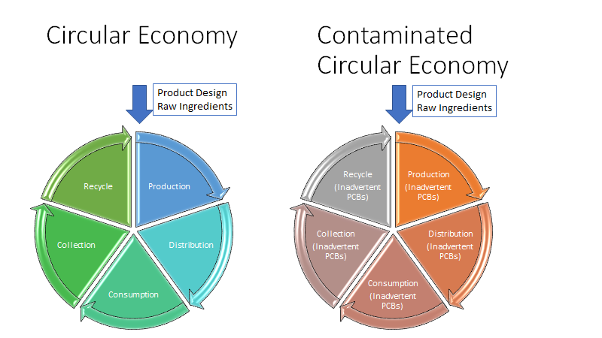

Figure 5: Circular vs Contaminated Circular Economy

Strategic Solutions and Next Steps
Regulatory approaches play a critical role in reducing inadvertent PCB pollution. However, proposing legal and regulatory actions are beyond the scope of this paper. Rather, we propose a set of voluntary and collaborative approaches to complement regulatory action and to expedite needed solutions. Successful voluntary initiatives can complement regulations, inform regulations and in some cases reduce the need for regulations. Voluntary initiatives could help identify best practices such as best available technologies and feasible lower limits for inadvertent PCBs in pigments. When markets shift voluntarily, regulations can then help to raise the bar and level the playing field for all players.
Northwest Green Chemistry proposes a set of activities that are inter-related and that fall under the four categories. They are discussed in the next section.
- Targeted cross-sectoral and multi stakeholder collaborations
- Green chemistry and engineering research
- Alternatives assessment
- Procurement to drive substitution of safer alternatives

Targeted Collaborations
Cross-sectoral and multi-stakeholder collaborations are well-proven approaches to shifting industry practices and creating buy-in from participants. Benefits from targeted collaborations include shared education, awareness and motivation and access to information and insights that can only come through conversations with people at different points in the supply chain. Participants can provide advice and guidance and work together to generate practical solutions. Active engagement by participants typically leads to greater commitment to solutions that are developed. Targeted collaborations can be designed to address the entire supply chain and to include stakeholders who represent human health and environmental interests such as representatives from governments and environmental or health advocacy NGOs.
There are various models of targeted collaborations. For some industry sectors, company representatives have formed roundtables where pre-competitive, sustainable innovations are discussed. For example, the American Chemical Society Green Chemistry Institute facilitates several industrial roundtables: pharmaceutical, formulator’s, chemical manufacturer’s, biochemical technology and hydraulic fracturing (American Chemical Society 2018). These collaborations result in educational resources, tools for implementing greener alternatives, grants to support research into sustainable, safer products and processes and industry adoption of these safer alternative products and processes.
Another example is the Green America Center for Sustainability Solutions that convenes brands, NGOs, government agencies and scientists and engineers (Green America Center for Sustainability Solutions n.d.). These stakeholders collaborate (bound to a non-disclosure agreement) to understand supply chain hazards, identify safer processes and select alternatives substances. Other industry collaborations like Zero Discharge of Hazardous Chemicals (ZDHC), a coalition of signatory textile, leather and footwear brands, work to conform to a standardized list of restricted substances for companies in the sector (Zero Discharge of Hazardous Chemicals (ZDHC) 2018). Any of these models could inform a targeted industry collaboration to address inadvertent PCBs in packaging or newsprint.
Business-focused chemical management initiatives are, in fact, already common in the colorants sector but they are not always multi-sectoral or inclusive of diverse stakeholders. Several industry associations have created guidelines for their member companies around best practices for inadvertent PCBs and would be valuable partners for creating more progressive internal industry standards on inadvertent PCB production. These organizations include:

- The Ecological and Toxicological Association of Dyes and Organic Pigments Manufacturers (ETAD). ETAD has produced a series of guidelines for pigments (Ecological and Toxicological Association of Dyes and Organic Pigments Manufacturers (ETAD) 2018). ETAD works to harmonize regulations, making compliance easier for both member companies and regulatory bodies. They also conduct research and testing for pigment hazards. Note that some of the ETAD PCB activities appear to fall under the scope of work of the Color Pigments Manufacturers association through collaboration.
- Color Pigments Manufacturers Association (CPMA). CPMA provides similar benefits to members as ETAD, though some companies - including those in Appendix D - are members of both organizations. CPMA is heavily focused on public policy related to pigment manufacturers in the U.S. (Color Pigments Manufacturers Association 2018)
- American Coatings Association (ACA). The ACA has been helpful in recommending and identifying non-diarylide yellow road paints to meet updated public procurement requirements. Working with industry associations can set a good tone with individual companies and coordinate actions including setting realistic goals and timelines for implementation of safer alternatives.

Greater multi-stakeholder and cross-sectoral collaboration is necessary to increase awareness around and drive demand for safer, lower PCB-containing products. NGC has begun identifying and engaging some key stakeholders in initial scoping discussions. A list is found in Appendices D and H. Some highlights are discussed below.
Northwest Green Chemistry has engaged in extensive discussions with the NGO Green Blue Institute (GreenBlue) that hosts the industry association hosted called the Sustainable Packaging Coalition (SPC). The SPC is a member-based organization of approximately 240 national and global organizations across the packaging supply chain committed to taking meaningful actions toward packaging sustainability. They are interested in having NGC and potentially other members of SRRTTF present to GreenBlue and SPC leadership on inadvertent PCBs. They want to better understand the issue and to consider next steps. James Ewell of GreenBlue is interested in guiding the interactions to ensure that the SPC members understand that the issue of inadvertent PCBs is a global issue and that it is important enough for them to commit member time to address. The SPC hosts annual meetings in the US and internationally. If successfully adopted, the issue would be brought to their members via webinars and possibly via live presentations at annual meetings. They are committed to the idea of a circular economy and to the extent that iPCBs hinder a circular economy, this project could be a model for how to address systemic challenges of toxics in packaging and paper material streams.
Other suggested activities, pending endorsement by GreenBlue and SPC leadership, that were discussed include 1) assistance with research of available safer alternatives, 2) creation of educational and training materials as part of the SPC training curriculum and 3) creation of a packaging design guide for members to address the challenge of iPCBs. The SRRTTF could benefit by gaining access to individuals from brands, packaging manufacturers and others in the supply chain who can provide insight into how pigments are selected. Engagement should also provide insight into how aware these companies are of the issues of inadvertent PCBs and if there are best practices already being used.
NGC has been in communication with a leading global color scientist, Dr. Romesh Kumar, who works for Clariant, a Swiss manufacturer of pigments, paints, inks and coatings amongst other products. Dr. Kumar has agreed to assist NGC and SRRTTF with answering technical questions about inadvertent PCBs and feasible alternatives. Discussions with another ink manufacturer have already revealed that the company sees inadvertent PCBs as a nascent issue and they are looking for guidance on what specifications, i.e. allowable levels of inadvertent PCBs, they should set for their suppliers. NGC views further interaction with GreenBlue, SPC, and the other stakeholders identified in Appendix H as a critical first step in gathering information and identifying creative solutions to expedite solutions to inadvertent PCBs. Please note that while NGC has good connections in the packaging sector, we do not have good connections in the newsprint industry. However, Doug Krapas of the SRRTTF has generously agreed to provide suggested contacts as needed.

Green Chemistry and Engineering Research

Green chemistry and engineering are approaches to science and engineering that drive innovation by creating products and processes that reduce or eliminate the use and generation of hazard. Hazard in green chemistry and engineering is considered broadly to include, not only toxic chemicals, but also toxic by-products and emissions, energy consumption and risk from processes that generate heat and other physical hazards. Green chemistry and engineering solutions are likely to succeed on a longer timeline but they inevitably produce new understanding and great ideas.

Building on Strategy 1, Creating Targeted Collaborations, Northwest Green Chemistry has engaged with the director of the Berkeley Center for Green Chemistry (BCGC) and the Greener Solutions course. They have expressed interest in having their graduate students in the Greener Solutions program explore both chemistry and engineering solutions to the challenges of inadvertent PCBs. The Greener Solutions program matches graduate students and advanced undergraduates with organizations to take on interdisciplinary projects that leverage student knowledge to address real-world problems. While most of the solutions the students identify will take more that one semester to fully realize in the marketplace, the student teams produce an opportunity map for manufacturers as a deliverable. The students have completed projects such as “Establishing a proactive approach to address emerging contaminants in the informal e-waste sector with HP (2012) and “Identifying a range of safer alternatives to address the use of free isocyanates in spray foam insulation (2014).

Initial interest does not constitute a commitment by BCGC. A project would need to be approved by an internal team. Rather, it is an opportunity to engage BCGC to meet with SRRTTF and other stakeholders identified through this project to develop a scope of work that offers an appropriate challenge to the students. Initial ideas focused on the manufacture of TiO₂. There is interest in exploring alternative green chemistry approaches such as alternative synthetic pathways for making pigments that do not generate inadvertent PCBs. These processes could include new synthetic pathways or biomimetic approaches. There is also interest in exploring innovative green engineering approaches that could improve existing processes and existing pigments by reducing the generation of inadvertent PCBs. NGC recommends that the SRRTTF move forward with discussions to develop a Greener Solutions project that could benefit the goals of the SRRTTF.

Alternatives Assessment
Alternatives assessment (AA) is a process for identifying and comparing potential chemical and non-chemical alternatives that can be used as substitutes to replace chemicals or technologies of concern. Alternatives assessment is designed to reduce the likelihood of restricting or banning chemicals or products and replacing them with ‘regrettable substitutions’. The AA process is intended to address at a minimum, hazard, exposure, performance, and cost and availability. There are additional optional modules for life cycle assessment, social impact assessment and circularity that may be included. In the case of inadvertent PCBs, alternatives could include existing or emerging pigments that do not contain inadvertent PCBs. These could be different pigments or the same pigments but manufactured in ways that do not produce iPCBs. Alternatives could also include different ways of providing color to packaging materials or even alternative forms of packaging.
Alternatives assessment is designed to answer the following questions
- Do commercially available alternatives exist and/or are there alternatives emerging?
- Are they safer?
- Do they meet performance requirements?
- Are they affordable/economical?
- Can they be purchased in sufficient quantities?
- Will they support circularity?

Alternatives assessment can be a streamlined process or it can be a massive undertaking. First of all, it is necessary to identify the chemical of concern. In the case of iPCBs, it may be necessary to narrow down the number of pigments for which alternatives are evaluated. The next step is to determine if the chemical or pigment of concern can simply be avoided or eliminated. If not, then it is necessary to identify and engage relevant stakeholders and to establish a decision framework that will help identify the requirements for what would be considered a viable alternative. This is where the modules outlined in the AA guidance are selected. The next step is to search broadly for alternatives. And then finally, the alternatives are evaluated and compared. Throughout the AA process, stakeholder engagement is recommended at every step. Stakeholders are needed from each stage in the supply chain and from diverse stakeholder groups to ensure balanced perspectives and access to the best available information.
Finding viable chemical or product choices is valuable to industry and consumers. It can reduce risks to human health and the environment while driving both incremental product improvements and disruptive innovation. NGC has conducted and/or is currently conducting alternatives assessment projects to identify safer, more sustainable products or materials that are suitable replacements for recreational boat paints containing copper, for certain phthalates, for bridge coatings and for food packaging containing per- or poly-fluorinated additives. Each AA has proven to require a slightly different approach and scope. But they are all best achieved with active stakeholder engagement.
At this time, the availability of viable alternatives is unknown. Understanding the performance, cost and availability requirements of those who purchase pigments will need to be known. Currently, products labelled as “PCB free” are legally allowed to contain up to 50 ppm PCBs (National Pollution Prevention Roundtable). Because of this, our initial web-based searches did not identify inks and dyes for packaging materials that are verifiably PCB-free. With incessant demand for packaging, there is growing need for packaging inks that are safe and sustainable (Smyth & Smithers, 2016).
There are non-diarylide yellow pigments on the market, but we have not verified that their production processes do not generate PCBs and that the alternative pigments themselves are as safe or safer than the pigments they could replace. For example Dominion Colour Corporation produces DCC Yellow 7391 (Dominion Colour Corporation). It would be valuable to evaluate its performance properties, cost and availability and inherent potential for hazard and exposure across the product life cycle to determine if it is indeed a preferred alternative.
As an example of a potentially disruptive chemical innovation Lumen BioScience is creating a “natural” pigment made from algae (Lumen Bioscience, 2017). While it is not yet applicable for inks and dyes, it is a step toward innovative pigment manufacturing solutions. Lumen Bioscience advanced their spirulina pigment research only after a $13 million investment, demonstrating the need for champions and investors to bring disruptive innovations to fruition.
Products that are potential alternatives to PCB-containing products must also be evaluated for environmental and human health hazards. A product that avoids one hazard only to introduce another is probably not a more sustainable product choice. The whole life cycle of a potential alternative must also be considered. For more information on evaluating sustainability throughout the product design process, tools such as the Green Design and Assessment Workbook created by Northwest Green Chemistry can support a holistic approach to product design. Likewise, the Sustainable Packaging Coalition has developed principles and tools to support sustainable packaging design and assessment. But these SPC tools do not currently address impurity issues such as those associated with inadvertent PCBs.
NGC recommends working with SRRTTF to scope and launch an alternatives assessment to identify alternatives for specific pigments for specific applications. Work could be done sequentially or concurrently to identify alternatives for pigments used in packaging paper or ub newsprint. Initial evaluation work can help to refine the scope. The availability of alternative pigments, processes or products is essential to the success of the fourth strategy, Implementing procurement policies to drive substitution.

Implementing Procurement Policies to Drive Substitution
Alternatives assessment and substitution are related but separate activities. The identification of viable, inherently safer alternatives is essential for procurement and substitution. However, the existence of inherently safer alternatives does not guarantee that they will be adopted in the marketplace and that they will be used as substitutes for the chemicals of concern.
Procurement policies can also drive the purchase of inherently safer alternatives. Public procurement policies can also foster innovation, especially for emerging sustainable technologies (Baron, 2016). The promise of a market for innovative products can be a big incentive for their development as long as the promise is fulfilled.
Environmentally-focused policies can be significant market drivers; the public procurement expenditure in OECD countries is, on average, 13% of their GDP. Agencies or organizations that specify no or ultra-low PCB pigments in their procurement requirements for packaging products could drive substitution and encourage design of new products.
The State of Washington and the City of Spokane have taken steps to address inadvertent PCBs through the power of procurement specifications. In addition to the promising development of procurement language around PCB-containing products, Washington developed a PCB risk calculator. This tool is designed to help purchasers identify products that might contain PCBs and ultimately make more informed, sustainable selections. The calculator is free and publicly accessible on a dedicated website (Washington State Department of Enterprise Services 2018). In addition to implementing procurement requirements with environmental considerations, the State of Washington provides regular employee trainings on updated specifications. Developing a labeling scheme for identifying pigments and materials that contain no or ultralow levels of PCBs can also help procurement professionals. Greater adoption of similar policies requires incentivizing procurement professionals. Identifying and nurturing relationships with sustainability champions in purchasing departments is also essential. The City of San Francisco, for example, has a robust sustainable procurement program. It is often up to individuals in procurement departments to initiate discussions on and establish environmentally preferable purchasing policies. These programs allow competitive ‘greener’ products to be purchased even if they are priced slightly higher than less sustainable products. We recommend making resources about inadvertent PCBs more widely available and organizing training and outreach to procurement departments.
Procurement policies do not need to come only from government. Voluntary procurement specifications developed within coalitions and industry sectors can help to shift the market. While there are still many ‘ifs’ to resolve, the purchasing power of groups such as the Sustainable Packaging Coalition is enormous. If the members agreed to set voluntarily lower limits for inadvertent PCBs as a prerequisite for products purchased from their suppliers, there could potentially be a major shift in the market place.
A current example with road paint can illustrate how some of the elements outlined in the four strategies described above can work together. Yellow road paints are often specified with diarylide yellow pigments that are known to contain inadvertent PCBs. In partnership with the American Coatings Association (ACA), it was determined that non-diarylide formulations for yellow road paint are available and that they are expected to contain reduced inadvertent PCBs. It was then discovered that the Washington Department of Transportation (DOT) already has approved the use of non-diarylide formulations for yellow road paint as part of their color box for road paints. As a result, Washington DOT was able to update their procurement specifications to exclude the purchase of diarylide yellow road paint (Spokane River Regional Toxics Task Force, 2018). The procurement specification language was subsequently shared with the City of San Francisco procurement department where individuals are considering how best to implement it. While it is recommended that the non-diarylide yellow undergo evaluation for hazard and exposure to ensure that it does indeed contain low or ultra low levels of inadvertent PCBS and that it does not introduce some other toxic chemicals, this case study is an example of how engaging key individuals in the supply chain can lead to potentially systemic solutions. While this case study is still in its early stages, it illustrates the effectiveness of using targeted collaborations to identify viable alternatives developed with greener chemistry or engineering processes that can be specified for use using procurement policies.

Conclusion
Inadvertent PCBs are a continuing concern for human health and the environment due to their persistence (P), bioaccumulation potential (B), and their toxicity (T). These PBTs can be found all over the world, in many consumer goods, and are detectable in human and wildlife tissues. They also present a growing concern and a threat to the ability of regions and nations to realize the United Nations Sustainable Development Goals because their presence in pigments contaminates recycling streams and diminishes the potential for economically sustainable recycling of materials in a circular economy.
In this report we propose a set of four strategies and associated initial activities to help shift the marketplace toward the use of pigments that contain no or ultra-low levels of PCBS. These strategies include:
- Targeted cross-sectoral and multi stakeholder collaborations
- Green chemistry and engineering research
- Alternatives assessment
- Procurement to drive substitution of safer alternatives
A number of key stakeholders from different sectors have already been identified and have expressed their willingness to engage in this project. The challenge of inadvertent PCBs is a complex challenge that crosses the global supply chain. Therefore, participants from across the supply chain and other stakeholders from governments and NGOs need to be engaged to best understand the constraints and the opportunities and to develop creative solutions that will lead to systemic solutions.
It is hoped that the proposed strategies presented in this white paper will help the SRRTTF refine the next steps needed to most effectively achieve their mission and goals.

References

Adeogun, A. O., Chukwuka, A. V., Okoli, C. P., & Arukwe, A. (2016, August). Concentration of polychlorinated biphenyl (PCB) congeners in the muscle of Clarias gariepinus and sediment from inland rivers of southwestern Nigeria and estimated potential human health consequences. Journal of Toxicology and Environmental Health, Part A, 969 - 983. Retrieved 2018, from https://www.tandfonline.com/doi/abs/10.1080/15287394.2016.1209141
American Chemical Society. (2018). Industry & Business. Retrieved 2018, from https://www.acs.org/content/acs/en/greenchemistry/industry-business.html
Baron, R. (2016, April 13). The Role of Public Procurement in Low-carbon Innovation. Retrieved 2018, from oecd.org: https://www.oecd.org/sd-roundtable/papersandpublications/The%20Role%20of%20Public%20Procurement%20in%20Low-carbon%20Innovation.pdf
Battelle Memorial Institute, G. M. (2012, October). PCB Sediment Handbook. Retrieved 2018, from clu-in.org: https://clu-in.org/download/contaminantfocus/pcb/pcb_sediment_handbook.pdf
Beyer, A., & Biziuk, M. (2009). Environmental fate and global distribution of polychlorinated biphenyls. Reviews of environmental contamination and toxicology, 137 - 158. Retrieved 2018, from https://www.ncbi.nlm.nih.gov/pubmed/19484591
Bienkowski, B. (2014, February). Yellow Pigments in Clothing and Paper Contain Long-Banned Chemical. Scientific American. Retrieved 2018, from https://www.scientificamerican.com/article/yellow-pigments-in-clothing-and-paper-contain-long-banned-chemical/
Borlakoglu, J. T., & Walker, C. H. (1989, April). Comparative aspects of congener specific PCB metabolism. European Journal of Drug Metabolism and Pharmacokinetics, 127 - 131. Retrieved 2018, from https://link.springer.com/article/10.1007%2FBF03190852
Carey, A. J., Lanksbury, J. A., Niewolny, L. A., West, J. E., Ylitalo, G., Johnson, L., & O'Neill, S. M. (2016). Assessing the threat of toxic contamination to early marine survival of Chinook salmon from Puget Sound. Retrieved 2018, from https://cedar.wwu.edu/ssec/2016ssec/species_food_webs/45/
Chang, F., Pagano, J., Crimmins, B., Milligan, M., Xia, X., Hopke, P., & Holsen, T. (2012, November). Temporal trends of polychlorinated biphenyls and organochlorine pesticides in Great Lakes fish, 1999-2009. The Science of the total envrionment, 284 - 290. Retrieved from https://www.ncbi.nlm.nih.gov/pubmed/23085469
City of Spokane Wastewater Management Department. (2015, July 21). PCBs in Municipal Products. Retrieved 2018, from srrttf.org: http://srrttf.org/wp-content/uploads/2015/03/Revised-Prduct-Testing-Report-7-21-15.pdf
Clu-In. (2018, February 8). Polychlorinated Biphenyls (PCBs) Detection and Site Characterization. Retrieved 2018, from https://clu-in.org/contaminantfocus/default.focus/sec/Polychlorinated_Biphenyls_(PCBs)/cat/Detection_and_Site_Characterization/
Colborn, T., von Saal, F. S., & Soto, A. M. (1993, October). Developmental Effects of Endocrine-Disrupting Chemicals in Wildlife and Humans. Environmental Health Perspectives, 378 - 384. Retrieved 2018, from https://www.ncbi.nlm.nih.gov/pmc/articles/PMC1519860/pdf/envhper00375-0020.pdf
Color Pigments Manufacturers Association. (2018). Who We Are. Retrieved 2018, from https://www.pigments.org/about/who-we-are/
Commonwealth of Massachusetts. (2018). Guide Drinking Water Standards and Guidelines. Retrieved 2018, from https://www.mass.gov/guides/drinking-water-standards-and-guidelines
Communications Workers of America. (2018). Polychlorinated Biphenyls (PCB) and the Workplace. Retrieved 2018, from https://www.cwa-union.org/national-issues/health-and-safety/health-and-safety-fact-sheets/polychlorinated-biphenyls-pcb-and
Daryl J. McGoldrick, E. W., McGoldrick, D. J., & Murphy, E. W. (2016, October). Concentration and distribution of contaminants in lake trout and walleye from the Laurentian Great Lakes (2008–2012). Environmental Pollution, 85 - 96. Retrieved 2018, from https://www.sciencedirect.com/science/article/pii/S0269749115302335
Delaware River Basin Commission. (2018, April 30). PCBs. Retrieved 2018, from http://www.state.nj.us/drbc/quality/toxics/pcb.html
Desforges, J.-P. W., Sonne, C., Levin, M., Siebert, U., De Guise, S., & Dietz, R. (2016, January). Immunotoxic effects of environmental pollutants in marine mammals. Environmental International, 126-139. Retrieved 2018, from https://www.sciencedirect.com/science/article/pii/S0160412015300738?via%3Dihub#!
Dominion Colour Corporation. (n.d.). DCC Yellow 7391. Retrieved 2018, from dominioncolour.com: https://www.dominioncolour.com/media/k2/attachments/DCC_Yellow_7391_PFS.pdf
Ecological and Toxicological Association of Dyes and Organic Pigments Manufacturers (ETAD). (2018). Working together for safer colorants. Retrieved 2018, from http://etad.com/en/
Ellen MaCarthur Foundation. (2017). Circular Economy Overview. Retrieved 2018, from https://www.ellenmacarthurfoundation.org/circular-economy/overview/concept
Eqani, S., Cincinelli, A., Mehmood, A., Malik, R., & Zhang, G. (2015, November). Occurrence, bioaccumulation and risk assessment of dioxin-like PCBs along the Chenab river, Pakistan. Environmental Pollution, 688 - 695. Retrieved 2018, from https://www.sciencedirect.com/science/article/pii/S0269749115300397
Estuary Partnership. (2014, June). Facts & Figures: Polychlorinated Biphenyls (PCBs). Retrieved 2018, from estuarypartnership.org: http://www.estuarypartnership.org/sites/default/files/PCB%20fact%20sheet.pdf
European Commission. (2016, August 6). Waste Titanium Dioxide. Retrieved 2018, from http://ec.europa.eu/environment/waste/titanium.htm
Green America Center for Sustainability Solutions. (n.d.). Home. Retrieved 2018, from http://www.centerforsustainabilitysolutions.org/#home-intro
Grossman, E. (2013). Nonlegacy PCBs: Pigment Manufacturing By-Products Get a Second Look. Retrieved 2018, from Environmental Health Perspectives: https://ehp.niehs.nih.gov/121-a86/
Guo, J., Capozzi, S. L., Kraeutler, T. M., & Rodenburg, L. A. (2014, June 26). Global Distribution and Local Impacts of Inadvertently Generated Polychlorinated Biphenyls in Pigments. Environmental Science & Technology, 8573 - 8580. doi:10.1021/es502291b
Hites, R. A. (2018). Atmospheric Concentrations of PCB-11 Near the Great Lakes Have Not Decreased Since 2004. Environmental Science & Technology Letters, 131 - 135. Retrieved from https://pubs.acs.org/doi/abs/10.1021/acs.estlett.8b00019?journalCode=estlcu
Hu, D., & Hornbuckle, K. C. (2009). Inadvertent Polychlorinated Biphenyls in Commercial Paint Pigments. Environmental Science & Technology, 2822 - 2827. doi:10.1021/es902413k
Hu, D., Martinez, A., & Hornbuckle, K. C. (2008, November 1). Discovery of Non-Aroclor PCB (3,3′-Dichlorobiphenyl) in Chicago Air. Environmental Science & Technology, 7873 - 7877. Retrieved 2018, from https://www.ncbi.nlm.nih.gov/pmc/articles/PMC2646757/
Interstate Chemicals Clearinghouse. (2017). Alternatives Assessment Guide. Retrieved 2018, from http://theic2.org/alternatives_assessment_guide
Jia Guo, S. L. (2014). Global Distribution and Local Impacts of Inadvertently Generated Polychlorinated Biphenyls in Pigments. Environmental Science & Technology, 8573 - 8580. doi:10.1021/es502291b
Kolbye, A. C. (1972, April). Food Exposures to Polychlorinated Biphenyls. Environmental Health Perspectives, 85 - 88. Retrieved 2018, from https://www.ncbi.nlm.nih.gov/pmc/articles/PMC1474884/pdf/envhper00504-0083.pdf
Kopp, T. (1976). PCBs in the United States Industrial Use and Environmental Distribution. United State Environmental Protection Agency. Retrieved 2018, from nepis.epa.gov: https://nepis.epa.gov/
Kramer, B. (2014, January 7). Spokane Tribe adopts strict water quality standards. Retrieved 2018, from http://www.spokesman.com/stories/2014/jan/07/spokane-tribe-adopts-strict-water-quality/
Kuratsune, M., & Masuda, Y. (1972). Polychlorinated Biphenyls in Non-carbon Copy Paper. Environmental Health Perspectives, 61 - 62. Retrieved 2018, from https://www.ncbi.nlm.nih.gov/pmc/articles/PMC1474878/?page=1
Lerner, D. T., Björnsson, B. T., & McCormick, S. D. (2007, March). Effects of aqueous exposure to polychlorinated biphenyls (Aroclor 1254) on physiology and behavior of smolt development of Atlantic salmon. Aquatic Toxicology, 329 - 336. doi:10.1016/j.aquatox.2006.12.018
Litten, S., Fowler, B., & Luszniak, D. (2002, March). Identification of a novel PCB source through analysis of 209 PCB congeners by US EPA modified method 1668. Chemosphere, 1457 - 1459. doi:doi.org/10.1016/S0045-6535(01)00253-3
Litten, W. (2014, August 11). Tests Find Consumers Products Tainted with PCBs. Retrieved 2018, from linkedin.com: https://www.linkedin.com/pulse/20140811194022-38194769-tests-find-consumers-products-tainted-with-pcbs/
Lumen Bioscience. (2017). Lumen Bioscience. Retrieved 2018, from https://www.lumenbioscience.com/
Lumen Bioscience. (2017, December 5). Lumen Raises $13M for New Biotech Production Platform. Retrieved 2018, from https://www.lumenbioscience.com/lumen-raises-usd13m-dec-5-2017
McGill, L. M., Gerig, B. S., Chaloner, D. T., & Lamberti, G. A. (2017, April 21). An ecosystem model for evaluating the effects of introduced Pacific salmon on contaminant burdens of stream-resident fish. Ecological Modelling, 39 - 48. doi:10.1016/j.ecolmodel.2017.03.027
McKinley, J. (2016, September 8). G.E. Spent Years Cleaning Up the Hudson. Was It Enough? Retrieved 2018, from New York Times: https://www.nytimes.com/2016/09/09/nyregion/general-electric-pcbs-hudson-river.html
Miranda, D. A., & Yogui, T. G. (2016, November). Polychlorinated biphenyls and chlorinated pesticides in king mackerel caught off the coast of Pernambuco, northeastern Brazil: Occurrence, contaminant profile, biological parameters and human intake. The Science of the total environment, 1510 - 1516. Retrieved 2018, from https://www.sciencedirect.com/science/article/pii/S0048969716314309
Moll, A. (1982). Economic Analysis for the Final Rule to Exclude Closed and Controlled Processes from the PCB (Polychlorinated Biphenyls) Ban. United State Environmental Protection Agency. Retrieved 2018, from National Service Center for Environmental Publications (NSCEP) - Economic Analysis for the Final Rule to Exclude Closed and Controlled Processes From the PCB (Polychlorinated Biphenyls) Ban Rule: https://nepis.epa.gov/Exe/ZyNET.exe/9100B9O9.txt?ZyActionD=ZyDocument&Client=EPA&Index=1981%20Thru%201985&Docs=&Query=&Time=&EndTime=&SearchMethod=1&TocRestrict=n&Toc=&TocEntry=&QField=&QFieldYear=&QFieldMonth=&QFieldDay=&UseQField=&IntQFieldOp=0&ExtQFiel
Mongillo, T. M., Ylitalo, G. M., Rhodes, L. D., O'Neill, S. M., Noren, D. P., & Hanson, M. B. (2016, November). Exposure to a mixture of toxic chemcials: Implications for the health fo endangered southern resident killer whales. Retrieved 2018, from https://repository.library.noaa.gov/view/noaa/12818
Muncke, J. (2014, August 15). PCBs found in food packaging. Retrieved 2018, from https://www.foodpackagingforum.org/news/pcbs-found-in-food-packaging
National Association of Printing Ink Manufacturers. (2015). NAPIM Printing Ink Members. Retrieved 2018, from http://www.napim.org/printing-inks#Publication
National Pollution Prevention Roundtable. (n.d.). 2025 Safer Chemistry Challenge Program. Retrieved from http://www.p2.org/wp-content/uploads/june-27-pcbs-webinar.pdf
Oregon Department of Environmental Quality (DEQ). (n.d.). Fact Sheet: Sources of Polychlorinated Biphenyls. Retrieved 2018, from oregon.gov: http://www.oregon.gov/deq/FilterDocs/ph-SourcePCBs.pdf
Pan, H., Geng, J., Qin, Y., Tou, F., Zhou, J., Liu, M., & Yang, Y. (2016, October). PCBs and OCPs in fish along coastal fisheries in China: Distribution and health risk assessment. Marine Pollution Bulletin, 483 - 487. Retrieved 2018, from https://www.sciencedirect.com/science/article/pii/S0025326X16304684#!
Plísková , M., Vondrácek , J., Canton, R. F., Nera, J., Kocan, A., Petrík, J., . . . Machala, M. (2005). Impact of polychlorinated biphenyls contamination on estrogenic activity in human male serum. Environmental Health Perspectives. Retrieved from https://openi.nlm.nih.gov/detailedresult.php?img=PMC1281266_ehp0113-001277f1&req=4
Profita, C. (2014, August 7). Report: Banned Toxic PCB Still Showing In Everyday Products. Retrieved 2018, from https://www.opb.org/news/article/report-banned-toxin-pcb-still-showing-up-in-everyd/
Rodenburg, L. A. (2010, August 7). Evidence for Unique and Ubiquitous Environmental Sources of 3,3'-Dichlorobiphenyl (PCB 11). Retrieved from Environmental Science and Technology. ACS Publications.: https://www.ncbi.nlm.nih.gov/pubmed/20384375
Rodenburg, L. A., Guo, J., Du, S., & Cavallo, G. J. (2010). Evidence for Unique and Ubiquitous Environmental Sources of 3,3′-Dichlorobiphenyl (PCB 11). Environmental Science & Technology, 2816 - 2821. Retrieved from https://pubs.acs.org/doi/abs/10.1021/es901155h
Rodenburg, L., Guo, J., & Christie, R. (2015, June 26). Polychlorinated biphenyls in pigments:. Coloration Technology. Retrieved 2018, from https://ecology.wa.gov/DOE/files/5e/5eba04f9-d41f-4e9f-ad9c-a98a01a431ca.pdf
Rose, M., Fernandes, A., Mortimer, D., & Baskaran, C. (2015, March). Contamination of fish in UK fresh water systems: Risk assessment for human consumption. Chemosphere, 183-189. Retrieved 2018, from https://www.sciencedirect.com/science/article/pii/S0045653514013691
San Francisco Bay Regional Water Quality Control Board. (2016, March). San Francisco Bay PCBs TMDL - Implementation at Cleanup & Spill Sites. Retrieved 2018, from waterboards.ca.gov: https://www.waterboards.ca.gov/sanfranciscobay/water_issues/programs/TMDLs/sfbaypcbs/SF%20Bay%20PCBs%20TMDL%20-%20Considerations%20for%20Cleanup%20Sites%20March%202016.pdf
Shain, W., Bush, B., & Seegal, R. (1991). Neurotoxicity of polychlorinated biphenyls: Structure-activity relationship of individual congeners. Toxicology and Applied Pharmacology, 33 - 42. Retrieved 2018, from https://www.sciencedirect.com/science/article/pii/0041008X9190131W?via%3Dihub
Shanahan, C. E., Spak, S. N., Martinez, A., & Hornbuckle, K. (2015). Inventory of PCBs in Chicago and Opportunities for Reduction in Airborne Emissions and Human Exposure. Environmental Science & Technology, 13878 - 13888. doi:10.1021/acs.est.5b00906
Shang, H., Li, Y., Wang, T., Wang, P., Zhang, H., Zhang, Q., & Jiang, G. (2014, November). The presence of polychlorinated biphenyls in yellow pigment products in China with emphasis on 3,30. Chemosphere, 44-50. Retrieved 2018, from Chemosphere: http://library.rcees.ac.cn/bitstream/311016/9475/1/The%20presence%20of%20polychlorinated%20biphenyls%20in%20yellow%20pigment%20products%20in%20China%20with%20emphasis%20on%203%2C3%E2%80%B2-dichlorobiphenyl%20%28PCB%2011%29.pdf
Smyth, S., & Smithers, P. (2016, December 1). Food-Safe PRinting Inks to Grow Faster than the Food Packaging Market. Retrieved 2018, from https://www.inkworldmagazine.com/issues/2017-01-01/view_experts-opinion/food-safe-printing-inks-to-grow-faster-than-the-food-packaging-market/39717
Spokane River Regional Toxics Task Force. (2016, November 29). Comprehensive Plan to Reduce Polychlorinated Biphenyls (PCBs) in the Spokane River. Retrieved 2018, from srrttf.org: http://srrttf.org/wp-content/uploads/2016/04/Comp_Plan_Final_11-29-16-2.pdf
Spokane River Regional Toxics Task Force. (2018). Letter to WA Governmental Organization. Retrieved 2018, from chrome-extension://gbkeegbaiigmenfmjfclcdgdpimamgkj/views/app.html: chrome-extension://gbkeegbaiigmenfmjfclcdgdpimamgkj/views/app.html
State of Narragansett Bay and Its Watershed. (2017). Chapter 9. Legacy Contaminants. Providence, RI: Narragansett Bay Estuary Program. Retrieved 2018, from http://nbep.org/01/wp-content/uploads/2017/03/Chapter-9-Legacy-Contaminants.pdf
Statista. (2017). Paper Industry - Statistics & Facts. Retrieved 2018, from https://www.statista.com/topics/1701/paper-industry/
Statista. (2017). Pulp & Paper. Retrieved 2018, from https://www.statista.com/statistics/240187/import-and-export-of-paper-and-cardboard-in-selected-countries-2010/
Stone, A. (2014, June). Polychlorinated Biphenyls (PCBs) in General Consumer Products. Olympia, WA: Washington State Department of Ecology. Retrieved 2018, from fortress.wa.gov: https://fortress.wa.gov/ecy/publications/documents/1404035.pdf
Stone, S. (2017, November 27). Closing the loop: how a circular economy helps us #BeatPollution. Retrieved 2018, from UN Environment: https://www.unenvironment.org/news-and-stories/story/closing-loop-how-circular-economy-helps-us-beatpollution
The Essential Chemcial Industry - Online. (2016). Titanium dioxide. Retrieved 2018, from http://www.essentialchemicalindustry.org/chemicals/titanium-dioxide.html
Titanium Dioxide Manufacturers Association. (n.d.). Titanium dioxide in food. Retrieved 2018, from https://tdma.info/titanium-dioxide-in-food/
Umeda, G. (1972). PCB Poisoning in Japan. Royal Swedish Academy of Sciences, 132. Retrieved 2018, from https://www.jstor.org/stable/4311964?seq=1#page_scan_tab_contents
United Nations Environment Programme (UNEP) Chemicals. (1999, August). Download. Retrieved 2018, from chm.pops.int: http://chm.pops.int/Implementation/PCBs/Guidance/tabid/665/ctl/Download/mid/4238/Default.aspx?id=8&ObjID=4432
United States Environmental Protection Agency. (2016, Septemeber 12). TSCA Import - Export Requirements. Retrieved 2018, from https://www.epa.gov/tsca-import-export-requirements/tsca-section-6-importexport-requirements-specific-chemicals
United States Environmental Protection Agency. (2018, March 22). Ground Water and Drinking Water. Retrieved 2018, from https://www.epa.gov/ground-water-and-drinking-water/national-primary-drinking-water-regulations
United States Environmental Protection Agency. (2018, April 13). Learn about Polychlorinated Biphenyls (PCBs). Retrieved 2018, from https://www.epa.gov/pcbs/learn-about-polychlorinated-biphenyls-pcbs
United States Environmental Protection Agency. (2018, April 13). Polychlorinated Biphenyls (PCBs). Retrieved 2018, from https://www.epa.gov/pcbs
United States Environmental Protection Agency. (n.d.). Biomonitoring Polychlorinated Biphenyls (PCBs). Retrieved 2018, from https://www.epa.gov/sites/production/files/2015-05/documents/biomonitoring-pcbs.pdf
United States Evironmental Protection Agency. (2016, December 11). Polychlorinated Biphenyls (PCB) Inspection Manual. Retrieved 2018, from https://www.epa.gov/compliance/polychlorinated-biphenyls-pcb-inspection-manual
United States Geological Survey. (2013, January 11). Titanium Statistical Compendium. Retrieved 2018, from https://minerals.usgs.gov/minerals/pubs/commodity/titanium/stat/
University of Iowa - IIHR Hydroscience and Engineering. (2015, June 25). PCBs: A Disturbing Legacy and Ongoing Threat. Retrieved 2018, from http://www.iihr.uiowa.edu/research/understanding-pcbs/pcbs-a-disturbing-legacy-and-ongoing-threat/
Washington State Department of Ecology. (2015). PCB Chemical Action Plan. Olympia, WA: Washington State Department of Ecology. Retrieved 2018, from https://fortress.wa.gov/ecy/publications/documents/1507002.pdf
Washington State Department of Enterprise Services. (2018). PCBs risk calculator. Retrieved 2018, from https://des.wa.gov/sites/default/files/public/documents/About/Procurement_reform/training/NonStateEmp/PCB/PCBsRiskCalculator/story_html5.html?4px031t
Willy Herbst, K. H. (2004). Industrial Organic Pigments: Production, Properties, Applications. Wiley-VCH. Retrieved from https://books.google.ca/books?id=39TM9l5uJWEC&pg=PA427&lpg=PA427&dq=chlorine+free+pigments&source=bl&ots=UbrgxDBNAN&sig=zuniwza8g74kyicRDJIFOpe2bbA&hl=en&sa=X&ved=0ahUKEwjpwPHLncLaAhVk7IMKHWimBQYQ6AEIZjAH#v=onepage&q=chlorine%20free%20pigments&f=false
Wu, A. H. (2018, January 11). Hudson River at a crossroats: GE, groups await EPA decision on PCBs. Poughkeesie Journal. Retrieved from https://www.poughkeepsiejournal.com/story/tech/science/environment/2018/01/11/ge-groups-await-epa-pcbs/972742001/
Yoshihara, S., Kawano, K., & Yoshimura, H. (1979). Toxicological Assessment of Highly Chlorinated Biphenyl Congeners Retained in the Yusho Patients. Chemosphere, 531 - 538. Retrieved 2018, from https://www.sciencedirect.com/sdfe/pdf/download/eid/1-s2.0-0045653579901000/first-page-pdf
Yueming, Z., Mapuskar, K. A., Marek, R. F., Xu, W., Lehmler, H., Robertson, L. W., . . . Aykin-Burns, N. (2013, August 31). A New Player in Environmentally Induced Oxidative Stress: Polychlorinated Biphenyl Congener, 3,3′-Dichlorobiphenyl (PCB11). Toxicological Sciences, 39 - 50. doi:10.1093/toxsci/kft186
Zero Discharge of Hazardous Chemicals (ZDHC). (2018). About. Retrieved 2018, from https://www.roadmaptozero.com/about/

Appendix A: PCB Trade Names
Appendix A contains a list of international trade names of legacy PCB mixtures from manufacturers worldwide. None of these trade names refer to inadvertent PCBs. Countries represented include the Czech Republic, France, Germany, Italy, Japan, Russia and the US.
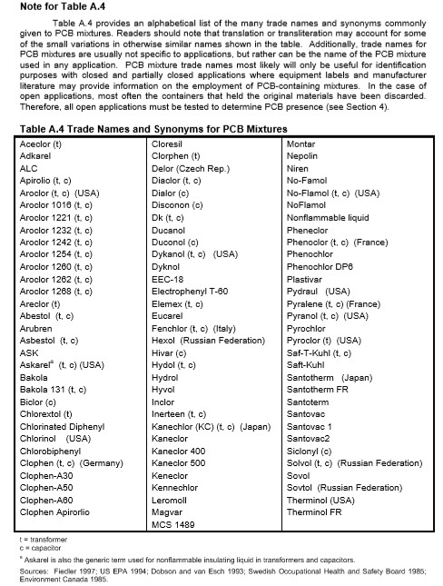

Table A1: Table of international PCB trade names (United Nations Environment Programme (UNEP) Chemicals, 1999)

Appendix B: Manufacturing Processes
Figure B1 is the U.S. EPA’s list of 70 manufacturing processes have high potential of generating inadvertent PCBs (Washington State Department of Ecology, 2015).

Table B1: US EPA list of manufacturing processes likely to generate inadvertent PCBs
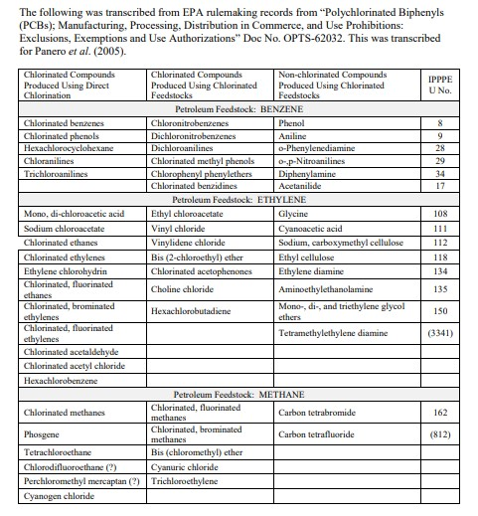

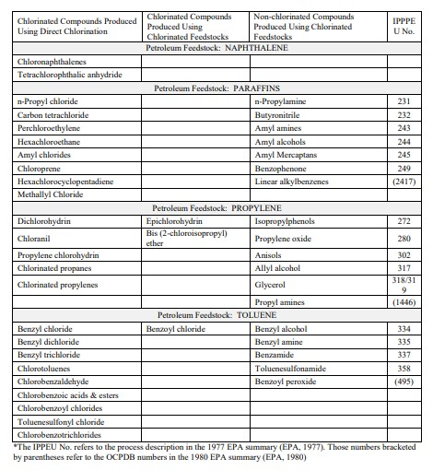

Table B2: End products of manufacturing processes in which PCBs are incidentally generated (Moll, 1982)
End-Products of Manufacturing Processes in Which PCBs are Incidentally Generated
Dyes
diarylide yellow
dyes/pigments made with halogenated solvents
halogenated dyes/pigments
halogenated solvents, unspecified
phthalocyanine

Organic Chemicals
alkyl benzene
alkyl chlorophosphine derivatives
benzene chlorination (process)
benzene phosphorus dichloride
biphenyl derivatives
carbon tetrachloride
chlorinated aryl phosphines
chlorinated naphthalene derivatives
chlorobutane derivatives
chlorosilane derivatives
chloroxylene derivatives
diphenyl oxide and derivatives
ethyl benzene
halogenated solvents, unspecified
monochlorinated butylated diphenyl
monochlorinated terphenyls
organo phosphorus trichloride derivative
pentachloronitrobenzene
phenyl chlorosilanes
phenyl siloxanes
polychlorinated terphenyls
tetrachloroethylene
aluminum chloride

Appendix C: Exposure to PCBs
An in-depth discussion of routes of exposure to PCBs is outside the scope of the main report. However, the following supplementary details may be of interest.
Air/Atmosphere
Lighter-weight PCB congeners are widely distributed around the world through the air. They accumulate in remote regions, far from urban development. About 90% of the PCBs entering Lake Superior, for instance, come from the atmosphere (Colborn, von Saal, & Soto, 1993). This is an important route of exposure to consider when discussing the ubiquity of PCBs. Not all chemicals are mobile in air, which makes PCBs especially challenging to control once dispersed. Therefore, controlling their manufacture, inadvertent or intentional - can aid in decreasing global environmental PCB contamination.
Water
According to the EPA, PCBs enter waterways primarily through runoff from landfills and building materials and discharge of waste chemicals (Stone A. , 2014). Fish are particularly vulnerable to this class of chemicals, which contributed to the implementation of nationwide water concentration limits for PCBs (Carey, et al., 2016). Marine species - like pacific salmon and killer whales (which eat pacific salmon) - are especially prone to the consequences of PCB pollution. Salmon readily accumulate the lipid (fat) loving PCBs due to their high fat content; while killer whales accumulate relatively high levels of PCBs through their diets since they are at the top of the food chain. Research presented in a 2016 National Oceanic and Atmospheric Administration report revealed that pacific salmon have average PCB levels between 7.7 and 14.4ng/g ww (Mongillo, et al., 2016). This results in higher occurrences of developmental impacts and overall mortality for these species (Lerner, Björnsson, & McCormick, 2007) (Desforges, et al., 2016). Additionally, aquatic species have the potential to transport PCBs from highly contaminated to less contaminated areas (McGill, Gerig, Chaloner, & Lamberti, 2017).
Drinking water can also be a source of exposure, suggesting why the Clean Water Act has such a low concentration limit compared to TSCA.
Food
In Japan, the primary trade name for PCBs was Kanechlor 400. Kanechlor resulted in widespread PCB poisoning in 1968.The number of people reportedly harmed from the contamination in Kanemi Rice Oil varies, with some estimates as high as 15,000 (Umeda, 1972). The impacts of this exposure were still detectable in the body tissues of those affected even nine years after the incident (Yoshihara, Kawano, & Yoshimura, 1979).
Although legacy PCBs are no longer manufactured in the U.S., PCBs may still enter the environment and create a risk of exposure through:
- Illegal importation of products containing PCBs
- Illegal disposal of legacy PCB-containing products
- Inadvertent manufacture of PCBs
- Insufficient worker training on hazards and PCB contamination risks leading to:
  - Improper use of or insufficient personal protective equipment
  - Improper handling techniques
  - Improper disposal of PCB-contaminated equipment
(United States Evironmental Protection Agency, 2016)

Appendix D: Pigment Manufacturers
Table D1: Leading newsprint and packaging pigment manufacturers (National Association of Printing Ink Manufacturers, 2015)
Printing Sector | Company Name | Location
Flexo  Gravure | Actega North America, Inc | Lincolnton, NC
Flexo  Heatset  Letter Press  Offset  Publication | Alden & Ott Printing Inks LP | Arlington Heights, IL
Flexo  Heatset  Letter Press  Offset | Braden Sutphin Ink Co. | Cleveland, OH
Heatset  Offset | Central Ink Corp. | West Chicago, IL
Flexo  Offset | Chromatic Technologies, Inc. | Colorado Springs, CO
Flexo  Gravure  Heatset  Letter Press  Offset | Colorcon, No-Tox Products | Chalfont, PA
Flexo | Graphix Essentials | St. Louis, MO
Flexo | Grand Rapids Printing Ink | Grand Rapids, MI
Flexo  Gravure  Heatset  Letter Press  Offset  Publication | Flint Group | Plymouth, MI
Letter Press  Offset | Gans Ink and Supply Co., Inc. | Los Angeles, CA
Gravure | Gotham Ink & Color | Stoney Point, NY
Offset | Grand Rapids Printing Ink | Grand Rapids, MI
Flexo  Gravure | Hi-Tech Color, Inc. | Odenton, MD
Flexo  Heatset  Letter Press  Offset  Publication | hubergroup North America | Kankakee, IL
Letter Press | Hongtu Industry | CongQing City, China
Heatset  Offset | Ink Systems, Inc. | Commerce, CA
Flexo  Gravure  Heatset  Letter Press  Offset  Publication | INX International Ink Co. | Schaumburg, IL
Flexo | Joules Angstrom U.V. Printing Inks Corp. | Pataskala, OH
Flexo  Heatset  Letter Press  Offset  Publication | R.A.Kerley Ink Engineers, Inc. | Broadview, IL
Gravure | LioChem | Conyers, GA
Flexo  Gravure | Magnum Inks & Coating | Middletown, OH
Flexo  Heatset  Letter Press  Offset  Publication | Mallard Ink Co., Inc. | St. Anthony, MN
Flexo  Offset | Megami Ink Mfg. Co., Ltd - U.S. Branch | Schaumburg, IL
Flexo | Optihue® Inks | Kenton, OH
Flexo  Letter Press  Offset | Press Color, Ink.. | Glendale, WI
Flexo  Gravure | Siegwerk USA Co. | Des Moines, IA
Letter Press  Offset | Spinks Ink Company | Tampa, FL
Flexo  Gravure  Heatset  Letter Press  Offset  Publication | Sun Chemical Corporation North American Inks | Northlake, IL
Flexo  Gravure  Heatset  Letter Press  Offset | Superior Printing Ink Co., Inc. | Teterboro, NJ
Flexo  Heatset  Letter Press  Offset | Toyo Ink America, LLC. | Wood Dale, IL
Letter Press  Offset | US Ink | Carlstadt, NJ
Flexo  Gravure | Wikoff Color Corporation | Fort Mill, SC

Appendix E: PCB Control Actions
Table E1: Control actions identified as potentially applicable for reducing PCB loads to the Spokane River and Lake Spokane (Spokane River Regional Toxics Task Force, 2016)
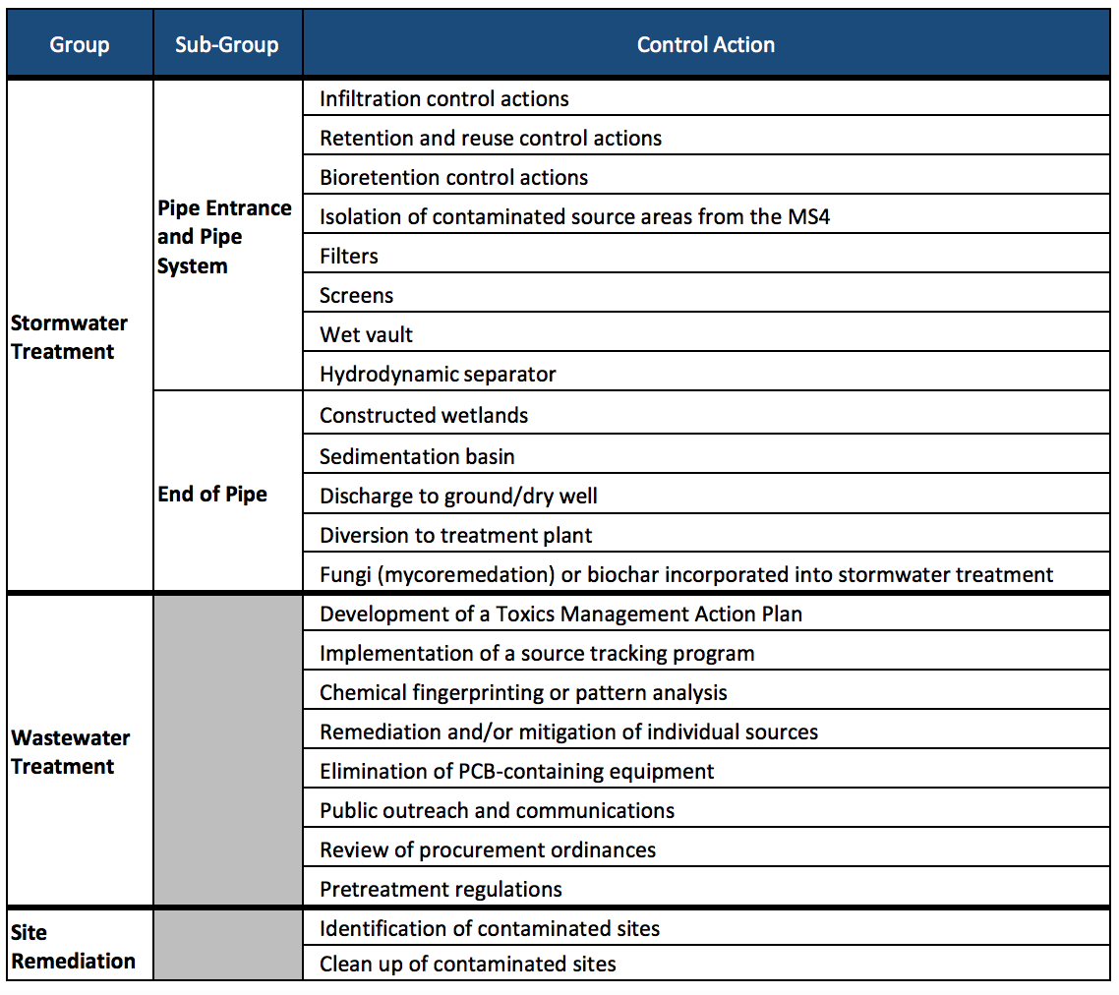

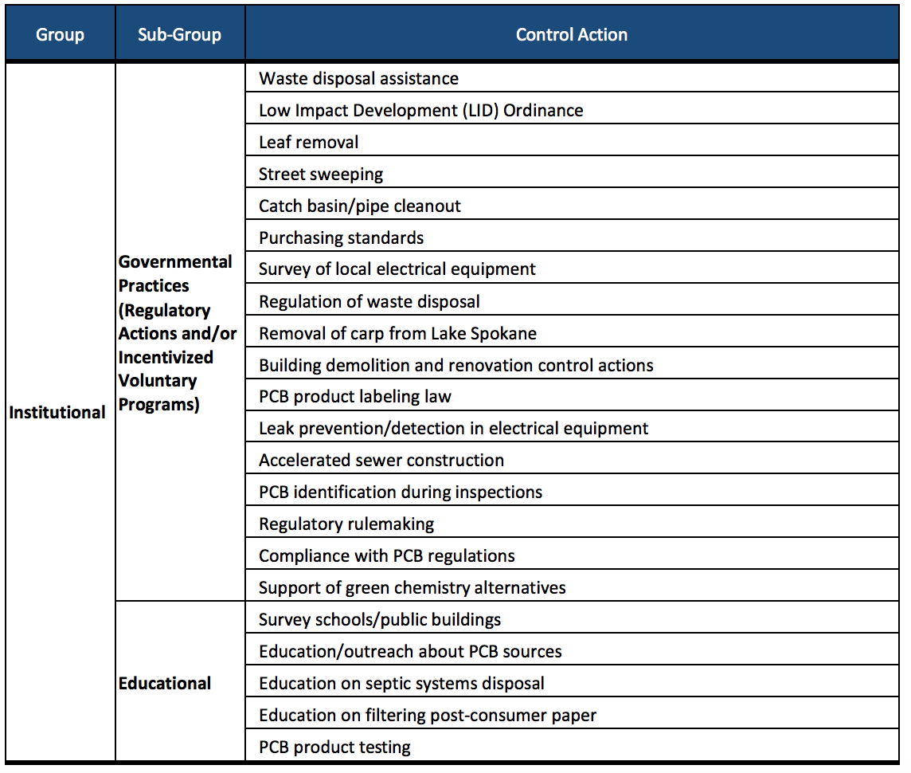

Appendix F: A Closer Look at PCB 11
Inadvertent PCBs can be separated into two categories: byproducts found in Aroclor mixtures and those which are not associated with any legacy PCB production process. Because researchers have not found any link between Aroclor production and PCB 11, it has become a hallmark indicator of inadvertent PCB creation (Hu, Martinez, & Hornbuckle, Discovery of Non-Aroclor PCB (3,3′-Dichlorobiphenyl) in Chicago Air, 2008).
In 2002, Litten et. al were among the first researchers to express concern about PCB 11 in the environment (Litten, Fowler, & Luszniak, 2002). They made the connection between pigment manufacture and inadvertent PCBs after detecting PCB 11 in surface and wastewater near two pigment factories in the New York/New Jersey Harbor area.
Studies have shown that PCB 11 concentrations have remained steady in a number of locations, including the Great Lakes region. For example, researchers at Indiana University found that PCB 11 concentrations have not decreased since 2004 (Hites, 2018). In 2007, researchers found PCB 11 in 91% of air samples taken near 40 Chicago elementary schools, with varying concentrations throughout the year. The presence of airborne PCB 11 increases children’s risk of exposure via inhalation (Hu, Martinez, & Hornbuckle, Discovery of Non-Aroclor PCB (3,3′-Dichlorobiphenyl) in Chicago Air, 2008) (Shanahan, Spak, Martinez, & Hornbuckle, 2015).
While there is no evidence suggesting that PCB 11 accumulates in living organisms, its pervasiveness in the environment and in printed products, from packaging to children’s pajamas, has raised concern (Guo, Capozzi, Kraeutler, & Rodenburg, 2014)There is emerging evidence that PCB 11 may have health hazards, such as neurotoxicity (Shain, Bush, & Seegal, 1991). Another study found that PCB 11 accumulation in the body could suppress cell growth, but its toxicological profile is still being developed (Yueming, et al., 2013).

Appendix G: PCB 11 Concentrations in Printed Materials
Table G1: PCB 11 Concentrations in printed materials worldwide (Washington State Department of Ecology, 2015)
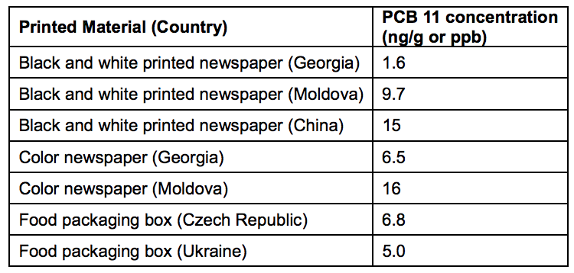

Table G2: PCB 11 concentrations in consumer goods (collected in 2008) (Rodenburg L. A., Guo, Du, & Cavallo, 2010)

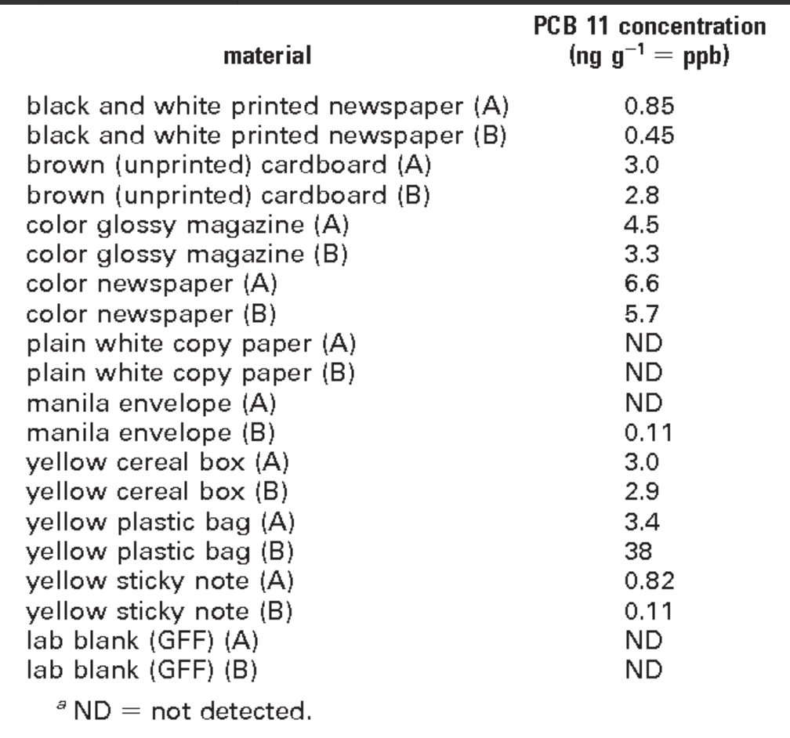

Appendix H: Initial Recommended Collaborators
The next steps for reducing inadvertent PCB pollution involve partnering with a wide variety of stakeholders. Although the general approach to solutions is the same for both packaging and newsprint, some of the partners will differ.
Using EPA reporting data from the 1990’s to 2011 we identified several companies that produce pigments correlated to the production of inadvertent PCBs (Washington State Department of Ecology, 2015). Collaboration with these businesses, enumerated in the table below, will be an essential part of mitigating inadvertent PCB production and identifying safer alternatives. Additional leading pigment and newsprint manufacturers that could be involved, but that were not mentioned in the WA DOE report, are listed in Appendix D.
Partner | Stakeholder Type | Packaging/Newsprint
Spokane River Regional Toxics Task Force | NGO | Working group committed to collaborative solutions
GreenBlue | NGO | Packaging
Sustainable Packaging Coalition | Industry Association | Packaging
Color Pigment Manufacturers Association (CPMA) | Industry Association | Packaging/Newsprint
American Coatings Association (ACA) | Industry Association | Packaging/Newsprint
Washington Department of Ecology (WA DOE) | Regulatory | Packaging/Newsprint
City of San Francisco Procurement | Procurement | Packaging/Newsprint
Interstate Chemicals Clearinghouse | Policy/Regulatory/Procurement | Packaging/Newsprint
Environmental Protection Agency (EPA) Region 10 | Regulatory | Packaging/Newsprint
University of California Berkeley Greener Solutions; Berkeley Center for Green Chemistry | University | Alternative processes for manufacturing pigments; focus on TiO₂
Companies:  - BASF  - Cappelle  - CDR Pigments and Dispersions  - Clariant  - Ciba-Geigy (Pigments Division, as well as other divisions)  - DIC Trading  - Englehard  - Fabricolor  - Hewlett Packard  - Lansco Colors  - Magruder Color Co  - Mil International  - PCL Group  - Sun Chemical Corporation  - Uhlich Color Co  - UMC (United Mineral and Chem)  - Zeneca | Manufacturers | Packaging/Newsprint
Inland Empire Paper | Recycler | Newsprint
 | Consumers | Packaging/Newsprint

Table H1: Recommended collaborators

